|  |  |
| --- | --- |
| **Ticket ID** | TT5655 |
| **Ticket description** | We need to provide regularization report & attendance report access to all the BM's. Attached is the excel sheet to whom the access is to be given. At the same time also provide access for uploading rotational shift assignment to the employees. |
| **Created by** | Sanket Shaha |
| **Created on** | 30/09/2022 |
| **Priority** | Medium |
| **Version** | 1 |

**Version**

|  |  |  |  |  |
| --- | --- | --- | --- | --- |
| **Sr. No** | **Version no** | **Version Date** | **User name** | **User department** |
| 1 | 1 | 07.10.2022 | Sanket Shaha | HR Team |

**Approvals**

|  |  |  |
| --- | --- | --- |
| **Field** | **Name of the User** | **Approved date by the user** |
| **Actual User Name** | Sanket Shaha | 30/09/2022 |
| **Actual User Department** | HR Team |  |
| **Organization Name** | C S Jewellers |  |
| **Sign-off** |  |  |
| **Assigned BA** | Mounika KrishnaVeni Annamneedi | 07.10.2022 |

**Estimation**

|  |  |  |  |  |
| --- | --- | --- | --- | --- |
| **Department name** | **Estimated Time (In hr)** | **Scheduled Date (Starting date )** | **Estimated date** | **Actual delivery date** |
| **BA** | 1 | 11.10.2022 | 11.10.2022 |  |

**Business Requirement**

Access of accessing the regularization report and attendance report to the branch managers according to the authority (according to their branch-wise).

Rotational shift master authority to the branch managers to upload their branch employees rotational shift.

**Existing system**

As per the existing system, the attendance report and regularization report shows the details of all the employees.

No authority to branch managers for rotational shift master.

**Proposed system**

* Creation of authority branch wise in attendance daily report so that branch managers can view their (only their branch) attendance daily report.
* Creation of authority branch wise in regularization report so that branch managers can view their (only their branch) regularization report.

Step 1

In Connect Us >> Monthly Payroll >> Attendance Daily Report

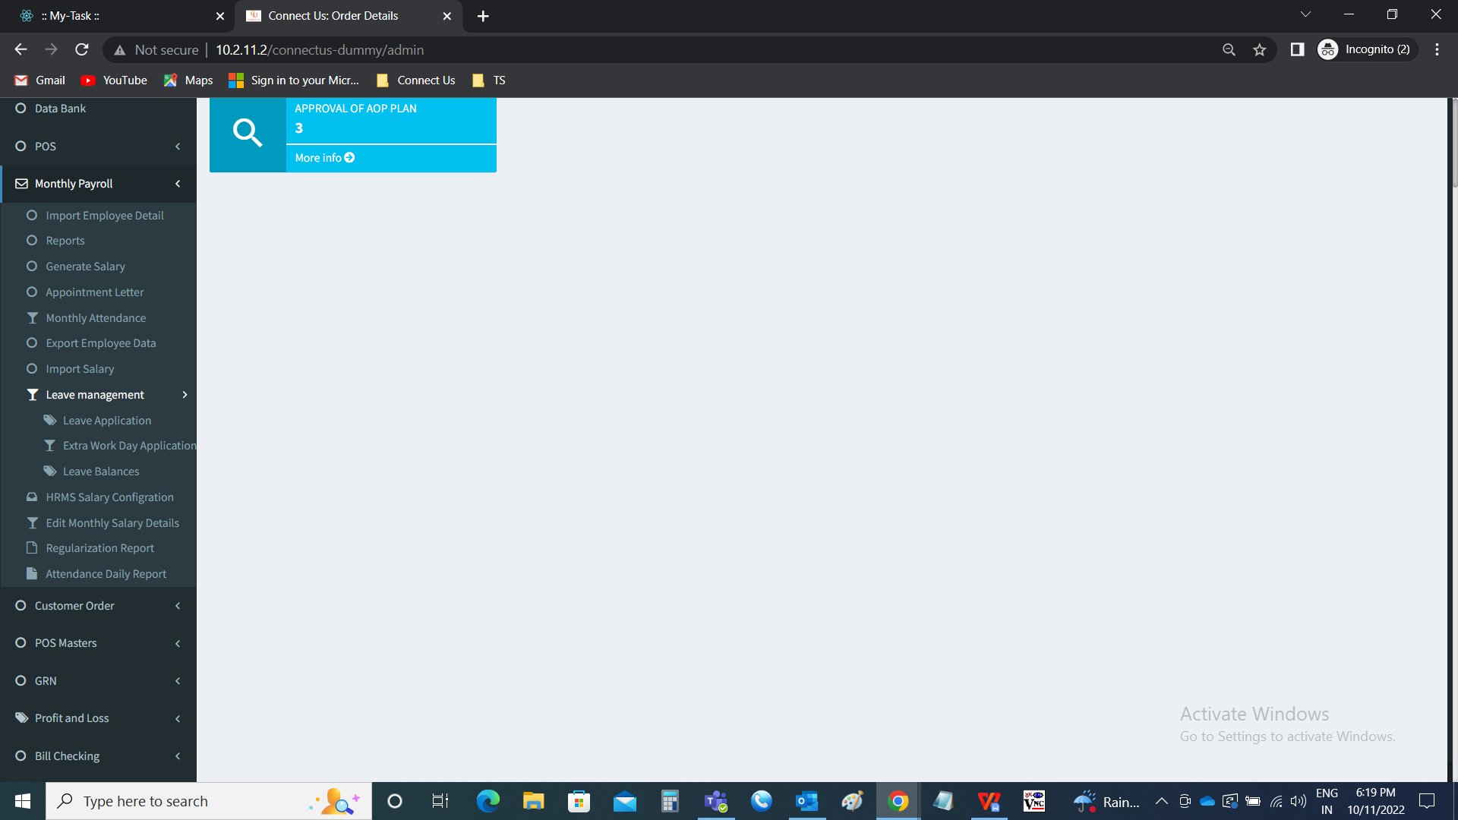

Creation of access to branch managers/ cluster managers based on authority. The branch manager/ cluster manager can only view the report of their branches assigned.

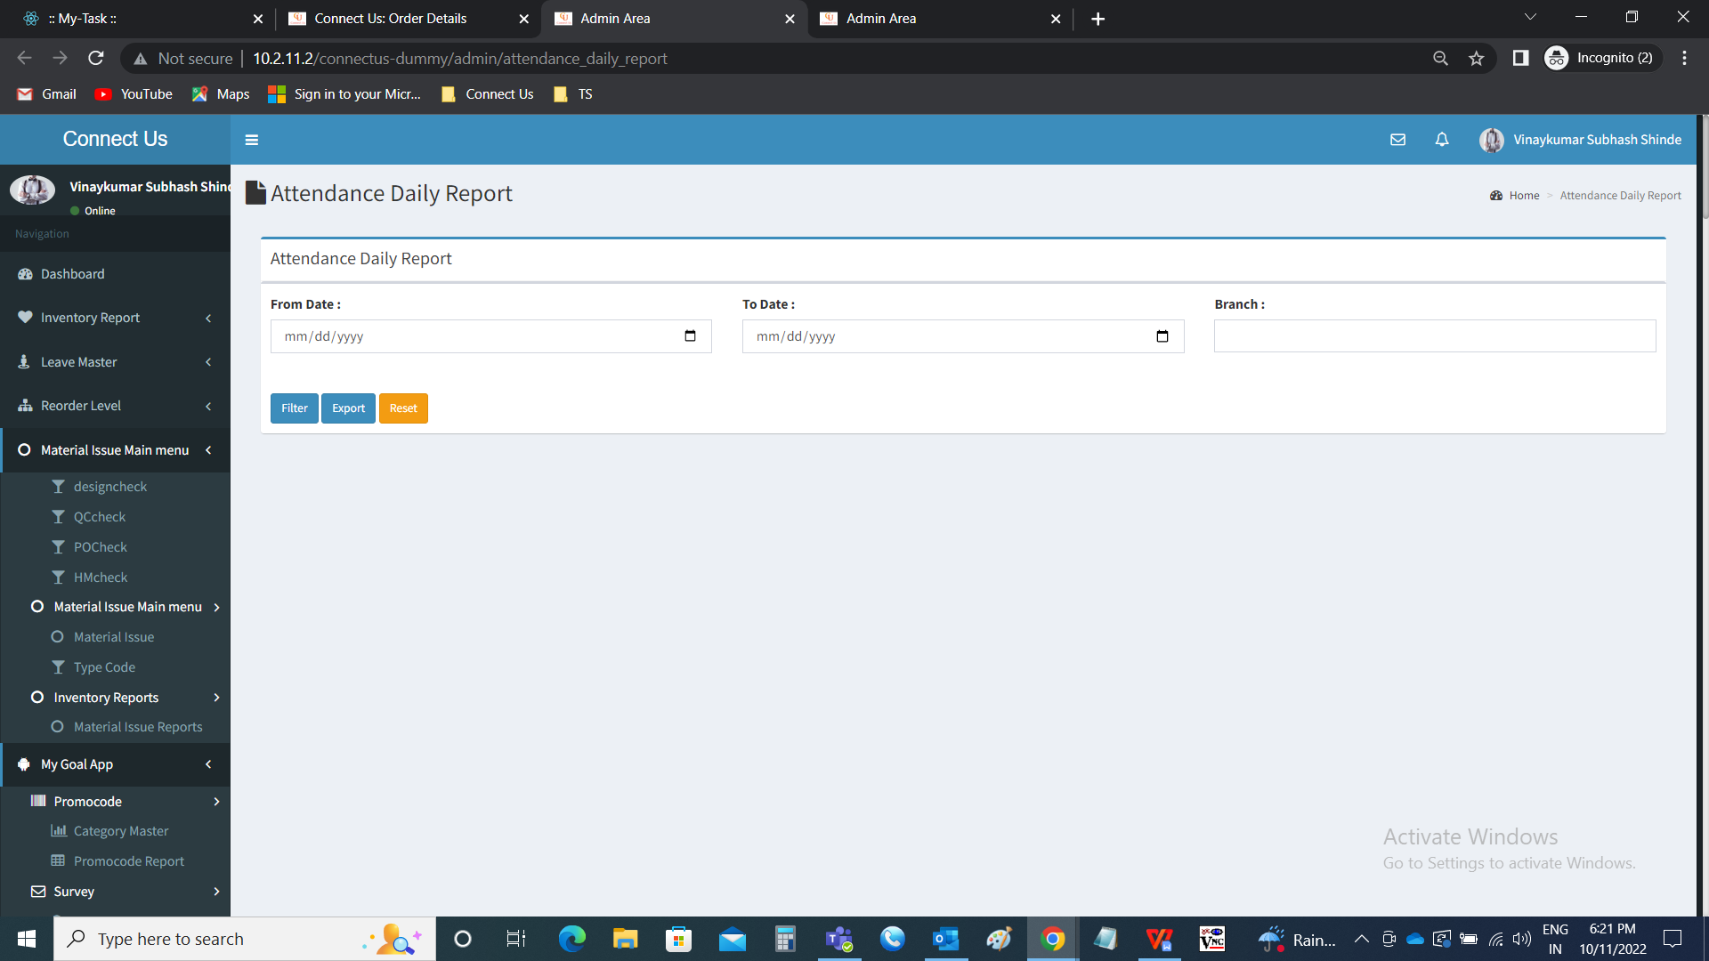

Step 2

In Connect Us >> Monthly Payroll >> Attendance Daily Report



Creation of access to branch managers/ cluster managers based on authority. The branch manager/ cluster manager can only view the report of their branches assigned.

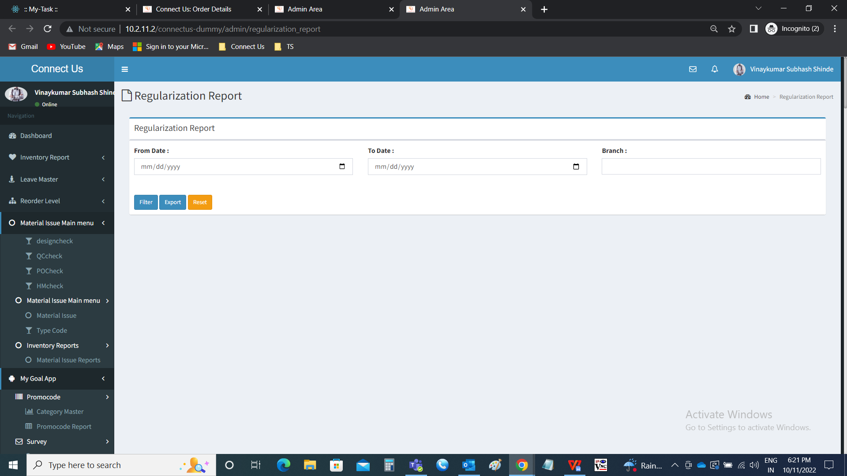

**References of the users**

|  |  |  |  |
| --- | --- | --- | --- |
| **User** | **Name** | **Mail** | **Contact number** |
| **Actual user** | Sanket Shaha | hrhead1@csjewellers.com |  |
| **Assigned business analyst** | Mounika KrishnaVeni Annamneedi | Mounika.annamneedi@techneai.com | 9885900039 |