|  |  |
| --- | --- |
| **Ticket ID** | TT5656 |
| **Ticket description** | We need a custom report tick box in connect us. This point has been discussed between Amruta Wandekar & Monika |
| **Created by** | Sanket Shaha |
| **Created on** | 30/09/2022 |
| **Priority** | Medium |
| **Version** | 2 |

**Version**

|  |  |  |  |  |
| --- | --- | --- | --- | --- |
| **Sr. No** | **Version no** | **Version Date** | **User name** | **User department** |
| 1 | 1 | 03.10.2022 | Sanket Shaha | HR Team |
| 2 | 2 | 06.10.2022 | Sanket Shaha | HR Team |

**Approvals**

|  |  |  |
| --- | --- | --- |
| **Field** | **Name of the User** | **Approved date by the user** |
| **Actual User Name** | Sanket Shaha | 03/10/2022 |
| **Actual User Department** | HR Team |  |
| **Organization Name** | C S Jewellers |  |
| **Sign-off** |  |  |
| **Assigned BA** | Mounika KrishnaVeni Annamneedi | 03.10.2022 |

**Estimation**

|  |  |  |  |  |
| --- | --- | --- | --- | --- |
| **Department name** | **Estimated Time (In hr)** | **Scheduled Date (Starting date )** | **Estimated date** | **Actual delivery date** |
| **BA** | 2 | 03.10.2022 | 04.10.2022 |  |
| **BA** | 0.5 | 06.10.2022 | 06.10.2022 |  |

**Business Requirement**

Custom export of employee master data in connect us.

**Existing system**

There is no custom export in the existing system.

**Proposed system**

Creation of the custom export in the employee master with a special authority.

Step 1

Creation of custom export button

In Connect Us >> Masters >> General Masters >> Employee Master >> Custom export

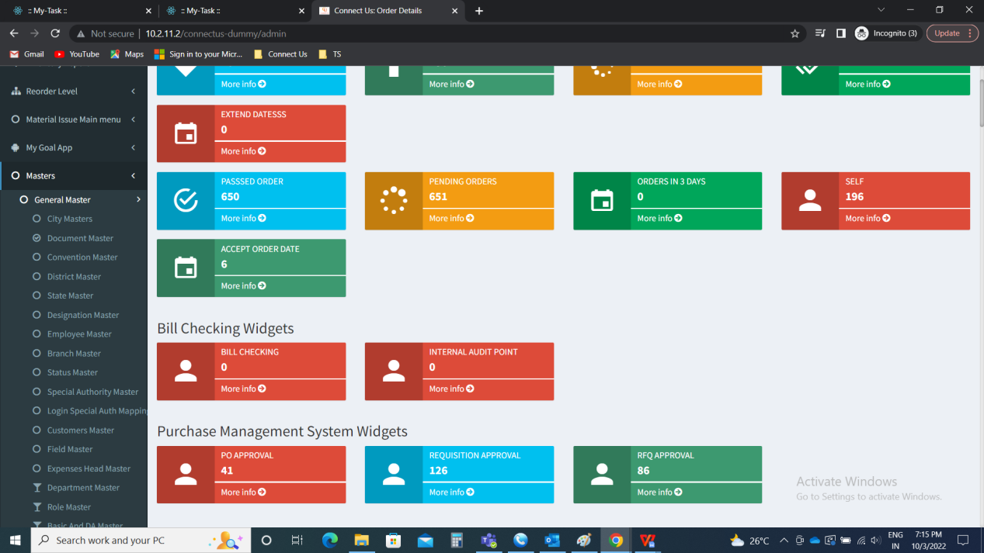

Employee master >> Add custom export button

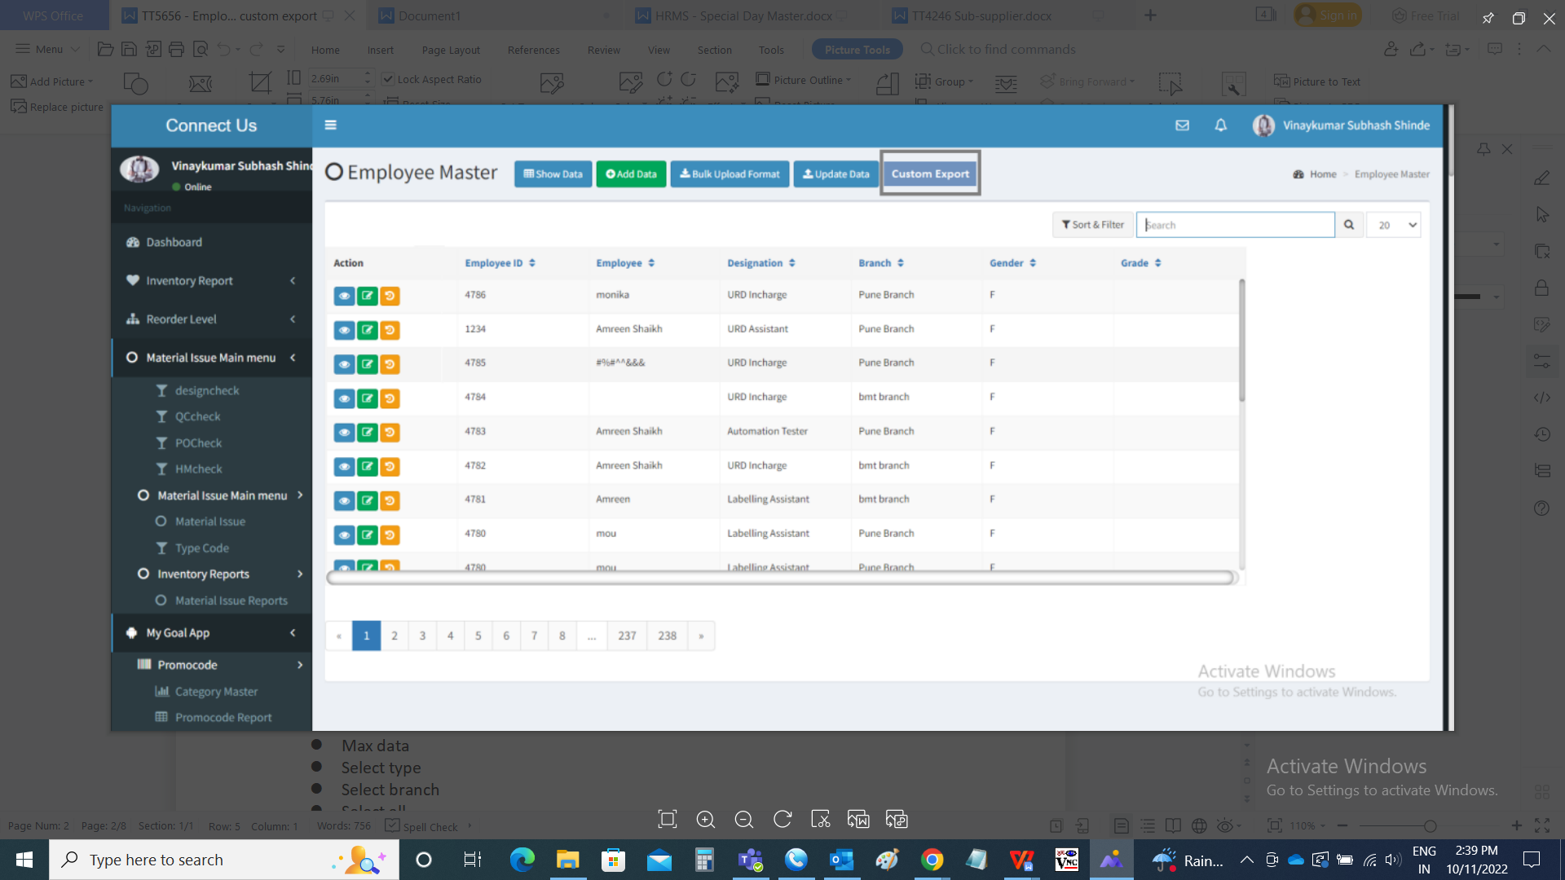

Custom export

The custom export consists of customized fields for exporting the data.

The “export custom” consists of the following fields such as

* File name
* Select branch
* Select all
* Fields to select such as
  + Emp ID
  + Employee name
  + Date of joining
  + Branch
  + Branch Effective Date
  + Designation Effective Date
  + Date of Promotion
  + Promotional Remark
  + Date of Leaving
  + Notice period (In days)
  + Separation mode
  + Role
  + Reporting to
  + Source
  + Reporting managers
  + Shift type
  + Is eligible
  + Date of birth
  + Birth place
  + Gender
  + Blood group
  + Marital status
  + Date of anniversary
  + Nationality
  + Permanent state
  + City
  + Pin-code
  + Present address
  + Permanent address
  + Personal contact number
  + Personal email ID
  + Aadhar card number
  + Pan number
  + Driving license number
  + Driving license expiry date
  + Gratuity number
  + Passport number
  + Physically handicapped
  + On roll type
  + Type of employment
  + PT applicable
  + Salary template
  + Leave encashment
  + Gross
  + Variable pay
  + Net take home
  + CTC
  + Basic
  + DA
  + HRA
  + Conveyance allowance
  + Medical allowance
  + Other allowance
  + Leave encashment
  + Employer PF
  + Employer ESIC
  + Employee PF
  + Employee PT
  + Employee ESIC
  + Annual CTC
  + Grade for variable pay
  + MLWF
  + Bank name
  + Bank account No
  + IFSC Code
  + Bank branch name
  + PF Number
  + PF nominee
  + ESIC Number
  + ESIC Nominee
  + UAN Number
  + Official mail ID
  + Office mobile number
  + Emergency contact number
  + Highest qualification
  + University
  + Passing year
  + Grade
  + Previous company
  + Previous designation
  + Experience
  + City
  + From date
  + To date
  + Relation (Family details)
  + Full name (Family details)
  + DOB (Family details)
  + Aadhar number (Family details)
* Export

|  |  |  |  |
| --- | --- | --- | --- |
| **FIELDS** | **INPUT TYPE** | **MANDATORY/ OPTIONAL** | **DESCRIPTION** |
| File name | Text | Mandatory | The name of the file will be automatically generated but if we want to edit it, we can edit the file name according to the requirement |
| Select all | Check box | Optional | If the user wants all the fields existed, the select all is selected |
| Select fields | Check box | Optional | The following fields required is selected |
| Select branch | Drop down | Optional | The filter for exporting the employees branch-wise. The branches are selected from the drop-down. The branch can be multiple, single and all option to select all the branches. The drop down options are fetched from branch master (in connect us >> masters >> general masters >> branch master) |
| Export | Button | Optional | The button to export the data |

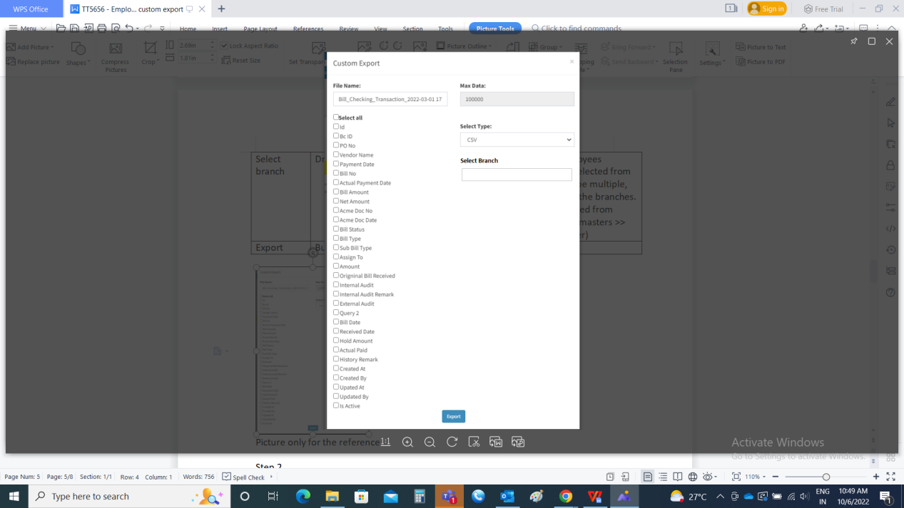

Picture only for the reference

Step 2

Creation of special privilege for the custom export (in connect us >> masters >> general masters >> employee master >> custom export

In Connect Us >> Bill Checking >> Bill Checking Masters >> Special Authority Master

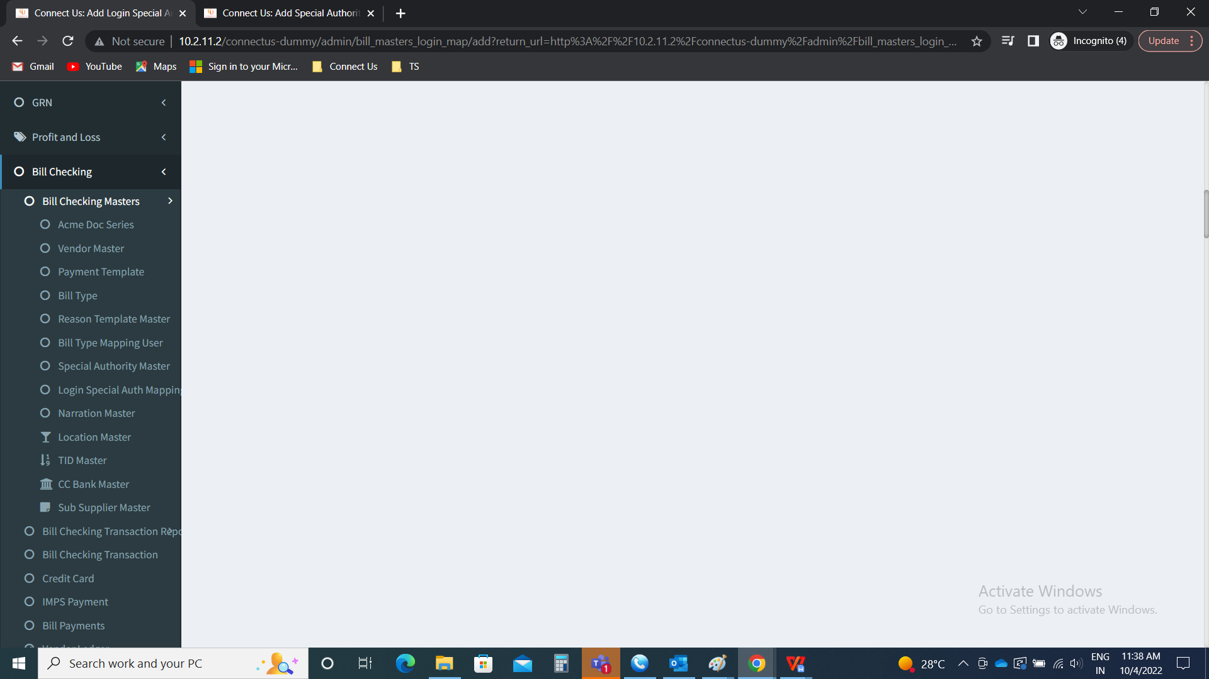

Special authority master >> add data

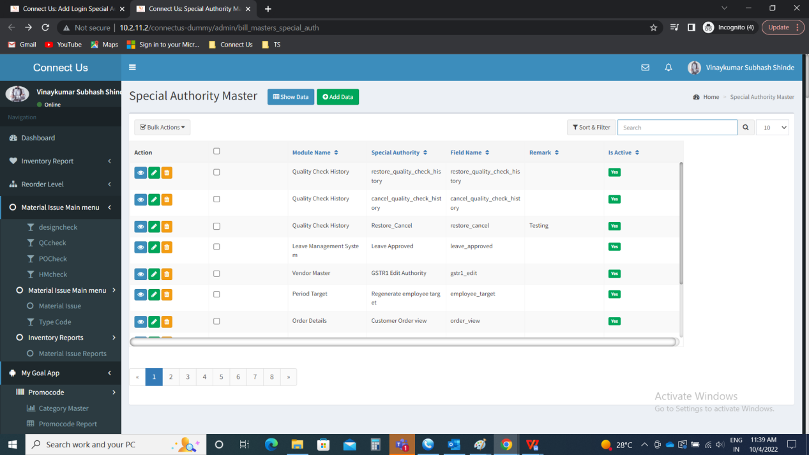

Creation of special authority.

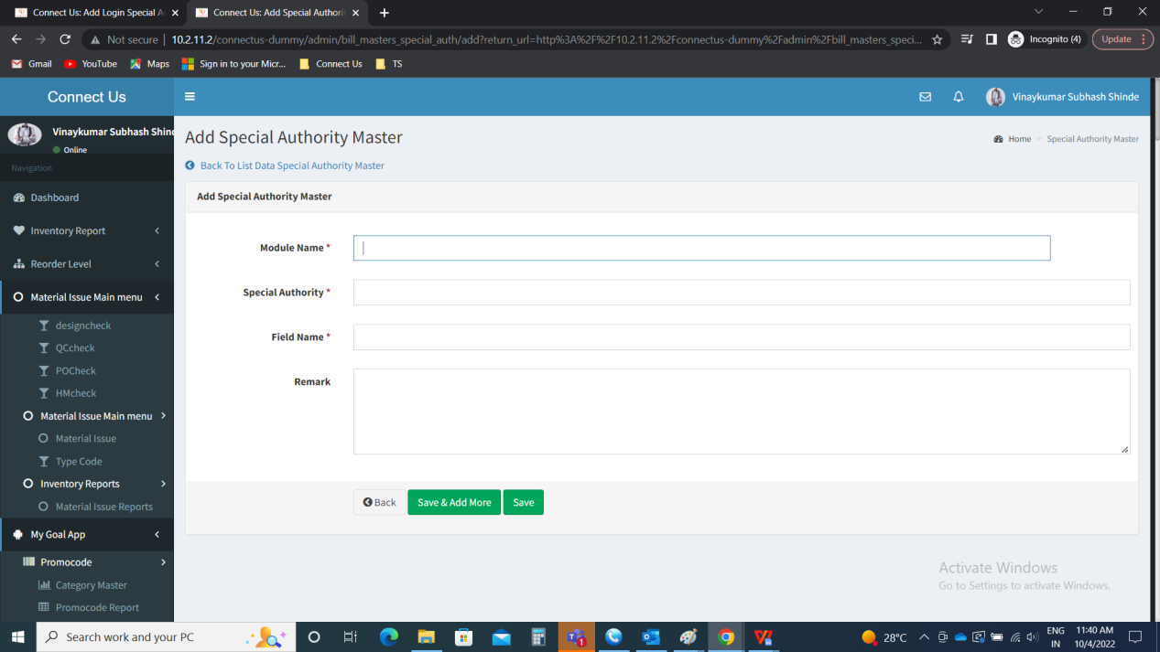

Step 3

Mapping of special authority for the employee login

In Connect Us >> Bill Checking >> Bill Checking Masters >> Special Authority Master



Login special authority mapping >> add data

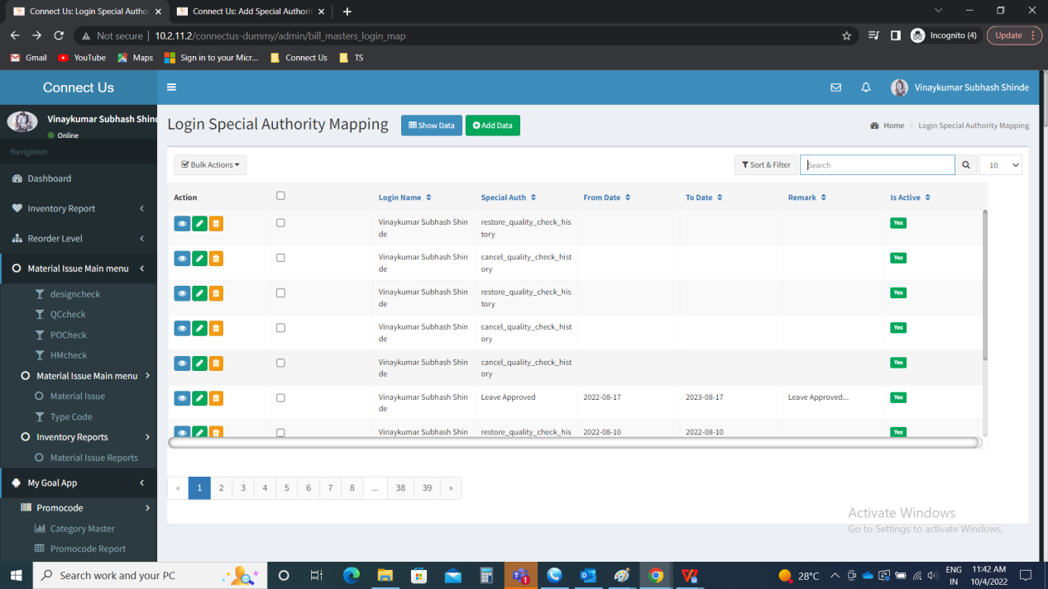

Mapping the users with that special authority

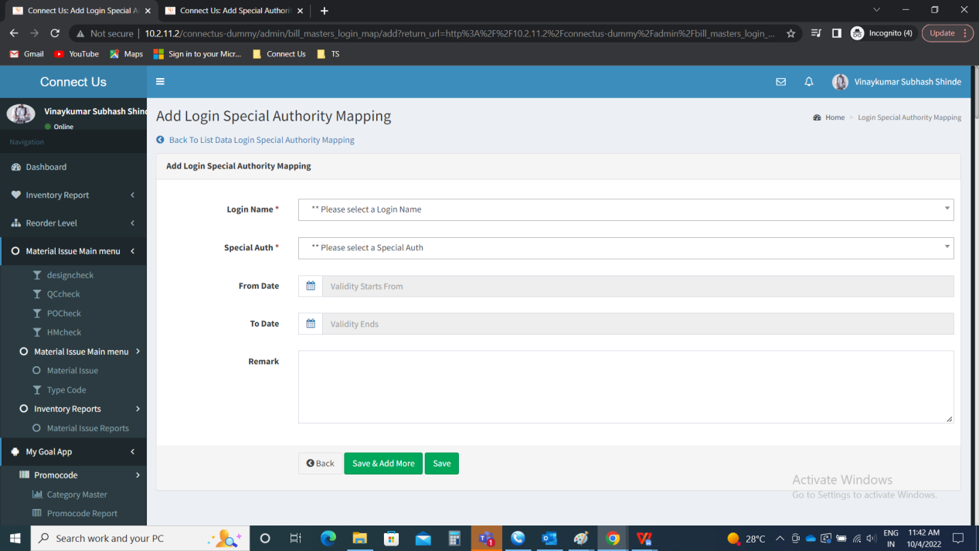

**References of the users**

|  |  |  |  |
| --- | --- | --- | --- |
| **User** | **Name** | **Mail** | **Contact number** |
| **Actual user** | Sanket Shaha | hrhead1@csjewellers.com |  |
| **Assigned business analyst** | Mounika KrishnaVeni Annamneedi | Mounika.annamneedi@techneai.com | 9885900039 |