TEST CASES

The test cases are created by the tester for the developments done by the developers. These test cases are reviewed by the business analysts. The developers and business analysts can view whether the test case is passed or failed (detection of the bugs) and can give the remark of necessary. When the test cases are passed, then it is treated that the development is properly done.

The test cases are presented in the ticket task based on the authority given on the tickets by the ticket owner. So, the assigned users can edit and view the test cases.

At the time of creation of the project, the assigned BA, assigned developer and the assigned tester is selected in the project.

Step 1

In ticketing system >> project management >> project master

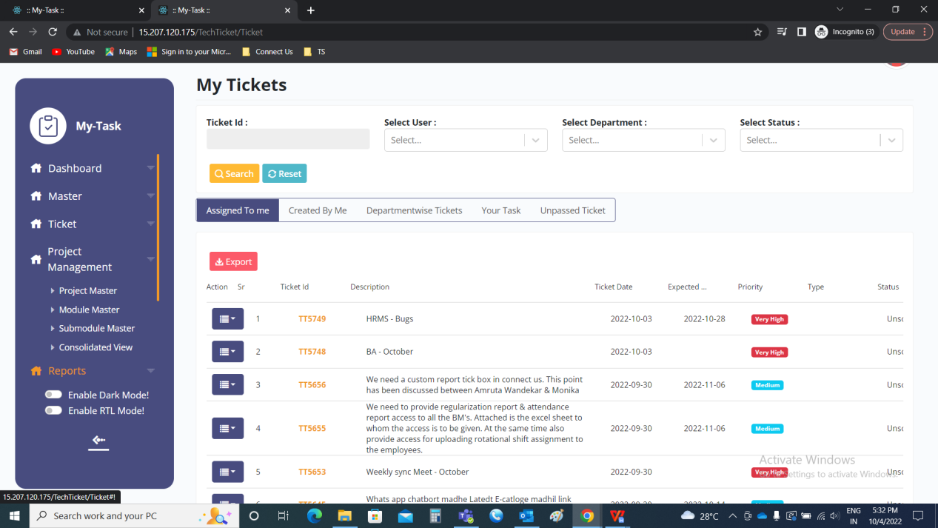

Project master >> add project

Insertion of 3 new fields such as

* Assigned BA
* Assigned Developer
* Assigned Tester

|  |  |  |  |
| --- | --- | --- | --- |
| **FIELDS** | **INPUT TYPE** | **MANDATORY/ OPTIONAL** | **DESCRIPTION** |
| Assigned BA | Drop down | Optional | The assigned BA is selected from the drop down options. The drop down options are fetched from the user master where users, who’s department is IT Implementation/ Business Analyst. |
| Assigned Developer | Drop down | Optional | The assigned developer is selected from the drop down options. The drop down options are fetched from the user master where users, who’s department is IT development. |
| Assigned Tester | Drop down | Optional | The assigned tester is selected from the drop down options. The drop down options are fetched from the user master where users, who’s department is IT testing. |

IMAGE

Note: These 3 fields are fetched in grid view and edit project.

Step 2

In ticketing system >> ticket >> my tickets >> edit ticket

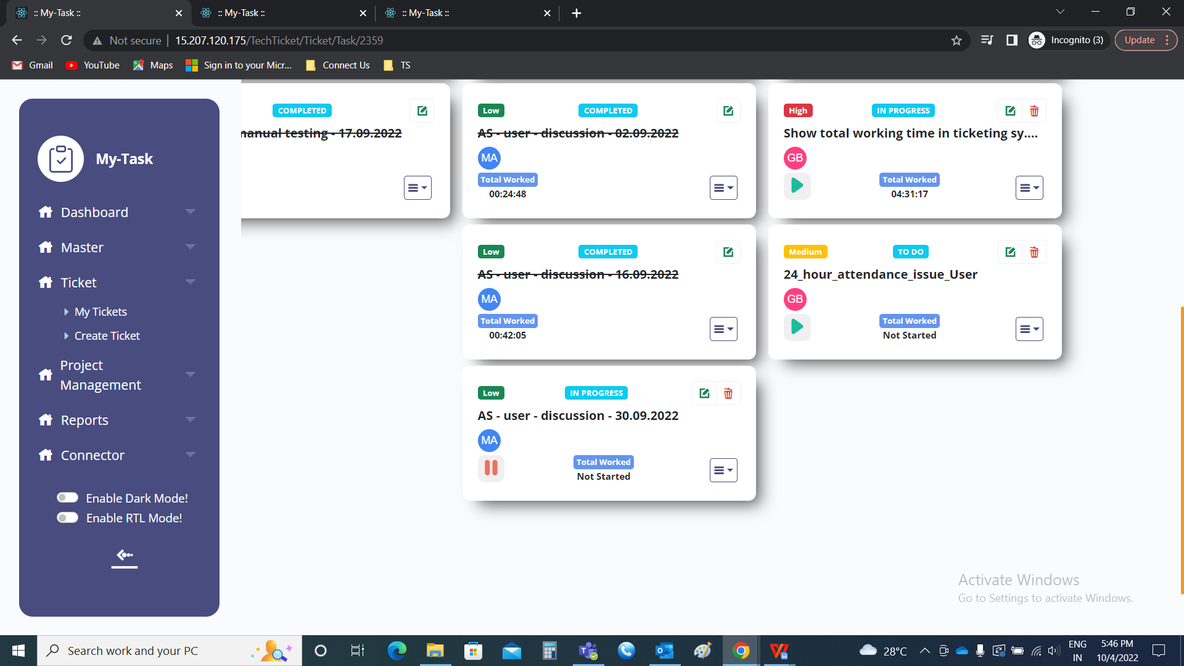

My tickets >> edit ticket

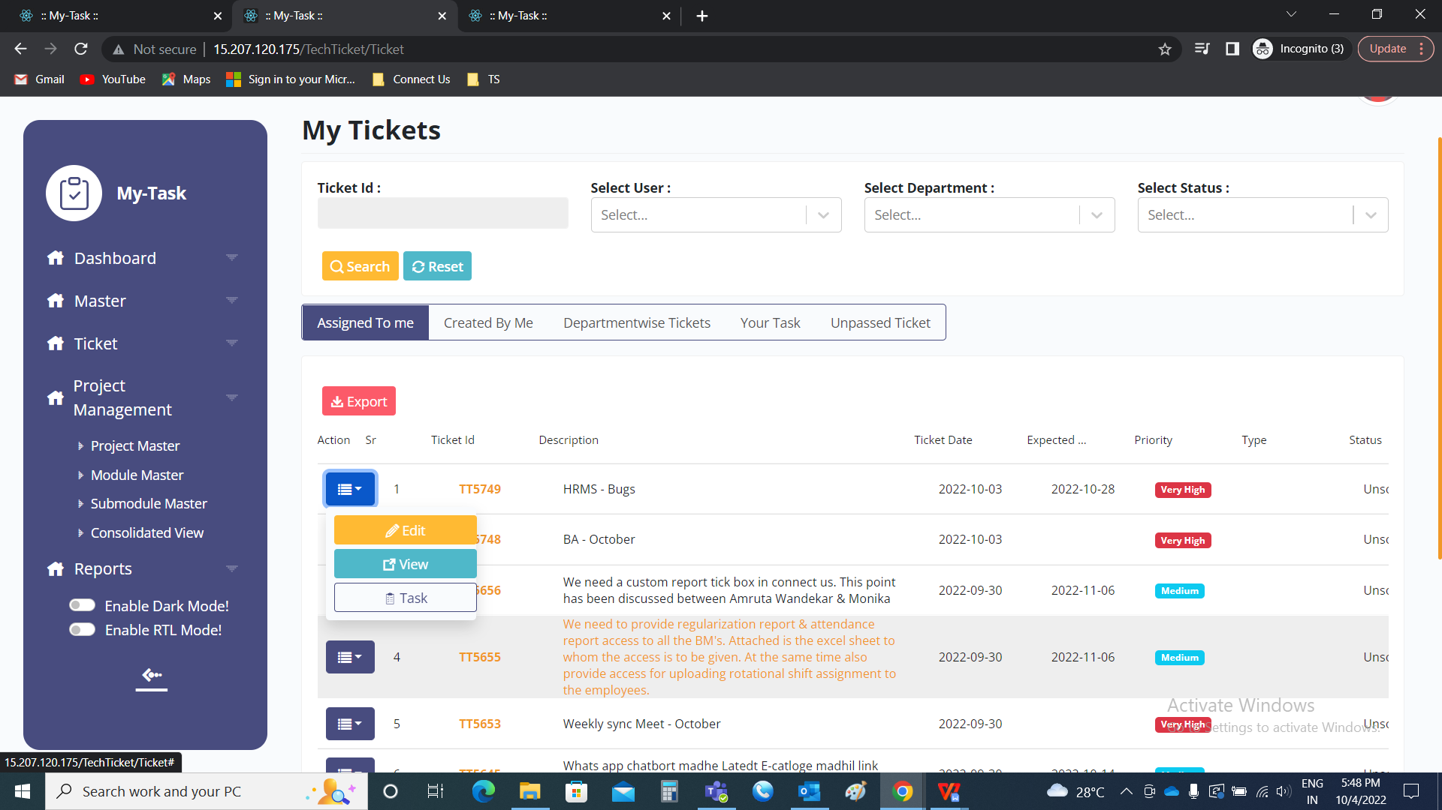

Edit ticket

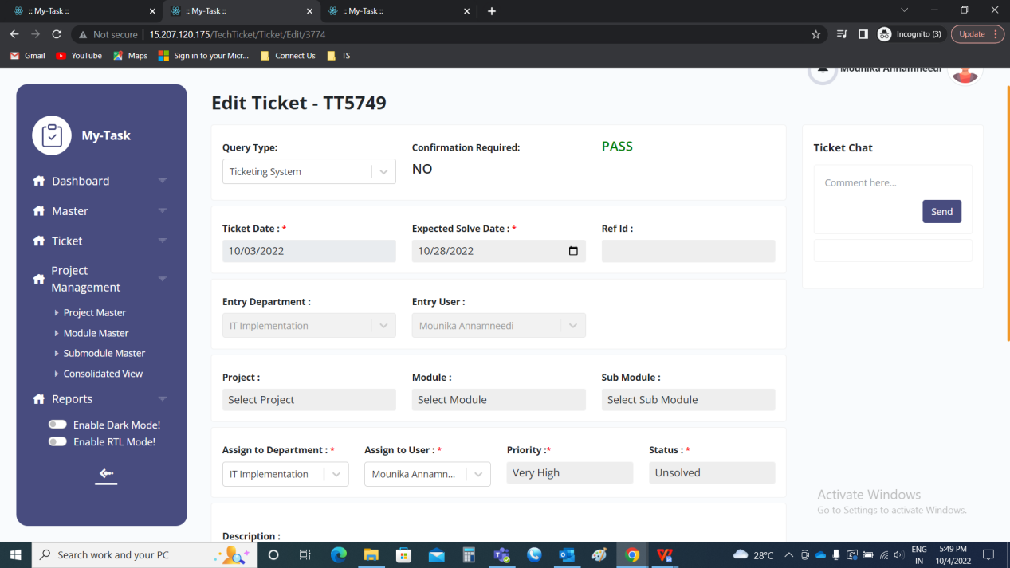

Insertion of 3 new fields such as

* Assigned BA
* Assigned Developer
* Assigned Tester

|  |  |  |  |
| --- | --- | --- | --- |
| **FIELDS** | **INPUT TYPE** | **MANDATORY/ OPTIONAL** | **DESCRIPTION** |
| Assigned BA | Drop down | Optional | The assigned BA is selected from the drop down options. The drop down options are fetched from the user master where users, who’s department is IT Implementation/ Business Analyst. |
| Assigned Developer | Drop down | Optional | The assigned developer is selected from the drop down options. The drop down options are fetched from the user master where users, who’s department is IT development. |
| Assigned Tester | Drop down | Optional | The assigned tester is selected from the drop down options. The drop down options are fetched from the user master where users, who’s department is IT testing. |

IMAGE

Note: These 3 fields are fetched in ticket view and ticket task.

Step 3

In ticketing system >> ticket >> my tickets >> task



My tickets >> task



Task >> hamburger menu >> test cases

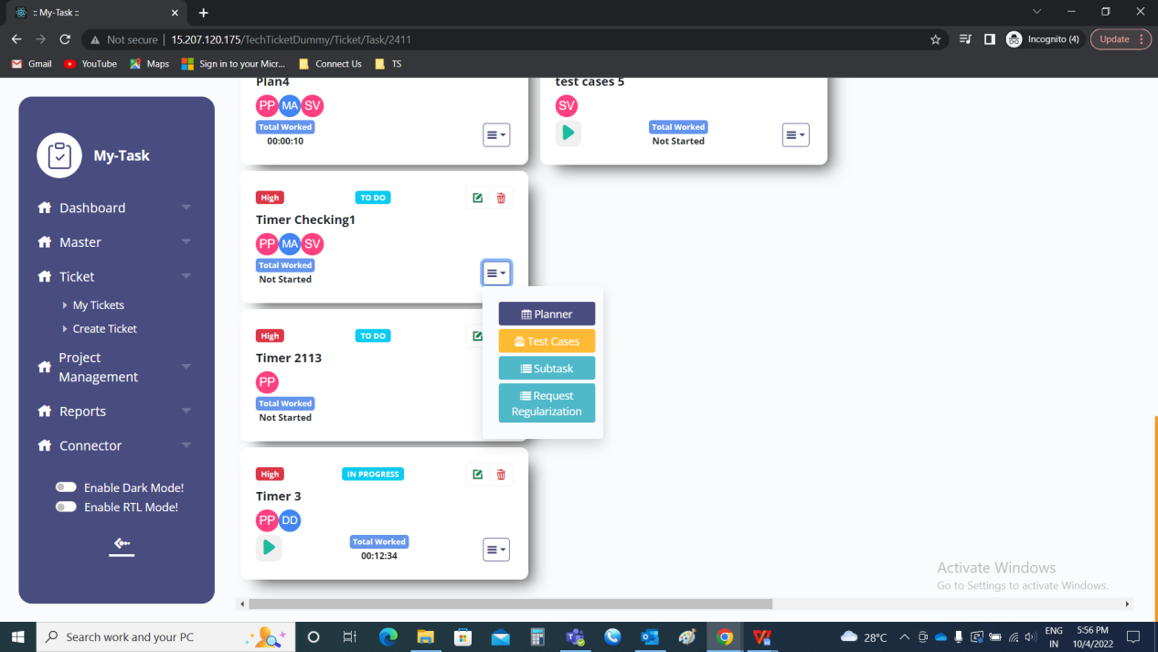

The assigned tester can write the test cases in the test cases field. The test cases consists of the following fields.

Create test case

* Test case ID
* Testing type
* Function
* Platform
* APK version
* OS version
* Test description
* Expected result
* Actual result
* Tester comment
* Status
* Severity
* Screenshot
* Submit
* Cancel

|  |  |  |  |
| --- | --- | --- | --- |
| **FIELDS** | **INPUT TYPE** | **MANDATORY/ OPTIONAL** | **DESCRIPTION** |
| Test case ID | Auto | - | The test case ID is automatically generated by the system in the order |
| Testing type | Drop down | Mandatory | The testing type refers to type of testing. The following are the drop down options.   * Functional * Integration * Validation * UI/UX |
| Function | Text | Mandatory | The functionality of the test case is mentioned |
| Platform | Drop down | Mandatory | The drop down consists of 2 options. They are as follows.   * Website * App   When the test cases about the website, then website is selected.  When the test cases about the application (app), then app is selected. If app is selected, 2 fields are shown.   * APK version * OS version |
| APK Version | Text | Optional | The APK version of the module is mentioned |
| OS Version | Text | Optional | The OS version of the module is mentioned |
| Test description | Text | Mandatory | The test description is entered |
| Expected result | Text | Mandatory | The expected result of the test case is mentioned |
| Actual result | Text | Mandatory | The actual result of the test case is mentioned |
| Tester comment | Text | Optional | The test comment is mentioned if any |
| Status | Drop down | Mandatory | The status of the test case is selected from the drop down menu. The following are the drop down options.   * Pass * Fail |
| Severity | Drop down | Mandatory | The severity of the test cases are selected from the drop down menu. The following are the drop down options.   * High * Medium * Low |
| Screenshot path | File upload | Optional | The screenshots if any are attached |
| Submit | Button | Optional | To submit the test case. As soon the tester submits the data, the data is shown in grid view and new empty field is visible. |
| Cancel | Button | Optional | To cancel the test case |

IMAGE

The same which is saved in viewed in the grid view. There is an option to import the test cases from excel sheet. The following are fields in the grid view.

* Export
* Import
* Download format file
* Filter
* Action
* Test case ID
* Testing Type
* Module
* Sub-module
* Platform
* APK version
* OS version
* Description
* Expected result
* Actual result
* Tester comment
* Tester status
* Severity
* Screenshot
* Review

|  |  |
| --- | --- |
| Field | Description |
| Export | The records will be exported when export button is clicked |
| Import | The import button to import the test cases. The format should be as per the download format file. Otherwise, the file is not accepted. |
| Download format file | The download format file is for the reference to download the file for the import of the data |
| Action | The action field consists of edit, history and disable functions.  The edit button to edit the data.  The history button to know the history of the record.  The disable button to disable any record which is not in use. |
| Test case ID | The test cases ID’s are displayed |
| Testing Type | The testing type is displayed |
| Module | The module is fetched from the ticket and displayed |
| Sub-module | The sub-module is fetched from the ticket and displayed |
| Platform | The platform where the development is done is displayed |
| APK version | The APK version of the application is displayed. If the development belongs to application and APK. |
| OS version | The OS version of the application is displayed. If the development belongs to application and OS. |
| Description | The description of the test cases are displayed |
| Expected result | The expected result of the test cases are displayed |
| Actual result | The actual result of the test cases are displayed |
| Tester comment | The tester comment is displayed, if any is mentioned |
| Tester status | The tester status is displayed |
| Severity | The severity of the test case is displayed |
| Screenshot | The screenshot attached is displayed |
| Review | The review button is clicked, when the test cases are updated. Once the test cases are updated, notifications are sent to assigned BA and the assigned developer. These test cases are viewed in the ticket task (in ticketing system >> ticket >> my tickets >> task). |

IMAGE

Export

The export button is used to export the data of the test cases. The export consists of the following fields.

* ID
* Test case ID
* Testing Type
* Module
* Sub-module
* Platform
* APK version
* OS version
* Description
* Expected result
* Actual result
* Tester comment
* Tester status
* Severity
* Screenshot

IMAGE

Import

The import button to import the file. When the user clicks on the import button, a pop up box opens. The pop-up consists of the following.

* Choose file
* Import
* Cancel

|  |  |  |  |
| --- | --- | --- | --- |
| **FIELDS** | **INPUT TYPE** | **MANDATORY/ OPTIONAL** | **DESCRIPTION** |
| Choose file | File upload | Optional | The file is uploaded to import the data |
| Import | Button | Optional | The import button to import the data I.e., to submit the data |
| Cancel | Button | Optional | The cancel button to cancel the data |

IMAGE

When an empty file or wrong format file or invalid fields are found, error file is displayed.

IMAGE

The error file is downloaded and error is mentioned in cases of no validation.

IMAGE

Download format file

The download format file consists of the file format to be imported. The following are the fields in the import file.

* Testing Type
* Platform
* APK version
* OS version
* Description
* Expected result
* Actual result
* Tester comment
* Tester status
* Severity
* Screenshot

IMAGE

Edit data

The action field consists of the edit button. The following are the fields that can be edited.

* Testing type
* Function
* Platform
* APK version
* OS version
* Test description
* Expected result
* Actual result
* Tester comment
* Status
* Severity
* Screenshot

History

The history button consists of all the data of the changes made for that particular record.

IMAGE

Disable

The disable button consists of the disable feature for disabling any particular record which is not in use. The disabled record cannot be edited.

IMAGE

Step 4

The updated test cases can be viewed and edited in the test cases in the ticket tasks.

IMAGE

When the assigned BA or developer or tester clicks on the test cases button, the grid view of test cases is opened. The following are the fields in the test cases.

* Export
* Filter
* Action
* Test case ID
* Testing Type
* Module
* Sub-module
* Platform
* APK version
* OS version
* Description
* Expected result
* Actual result
* Tester comment
* Tester status
* Severity
* BA status
* BA comment
* Tester status
* Tester comment
* Priority
* Screenshot
* Submit

|  |  |
| --- | --- |
| Field | Description |
| Export | The records will be exported when export button is clicked |
| Filter | The filter button to filter the data. The following are the filters.   * Task * Tester status * BA status * Developer status * Priority * Severity |
| Action | The action field consists of edit, history and disable functions.  The edit button to edit the data.  The history button to know the history of the record.  The disable button to disable any record which is not in use. |
| Test case ID | The test cases ID’s are displayed |
| Testing Type | The testing type is displayed |
| Module | The module is fetched from the ticket and displayed |
| Sub-module | The sub-module is fetched from the ticket and displayed |
| Platform | The platform where the development is done is displayed |
| APK version | The APK version of the application is displayed. If the development belongs to application and APK. |
| OS version | The OS version of the application is displayed. If the development belongs to application and OS. |
| Description | The description of the test cases are displayed |
| Expected result | The expected result of the test cases are displayed |
| Actual result | The actual result of the test cases are displayed |
| Tester comment | The tester comment is displayed, if any is mentioned |
| Tester status | The tester status is displayed |
| Severity | The severity of the test case is displayed |
| Screenshot | The screenshot attached is displayed |
| BA comment | The BA comment is displayed, if any is mentioned |
| BA status | The BA status is displayed |
| Priority | The priority of the test cases is displayed |
| Developer comment | The Developer comment is displayed, if any is mentioned |
| Developer status | The Developer status is displayed |
| Submit | The submit button is clicked, when the test cases are updated. Once the test cases are updated, notifications are sent to assigned BA, assigned developer and the assigned tester accordingly. |

IMAGE

Export

The export button to export the data. The following are the fields that are exported.

* ID
* Test case ID
* Testing Type
* Module
* Sub-module
* Platform
* APK version
* OS version
* Description
* Expected result
* Actual result
* Tester comment
* Tester status
* Severity
* Screenshot
* BA status
* BA comment
* Developer status
* Developer comment

IMAGE

Filter

The filter button consists of the following filters.

* Task
* Tester status
* BA status
* Developer status
* Priority
* Severity

|  |  |  |  |
| --- | --- | --- | --- |
| **FIELDS** | **INPUT TYPE** | **MANDATORY/ OPTIONAL** | **DESCRIPTION** |
| Task | Drop down | Optional | The tasks for which the test cases to be viewed is selected from the drop down. The drop down consists of the record of the tasks which are updated by the tester in the tasks (in ticketing system >> ticket >> my ticket >> task >> test cases in task >> review). |
| Tester status | Drop down | Optional | The tester status is selected from the drop-down. The following are the drop down options.   * Pass * Fail |
| BA status | Drop down | Optional | The BA status is selected from the drop-down. The following are the drop down options.   * Closed |
| Developer status | Drop down | Optional | The developer status is selected from the drop-down. The following are the drop down options. |
| Priority | Drop down | Optional | The priority of the test cases is selected from the drop-down. The following are the drop down options.   * High * Medium * Low |
| Severity | Drop down | Optional | The priority of the test cases is selected from the drop-down. The following are the drop down options.   * High * Medium * Low |

Edit

The edit button in the action field is used to edit the data. The edit is based on the authority basis.

For the assigned BA, the following are the fields that can be edited.

* BA status
* BA comment
* Priority

For the assigned developer, the following are the fields that can be edited.

* Developer status
* Developer comment

For the assigned tester, the following are the fields that can be edited.

* Tester status
* Tester comment
* Severity
* Actual result
* Screenshot

History

The history button consists of all the data of the changes made for that particular record.

IMAGE

Disable

The disable button consists of the disable feature for disabling any particular record which is not in use. The disabled record cannot be edited. The disable feature is available only to the tester.

IMAGE