**USER MASTER**

The user master refers to the users using the ticketing system for say, employees and also the customers of the organization. The following are the fields in the user master.

* Search
* Add user
* Sr
* Account for
* Customer
* Name
* Email
* Contact no
* Username
* Status
* Updated by
* Updated at
* Action

|  |  |
| --- | --- |
| Field | Description |
| Search bar | To search the fields |
| Add user button | To add a new user in the master |
| Sr | The serial count of the records |
| Account for | Whether the user is created for themselves or for others (internal or external users) |
| Name | The name of the user displays |
| Email | The email ID of the user is displayed |
| Contact no | The contact number of the user is displayed |
| Status | It displays whether the user is active or not |
| Updated by | Last updated by is mentioned |
| Updated at | The time on which it is updated last is displayed |
| Action | The action field consists of the edit button to edit the existing user |

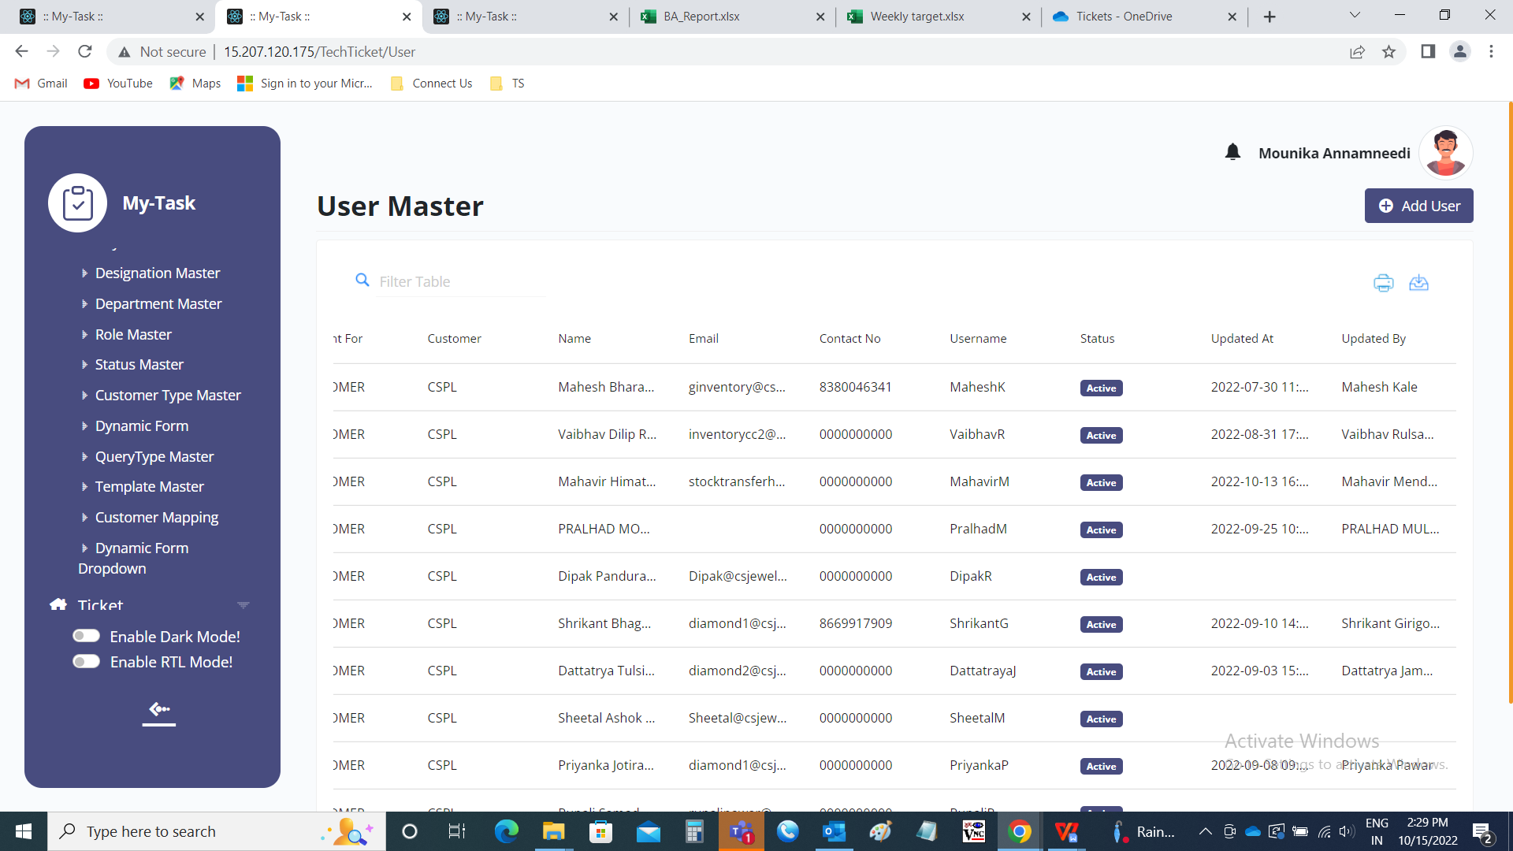

Add data:

The user master consists of 2 pages

* User details
* User settings

The add page user details consists of the following fields.

* User details
  + - Account for
    - Full name
    - Email address
    - Contact number
    - Whatsapp number
    - Username
    - Password
    - Select role
    - Select designation
* Address details
  + - Address
    - Pincode
    - Country
    - State
    - City
* Submit
* Cancel

|  |  |  |  |
| --- | --- | --- | --- |
| **FIELDS** | **INPUT TYPE** | **MANDATORY/ OPTIONAL** | **DESCRIPTION** |
| Account for | Drop down | Mandatory | The account for relates to, to whom does the account is created.  The drop down consists of self and customer.  If the user is creating for themselves (I.e., for the internal users), then self is used. Or else, if the user is creating for the customer (I.e., for external users), then customer is used. |
| Full name | Text | Mandatory | The full name denotes full name of the user. The full name is divided into three parts such as first name, middle name and last name. Accordingly, the name of the user is entered. |
| Email address | Text | Mandatory | The email address of the user is entered. The email name should be unique. |
| Contact number | Int | Mandatory | The contact number of the user is entered. The contact number should be unique. |
| Whatsapp number | Int | Optional | The whatsapp number of the user is entered. |
| Username | Text | Mandatory | The username of the user is entered. The username should be unique. |
| Password | Text | Mandatory | The password for the log in process is entered initially by the creator. Later the user can change their password in the user profile. |
| Select role | Drop down | Mandatory | The role of the user is selected from the drop down options. This data is fetched from the role master (In ticketing system >> Masters >> Role Master). |
| Select designation | Drop down | Mandatory | The designation of the user is selected from the drop down options. This data is fetched from designation master (In ticketing system >> Masters >> Designation Master). |
| Address | Text | Mandatory | The address of the user is entered. |
| Pin-code | Int | Mandatory | The pin-code of the user is entered. |
| Country | Drop down | Mandatory | The country of the user is selected from the drop down options. The country is selected from the drop box menu which is fetched from country master (In ticketing system >> Masters >> Country Master). |
| State | Drop down | Mandatory | The state of the user belonged to is selected from the drop down options. The drop downs are dependent on country drop downs. The state is selected from the drop box menu which is fetched from state master (in ticketing system >> Masters >> State Master). |
| City | Drop down | Mandatory | The city to which the user is belonging to is selected from the drop down options. The drop downs are dependent on state drop downs. The city is selected from the drop box menu which is fetched from city master (In ticketing system >> Masters >> City Master). |
| Submit | Button | Optional | To create the user |
| cancel | Button | Optional | To navigate to the user main page |

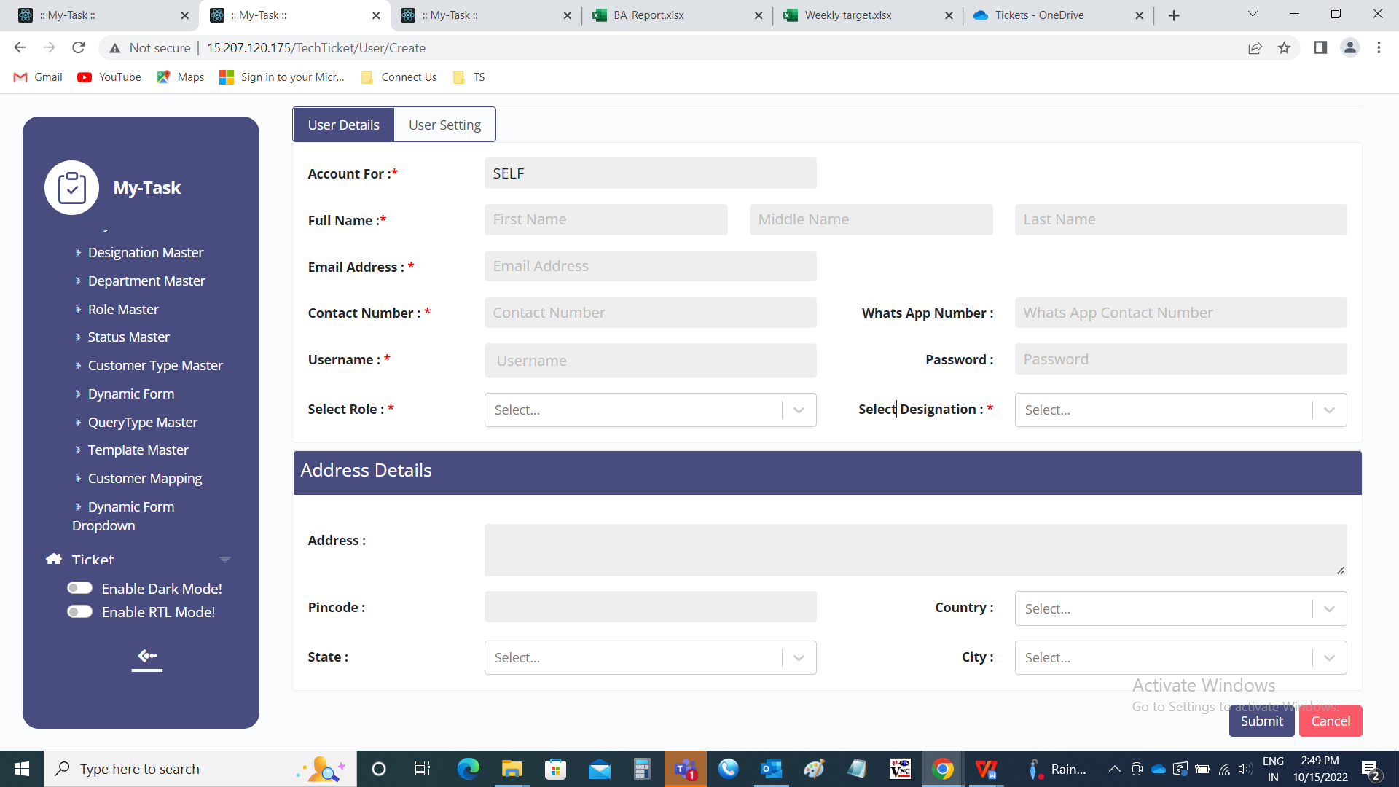

* User setting

The user setting consists of the departments and authority assigned to the user. The user setting consists of the following fields.

* Department
* Ticket type show
* Ticket passing authority
* Make default
* Action
* Submit
* Cancel

|  |  |  |  |
| --- | --- | --- | --- |
| **FIELDS** | **INPUT TYPE** | **MANDATORY/ OPTIONAL** | **DESCRIPTION** |
| Department | Drop down | Optional | The department to which the user is belonged is selected from the drop down. The drop down options are fetched from the department master (in Ticketing System >> Masters >> Department Master). |
| Ticket type show | Drop down | Optional | The type of the tickets to be shown in my tickets (in Ticketing system >> Ticket >> My ticket) of the user is selected from the drop down. The drop down consists of the following options.   * My tickets * Department tickets   My tickets consists of all the tickets where the user created or assigned or any task assigned or basket assigned in that ticket.  Department tickets consists of all the department users tickets. |
| Ticket passing authority | Check box | Optional | The ticket passing authority to be given to the user or not is selected. If the user haves the authority, the tickets created by users who are not having the passing authority, all shown in the unpassed tickets (in Ticketing System >> Ticket >> My ticket >> Unpassed tickets), so that the authority person can pass or reject the ticket. If any authority person created the ticket, the ticket is directly passed. |
| Make default | Check box | Optional | The make default option is used for making the department as a default option. |
| Action | Button | Optional | The action field consists of the plus button to add the new row to add the multiple departments against the user |
| Submit | Button | Optional | The submit button to submit the details |
| Cancel | Button | Optional | The cancel button to navigate to user master main page |

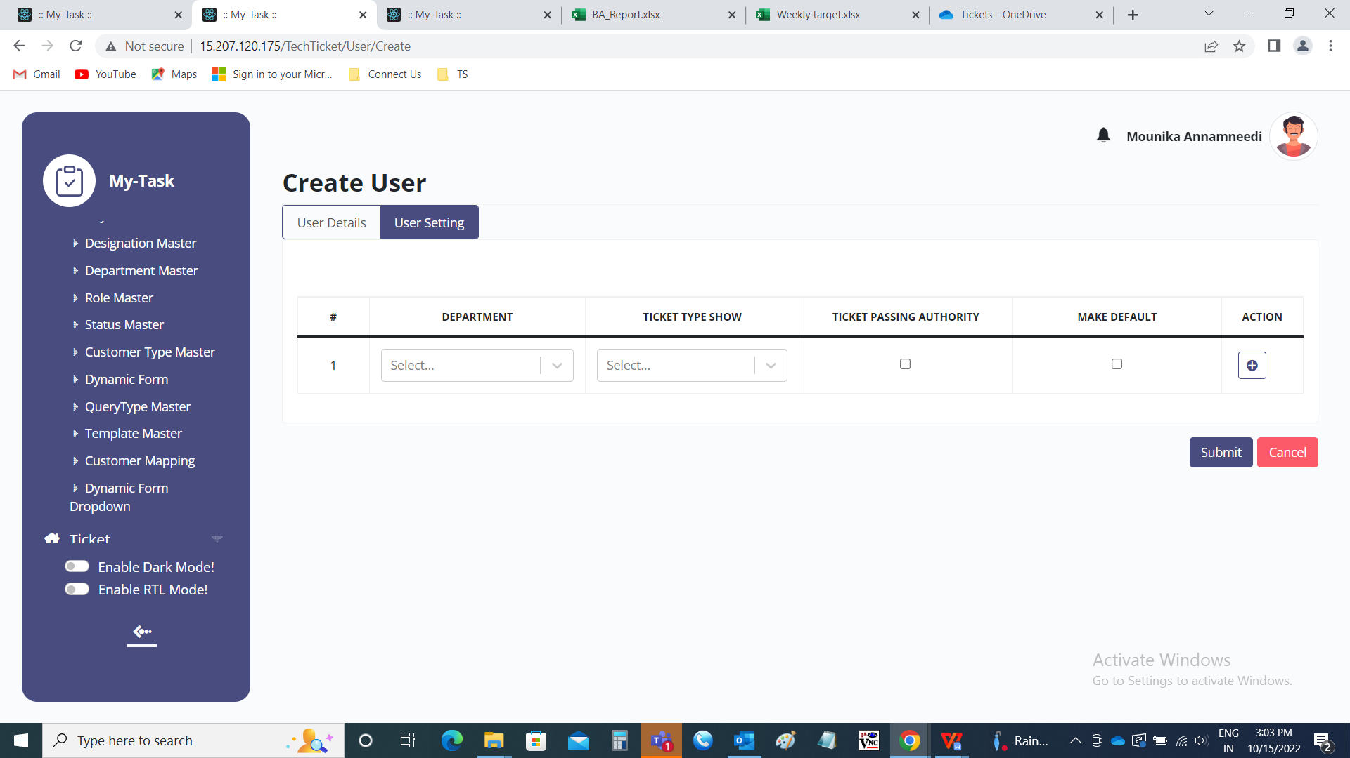

Edit page:

The edit page consists of the following and all fields can be edited if required.

* User details
  + - Account for
    - Full name
    - Email address
    - Contact number
    - Whatsapp number
    - Username
    - Password
    - Select role
    - Select designation
* Address details
  + - Address
    - Pincode
    - Country
    - State
    - City
  + Update
  + Cancel
* Departments
  + Department
  + Ticket type show
  + Ticket passing authority
  + Make default
  + Action
  + Update
  + Cancel

User Details

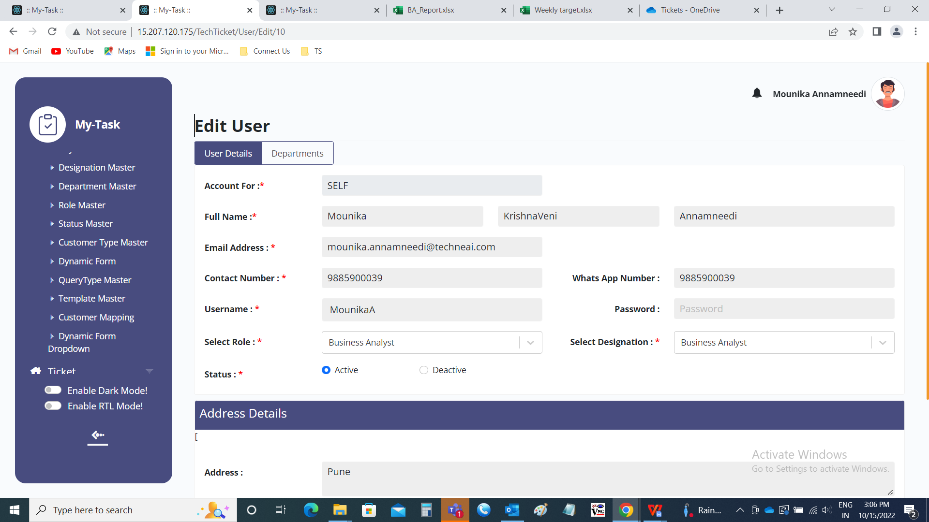

Departments

