**VARIANCE REPORT**

The variance report is the report which is made to know the status of the user task based on the scheduled dates and time. The variance report helps in fetching the data of the employees to take the better decisions for the growth of the employees and the organization. It tracks the employees based on the tasks.

In Ticketing system >> Reports >> Variance Report

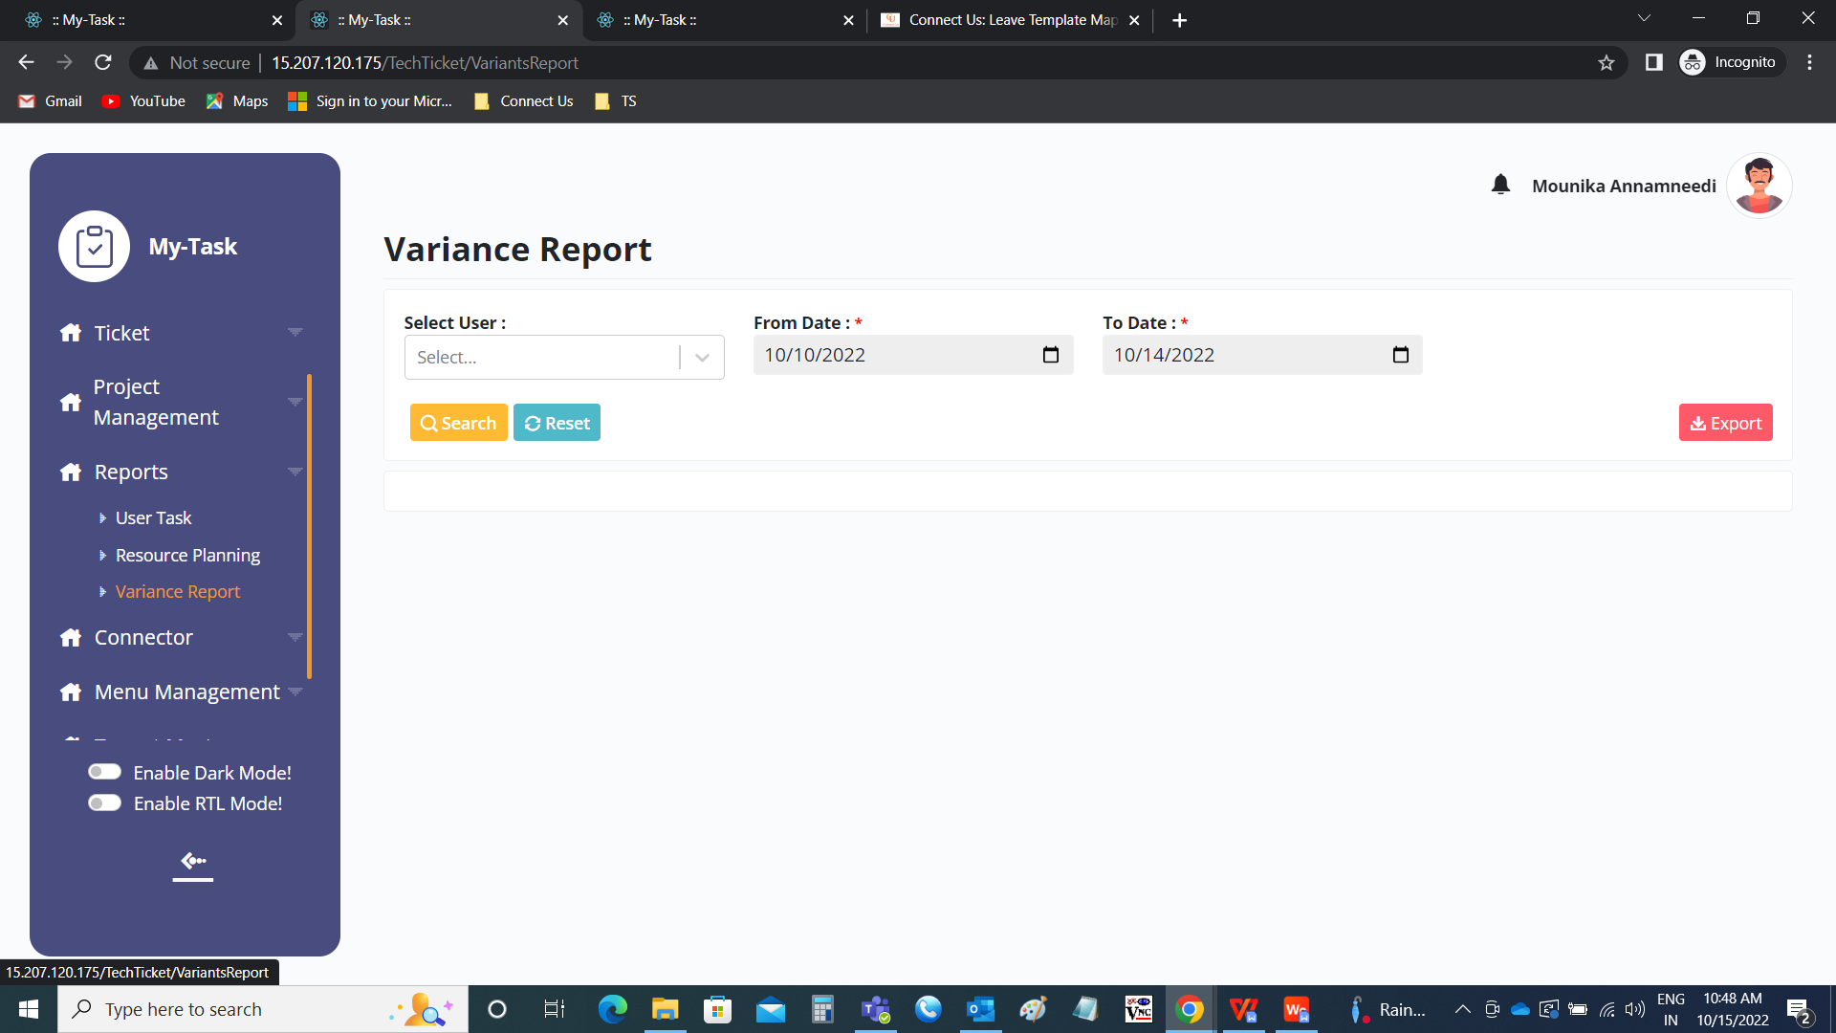

The following are the filters in the variance report.

* Username
* From date
* To date
* Search
* Reset
* Export

The filters included the search button, refresh button and the export button.

|  |  |  |  |
| --- | --- | --- | --- |
| **FIELDS** | **INPUT TYPE** | **MANDATORY/ OPTIONAL** | **DESCRIPTION** |
| User name | Text | Optional | To search based on the username. The username can be single selection, multiple selection. |
| From date | Text | Optional | To search based on from date of the tasks on that date scheduled in the task planner. |
| To date | Text | Optional | To search based on to date of the tasks on that date scheduled in the task planner. |
| Search | Button | Optional | To search that specific filter or combination of filters |
| Reset | Button | Optional | To refresh the filters selected |
| Export | Button | Optional | To export the sheet. If no filters selected, then all the tickets of the user signed in will export. |

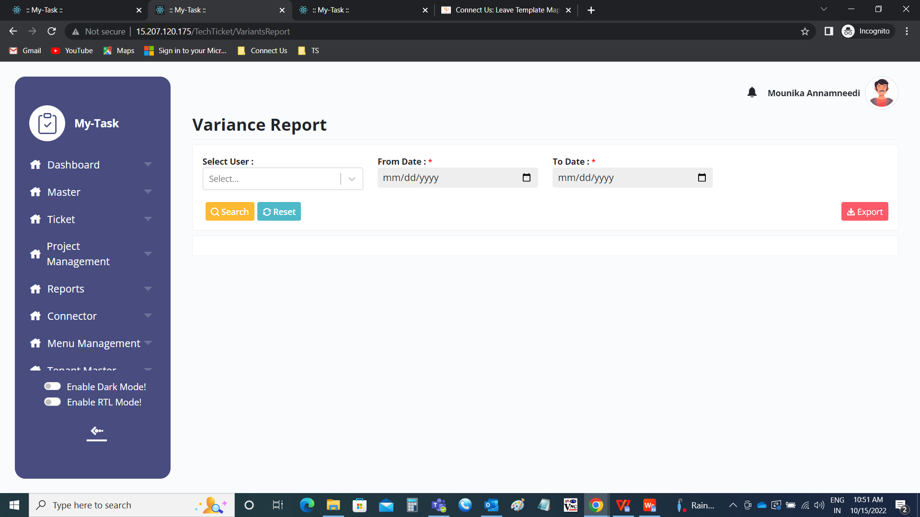

The following are the fields in the report

* Sr no
* Ticket ID
* Task owner
* Task name
* Start date
* Hours scheduled
* Actual worked
* Delivery scheduled
* Status
* Actual status
* Completed at

|  |  |
| --- | --- |
| Field | Description |
| Sr no | The serial number is shown in the order |
| Ticket ID | The ticket ID of the task is displayed |
| Task owner | The task owner of the task is displayed |
| Task name | The task name mentioned in the task is displayed |
| Start date | The start date of the task is displayed |
| Hours scheduled | The total number of hours scheduled for that task is displayed |
| Actual worked | The actual hours worked for that respective task id displayed. The actual work is calculated based on the task played time. |
| Delivery scheduled | The end date of the task is displayed |
| Status | The status of the task is displayed |
| Actual status | The actual status of the task is displayed. If the task date scheduled is greater than the today’s date, then shown as delayed irrespective of the actual status. If the actual working hours are greater than the scheduled hours, then it is shown as delayed |
| Completed at | The task completion date and time is displayed |

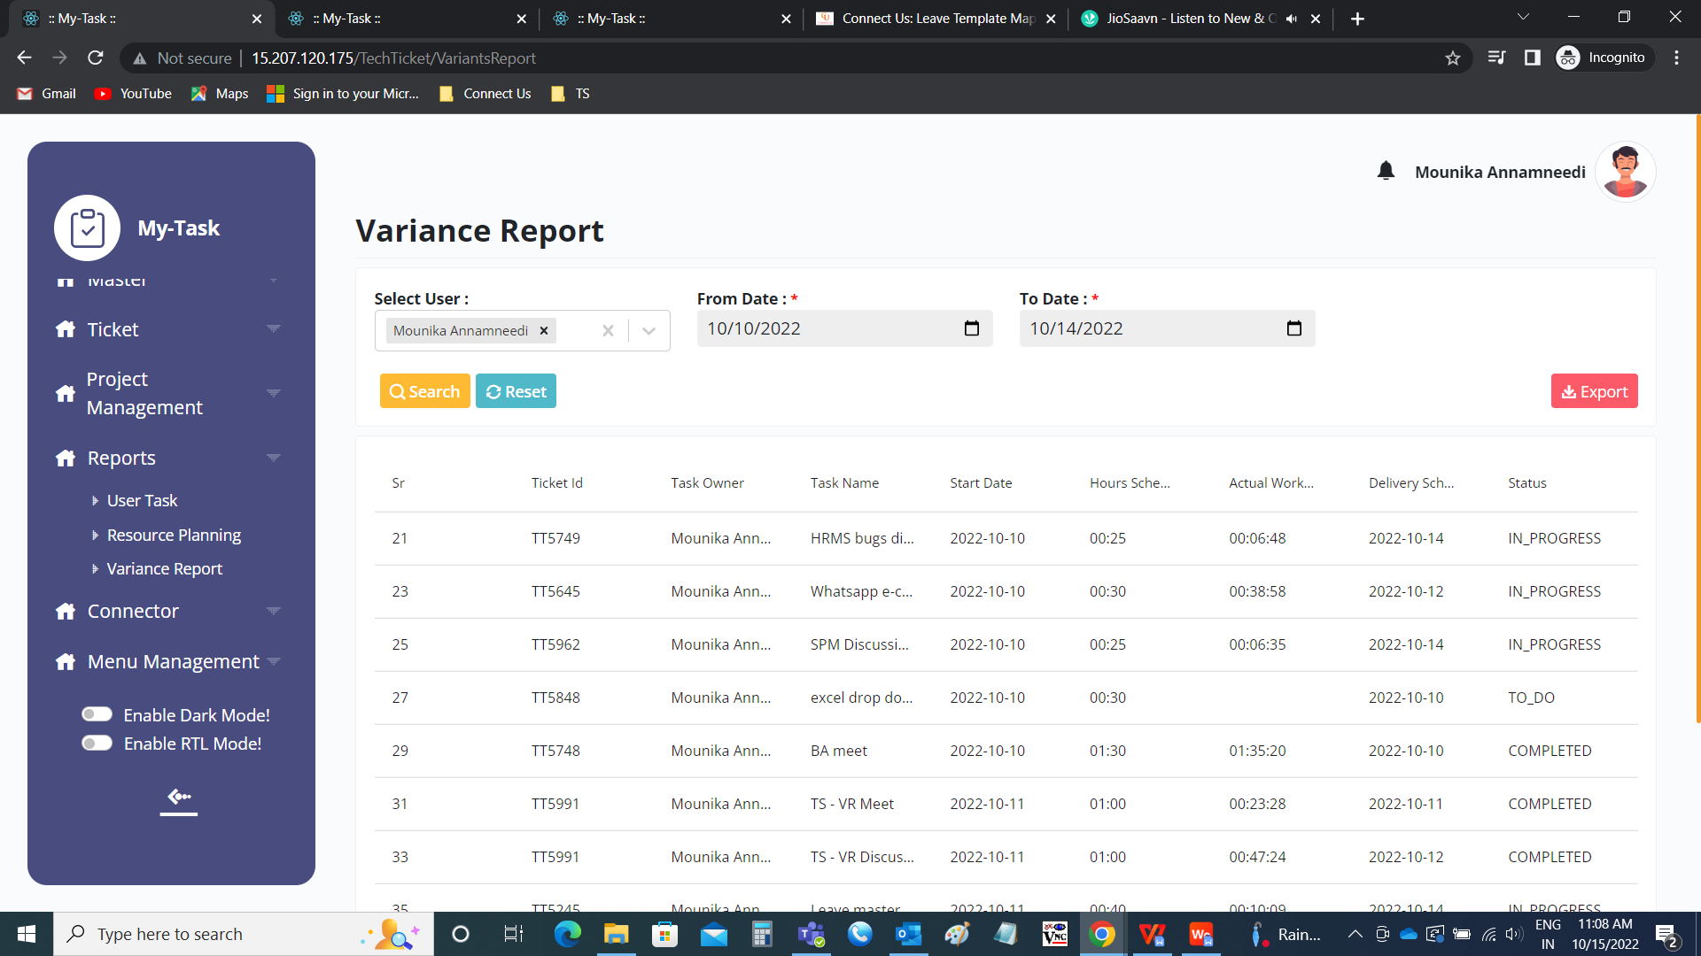

Export

The export button exports the data. The following are the fields in the export file.

* Sr
* Ticket_ID
* Task_owner
* Task_name
* Task_start_date
* Task_scheduled_hours
* Task_actual_worked
* Task_delivery_scheduled
* Task_completed_at
* Task_status
* Task_actual_status

