|  |  |
| --- | --- |
| **Ticket ID** | TT4065 |
| **Ticket description** | Scheme Re-enrolment chi process deli ahe ashi provision padm madhe karun dene. Details - See attachment |
| **Created by** | Vishal Patil |
| **Created on** | 08/08/2022 |
| **Priority** | Medium |
| **Version** | 1 |

**Version**

|  |  |  |  |  |
| --- | --- | --- | --- | --- |
| **Sr. No** | **Version no** | **Version Date** | **User name** | **User department** |
| 1 | 1 | 01.11.2022 | Vishal Patil | Operations Team |

**Approvals**

|  |  |  |
| --- | --- | --- |
| **Field** | **Name of the User** | **Approved date by the user** |
| **Actual User Name** | Vishal Patil | 01.11.2022 |
| **Actual User Department** | Operations Team |  |
| **Organization Name** | C S Jewellers |  |
| **Sign-off** |  |  |
| **Assigned BA** | Mounika KrishnaVeni Annamneedi | 01.11.2022 |
| **Assigned Developer** |  |  |
| **Assigned Tester** |  |  |

**Estimation**

|  |  |  |  |  |
| --- | --- | --- | --- | --- |
| **Department name** | **Estimated Time (In hr)** | **Scheduled Date (Starting date )** | **Estimated date** | **Actual delivery date** |
| **BA** | 2 | 01.11.2022 | 01.11.2022 |  |

**Business requirement**

A new module to know whether the customer is eligible for the discount at the time re-enrollment of the scheme.

**Existing system**

In the existing system, there is no such system.

**Proposed system**

Creation of the new module “Scheme re-enrollment”.

Step 1

In connect us >> Schemes >> scheme re-enrollment

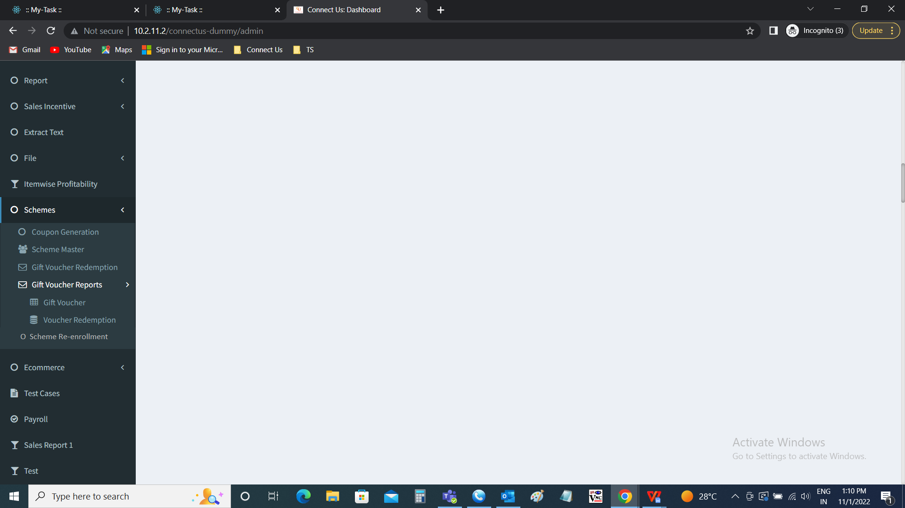

Step 2

Scheme re-enrollment

The scheme re-enrollment module is used by the cashiers in the branch to know whether the customer is eligible for the discount at the time of re-enrollment of the scheme.

The scheme re-enrollment consists of the following fields

* Enter customer number
* Submit
* Cancel

|  |  |  |  |
| --- | --- | --- | --- |
| **FIELDS** | **INPUT TYPE** | **MANDATORY/ OPTIONAL** | **DESCRIPTION** |
| Enter customer number | Int | Mandatory | The customer number is entered. The number should be of the existing customer. |
| Submit | Button | Optional | The submit button to fetch the details of the customers. |
| Cancel | Button | Optional | The cancel button to reset the page |

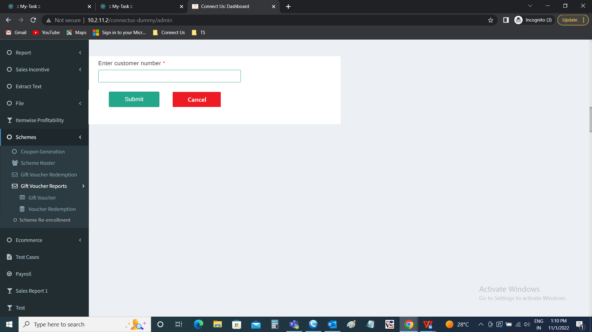

Once the customer number is entered. The following data is displayed related to the customer. The data is fetched from the Padm. The following are the fields.

* Scheme ID
* Customer name
* Scheme name
* Scheme amount
* Scheme maturity date
* Offer applicable or not

|  |  |
| --- | --- |
| Field | Description |
| Scheme ID | The scheme ID currently running is displayed |
| Customer name | The customer name is displayed |
| Scheme name | The scheme name is displayed |
| Scheme amount | The scheme amount is displayed |
| Scheme maturity date | The scheme maturity date is displayed |
| Offer applicable or not | The offer applicable or not to the following customer is displayed. The following are the conditions for the application of the discount.   * The scheme maturity date should not be exceeding 1 month before and after maturity date of the existing scheme. * The offer applicable or not is highlighted. |

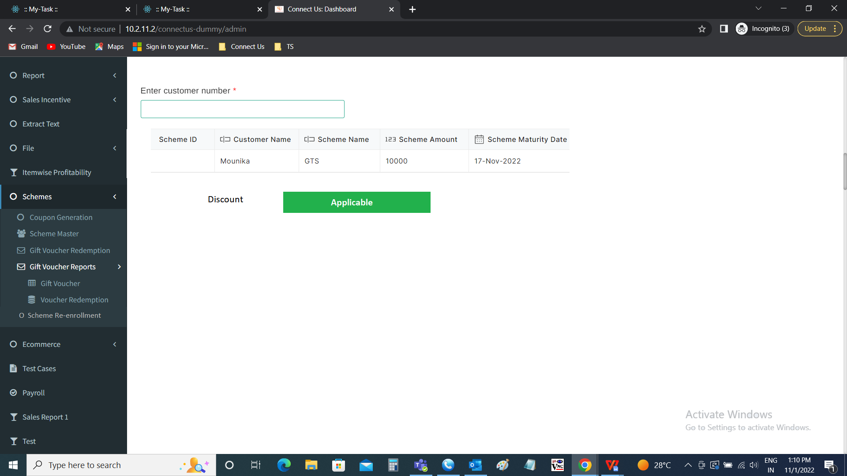

Step 3

* In padm >> document >> Gold tree new member
  + Insertion of new field “Re-enrollment discount amount”,
    - In that field amount of discount, I.e., 10% of the first installment amount is mentioned.
  + Amount received will be (first installment amount - re-enrollment discount amount).
  + The receipt will be considered for the total amount in the first installment.
  + The scheme will be locked to 8 months, if redeemed before the 8 months, then, discount amount will be reduced from the amount redeemed.

Step 4

* In Padm >> document >> Kalpataru new member
  + Insertion of new field “Re-enrollment discount amount”,
    - In that field amount of discount, I.e., 10% of the first installment amount is mentioned.
  + Amount received will be (first installment amount - re-enrollment discount amount).
  + The receipt will be considered for the total amount in the first installment.
  + The scheme will be locked to 8 months, if redeemed before the 8 months, then, discount amount will be reduced from the amount redeemed.
* The receipt will be received for the total amount.

**References of the users**

|  |  |  |  |
| --- | --- | --- | --- |
| **User** | **Name** | **Mail** | **Contact number** |
| **Actual user** | Vishal Patil | hobcs@csjewellers.com |  |
| **Assigned business analyst** | Mounika KrishnaVeni Annamneedi | Mounika.annamneedi@techneai.com | 9885900039 |