**27 Jan 2023**

**http://15.207.120.175/TechTicketDummy/Dashboard**

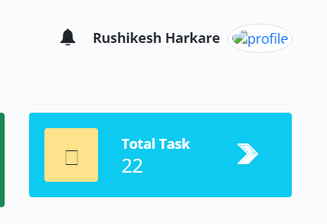

1. Profile is not displayed.

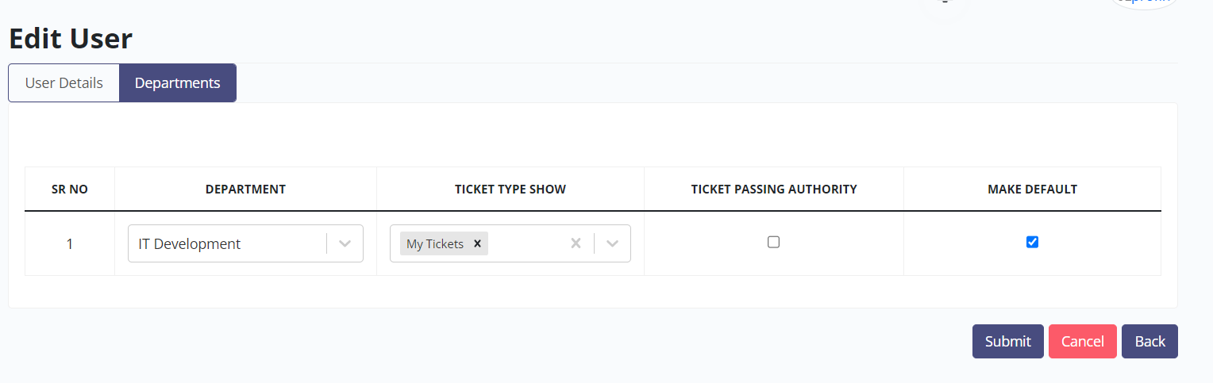

1. While editing the user, unable to add the department as “+” icon not there. It is expected Beside ‘Make Default’ there should be provision to add the department.

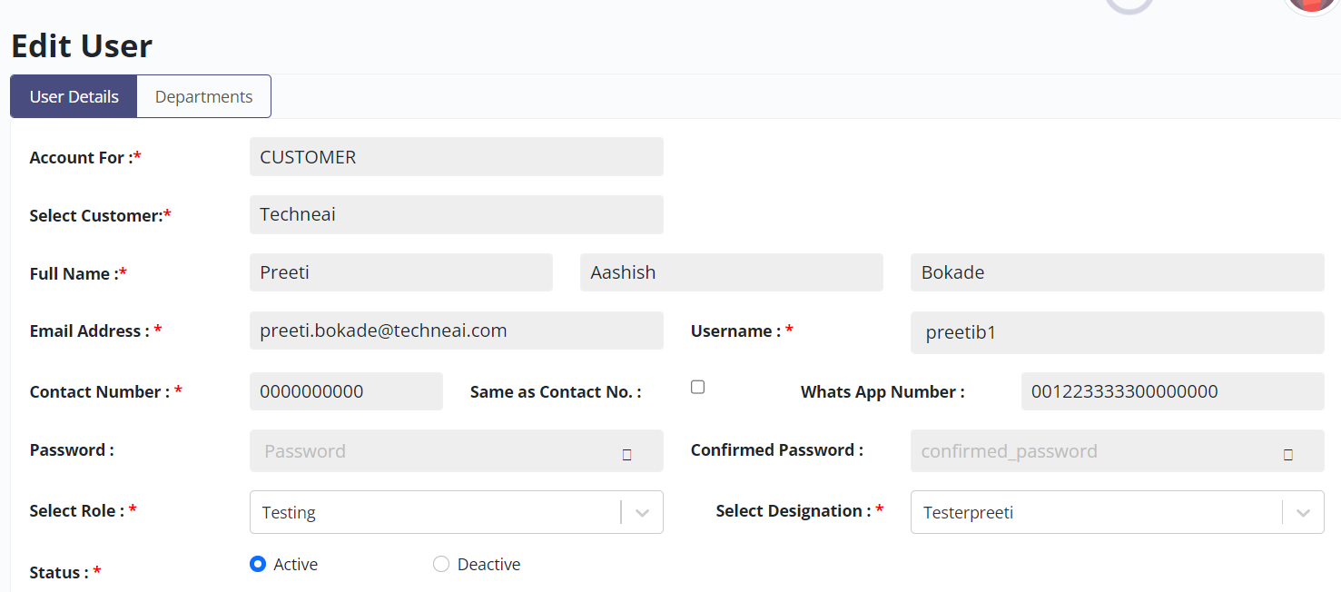

1. Contact number accepting as all 10 digit as ‘0’. it is expected as only accept 1to 9 digit and zero can be accepted at last digit.
2. WhatsApp Number : Editable and allows user to enter more than 10 digits. It is accepting all ten digits as ‘0’. Expected result - it should accept 10 digits - 1 to 9 digit and zero can be accepted at last digit.

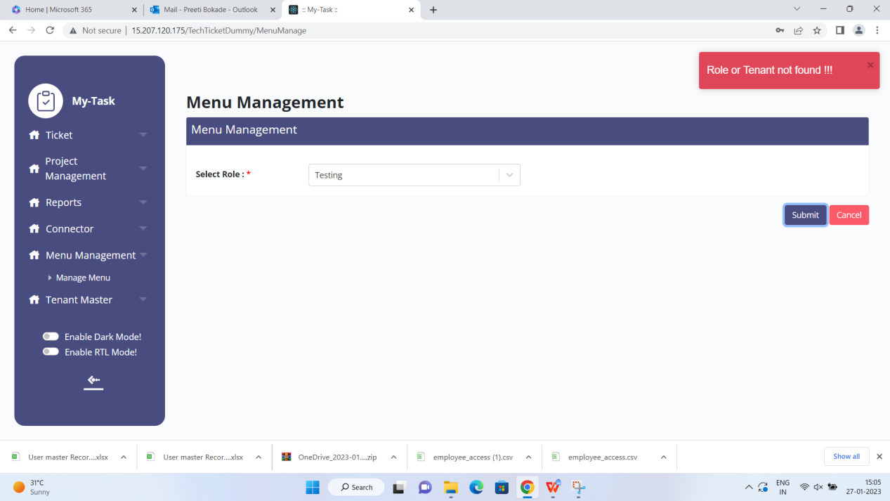

1. In menu management system upon click on Submit button , user get ire-relevant error “ Role or Tenant not found”.

Steps followed

search the Role as “ Testing” and click on Submit button.

Select all menu and click on update button .

Again click on submit button .

6.

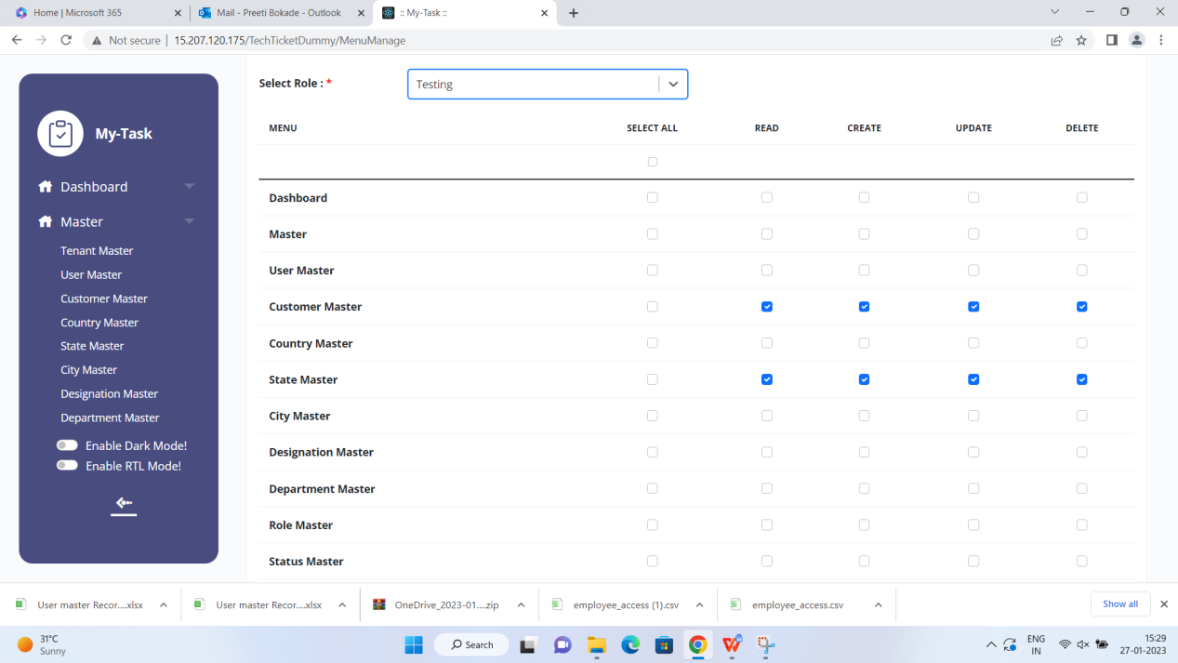

System is allowing to select child master (sub module ) however parent master ( module ) is not selected. It is expected if parent master is not selected then system should not allow to select child master .

1. In case of user logged in and the user has all masters & menu access , if somebody revoke the access , still user allowed to see the masters . it is expected that user should not allow to view the masters.

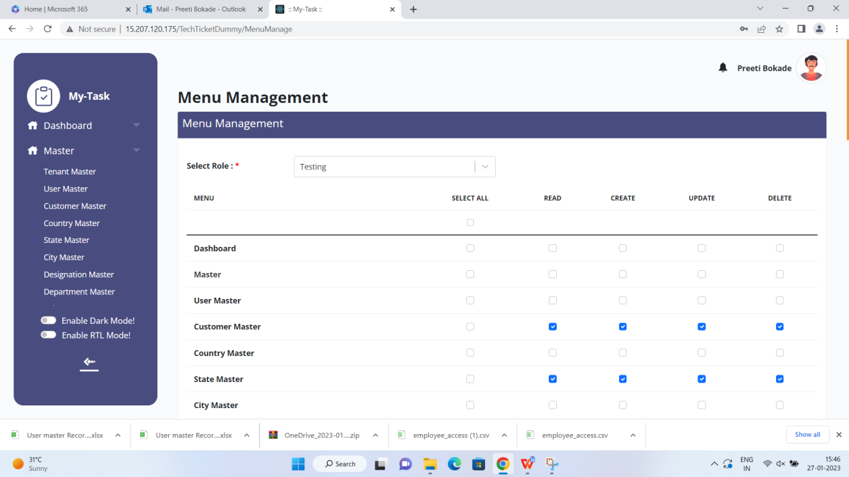

7.

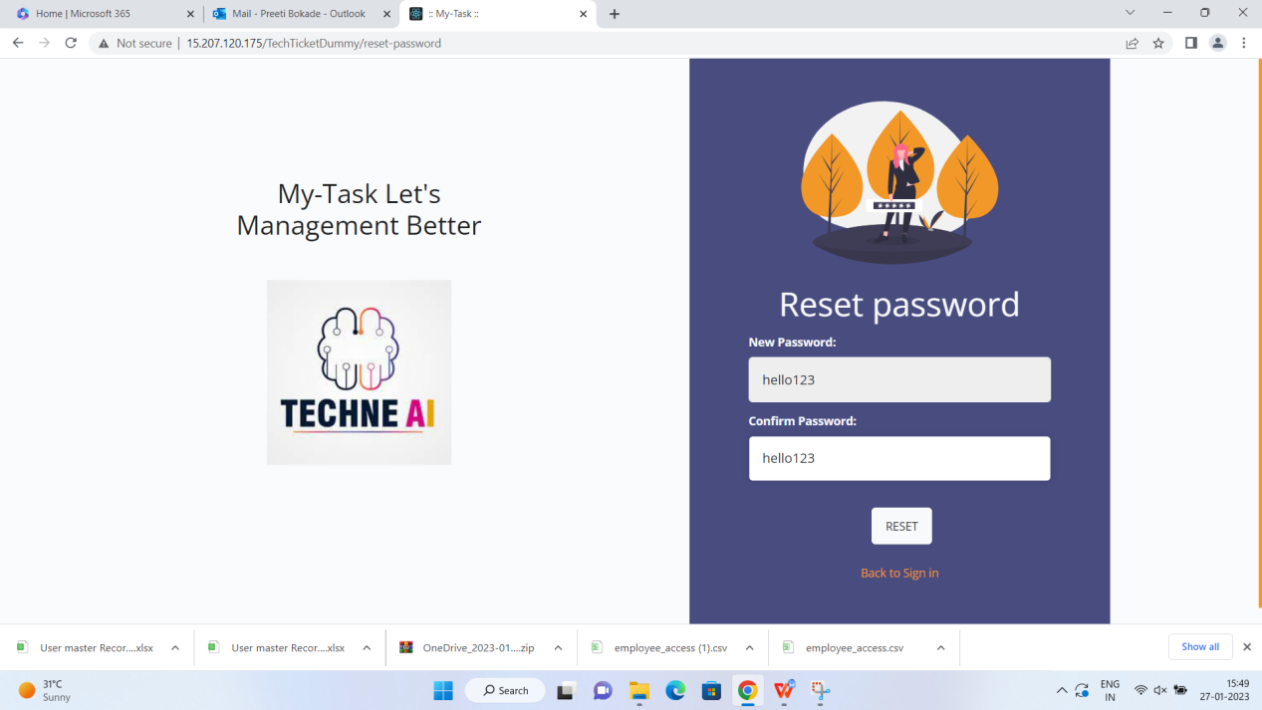

On reset password screen , New Password & Confirm password field values are displayed. It should be masked and provide the provision to user to view by clicking “eye icon” if user wish.

8.

I have created 2 users with same email id hence while resetting the pwd system has changed the password of last login user and allowed to login with changed password . However for 2nd user ( having the same email id ) does not allowed to login with neither with changed password nor with old password. Please look into this on priority.

1. 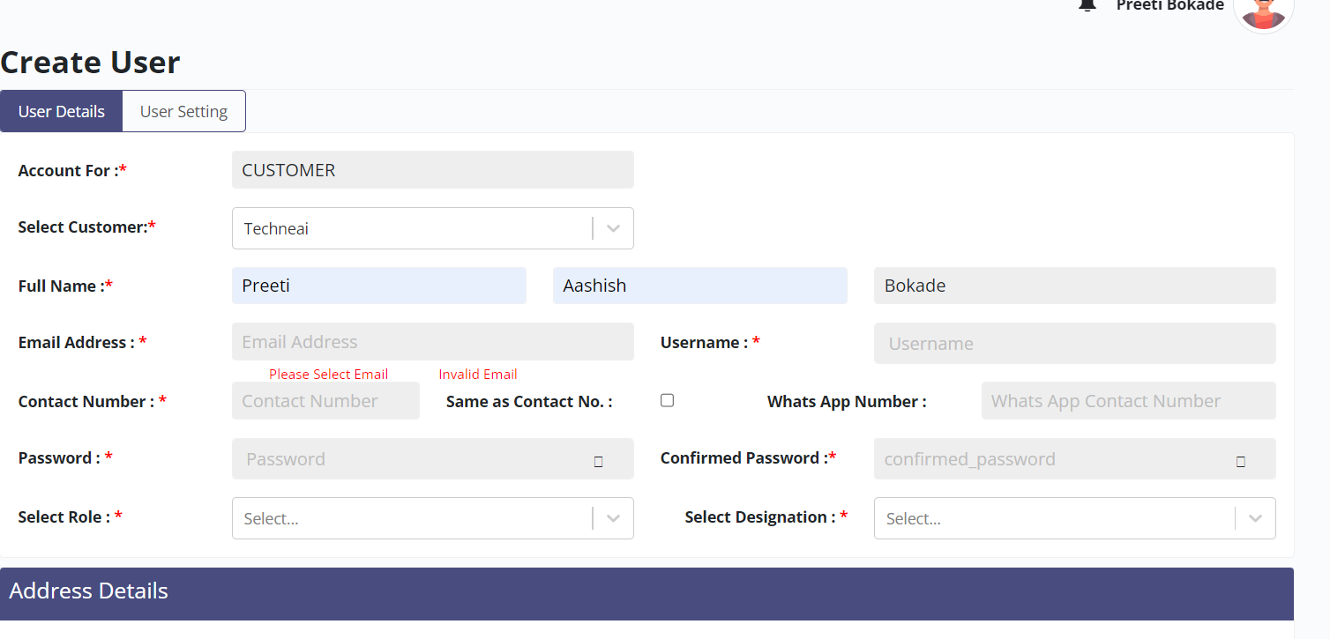

User getting instruction and error simultaneously for one field. It is expected that user get error once the focus goes to other field.

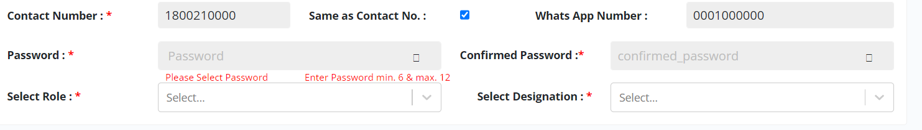

1. Same issue observed for password field as well.

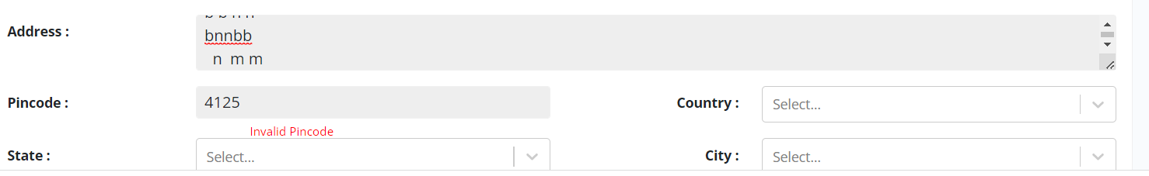

1. For Pincode: user has not yet finished the pincode entry and system throwing error. Let user to finish the pincode then system throwing error seems to be meaningful.
2. Address field accepting unlimited characters , lets system to allow

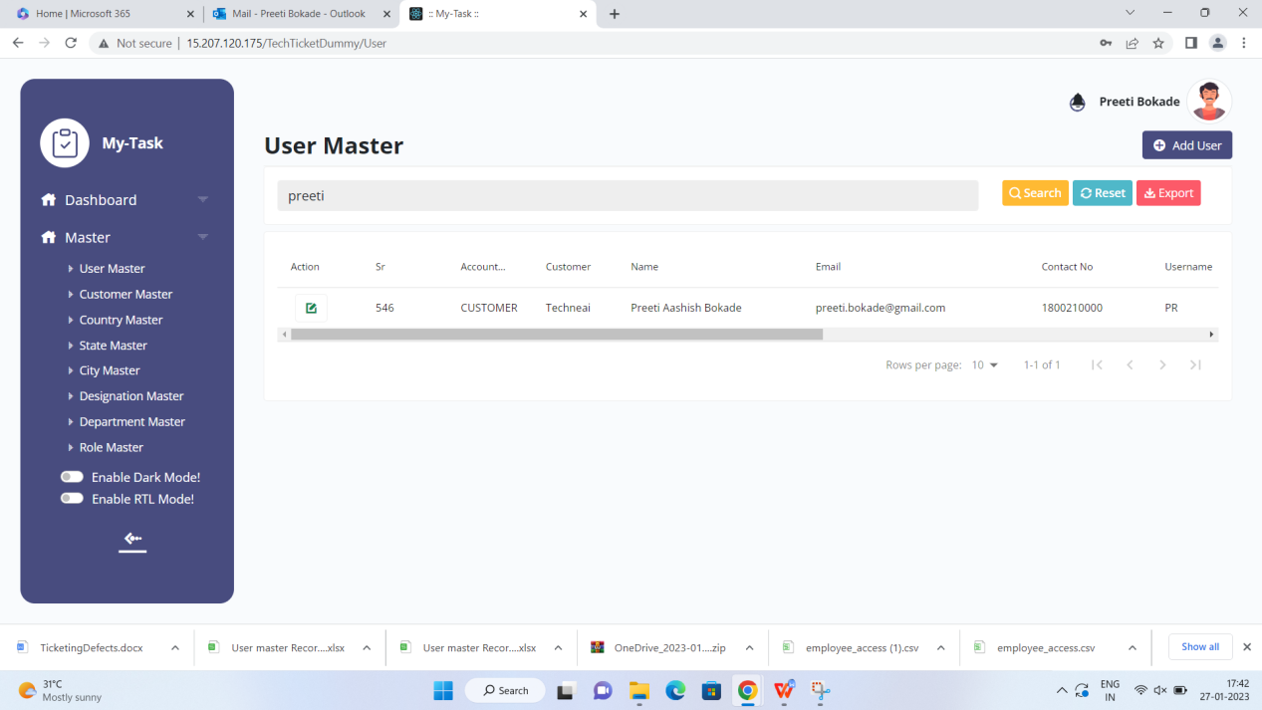

1. It has been observed that while creating the 3 user with same name ,the latest user is only displayed in grid view expected all users get displayed .