|  |  |
| --- | --- |
| **Ticket ID** | *TT7641* |
| **Ticket description** | Need a provision to generate otp and enter the same in cash payment / bank payment voucher in Padama and OTP will be generate in connect us ( Same Logic as per GTS Closure) |
| **Created by** | *Pritam Mehta* |
| **Created on** | *08/Dec/2022* |
| **Priority** | *medium* |
| **Version** | *1.0* |

**Version**

|  |  |  |  |  |
| --- | --- | --- | --- | --- |
| **Sr. No** | **Version no** | **Version Date** | **User name** | **User department** |
| **1** | **1.0** | **21/Dec/2022** | **Pritam Mehta** |  |
|  |  |  |  |  |
|  |  |  |  |  |

**Approvals**

|  |  |  |
| --- | --- | --- |
| **Field** | **Name of the User** | **Approved date by the user** |
| **Actual User Name** | Pritam Mehta |  |
| **Actual User Department** |  |  |
| **Organization Name** | CSJewellers |  |
| **Assigned BA** | Manali Bhadirage |  |
| **Assigned Developer** |  |  |
| **Assigned Tester** | Abhijeet Ghodke |  |

**Estimation**

|  |  |  |  |  |
| --- | --- | --- | --- | --- |
| **Department name** | **Estimated Time (In hr)** | **Scheduled Date (Starting date )** | **Estimated date** | **Actual delivery date** |
| **BA** |  |  |  |  |
| **Development** |  |  |  |  |
| **Testing** |  |  |  |  |
|  |  |  |  |  |

**Introduction**

*Through Cash Payment Verification module, user wish to send OTP to customer and also wants to have report of the same. Module is needed for verification of customer’s payment.*

**Business requirement**

* *Create Cash Payment Verification module in Connect US.*
* *Create two sub-modules under it namely ‘Generate OTP’ and ‘Cash Payment Verification Report’.*

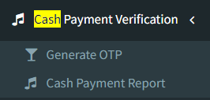

**Existing system**

*There is no existing system.*

**Proposed system**

* Firstly, in CU we have to create Cash Payment Verification -> Generate OTP. It will have following fields:
* Customer Name
* Doc No.
* Amount
* SMS Type
* Send OTP (button)

|  |  |  |
| --- | --- | --- |
| **FIELDS** | **INPUT TYPE** | **DESCRIPTION** |
| Customer Name | Text | 1. User will enter the customer name from padm -> documents -> name as per any bill. 2. It should accept only characters and space. 3. It should accept maximum length of 100 values. 4. It shouldn’t be case sensitive. 5. When user will enter name, it will display the list of relevant customers as suggestions. If entered name doesn’t match with the customer’s name in padm, then display message as “Please enter valid customer’s name.” |
| Doc No. | Alphanumeric | 1. Either customer name will be mandatory or doc no. will be mandatory. (one of them) 2. User will enter the customer name from Padm -> documents -> name as per any bill. 3. It should accept characters, numbers and hyphen. 4. It should accept maximum length of 100 values. 5. If entered Doc No. doesn’t match with the doc no. in padm, then display message as “Please enter valid Doc No.” |
| Amount | Number | 1. User will manually enter the amount as per cash payment to be done by customer. 2. It should accept decimal values too. 3. It only accept . as special character. 4. It shouldn’t accept space. |
| SMS Type | Drop-down | 1. It will be mandatory field. 2. It will be drop-down displaying SMS and WhatsApp in the list. 3. It should be single select only. |
| Send OTP | button | 1. Once user enters either customer name or doc no. and clicks on OTP, 6 digit numeric OTP should get sent on the registered customer’s number. 2. Its template will be:   Customer, Your OTP is ${otp} for the amount ## rupees. Thank You Chandukaka Saraf & Sons Pvt Ltd.   1. If WhatsApp number is mentioned in customer’s details, then only OTP will get sent via WhatsApp to customer. 2. Once OTP is sent then display message at top as “OTP sent successfully on registered number.” |

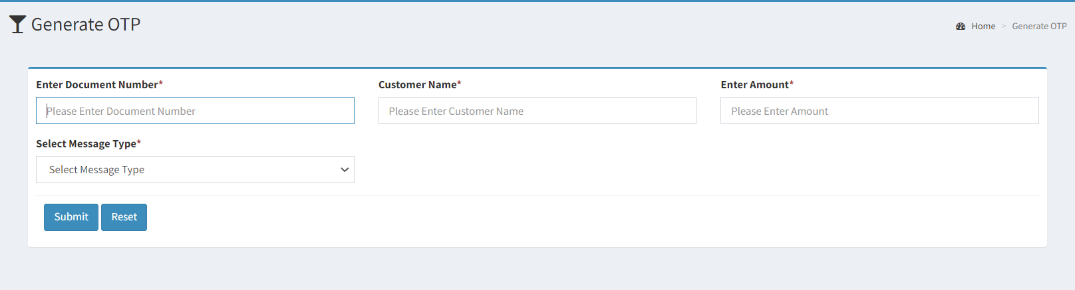

Fig: OTP Generation

* Secondly, create Cash Payment Verification Report. It will have following fields:
* From Date
* To Date
* Generated By
* Submit (button)
* Report (after clicking on submit)
* Export

|  |  |
| --- | --- |
| **FIELDS** | **DESCRIPTION** |
| From Date | It is mandatory field.  Future date should be disabled in calendar. |
| To Date | It is mandatory field.  Future date should be disabled in calendar. |
| Generated By | It will be optional field  Provide drop-down having list of active employees from employee master. |
| Submit | Once user selects date and generated by fields and clicks on submit, then it should display filtered data. |
| Report | Report will have following fields:   * Sr. No. * Customer Name * Doc No. * Amount * OTP * Generated By * Generated On (display Date & Time on which OTP was generated) |
| Export | Once user clicks on export button, report will get downloaded in .csv format. Export file will have following fields:   * Sr. No. * Customer Name * Doc No. * Amount * OTP * Generated By * Generated On |

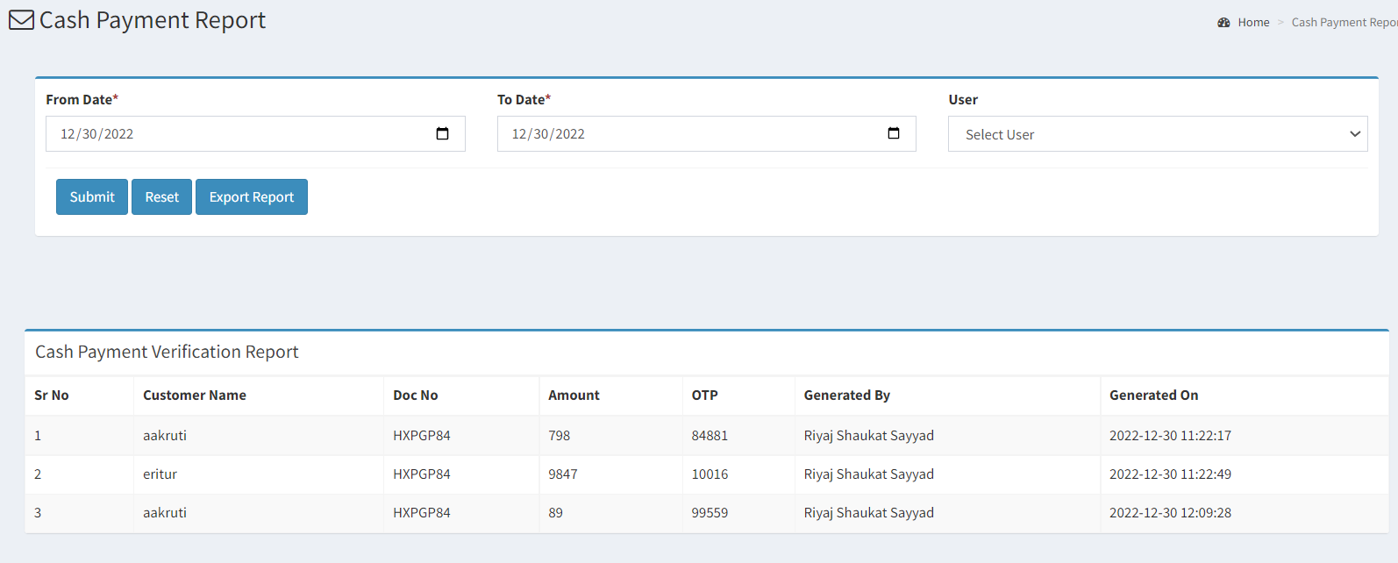

Fig: Cash Payment Report

**References of the users**

|  |  |  |  |
| --- | --- | --- | --- |
| **User** | **Name** | **Mail** | **Contact number** |
| **Actual user** | Pritam Mehta | ia@csjewellers.com |  |
| **Ticket created by (if any)** | Pritam Mehta | ia@csjewellers.com |  |
| **Assigned business analyst** | Manali bhadirage | Manali.bhadirage@techneai.com | 2965 |
| **Assigned developer** | Punam Shinde | Punam.shinde@techneai.com | 2965 |
| **Assigned tester** | Abhijeet ghodke | Abhijeet.ghodke@techneai.com | 2965 |