URL:--- <http://15.207.120.175/TechTicketDummy/>

Defects in Ticketing

Module:--1. **login**

1. with wrong password error message is displaying “Incorrect credentials” instead it should be displayed “password doesn’t match”.

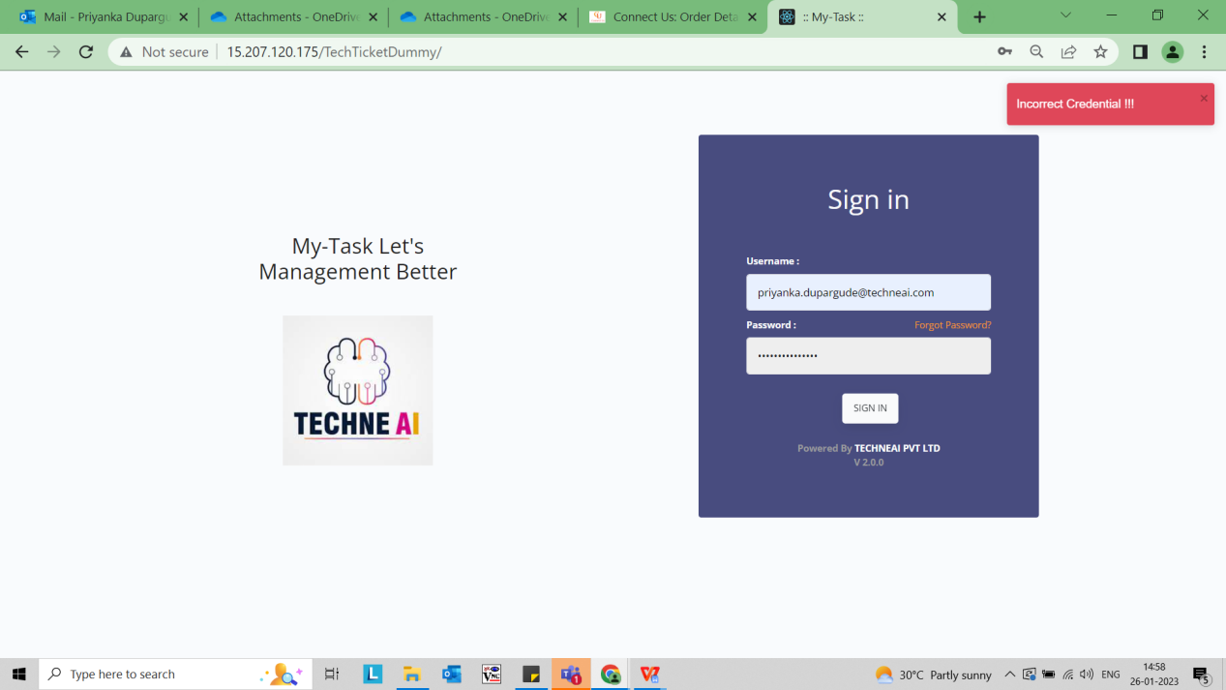

Resolved at 2022/01/27

1. when we clicked on forgot password otp is not received on mobile number and when user clicked on “Resend otp” blank page is displaying.

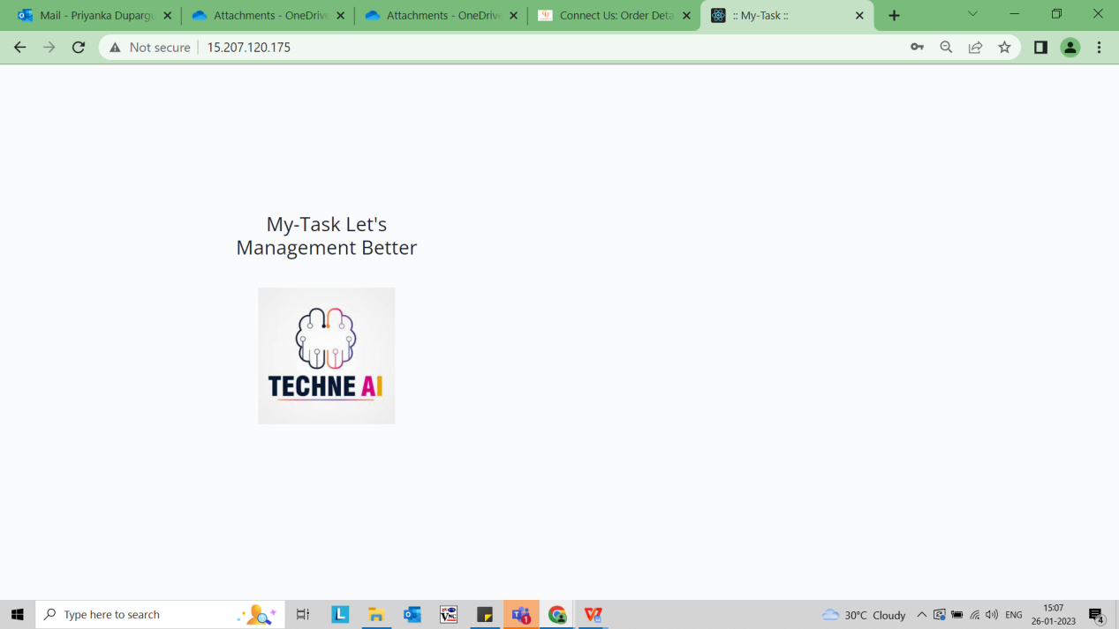

Need Backend Resource

1. While entering otp field should not be accepted characters.it should be accepted only numeric values.
2. When we set password it doesn’t display any warning message like “your password should be at least 8 characters ”.
3. Eye button is not present to show and hide the password.

---------------------------------------------------------------------------------------------------------------------------------------

Module:--**Your Profile**

1. when user clicks on profile pop up is not closed. It should be closed when user clicks anywhere outside of the pop up.

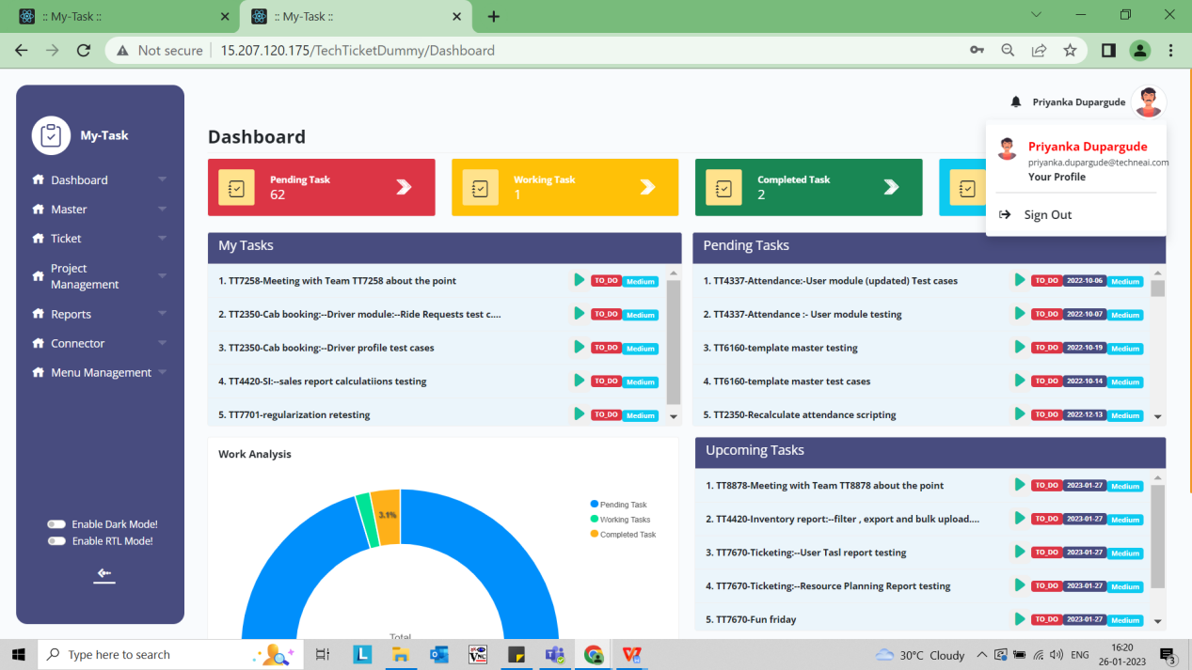

1. User is not able to update the profile picture when clicked on dummy user image.
2. Contact no and whats app field doesn’t support for copy paste.
3. While entering new password should be display error warning message like “your password should be at least 8 characters”.
4. Suggestion:--If user has entered same old password display a warning message like “new password should not be your old password”
5. When new password and confirm password is different and user clicked on update it displays “password updated ”pop up.

