|  |  |
| --- | --- |
| **Ticket ID** | T200736 |
| **Ticket description** | 1) connect us madhe in transit ho to ch, bh, kt, pn ( silver, gold, diamond, platinum, mrp, stone) -ya group madhe one barcode generate (label & print) + cspl tag no. 000001( for eg.) ad zala pahije  2) connect us madhe in transit ho to sr, hd, cn ( under group -silver, gold, diamond, platinum, mrp, stone) -ya group madhe one barcode(label & print) generate + cspl tag no. 000001( for eg.) ad zala pahije |
| **Created by** | Pralhad Mohan Mulik |
| **Created on** | 23/02/2022 |
| **Priority** | High |
| **Version** | 0 |

**Version**

|  |  |  |  |  |
| --- | --- | --- | --- | --- |
| **Sr. No** | **Version no** | **Version Date** | **User name** | **User department** |
| 1 | 0 | 10.05.2022 | Tushar Shivaji Nikam | Inventory Gold HO |

**Approvals**

|  |  |  |
| --- | --- | --- |
| **Field** | **Name of the User** | **Approved date by the user** |
| **Actual User Name** | Pralhad Mohan Mulik | 23.02.2022 |
| **Actual User Department** | Inventory Gold HO |  |
| **Organization Name** | C S Jewellers |  |
| **Sign-off** |  |  |
| **Assigned BA** | Mounika KrishnaVeni Annamneedi | 10.05.2022 |
| **Assigned Developer** |  |  |
| **Assigned Tester** |  |  |

**Estimation**

|  |  |  |  |  |
| --- | --- | --- | --- | --- |
| **Department name** | **Estimated Time (In hr)** | **Scheduled Date (Starting date )** | **Estimated date** | **Actual delivery date** |
| **BA** | 3 | 10.05.2022 | 10.05.2022 |  |
| **Development** |  |  |  |  |
| **Testing** |  |  |  |  |

**Business requirement**

In stock tranfer system, the user wants new fields both in stock transfer system and transfer in out details menu for easy accessing.

**Existing system**

In the existing system, there is no fields.

**Proposed system**

* Addition of new fields in stock transfer system.
* Addition of new fields in transfer in out details.
* When the data saved in stock transfer system, the user requires auto print view of the barcode (barcode against tag number and tag number on barcode print)

**Process**

Step 1

In connect us -> stock transfer system -> stock transfer system

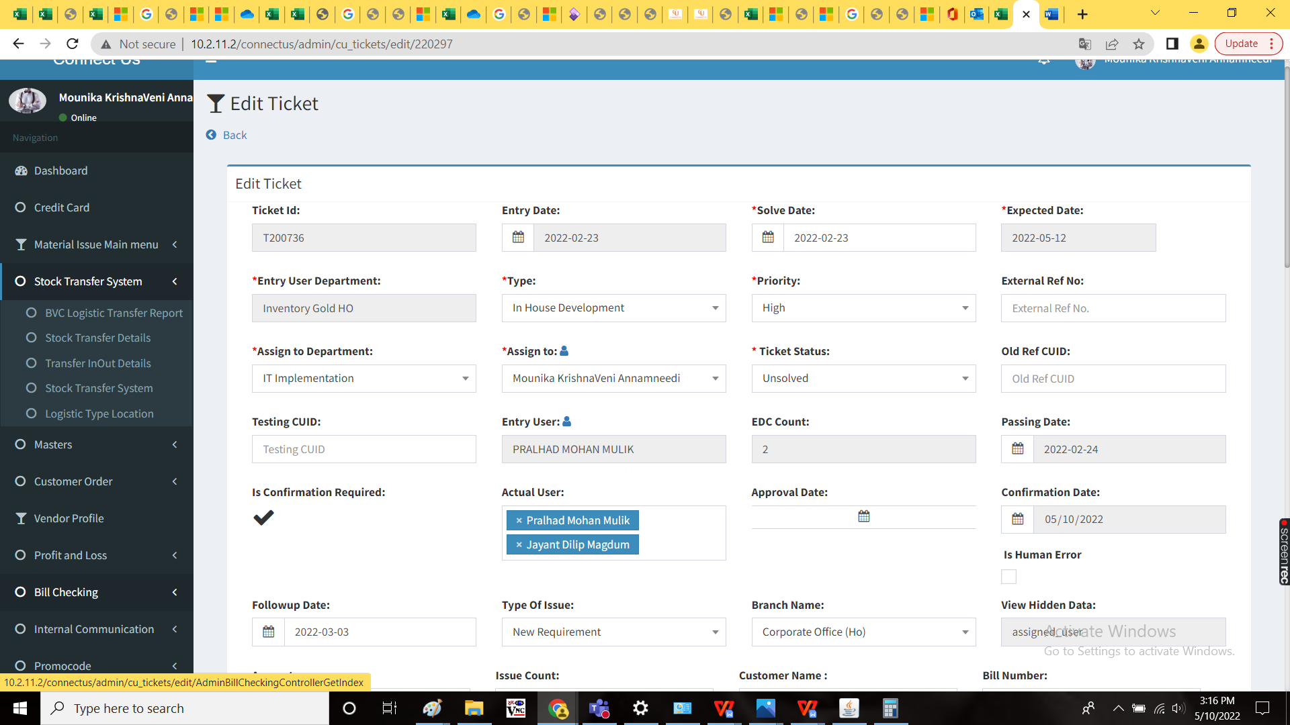

Addition of following fields

* Tag number
* Tag number in stock transfer details

|  |  |  |  |
| --- | --- | --- | --- |
| Field | Type | Mandatory/ optional | Description |
| Tag number | Text | Mandatory | The unique tag number of that product/ stock |
| Tag number | Text | Mandatory | The unique tag number of that product/ stock |

Note:

When the data saved in stock transfer system, the user requires auto print view of the barcode (barcode against tag number and tag number on barcode print)

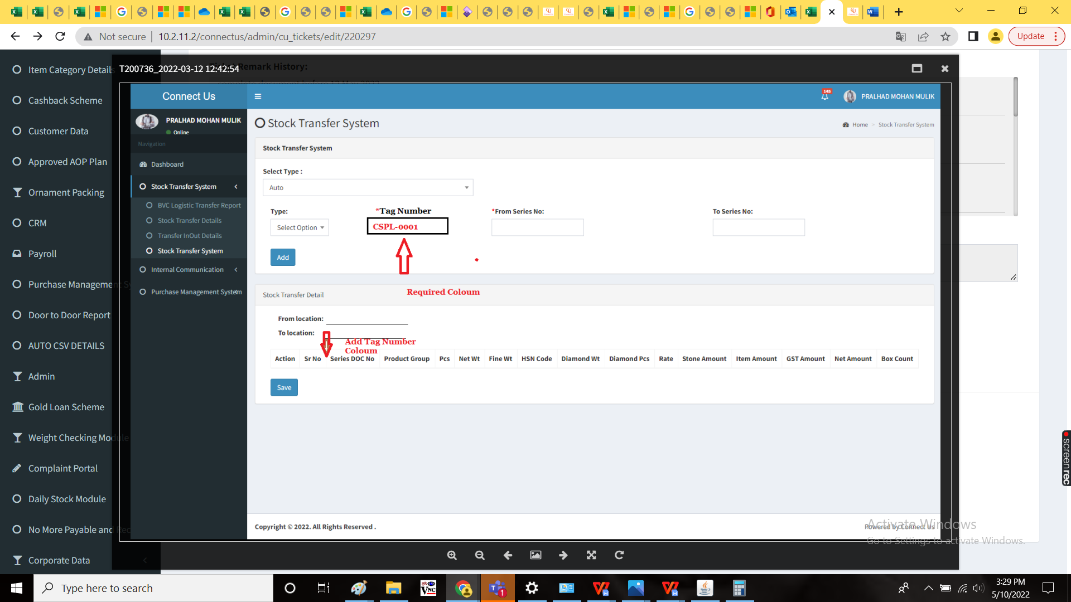

Step 2

In connect us -> stock transfer system -> transfer in out details



Addition of new fields

* Scan barcode
* Tag number
* Box count
* Product group

|  |  |  |  |
| --- | --- | --- | --- |
| Field | Type | Mandatory/ optional | Description |
| Scan barcode | Scanner input | Mandatory | The barcode to be scanned using scanner |
| Tag number | Text | Mandatory | The tag number to be entered |
| Box count | Int | Mandatory | The box count to be entered |
| Product group | Text | Mandatory | The product group to be entered |

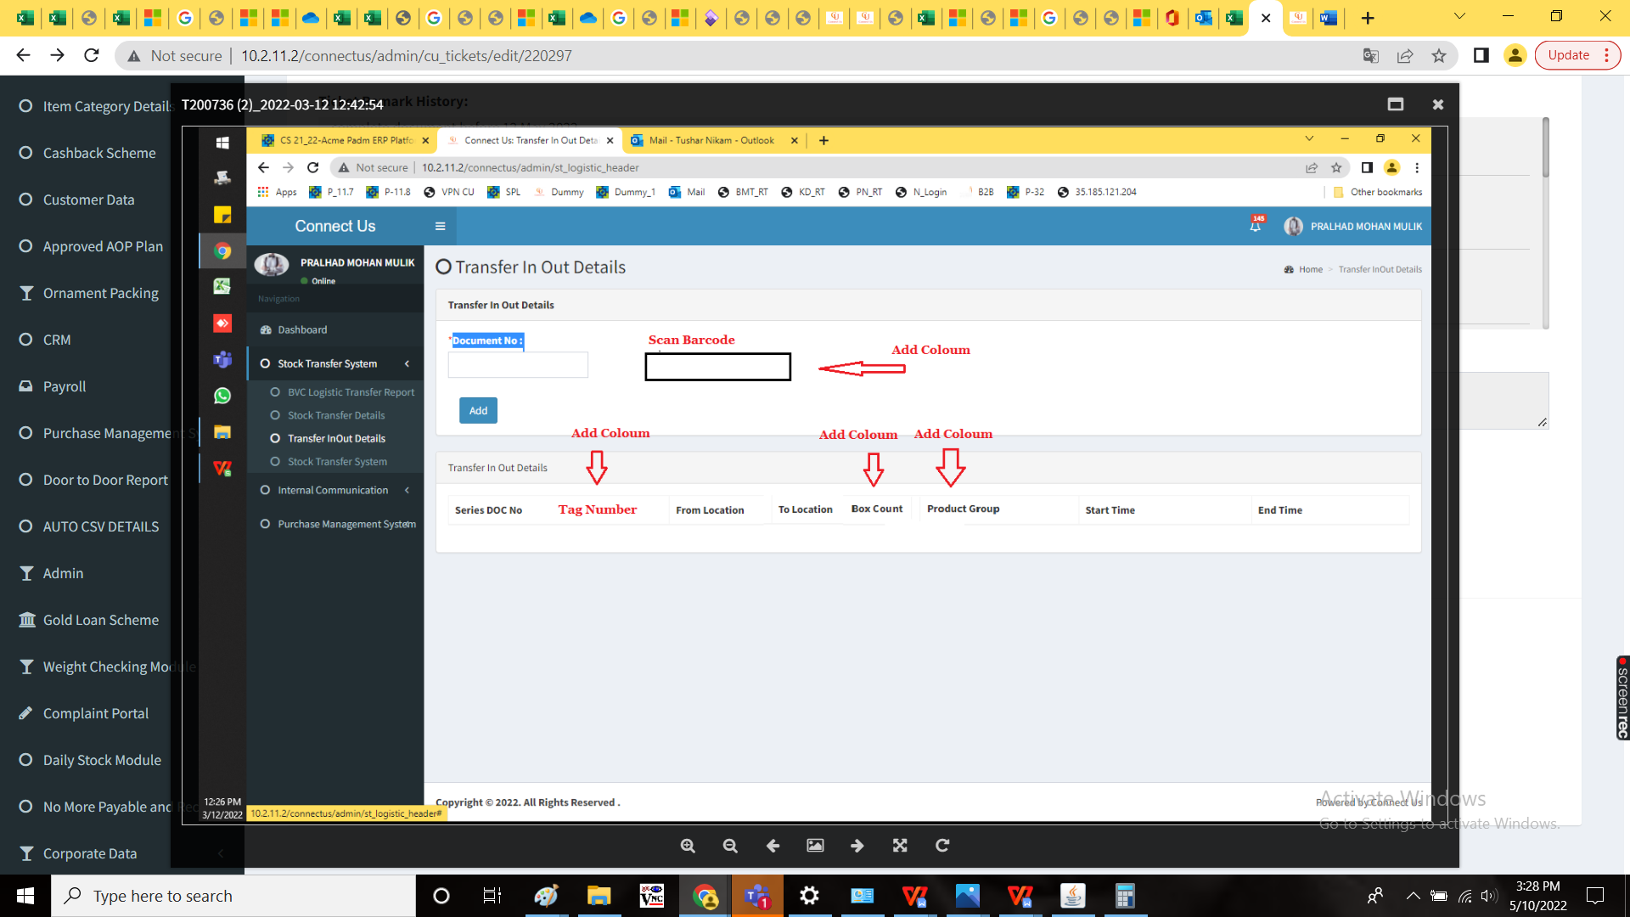

Note:

When the barcode is scanned, the data to be fetched and fields to be filled.

**References of the users**

|  |  |  |  |
| --- | --- | --- | --- |
| **User** | **Name** | **Mail** | **Contact number** |
| **Actual user** | Pralhad Mohan Mulik | stocktransferho@csjewellers.com |  |
| **Assigned business analyst** | Mounika KrishnaVeni Annamneedi | Mounika.annamneedi@techneai.com | 8669917920 |
| **Assigned developer** |  |  |  |
| **Assigned tester** | Monika Kolpe | Monika.kolpe@techneai.com |  |