|  |  |
| --- | --- |
| **Ticket ID** | T219644 |
| **Ticket description** | Please do make a provision into system for referral draw offer. PFA for process document. Provision have to be live on 18th may 2022. (kindly discuss with Mr. Gaurav sir if any query) |
| **Created by** | Harshali Rananaware |
| **Created on** | 16 May 2022 |
| **Priority** | Very high |
| **Version** | 1 |

**Version**

|  |  |  |  |  |
| --- | --- | --- | --- | --- |
| **Sr. No** | **Version no** | **Version Date** | **User name** | **User department** |
| 1 | 1 | 16 May 2022 | Rushikesh Gokul Thorat | Branch Operation Control |

**Approvals**

|  |  |  |
| --- | --- | --- |
| **Field** | **Name of the User** | **Approved date by the user** |
| **Actual User Name** | Rushikesh Gokul Thorat |  |
| **Actual User Department** | Branch Operation Control |  |
| **Organization Name** | CSPL |  |
| **Assigned BA** | Harshali Rananaware |  |
| **Assigned Developer** |  |  |
| **Assigned Tester** |  |  |

**Business requirement :** Please do make a provision into system for referral draw offer. PFA for process document. Provision have to be live on 18th may 2022. (kindly discuss with Mr. Gaurav sir if any query)

**Abbreviations & terms :**

Connect us - CU

**Proposed System :**

User want to new option scan QR code. Scan this QR code then open a one form. Following field added in the form.

Below all fields are mandatory.

**Customer**

1. Name
2. Address
3. Mobile No
4. DOB - Date should be select above 18 years.

**Referal**

1. Name
2. Address
3. Mobile No
4. DOB - Date should be select above 18 years.
5. Submit

Check the below form:

https://www.jotform.com/form/221353753727054#preview

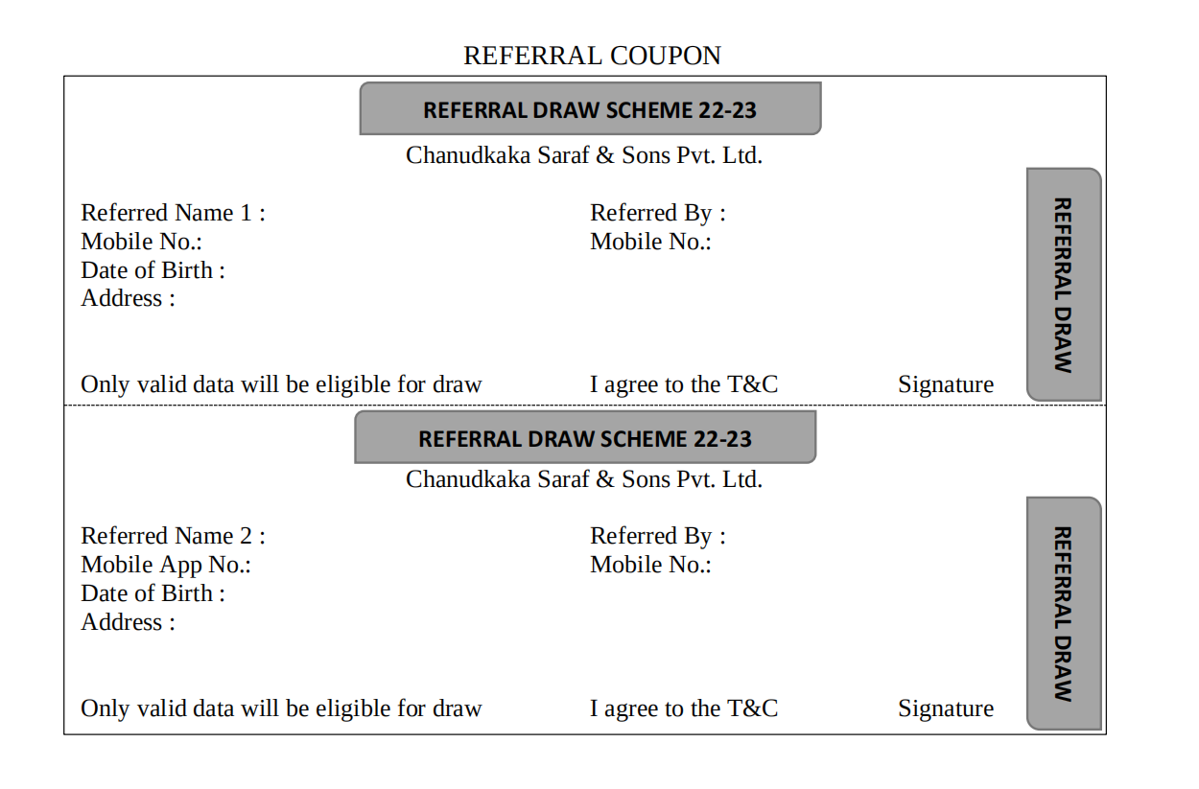

**Report** :

Create a new report in CU-> Coupon Report.

**Input** -

From date

To date

Submit

**Output** -

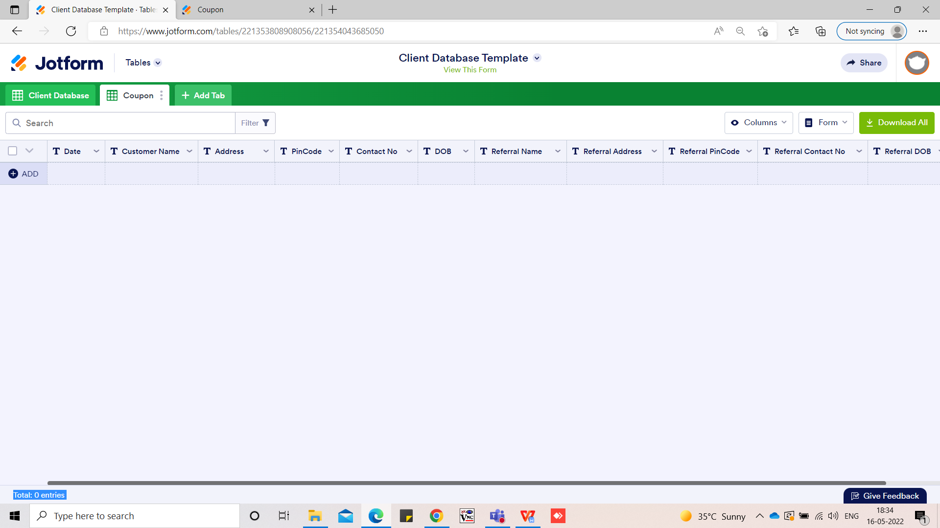

**References of the users**

|  |  |  |  |
| --- | --- | --- | --- |
| **User** | **Name** | **Mail** | **Contact number** |
| **Actual user** | Rushikesh Gokul Thorat |  | 2954 |
| **Assigned business analyst** | Harshali Rananaware | [harshali.rananaware@techneai.com](mailto:harshali.rananaware@techneai.com) | 8669917920 |
| **Assigned developer** | Nikhil Bhosale | nikhil.bhosale@techneai.com |  |