|  |  |
| --- | --- |
| **Ticket ID** | *T110192* |
| **Ticket description** | *User need to change status of Hold to Hold Till Audit in CU --> Payment Details Module.* |
| **Created by** | *Sandeep Avchitte* |
| **Created on** | *30/11/2021* |
| **Priority** | *Very High* |
| **Version** | *1* |

**Version**

|  |  |  |  |  |
| --- | --- | --- | --- | --- |
| **Sr. No** | **Version no** | **Version Date** | **User name** | **User department** |
| **1** | **1** | **30/11/2021** | **Saurabh Divakar** | **Accounts** |

**Approvals**

|  |  |  |
| --- | --- | --- |
| **Field** | **Name of the User** | **Approved date by the user** |
| **Actual User Name** | Saurabh Divakar |  |
| **Actual User Department** | Accounts |  |
| **Organization Name** | CSPL |  |
| **Assigned BA** | Sandeep Avchitte |  |
| **Assigned Developer** | Baliram Rajwad |  |
| **Assigned Tester** | Rohan Magar |  |

**Estimation**

|  |  |  |  |  |
| --- | --- | --- | --- | --- |
| **Department name** | **Estimated Time (In hr)** | **Scheduled Date (Starting date )** | **Estimated date** | **Actual delivery date** |
| **BA** |  |  |  |  |
| **Development** |  |  |  |  |
| **Testing** |  |  |  |  |

**Introduction**

*User need to change status of Hold to Hold Till Audit in CU --> Payment Details Module.*

**Business requirement**

*User need to change status of Hold to Hold Till Audit in CU --> Payment Details Module.*

**Abbreviations & terms**

*CU --> Connect US.*

**Existing system**

*Currently there is no provision in CU --> Payment Details Module to change the status Hold to Hold Till Audit.*

**Proposed system**

*Firstly, user should be click on Edit button as shown in the below image 1 then user will change the GST Default Supplier Status -* ***“Active”*** *to “****Defaulter”*** *then* ***Hold Till Audit*** *status should be change to* ***Hold*** *and remark should remain there.*

*When user will change the GST Default Supplier Status -* ***“Defaulter”*** *to* ***“Active”*** *then* ***Hold*** *status should be change to* ***Hold Till Audit*** *and remark should not be there as shown in the below image.*

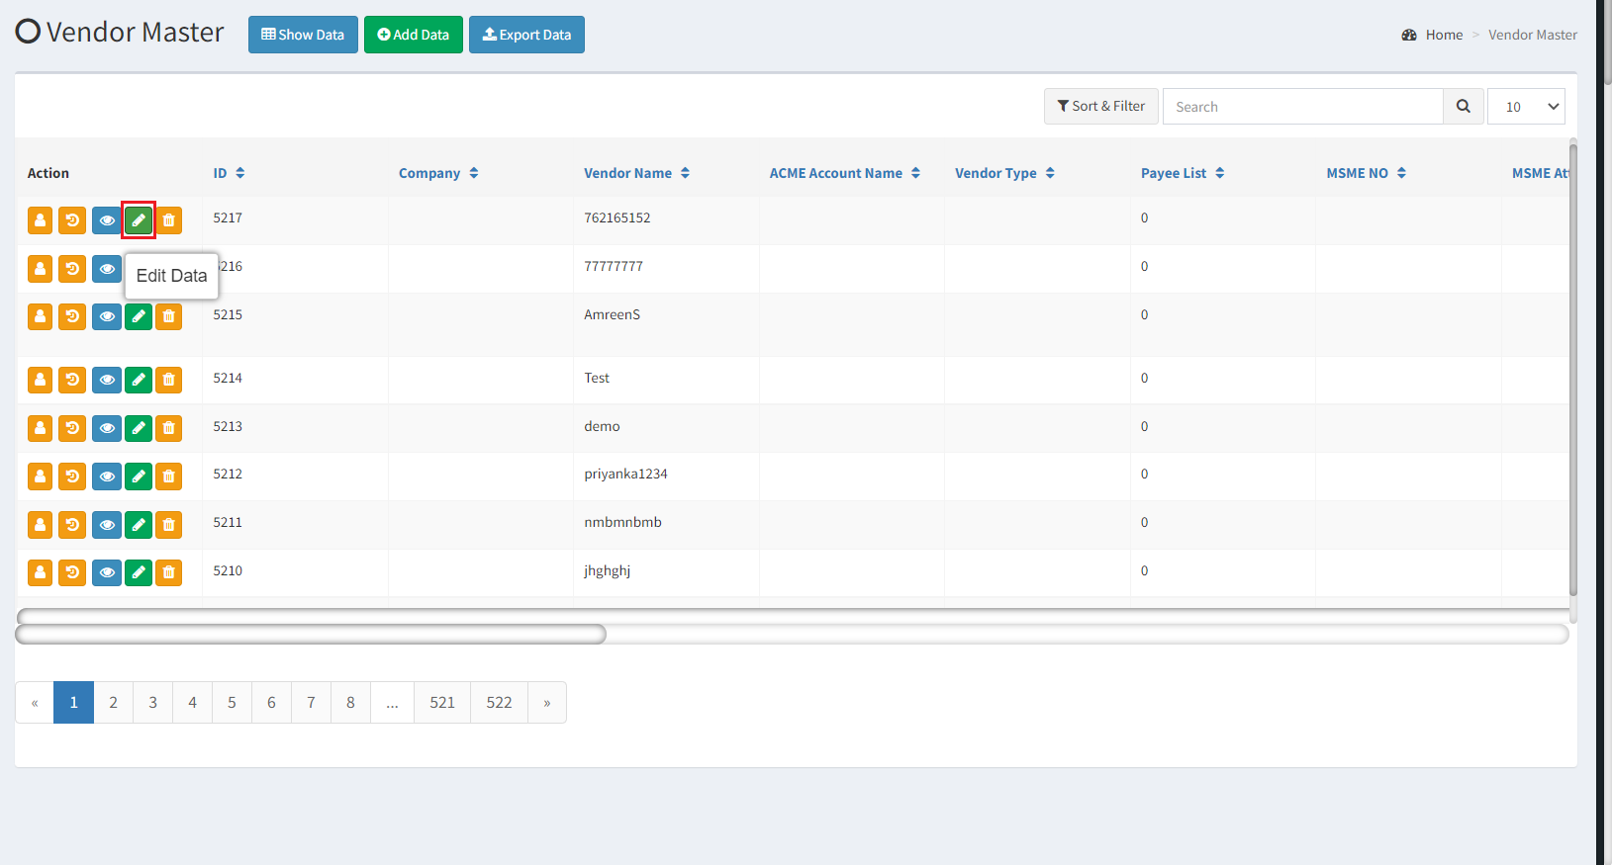

Image 1

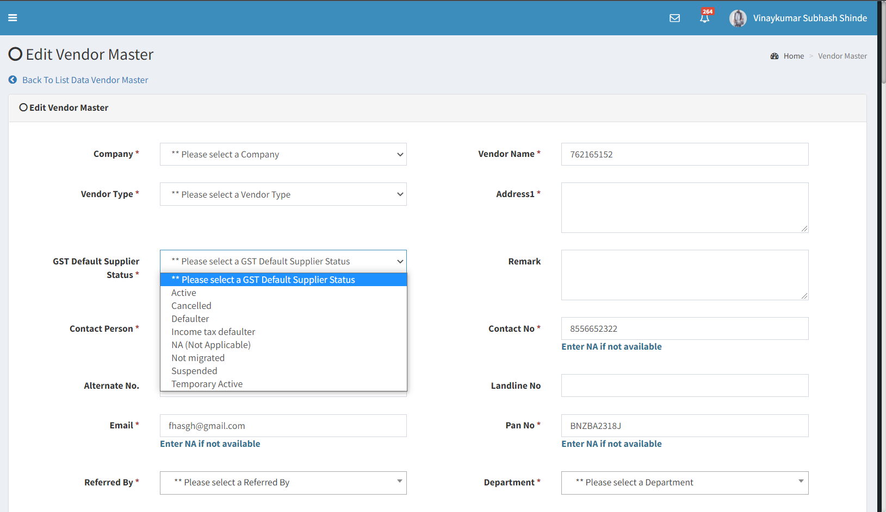

Image 2

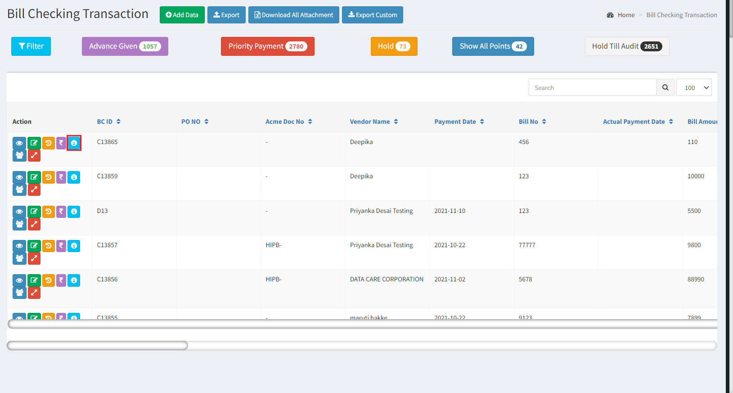

Image 3

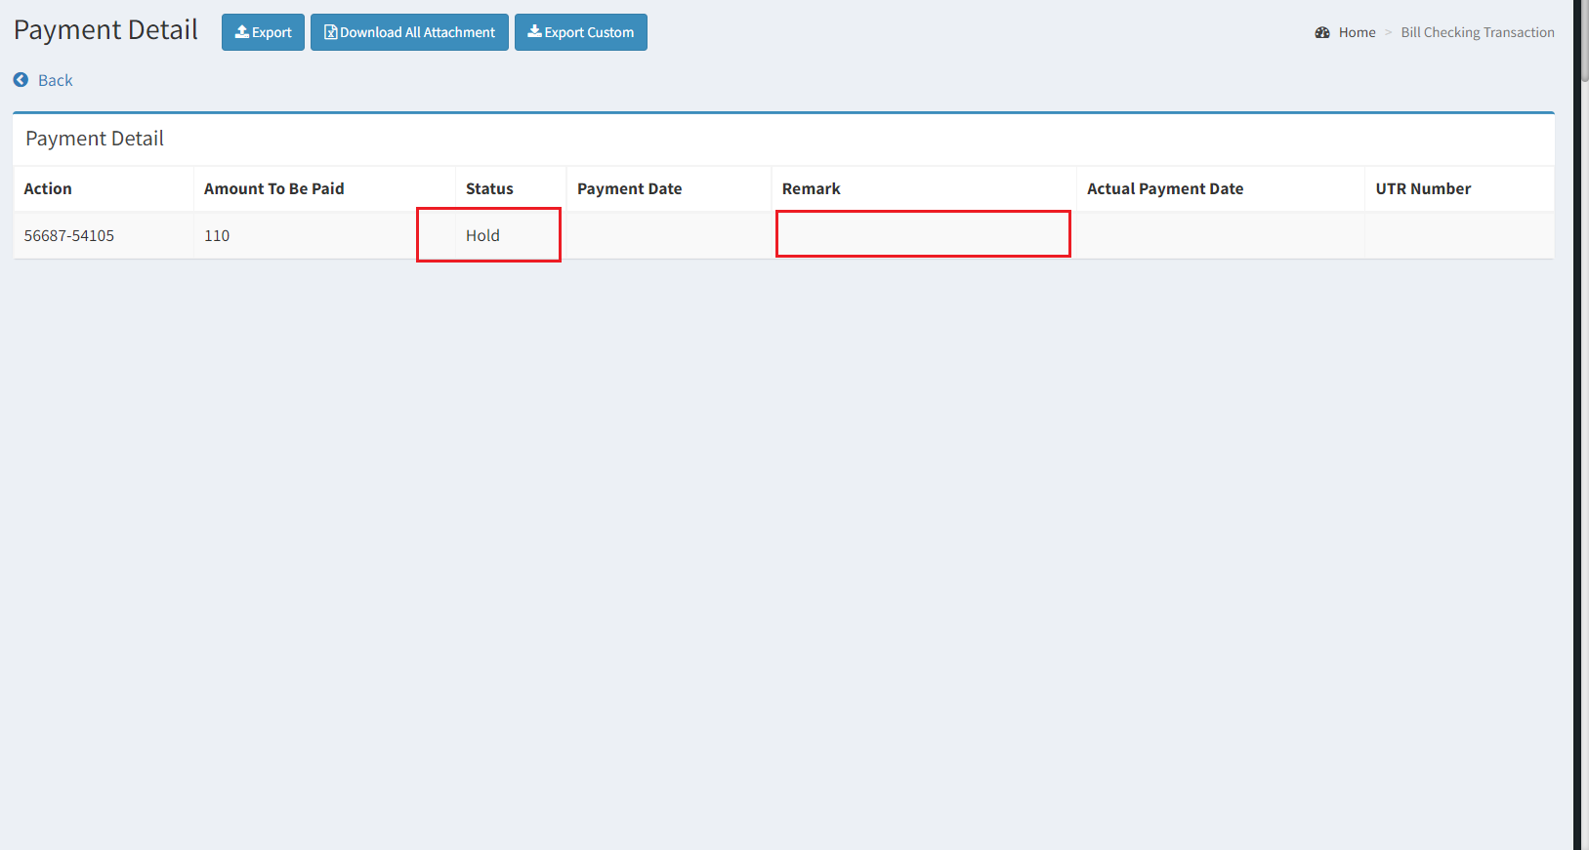

Hold Till Audit

Keep Blank Remark

Image 4

**References of the users**

|  |  |  |  |
| --- | --- | --- | --- |
| **User** | **Name** | **Mail** | **Contact number** |
| **Actual user** | *Saurabh Divakar* | *ap@csjewellers.com* |  |
| **Assigned business analyst** | Sandeep Avchitte | Sandeep.avchitte@techneai.com | 2967 |
| **Assigned developer** | Baliram Rajwad | Baliram.rajwad@techneai.com | 2965 |
| **Assigned tester** | Rohan Magar | Rohan.magar@techneai.com | 2979 |