* **Ticket ID :** T103892
* **PROJECT NAME :** Sales Incentive.
* **Version :**

Version Number : 1.1

Date : 23 June 2021.

* **Approval :**

Approved by : Dinesh Bhagyawan Sonawane.

Department / Role : Accounting Department

Date of approval :

* **Terminologies :** Sales Incentive-SI, Wedding Jewellery Destination-WJD
* **Current Process :** Kundan Jewellery (Only For WJD Counter) SI structure is not present in the system.
* **User Requirement :** In Sales Incentive we need new option for Kundan Jewellery Sales incentive for specific Wedding jewellery Destination counter in Hadpasar and Sangali Branch as per attached sheet.
* **Proposed System :** In proposed system required kundan jewellery SI structure only for wedding jewellery destination counter.

1. New Incentive type for Sales Person Kundan Jewellery Incentive,Its only specified for Wedding Jewellery Destination Counter.
2. The Contribution Margin (CM) will not be for the Wedding Jewelry Destination counter Because they will have Kundan Jewelry Incentive structure.
3. Kundan Jewellery applicable to Individual level above 65 % of individual performance.
4. Payout slab and payout % are applicable for a monthly basis only.
5. For currently, consider the slab as per mention in the provided sheet.
6. Kundan Jewellery Sales target in Pcs(Barcode) only, Kundan Jewellery Sales target depends on your overall WJD Actual Sales pieces, Sales pieces target is 5% on your WJD sales pieces or 4 pcs(Barcode) per Sales person whichever is higher.
7. Kundan Jewellery target will be divided equally to each sales person.
8. Sales return logic same apply of kundan jewellery incentive.

**Note :** Now Kundan Jewelry Target will be given to individual level, if needed in future we will also apply it to branch level.

|  |  |  |
| --- | --- | --- |
| **kundan jewellery Incentive** | | |
|  | **Columns** | **Calculation** |
| 1 | Kundan Jewellery incentive | Kundan Jewellery will be fixed as his grade. |
| 2 | Kundan Jewellery Target in Pcs | Kundan Jewellery Incentives*5%=Total Total/Total person of counter=Kundan jewellery taregt in pcs Sales pieces target is 5% on your WJD sales pieces or 4 per Sales person whichever is higher. |
| 3 | Actual Kundan Jewellery Target in Pcs |  |
| 4 | % | Actual Kundan Jewellery Target in Pcs/Kundan Jewellery Target in Pcs% |
| 5 | Applicable slab | To check which slab the percentage is coming in and which slab will be applicable and take a payout of that slab |
| 6 | SI Amount | Kundan Jewellery *Applicable slab. |

* Do the changes in below report :

**Employee Target Setting :**

- Go to Connect us-Sales Incentive-Sales Transaction-Employee Target Setting.

**Period-wise target & achievement:**

- Go to Connect us-Sales Incentive-Sales Transaction- Period-wise target & achievement.

* Individual Employee Level Performance as Per Sales Incentive against add below columns-

Column Name : Kundan jewellery target in pcs,Kundan jewellery achievement pcs,Kundan jewellery achievement %.

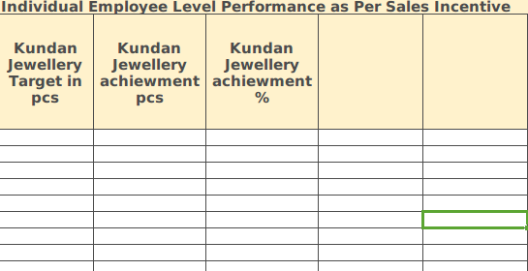

* Employee Sales incentive Amount against add below columns-

Column Name :Kundan Jewellery Amount

