|  |  |
| --- | --- |
| **Ticket ID** | T200266 |
| **Ticket description** | Please do make provision into system for customer birthday info pop-up for our branch staff. (If customers came to branch in birthday month then it should be pop-up about that month has customers birthday)  1. PRO : while taking customer's mobile number (customer feedback CRM task) system have to give pop-up about customer's birthday month & also need to print it on CRM customer barcode receipt.  2. While making sale bill when cashier enters customers mobile number then system have to show pop-up for the same. |
| **Created by** | Rushikesh Gokul Thorat |
| **Created on** | 18/02/2022 |
| **Priority** | Medium |
| **Version** | 1 |

**Version**

|  |  |  |  |  |
| --- | --- | --- | --- | --- |
| **Sr. No** | **Version no** | **Version Date** | **User name** | **User department** |
| 1 | 0 | 03.03.2022 | Rushikesh Gokul Thorat | Branch Operation Control |
| 2 | 1 | 07.06.2022 | Rushikesh Gokul Thorat | Branch Operation Control |

**Approvals**

|  |  |  |
| --- | --- | --- |
| **Field** | **Name of the User** | **Approved date by the user** |
| **Actual User Name** | Rushikesh Gokul Thorat | 18.02.2022 |
| **Actual User Department** | Branch Operation Control |  |
| **Organization Name** | C S Jewellers |  |
| **Sign-off** |  |  |
| **Assigned BA** | Mounika KrishnaVeni Annamneedi | 03.03.2022 |
| **Assigned Developer** |  |  |
| **Assigned Tester** |  |  |

**Estimation**

|  |  |  |  |  |
| --- | --- | --- | --- | --- |
| **Department name** | **Estimated Time (In hr)** | **Scheduled Date (Starting date )** | **Estimated date** | **Actual delivery date** |
| **BA** | 3 | 03.03.2022 | 03.03.2022 |  |

**Abbreviations & terms**

CRM App - Customer Relationship Management application

**Business requirement**

The user want to know the birthday of the customer visiting the store if it is in the month of visiting in the form of pop-up. So that the user can wish the customer accordingly which increases the relationship with the customer.

**Existing system**

In the existing system, there is no provision to know the birthday of the customer in the form of pop-up when the customer visits the store in his/ her birthday month.

**Proposed system**

* Getting the pop-up message if the customer visits the store in his/ her birthday month in CRM app.

Step-1

Go to CSJ CRM app.

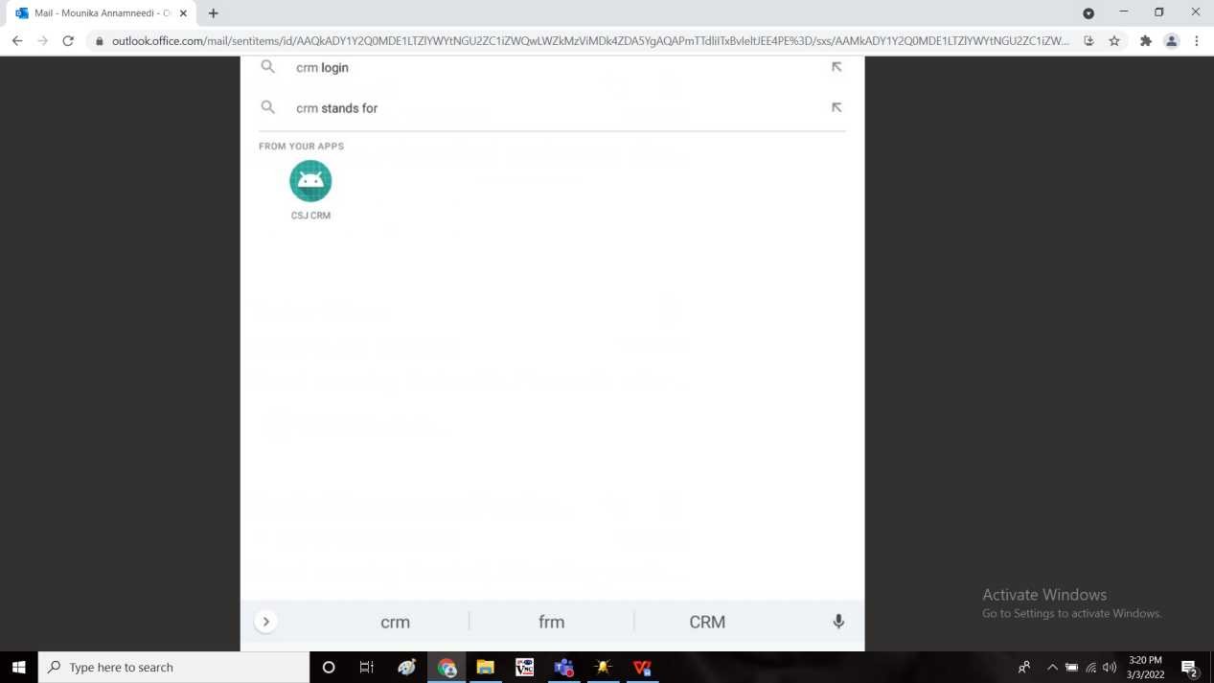

Step-2

Enter the emp code (employee code). It automatically fetches the employee name.

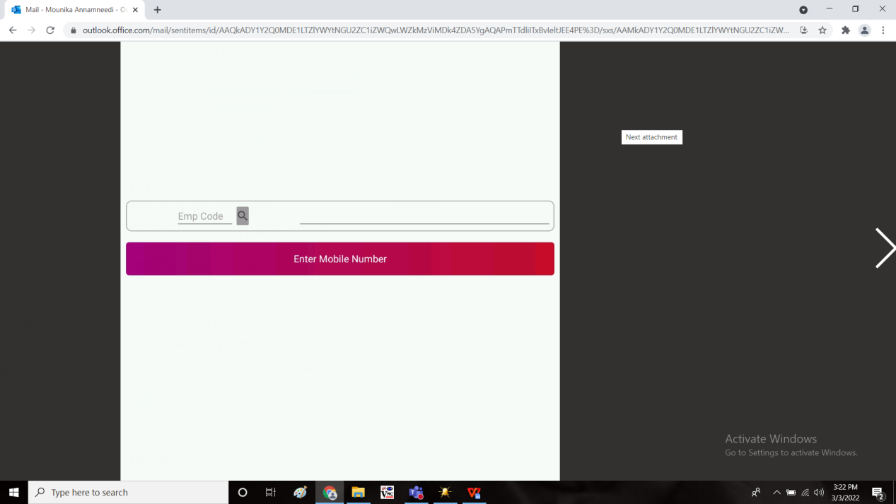

Step-3

Enter the mobile number of the customer

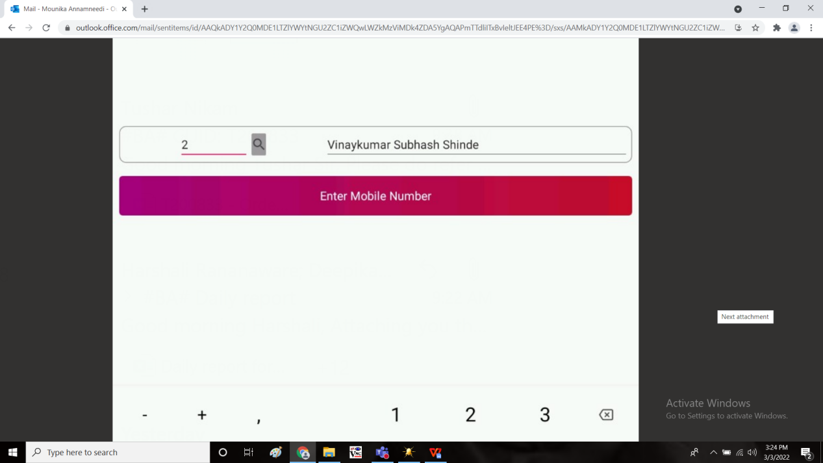

Step-4

The customer details will open. In the if the customer have his/ her birthday in the visiting.

Birthday pop-up can be 15 days prior or on the same date or 15 days after.

Ex: If customers birthday on 15 March & he visits to the branch before or after 15 days (1 march to 30 march) the pop should be appeared.

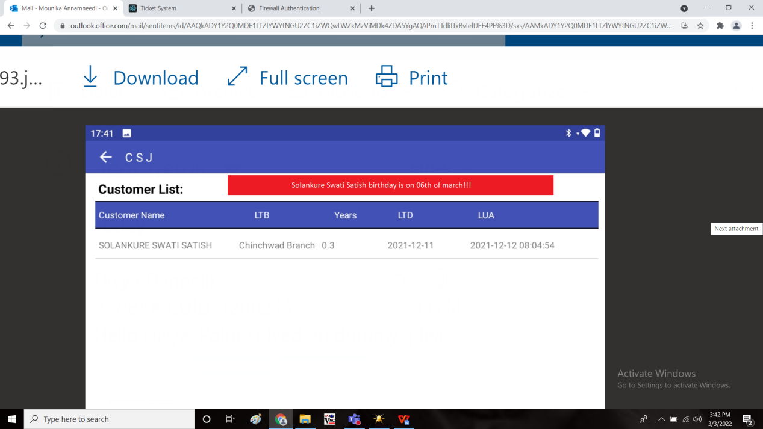

Step-5

Fetch the customer data from the Connect Us -> Masters -> General Masters -> Customer masters

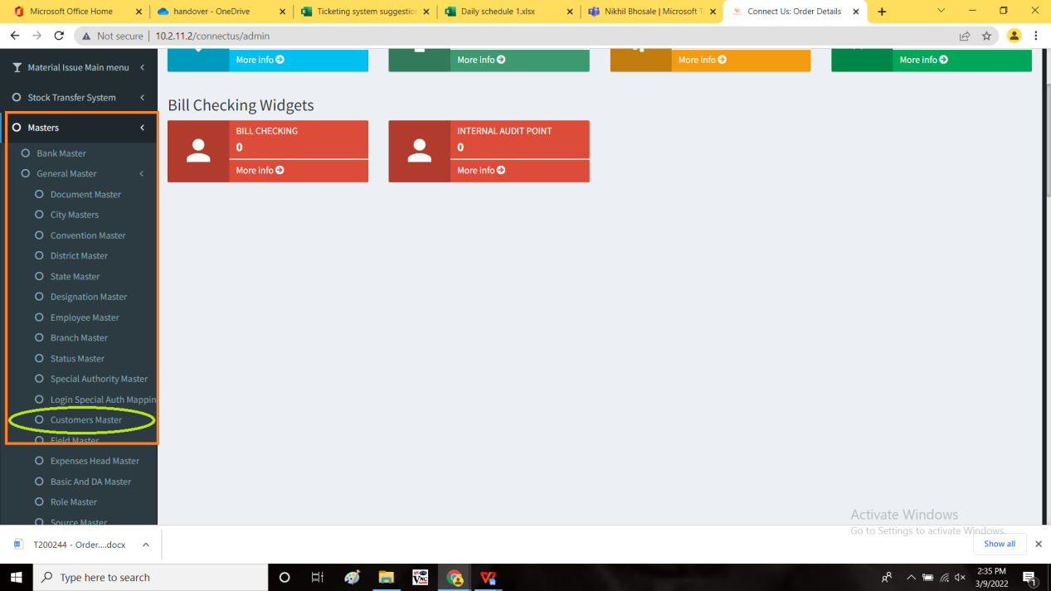

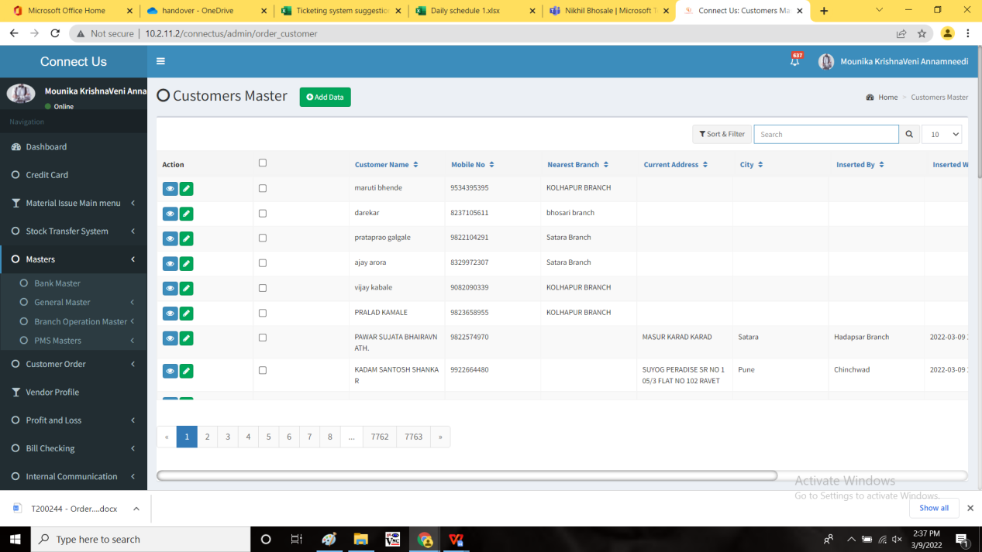

**References of the users**

|  |  |  |  |
| --- | --- | --- | --- |
| **User** | **Name** | **Mail** | **Contact number** |
| **Actual user** | Rushikesh Gokul Thorat | boe@csjewellers.com |  |
| **Assigned business analyst** | Mounika KrishnaVeni Annamneedi | Mounika.annamneedi@techneai.com | 8669917920 |
| **Assigned developer** |  |  |  |
| **Assigned tester** |  |  |  |