|  |  |
| --- | --- |
| **Ticket ID** | T226573/TT2710 |
| **Ticket description** | Please do make a provision for draw offer as per attached document. we need this system within one week so please do the needful & let me know if needed any info with the same. |
| **Created by** | Harshali Rananaware |
| **Created on** | 08 Jun 2022 |
| **Priority** | Very high |
| **Version** | 1 |

**Version**

|  |  |  |  |  |
| --- | --- | --- | --- | --- |
| **Sr. No** | **Version no** | **Version Date** | **User name** | **User department** |
| 1 | 1 | 08 Jun 2022 | Rushikesh Gokul Thorat | Branch Operation Control |

**Approvals**

|  |  |  |
| --- | --- | --- |
| **Field** | **Name of the User** | **Approved date by the user** |
| **Actual User Name** | Rushikesh Gokul Thorat |  |
| **Actual User Department** | Branch Operation Control |  |
| **Organization Name** | CSPL |  |
| **Assigned BA** | Harshali Rananaware |  |
| **Assigned Developer** |  |  |
| **Assigned Tester** |  |  |

**Estimation**

|  |  |  |  |  |
| --- | --- | --- | --- | --- |
| **Department name** | **Estimated Time (In hr)** | **Scheduled Date (Starting date )** | **Estimated date** | **Actual delivery date** |
| **BA** | 2 | 08 Jun 2022 | 10 Jun 2022 |  |
| **Development** |  | 13 Jun 2022 | 17 Jun 2022 |  |
| **Testing** |  | 15 Jun 2022 | 17 Jun 2022 |  |

**Business requirement**

Please do make a provision for draw offer as per attached document. we need this system within one week so please do the needful & let me know if needed any info with the same.

**Abbreviations & terms :**

Connect us - CU

**Proposed System :**

User want to add new form to generate a coupon for customer. Generate a unique code for each customer.

Each coupon have 1 month validity from the generate coupon.

In this form should not be add same mobile number in same location. If validity complete then same mobile number we can enter.

Generate branch wise unique code and coupon series.

Following field added in the form. Below all fields are mandatory.

1. Customer Name -
2. Address -
3. Whats app Mobile No - Mobile number accept only 10 digits.
4. DOB - Date should be select above 18 years.
5. T&c want Hyperlink if we select the check box
6. Save

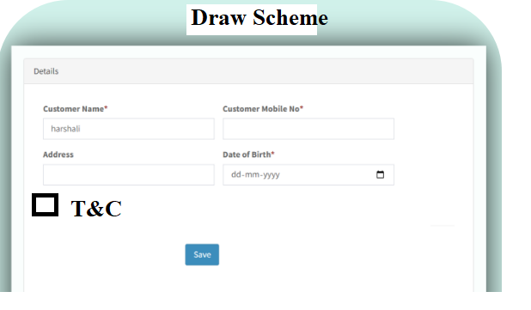

Image 1

After click on save button then data should be send on the Whats app. Below is the whats app template.

User print the coupon one time in bulk. For example in a day 10 transaction complete then generate a print at a time. Admin Print multiple time.

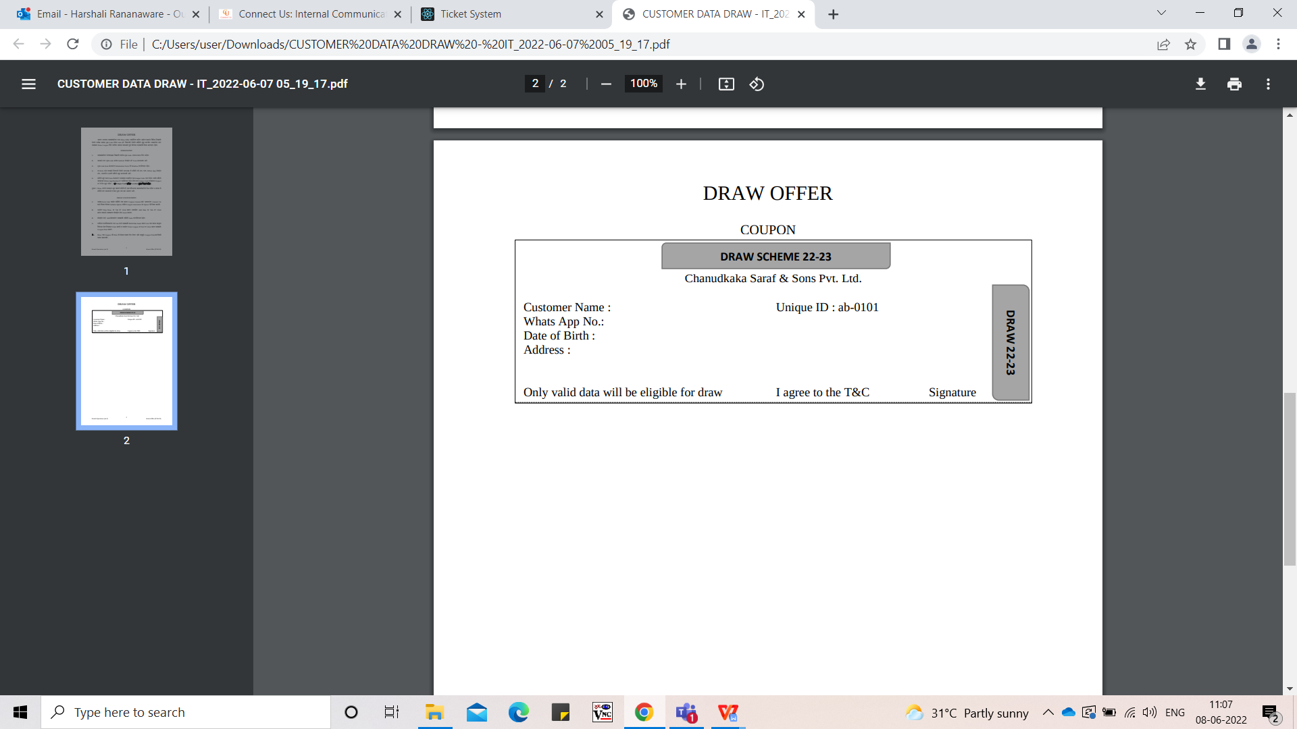

Image 2

In CU scheme -> Coupon Generation (Refer Image 3) click on this menu then show in the below (Refer Image 4). We can user to search by mobile number or branch , from date and to date.

**Branch Name** - Select all branch or single. Branch shoe as per login. This is mandatory field.

**From Date** - This is mandatory field.

**To Date** - This is mandatory field.

**Mobile No** - We can enter mobile no and search the particular customer.

**Export** - Click on export then data should export in csv file.

**Reset** - All referral details show in the report.

**Submit** - Date not select and click on submit then data should be select.

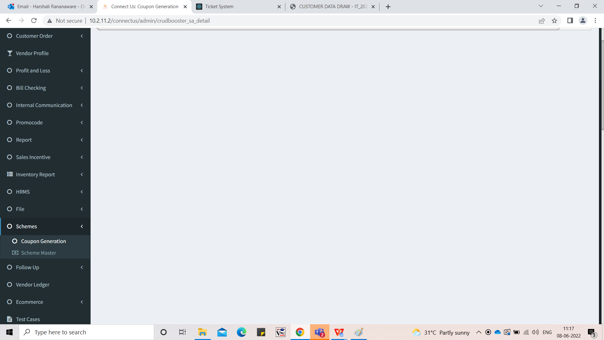

Image 3

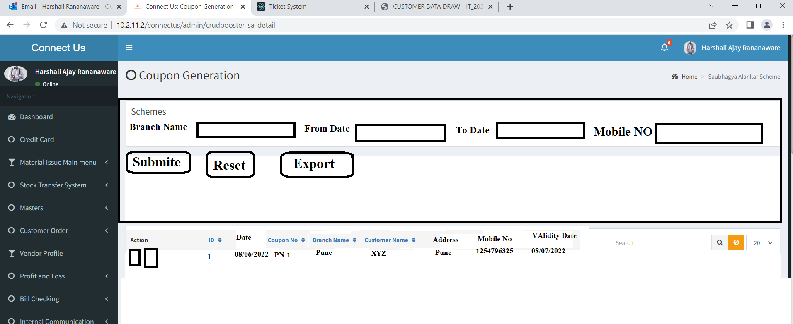

Image 4

**References of the users**

|  |  |  |  |
| --- | --- | --- | --- |
| **User** | **Name** | **Mail** | **Contact number** |
| **Actual user** | Rushikesh Gokul Thorat | boe@csjewellers.com | 2954 |
| **Assigned business analyst** | Harshali Rananaware | [harshali.rananaware@techneai.com](mailto:harshali.rananaware@techneai.com) | 8669917920 |
| **Assigned developer** | Parth Patel | [parth.patel@techneai.com](mailto:parth.patel@techneai.com) |  |