**Rakshabandhan 2022**

1. There will be a banner show at the top of the landing page.

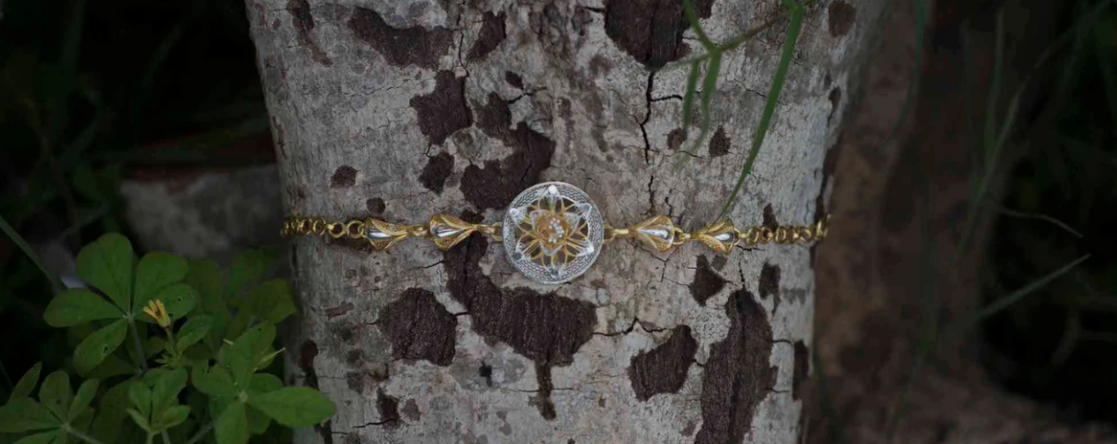

The banner will not be clickable and will not have a button.

1. Below the banner will be a text field with a brief overview of this festival, product category and special product. The text field will be 3 to 4 lines long.

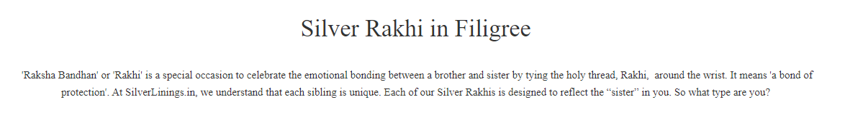

1. We will have 4 types of Rakhi online. Those types are as follows.
2. Customize Rakhi
3. Silver Rakhi
4. Gold Rakhi
5. Rakhi Cum Pendant

We want to show these 4 types of categories and there will be 4 category banners. These banners will be clickable. Clicking on the banner will open the product page respectively.

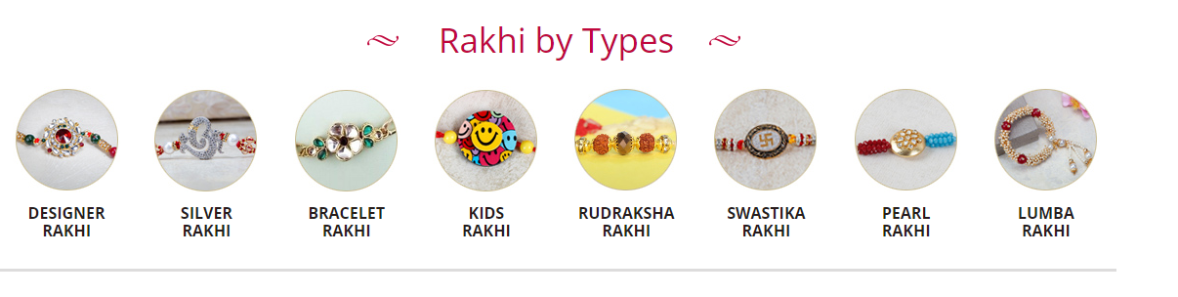

1. A text filed will appear below the category banners. Which will include online free shipping, online term and condition and other information.

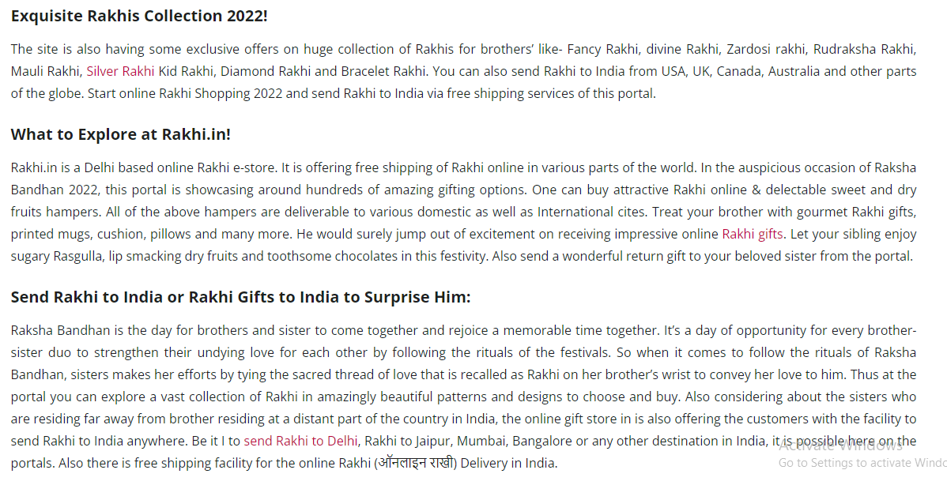

1. Finally, the footer page of the website will be displayed here.

