|  |  |
| --- | --- |
| **Ticket ID** | TT4029 |
| **Ticket description** | In connect us - Bill checking transaction in bifurcate column there is Remark column which is not been displayed to user and accounts dept after submitting the point. Kindly check and solve the point |
| **Created by** | Manali Bhadirage |
| **Created on** | 16/08/2022 |
| **Priority** | Medium |
| **Version** | 1.0 |

**Version**

|  |  |  |  |  |
| --- | --- | --- | --- | --- |
| **Sr. No** | **Version no** | **Version Date** | **User name** | **User department** |
| 01 | 1.0 | 10/08/2022 | Siddhi Kelkar | Advertisement |
|  |  |  |  |  |
|  |  |  |  |  |

**Approvals**

|  |  |  |
| --- | --- | --- |
| **Field** | **Name of the User** | **Approved date by the user** |
| **Actual User Name** | Siddhi Kelkar |  |
| **Actual User Department** | Advertisement |  |
| **Organization Name** | CS Jewellers |  |
| **Assigned BA** | Manali Bhadirage |  |
| **Assigned Developer** |  |  |
| **Assigned Tester** | Priyanka Dupargude |  |

**Estimation**

|  |  |  |  |  |
| --- | --- | --- | --- | --- |
| **Department name** | **Estimated Time (In hr)** | **Scheduled Date (Starting date )** | **Estimated date** | **Actual delivery date** |
| **BA** |  |  |  |  |
| **Development** |  |  |  |  |
| **Testing** |  |  |  |  |
|  |  |  |  |  |

**Introduction**

Through Bill checking -> Bill checking Transaction module in Connect Us, user can submit the bills and also have provision to bifurcate the bill amount equally, by percentage or by amount among branches.

**Business requirement**

In connect us - Bill checking transaction in bifurcate column there is Remark column which is not been displayed to user and accounts dept after submitting the point. Kindly check and solve the point.

**Abbreviations & terms**

GST - Goods and Services Tax

TCS - Tax Collected at Source.

TDS - Tax Deducted at Source.

**Existing system**

Once the data is added in Bill checking -> bill checking transaction, it will be displayed in grid of Bill Checking Transaction page.

Action field in grid has following options:

* View Data
* Edit Data
* History Data
* Payment History Data
* Payment detail
* Assign person data
* Bifurcate amount

Once the user clicks on edit data, following fields will be displayed:

* Bill type
* Sub bill type
* Assign to
* Vendor name
* Branch name
* Vendor bill No
* Challan / PO No
* Bill Date
* Received date
* Debit Advance
* Taxable Amount / Amount
* GST
* Round off
* TCS
* TDS%
* Net payment
* Net payment in words
* Remark
* Padm Doc Date
* Padm Doc Name
* A/C effect
* Bifurcate By
* Internal Audit Remark
* External Audit remark
* Attachment
* Updated by
* Updated At
* Submit

In “bifurcate by” following fields are displayed:

* Drop-down
* Calculate button
* Reset Button

In drop-down, user selects the method to bifurcate the bill as below:

* Equally
* Manually %
* Manually ₹

Through this, user can divide the amount equally / percentage wise / manual amount among selected branches.

Once user selects any one out of these option from drop-down, user has to fill the following details in the box appearing below:

* Branch Name
* Percentage %
* Amount ₹
* Remark
* Action

|  |  |  |
| --- | --- | --- |
| **FIELDS** | **INPUT TYPE** | **DESCRIPTION** |
| Branch Name | select | User has to select the branch name from the drop-down. If required user can divide the bill into more than one branch.  If user wants to bifurcate amount into more than one branch, user can click “+” icon from action field and select one more branch name from drop-down. |
| Percentage % | Auto | Percentage % gets auto calculated and is displayed within the branches selected by the user.  If user selects manually % in action drop-down, then user will have to enter percentage for particular branch and amount gets auto calculated and displayed. |
| Amount ₹ | Numeric | User can manually enter the bill amount into one or more branches.  If user selects manually ₹ in action drop-down, then user will have to enter amount for particular branch and its remaining amount of total bill gets auto calculated for another branch. |
| Remark | Alphanumeric | User can enter any additional notes in remark field.  It is not mandatory field. |
| Action | Click | Action has two menus:  + for adding branch and its bifurcation.  X for deleting already added entry.  Through “+” action, user can either add more branches if user want to divide the bill into more than one branch.  Through “X” icon, user can delete any already added branch. |

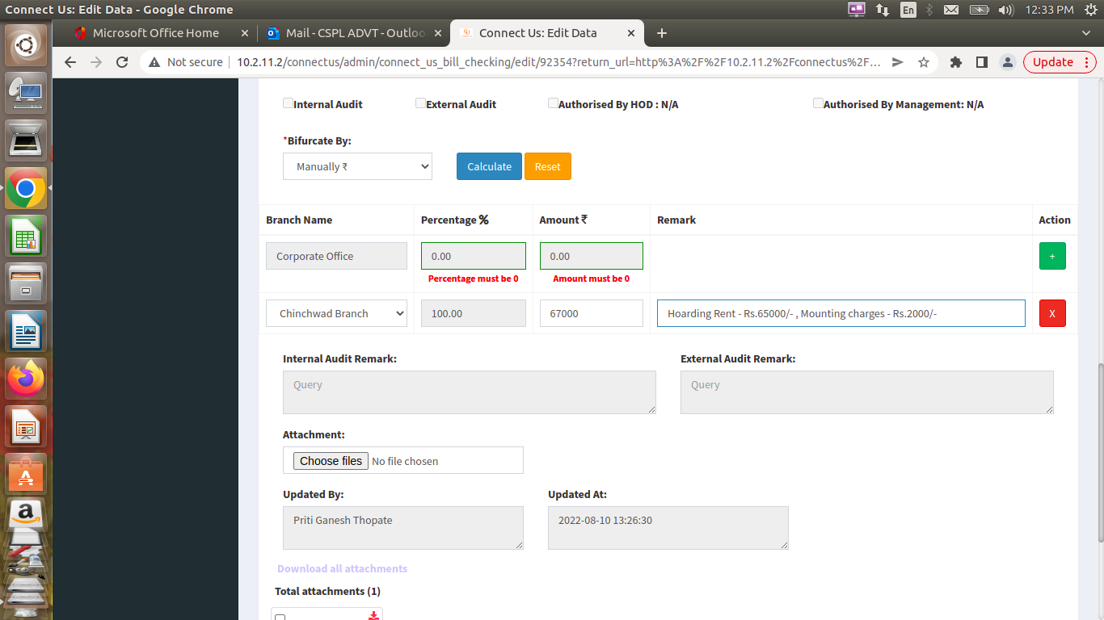

Fig: Bifurcate by

Once the user enters bifurcate details, adds remark and submits it, then the data is shown as successfully added. However, “Remark” field isn’t displayed in View data action.

Also, if user wish to edit data and clicks on Edit Data action, the remark field isn’t displayed.

Remark field isn’t displayed neither to the user who has added, edited data nor to the user to whom the bill is assigned to.

Remark can be seen only through “Bifurcate Amount” action in grid.

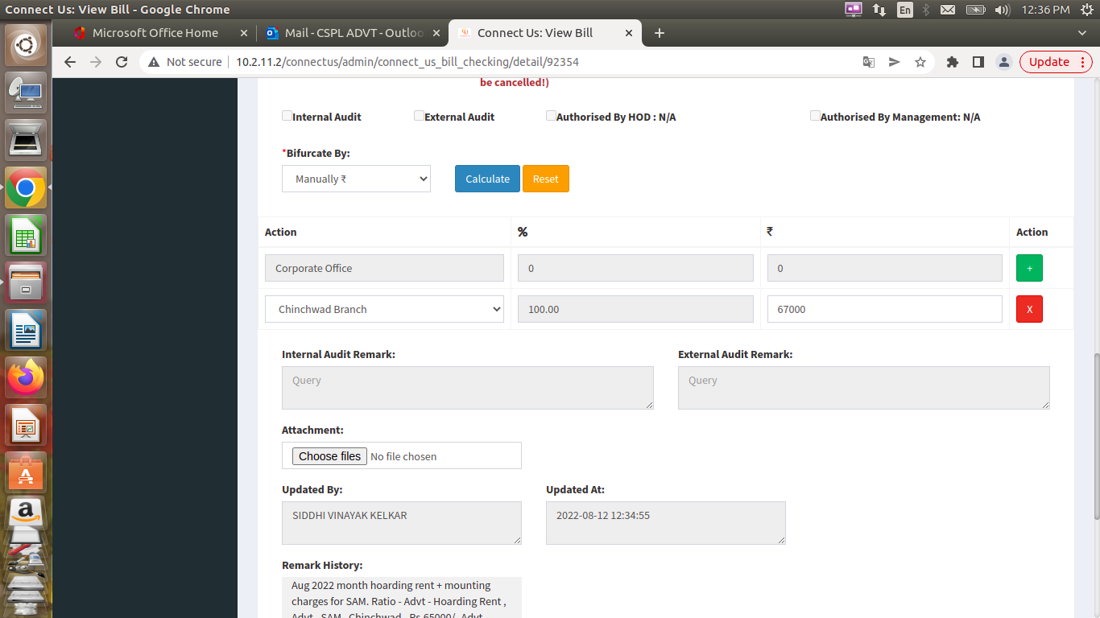

Fig: Existing doesn’t have remark field

**Proposed system**

Once the user enters bifurcate details, enters remark and submits it, then in view data action, “Remark” field should be displayed to all the users who have view authority.

Also, “Remark” field should be displayed to all the users who have edit authority and should be able to edit it.



Fig: Proposed should have Remark field in View data & Edit data

This remark issue is not observed on dummy. On dummy we could see “Remark” field in view data and edit data actions. However, the remark issue is being observed on live.

**References of the users**

|  |  |  |  |
| --- | --- | --- | --- |
| **User** | **Name** | **Mail** | **Contact number** |
| **Actual user** | Siddhi Kelkar | advt@csjewellers.com | 2912 |
| **Ticket created by (if any)** | Siddhi Kelkar | advt@csjewellers.com | 2912 |
| **Assigned business analyst** | Manali Bhadirage | manali.bhadirage@techneai.com | 2964 |
| **Assigned developer** |  |  |  |
| **Assigned tester** | Priyanka Dupargude | piyanka.dupargude@techneai.com | 2964 |