|  |  |
| --- | --- |
| **Ticket ID** | TT4029 |
| **Ticket description** | In connect us - Bill checking transaction in bifurcate column there is Remark column which is not been displayed to user and accounts dept after submitting the point. Kindly check and solve the point |
| **Created by** | Manali Bhadirage |
| **Created on** | 18/08/2022 |
| **Priority** | Medium |
| **Version** | 1.0 |

**Introduction**

Through Bill checking -> Bill checking Transaction module in Connect Us, user can submit the bills and also have provision to bifurcate the bill amount equally, by percentage or by amount among branches.

**Business requirement**

In connect us - Bill checking transaction in bifurcate column there is Remark column which is not been displayed to user and accounts dept after submitting the point. Kindly check and solve the point.

**Developed system**

Once the data is added in Bill checking -> bill checking transaction, it will be displayed in grid of Bill Checking Transaction page.

Once user clicks on “Edit data” action from grid, user can view all bill details.

Here, in “bifurcate by” following fields are displayed:

* Drop-down
* Calculate button
* Reset Button

In drop-down, user selects the method to bifurcate the bill as below:

* Equally
* Manually %
* Manually ₹

Once user selects any one out of these option from drop-down, user has to fill the following details in the box appearing below:

* Branch Name
* Percentage %
* Amount ₹
* Remark
* Action

Earlier, once user adds Remark here, this remark field was not displayed to users in “View data” and “edit data” action.

Now as per our developed system, this remark field will be displayed in “View Data” action to the user who has added the remark and also will be displayed to the user to whom the bill is assigned to.

Moreover, the users having authority to edit data will be able to view as well as edit these remarks.

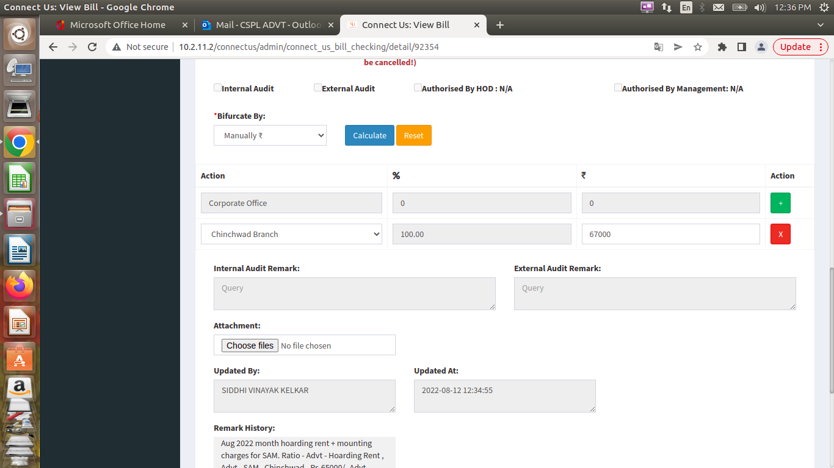

Fig: Remark field earlier.

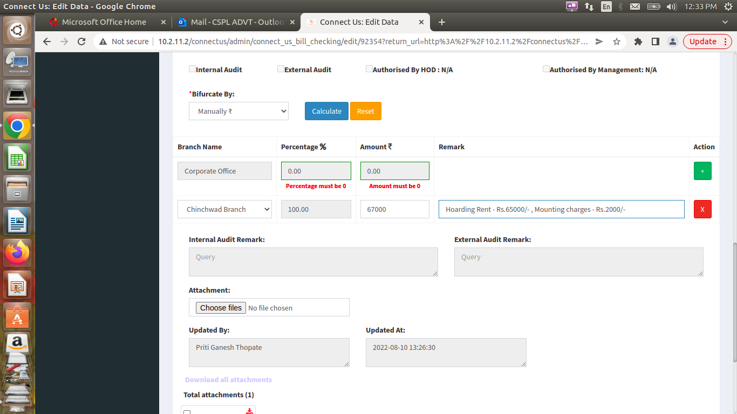

Fig: Remark field now

**References of the users**

|  |  |  |  |
| --- | --- | --- | --- |
| **User** | **Name** | **Mail** | **Contact number** |
| **Actual user** | Siddhi Kelkar | advt@csjewellers.com | 2912 |
| **Assigned business analyst** | Manali Bhadirage | manali.bhadirage@techneai.com | 2964 |
| **Assigned developer** | Punam Shinde | punam.shinde@techneai.com | 2964 |
| **Assigned tester** | Priyanka Dupargude | piyanka.dupargude@techneai.com | 2964 |