|  |  |
| --- | --- |
| **Ticket ID** | TT4452 |
| **Ticket description** | Create a report for daily antecedence and REGULARIZATION REPORT. |
| **Created by** | Harshali Rananaware |
| **Created on** | 26 Aug 2022 |
| **Priority** | Very high |
| **Version** | 1 |

ATTENDANCE DAILY REPORT:

In Connect us -> Monthly Payroll -> Attendance Daily Report

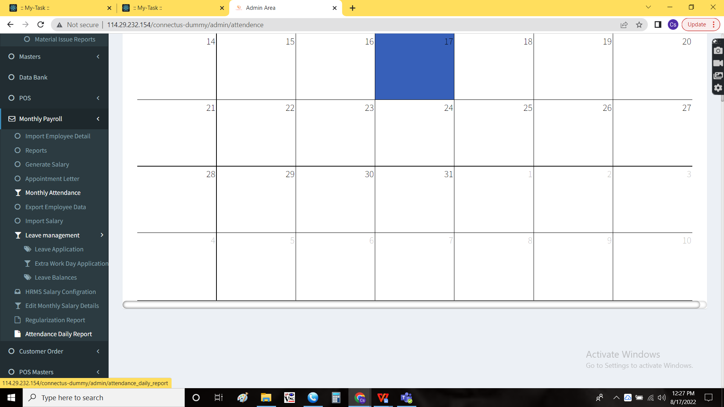

Attendance Daily Report:

Attendance daily report displays the data of the employees attendance for the particular period. The attendance report consists of the following filters.

* From date
* To date
* Branch

|  |  |  |  |
| --- | --- | --- | --- |
| **FIELDS** | **INPUT TYPE** | **MANDATORY/ OPTIONAL** | **DESCRIPTION** |
| From date | Calender | Mandatory | The period from when the data to be generated |
| To date | Calender | Mandatory | The period to when the data to be generated |
| Branch | Drop down | Mandatory | The data for which branches required are selected. Multiple selection for the branches is allowed. The drop down options are fetched from branch master (In connect us -> masters -> general masters -> branch master) |

There are few more button such as

* Filter
* Export
* Reset

|  |  |
| --- | --- |
| Field | Description |
| Filter | To filter the data based on the data selected from the branches |
| Export | The export button to export the data |
| Reset | The reset button to reset the data on the fields mentioned |

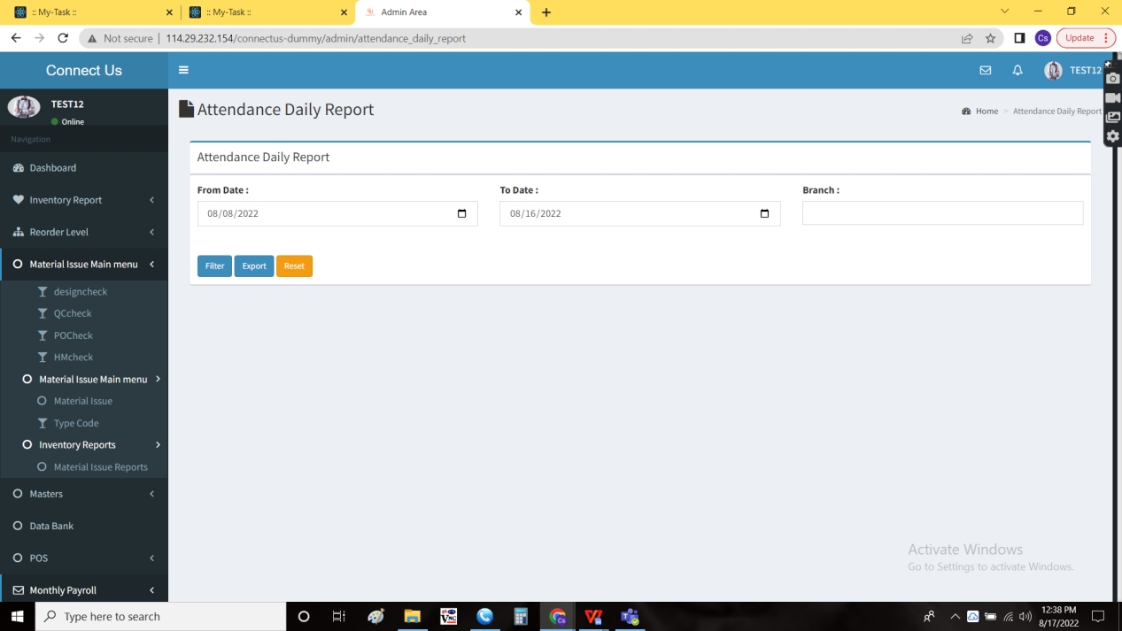

The report consists of the following fields

* Sr no
* Emp Id
* Emp name
* Emp designation
* Branch
* Date
* In time
* Out time
* Total

|  |  |
| --- | --- |
| Field | Description |
| Sr no | The serial number is displayed |
| Emp Id | The employee Id is displayed. The employee ID is fetched from the employee master (In connect us -> masters -> general masters -> employee master) |
| Emp name | The employee name is displayed. The employee name is fetched from the employee master (In connect us -> masters -> general masters -> employee master) |
| Emp designation | The employee designation is displayed. The employee designation is fetched from the employee master (In connect us -> masters -> general masters -> employee master) |
| Branch | The branch of that employee is displayed. The employee ID is fetched from the employee master (In connect us -> masters -> general masters -> employee master) |
| Date | The count of the attendance is shown. If the employee works for more than or equal to 9 hours, it is considered as full day, I.e., 1.  If the employee works more than 4.5 hours and less than 9 hours, it is considered as half day, I.e., 0.5.  If the employee is absent, then considered as leave, I.e., 0. |
| In time | The in time of the employee is displayed. The data is fetched from (In connect us -> monthly payroll -> monthly attendance) |
| Out time | The out time of the employee is displayed. The data is fetched from (In connect us -> monthly payroll -> monthly attendance) |
| Total | The total count of that employee is displayed |

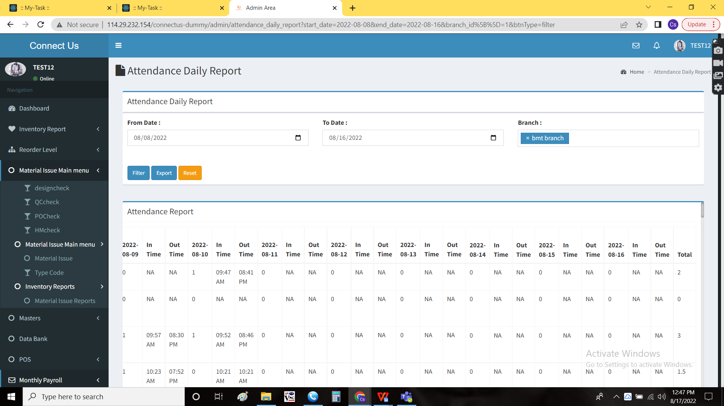

Export data:

The data is exported when the user clicks on the “export” button. The data displayed is exported.

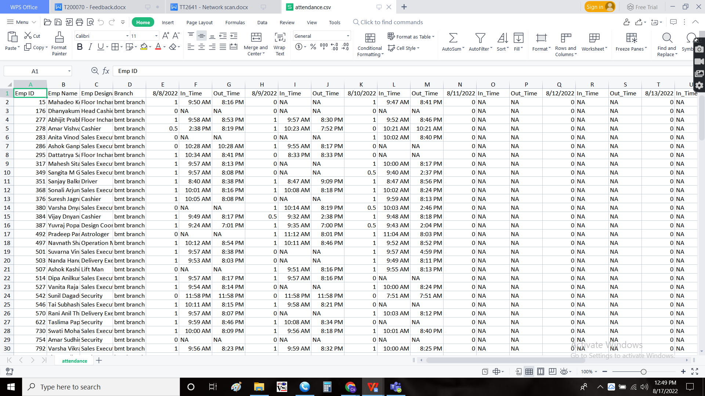

REGULARIZATION REPORT:

In Connect us -> Monthly Payroll -> Regularization Report



The regularization report consists of the data of the employees who raised the regularization of attendance in monthly attendance (In connect us -> monthly payroll -> monthly attendance). The regularization report consists of the following data.

* From date
* To date
* Branch

|  |  |  |  |
| --- | --- | --- | --- |
| **FIELDS** | **INPUT TYPE** | **MANDATORY/ OPTIONAL** | **DESCRIPTION** |
| From date | Calender | Mandatory | The period from when the data to be generated |
| To date | Calender | Mandatory | The period to when the data to be generated |
| Branch | Drop down | Mandatory | The data for which branches required are selected. Multiple selection for the branches is allowed. The drop down options are fetched from branch master (In connect us -> masters -> general masters -> branch master) |

There are few more button such as

* Filter
* Export
* Reset

|  |  |
| --- | --- |
| Field | Description |
| Filter | To filter the data based on the data selected from the branches |
| Export | The export button to export the data |
| Reset | The reset button to reset the data on the fields mentioned |

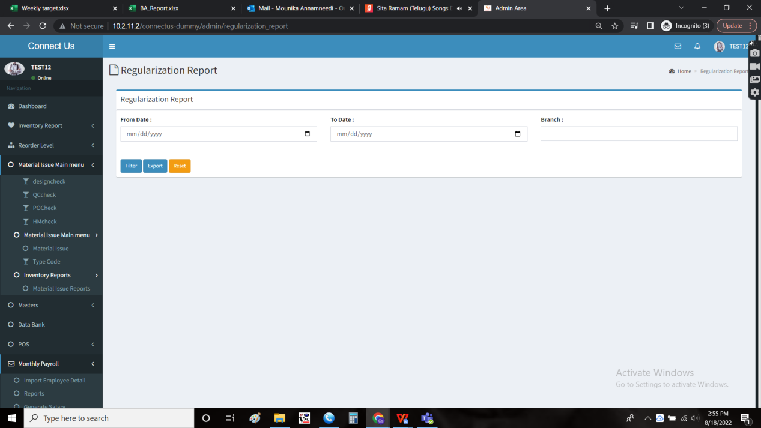

The report consists of the following fields.

* Sr no
* Emp Id
* Emp name
* Branch
* Date
* In
* Out
* Total hr
* Regularization
* Status
* Approval name

|  |  |
| --- | --- |
| Field | Description |
| Sr no | The serial number is displayed |
| Emp Id | The employee Id is displayed. The employee ID is fetched from the employee master (In connect us -> masters -> general masters -> employee master) |
| Emp name | The employee name is displayed. The employee name is fetched from the employee master (In connect us -> masters -> general masters -> employee master) |
| Branch | The branch of that employee is displayed. The employee ID is fetched from the employee master (In connect us -> masters -> general masters -> employee master) |
| Date | The count of the attendance is shown. If the employee works for more than or equal to 9 hours, it is considered as full day, I.e., 1.  If the employee works more than 4.5 hours and less than 9 hours, it is considered as half day, I.e., 0.5.  If the employee is absent, then considered as leave, I.e., 0. |
| In | The in time of the employee is displayed. |
| Out | The out time of the employee is displayed. |
| Total hr | The total count of that employee is displayed |
| Regularization | The regularization date is displayed |
| Status | The status whether it is approved or pending is displayed |
| Approval name | The approval person name is displayed |

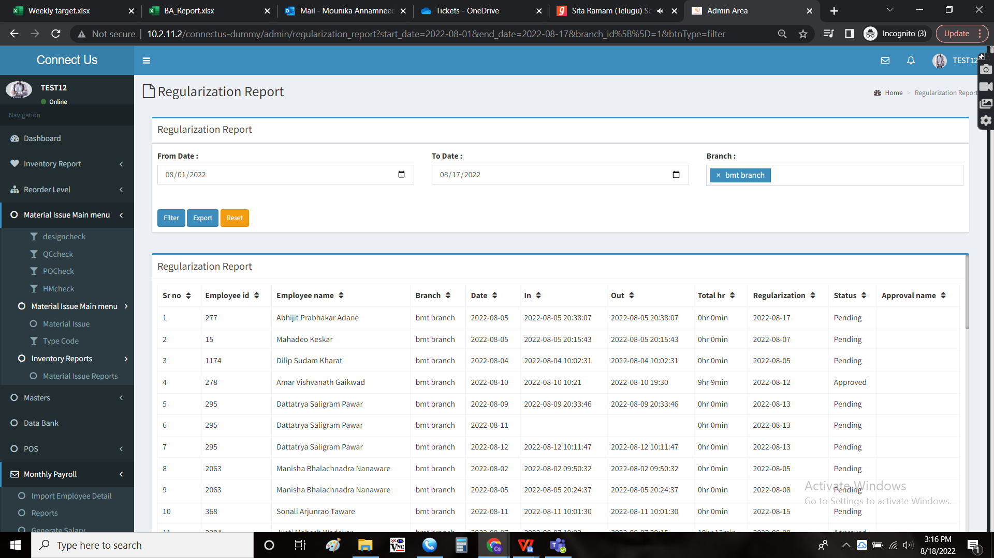

Export data:

The data is exported when the user clicks on the “export” button. The data displayed is exported.