|  |  |
| --- | --- |
| **Ticket ID** | TT4022 |
| **Ticket description** | ConnectUS Madhe HM Print Madhe New Hm Address Add Karun pahije Please find Attachment Name :- SHREE PARSHWA HALLMARKING CENTER Address :- 1ST FLR, S NO- 491, PANDURANG NIWAS MOTI CHOWK, RAVIWAR PETH. PUNE Maharashtra,411002 GST Number :- 27AENFS6746N1Z1 PAN Number :- AENFS6746N Mobile number :- 9730782692 Email :- sphcpune@gmail.com |
| **Created by** | Manali Bhadirage |
| **Created on** | 10/08/2022 |
| **Priority** | Medium |
| **Version** | 1.0 |

**Version**

|  |  |  |  |  |
| --- | --- | --- | --- | --- |
| **Sr. No** | **Version no** | **Version Date** | **User name** | **User department** |
| **01** | **1.0** | **10/08/2022** | **Tushar Nikam** | **CS Jewellers** |
|  |  |  |  |  |
|  |  |  |  |  |

**Approvals**

|  |  |  |
| --- | --- | --- |
| **Field** | **Name of the User** | **Approved date by the user** |
| **Actual User Name** | Tushar Nikam |  |
| **Actual User Department** | Inventory |  |
| **Organization Name** | CSJewellers |  |
| **Assigned BA** | Manali Bhadirage |  |
| **Assigned Developer** |  |  |
| **Assigned Tester** | Priyanka Dupargude |  |

**Estimation**

|  |  |  |  |  |
| --- | --- | --- | --- | --- |
| **Department name** | **Estimated Time (In hr)** | **Scheduled Date (Starting date )** | **Estimated date** | **Actual delivery date** |
| **BA** |  |  |  |  |
| **Development** |  |  |  |  |
| **Testing** |  |  |  |  |
|  |  |  |  |  |

**Introduction**

In Connect Us -> Material Issue Main Menu -> Material issue -> View -> Print, once user add details of the box and selects address, user can print the details of the document.

**Business requirement**

ConnectUS Madhe HM Print Madhe New Hm Address Add Karun pahije Please find Attachment Name :- SHREE PARSHWA HALLMARKING CENTER Address :- 1ST FLR, S NO- 491, PANDURANG NIWAS MOTI CHOWK, RAVIWAR PETH. PUNE Maharashtra,411002 GST Number :- 27AENFS6746N1Z1 PAN Number :- AENFS6746N Mobile number :- 9730782692 Email :- [sphcpune@gmail.com](mailto:sphcpune@gmail.com)

**Abbreviations & terms**

HM - Hall Marking.

LM - Laser Marking.

BMT - Baramati.

**Existing system**

In Material Issue Main Menu -> Material issue, data is displayed in grid. Grid consists of following fields:

* Action
* Doc no
* Date
* Challan no
* Net wt
* Location Issued type
* Vendor
* Narration
* Received status
* Time Diff.

Out of which, Action field consists below options:

* View data
* History data
* Edit data
* Take print
* Get attachment data

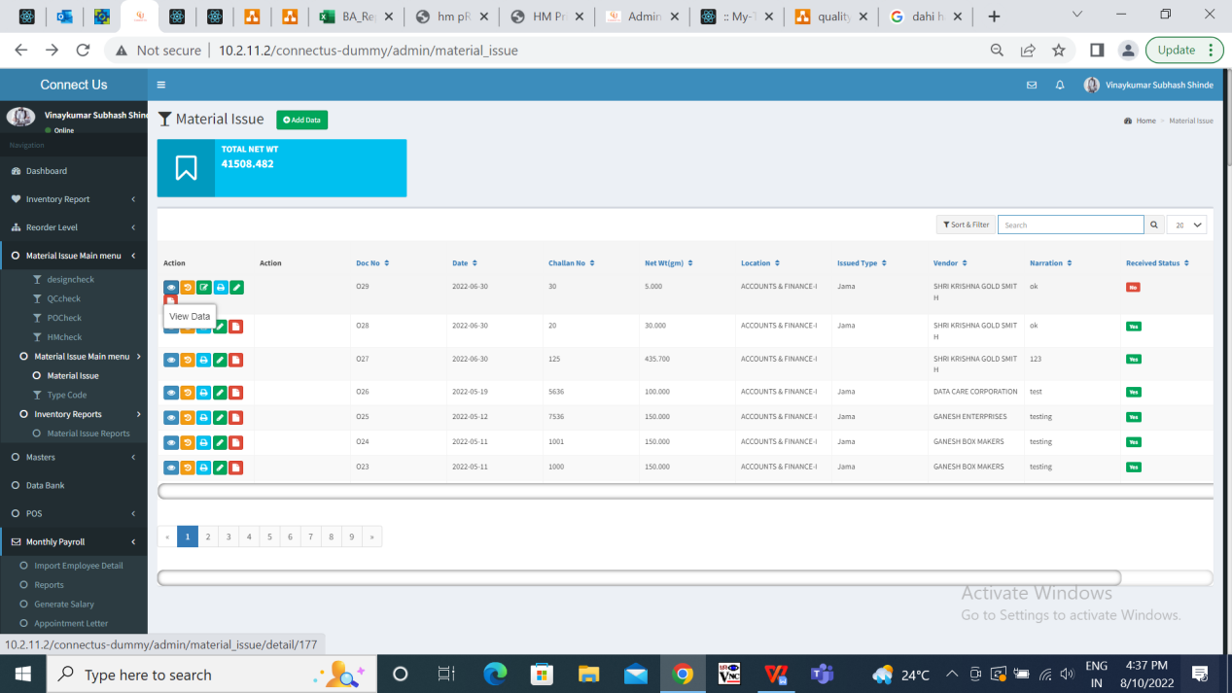

Fig: Action - View data in material issue

Once user clicks on view data of any particular row, details of material issue are being displayed. After clicking on “Print”, one window pops up where user has to fill the details of the document namely:

* Box wt
* Tunch nt wt
* Tunch pcs
* Hallmark pcs
* Select location (drop-down)

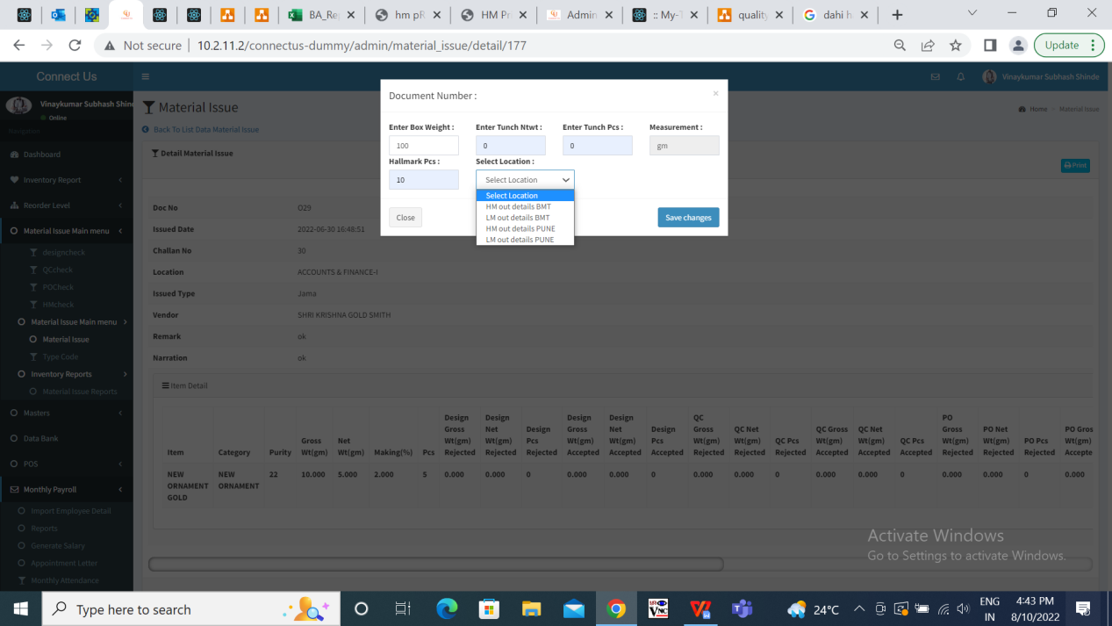

Fig: Details of document window

Select location drop-down has four locations as below:

* HM out details BMT
* LM out details BMT
* HM out details PUNE
* LM out details PUNE

Once the user fills details, selects any of the intended location and clicks on save changes, print preview shows details as in the attached image below.

All the four locations display same format in print preview.

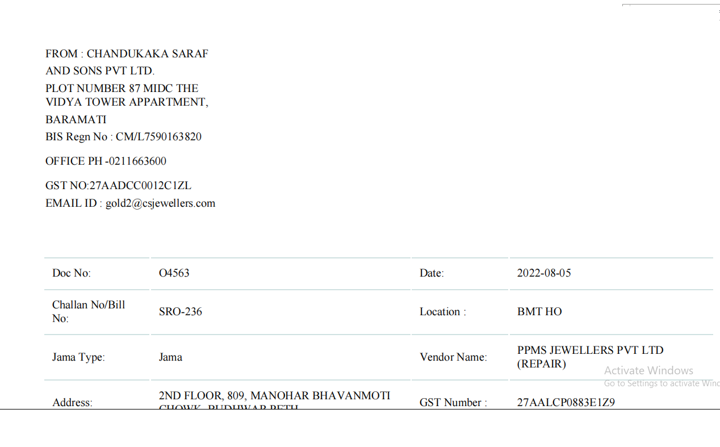

Fig: Print Preview - existing.

**Proposed system**

In Connect US -> Material issue main menu -> material issue -> view data -> print -> details of document window will include following fields:

* Box wt
* Tunch nt wt
* Tunch pcs
* Hallmark pcs
* Select location (drop-down)
* Save changes button
* Close button

Here, select location drop-down should include six locations as below:

* HM out details BMT
* LM out details BMT
* HM out details PUNE
* LM out details PUNE
* HM out Parshwa PUNE
* LM out Parshwa PUNE

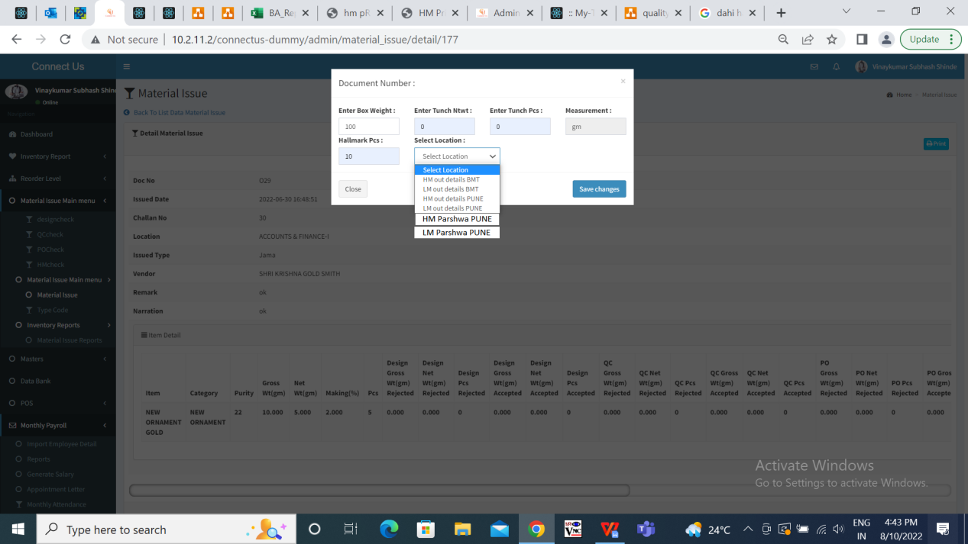

Fig: Select location drop-down

Once the user fills document details in window and selects one of the location - HM out details /LM out details BMT / HM out details PUNE / LM out details PUNE, the print preview of these four locations remains the same as in existing system.

Whereas, once user selects location as HM Parshwa PUNE in drop-down and clicks on save changes, then its print preview should be as the below attached image.

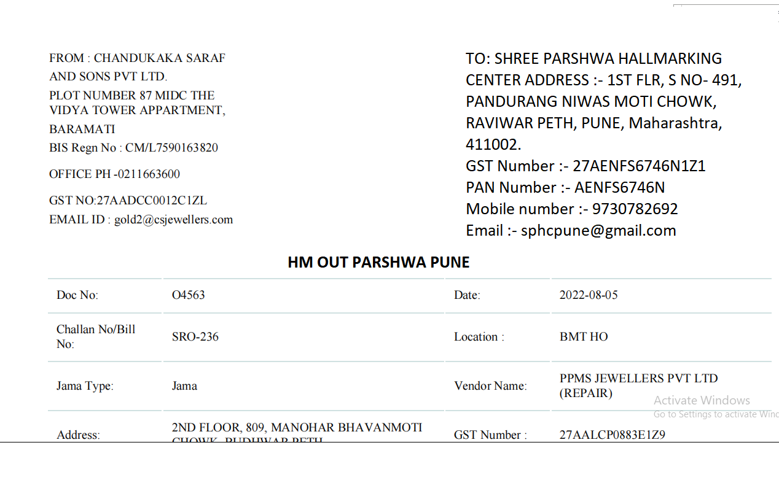

Fig: Print - HM Parshwa PUNE

Similarly, once user selects location as LM parshwa PUNE in drop-down and clicks on save changes, then its print preview should be as the below attached image.

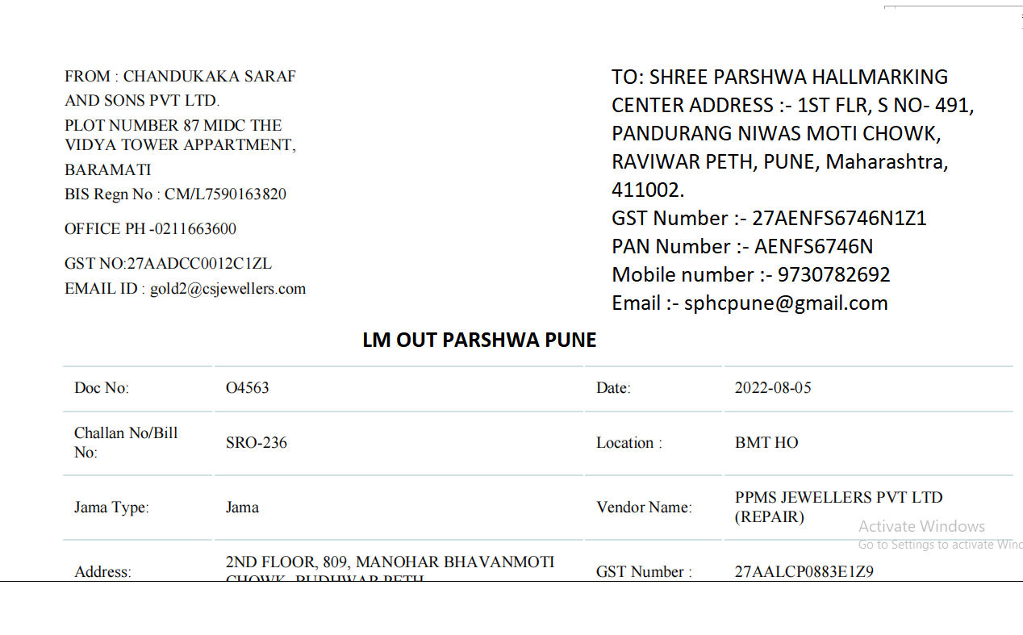

Fig: Print - LM Parshwa PUNE

**References of the users**

|  |  |  |  |
| --- | --- | --- | --- |
| **User** | **Name** | **Mail** | **Contact number** |
| **Actual user** | Tushar Nikam |  | 2607 |
| **Ticket created by (if any)** | Tushar Nikam |  | 2607 |
| **Assigned business analyst** | Manali Bhadirage | manali.bhadirage@techneai.com | 2964 |
| **Assigned developer** |  |  |  |
| **Assigned tester** | Priyanka Dupargude | priyanka.dupargude@techneai.com | 2964 |