|  |  |
| --- | --- |
| **Ticket ID** | TT4022 |
| **Ticket description** | ConnectUS Madhe HM Print Madhe New Hm Address Add Karun pahije Please find Attachment Name :- SHREE PARSHWA HALLMARKING CENTER Address :- 1ST FLR, S NO- 491, PANDURANG NIWAS MOTI CHOWK, RAVIWAR PETH. PUNE Maharashtra,411002 GST Number :- 27AENFS6746N1Z1 PAN Number :- AENFS6746N Mobile number :- 9730782692 Email :- sphcpune@gmail.com |
| **Created by** | Manali Bhadirage |
| **Created on** | 17/08/2022 |
| **Priority** | Medium |
| **Version** | 1.0 |

**Introduction**

In Connect Us -> Material Issue Main Menu -> Material issue -> View -> Print, once user add details of the box and selects address, user can print the details of the document.

**Business requirement**

ConnectUS Madhe HM Print Madhe New Hm Address Add Karun pahije Please find Attachment Name :- SHREE PARSHWA HALLMARKING CENTER Address :- 1ST FLR, S NO- 491, PANDURANG NIWAS MOTI CHOWK, RAVIWAR PETH. PUNE Maharashtra,411002 GST Number :- 27AENFS6746N1Z1 PAN Number :- AENFS6746N Mobile number :- 9730782692 Email :- [sphcpune@gmail.com](mailto:sphcpune@gmail.com)

**Abbreviations & terms**

HM - Hall Marking.

LM - Laser Marking.

BMT - Baramati.

**Proposed System**

In Connect Us -> Material issue main menu -> Material issue, when we click on view action of any entry in grid, we will be directed to detail material issue page. After clicking on “Print”, one window pops up where user has to fill the details of the document namely:

* Box wt
* Tunch nt wt
* Tunch pcs
* Hallmark pcs
* Select location (drop-down)

Here, select location drop-down now includes six locations as below:

* HM Out Details BMT
* LM Out Details BMT
* HM Out Details PUNE
* LM Out Details PUNE
* HM Out Parshwa PUNE
* LM Out Parshwa PUNE

Once the user fills document details in pop-up window and selects one of the location - HM Out Details BMT /LM Out Details BMT / HM Out Details PUNE / LM Out Details PUNE, the print preview of these four locations will remain the same as in existing system.

Whereas, once user selects location as HM Out Parshwa PUNE in drop-down and clicks on save changes, then its print preview will be as in the image attached below.

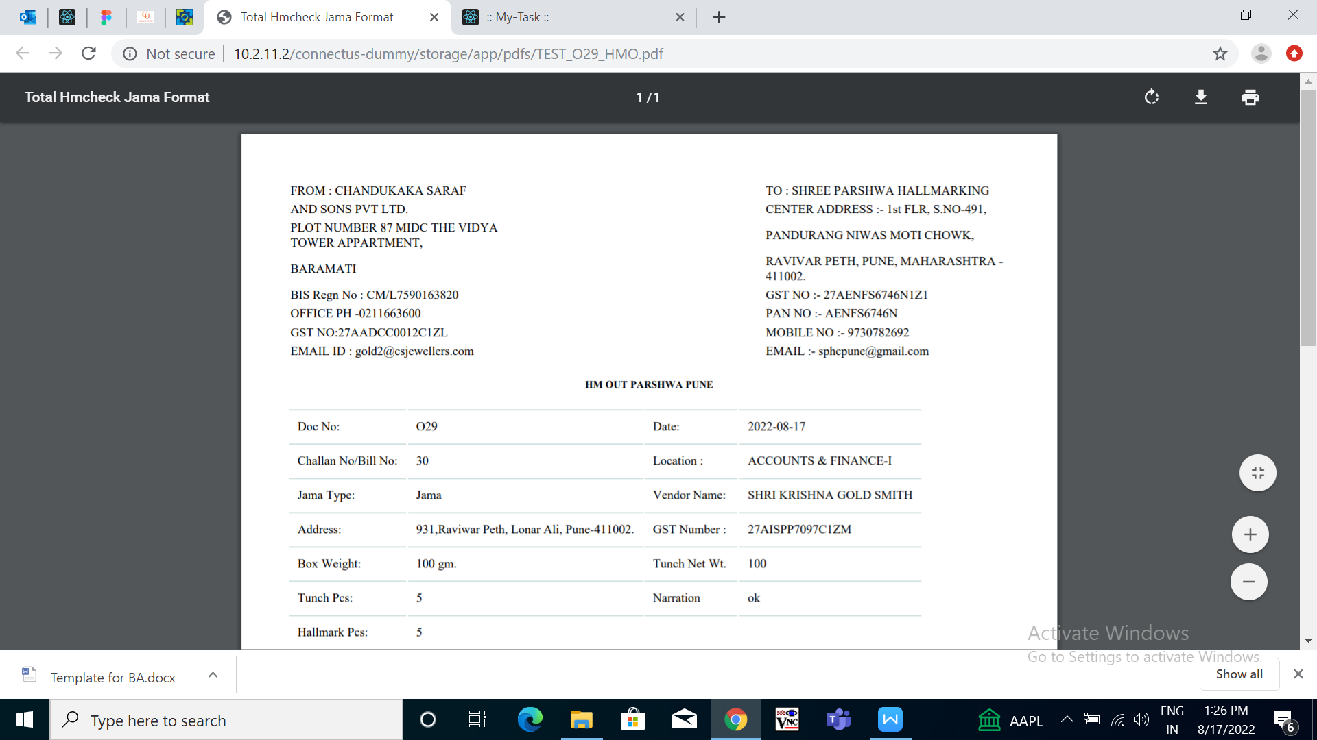

Fig: HM OUT PARSHWA PUNE

Here, we have added “To address and details” at top right column and have given the title “HM OUT PARSHWA PUNE” above the package details.

Similarly, once user selects location as LM out Parshwa PUNE in drop-down and clicks on save changes, then its print preview will be as in the image attached below.

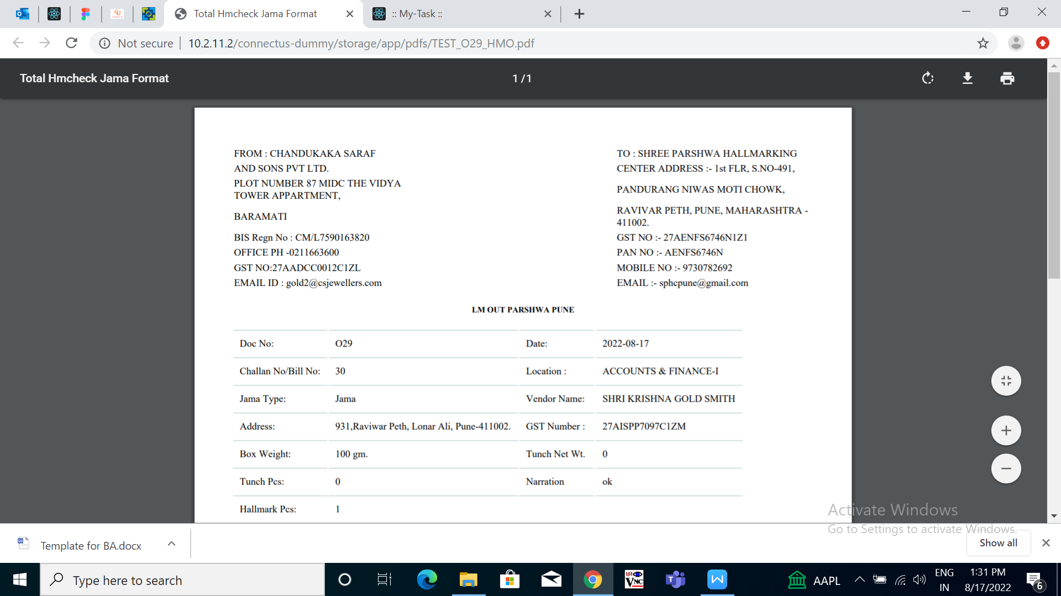

Fig: LM OUT PARSHWA PUNE

Here, we have added “To address and details” at top right column and have given the title “LM OUT PARSHWA PUNE” above the package details.

**References of the users**

|  |  |  |  |
| --- | --- | --- | --- |
| **User** | **Name** | **Mail** | **Contact number** |
| **Actual user** | Tushar Nikam | itinv@csjewellers.com | 2607 |
| **Ticket created by (if any)** | Tushar Nikam | itinv@csjewellers.com | 2607 |
| **Assigned business analyst** | Manali Bhadirage | manali.bhadirage@techneai.com | 2964 |
| **Assigned developer** | Punam Shinde | punam.shinde@techneai.com | 2964 |
| **Assigned tester** | Priyanka Dupargude | priyanka.dupargude@techneai.com | 2964 |