|  |  |
| --- | --- |
| **Ticket ID** | TT3607 |
| **Ticket description** | Quality Check History Madhe New Changes Karne 1) Add data and Add new entry Madhe Entry Kartana New Narration Coloam Add Karne Reason Type Ya Navane Add Karne V Tya Madhe material Issue Madhil Design qc po hm Madhil All Type Show Jhale Pahijet and (Material Issue Design Check narration Pramane ) 2) line Item La aslele All Coloum Excel La export Jhale Pahijet Sr Number Pasun Cancel Status Paryant 3) Restore and cancel Batan Authority Basis Varti Karun Dene |
| **Created by** | Manali Bhadirage |
| **Created on** | 26/07/2022 |
| **Priority** | Very high |
| **Version** | 1.0 |

**Version**

|  |  |  |  |  |
| --- | --- | --- | --- | --- |
| **Sr. No** | **Version no** | **Version Date** | **User name** | **User department** |
| 01 | 1.0 | 26/07/2022 | Tushar Nikam | Inventory |

**Approvals**

|  |  |  |
| --- | --- | --- |
| **Field** | **Name of the User** | **Approved date by the user** |
| **Actual User Name** | Tushar Nikam | 27/07/2022 |
| **Actual User Department** | Inventory | 27/07/2022 |
| **Organization Name** | Csjewellers |  |
| **Assigned BA** | Manali Bhadirage |  |
| **Assigned Developer** | Prathamesh Shinde |  |
| **Assigned Tester** | Priyanka Dupargude |  |

**Estimation**

|  |  |  |  |  |
| --- | --- | --- | --- | --- |
| **Department name** | **Estimated Time (In hr)** | **Scheduled Date (Starting date )** | **Estimated date** | **Actual delivery date** |
| **BA** |  |  |  |  |
| **Development** |  |  |  |  |
| **Testing** |  |  |  |  |
|  |  |  |  |  |

**Introduction**

The purpose of the Quality Check History in Connect Us is to enable users to add details of the accepted items and rejected items from particular Lot they will be checking. Also, user can view the history and export desired report with all the details of each item.

**Business requirement**

Quality Check History Madhe New Changes Karne 1) Add data and Add new entry Madhe Entry Kartana New Narration Coloam Add Karne Reason Type Ya Navane Add Karne V Tya Madhe material Issue Madhil Design qc po hm Madhil All Type Show Jhale Pahijet and (Material Issue Design Check narration Pramane ) 2) line Item La aslele All Coloum Excel La export Jhale Pahijet Sr Number Pasun Cancel Status Paryant 3) Restore and cancel Batan Authority Basis Varti Karun Dene

**Abbreviations & terms**

Doc- Document.

Kt - Karat.

Pcs- Pieces.

Wt- Weight.

**Existing system**

Connect Us do have Quality Check History module present in it. Following are the fields present in Quality Check History:

* Show Data
* Add Data
* Add New Entry
* Filter
* Export
* Reset
* Quality Check History (Grid)

|  |  |
| --- | --- |
| **FIELDS** | **DESCRIPTION** |
| Show Data | User can view desired data in Quality Check History. |
| Add Data | Add data enables user to add details of the items the user will be checking. |
| Add New Entry | Add New Entry enables user to add data of items along with challan number. |
| Filter | The Filter allows user to get selected data. |
| Reset | The Reset allows user to reset all the fields. |
| Export | The Export action allows user to extract the desired data in PDF/XLX/CSV format. |
| Quality Check History (Grid) | The field consists of details of each data (in tabular form) added by user. |
| Action | Each row in Quality Check History will have action field. The action field consists of options namely history, cancel, restore, read, edit. |

* Add Data

After clicking on add data, user is directed to add data page where the user enters the Doc number. Once the system recognizes the doc number, user is requested to fill in the following fields of the item that user is checking:

* Date
* Doc Number
* Supplier
* Sales person
* Product Group
* Item
* Category
* Kt
* Reference
* Narration
* Net wt
* Gross wt
* Pcs
* Rejected - Net wt, Gross wt, Pcs.
* Accepted - Net wt, Gross wt, Pcs.

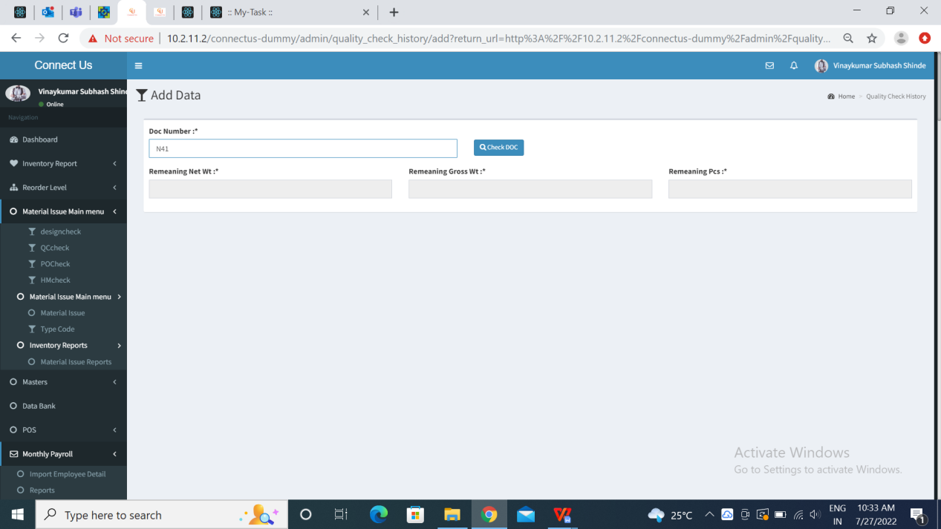

Fig: Add Data (1)

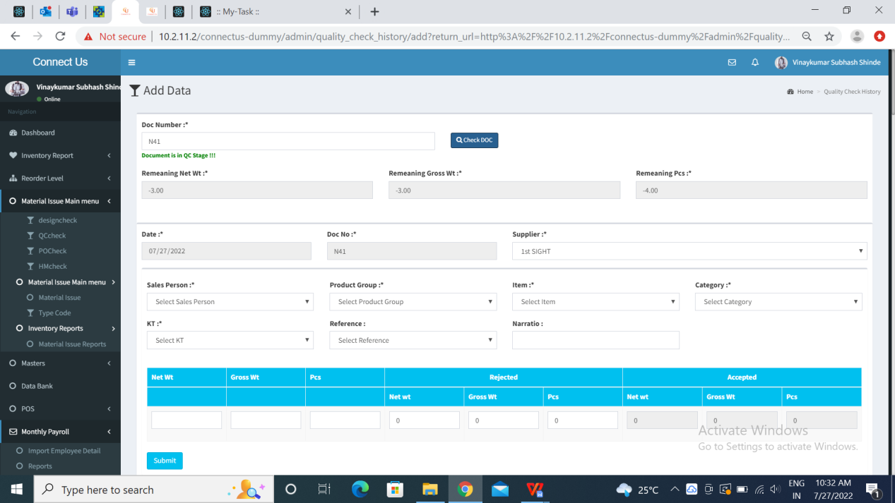

Fig: Add Data (2)

* Add New Entry
* Date
* Doc number
* Challan number
* Supplier
* Sales person
* Product Group
* Item
* Category
* Kt
* Net wt
* Gross wt
* Pcs
* Rejected - Net wt, Gross wt, Pcs
* Accepted - Net wt, Gross wt, Pcs
* Reference
* Narration
* Action

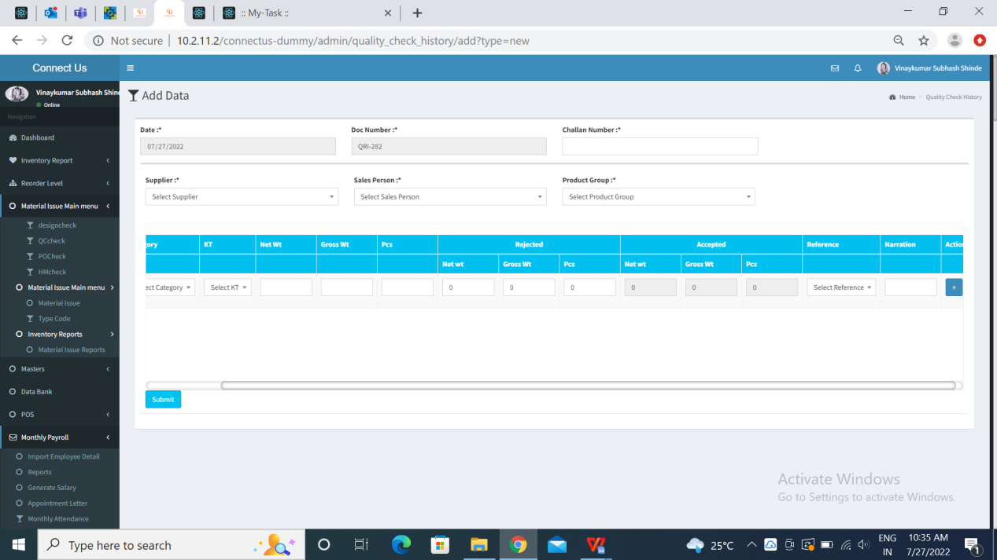

Fig: Add New Entry

* Export

The added data is displayed on Quality Checking History (Grid). The user can search desired data by filtering it and this filtered data can be exported in csv/excel format. Following are the fields in csv/excel:

* Doc Date
* Doc No
* Product Group
* Supplier
* Item Name
* Category
* Kt
* Total Gross wt
* Total Net wt
* Total Pcs
* Rejected Gross wt
* Rejected Net wt
* Rejected Pcs
* Accepted Gross wt
* Accepted Net wt
* Accepted Pcs
* Reference
* Updated At
* Action

Action consists of the following fields to all the users:

* History
* Cancel
* Restore
* Detail
* Edit
* Delete

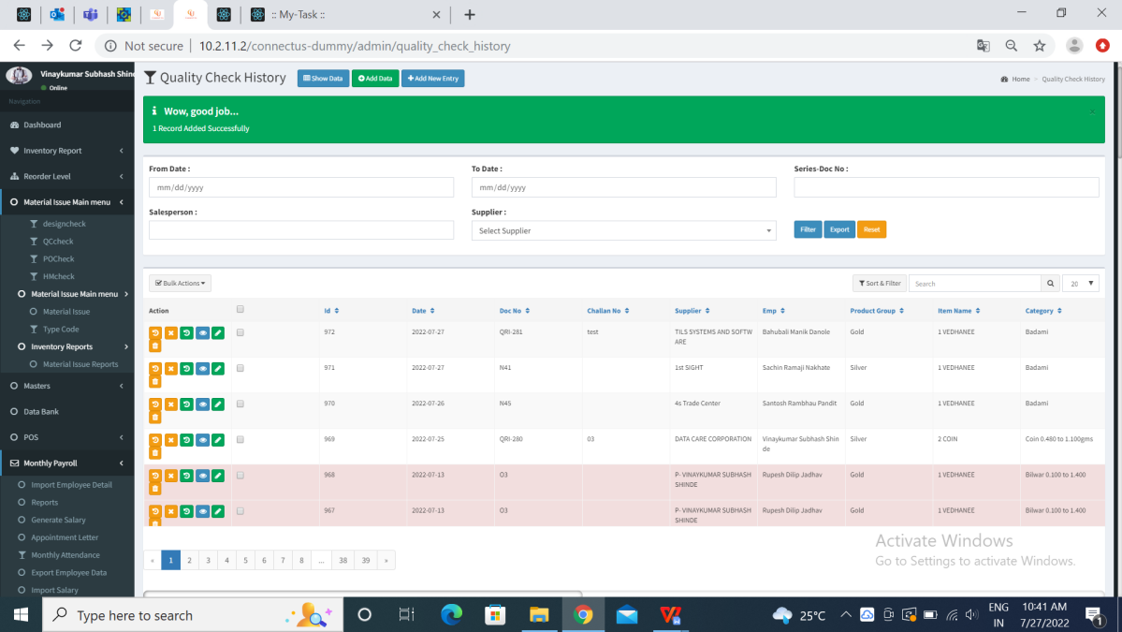

Fig: Action

**Proposed system**

* Create “Reason Type” as new column in Add data.
* Create “Reason Type” as new column in Add new entry.
* Mention list of material issues under drop-down of Reason Type.
* Exported data should have all the columns in report, in same sequence as it shows on Quality Check History (Grid).
* Provision of restore and cancel button based on authority.
* **Add data**

Quality Check History -> Add Data

Once the user clicks on Add Data in Quality Check History, user is directed to add data page. Add data consists of following fields:

* Doc Number
* Remaining Net Wt
* Remaining Gross wt
* Remaining Pcs

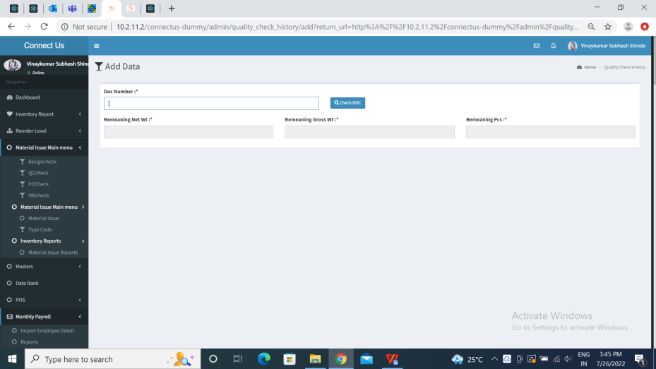

After entering Doc number, the system directs the user to the following fields:

* Date
* Doc Number
* Supplier
* Sales person
* Product Group
* Item
* Category
* Kt
* Reference
* Net wt
* Gross wt
* Pcs
* Rejected Net wt
* Rejected Gross wt
* Rejected Pcs
* Accepted Net wt
* Accepted Gross wt
* Accepted Pcs
* Reason Type - **NEW**
* Narration - **NEW**

All the other fields, apart from Reason Type & Narration, remains the same as in existing module.

|  |  |  |  |
| --- | --- | --- | --- |
| **FIELDS** | **INPUT TYPE** | **MANDATORY/ OPTIONAL** | **DESCRIPTION** |
| Reason Type | Drop-down | Mandatory | The user can manually select the reason i.e. type code of material issue namely design, QC, PO or HM through drop-down.  Connect Us-> Material issue main menu-> Type Code (active) |
| Narration | Text | Optional | User will enter additional comments in narration if needed.  Existing module had Narration field beside Reference field and above the table. However, in proposed module provide Narration field in beside Reason Type field in the table. |

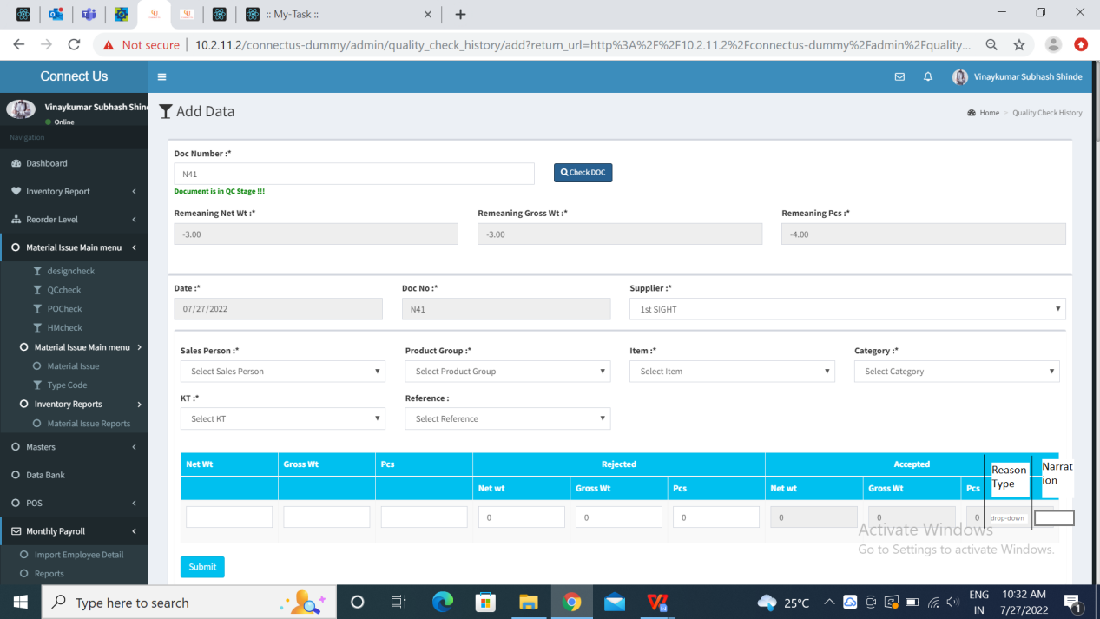

Fig: Add Data (Proposed system)

Once the data is added, all the details should be displayed on Quality Check History (Grid).

* **Add New Entry**

Quality Check History-> Add New Entry

Add New entry should have following fields:

* Date
* Doc number
* Challan number
* Supplier
* Sales person
* Product Group
* Item
* Category
* Kt
* Net wt
* Gross wt
* Pcs
* Rejected Net wt
* Rejecetd Gross wt
* Rejecetd Pcs
* Accepted Net wt
* Accepted Gross wt
* Accepted Pcs
* Reference
* Reason Type - **NEW**
* Narration
* Action

All the other fields, apart from Reason Type, remains the same as in existing module.

|  |  |  |  |
| --- | --- | --- | --- |
| **FIELDS** | **INPUT TYPE** | **MANDATORY/ OPTIONAL** | **DESCRIPTION** |
| Reason Type | Drop-down | Mandatory | The user can manually select the reason i.e. type code of material issue namely design, QC, PO or HM through drop-down.  Connect Us-> Material issue main menu-> Type Code (active) |

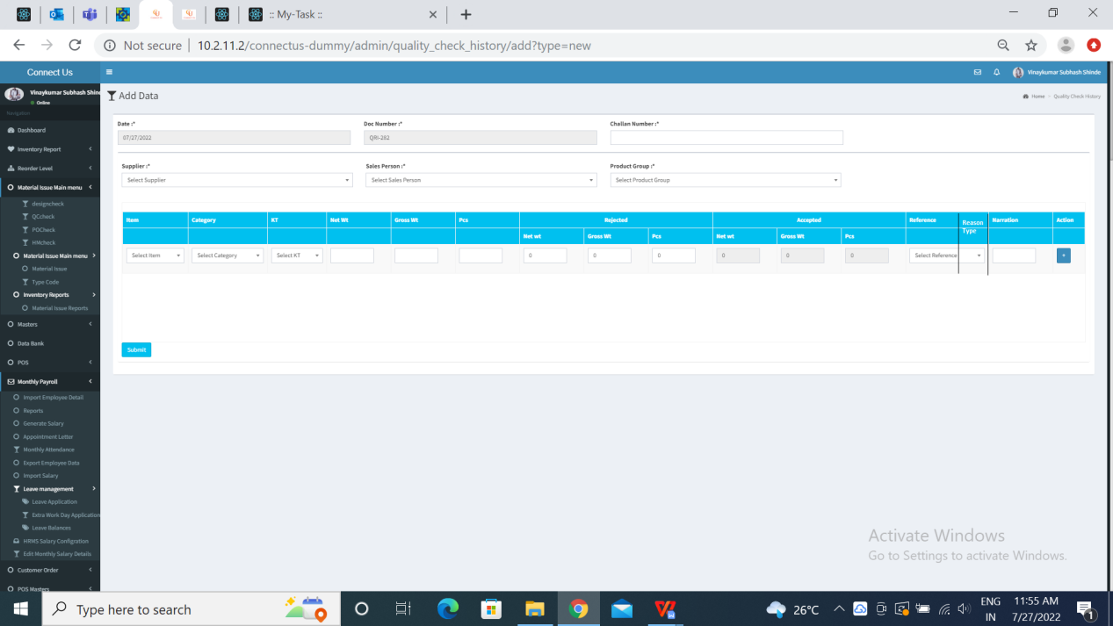

Fig: Add New Entry (Proposed system)

Once the data is added, it will be displayed on Quality Checking History (Grid). The Grid have following fields:

* Actions
* Selection
* ID
* Date
* Doc number
* Challan Number
* Supplier
* Employee name
* Product Group
* Item name
* Category
* Kt
* Total Net wt
* Total Gross wt
* Total Pcs
* Rejected Net wt
* Rejected Gross wt
* Rejected Pcs
* Accepted Net wt
* Accepted Gross wt
* Accepted Pcs
* Reason Type
* Narration
* Reference
* Is cancel

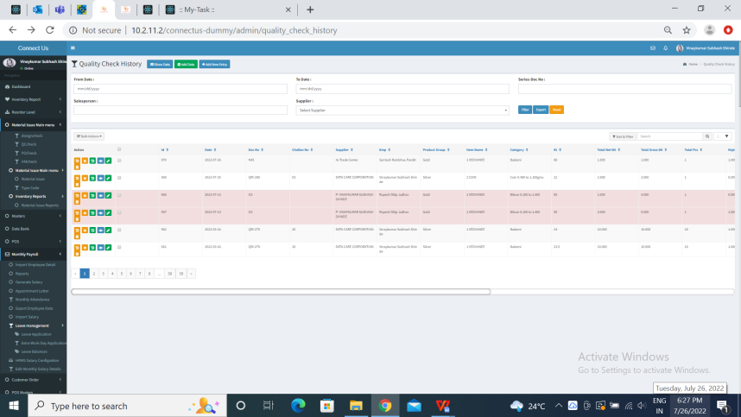

* **Export**

Quality Check History-> Export

Whenever user exports desired data, the data should be exported in the same sequence of columns in csv/excel format as it is displayed on Quality Check History (Grid). The exported report should have all the following fields:

* Sr No.
* Date
* Doc number
* Challan Number
* Supplier
* Employee name
* Product Group
* Item name
* Category
* Kt
* Total Net wt
* Total Gross wt
* Total Pcs
* Rejected Net wt
* Rejected Gross wt
* Rejected Pcs
* Accepted Net wt
* Accepted Gross wt
* Accepted Pcs
* Reason Type
* Narration
* Reference
* Is cancel
* **Action**

Quality Check History-> Action

The action field consists of the following fields:

* History
* Cancel - **NEW UPDATE**
* Restore - **NEW UPDATE**
* Detail
* Edit
* Delete

|  |  |
| --- | --- |
| **FIELDS** | **DESCRIPTION** |
| Restore | User can restore canceled data. Restore action should be provided to user based on authority only. Create Login special authority.  Connect Us-> Bill Checking-> Bill Checking Masters-> Login Special Auth Mapping-> Add Data |
| Cancel | User can edit his already added data. Restore action should be provided to user based on authority. Create Login special authority.  Connect Us-> Bill Checking-> Bill Checking Masters-> Login Special Auth Mapping-> Add Data |

**References of the users**

|  |  |  |  |
| --- | --- | --- | --- |
| **User** | **Name** | **Mail** | **Contact number** |
| **Actual user** | Tushar Nikam | itinv@csjewellers.com | 2607 |
| **Ticket created by (if any)** | Tushar Nikam | itinv@csjewellers.com | 2607 |
| **Assigned business analyst** | Manali Bhadirage | manali.bhadirage@techneai.com | 2964 |
| **Assigned developer** | Prathamesh Shinde | prathamesh.shinde@techneai.com |  |
| **Assigned tester** | Priyanka Dupargude | Priyanka.dupargude@techneai.com | 2964 |