|  |  |
| --- | --- |
| **Ticket ID** | TT3607 |
| **Ticket description** | Quality Check History Madhe New Changes Karne 1) Add data and Add new entry Madhe Entry Kartana New Narration Coloam Add Karne Reason Type Ya Navane Add Karne V Tya Madhe material Issue Madhil Design qc po hm Madhil All Type Show Jhale Pahijet and (Material Issue Design Check narration Pramane ) 2) line Item La aslele All Coloum Excel La export Jhale Pahijet Sr Number Pasun Cancel Status Paryant 3) Restore and cancel Batan Authority Basis Varti Karun Dene |
| **Created by** | Manali Bhadirage |
| **Created on** | 26/07/2022 |
| **Priority** | Very high |
| **Version** | 1.0 |

**Introduction**

The purpose of the Quality Check History in Connect Us is to enable users to add details of the accepted items and rejected items from particular Lot they will be checking. Also, user can view the history and export desired report with all the details of each item.

**Business requirement**

Quality Check History Madhe New Changes Karne 1) Add data and Add new entry Madhe Entry Kartana New Narration Coloam Add Karne Reason Type Ya Navane Add Karne V Tya Madhe material Issue Madhil Design qc po hm Madhil All Type Show Jhale Pahijet and (Material Issue Design Check narration Pramane ) 2) line Item La aslele All Coloum Excel La export Jhale Pahijet Sr Number Pasun Cancel Status Paryant 3) Restore and cancel Batan Authority Basis Varti Karun Dene

**Proposed system**

In Connect us-> Quality Check History, we have made below changes as per user requirement.

1. **In Quality Check History -> Add data, we have added “Reason” and “Narration” columns.**

Documents which are in QC stage are added through Add data.

Once user clicks on “Add data” and enters document number, following fields will be displayed:

* Date
* Doc Number
* Supplier
* Sales person
* Product Group
* Item
* Category
* Kt
* Reference
* Net wt
* Gross wt
* Pcs
* Rejected Net wt
* Rejected Gross wt
* Rejected Pcs
* Accepted Net wt - Appears auto calculated by system once rejected Net wt is filled.
* Accepted Gross wt - Appears auto calculated by system once rejected Gross wt is filled.
* Accepted Pcs - Appears auto calculated by system once rejected pcs is filled.
* Reason
* Narration
* Submit

Reason includes material issue type code. Type codes in the Reason field will be display the active type codes in material issue main menu-> Type code. User can select multiple type codes in Reason.

Whereas, Narration accepts alphanumeric value and it is not mandatory field.

Once the added data is submitted, it will be displayed in quality check history grid.

On edit action, user will get the same fields as in “Add data” and can edit it and submit.

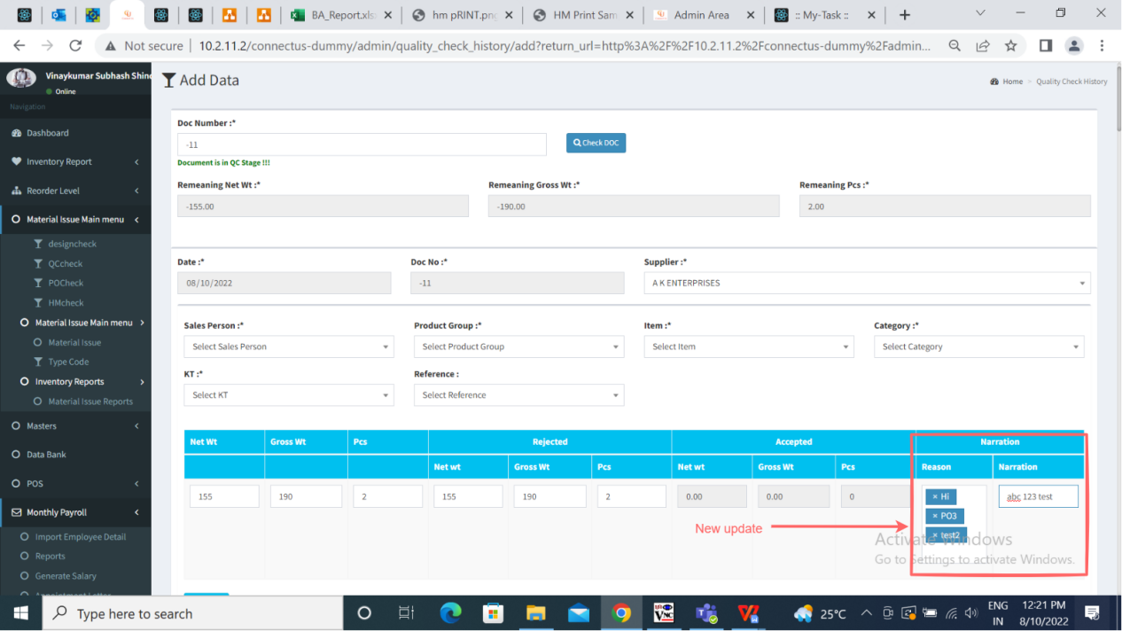

Fig: Quality Check History - Add Data

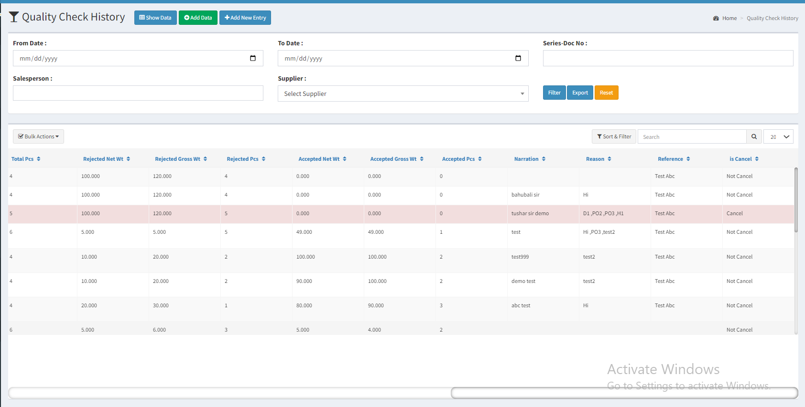

Fig: Quality Check history Grid

1. **In Quality Check History -> Add data, we have added “Reason” and “Narration” columns.**

Documents which are in design check, PO check and hm check stage, will be added through “Add new entry”.

Once the user clicks on Add New entry, following fields will be displayed:

* Date
* Doc number
* Challan number
* Supplier
* Sales person
* Product Group
* Item
* Category
* Kt
* Net wt
* Gross wt
* Pcs
* Rejected Net wt
* Rejecetd Gross wt
* Rejecetd Pcs
* Accepted Net wt - Appears auto calculated by system once rejected Net wt is filled.
* Accepted Gross wt - Appears auto calculated by system once rejected Gross wt is filled.
* Accepted Pcs - Appears auto calculated by system once rejected pcs is filled.
* Reference
* Reason
* Narration
* Submit

Reason includes material issue type code. Type codes in the Reason field will be display the active type codes in material issue main menu-> Type code. User can select multiple type codes in Reason.

Whereas, Narration accepts alphanumeric value and is not mandatory field.

Once the added fields in add new entry are submitted, it will be displayed in quality check history grid.

If user wants to edit his entry, then from “edit action”, user will get the same fields as in Add New entry and can edit it and submit.

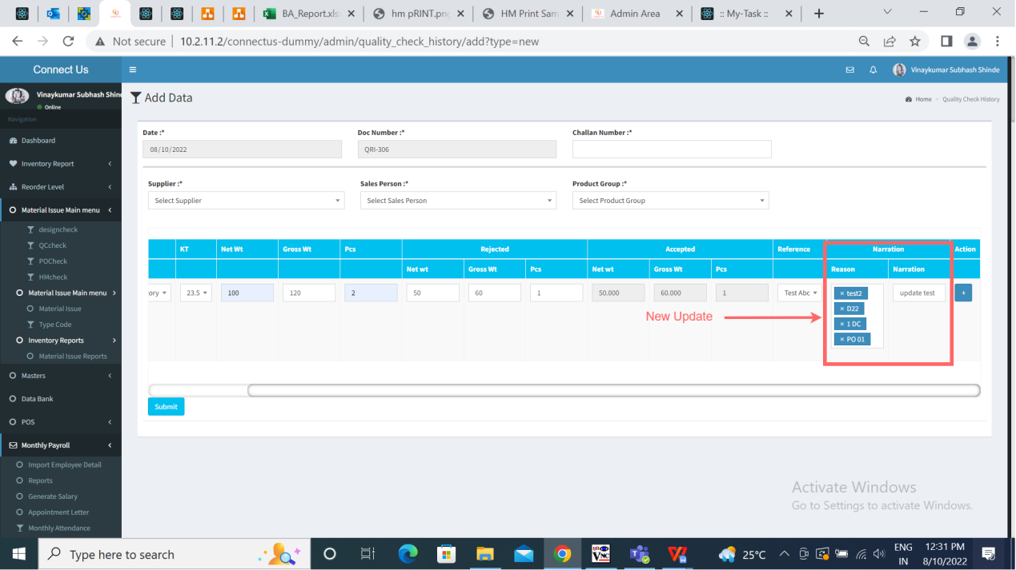

Fig: Quality Check History - Add New entry

1. **Restore and Cancel button will be provided based on authority.**

The action field consists of the following fields:

* History
* Cancel
* Restore
* Detail
* Edit
* Delete

History, Detail, Edit and Delete actions are available for all. Cancel and Restore actions will be provided based on authority now.

Cancel

Admin/Super-admin can enable provision of “cancel action” to user from Bill checking-> Bill checking masters-> Login special auth mapping -> Add data -> choose user name -> select special auth as “Cancel_quality_check_history” -> Set deadline -> Save

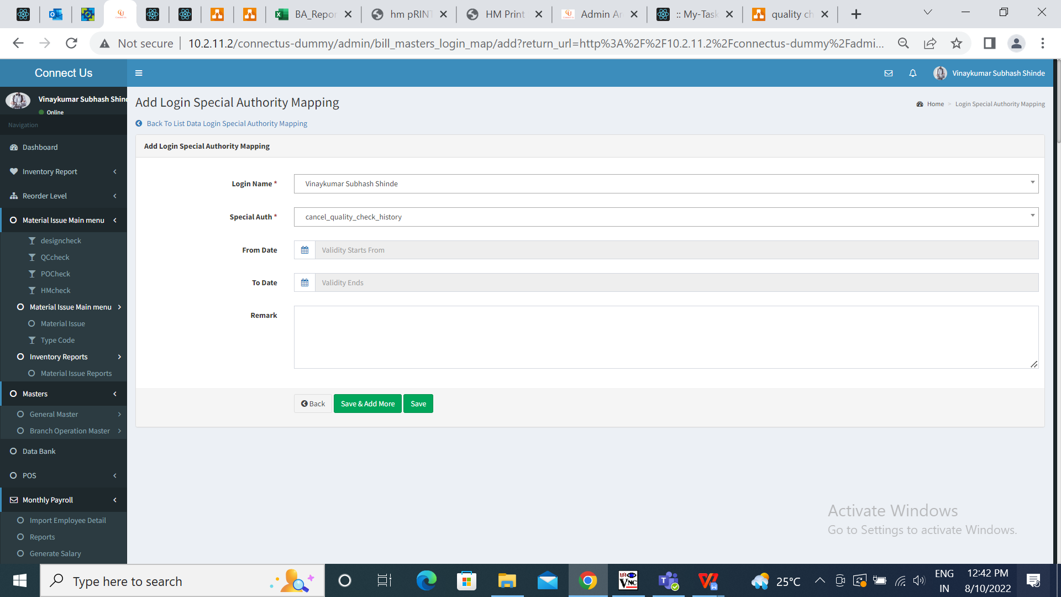

Fig: Login special auth - Cancel quality check history

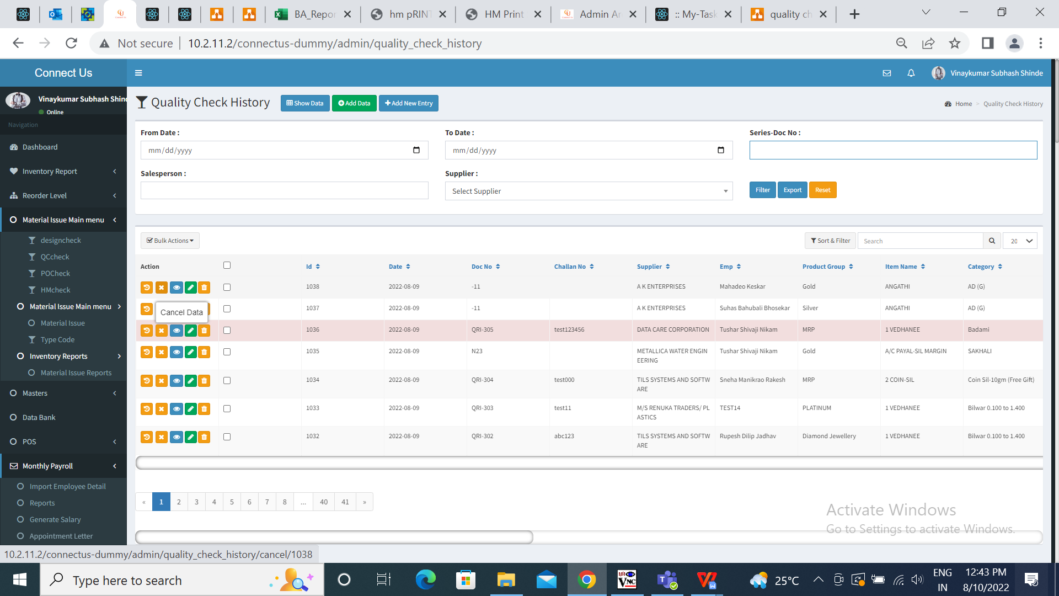

Fig: Cancel action enabled

Restore

Admin can enable provision of “restore action” to user from Bill checking-> Bill checking masters-> Login special auth mapping -> Add data -> choose user name -> select “restore_quality_check_history” under special auth -> Set deadline -> Save

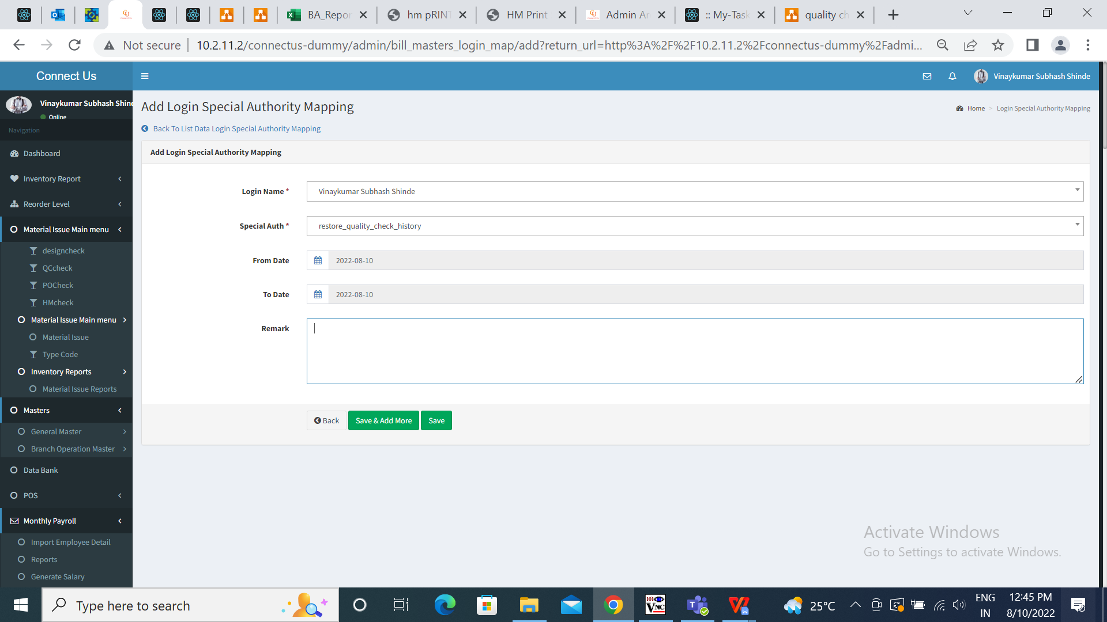

Fig: Login special auth - Restore quality check history

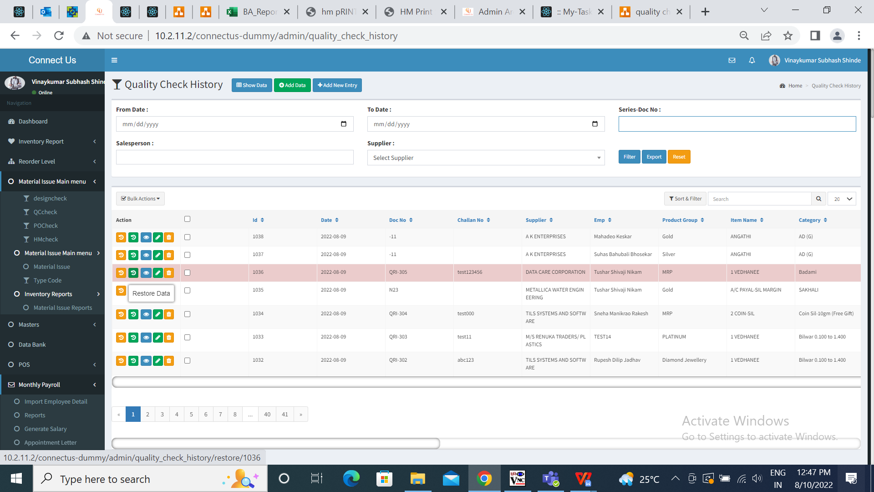

Fig: Restore action enabled

If admin/super-admin wants to enable Cancel and Restore both the actions to user, then admin will have to add both the special auth : Cancel_quality_check_history and restore_quality_check_history for that user.

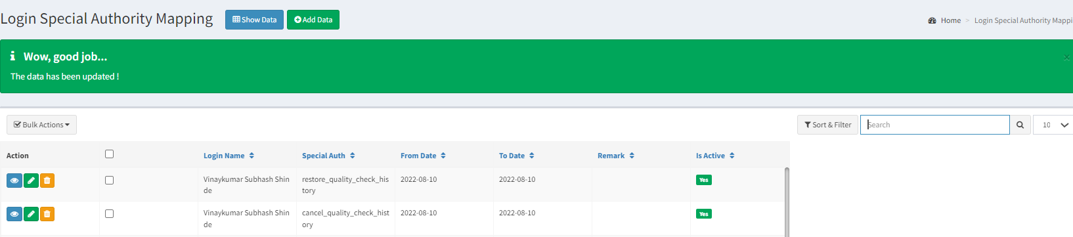

Fig: Cancel and Restore both enabled

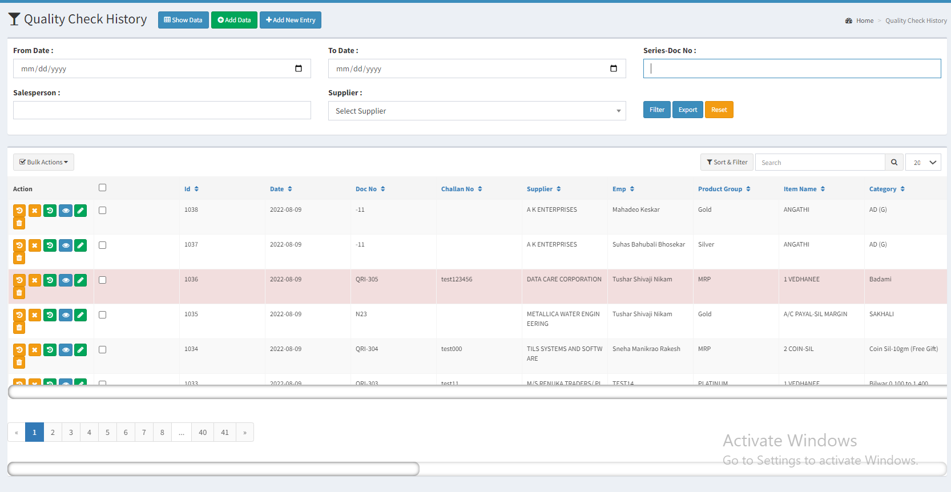

Fig: Cancel and Restore both enabled

1. **Exported sheet will display all the columns as in grid and in the same sequence.**

Once user exports data from Quality Check History, then exported csv sheet will display all the columns in the same sequence as in grid. Following are the fields of sheet:

* ID
* Doc Date
* Doc no
* Challan no
* Supplier
* Empl
* Product Group
* Item name
* Category
* Kt
* Total Net wt
* Total Gross wt
* Total Pcs
* Rejected Net wt
* Rejected Gross wt
* Rejected Pcs
* Accepted Net wt
* Accepted Gross wt
* Accepted Pcs
* Narration
* Reason
* Reference
* Is cancel



Fig: Export sheet

**References of the users**

|  |  |  |  |
| --- | --- | --- | --- |
| **User** | **Name** | **Mail** | **Contact number** |
| **Actual user** | Tushar Nikam | itinv@csjewellers.com | 2607 |
| **Ticket created by (if any)** | Tushar Nikam | itinv@csjewellers.com | 2607 |
| **Assigned business analyst** | Manali Bhadirage | manali.bhadirage@techneai.com | 2964 |
| **Assigned developer** | Prathamesh Shinde | prathamesh.shinde@techneai.com |  |
| **Assigned tester** | Priyanka Dupargude | Priyanka.dupargude@techneai.com | 2964 |