|  |  |
| --- | --- |
| **Ticket ID** | TT2641 |
| **Ticket description** | Implimentation of QR code for each inventorry item of IT |
| **Created by** | Pradeep Wagh |
| **Created on** | 02/06/2022 |
| **Priority** | Very High |
| **Version** | 3 |

**Version**

|  |  |  |  |  |
| --- | --- | --- | --- | --- |
| **Sr. No** | **Version no** | **Version Date** | **User name** | **User department** |
| 1 | 1 | 06.06.2022 | Pradeep Wagh | Hardware and Networking |
| 2 | 2 | 29.06.2022 | Pradeep wagh | Hardware and Networking |
| 3 | 3 | 05.07.2022 | Pradeep Wagh | Hardware and Networking |

**Approvals**

|  |  |  |
| --- | --- | --- |
| **Field** | **Name of the User** | **Approved date by the user** |
| **Actual User Name** | Pradeep Wagh | 02/06/2022 |
| **Actual User Department** | Pradeep Wagh |  |
| **Organization Name** | Techneai Pvt Ltd |  |
| **Sign-off** |  |  |
| **Assigned BA** | Mounika KrishnaVeni Annamneedi | 06.06.2022 |
| **Assigned Developer** |  |  |
| **Assigned Tester** |  |  |

**Estimation**

|  |  |  |  |  |
| --- | --- | --- | --- | --- |
| **Department name** | **Estimated Time (In hr)** | **Scheduled Date (Starting date )** | **Estimated date** | **Actual delivery date** |
| **BA** | 4 | 06.06.2022 | 07.06.2022 |  |
|  | 4 | 29.06.2022 | 30.06.2022 |  |
|  | 1 | 05.07.2022 | 05.07.2022 |  |
| **Development** |  |  |  |  |
| **Testing** |  |  |  |  |

**Introduction**

Scanning IT devices and fetching the information from them helps the user in fetching the data easily and manages time.

**Business requirement**

The user requires the information of the IT devices when scanned.

**Existing system**

There is no existing system.

**Proposed system**

* Creation of new module “Device Management” in Connect Us
* Under device management,
  + Device master
  + Location master
  + Create device
  + Scan device
  + Report
* Device master : Creation of the device list. Consists of view,edit, export - the following are the fields
  + Device name
  + Company name
  + Remark
  + Is active
* Location master - where the location details are added. Consists of view,edit, export - the following are the fields
  + Location name
  + Remark
  + Is active
* Create device : For creating the device information and for the creation of QR code. Consists of view, edit, export. The following are the fields.
  + Device ID
    - A device ID is generated automatically, where the series start from “D_0000001”
  + Device
    - Drop down list fetched from device master (shows : “device name - company name” format)
  + Description
  + IP address
  + Host name
  + Serial number
  + Branch
    - Branch drop down consists of all the branches name and all option fetched from branch master
  + Location
    - Location drop down is fetched from location master
  + Status
    - Status drop down options are as follows.
      * New
      * In use
      * Extra stock
      * Repair
      * Scrap
      * Festival
      * Problem
      * Refilling
      * Not found
      * Sold out
  + PO Number
  + Expiry date
  + Bill date
  + Generate QR code - the system should automatically generate the QR code uniquely for each and every device.

All the added details are viewed in the table format in create device, if required, the user can export.

* Scan device - the scan device is used to scan the devices and knowing the information. The user can scan multiple devices. All the data scanned will be shown in list format until the user closes the tab or resets the tab. The following are the fields.
  + Scan device - when the device is scanned, the details are viewed in the list format. The following are the fields.
    - QR code
    - Device ID
    - Device
    - Description
    - IP address
    - Host name
    - Serial number
    - Branch
    - Location
    - Status
    - PO Number
    - Expiry date
    - Bill date
  + Scan more - Initially, when a device is scanned, from then, scan more option is shown, so that user can scan the multiple devices. When the same device is scanned, duplicate entry pop up is shown. The devices can be scanned until the tab is refreshed.
  + Export - export button to export the data.
* Reports - the reports can be generated based on the following filters. The reports can be exported if required.
  + Device
  + Status
  + Location
  + Branch

Step 1

Creation of new module “Device Management”

In connect Us -> creation of new module - Device Management.

Under, device management, following to be added.

* + Device master
  + Location master
  + Create device
  + Scan device
  + Report

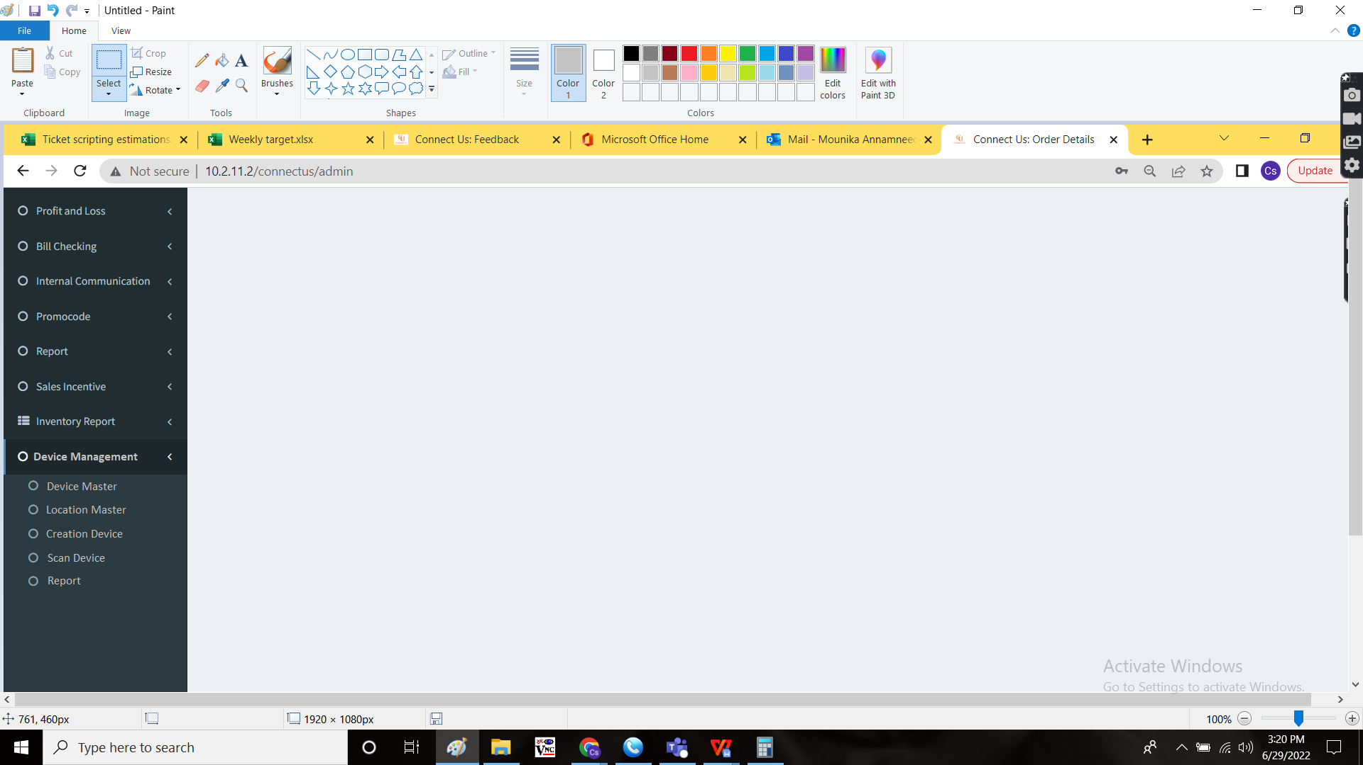

Step - 2

Device Master

In Connect Us -> In Device Management -> Device master



The device master consists of the products available as the support and assets of the company. The following are the fields in device master.

* Search bar
* Filter button
* Add data button
* Export
* Action
* Device Name
* Company Name
* Remark
* Active or De-active
* Updated by
* Updated at

|  |  |
| --- | --- |
| Field | Description |
| Search bar | To search for any particular product |
| Filter button | To filter the data |
| Add data button | To add new field |
| Export | To export the data |
| Action | The action field with view, edit and history buttons |
| Device Name | The device name is mentioned |
| Company Name | The company name is mentioned |
| Remark | The remark, if any is mentioned |
| Active or De-active | The active or de active status of the product |
| Updated by | The last updated person |
| Updated at | The last updated time |

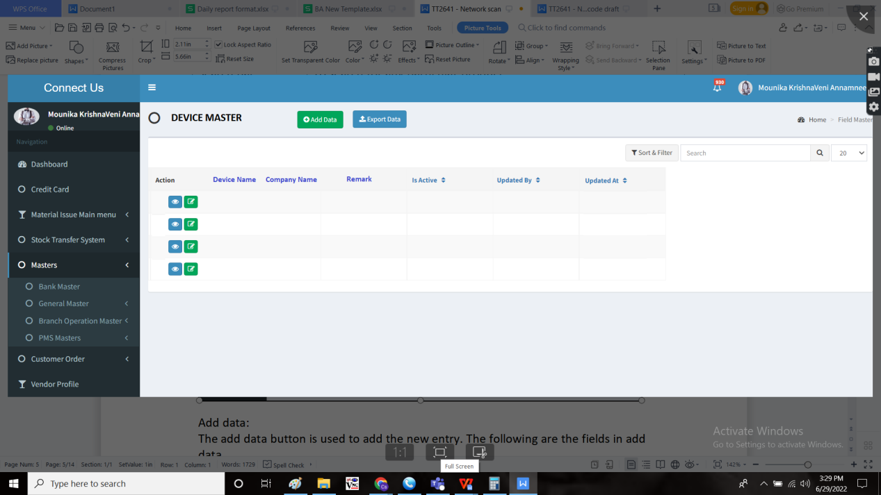

Add data:

The add data button is used to add the new entry. The following are the fields in add data.

* Device Name
* Company Name
* Active or de active
* Remark
* Add
* Cancel

|  |  |  |  |
| --- | --- | --- | --- |
| **FIELDS** | **INPUT TYPE** | **MANDATORY/ OPTIONAL** | **DESCRIPTION** |
| Device Name | Text | Mandatory | The device name is mentioned |
| Company Name | Text | Mandatory | The company name is mentioned |
| Remark | Text | Optional | The remark if any |
| Active or de active | Radio button | Mandatory | The radio button to get the status whether the product is in active or not |
| Back | Button | Optional | To navigate to the back page |
| Save and add more | Button | Optional | To save the existing data and add more |
| Save | Button | Optional | To save the existing data |

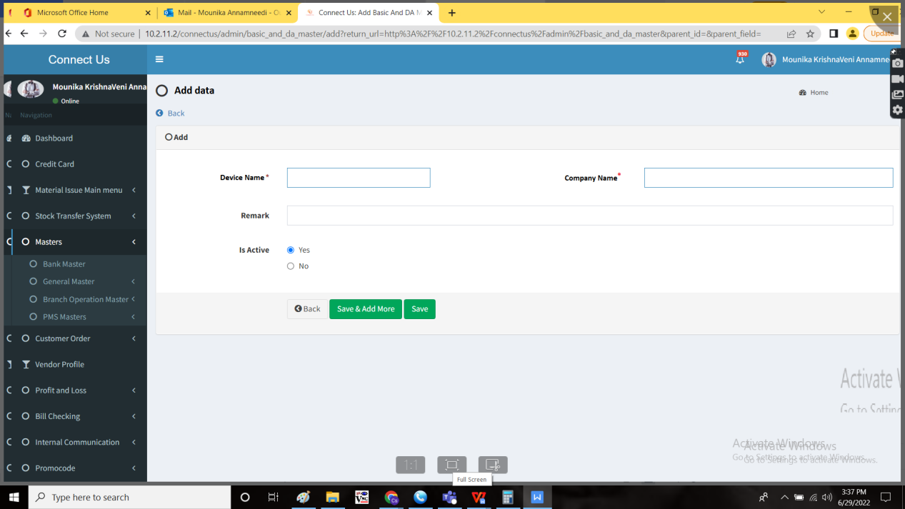

View page:

The following are the fields in view page.

* Device Name
* Company Name
* Remark
* Is active
* Back button

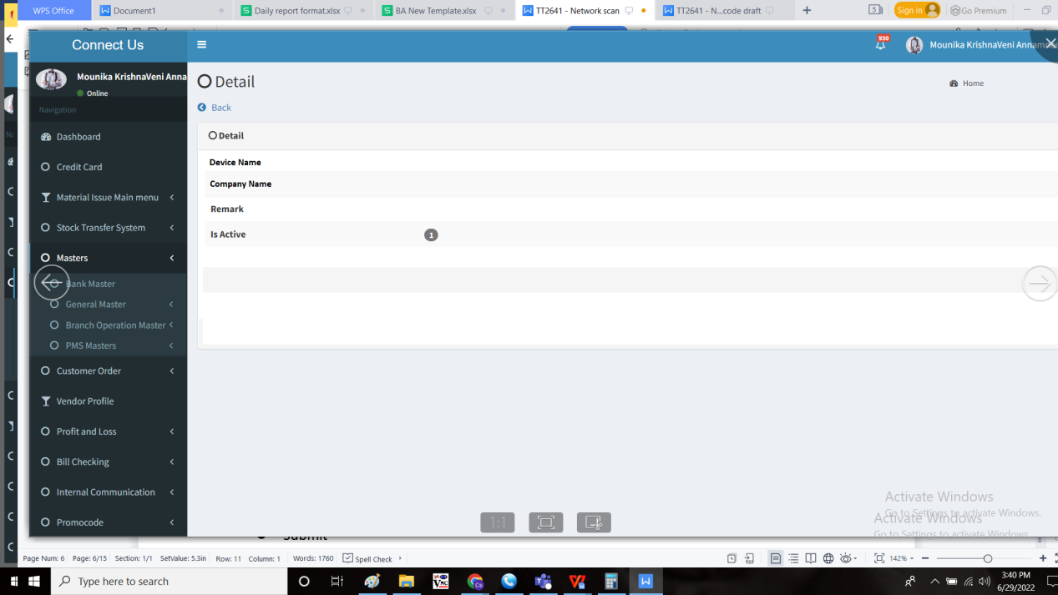

Edit data:

The following are the fields in edit data and all the fields can be edited.

* Device Name
* Company Name
* Remark
* Active or de-active
* Submit
* Cancel

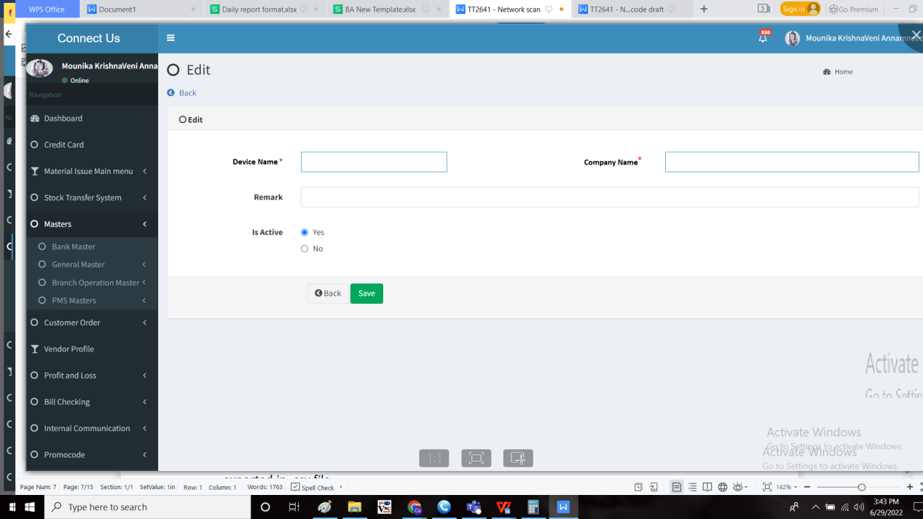

Export:

The export button is used to export the data. The following are the fields are to be exported in .csv file.

* S.No
* Device Name
* Company Name
* Remark
* Is active
* Updated by
* Updated at

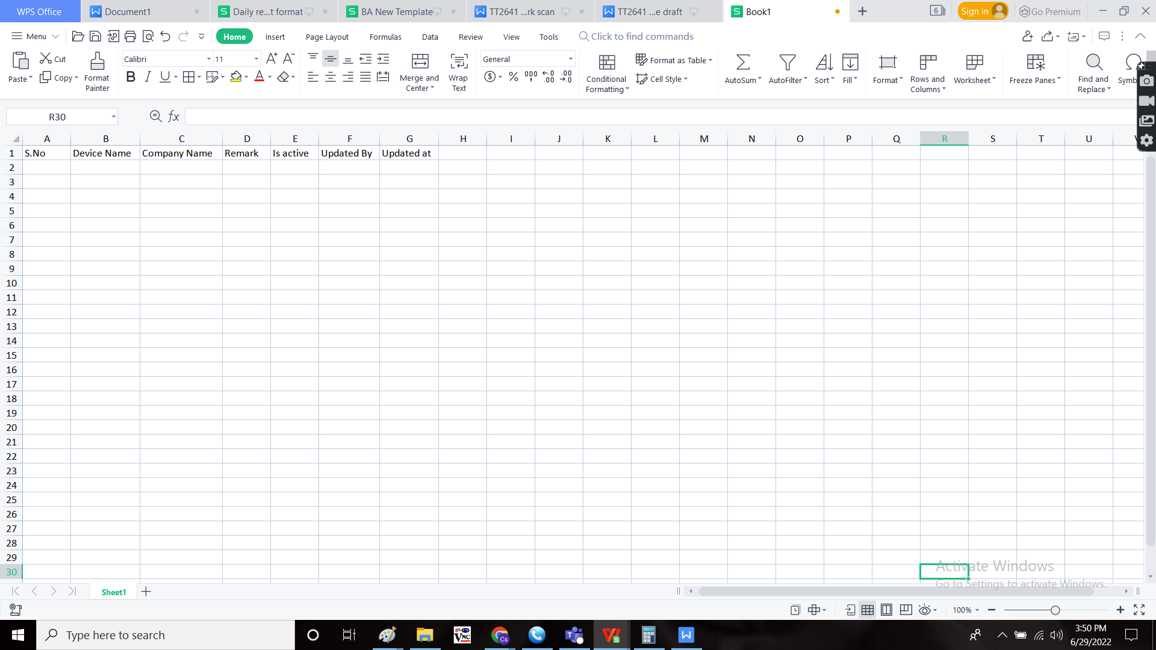

Step - 3

Creation of “Location Master”

In Connect Us -> Device Management -> Location Master



The location master consists of the location details. The following are the fields in location master.

* Search bar
* Filter button
* Add data button
* Export
* Action
* Location Name
* Remark
* Active or De-active
* Updated by
* Updated at

|  |  |
| --- | --- |
| Field | Description |
| Search bar | To search for any particular location |
| Filter button | To filter the data |
| Add data button | To add new field |
| Export | To export the data |
| Action | The action field with view, edit and history buttons |
| Location Name | The location name is mentioned |
| Remark | The remark, if any is mentioned |
| Active or De-active | The active or de active status of the product |
| Updated by | The last updated person |
| Updated at | The last updated time |

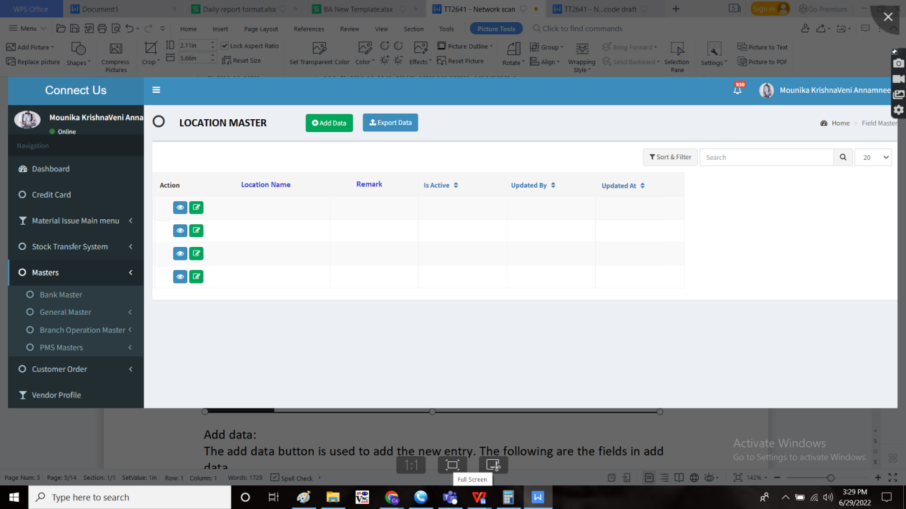

Add data:

The add data button is used to add the new entry. The following are the fields in add data.

* Location Name
* Active or de active
* Remark
* Add
* Cancel

|  |  |  |  |
| --- | --- | --- | --- |
| **FIELDS** | **INPUT TYPE** | **MANDATORY/ OPTIONAL** | **DESCRIPTION** |
| Location Name | Text | Mandatory | The Location name is mentioned |
| Remark | Text | Optional | The remark if any |
| Active or de active | Radio button | Mandatory | The radio button to get the status whether the location is in active or not |
| Back | Button | Optional | To navigate to the back page |
| Save and add more | Button | Optional | To save the existing data and add more |
| Save | Button | Optional | To save the existing data |

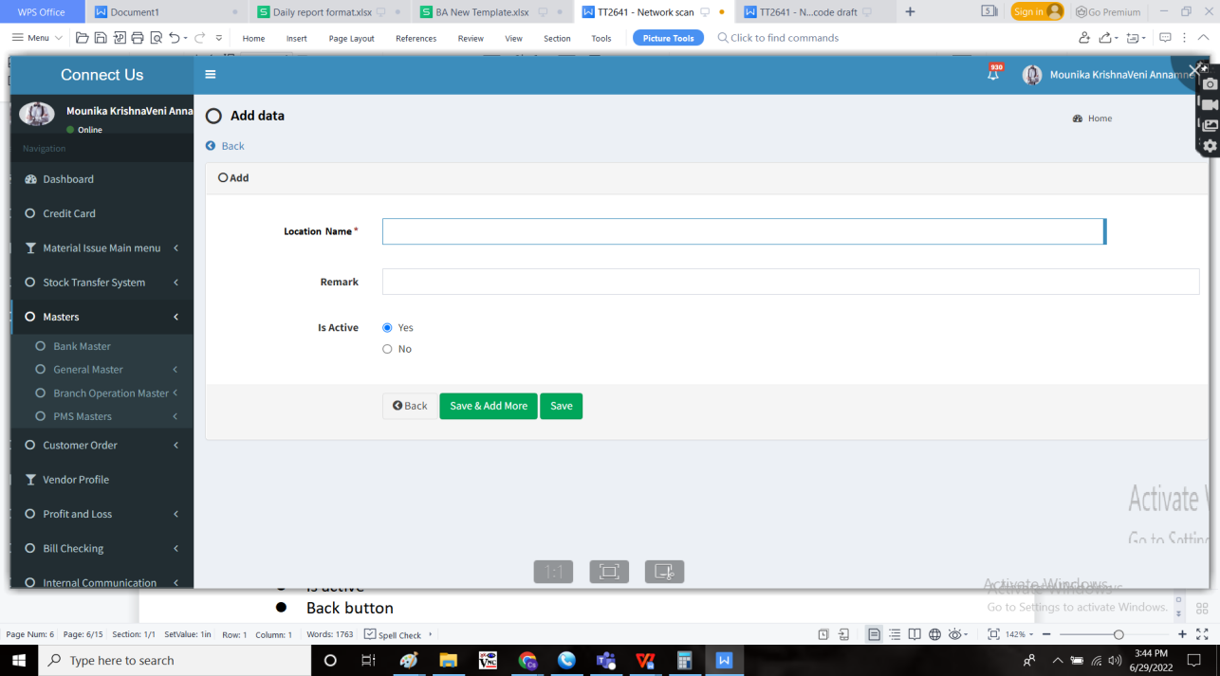

View page:

The following are the fields in view page.

* Location Name
* Remark
* Is active
* Back button

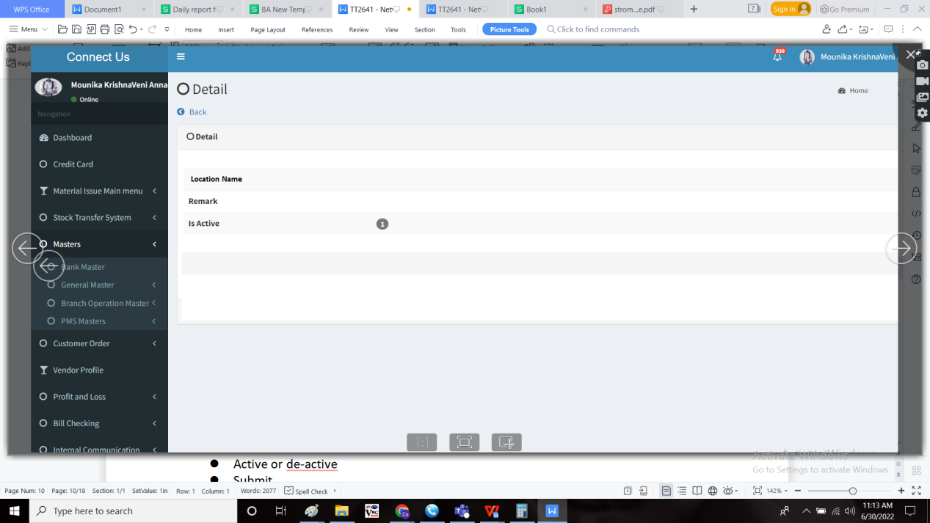

Edit data:

The following are the fields in edit data and all the fields can be edited.

* Location Name
* Remark
* Active or de-active
* Submit
* Cancel

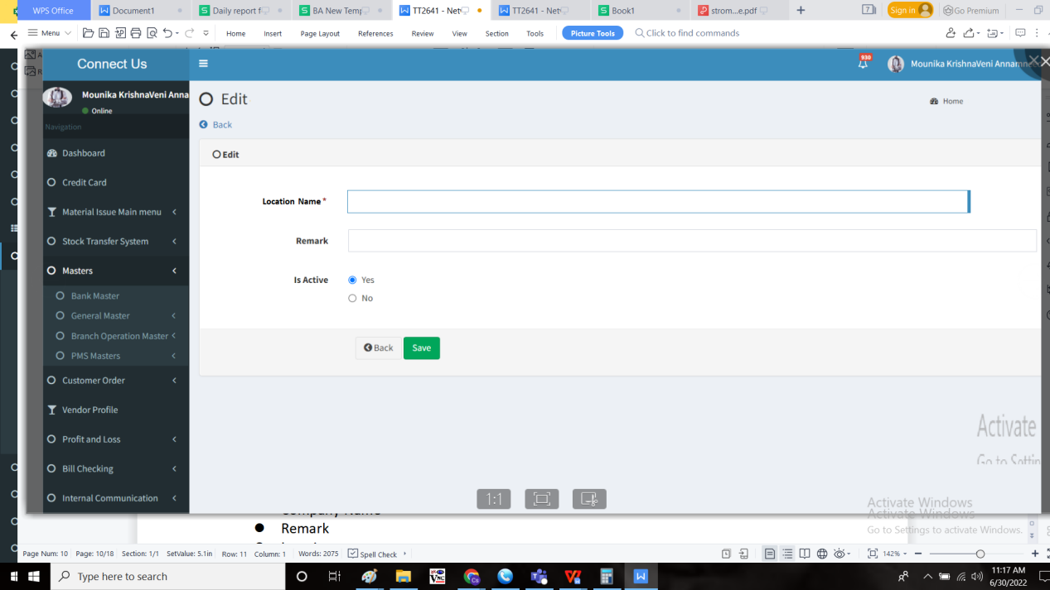

Export:

The export button is used to export the data. The following are the fields are to be exported in .csv file.

* S.No
* Location Name
* Remark
* Is active
* Updated by
* Updated at

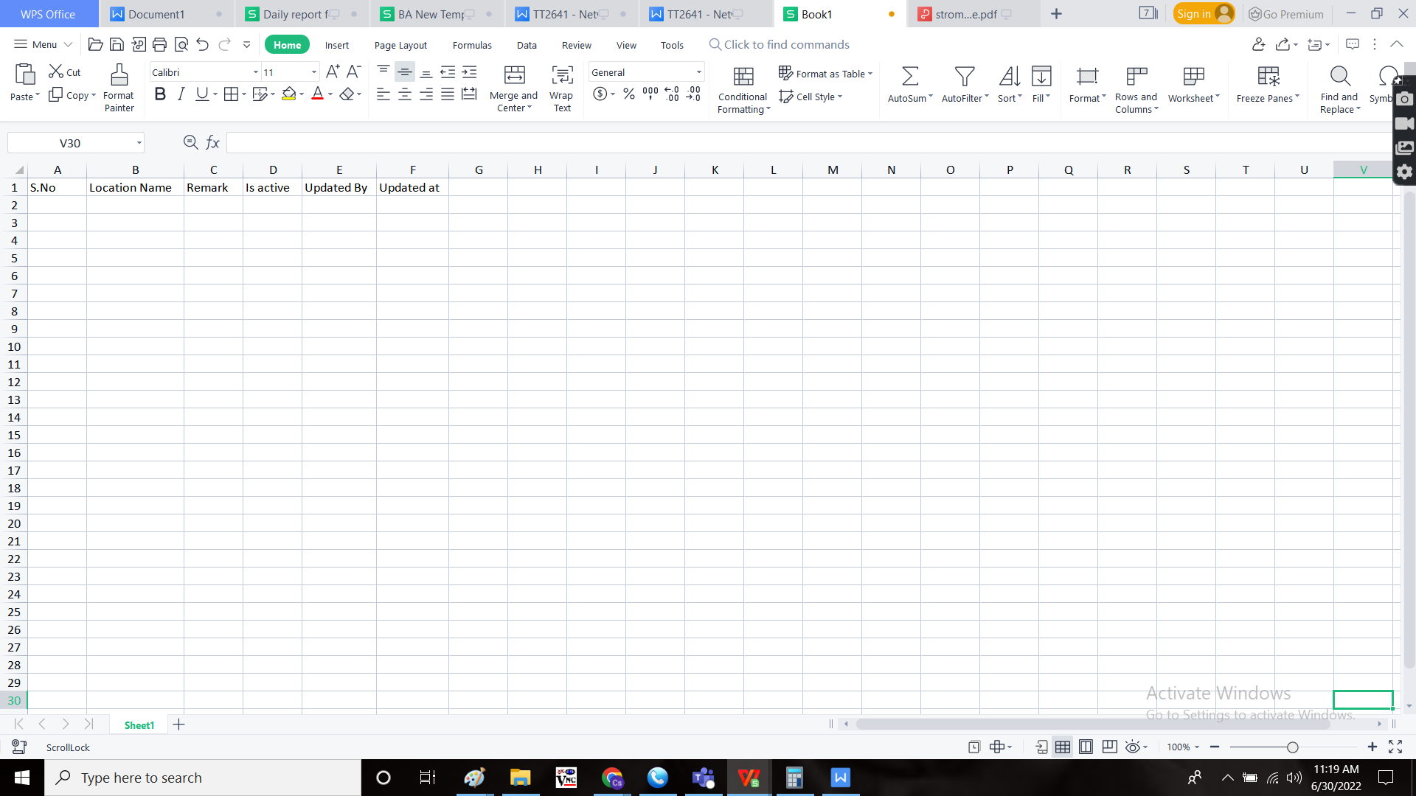

Step - 4

Creation of “create data” sub-module and provision to add data in that.

In Connect Us -> Device management -> create data

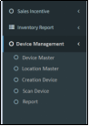

Create data

The create data menu consists of the data of the product. The following are the fields in the create data.

* Sort & Filter
* Search bar
* Add button
* Export button
* Action
* QR Code
* Device ID
* Device
* Description
* IP Address
* Host Name
* Serial Number
* Branch
* Location
* Status
* PO No.
* Expiry date
* Bill date
* Updated by
* Updated at

|  |  |
| --- | --- |
| Field | Description |
| Sort & Filter | To sort and filter the options |
| Search bar | To search for the data |
| Add button | To add new entry |
| Export button | To export the data |
| Action | The action field consists of the view and edit button |
| QR code | The QR code image of the product |
| Device ID | The Id of the product |
| Device | The product detail |
| Description | The description of the device |
| IP Address | The IP address of the device |
| Host Name | The host name is mentioned |
| Serial Number | The serial number of the device |
| Branch | The branch name where the product is existing |
| Location | The location at which the product is existing |
| Status | The status of the product |
| PO No. | The purchase order of the product |
| Expiry date | The expiry date of the device is mentioned |
| Bill date | The bill date of the device is mentioned |
| Updated by | The last updated by |
| Updated at | The last updated at |

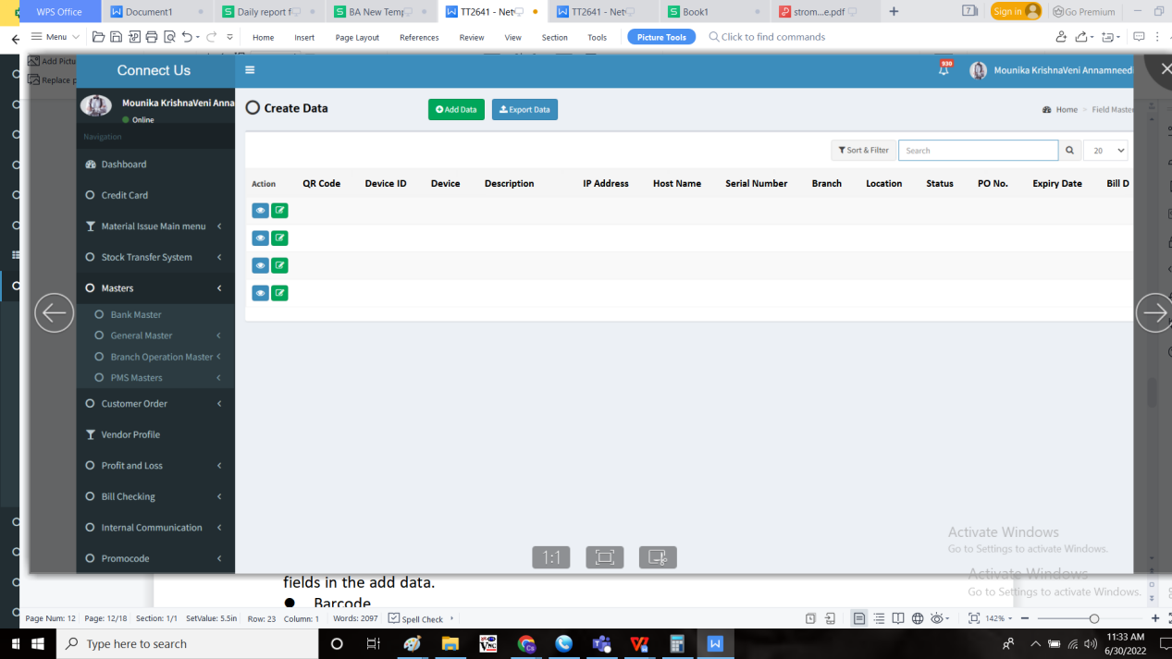

Add data:

The add data button is used to add the entries in the system. The following are the fields in the add data.

* Generate QR Code
* Add
* Device ID
* Device
* Description
* IP Address
* Host Name
* Serial Number
* Branch
* Location
* Status
* PO No.
* Expiry date
* Bill date
* Add
* cancel

|  |  |  |  |
| --- | --- | --- | --- |
| **FIELDS** | **INPUT TYPE** | **MANDATORY/ OPTIONAL** | **DESCRIPTION** |
| Generate QR Code | QR Code | Mandatory | To generate the QR code by the system. The QR code is generated by the system automatically. |
| Add | Button | Optional | To add the data under the QR code |
| Device ID | Auto | Mandatory | The ID for the product is generated automatically by the system. The series starts from “D_0000001” |
| Device | Drop down | Mandatory | The device I.e., product details is selected from the drop down. The drop down list fetched from device master. The date to be shown as follows “device name - company name” format. |
| Description | Text | Mandatory | The description of the product. |
| IP Address | Text | Mandatory | The IP address of the product. |
| Host Name | Text | Mandatory | The host name of the product is mentioned |
| Serial Number | Text | Mandatory | The serial number of the product |
| Branch | Drop down | Mandatory | The branch name where the product is existed is selected from the drop down. The drop down data is fetched from the branch master in Connect us -> masters -> general masters. |
| Location | Drop down | Mandatory | The location at which the product is existed is selected. The location drop down details are fetched from location master. |
| Status | Drop down | Mandatory | The status of the product is selected from the drop down menu. The following are the fields in the status.   * + - * New       * In use       * Extra stock       * Repair       * Scrap       * Festival       * Problem       * Refilling       * Not found       * Sold out |
| PO No. | Text | Mandatory | The purchase order number is entered |
| Expiry Date | Calender | Mandatory | The expiry date of the device is selected from the calender |
| Bill Date | Text | Mandatory | The bill date of the device is entered |
| Add | Button | Optional | The add button to add the data |
| cancel | Button | Optional | The cancel button to cancel the data |

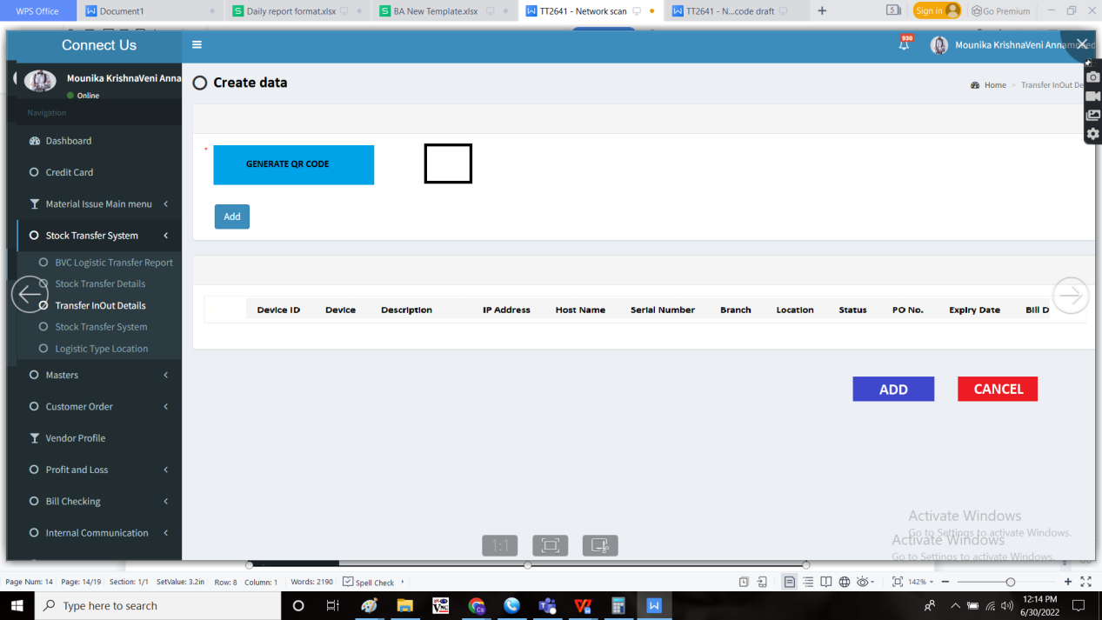

View data:

The following are the fields viewed in the view data.

* QR Code
* Device ID
* Device
* Description
* IP Address
* Host Name
* Serial Number
* Branch
* Location
* Status
* PO No.
* Expiry date
* Bill date

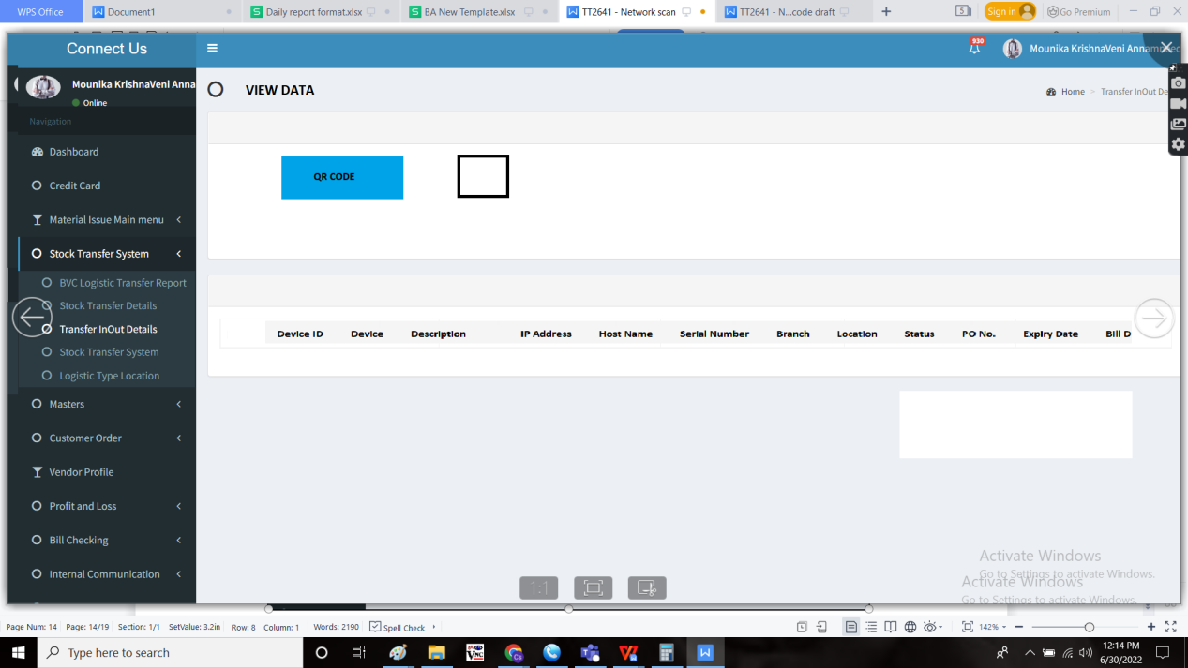

Edit data

The edit data button is used to edit the existing data. The following are the fields in the edit data and all fields can be edited.

* QR Code
* Device ID
* Device
* Description
* IP Address
* Host Name
* Serial Number
* Branch
* Location
* Status
* PO No.
* Expiry date
* Bill date
* Submit
* Cancel

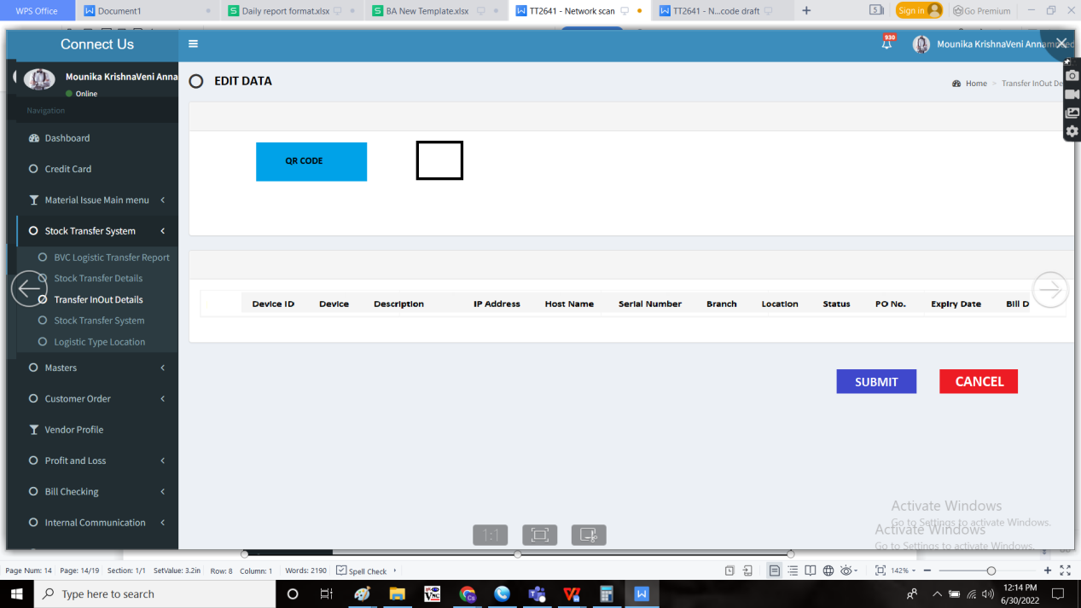

Export data:

The export button is used to export the data. The following are the fields in the export data.

* QR Code
* Device ID
* Device
* Description
* IP Address
* Host Name
* Serial Number
* Branch
* Location
* Status
* PO No.
* Expiry date
* Bill date

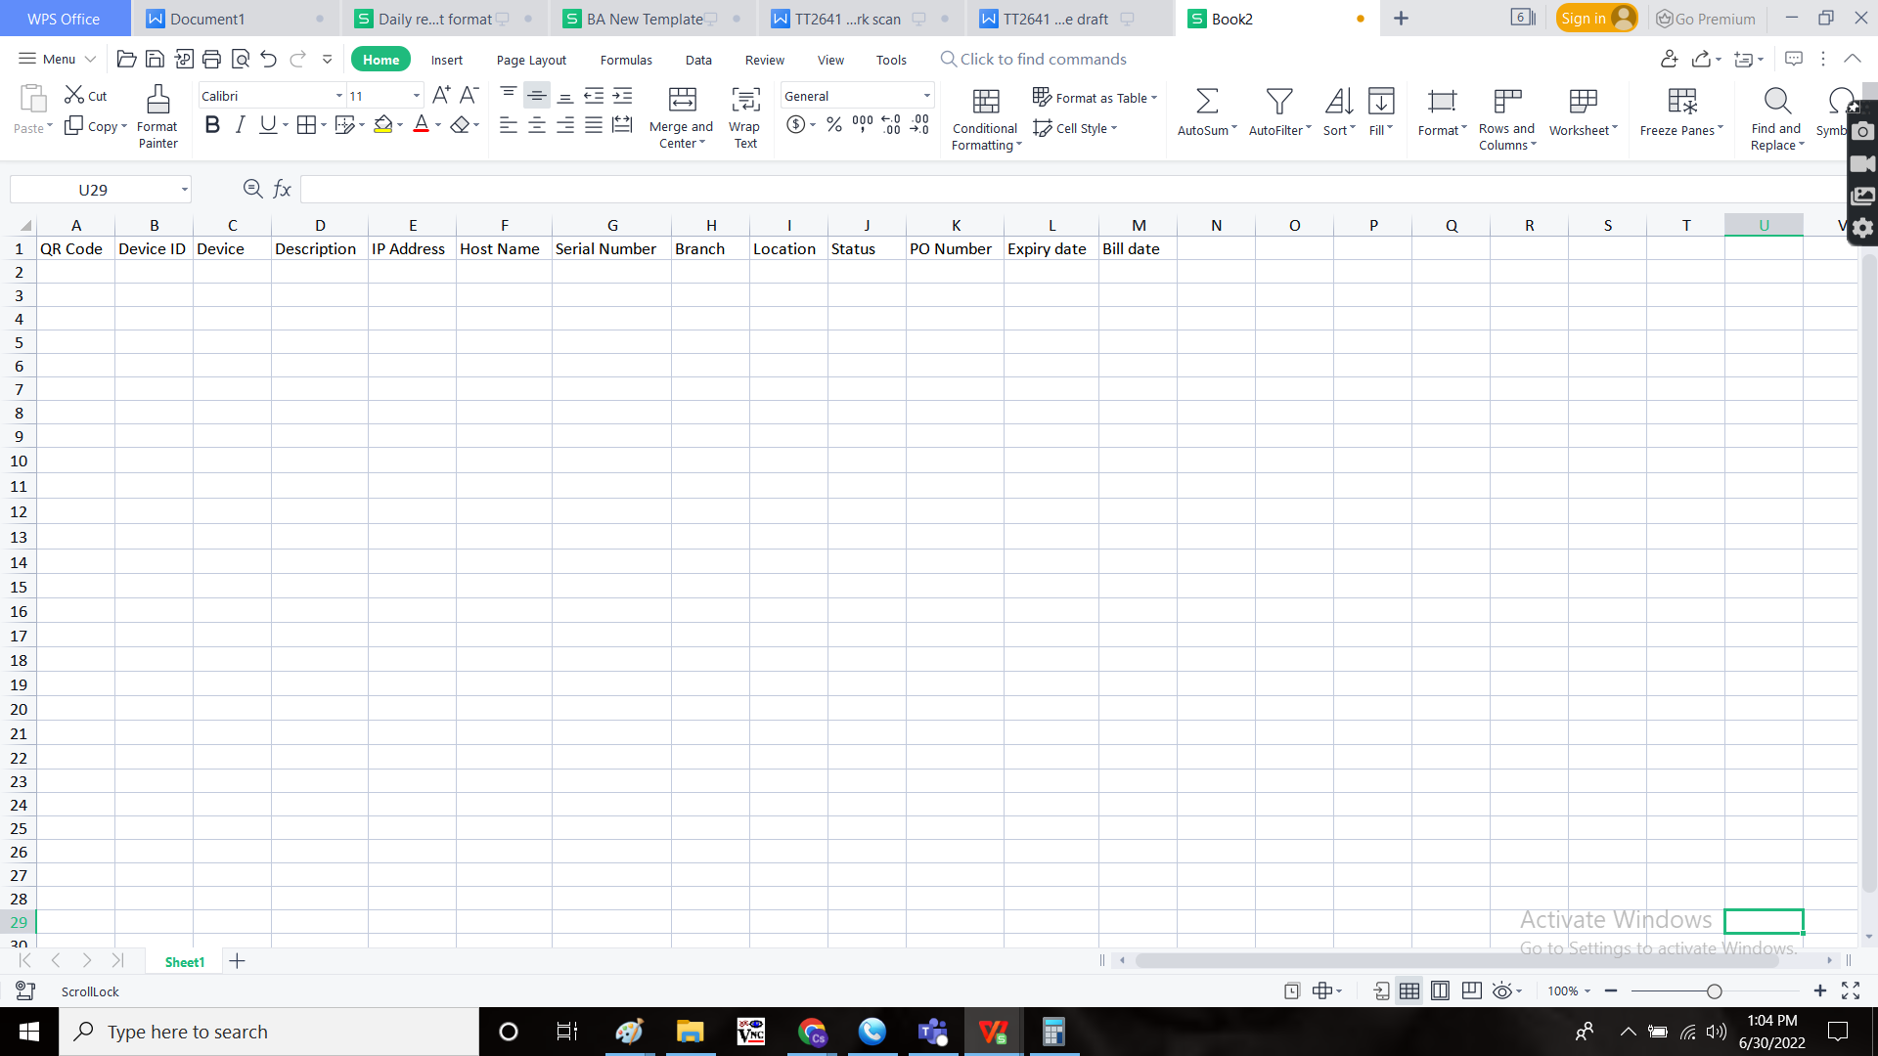

Step - 5

Creation of “scan data” sub-module, where the scan code is scanned, all data fetched.

In Connect Us -> Device Management -> Scan Device



The scan device is used to scan the devices and knowing the information. The user can scan multiple devices. All the data scanned will be shown in list format until the user closes the tab or resets the tab. The scan data is used to scan the barcode and generate the reports. The following are the fields in scan data.

* Scan QR code
* Fetch data

|  |  |  |  |
| --- | --- | --- | --- |
| **FIELDS** | **INPUT TYPE** | **MANDATORY/ OPTIONAL** | **DESCRIPTION** |
| Scan QR code | Scanner | Mandatory | The QR code is scanned, so that the data can be fetched. |
| Fetch data | Button | Optional | The button to fetch the data |

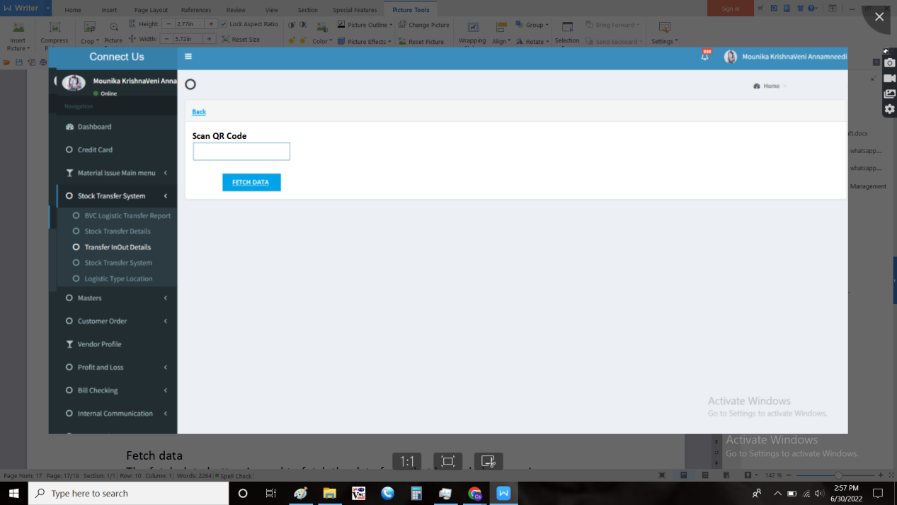

Fetch data

The fetch data button is used to fetch the data from that QR code by scanning.

The following are the fields

* Back
* Export
* Device ID
* Device
* Description
* IP Address
* Host Name
* Serial Number
* Branch
* Location
* Status
* PO No.
* Expiry date
* Bill date
* Compare

|  |  |
| --- | --- |
| Field | Description |
| Back | To navigate to back page |
| Export button | To export the data |
| Device ID | The device Id of the product |
| Device | The device name is mentioned |
| Description | The description of the device |
| IP Address | The IP address of the device |
| Host Name | The host name is mentioned |
| Serial Number | The serial number of the device |
| Branch | The branch name where the product is existing |
| Location | The location at which the product is existing |
| Status | The status of the product |
| PO No. | The purchase order of the product |
| Expiry date | The expiry date of the device is mentioned |
| Bill date | The bill date of the device is mentioned |
| Compare | To compare the data |

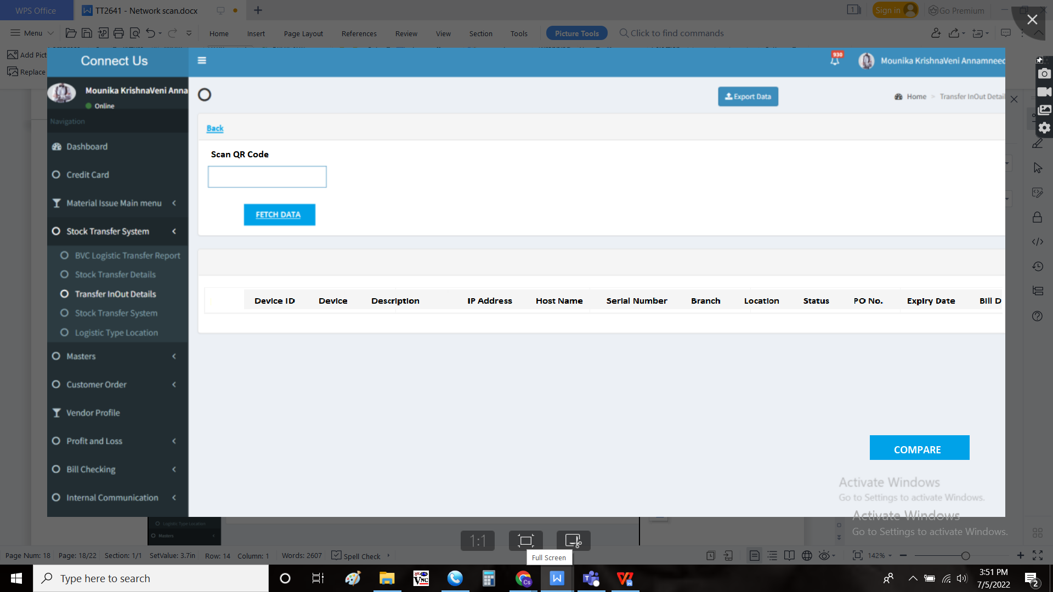

Note:

* Multiple devices can be scanned in the branch. The data to be shown in list view.
* When the same device is scanned, duplicate entry pop up is shown.

Compare:

The compare button is used to compare the data existed I.e., reports. When the user clicks on compare, the reports page open with filters such as device, status, location and branch. After selecting the above, the user can compare the list by clicking the compare button again.

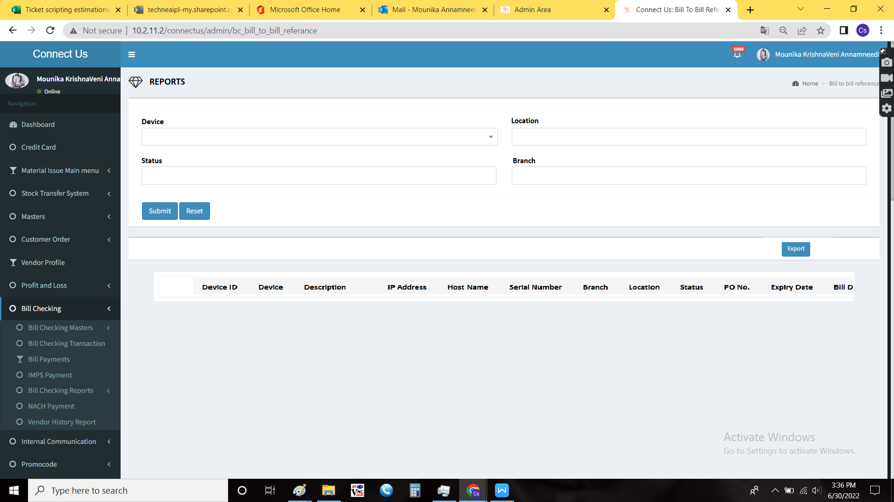

The unique will be displayed in green colour and the missing data with red. The user can export that sheet if required.

Export

The export button is used to export the data. The following are the fields in the export data.

* QR Code
* Device ID
* Device
* Description
* IP Address
* Host Name
* Serial Number
* Branch
* Location
* Status
* PO No.
* Expiry date
* Bill date



Note:

If it is the compared data, extra column - “Available/ not” field shown. If the device is available, then “yes, if not, then “no”.

Step - 6

Reports

In Connect Us -> Device Management -> Reports



The reports are based on the following filters.

* + Device
  + Status
  + Location
  + Branch

The following are the fields in the report

* Device
* Status
* Location
* Branch
* Submit
* Reset
* Export

|  |  |  |  |
| --- | --- | --- | --- |
| **FIELDS** | **INPUT TYPE** | **MANDATORY/ OPTIONAL** | **DESCRIPTION** |
| Device | Drop down | Optional | The device I.e., product details is selected from the drop down. The drop down list fetched from device master. The date to be shown as follows “device name - company name” format. |
| Status | Drop down | Optional | The status of the product is selected from the drop down menu. The following are the fields in the status.   * + - * New       * In use       * Extra stock       * Repair       * Scrap       * Festival       * Problem       * Refilling       * Not found       * Sold out |
| Location | Drop down | Optional | The location at which the product is existed is selected. The location drop down details are fetched from location master. |
| Branch | Drop down | Optional | The branch name where the product is existed is selected from the drop down. The drop down data is fetched from the branch master in Connect us -> masters -> general masters. |
| Submit | Button | Optional | The submit button to fetch the data based on the above filters |
| Reset | Button | Optional | To refresh the filters |
| Export | Button | Optional | The export button to export the data generated |

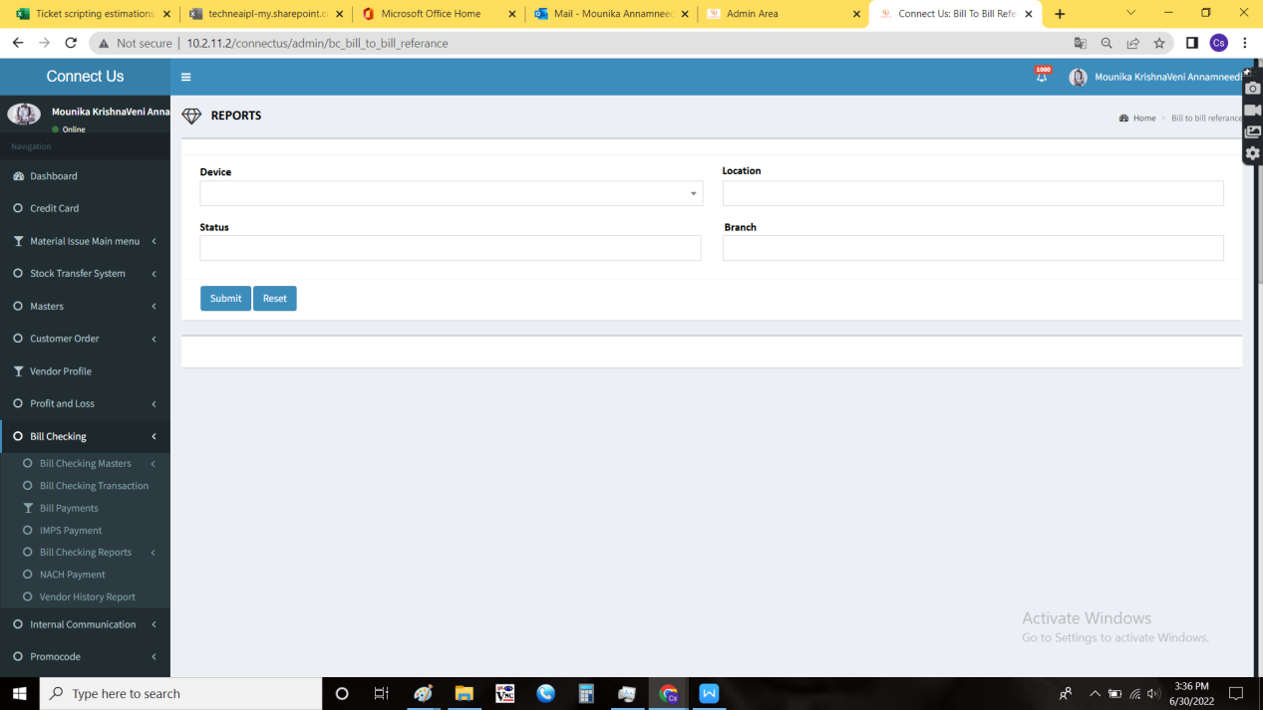

When the user generates any data, then the following fields be displayed as follows.

* QR Code
* Device ID
* Device
* Description
* IP Address
* Host Name
* Serial Number
* Branch
* Location
* Status
* PO No.
* Expiry date
* Bill date



Export

The export button is used to export the data. The following are the fields in the export data.

* QR Code
* Device ID
* Device
* Description
* IP Address
* Host Name
* Serial Number
* Branch
* Location
* Status
* PO No.
* Expiry date
* Bill date



**References of the users**

|  |  |  |  |
| --- | --- | --- | --- |
| **User** | **Name** | **Mail** | **Contact number** |
| **Actual user** | Pradeep Wagh | pradeep.wagh@techneai.com |  |
| **Assigned business analyst** | Mounika KrishnaVeni Annamneedi | Mounika.annamneedi@techneai.com | 9885900039 |
| **Assigned developer** |  |  |  |
| **Assigned tester** |  |  |  |