|  |  |
| --- | --- |
| **Ticket ID** | TT3550 |
| **Ticket description** | BMT HO yethil Tollfree Department Madhe Neox System ani Apli(Connect us system)he integrate karun paheje ahe |
| **Created by** | Reshma Sarfraj Sayyad |
| **Created on** | 29/07/2022 |
| **Priority** | High |
| **Version** | 0 |

**Version**

|  |  |  |  |  |
| --- | --- | --- | --- | --- |
| **Sr. No** | **Version no** | **Version Date** | **User name** | **User department** |
| 1 | 1 | 29.07.2022 | Reshma Sarfraj Sayyad | Tollfree |

**Approvals**

|  |  |  |
| --- | --- | --- |
| **Field** | **Name of the User** | **Approved date by the user** |
| **Actual User Name** | Reshma Sarfraj Sayyad | 19.07.2022 |
| **Actual User Department** | Tollfree |  |
| **Organization Name** | C S Jewellers |  |
| **Sign-off** |  |  |
| **Assigned BA** | Mounika KrishnaVeni Annamneedi | 27.07.2022 |

**Estimation**

|  |  |  |  |  |
| --- | --- | --- | --- | --- |
| **Department name** | **Estimated Time (In hr)** | **Scheduled Date (Starting date )** | **Estimated date** | **Actual delivery date** |
| **BA** | 4 | 29.07.2022 | 29.07.2022 |  |

**Business Requirement**

The user wants to know all the data of the customer when the customer calls to the toll free.

**Existing system**

There is no existing system.

**Proposed system**

* Creation of new menu Toll free call details in Connect Us
* Under toll free call details, add Customer data and Customer toll free report modules in Connect Us

Step 1

Creation of new menu “Toll free call details” in Connect Us.

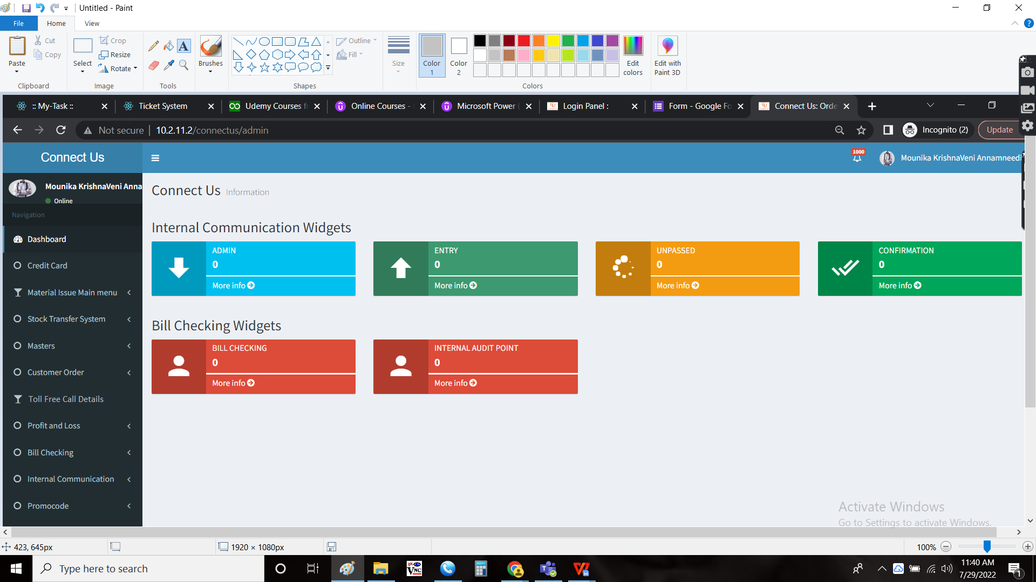

Step 2

Under Toll free call details, addition of 2 modules as follows in Connect Us.

1. Customer data
2. Customer toll free report

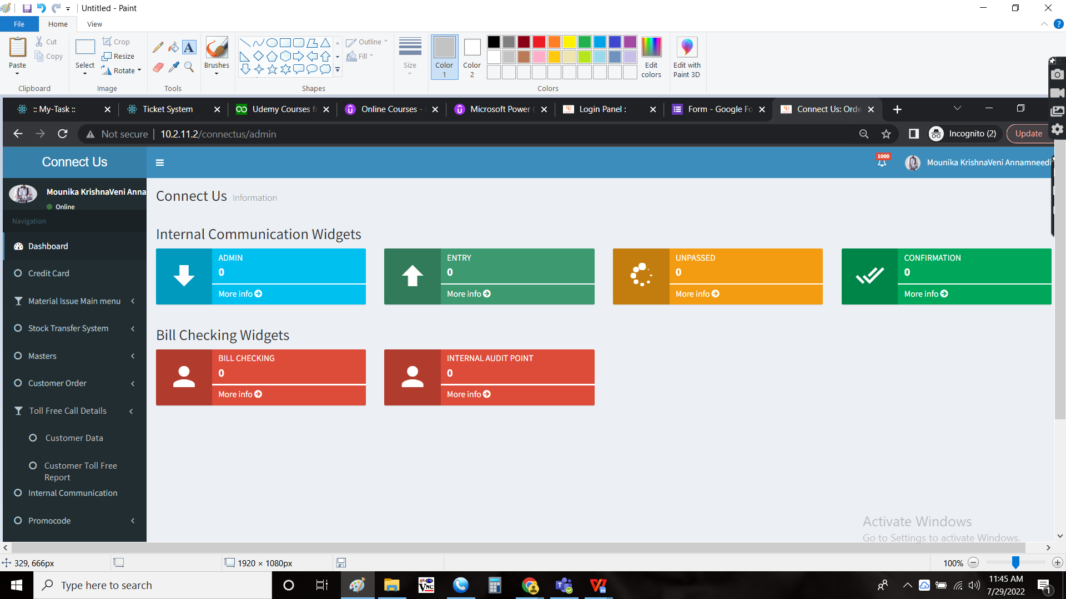

Step 3

When the customer calls the toll free department, the neox team receives the call and the following is displayed.

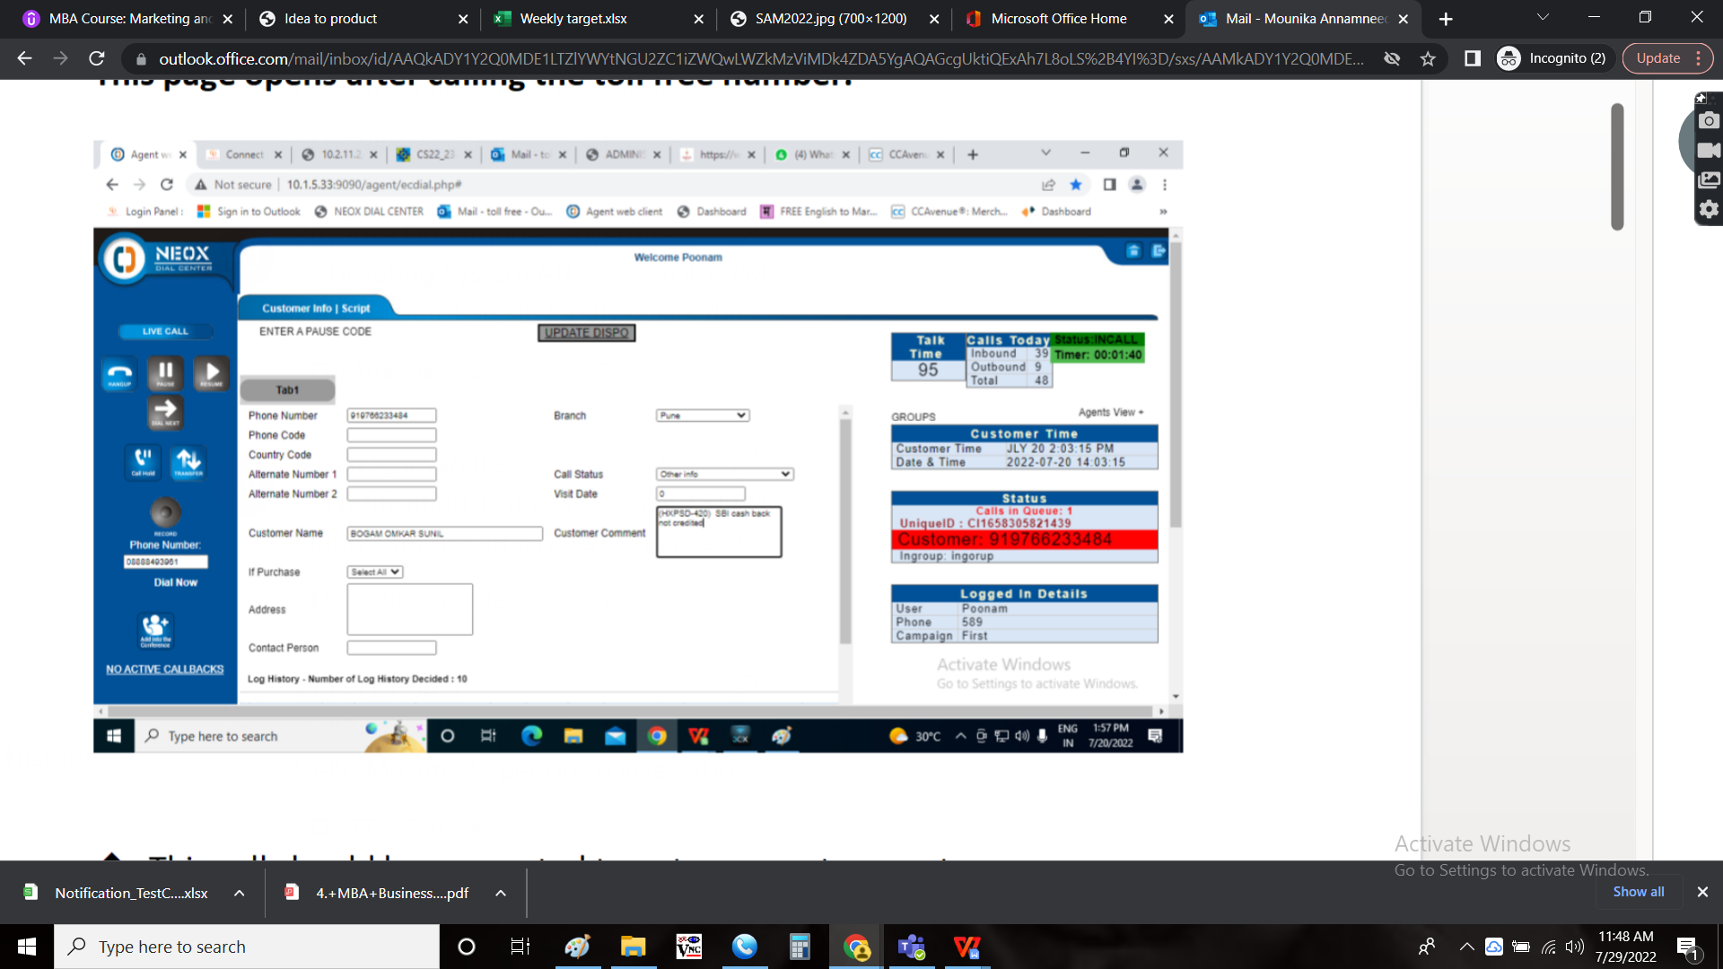

Now, the call should be synced and the data to be shown in the Connect Us -> Toll free call details -> Customer data. The following are shown in the page.

* Phone number
* Alternative number
* Name
* Address
* Branch
* Call status
* Customer comment
* Submit

|  |  |  |  |
| --- | --- | --- | --- |
| **FIELDS** | **INPUT TYPE** | **MANDATORY/ OPTIONAL** | **DESCRIPTION** |
| Phone number | Auto | - | The phone number is auto fetched from the neox system incoming call |
| Alternative number | Int | Optional | If the customer is calling from the alternative number, the number can be entered. So the details are fetched from the alternative number when entered. |
| Name | Auto (text) | Mandatory | The name of the customer is shown automatically from the Masters -> General Masters -> Customer Masters. The user can edit the name if required. |
| Address | Auto (text) | Mandatory | The address of the customer is shown automatically from the Masters -> General Masters -> Customer Masters. The user can edit the address if required. |
| Branch | Auto (Drop down) | Mandatory | The branch registered for the customer is shown automatically from the Masters -> General Masters -> Customer Masters. The user can edit the branch if required.  The following are the drop down options.   * Ahmednagar * Akluj * Athani * Baramati MIDC * Bhigwan * Bhosari * BMT * Chakan * Chandan Nagar * Chinchwad * E-Commerce * Hadapsar * Jaysingpur * Karad * Kolhapur * Kothrud * Nashik * Pune Satara Road * Sangamner * Sangli * Sangola * Satara |
| Call status | Drop down | Mandatory | The call status is selected from the drop down. The call status refers to the reason the customer called. The following are the drop down options.   * Online payment send video * Maturity info * New scheme start process info * Both scheme info * Installment details * Entry missing * Online payment problem * URD payment info * Metal break * Rate/ Making charges/ Shop info * Payment mode info * Order info * Online order info * Online COD info * Vedhani bifurcation * Only shop info * EMI offer info * Ornament exchange info * Cheque passing info * Offer info live offer status * Only rate * BDD info * Newspaper add info * Sale made * Testing * No ans return call * Enquiry * Network issue * Feedback * Auto close * Job info * Other info * Complaints * Miss chat call * Online payment process |
| Customer comment | Text | Mandatory | The customer comment for making the call is entered by the user |
| Submit | Button | Optional | The submit button to submit the data |

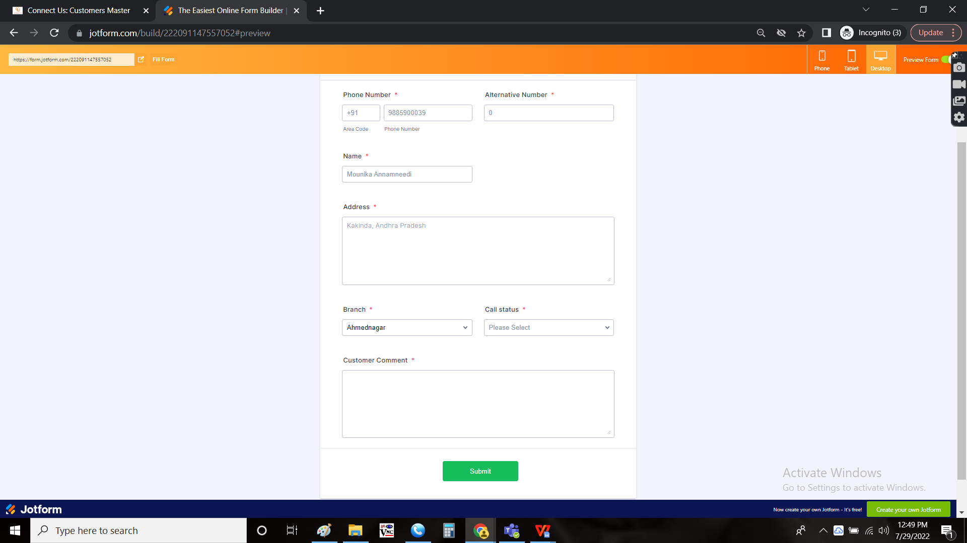

As soon as the user submits the data, the pop up message is displayed whether the customer is new or old.

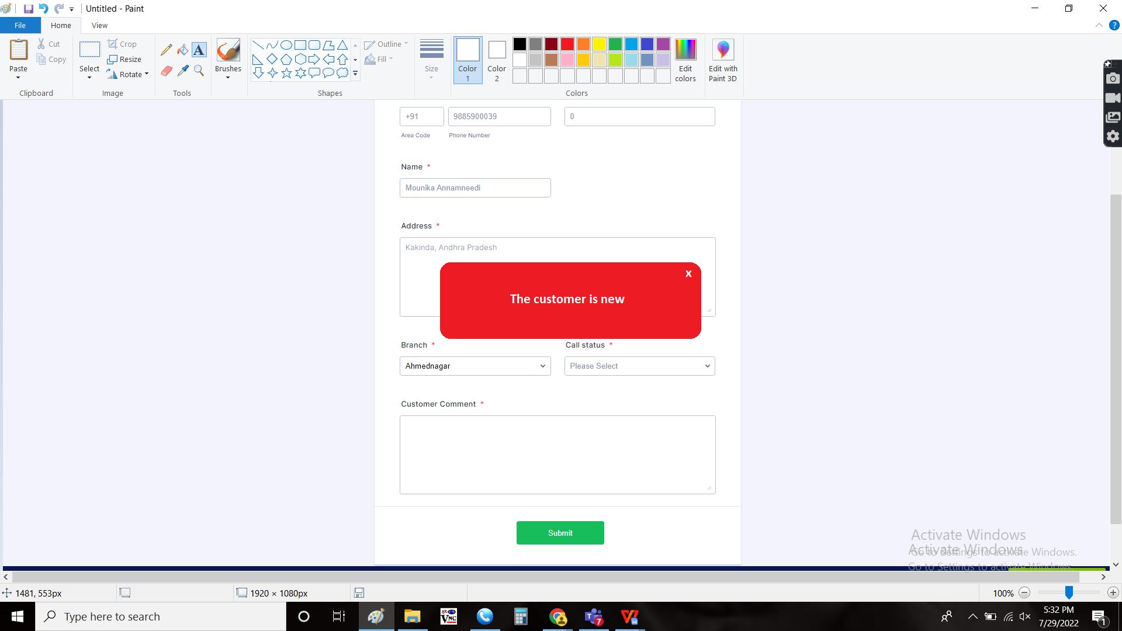

If the customer is new, no data is displayed.  
If the customer is old, the following data is displayed.

The following details are shown.

* Transactions
* Purchases
* Schemes
* Store visits
* Messages sent
* Calls made

|  |  |
| --- | --- |
| Field | Description |
| Transactions | The transaction details made by the customer |
| Purchases | The purchases made by the customer |
| Schemes | The schemes made by the customer |
| Store visits | The store visits of the customer |
| Messages sent | The messages (SMS & Whatsapp) sent to the customer |
| Calls made | The calls made to the customer |

The latest is shown. If the user clicks on view more, then all the following details are shown.

* Personal data
* Offline purchases
* Online purchases
* Schemes
* Store visits
* Messages sent
* Calls made
* Personal data
  + Customer birthday
  + Anniversary

Personal data:

The personal data relates to the personal information of the customer.

|  |  |
| --- | --- |
| Field | Description |
| Customer birthday | The customer birthday date is displayed |
| Anniversary | The anniversary of the customer (if married) is displayed. If the customer is not married, no data is displayed. |

* Offline Purchases
  + S.No
  + Date
  + Document No
  + Item
  + Category
  + Purity
  + Gross weight
  + Net weight
  + No. Of pieces
  + Branch
  + Mode of purchase

Offline Purchases:

The purchases relates to all the data the customer purchased from the organization offline from the branch.

|  |  |
| --- | --- |
| Field | Description |
| S.No | The serial number is displayed |
| Date | The date of purchase of the ornament |
| Document No | The document number of the purchase |
| Item | The item name, the customer purchased is displayed |
| Category | The category name, the customer purchased is displayed |
| Purity | The purity of the ornament purchased is displayed |
| Gross weight | The gross weight of the item is displayed |
| Net weight | The net weight of the item is displayed |
| No. Of pieces | The no. Of pieces purchased is displayed |
| Branch | The branch where the customer purchased is displayed |

* Online purchases
  + S.No
  + Date
  + Order ID
  + Transaction ID
  + Status
  + Tracking details
  + Mode of payment
  + Total amount
  + Shipping charges
  + Coupon/ voucher applied
  + Coupon/ Voucher
  + Discount applied
  + Discount
  + Gift wrapping applied
  + Gifting charges
  + Payment status
  + Item
  + Category
  + Purity
  + Gross weight
  + Net weight
  + No. Of pieces

Online Purchases:

The online purchases relates to the data, where the customer purchased online using web.

|  |  |
| --- | --- |
| Field | Description |
| S.No | The serial number is displayed |
| Date | The date of purchase of the ornament |
| Order ID | The order ID when purchased online is displayed |
| Transaction ID | The transaction ID when the transaction made online is displayed |
| Status | The status of the product whether it is processed, delivered or in transit is known |
| Tracking details | If the product in transit, the details are shown |
| Delivery date/ Expected delivery date | The delivery date of the product (if already delivered) or the expected delivery date (if not yet delivered) is shown |
| Mode of payment | The mode of payment is shown |
| Total amount | The total amount of the product is displayed |
| Shipping charges | The shipping charges are mentioned if any |
| Coupon/ voucher applied | Shows in terms of yes and no, whether the coupon/ voucher applied or not |
| Coupon/ voucher | If any coupons/ vouchers assigned to the order, they are mentioned in terms of amount (if coupon/ voucher applied) |
| Discount applied | Shows in terms of yes and no, whether the discount applied or not |
| Discount | The discount given is mentioned (if discount applied) |
| Gift wrapping applied | Shows in terms of yes and no, whether the gift wrapping applied or not |
| Gifting charges | The gifting charges if any is mentioned (if gift wrapping is selected) |
| Payment status | The payment status of the order is mentioned |
| Item | The item name, the customer purchased is displayed |
| Category | The category name, the customer purchased is displayed |
| Purity | The purity of the ornament purchased is displayed |
| Gross weight | The gross weight of the item is displayed |
| Net weight | The net weight of the item is displayed |
| No. Of pieces | The no. Of pieces purchased is displayed |

* Schemes
  + S.No
  + Date
  + Scheme name
  + No. Of installments
  + Amount per installment
  + Total amount
  + Completed installments
  + Pending installments
  + Last payment date
  + Branch
  + Mode of payment of last installment
  + Pending amount
  + Amount paid in total
  + Amount due
  + Due date

Schemes:

The schemes relates to the whether the customer is enrolled in any schemes and schemes data of the customer is shown.

|  |  |
| --- | --- |
| Field | Description |
| S.No | The serial number is displayed |
| Date | The date when the scheme enrolled is displayed |
| Scheme name | The scheme enrolled is mentioned |
| No. Of installments | The no. Of installments of the scheme is mentioned |
| Amount per installment | The amount for each installment is mentioned |
| Total amount | The total amount for the scheme is mentioned |
| Completed installments | The no. Of completed installments is mentioned |
| Pending installments | The no. Of pending installments is mentioned |
| Last payment date | The last payment date paid for the installment is mentioned |
| Branch | The branch where the scheme enrolled is mentioned. If the scheme enrolled online, then online is mentioned. |
| Mode of payment of last installment | The mode of payment of last installment paid is mentioned |
| Pending amount | The total pending amount for the scheme completion is mentioned |
| Amount paid in total | The total amount paid in total is mentioned |
| Amount due on installment date | The total amount due for the installment is mentioned |
| Due date | The due date for the installment is mentioned |
| Total amount to be paid | The total amount to be paid for the completion of the scheme is mentioned |

* Store visits
  + S.No
  + Date
  + Branch
  + Purchased/ No

Store visits:

The store visits consists of the information when and where the customer visits the store is shown.

|  |  |
| --- | --- |
| Field | Description |
| S.No | The serial number is displayed |
| Date | The date when the customer visited the store is displayed |
| Branch | The branch to which the customer visited is mentioned |
| Purchased/ No | Whether the customer purchased or not is displayed. If the customer purchased, then “yes” is mentioned. If no, then “no” is mentioned. |

* Messages sent
  + S.No
  + Date
  + Whatsapp/ SMS
  + Message text

Messages sent:

The messages sent to the customer are shown.

|  |  |
| --- | --- |
| Field | Description |
| S.No | The serial number is displayed |
| Date | The date when the messages sent by the organization to the customer are displayed |
| Whatsapp/ SMS | The channel through which the message is sent is shown |
| Messages text | The message text sent to the customer is shown |

* Calls made
  + S.No
  + Date
  + Purpose

Calls made:

The calls made to the customer is displayed.

|  |  |
| --- | --- |
| Field | Description |
| S.No | The serial number is displayed |
| Date | The date when the messages sent by the organization to the customer are displayed |
| Purpose | The reason for calling the customer is mentioned |

Note:

* The last transaction for each tab is shown initially.
* When the user clicks on “view more”, the data is shown year wise.
* The data for the above tabs is fetched from Padm.

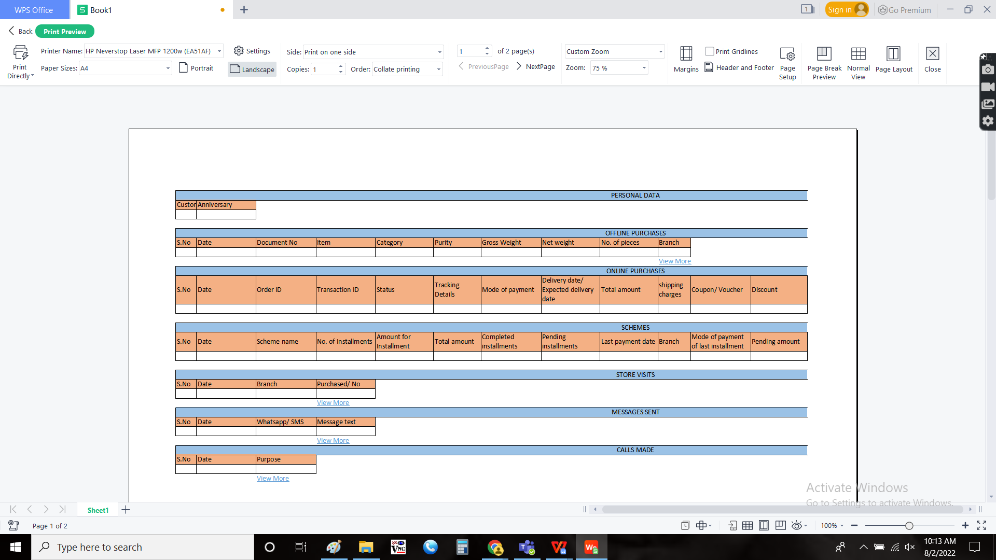

There is an auto send button, to send the SMS and whatsapp message instantly to the customer based on the query.

When the user clicks on “Auto send”, a drop down is opened. Based on the query, messages are sent. The drop down consists of following options.

* Current rate
* Latest e-catalogue
* Download mobile app
* Theme/ offer
* Monthly scheme
* Store location

|  |  |
| --- | --- |
| Field | Description |
| Current rate | The current rate consists of the current rate of the gold |
| Latest e-catalogue | The latest e-catalogue refers to the latest e-catalogue generated currently with the trend |
| Download mobile app | The download mobile app refers to the link for downloading the mobile application |
| Theme/ offer | The theme/ offer refers to the current theme and offers running in the organization |
| Monthly scheme | The monthly scheme refers to the scheme enrollment and payments and terms and conditions link |
| Store location | The store locations refers to the store locator links |

Step - 4

Customer toll free report

In Connect Us -> Toll free call details -> Customer toll free report



The customer toll free consists of the filters from date and the to date. The following fields are displayed in report based on the filter.

* Phone number
* Alternative number
* Name
* Address
* Branch
* Call status
* Customer comment