|  |  |
| --- | --- |
| **Ticket ID** | TT3715 |
| **Ticket description** | Daily Transactions Report (new Implement in Connect Us ) attached exmple file, If any query call me Ref. OLD CONNECT US ID- T217223 |
| **Created by** | Rajesh Barse |
| **Created on** | 27/07/2022 |
| **Priority** | Medium |
| **Version** | 1 |

**Version**

|  |  |  |  |  |
| --- | --- | --- | --- | --- |
| **Sr. No** | **Version no** | **Version Date** | **User name** | **User department** |
| 1 | 1 | 02.09.2022 | Rajesh Barse | Treasure |

**Approvals**

|  |  |  |
| --- | --- | --- |
| **Field** | **Name of the User** | **Approved date by the user** |
| **Actual User Name** | Rajesh Barse | 27/07/2022 |
| **Actual User Department** | Treasure |  |
| **Organization Name** | C S Jewellers |  |
| **Sign-off** |  |  |
| **Assigned BA** | Mounika KrishnaVeni Annamneedi | 02.09.2022 |

**Estimation**

|  |  |  |  |  |
| --- | --- | --- | --- | --- |
| **Department name** | **Estimated Time (In hr)** | **Scheduled Date (Starting date )** | **Estimated date** | **Actual delivery date** |
| **BA** | 4 | 02.09.2022 | 03.09.2022 |  |

**Business Requirement**

Generation of the daily transaction report where the branch-wise and daily report is considered.

**Existing system**

There is no existing system.

**Proposed system**

* Creation of new menu - daily transaction menu

Step - 1  
In connect us, create a new module “Daily transaction report”

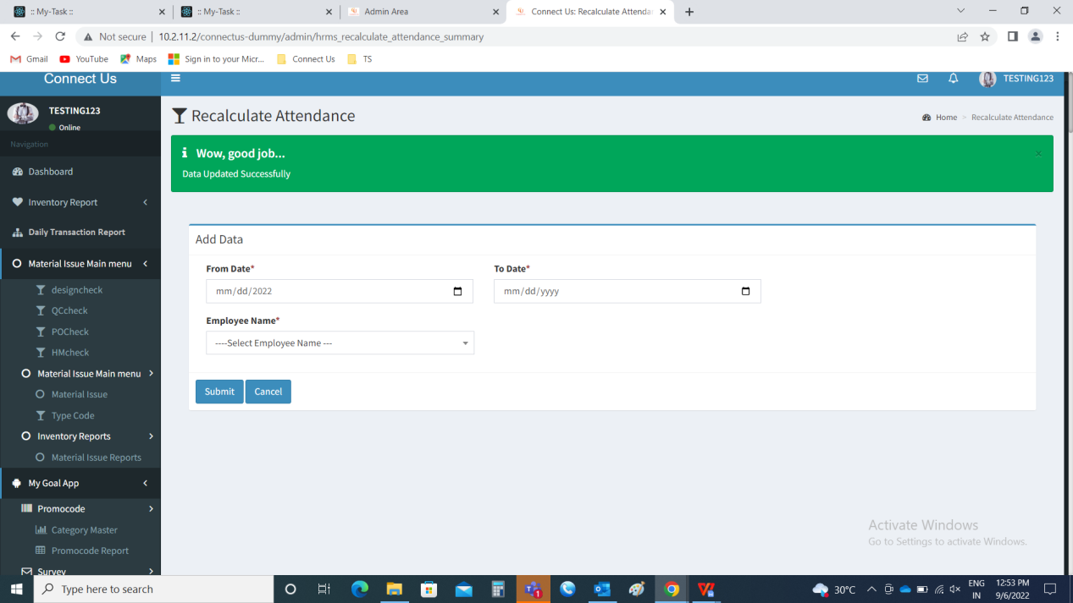

Step-2

Daily Transaction Report

The report consists of the from date, to date and branch filters and the buttons such as export, reset and the filter.

|  |  |  |  |
| --- | --- | --- | --- |
| **FIELDS** | **INPUT TYPE** | **MANDATORY/ OPTIONAL** | **DESCRIPTION** |
| From date | Calender | Mandatory | The from date filter is based on from when the data is required. |
| To date | Calender | Mandatory | The to date filter is based to when the data is required. |
| Branch | Drop down | Mandatory | The branch is selected. It can be single, multiple or all. An extra “all” field is required in drop down. The drop down fields are fetched from branch master (in connect us -> masters -> general master -> Branch Master) |
| Filter | Button | Optional | The filter button to generate the report |
| Reset | Button | Optional | The reset button to reset the filters |
| Export | Button | Optional | The export button to export the data generated |

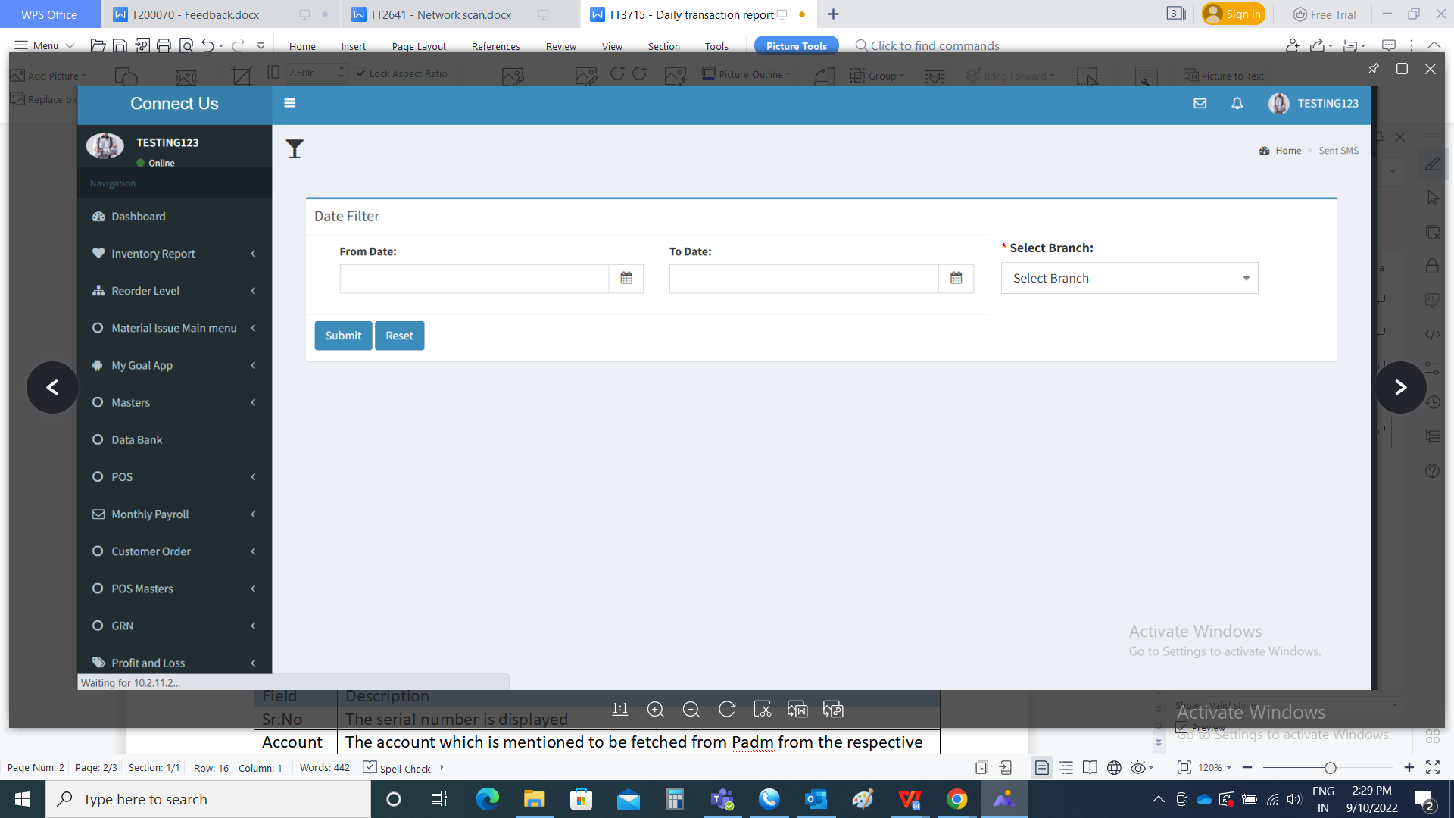

The following are the fields in the report

* Sr.No
* Account
* Branch

|  |  |
| --- | --- |
| Field | Description |
| Sr.No | The serial number is displayed |
| Account | The account which is mentioned to be fetched from Padm from the respective ledgers. The accounts consists of following.   * Cash account - Padm -> ledgers -> cash a/c * Credit card - Padm -> ledgers -> credit card a/c * HDFC QR code - Padm -> ledgers -> HDFC QR code UPI * Cheque in hand - Padm -> ledgers -> cheque in hand a/c * BCS advance - Padm -> ledgers -> BCS advance |
| Branch | The branch which is selected is displayed |
| Total | The total of all the accounts of branches is displayed |

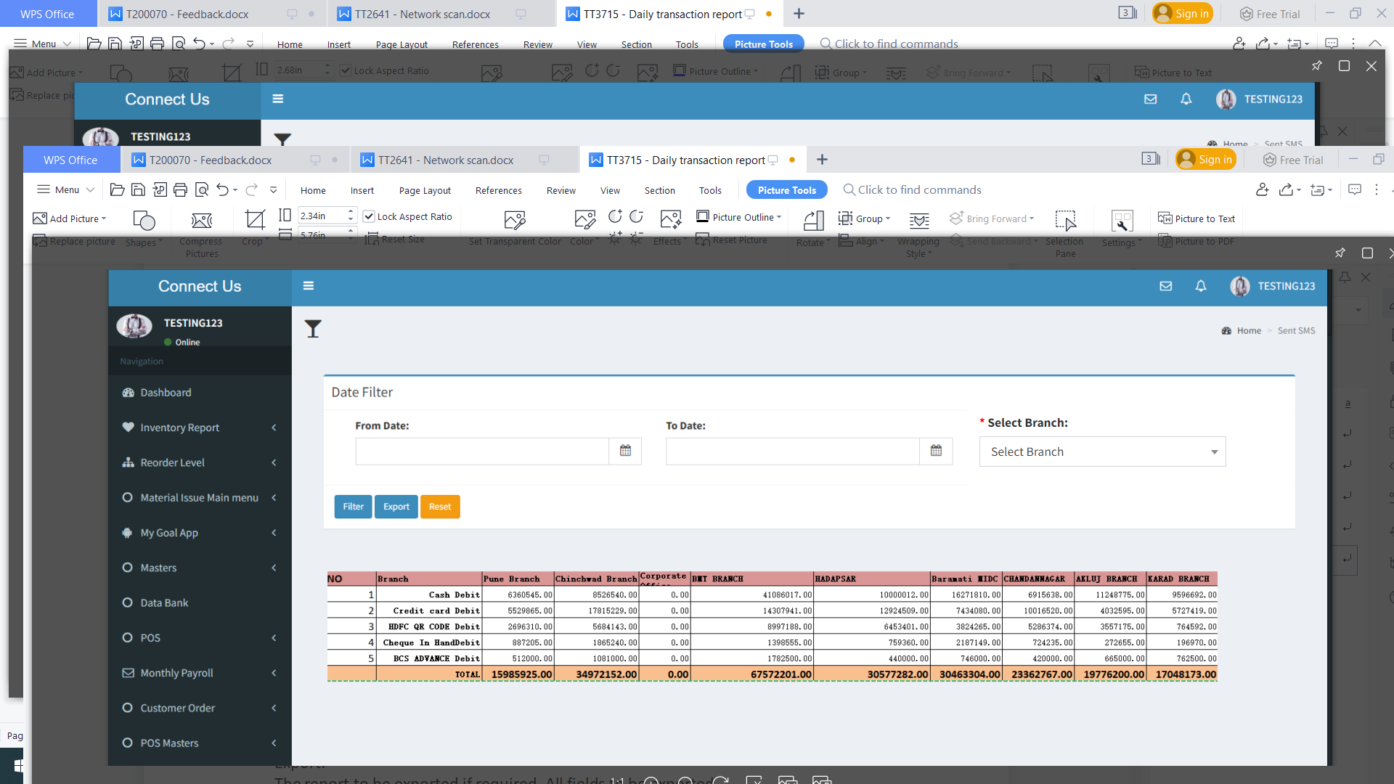

Export:

The report to be exported if required. All fields to be exported.

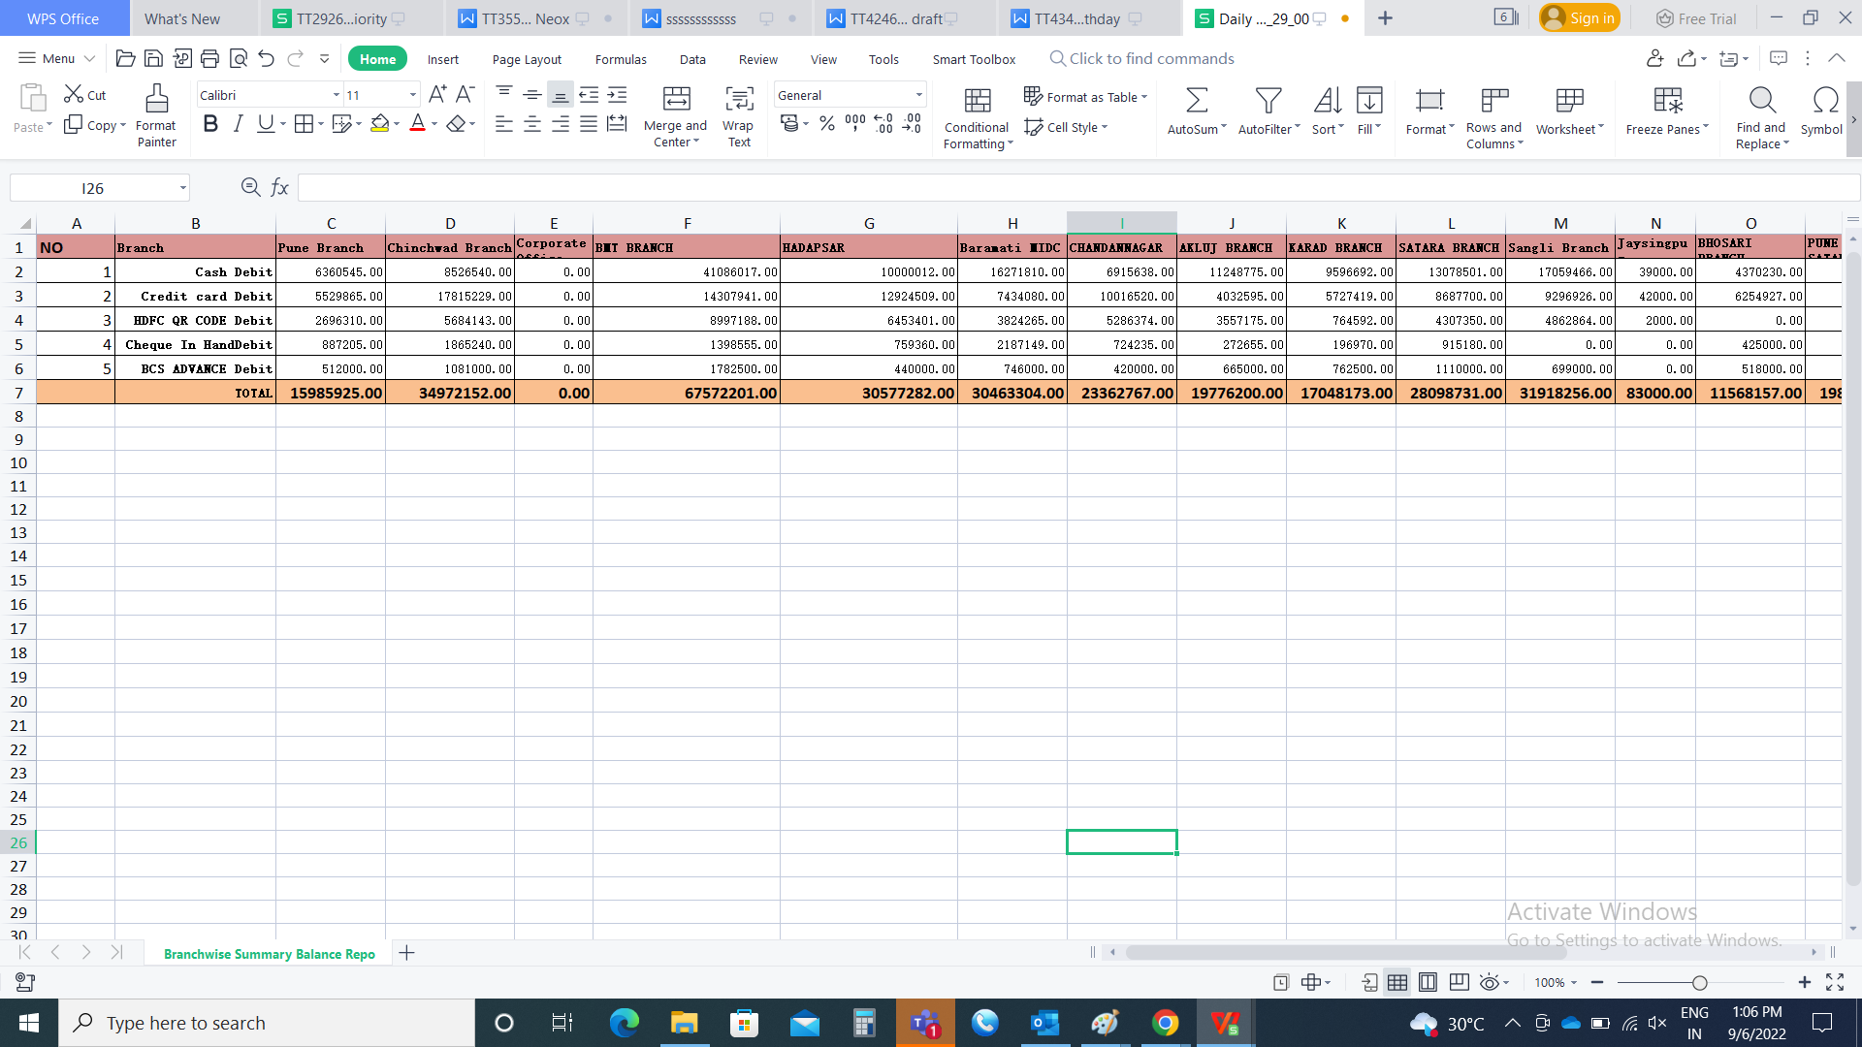

**References of the users**

|  |  |  |  |
| --- | --- | --- | --- |
| **User** | **Name** | **Mail** | **Contact number** |
| **Actual user** | Rajesh Barse |  |  |
| **Assigned business analyst** | Mounika KrishnaVeni Annamneedi | Mounika.annamneedi@techneai.com | 9885900039 |