|  |  |
| --- | --- |
| **Ticket ID** | TT4246 |
| **Ticket description** | ConnectUS Material Issue Madhe Deta Add Kartana Sub Supplier Name Coolum Add Karun Pahije Ani Supplier Name Drop Down List Show Jhali Pahije Reff :- Vinay Shinde Sir |
| **Created by** | Tushar Shivaji Nikam |
| **Created on** | 18/08/2022 |
| **Priority** | Very High |
| **Version** | 1 |

**Version**

|  |  |  |  |  |
| --- | --- | --- | --- | --- |
| **Sr. No** | **Version no** | **Version Date** | **User name** | **User department** |
| 1 | 1 | 25.08.2022 | Tushar Shivaji Nikam | Inventory Silver HO |

**Approvals**

|  |  |  |
| --- | --- | --- |
| **Field** | **Name of the User** | **Approved date by the user** |
| **Actual User Name** | Tushar Shivaji Nikam | 18.08.2022 |
| **Actual User Department** | Inventory Silver HO |  |
| **Organization Name** | C S Jewellers |  |
| **Sign-off** |  |  |
| **Assigned BA** | Mounika KrishnaVeni Annamneedi | 25.08.2022 |
| **Assigned Developer** |  |  |
| **Assigned Tester** |  |  |

**Estimation**

|  |  |  |  |  |
| --- | --- | --- | --- | --- |
| **Department name** | **Estimated Time (In hr)** | **Scheduled Date (Starting date )** | **Estimated date** | **Actual delivery date** |
| **BA** | 4 | 25.08.2022 | 25.08.2022 |  |

**Business requirement**

In material issue main menu, the user requires new field “Sub-supplier” for accessing and assigning the data.

**Existing system**

In the existing system, there is no such field.

**Proposed system**

* Creation of master - Sub-supplier
* Fields in sub-supplier master
  + ID (auto-generated)
  + Sub-supplier name
  + Sub-supplier address
  + Sub-supplier contact number
  + Sub-supplier pan No.
  + Sub-supplier GST No.
  + Status
  + Remark
* Addition of sub-supplier field in
  + Material issue main menu - material issue - add data
  + Design check
  + QC check
  + PO check
  + HM check
  + Material issue report - all reports and MI report
  + Inventory report - karagir issue - all reports and MI report

Step 1

Creation of Sub-supplier Master:

The sub-supplier master consists of all the details of the sub-supplier.

In connect -> Bill checking -> Bill checking Masters -> Sub-supplier master

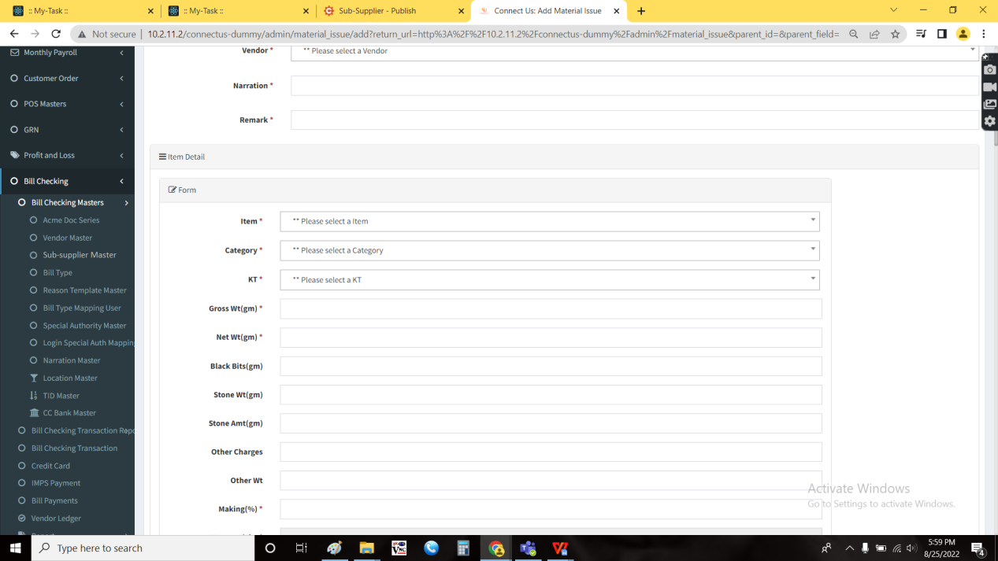

The sub-supplier master consists of the following fields

* ID
* Sub-supplier name
* Sub-supplier address
* Sub-supplier contact number
* Sub-supplier pan No.
* Sub-supplier GST No.
* Status
* Remark
* Updated by
* Updated at
* Action
* Add data

|  |  |
| --- | --- |
| Field | Description |
| ID | The ID of the sub-supplier |
| Sub-supplier name | The sub-supplier name is displayed |
| Sub-supplier address | The sub-supplier address is displayed |
| Sub-supplier contact number | The sub-supplier contact number is displayed |
| Sub-supplier pan No. | The sub-supplier PAN No. is displayed |
| Sub-supplier GST No. | The sub-supplier GST No. is displayed |
| Status | The sub-supplier status is displayed whether the sub-supplier is active or not |
| Remark | The remark, if any |
| Updated by | The last updated by is mentioned |
| Updated at | The last updated at is mentioned |
| Action | The action field to view, edit and delete |
| Add data | The add data button is used to add new sub-supplier |

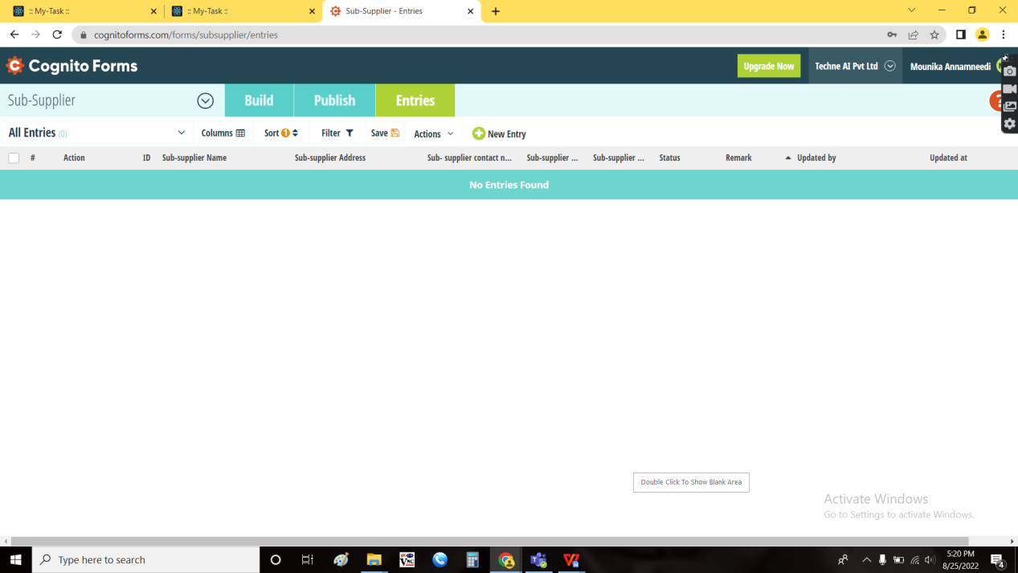

Add data:

The add data button is used to add new sub-supplier. The following are the fields in the Add data menu.

* ID
* Sub-supplier name
* Sub-supplier address
* Sub-supplier contact number
* Sub-supplier pan No.
* Sub-supplier GST No.
* Status
* Remark
* Back
* Save and add more
* Save

|  |  |  |  |
| --- | --- | --- | --- |
| **FIELDS** | **INPUT TYPE** | **MANDATORY/ OPTIONAL** | **DESCRIPTION** |
| ID | Auto-generated | Mandatory | The Id of the sub-supplier is auto generated in a numeric order |
| Sub-supplier name | Text | Mandatory | The sub-supplier name is entered |
| Sub-supplier address | Text | Mandatory | The sub-supplier address is entered |
| Sub-supplier contact number | Int | Mandatory | The sub-supplier contact number is entered |
| Sub-supplier pan No. | Text | Mandatory | The sub-supplier PAN No. is entered. Pan No. Validations are considered. |
| Sub-supplier GST No. | Text | Mandatory | The sub-supplier GST No.is entered. GST No. Validations are considered. |
| Status | Radio button | Mandatory | The status of the sub-supplier is selected. If the sub-supplier is active, then “active” is selected. If not, “de-active” is selected. |
| Remark | Text | Optional | The remark if any is entered |
| Back | Button | Optional | To navigate to back page |
| Save and add more | Button | Optional | To save the existing data and add more data |
| Save | Button | Optional | To save the existing data |

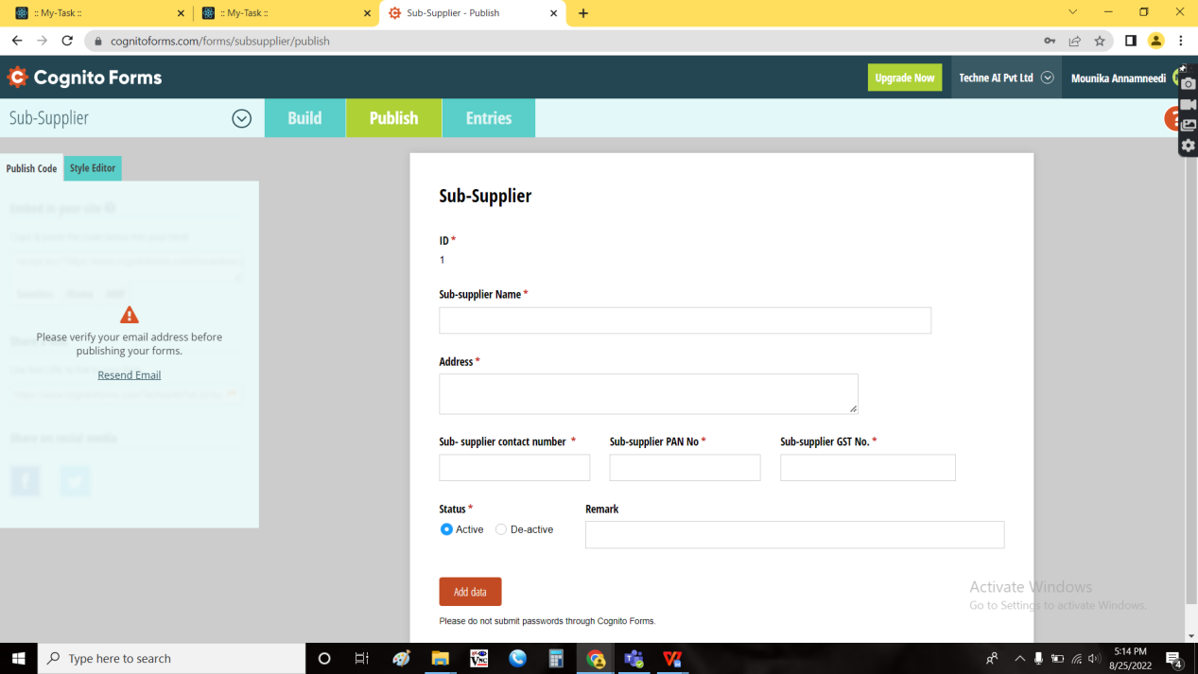

View data:

The view button in the action field is used to view the data. The following are the fields in the view data.

* ID
* Sub-supplier name
* Sub-supplier address
* Sub-supplier contact number
* Sub-supplier pan No.
* Sub-supplier GST No.
* Status
* Remark
* Back

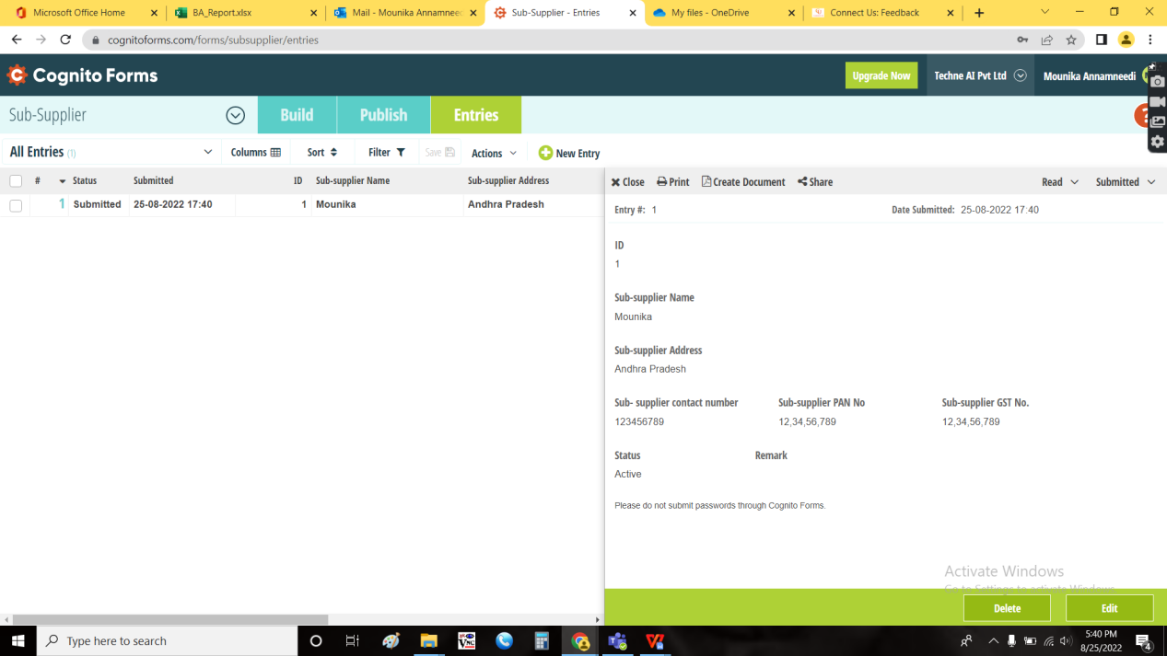

Edit data:

The edit button in the action field is used to edit the existing data. The following are the fields in the edit data and all the fields are editable.

* ID
* Sub-supplier name
* Sub-supplier address
* Sub-supplier contact number
* Sub-supplier pan No.
* Sub-supplier GST No.
* Status
* Remark
* Back
* Save

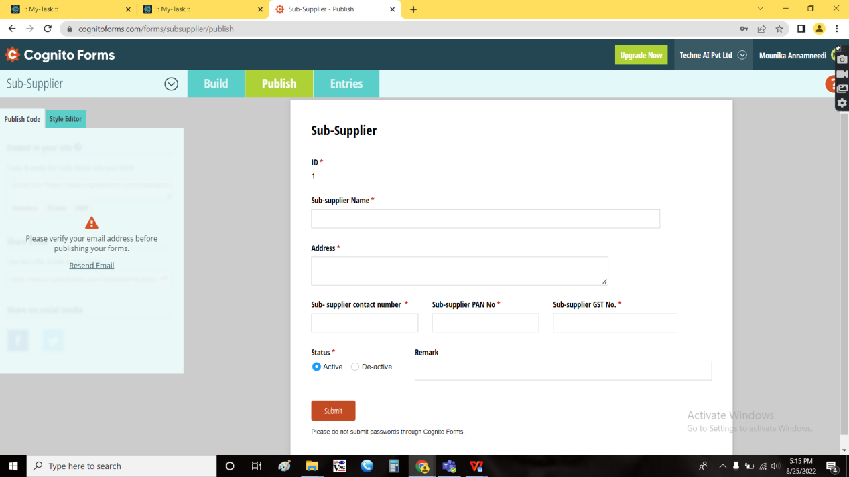

Delete data:

The delete data button in the action field is used to delete the data in the sub-supplier master.

Step 2

* Addition of sub-supplier field in
  + Material issue main menu - material issue - add data
  + Design check
  + QC check
  + PO check
  + HM check
  + Material issue report - all reports and MI report
  + Inventory report - karagir issue - all reports and MI report

In Connect Us -> Material issue main menu -> material issue

Add sub-supplier in table view

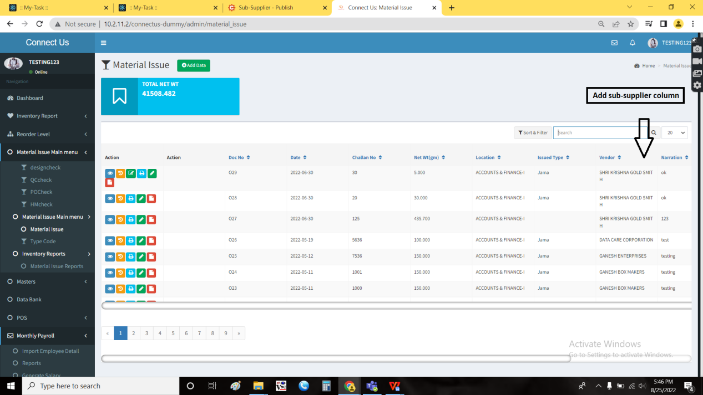

In Connect Us -> Material issue main menu -> material issue -> Add data

Add “Sub-supplier” field where the data is fetched from Sub-supplier master.

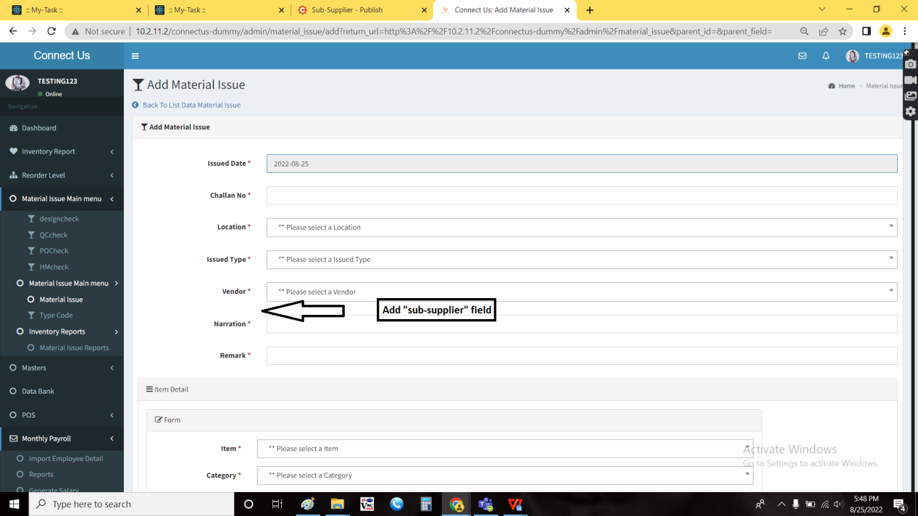

In Connect Us -> Material issue main menu -> material issue -> view

Add “Sub-supplier” field.

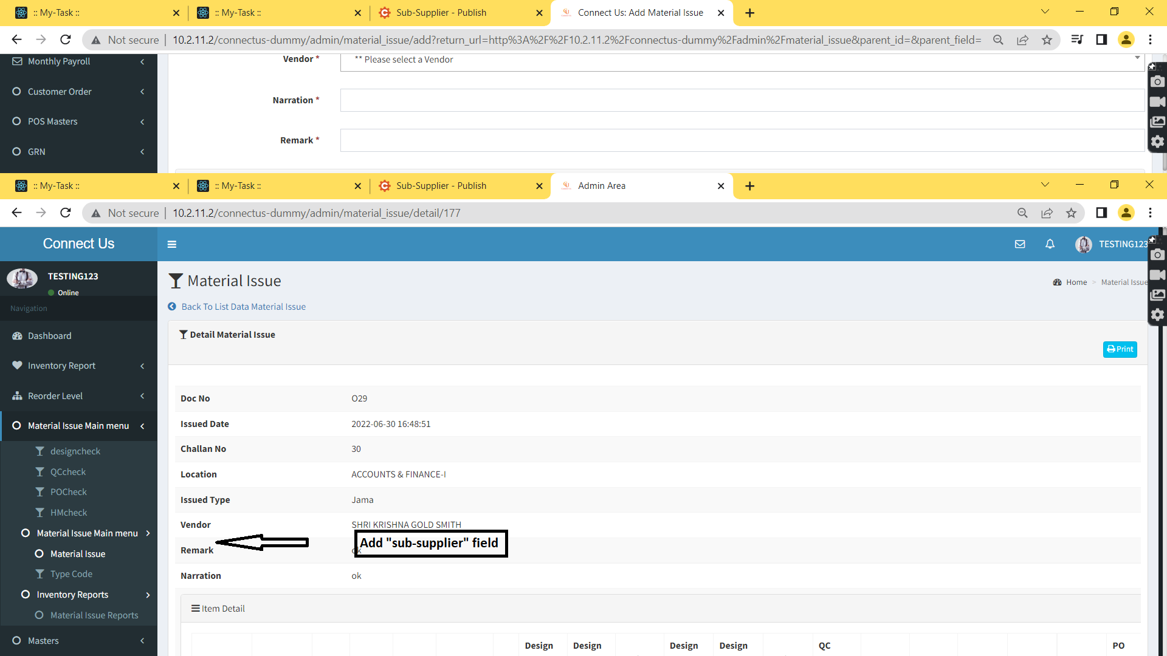

In Connect Us -> Material issue main menu -> material issue -> History

Add “Sub-supplier” column in table.

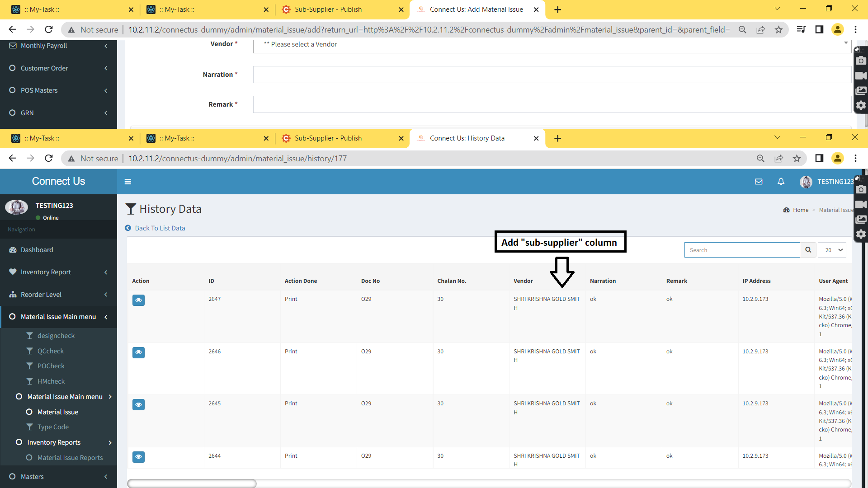

In Connect Us -> Material issue main menu -> material issue -> History -> View

Add “Sub-supplier” field.

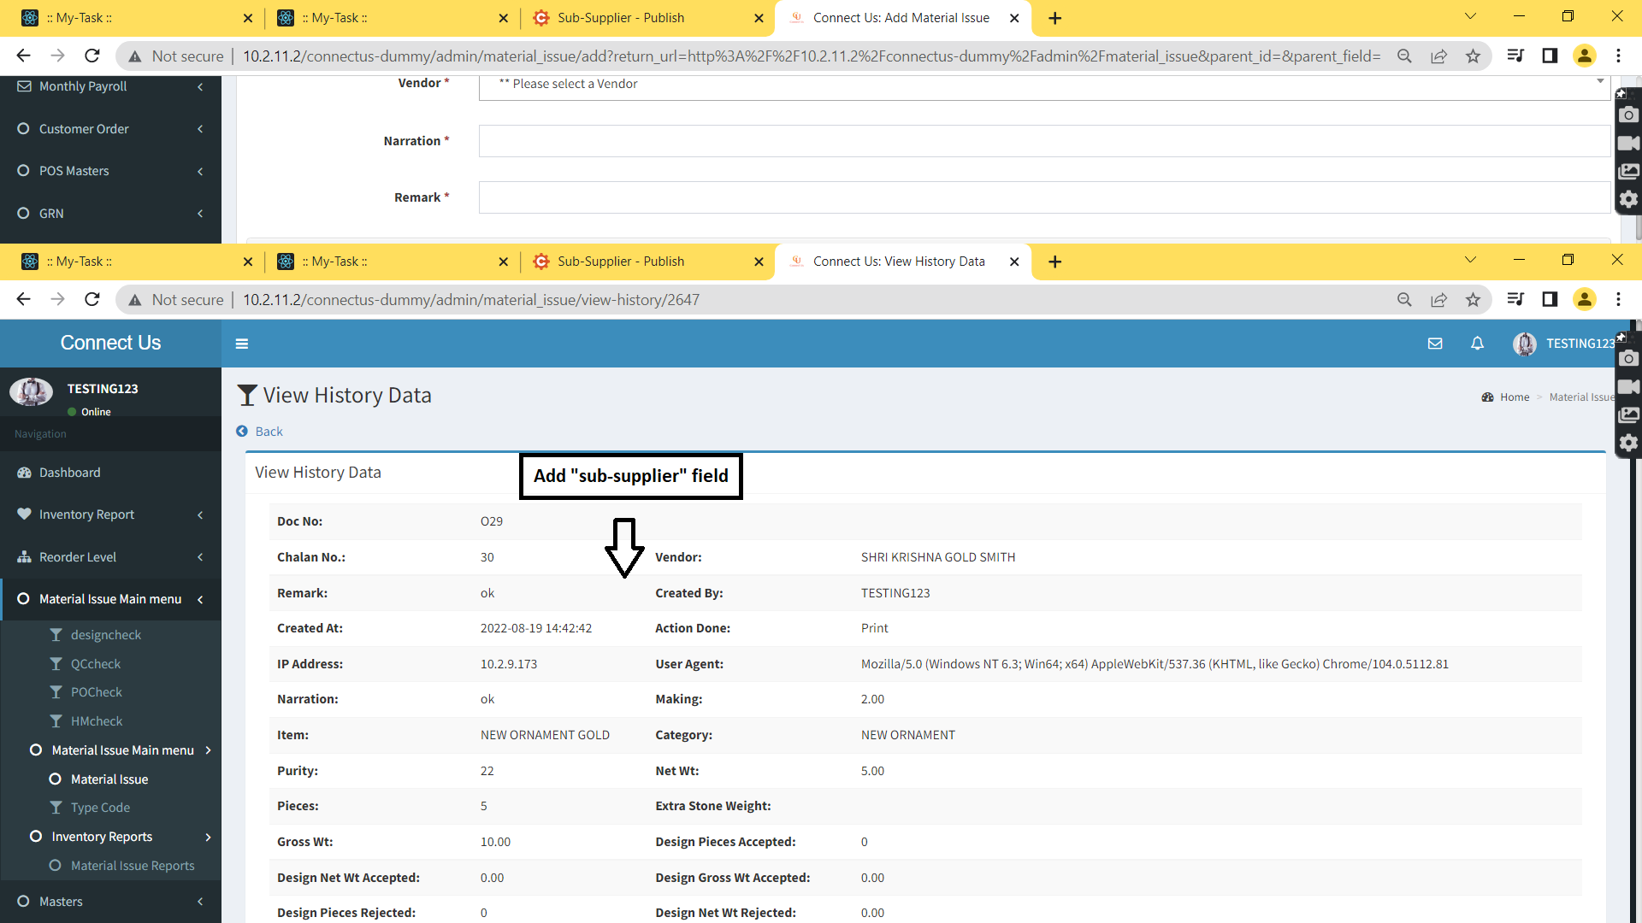

In Connect Us -> Material issue main menu -> material issue -> edit

Add “Sub-supplier” field.

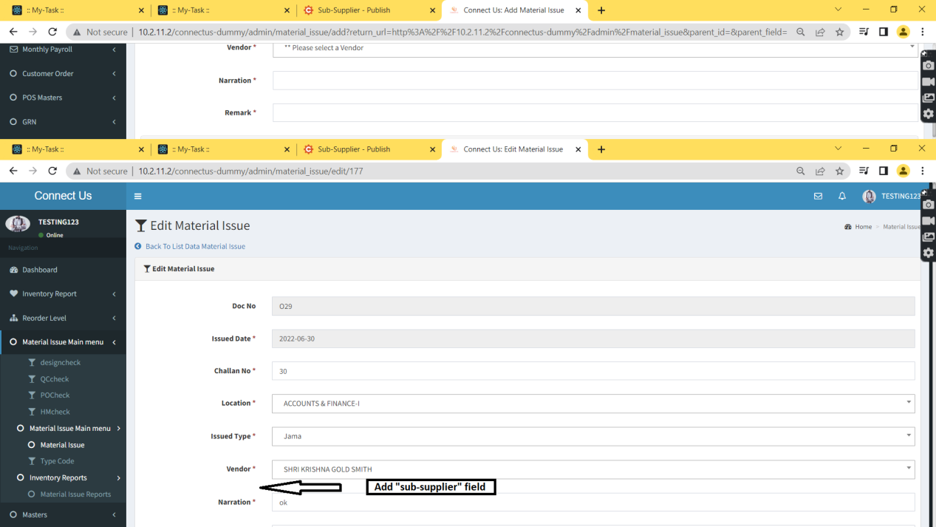

In Connect Us -> Material issue main menu -> design check

Add “Sub-supplier” column.

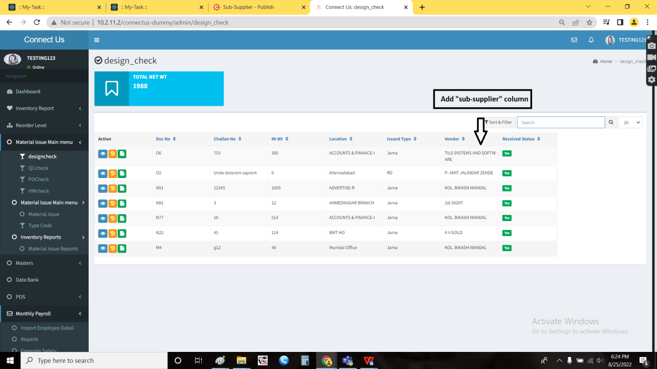

In Connect Us -> Material issue main menu -> design check -> view

Add “Sub-supplier” field.



In Connect Us -> Material issue main menu -> design check -> History

Add “Sub-supplier” column in table.



In Connect Us -> Material issue main menu -> design check -> History -> View

Add “Sub-supplier” field.



In Connect Us -> Material issue main menu -> design check -> issued format

Add “Sub-supplier” field.

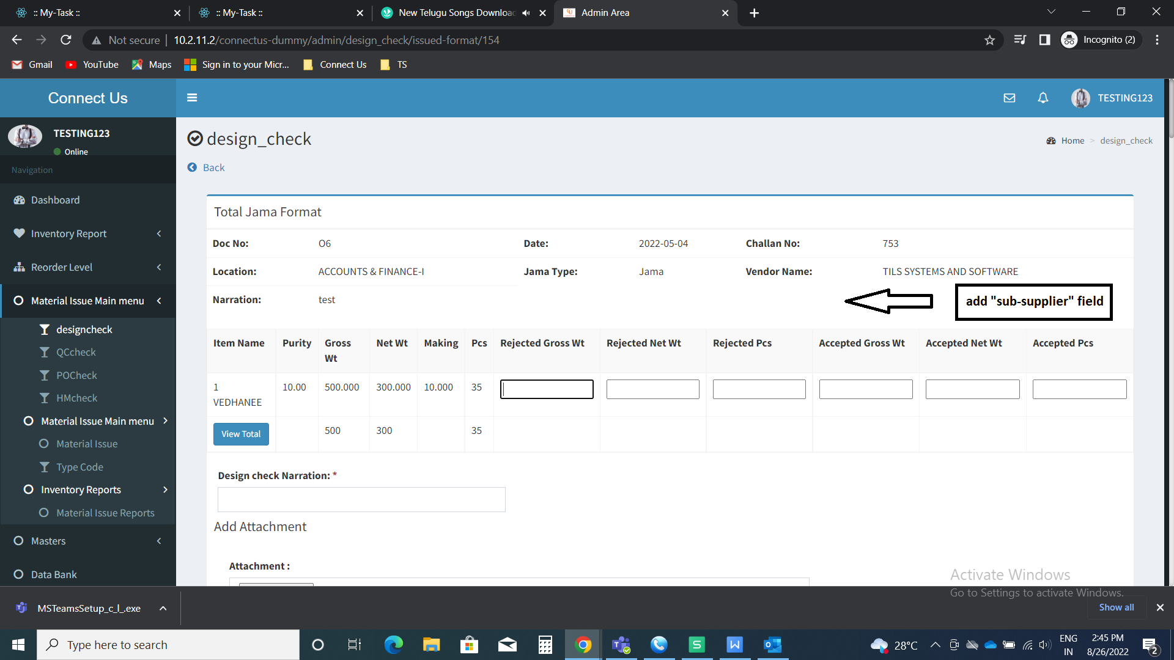

In Connect Us -> Material issue main menu -> QC check

Add “Sub-supplier” column.

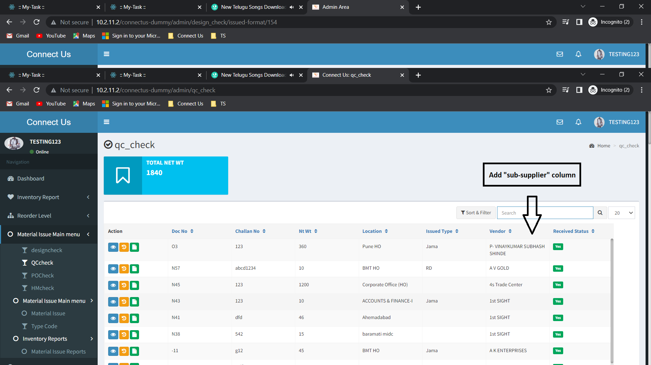

In Connect Us -> Material issue main menu -> QC check -> view

Add “Sub-supplier” field.



In Connect Us -> Material issue main menu -> QC check -> History

Add “Sub-supplier” column in table.



In Connect Us -> Material issue main menu -> QC check -> History -> View

Add “Sub-supplier” field.



In Connect Us -> Material issue main menu -> QC check -> issued format

Add “Sub-supplier” field.

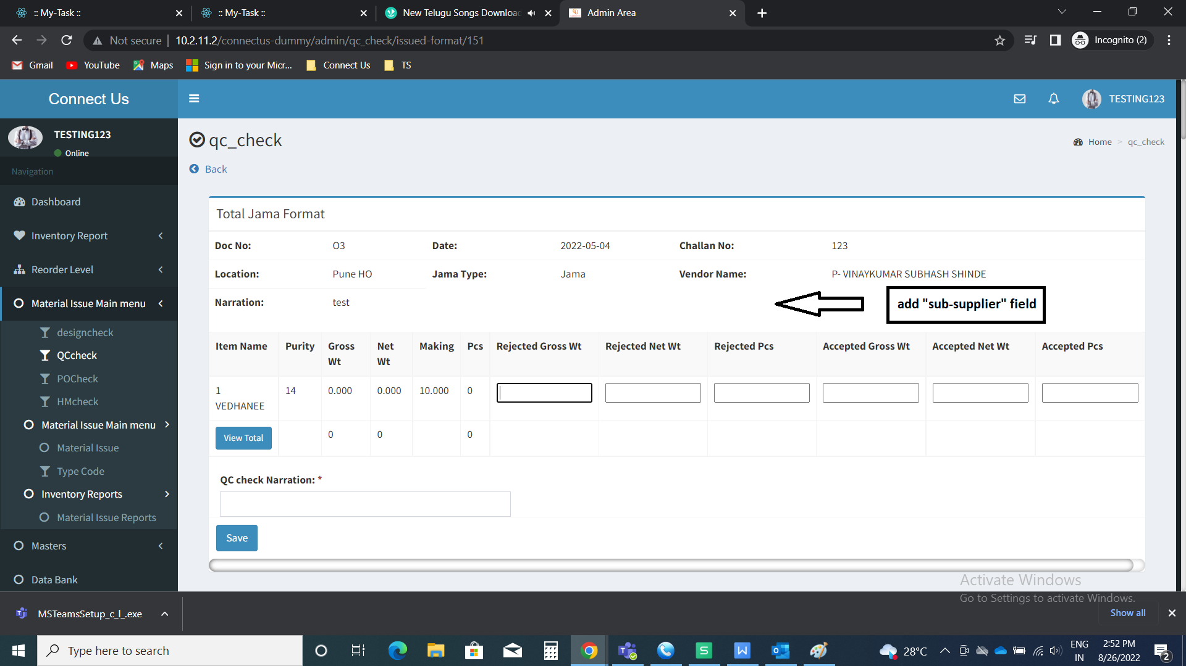

In Connect Us -> Material issue main menu -> PO check

Add “Sub-supplier” column.

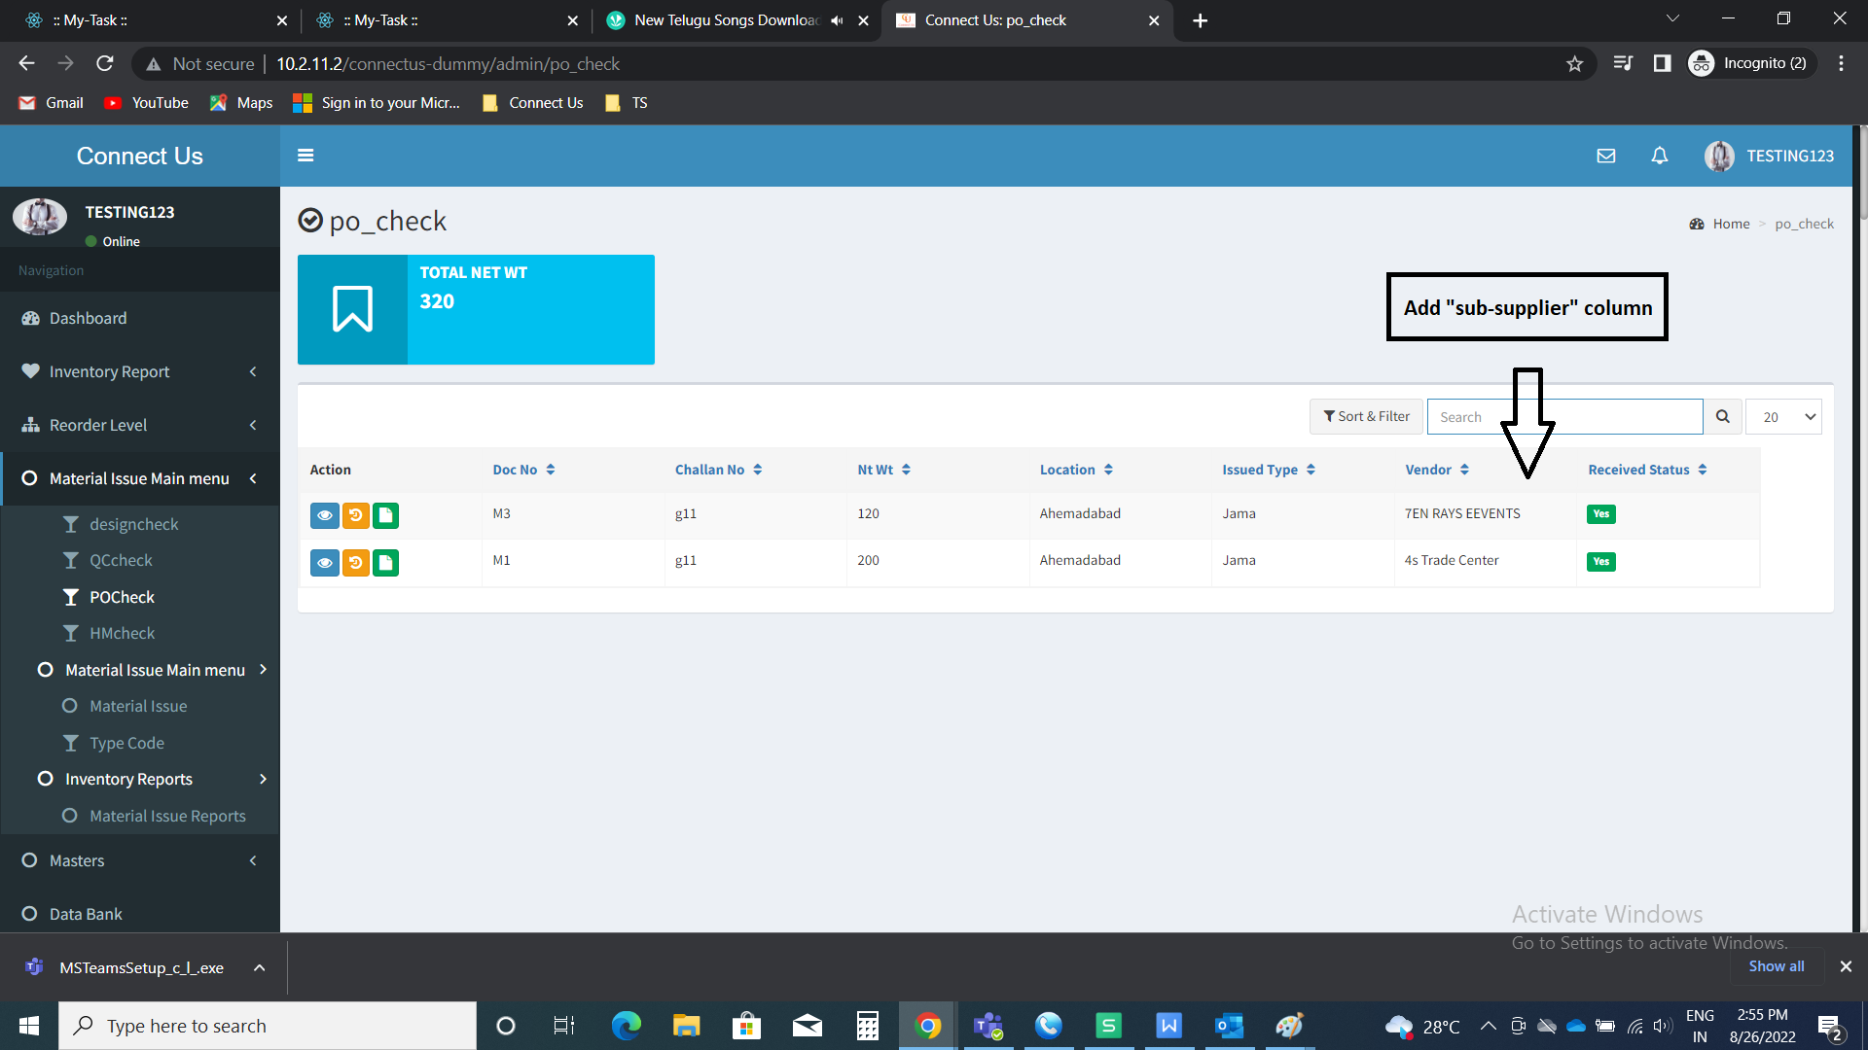

In Connect Us -> Material issue main menu -> PO check -> view

Add “Sub-supplier” field.



In Connect Us -> Material issue main menu -> PO check -> History

Add “Sub-supplier” column in table.



In Connect Us -> Material issue main menu -> PO check -> History -> View

Add “Sub-supplier” field.



In Connect Us -> Material issue main menu -> PO check -> issued format

Add “Sub-supplier” field.

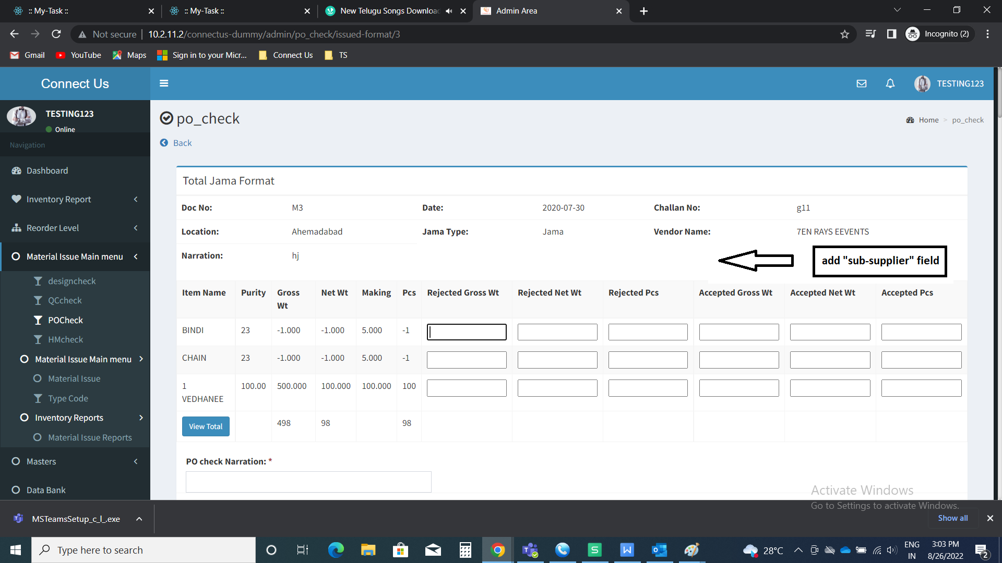

In Connect Us -> Material issue main menu -> HM check

Add “Sub-supplier” column.

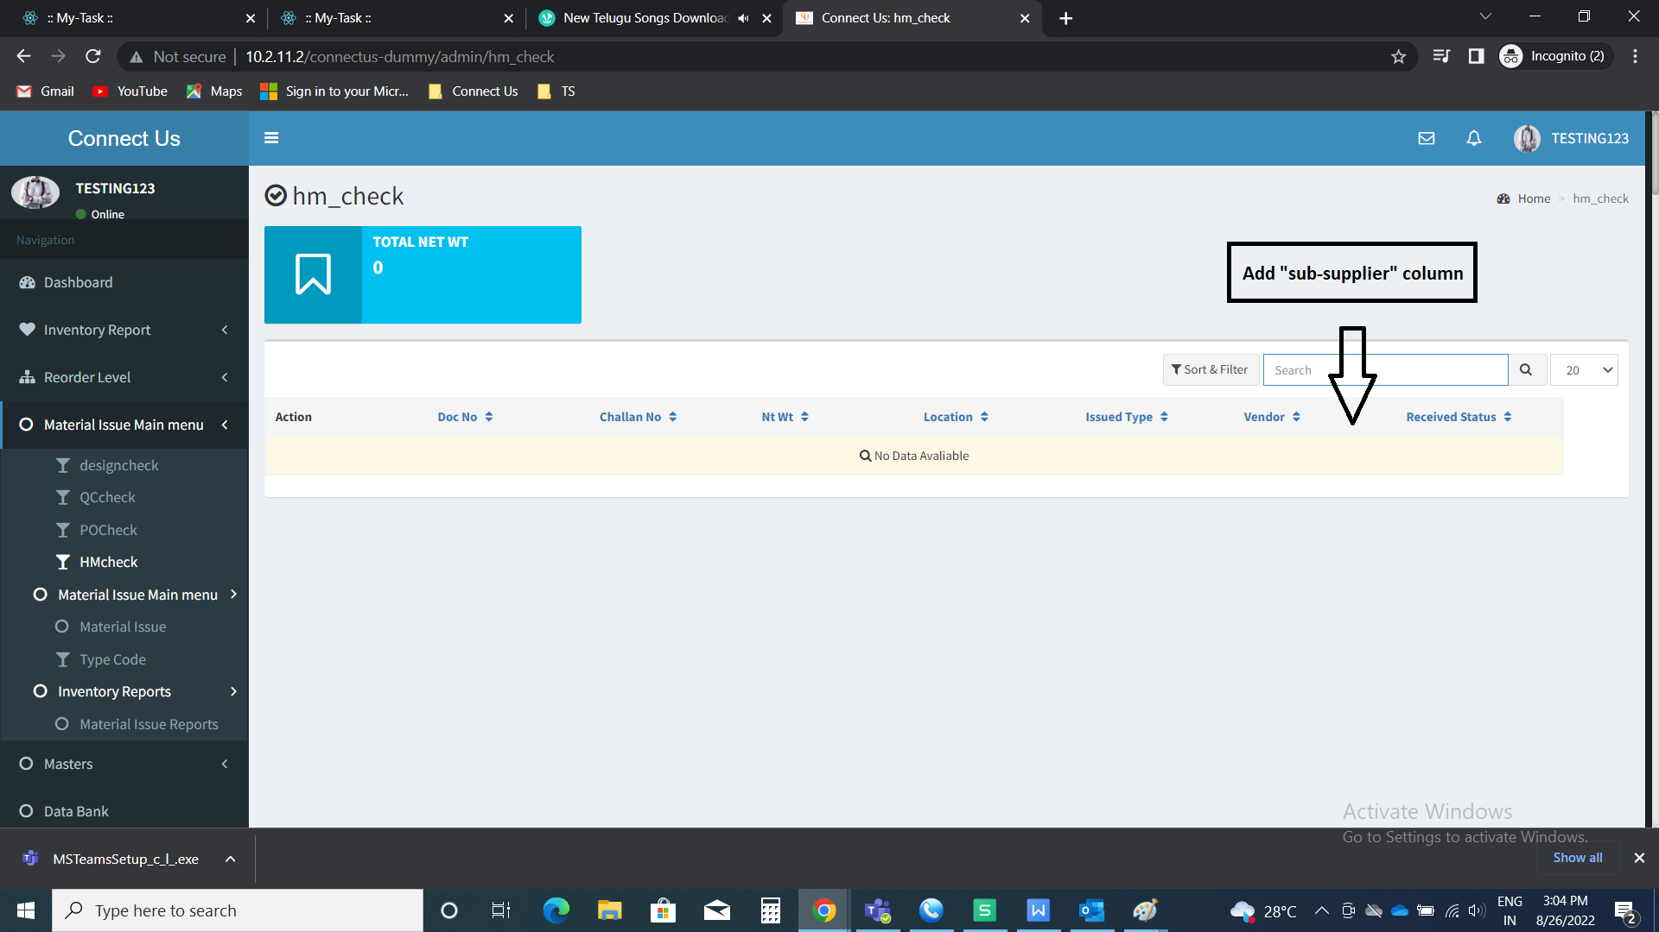

In Connect Us -> Material issue main menu -> HM check -> view

Add “Sub-supplier” field.



In Connect Us -> Material issue main menu -> HM check -> History

Add “Sub-supplier” column in table.



In Connect Us -> Material issue main menu -> HM check -> History -> View

Add “Sub-supplier” field.



In Connect Us -> Material issue main menu -> HM check -> issued format

Add “Sub-supplier” field.



In Connect Us -> Material issue main menu -> Material issue reports -> Material issued report

In type wise reports, user wise reports, K Jama reports, RD reports, Type wise and user wise reports, all reports - add “sub-supplier” column.

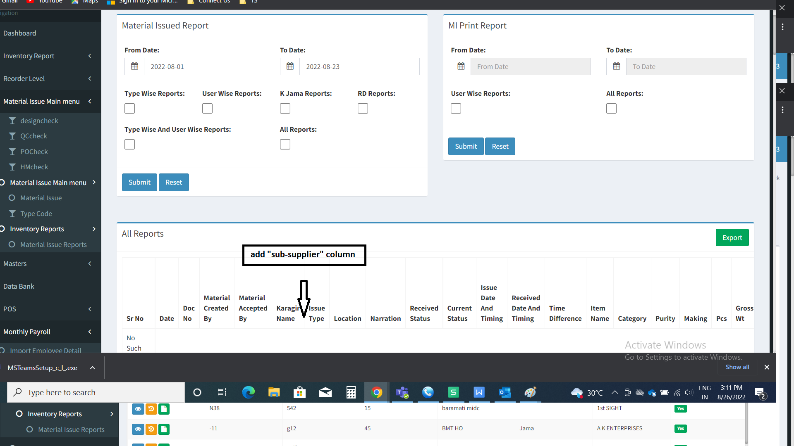

In Connect Us -> Material issue main menu -> Material issue reports -> Material issued report - export

Export of type wise reports, user wise reports, K Jama reports, RD reports, Type wise and user wise reports, all reports - add “sub-supplier” column.

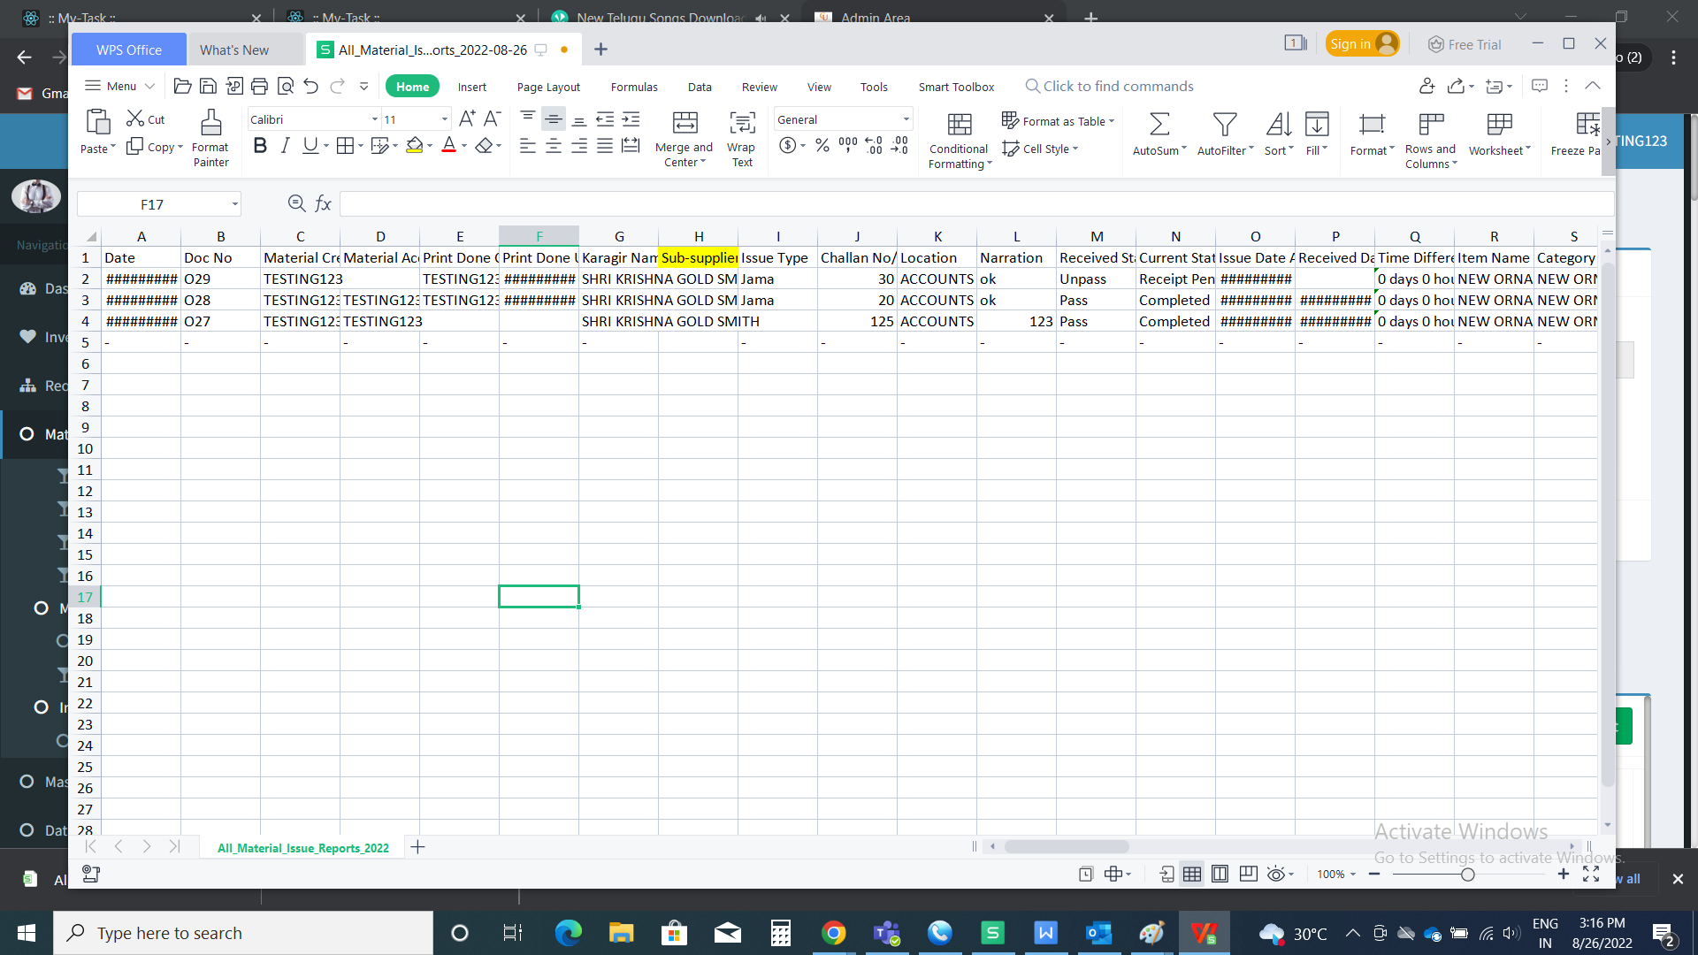

In Connect Us -> Material issue main menu -> Material issue reports -> MI print report

In user wise reports and all reports - add “sub-supplier” column.

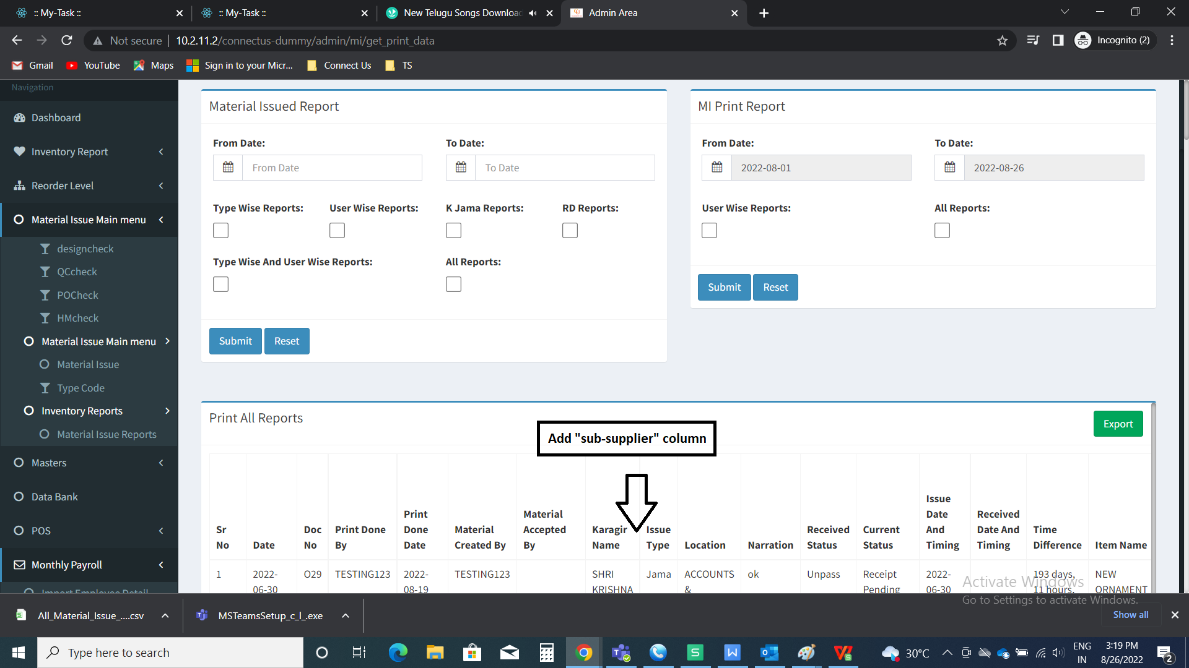

In Connect Us -> Material issue main menu -> Material issue reports -> MI print report -> export

Export of user wise reports and all reports - add “sub-supplier” column.



In Connect Us -> Inventory reports -> Karagir issue report -> Material issued report

In type wise reports, user wise reports, K Jama reports, RD reports, Type wise and user wise reports, all reports - add “sub-supplier” column.



In Connect Us -> Inventory reports -> Karagir issue report -> Material issue reports -> Material issued report - export

Export of type wise reports, user wise reports, K Jama reports, RD reports, Type wise and user wise reports, all reports - add “sub-supplier” column.



In Connect Us -> Inventory reports -> Karagir issue report -> MI print report

In user wise reports and all reports - add “sub-supplier” column.



In Connect Us -> Inventory reports -> Karagir issue report -> MI print report -> export

Export of user wise reports and all reports - add “sub-supplier” column.



**References of the users**

|  |  |  |  |
| --- | --- | --- | --- |
| **User** | **Name** | **Mail** | **Contact number** |
| **Actual user** | Tushar Shivaji Nikam | designgd@csjewellers.com |  |
| **Assigned business analyst** | Mounika KrishnaVeni Annamneedi | Mounika.annamneedi@techneai.com | 8669917920 |