|  |  |
| --- | --- |
| **Ticket ID** |  |
| **Ticket description** | *Bill checking process from Purchase order generation to vendor Invoice payment.* |
| **Created by** | *Sandeep Avchitte* |
| **Created on** | *28/02/2022* |
| **Priority** | *High* |
| **Version** | *1.0* |

**Version**

|  |  |  |  |  |
| --- | --- | --- | --- | --- |
| **Sr. No** | **Version no** | **Version Date** | **User name** | **User department** |
|  |  |  |  |  |

**Approvals**

|  |  |  |
| --- | --- | --- |
| **Field** | **Name of the User** | **Approved date by the user** |
| **Actual User Name** |  |  |
| **Actual User Department** |  |  |
| **Organization Name** |  |  |
| **Assigned BA** |  |  |
| **Assigned Developer** |  |  |
| **Assigned Tester** |  |  |

**Estimation**

|  |  |  |  |  |
| --- | --- | --- | --- | --- |
| **Department name** | **Estimated Time (In hr)** | **Scheduled Date (Starting date )** | **Estimated date** | **Actual delivery date** |
| **BA** |  |  |  |  |
| **Development** |  |  |  |  |
| **Testing** |  |  |  |  |

**Introduction**

*Bill checking process from Purchase order generation to vendor Invoice payment.*

**Business requirement**

*Need to implement Bill checking process from Purchase order generation to vendor Invoice payment.*

**Abbreviations & terms**

*PO - Purchase Order.*

**Proposed system**

*This system will be implemented for Bill checking process from Purchase order generation to vendor Invoice payment.*

*We have divided this system into sub-processes for more detail concept understanding as below.*

1. ***New Vendor Registration Process***

*For vendor registration vendor should be able to visit vendor registration page when he/she click on “Link Name”.*

*For vendor registration vendor should able to get vendor registration form when click on* ***“New Vendor Registration”*** *Button.*

*The New vendor registration process is illustrated below through the flowchart I.e. how the new vendor will interact with the system while his/her registration. (Please refer the below flowchart)*

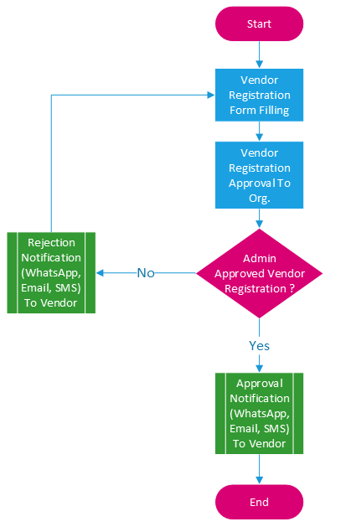

Image 1: New Vendor Registration

*Vendor should be able to get below fields at the time form filling (Please refer the below table)*

*Here in the table we have mentioned the the Field name, Data type of concern field followed by description of the same field.*

|  |  |  |  |
| --- | --- | --- | --- |
| ***Sr. No*** | ***Field*** | ***Data Type*** | ***Description*** |
| ***Personal Details*** | | | |
| *1* | *Vendor ID* | *Int(5)* | *This is an auto-increment field and this is disabled.* |
| *2* | *Vendor name* | *Char (200)* | *Here we can add vendor name.* |
| *3* | *Address* | *Varchar (200)* | *Here we can add address.* |
| *4* | *City* | *Drop-down* | *Enter city name manually.* |
| *5* | *State* | *Drop-down* | *Drop-down list given. Data fetch from state master.* |
| *6* | *Country* | *Drop-down* | *Drop-down list given. Data fetch from country master.* |
| *7* | *Pin code* | *Int* | *Enter Pin code manually* |
| *8* | *Mobile no* | *Int (10)* | *Mobile no must be 10 digit.* |
| *9* | *Email id* | *Varchar* | *Email id enter in slandered format.*  *Ex: abc1@gmail.com* |
| *10* | *Services* | *Drop-down* | *NA* |
| *11* | *Aadhar No* | *Int (12)* | *Aadhar no enter only 12 digit.* |
| *12* | *Upload Aadhar* | *File* | *Attachment upload* |
| ***Tax Details*** | | | |
| *13* | *PAN No* | *Varchar (10)* | *First 5 is alphabet next 4 is digit and last is alphabet.* |
| *14* | *Upload PAN* | *File* | *PAN upload* |
| *15* | *GST No* | *Varchar(15)* | *First is state code then PAN no and one digit then laste 2 alphabale.* |
| *16* | *Upload GST* | *File* | *Upload GST* |
| *17* | *MSME No* | *Varchar(50)* | *Enter MSME No.* |
| *18* | *Upload MSME* | *File* | *Upload MSME* |
| ***Bank Details*** | | | |
| *19* | *Bank name* | *Varchar (30)* | *Enter Bank Name* |
| *20* | *Bank branch name* | *Varchar(30)* | *Enter Branch Name* |
| *21* | *Bank account No* | *Int* | *Enter Bank Account No.* |
| *22* | *IFSC code* | *Varchar(20)* | *Enter IFSC Code* |
| *23* | *Upload Cheque* | *File* | *Upload Cheque* |
| *24* | *Upload Bank Passbook* | *File* | *Upload Bank Passbook* |
| *25* | *Save* | *Button* | *Submit* |

*As we mentioned earlier, We have given description for each field in the above table. Here below we have given the UI elements for the for the above and has illustrated the same. (Please refer the below UI elements)*

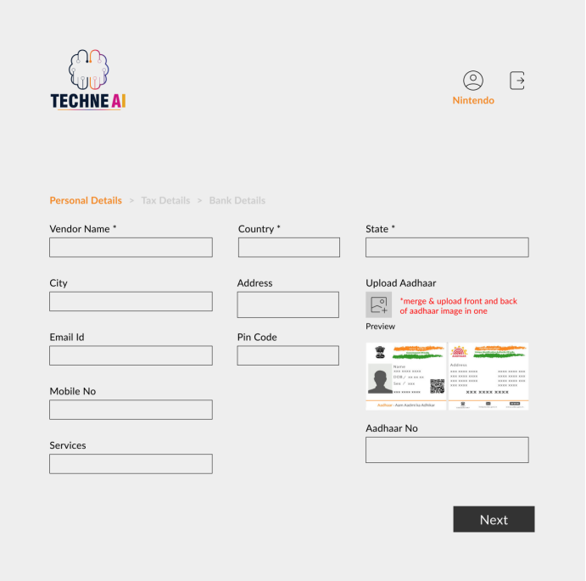

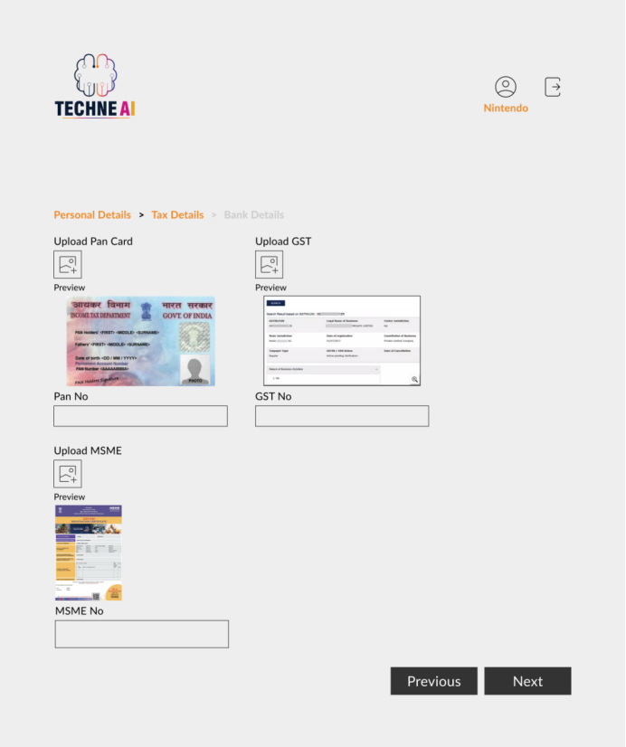

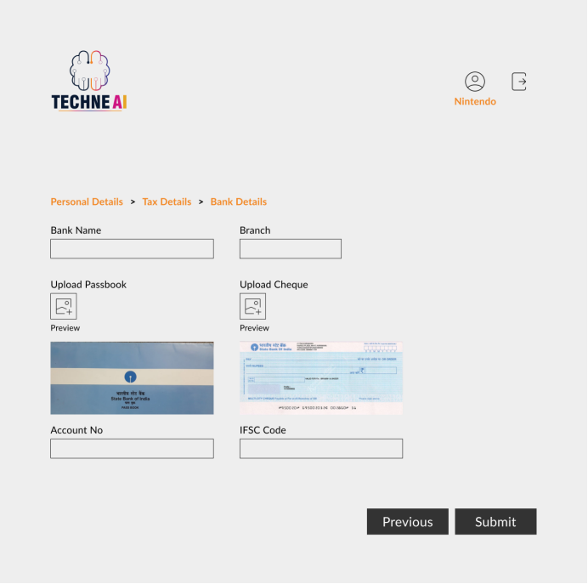

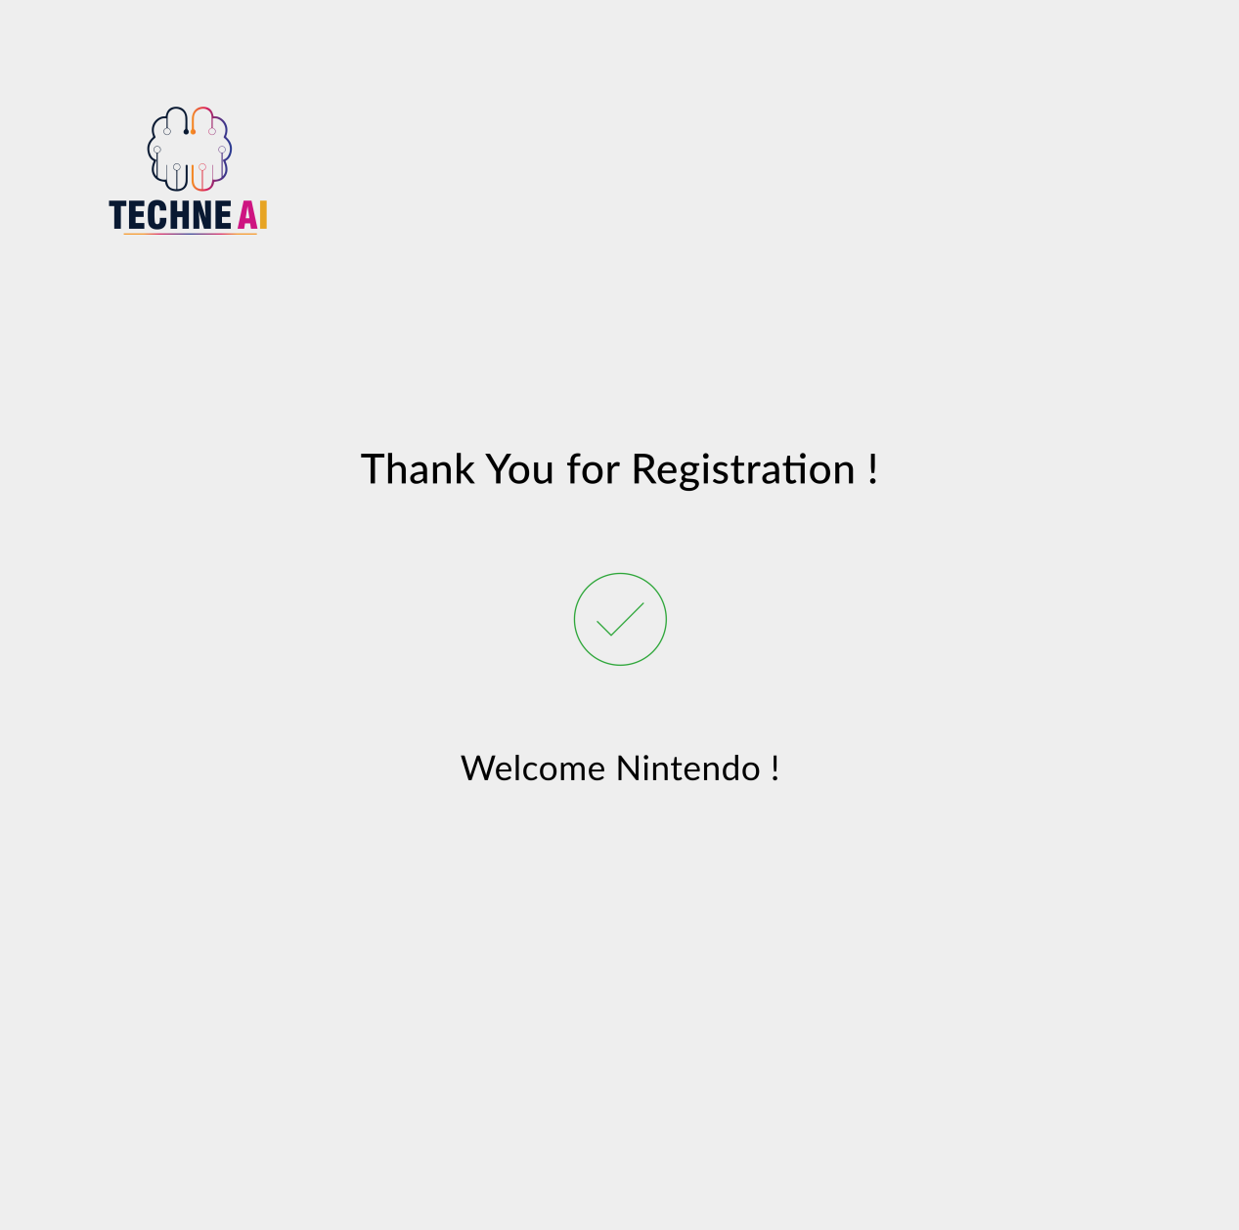

*When vendor click on submit button after filling up the registration form. The pop-up message should be populated on the screen* ***“Thank You for Registration !”***

*\*\*Please note that all the fields should be mandatory to fill and pop-up message should be populated on screen* ***“Something went wrong..!”*** *if vendor user enter any wrong information in any field I.e. It should be validation pop-up.*

1. ***Edit Vendor Profile Process***

*Vendor should able to edit his/her vendor profile when he/she wants.*

*The edit vendor profile process is illustrated below through the flowchart I.e. how the new vendor will interact with the system while editing his/her profile. (Please refer the below flowchart)*

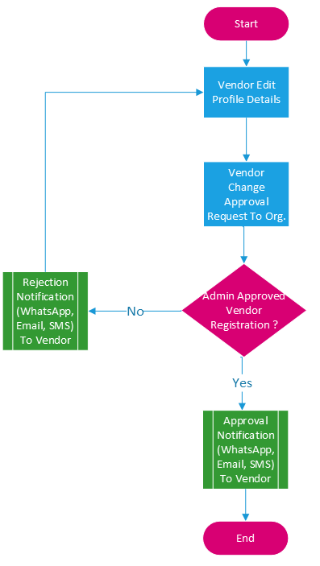

Image 2: Edit Vendor Profile

*Vendor should be able to edit below fields except Vendor ID at the time edit profile (Please refer the below table)*

*Here in the table we have mentioned the the Field name, Data type of concern field followed by description of the same field.*

|  |  |  |  |
| --- | --- | --- | --- |
| ***Sr. No*** | ***Field*** | ***Data Type*** | ***Description*** |
| ***Personal Details*** | | | |
| *1* | *Vendor ID* | *Int(5)* | *This is an auto-increment field and this is disabled.* |
| *2* | *Vendor name* | *Char (200)* | *Here we can add vendor name.* |
| *3* | *Address* | *Varchar (200)* | *Here we can add address.* |
| *4* | *City* | *Drop-down* | *Enter city name manually.* |
| *5* | *State* | *Drop-down* | *Drop-down list given. Data fetch from state master.* |
| *6* | *Country* | *Drop-down* | *Drop-down list given. Data fetch from country master.* |
| *7* | *Pin code* | *Int* | *Enter Pin code manually* |
| *8* | *Mobile no* | *Int (10)* | *Mobile no must be 10 digit.* |
| *9* | *Email id* | *Varchar* | *Email id enter in slandered format.*  *Ex: abc1@gmail.com* |
| *10* | *Services* | *Drop-down* | *NA* |
| *11* | *Aadhar No* | *Int (12)* | *Aadhar no enter only 12 digit.* |
| *12* | *Upload Aadhar* | *File* | *Attachment upload* |
| ***Tax Details*** | | | |
| *13* | *PAN No* | *Varchar (10)* | *First 5 is alphabet next 4 is digit and last is alphabet.* |
| *14* | *Upload PAN* | *File* | *PAN upload* |
| *15* | *GST No* | *Varchar(15)* | *First is state code then PAN no and one digit then laste 2 alphabale.* |
| *16* | *Upload GST* | *File* | *Upload GST* |
| *17* | *MSME No* | *Varchar(50)* | *Enter MSME No.* |
| *18* | *Upload MSME* | *File* | *Upload MSME* |
| ***Bank Details*** | | | |
| *19* | *Bank name* | *Varchar (30)* | *Enter Bank Name* |
| *20* | *Bank branch name* | *Varchar(30)* | *Enter Branch Name* |
| *21* | *Bank account No* | *Int* | *Enter Bank Account No.* |
| *22* | *IFSC code* | *Varchar(20)* | *Enter IFSC Code* |
| *23* | *Upload Cheque* | *File* | *Upload Cheque* |
| *24* | *Upload Bank Passbook* | *File* | *Upload Bank Passbook* |
| *25* | *Save* | *Button* | *Submit* |

*\*\*Please note that pop-up message should be populated on screen* ***“Something went wrong..!”*** *accordingly**if vendor user enter any wrong information in any field I.e. It should be validation pop-up. Also, UI elements will remain same as per new vendor registration process. (Please refer the same)*

1. ***Vendor Approval Process***

*When vendor will submit vendor registration form, his/her registration approval request should be submitted at Organization Admin so that he/she can give on approval or rejection on the same.*

*The vendor approval process is illustrated below through the flowchart I.e. how the new vendor will get his/her approval over his/her registration within the system. (Please refer the below flowchart)*

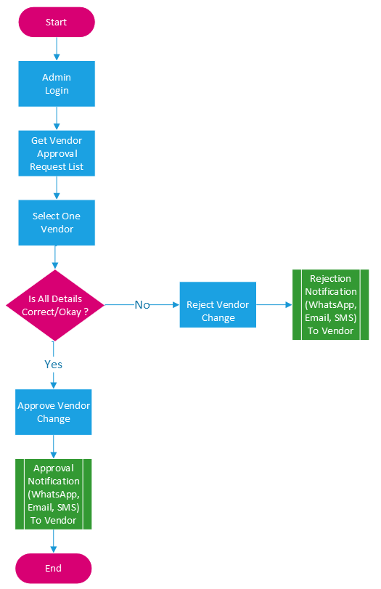

Image 3: Vendor Approval Process

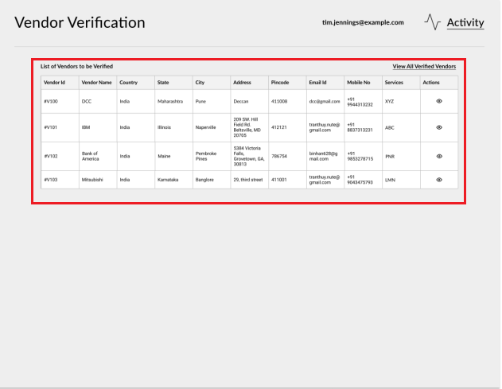

*Company/Organization Admin should be able to get new vendor registration approval requests at* ***“Vendor Verification”*** *module. The most recent vendor approval request should be appear on the top of list.*

*To approve or reject the request, Admin should be able to view the all the details of the particular request when click on the same. The UI for the same is showing below (Please refer)*

*After verifying the vendor details, Admin should be able to click on* ***“Reject”*** *or* ***“Approve”*** *button once and immediate after both buttons should get disable.*

*And accordingly the notification I.e. Whats App, E-mail and SMS should be sent to vendor registered number and email address.*

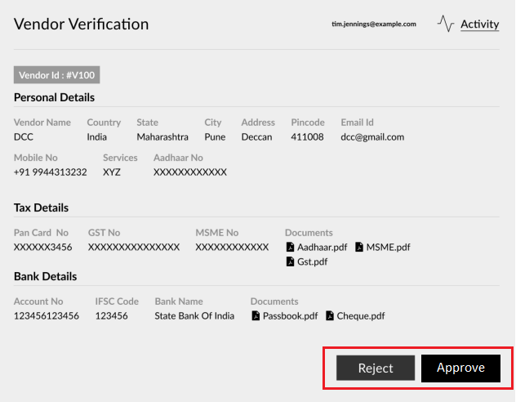

1. ***Vendor Payment Process***

*When vendor will submit the invoice on any PO then HOD should be able to retrieve the same through his/her login and accordingly he/she should be able to assign the invoice to the account team and account team should be further assign to the assign audit team.*

*The vendor payment process is illustrated below through the flowchart I.e. how the vendor invoice will get pass/approve for the payment. (Please refer the below flowchart)*

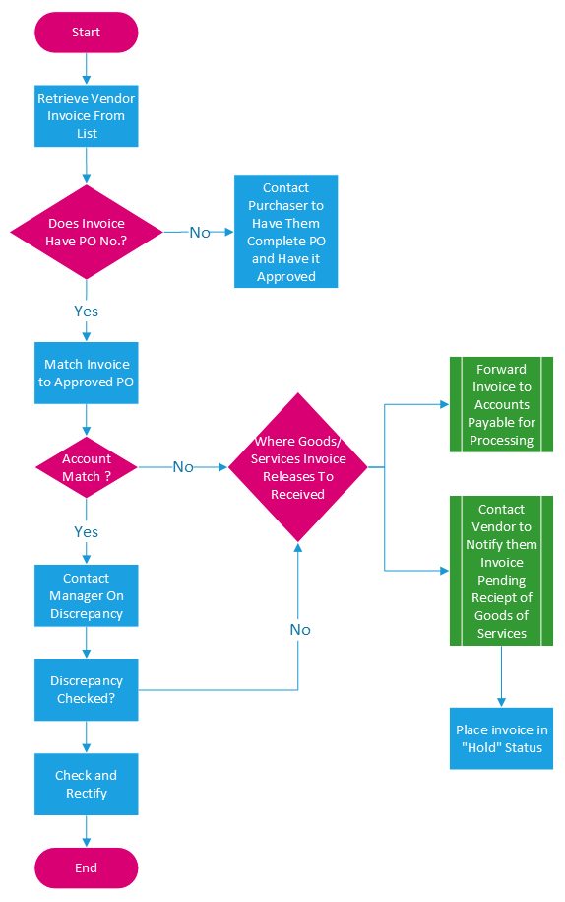

Image 4: Vendor Payment Process

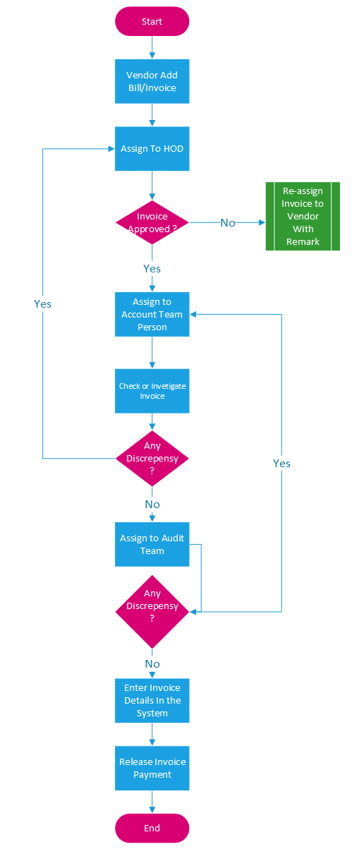

**Input table**

|  |  |  |  |  |
| --- | --- | --- | --- | --- |
| **FIELDS** | **INPUT TYPE** | **MANDATORY/ OPTIONAL** | **DESCRIPTION** | **CONDITIONS IF ANY** |
|  |  |  |  |  |
|  |  |  |  |  |
|  |  |  |  |  |

**References of the users**

|  |  |  |  |
| --- | --- | --- | --- |
| **User** | **Name** | **Mail** | **Contact number** |
| **Actual user** |  |  |  |
| **Ticket created by (if any)** |  |  |  |
| **Assigned business analyst** |  |  |  |
| **Assigned developer** |  |  |  |
| **Assigned tester** |  |  |  |