|  |  |
| --- | --- |
| **Ticket ID** |  |
| **Ticket description** | *Bill checking system* |
| **Created by** | *Harshali Ajay Rananaware* |
| **Created on** | *09 Nov 2021* |
| **Priority** | *Very high* |
| **Version** | *0* |

**Version**

|  |  |  |  |  |
| --- | --- | --- | --- | --- |
| **Sr. No** | **Version no** | **Version Date** | **User name** | **User department** |
| **1** | **0** | *09 Nov 2021* |  |  |

**Approvals**

|  |  |  |
| --- | --- | --- |
| **Field** | **Name of the User** | **Approved date by the user** |
| **Actual User Name** |  |  |
| **Actual User Department** |  |  |
| **Organization Name** |  |  |
| **Assigned BA** |  |  |
| **Assigned Developer** |  |  |
| **Assigned Tester** |  |  |

**Estimation**

|  |  |  |  |  |
| --- | --- | --- | --- | --- |
| **Department name** | **Estimated Time (In hr)** | **Scheduled Date (Starting date )** | **Estimated date** | **Actual delivery date** |
| **BA** |  |  |  |  |
| **Development** |  |  |  |  |
| **Testing** |  |  |  |  |

**Abbreviations & terms**

**Proposed system**

This system is mainly use for following purpose.

1. Digitalization of vendor bill
2. Payment on time
3. Auto-generation of the bill for the bank purpose

|  |  |  |
| --- | --- | --- |
| **Sr. No** | **Menu** | **Sub Menu** |
|  | Master | Country Master |
|  |  | State Master |
|  |  | City Master |
|  |  | Employee Master |
|  |  | Vendor Master |
|  |  | Department Master |
|  |  | Payment Master |
|  |  | User Login Master |
|  |  | Services Master |
| 2. | Invoice |  |
| 3. | Released bills |  |
| 4. | Payment status |  |

* **Vendor registration Link -** When the vendor registers by self, then following fields are shown.

The vendor add the details, then the approval should be given by the company. The administration team gets the notifiaction when new vendor is registered. The admin can approve or reject the vendor. There should be a notification to his/her login regarding that approval or rejection. The notifications are sent by whatsapp, e-mail and SMS.

**Vendor Profile Update process -**

After approve the vendor then vedor get notification vendor is approved, then open the vendor profile page. The vendor add the details, then the approval should be given by the company. The administration team gets the notifiaction when new vendor is registered. The admin can approve or reject the vendor. There should be a notification to his/her login regarding that approval or rejection. The notifications are sent by whatsapp, e-mail and SMS.

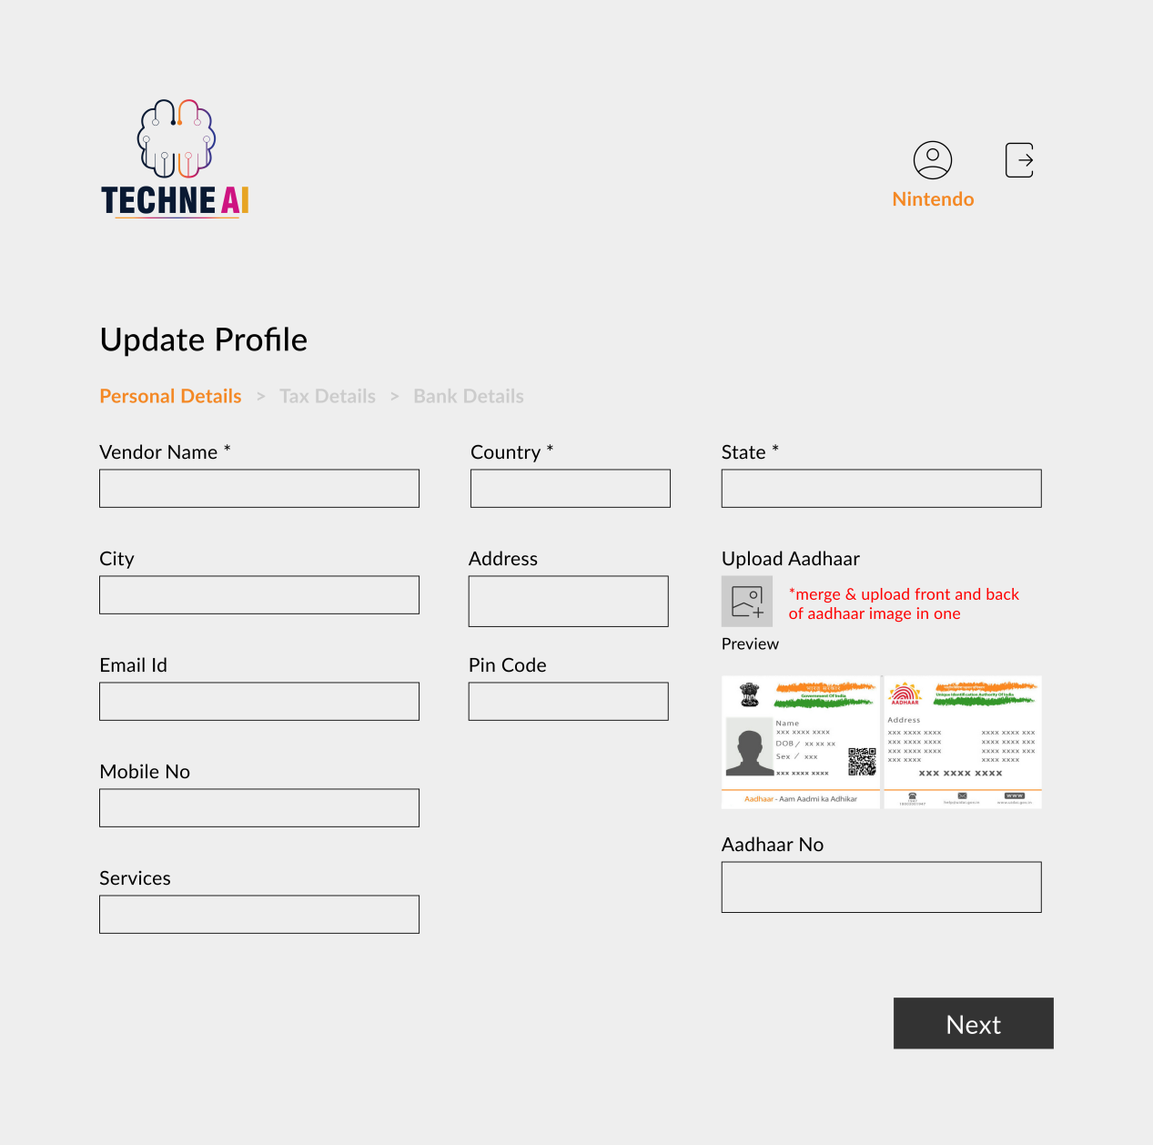

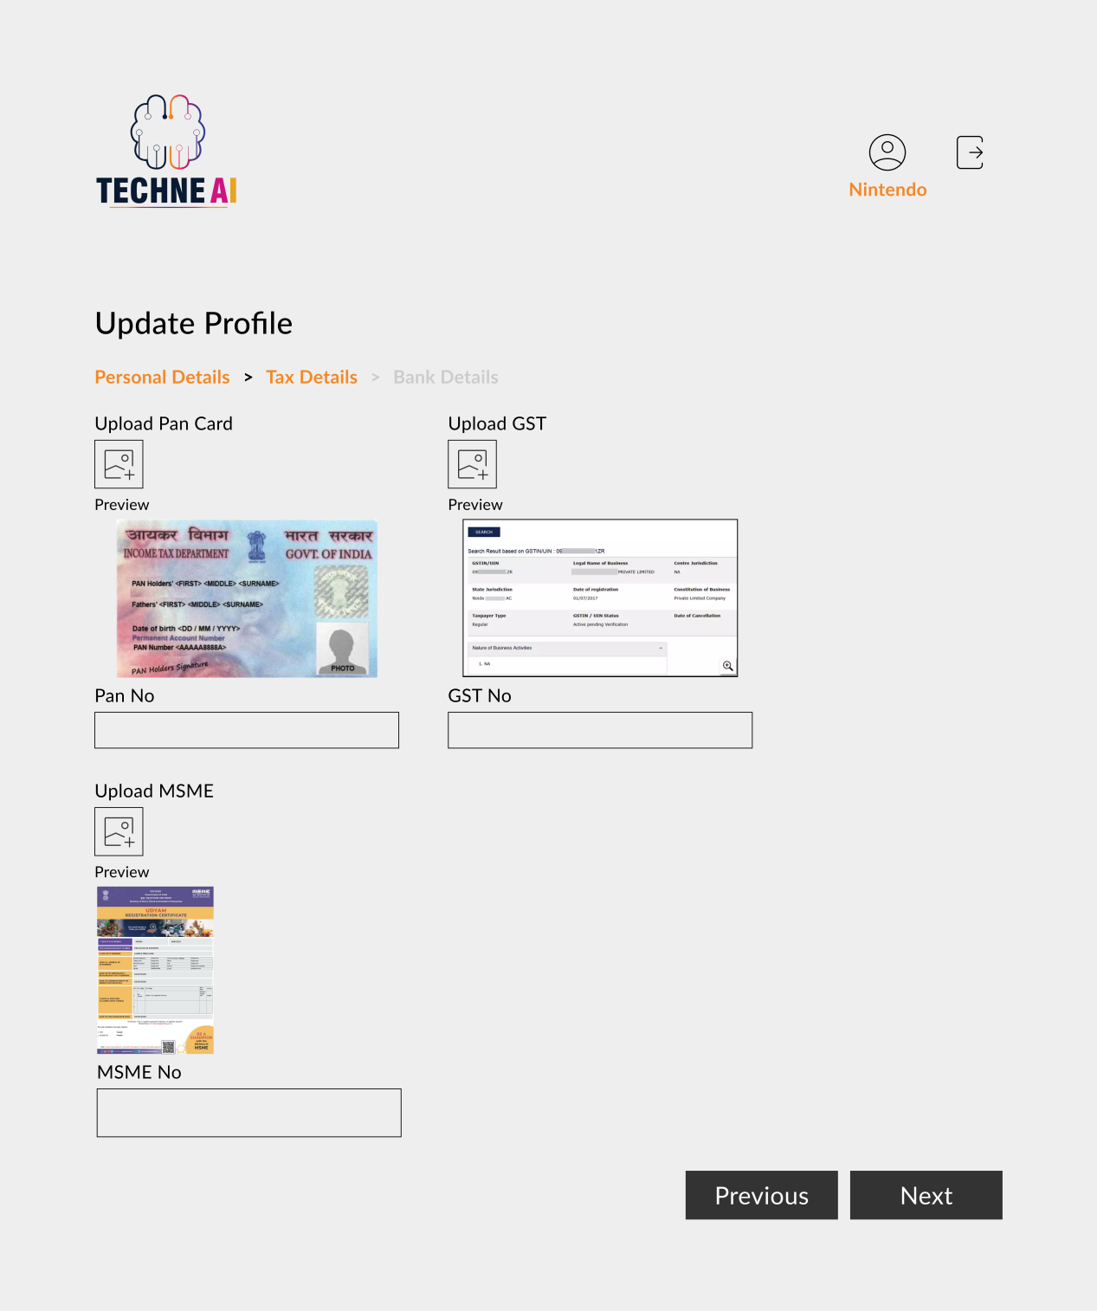

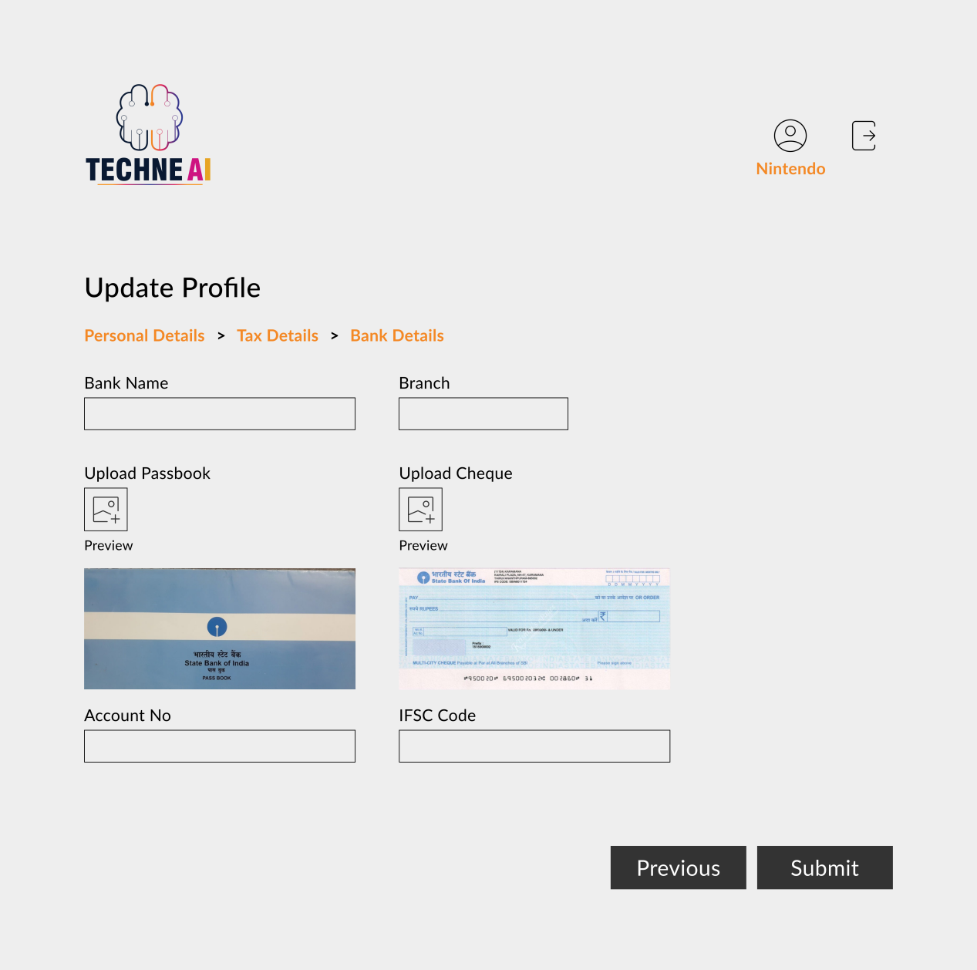

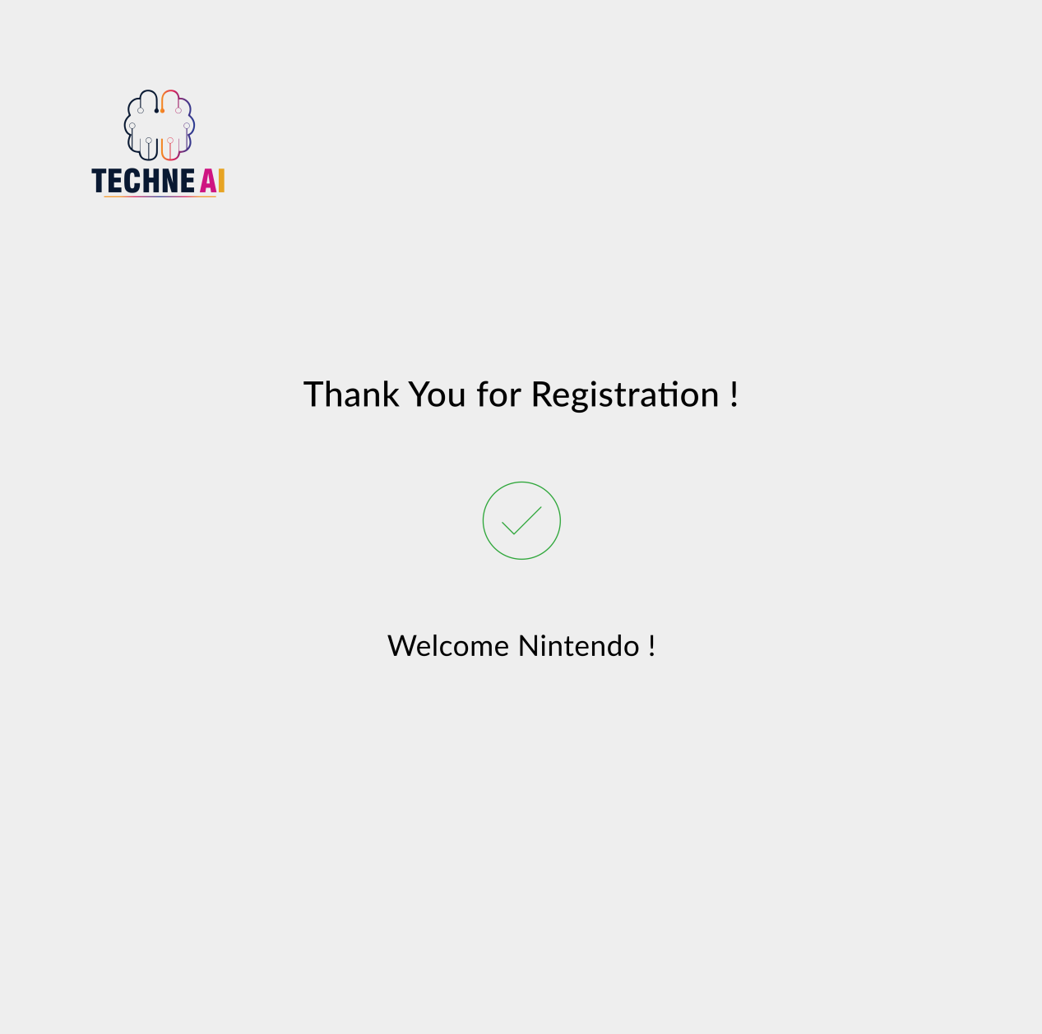

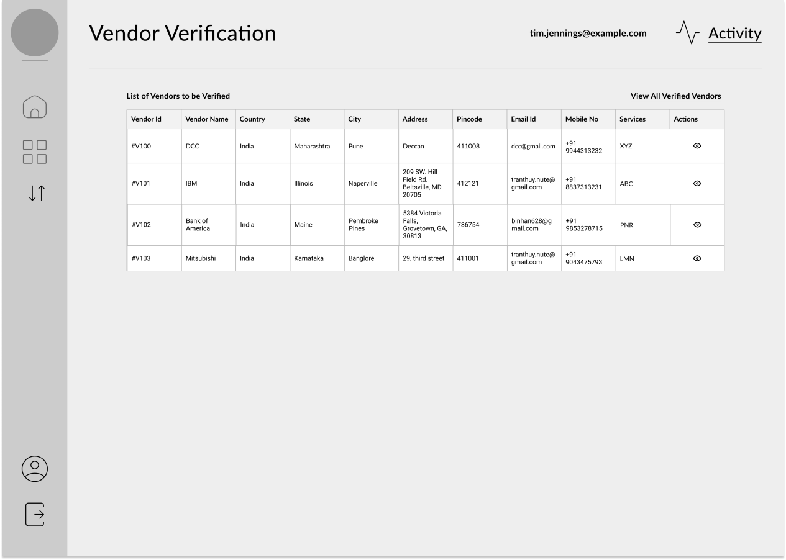

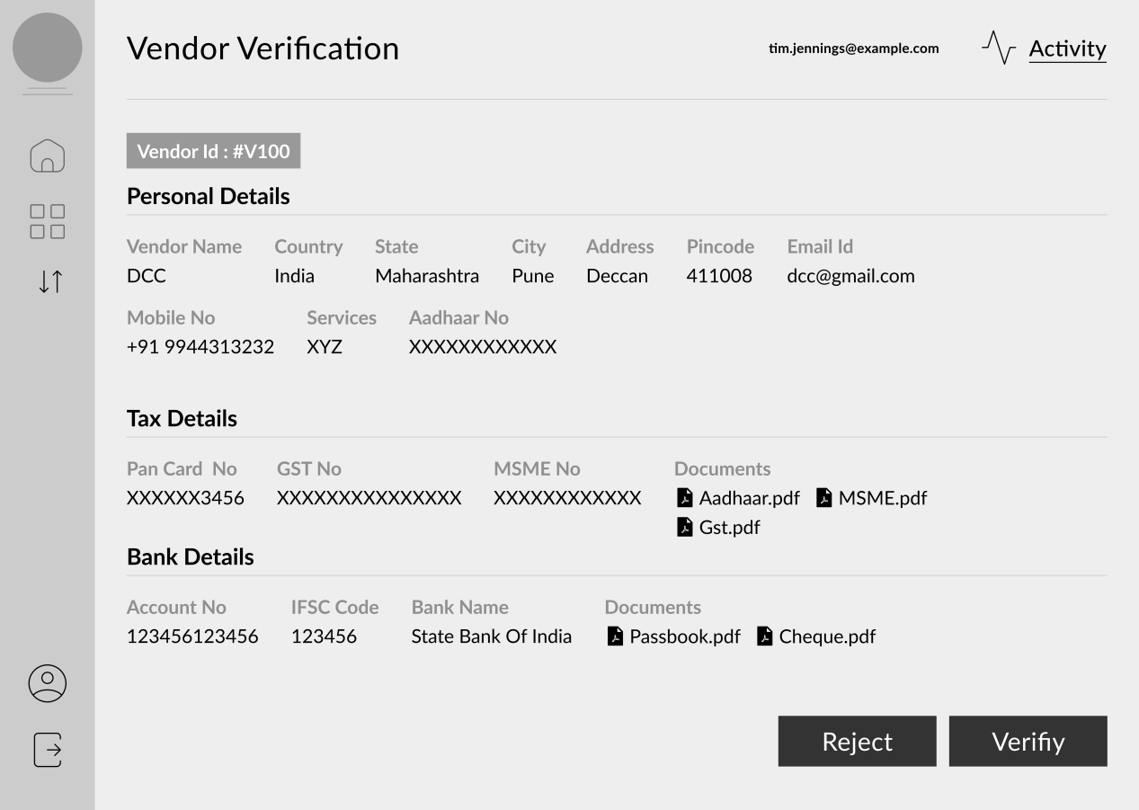

**Add data**

|  |  |  |  |
| --- | --- | --- | --- |
| **Sr. No** | **Field** | **Data Type** | **Description** |
| **Personal Details** | | | |
|  | Vendor ID | Int(5) | This is an auto-increment field and this is disabled. |
|  | Vendor name | Char (200) | Here we add vendor name. |
|  | Address | Varchar (200) | Here we add address. |
|  | City | Drop-down | Drop-down list given. Data fetch from city master. |
|  | State | Drop-down | Drop-down list given. Data fetch from state master. |
|  | Country | Drop-down | Drop-down list given. Data fetch from country master. |
|  | Pincode | Int | Drop-down list given. Data fetch from city master. |
|  | Mobile no | Int (10) | Mobile no must be 10 digit. |
|  | Email id | Varchar | Email id enter in standered format.  Ex abc1@gmail.com |
|  | Services | Drop-down |  |
|  | Adhar No | Int (12) | Aadhar no enter only 12 digit. |
|  | Upload Adhar | File |  |
| **Tax Details** | | | |
|  | PAN No | Varchar (10) | First 5 is alphabet next 4 is digit and last is alphabet. |
|  | Upload PAN | File |  |
|  | GST No | Varchar(15) | First is state code then PAN no and one digit then laste 2 alphabale. |
|  | Upload GST | File |  |
|  | MSME No | Varchar(50) |  |
|  | Upload MSME | File |  |
| **Bank Details** | | | |
|  | Bank name | Varchar (30) |  |
|  | Bank branch name | Varchar(30) |  |
|  | Bank account No | Int |  |
|  | IFSC code | Varchar(20) |  |
|  | Upload Cheque | File |  |
|  | Upload Bank Passbook | File |  |
|  | Save | Button |  |

**Verify profile**

Show all the details of the vendor on the admin login and also show the **approve or reject** button for the approval or the rejection. When the admin approves the vendor, then the vendor is added in vendor master automatically.

|  |  |  |  |
| --- | --- | --- | --- |
| **Sr. No** | **Field** | **Data Type** | **Description** |
| **Personal Details** | | | |
|  | Vendor ID | Int(5) | This is an auto-increment field and this is disabled. |
|  | Vendor name | Char (200) | Here we add vendor name. |
|  | Address | Varchar (200) | Here we add address. |
|  | City | Drop-down | Drop-down list given. Data fetch from city master. |
|  | State | Drop-down | Drop-down list given. Data fetch from state master. |
|  | Country | Drop-down | Drop-down list given. Data fetch from country master. |
|  | Pincode | Int | Drop-down list given. Data fetch from city master. |
|  | Mobile no | Int (10) | Mobile no must be 10 digit. |
|  | Email id | Varchar | Email id enter in standered format.  Ex abc1@gmail.com |
|  | Services | Drop-down |  |
|  | Adhar No | Int (12) | Aadhar no enter only 12 digit. |
|  | Upload Adhar | File |  |
| **Tax Details** | | | |
|  | PAN No | Varchar (10) | First 5 is alphabet next 4 is digit and last is alphabet. |
|  | Upload PAN | File |  |
|  | GST No | Varchar(15) | First is state code then PAN no and one digit then laste 2 alphabale. |
|  | Upload GST | File |  |
|  | MSME No | Varchar(50) |  |
|  | Upload MSME | File |  |
| **Bank Details** | | | |
|  | Bank name | Varchar (30) |  |
|  | Bank branch name | Varchar(30) |  |
|  | Bank account No | Int |  |
|  | IFSC code | Varchar(20) |  |
|  | Upload Cheque | File |  |
|  | Upload Bank Passbook | File |  |
| **Other Details** | | | |
| 53. | Status | Radio button | Approve or reject |
| 54. | Save | Button |  |

* **Invoice -**

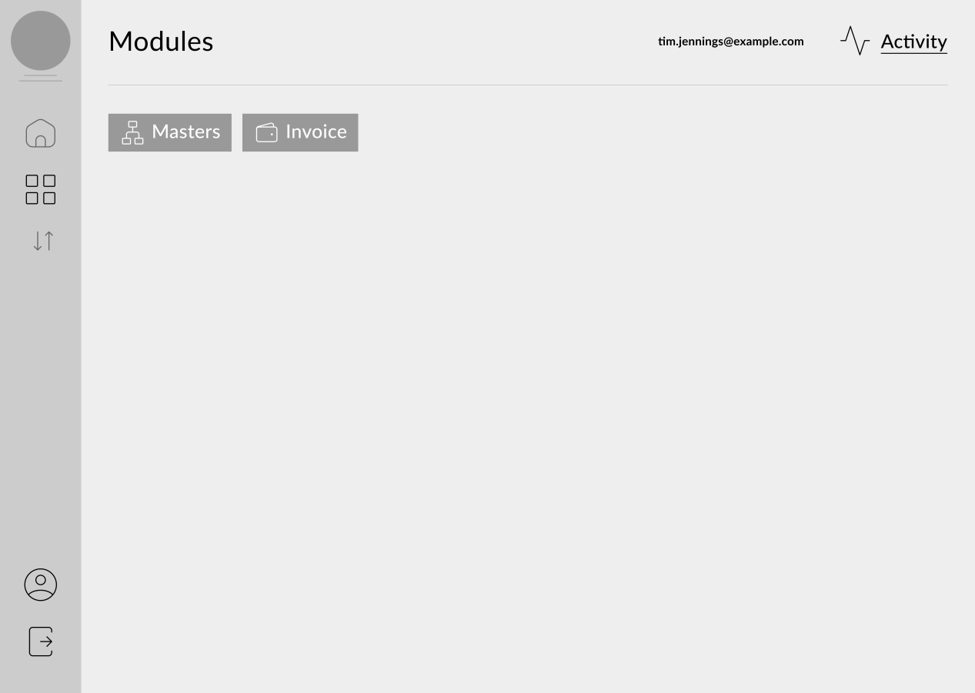

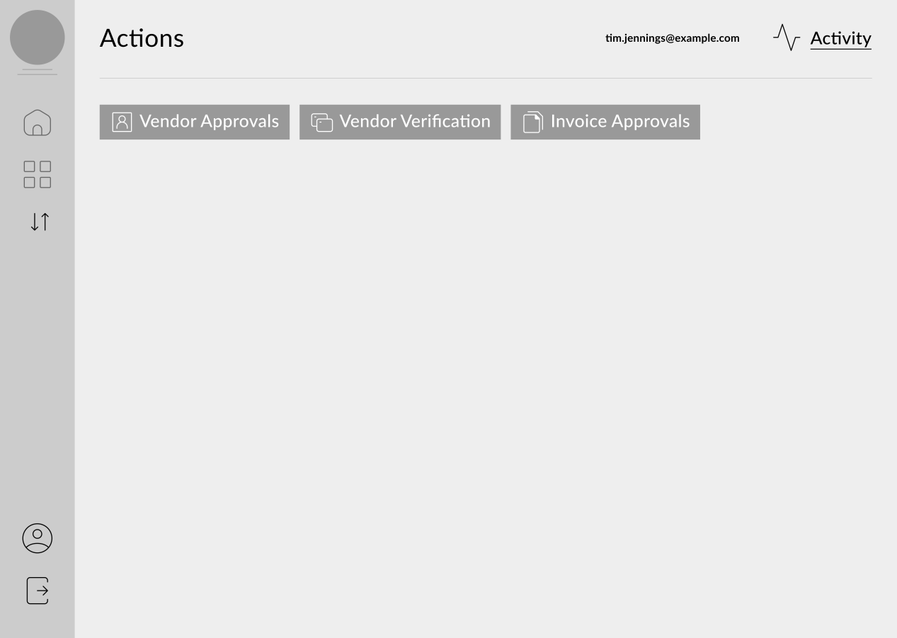

In bill checking, there is a requirement on authority-based setting.

Client can add the bill in the system, then this bill is assigned to the HOD. When HOD approves the bill, there are two ways for the completion of the payment.

Following are the two ways:

1) This bill is assigned to account team for the approval. The account team checks the bill and the bill is passed if there is no query. Then account team enters the bill in the system and then release the payment of that bill.

2) This bill is assigned to account team for the approval. The account team checks the bill and the bill is passed to the audit team. Then the audit team checks the bill and then enters the bill in the system and then release the payment of that bill.

**When the payment is rejected:**

When the account team has issue with the bill, then the account team reassigns the bill to HOD. HOD has an option to assign this bill to the team member. After the correction in the bill, then the team member can re-assign the bill to HOD. If there is an issue with the bill, then HOD has two options either to “**assign back**” or to “**assign forward**”.

The process is same in every level.

**Export** - Want export custom option. In this option all field list show if we select the perticuler field then click on submit then this filed infromation download on csv and excel format.

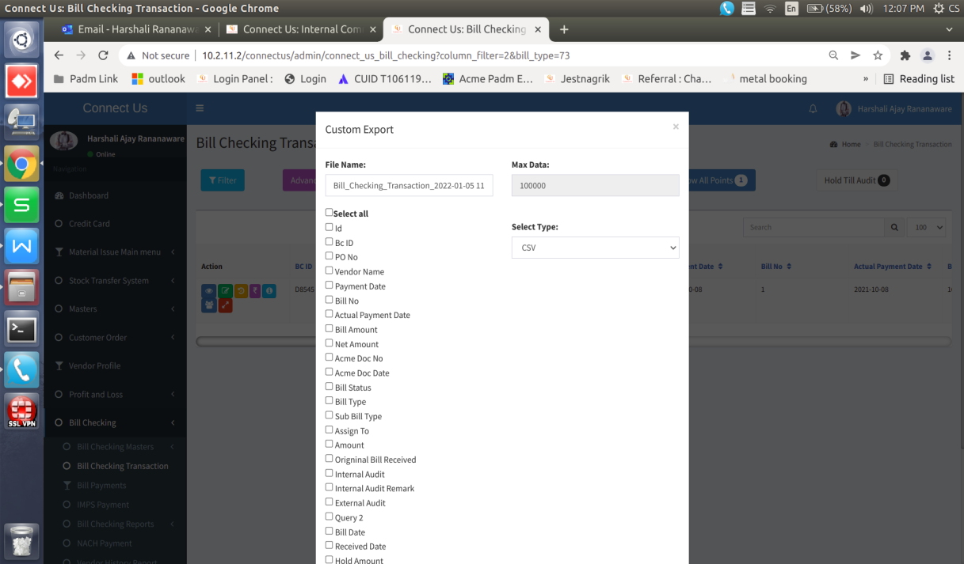

**Download All Attachment -** When we click on “Download All Attachment” then download in zip file. Here download all attchment against bill.

**Add data :** In bill checking, when we click on “add data”, then the following fields display.

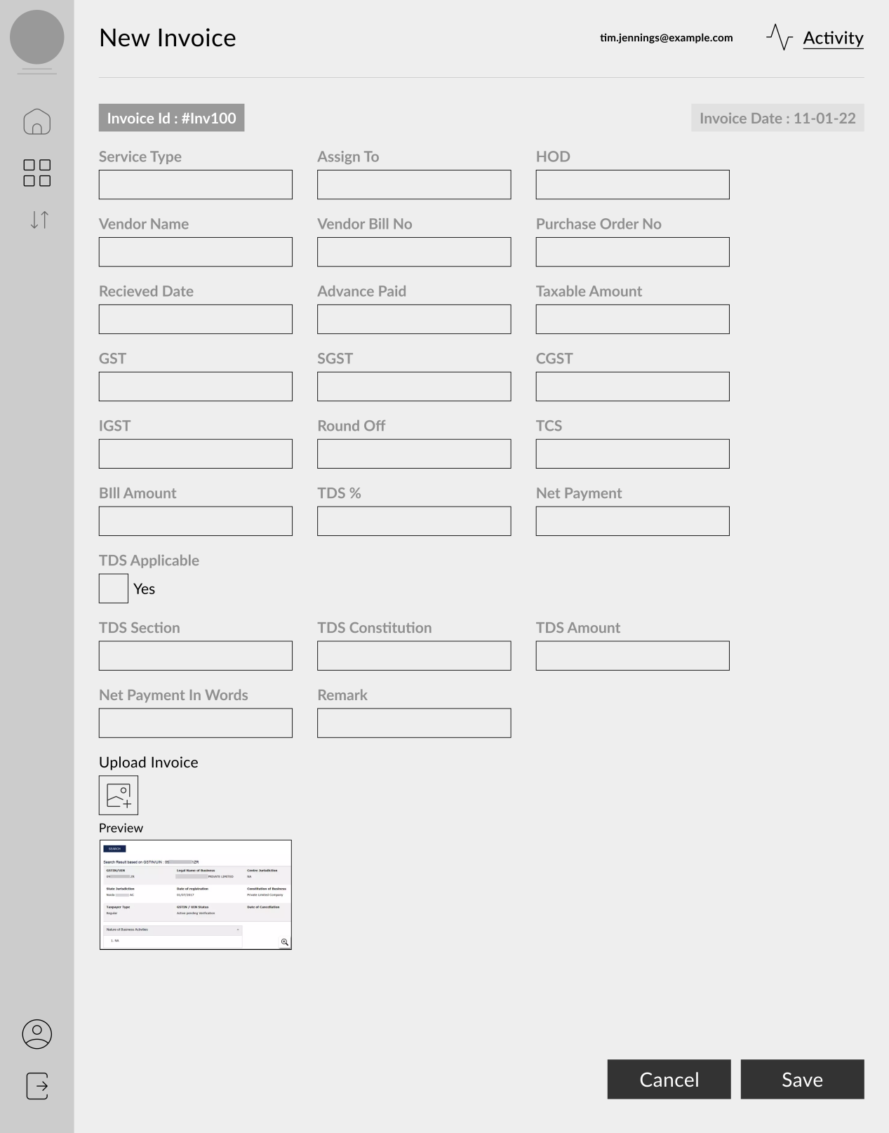

|  |  |  |  |
| --- | --- | --- | --- |
| **Sr. No.** | **Field name** | **Data Type** | **Description** |
|  | Bill ID | Int | This is an auto-increment field and this is disabled. |
|  | Service type | Drop-down | The data is fetched from the service master. |
|  | Assign to department | Drop-down | Select department. |
|  | Person name | View | Who is department head will be shown. |
|  | Vendor name | Drop-down | The data is fetched from the vendor master. |
|  | Vendor bill no | Text | We can enter vendor bill no. |
|  | Chalan po/ no | Text | We can enter chalan po ( purchase order ) / no. |
|  | Bill date | Date | We select the bill date. |
|  | Receive date | Date | We select the bill receive date. |
|  | Debit advance | Int | We enter debit advance. |
|  | Taxable amount | float | We can enter amount on this field. |
|  | GST | Check box | If select GST then enable SGST and CGST. If select GST then disable IGST. |
|  | SGST | Decimal | SGST amount is auto calculated. |
|  | CGST | Decimal | CGST amount is auto calculated. |
|  | IGST | Decimal | If select IGST then disable GST. |
|  | Round off | float | We enter round off amount. 0.5 |
|  | Tcs | float | We can enter TCS amount here. |
|  | Bill amount | float | Tax amount + GST/IGST + TCS |
|  | Tds % | Varchar | If TDS is applicable then TDS % show here. |
|  | Net payment | float | Tax amount + GST/IGST + TCS - TDS Amount |
|  | TDS Applicable | Check box | If TDS is applicable then click on check box and enter  TDS Amount |
|  | TDS section | Drop-down |  |
|  | TDS constitution | Drop-down |  |
|  | TDS Amount | Text field |  |
|  | Net payment in word | Text | Here net amount show in word. |
|  | Remark | Varchar | We can enter remark. |
|  | Upload Invoice |  | Here we can add attachment for example .png , .jpeg , .xls |
|  | Estimation | Drop-down | If select this field then open a table format. In that format add following fields depatment , % , amount , remark and add button.  In this field are 3 option.  1) Equally -  2) Manually % - % field is editable.  3) Manually amount - Amount field is editable. |
|  | Save | Button |  |
|  | Back | Button |  |

**Edit data :**

|  |  |  |  |
| --- | --- | --- | --- |
| **Sr. No.** | **Field name** | **Data Type** | **Editable** |
|  | BC Id |  | No |
|  | Service type | Drop-down | Yes |
|  | Assign ton departmet | Drop-down | Yes |
|  | Person name | Diable | No |
|  | Vendor name | Drop-down | Yes |
|  | Vendor bill no | Text | Yes |
|  | Chalan po / no | Text | Yes |
|  | Bill date | Date | Yes |
|  | Receive date | Date | Yes |
|  | Debit advance | Int | Yes |
|  | Taxable amount | float | Yes |
|  | GST | float | Yes |
|  | SGST | Decimal | Yes |
|  | CGST | Decimal | Yes |
|  | IGST | Decimal | Yes |
|  | Round off | float | Yes |
|  | Tcs | float | Yes |
|  | Bill amount | float | No |
|  | Tds % | Varchar | Yes |
|  | Net payment | float | No |
|  | TDS Applicable | Check box | Yes |
|  | Net payment in word | Text | No |
|  | Remark | Varchar | Yes |
|  | Upload Invoice |  | No |
|  | Updated By | Text | No |
|  | Updated At | Text | No |
|  | Is canceled | Check box | Yes |
| **Payment Details** | | | |
|  | Amount to be paid |  | No |
|  | Status | Drop-down | Yes |
|  | Payment date | Date | Yes |
|  | Remark | Text | Yes |
|  | Actual Payment Date | Date | Yes |
|  | Transaction ID | Varchar | Yes |
|  | Save | Button |  |

**Payment details :** In“Bill checking” click on payment details then we can split the payment amount and set the payment date (as per contract).

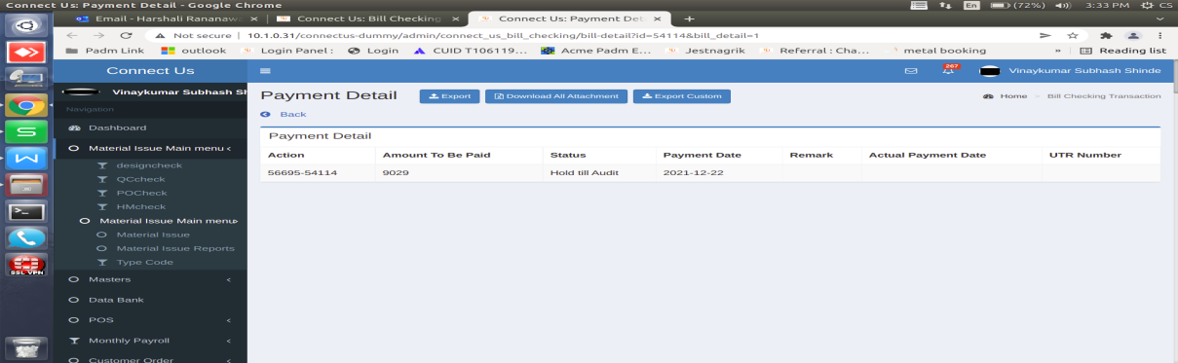

|  |  |  |
| --- | --- | --- |
| **Sr. No** | **Action** |  |
|  | Amount to be paid |  |
|  | Status |  |
|  | Payment date |  |
|  | Remark |  |
|  | Actual Payment Date |  |
|  | Transaction ID |  |

**History -** In Bill Checking show all transaction history.

**View -** Invoice details will be shown to the user as per the invocice database.

**Released bills -** In Released bills we can select the bill type and the date. Click on filter then all relese bill showing. Show the following column.

|  |  |  |
| --- | --- | --- |
| Sr. No | Field |  |
|  | Vendor name |  |
|  | Services type |  |
|  | Payment amount |  |
|  | Bill no |  |
|  |  |  |
|  |  |  |
|  |  |  |
|  |  |  |
|  |  |  |

**Download -** when clicked on this obutton then pop will be shown with two option as follows:

1. **Bank Format** - Click on download payment list then file download in text format. Any filed is blank then show in different color. After download file then point status auto change “ confirmation pending ”.

**2) Excel Format** - Click on this then we can download the all bill.

**payment Status** - Receive bank file then the user can upload this file by using “ auto update payment ”. The user can add text file and after click on update button then and upload successfully. Point status auto update paid. If any issue from bank side then status is bank reject. Give cancel option. Click on cancel then the show main window. After status change the paid, then auto whatsapp , SMS and EMAIL should be going to the customer.

* **Master**

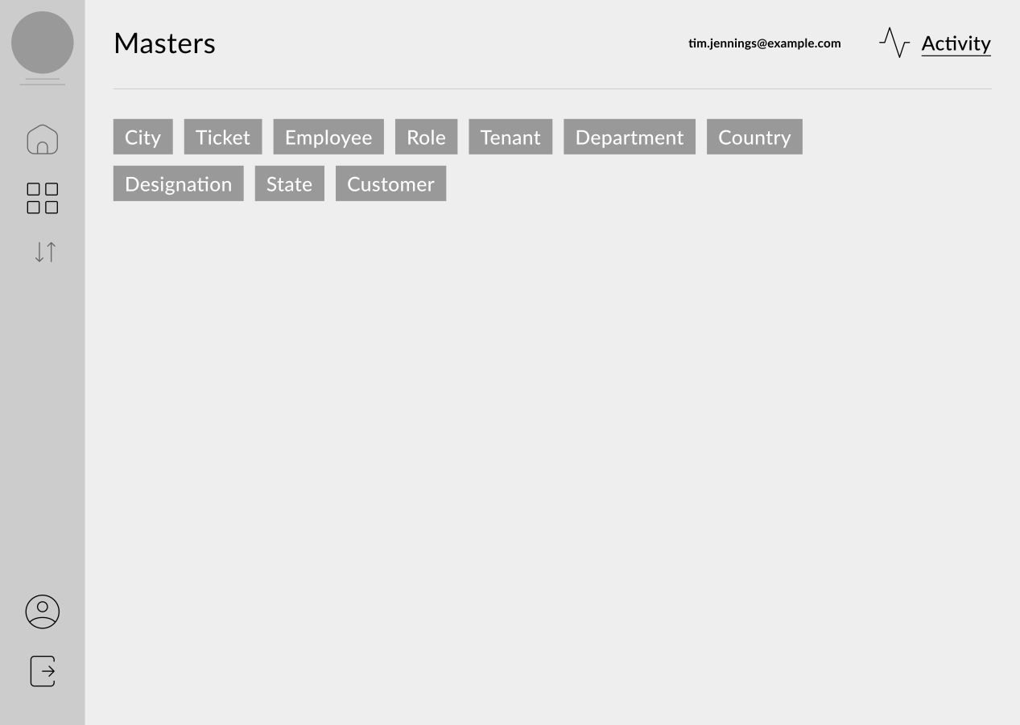

**History and View -** Below fileds are show in every master history.

|  |
| --- |
| **Field Name** |
| Created At |
| Created By |
| Updated At |
| Updated By |
| Ip address |

* **Country Master :**

**Add data -** In this master, we can enter the fields related to the country such as follows.

|  |  |  |
| --- | --- | --- |
| FIELDS | INPUT TYPE | Description |
| Country | Text | Here add country name |
| Remark | Text |  |
| Active | yes or no |  |

* **State Master** - State Master is the master where the details are displayed along with the country, name, remark, status.

**Add data -** In this master, we can enter the fields related to the state such as follows.

|  |  |  |
| --- | --- | --- |
| FIELDS | INPUT TYPE | Description |
| Country | Drop-down | Drop-down list given. Data fetch from country master. |
| State | Text |  |
| Remark | Text |  |
| Active | yes or no |  |

* **City Master -** “City Master” is the master where the details are displayed along with the country, state, name, remark, status.

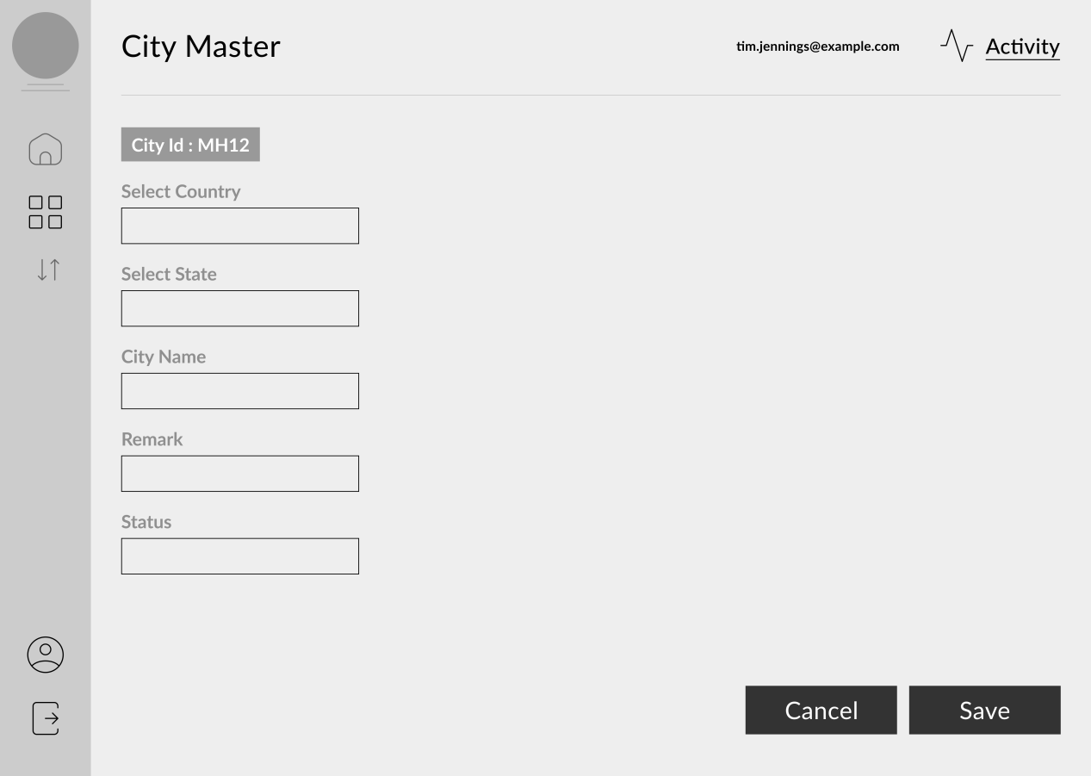

**Add data -** In this master, we can enter the fields related to the city such as follows.

|  |  |  |
| --- | --- | --- |
| FIELDS | INPUT TYPE | Description |
| Country | Drop-down | Drop-down list given. Data fetch from country master. |
| State | Drop-down | Drop-down list given. Data fetch from state master. |
| City | Text |  |
| Pincode | Int |  |
| Remark | Text |  |
| Active | yes or no |  |

* **Vendor master -** In vendor master, there are two ways to add the vendor details. In vendor master we want the PAN and aadhar base setting.

**Add data**

|  |  |  |  |
| --- | --- | --- | --- |
| Sr. No | Field | Data Type | Description |
|  | Vendor Id | Int | This is an auto-increment field and this is disabled. |
|  | Vendor name | Varchar | Here we add vendor name. Length is 200. |
|  | Address | Varchar | Here we add address. Length is upto 200. |
|  | City | Drop-down | Drop-down list given. Data fetch from city master. |
|  | State | Drop-down | Drop-down list given. Data fetch from state master. |
|  | Country | Drop-down | Drop-down list given. Data fetch from country master. |
|  | Pincode | Int | Drop-down list given. Data fetch from city master. |
|  | Mobile no | Int (10) | Mobile no must be 10 digit. |
|  | Email id | Varchar | Email id enter in standered format.  Ex abc1@gmail.com |
|  | PAN No | Varchar(10) | First 5 is alphabetnext 4 is digit and last is alphabet. |
|  | PAN No Attachment | File |  |
|  | Adhar No | Int (12) | Aadhar no accept only 12 digit. |
|  | Adhar No Attachment | File |  |
|  | MSME No | Varchar |  |
|  | MSME No Attachment | File |  |
|  | GST No | Varchar(15) | First is state code then PAN no and one digit then laste 2 alphabet. |
|  | GST No Attachment | File |  |
|  | Cheque Attchment | File |  |
|  | Bank Attchment | File |  |
|  | Consider In Payment | Drop-down | Give yes or no option. |
|  | Bank Name | Varchar(50) | Here add only alphabet. |
|  | Bank Branch Name | Varcher (50) | Here add only alphabet. |
|  | Account No | Int (18) | Here add only digit. |
|  | IFSC Code | Varchar(11) | Here add alpabet and digit . |
|  | Template | Drop-down | Drop-down list given. Data fetch from Payment Duration. |
|  | TDS | Char | Here we can add the TDS %.by default TDS % is 10. We can edit this TDS %. |

**NOTE :** The above all fields can be editable whenever the changes are required.

* **Department Master -** In this master, we can add the department to find to which department the bill is assigned.

**Add data**

|  |  |  |  |
| --- | --- | --- | --- |
| **Sr. No** | **Fields** | **Data Type** |  |
|  | Deptartment ID | Int |  |
|  | Dept Name | Varchar | Add dept name |
|  | Remark | Varchar |  |
|  | Is active | Radio button | Yes or no |
|  | Save | Button |  |

**NOTE:** The above all fields can be editable whenever the changes are required.

* **Payment Duration** - In this master, we add the Payment Duration to define the due dates of a particular payment related to the particular department.

**Add data**

|  |  |  |
| --- | --- | --- |
| **Sr. No** | **Fields** | **Data Type** |
| 1) | Payment Duration ID |  |
| 2) | Payment Duration | Varchar |
| 3) | Payment Type | Drop-down |
| 4) | Bill Type | Drop-down |
| 5) | Min days | Varchar |
| 6) | Payment Weekly | Drop-down |
| 7) | Bill Day | Date |
| 8) | Remark | Varchar |

**NOTE:** The above all fields can be editable whenever the changes are required.

* **Employee Master -** In employee master, we add the employee details.

**Add data -**

|  |  |  |  |
| --- | --- | --- | --- |
| **Sr. No** | **Fields** | **Data Type** | **Description** |
|  | Employee ID | Int | This is an auto-increment field and this is disabled. |
|  | Employee Name | Char (200) | Here we add employee name. |
|  | Address | Varchar (200) | Here we add address. |
|  | City | Drop-down | Drop-down list given. Data fetch from city master. |
|  | State | Drop-down | Drop-down list given. Data fetch from state master. |
|  | Country | Drop-down | Drop-down list given. Data fetch from country master. |
|  | Date Of Joining | Date | Here accepted date before todays date. |
|  | Designation | Char |  |
|  | Date Of Leaving | Date | Here accepted date before todays date. |
|  | Separation Mode | Drop-down |  |
|  | Date Of Birth | Date | Here accepted date before todays date. |
|  | Gender | Radio button | Male and Female |
|  | Blood Group | Drop-down | All blood group show here. |
|  | Marital Status | Drop-down |  |
|  | Email ID | Varchar | Email id enter in standered format.  Ex abc1@gmail.com |
|  | Aadhar no | Int (12) | Aadhar no accept only 12 digit. |
|  | PAN No | Varchar (10) | First 5 is alphabetnext 4 is digit and last is alphabet. |

**Edit data -**

|  |  |  |
| --- | --- | --- |
| **Sr. No** | **Fields** | **Editable** |
|  | Employee ID | No |
|  | Employee Name | Yes |
|  | Address | Yes |
|  | City | Yes |
|  | State | Yes |
|  | Country | Yes |
|  | Date Of Joining | No |
|  | Designation | Yes |
|  | Date Of Leaving | Yes |
|  | Separation Mode | Yes |
|  | Date Of Birth | Yes |
|  | Gender | Yes |
|  | Blood Group | Yes |
|  | Marital Status | Yes |
|  | Email ID | Yes |
|  | Aadhar no | Yes |
|  | PAN No | Yes |

**User Login Master -** The user login master is used to create the login credentitials of an employee.

**Add data** -

|  |  |  |  |
| --- | --- | --- | --- |
| **Sr. No** | **Fields** | **Data Type** | **Description** |
|  | Employee Name | Drop-down | Drop-down list given. Data fetch from employee master. In this field data search by employee id or employee name. |
|  | User Name | Char | Here accepted only alphbate. |
|  | Password | Varchar | Minimum of 8 characters in length.  Must have at least one special character.  Must have uppercase and lowercase. |
|  | Advance amount limit | Decimal | We can enter the from and to limit. ( 0-10000) |
|  | Original bill amount limit | Decimal | We can enter the from and to limit. ( 0-10000) |

**Edit data** -

|  |  |  |
| --- | --- | --- |
| **Sr. No** | **Fields** | **Editable** |
|  | Employee Name | No |
|  | User Name | No |
|  | Password | Yes |
|  | Advance amount limit | Yes |
|  | Original bill amount limit | Yes |

* **Services Master -** In this master, we can add the services.

**Add data**

|  |  |  |  |
| --- | --- | --- | --- |
| **Sr. No** | **Fields** | **Data Type** |  |
| 1) | Services Name | Varchar | Add services name |
| 2) | Remark | Varchar |  |
| 3) | Is active | Radio button | Yes or no |

**NOTE:** The above all fields can be editable whenever the changes are required.

**Report**

1. **Age Report Due date**
2. **Cashflow Report**

**References of the users**

|  |  |  |  |
| --- | --- | --- | --- |
| **User** | **Name** | **Mail** | **Contact number** |
| **Actual user** |  |  |  |
| **Ticket created by (if any)** |  |  |  |
| **Assigned business analyst** |  |  |  |
| **Assigned developer** |  |  |  |
| **Assigned tester** |  |  |  |