**Bill checking**

Bill checking menu is used to add the bills into the system and to check the bills.

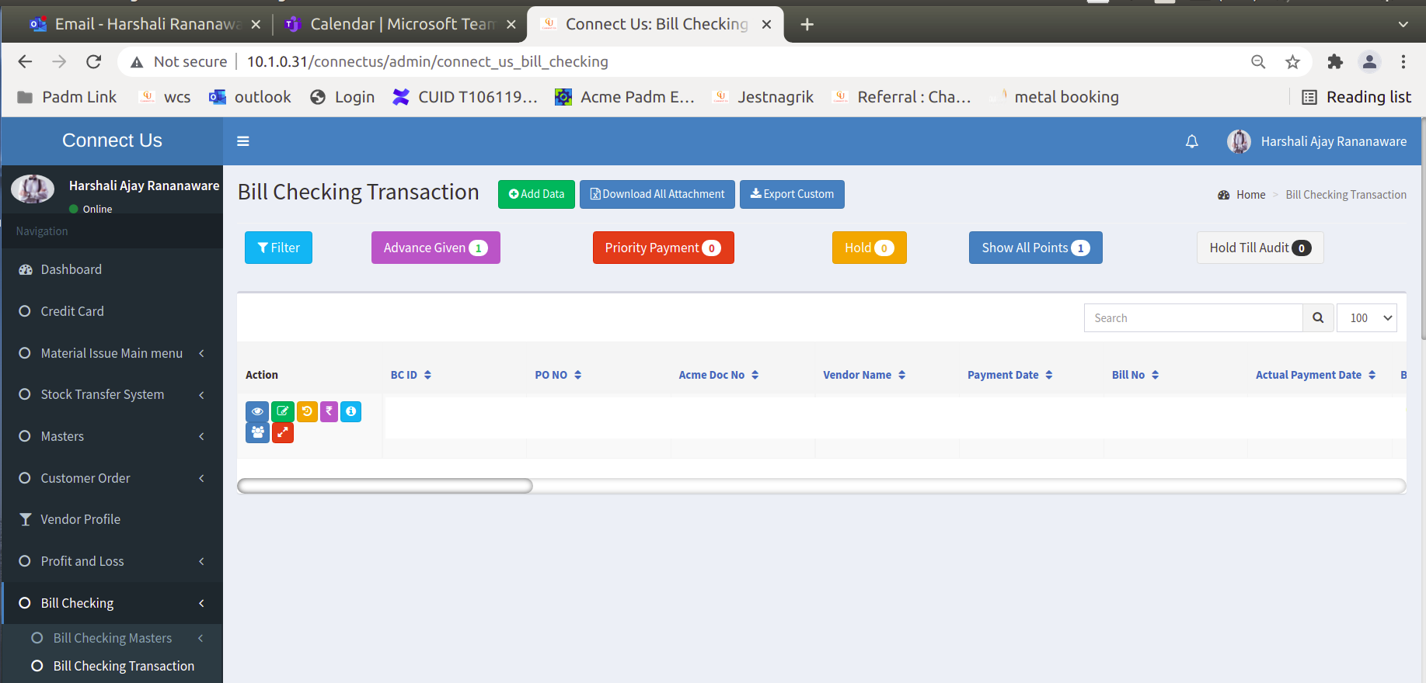

Click on add data show image 2

Image 1

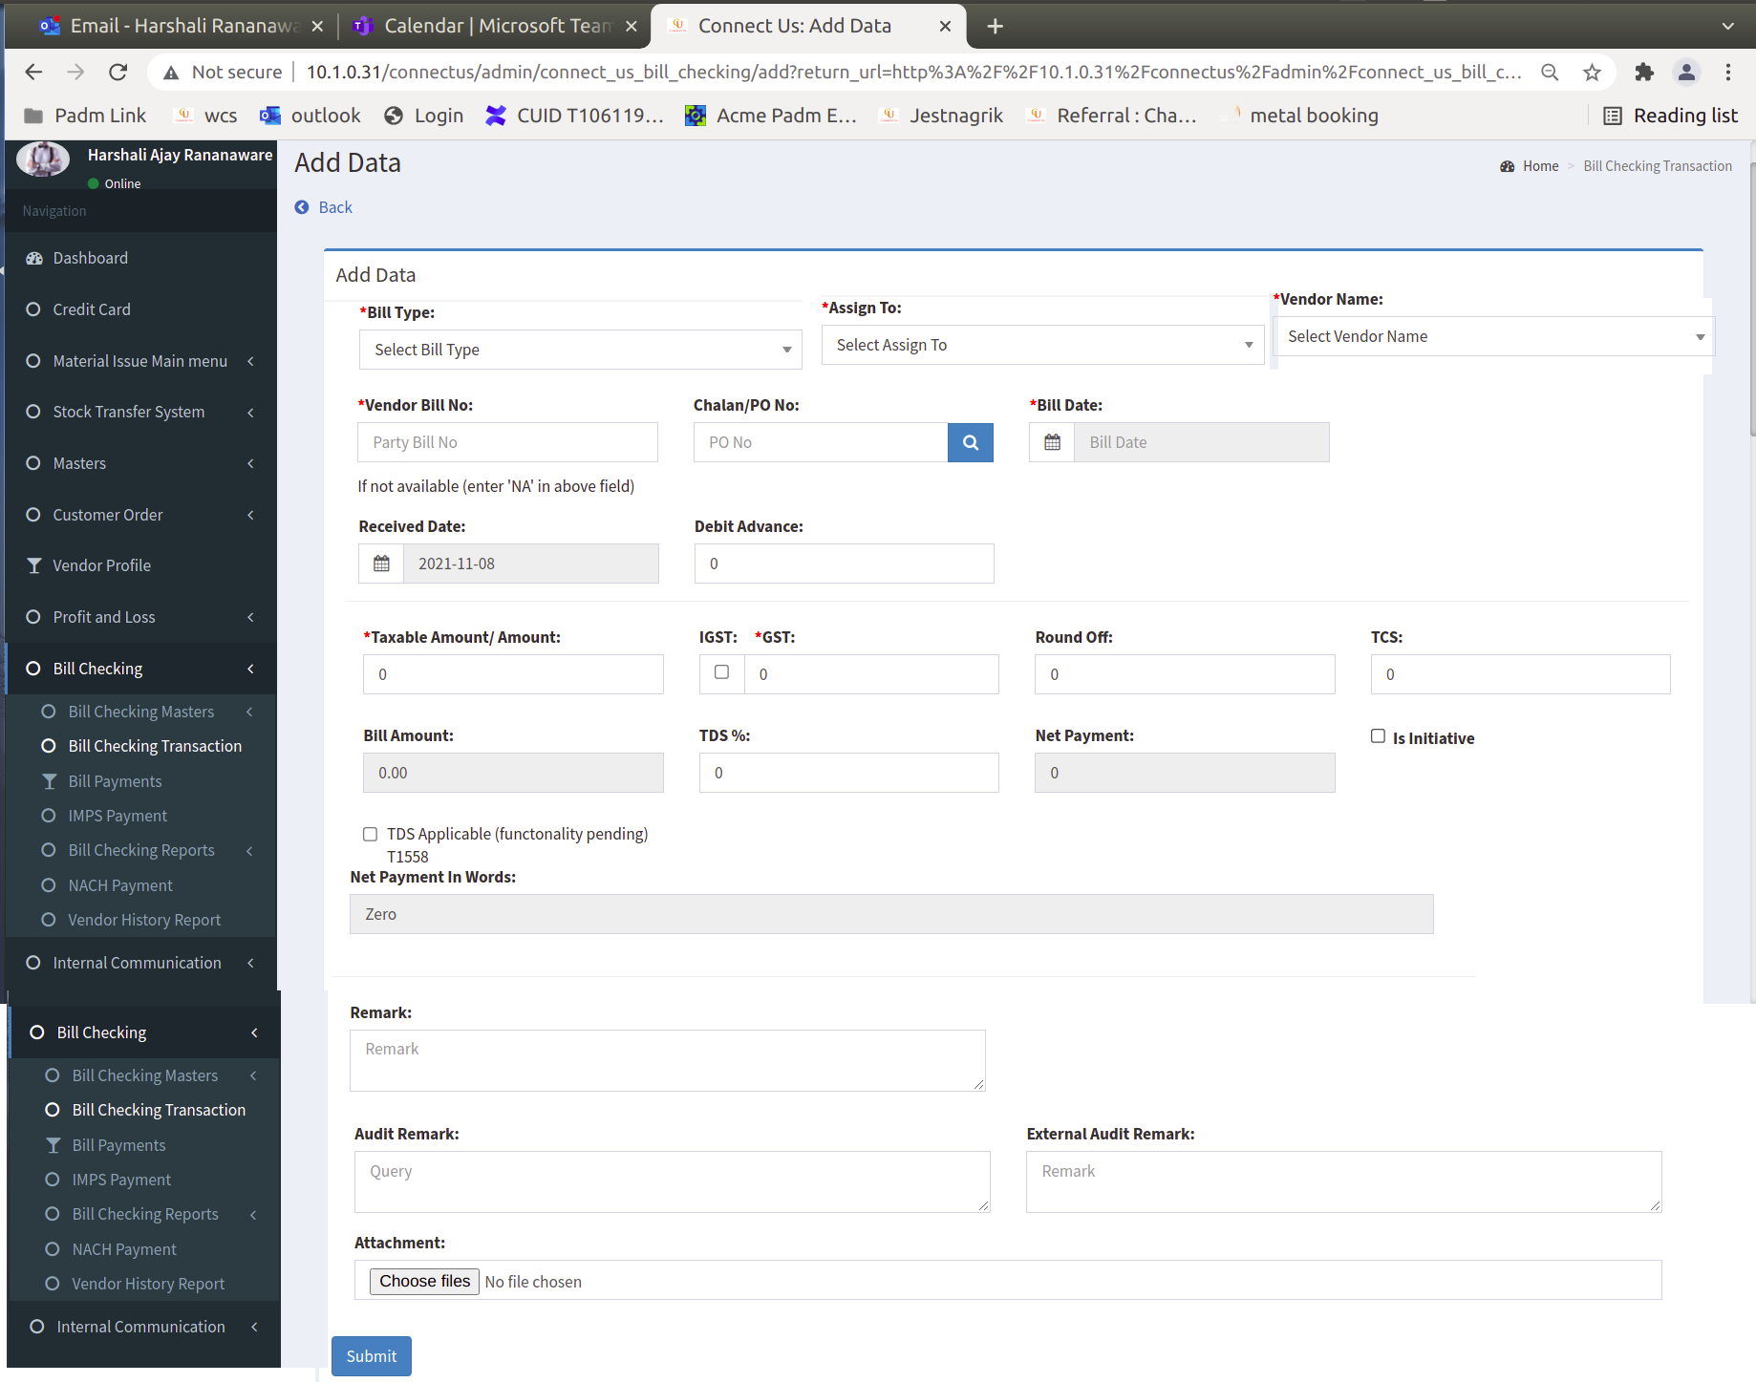

Image 2

**Add data :** In bill checking, when we click on “add data”, then the following fields display.

|  |  |  |  |
| --- | --- | --- | --- |
| **Sr. No.** | **Field name** | **Data Type** | **Description** |
|  | Bill type | Drop-down | The data is fetched from the Bill type master. |
|  | Assign to | Drop-down | When we select bill type, the person is assigned automatically. |
|  | Vendor name | Drop-down | The data is fetched from the vendor master. |
|  | Vendor bill no | Text | We can enter vendor bill no. |
|  | Chalan po/ no | Text | We can enter chalan po ( purchase order ) / no. |
|  | Bill date | Date | We select the bill date. |
|  | Receive date | Date | We select the bill receive date. |
|  | Debit advance | Int | We enter debit advance. |
|  | Taxable amount | float | We can enter amount on this field. |
|  | Gst /igst | float | If any IGST bill then we click on check box then IGST applicable. |
|  | Round off | float | We enter round off amount. |
|  | Tcs | float | We can enter TCS amount here. |
|  | Bill amount | float | Tax amount + GST/IGST + TCS |
|  | Tds % | Varchar | If TDS is applicable then TDS % show here. |
|  | Net payment | float | Tax amount + GST/IGST + TCS - TDS Amount |
|  | TDS Applicable (functonality pending) T1558 | Check box | If TDS is applicable then click on check box and enter   1. TDS section 2. TDS constitution 3. TDS Amount |
|  | Net payment in word | Text | Here net amount show in word. |
|  | Remark | Varchar | We can enter remark. |
|  | Attachment |  | Here we can add attachment for example .png , .jpeg , .xls |

**Edit Data :**



Click here to show image 4

Image 3

|  |  |  |  |
| --- | --- | --- | --- |
| **Sr. No.** | **Field name** | **Data Type** | **Editable** |
|  | BC Id |  | No |
|  | Bill type | Drop-down | Yes |
|  | Assign to | Drop-down | Yes |
|  | Vendor name | Drop-down | No |
|  | Vendor bill no | Text | Yes |
|  | Chalan po / no | Text | Yes |
|  | Bill date | Date | No |
|  | Receive date | Date | No |
|  | Debit advance | Int | Yes |
|  | Taxable amount | float | Yes |
|  | Gst /igst | float | Yes |
|  | Round off | float | Yes |
|  | Tcs | float | Yes |
|  | Bill amount | float | No |
|  | Tds % | Varchar | Yes |
|  | Net payment | float | No |
|  | TDS Applicable (functonality pending) T1558 | Check box | Yes |
|  | Net payment in word | Text | No |
|  | Remark | Varchar | Yes |
|  | Audit Remark | Text | Yes |
|  | External Audit Remark | Text | Yes |
|  | Attachment |  | No |
|  | Updated By | Text | No |
|  | Updated At | Text | No |
|  | Internal Audit | Check box | Yes |
|  | External Audit | Check box | Yes |
|  | Authorised By HOD : N/A | Check box | Yes |
|  | Authorised By Management: N/A | Check box | Yes |
|  | Is canceled | Check box | Yes |
|  | Amount to be paid |  | No |
|  | Status ( As per current system ) | Drop-down | Yes |
|  | Payment date | Date | Yes |
|  | Remark | Text | Yes |
|  | Actual Payment Date | Date | Yes |
|  | Reference No | Varchar | Yes |
|  | Recalculate | Button | Yes |

**Payment details :** Below fields are shown in the payment details field.



Click here to show image 5

Image 4

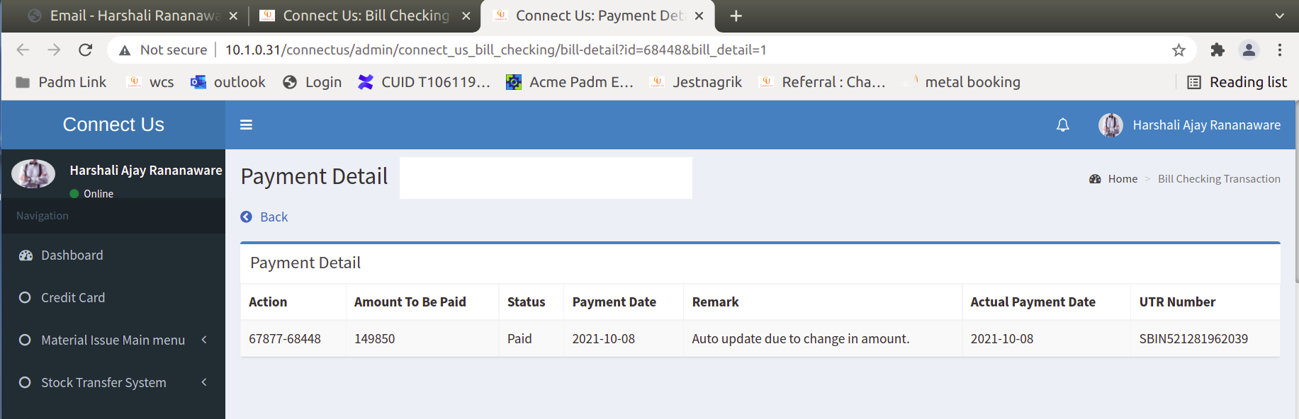

Image 5

|  |  |  |
| --- | --- | --- |
| **Sr. No** | **Action** |  |
|  | Amount to be paid |  |
|  | Status ( As per current system ) |  |
|  | Payment date |  |
|  | Remark |  |
|  | Actual Payment Date |  |
|  | Reference No |  |

**Filter :** Click on filter then we can filter data in any one of the field. Click on submit then the records show.



Click here to show image 7

Image 6

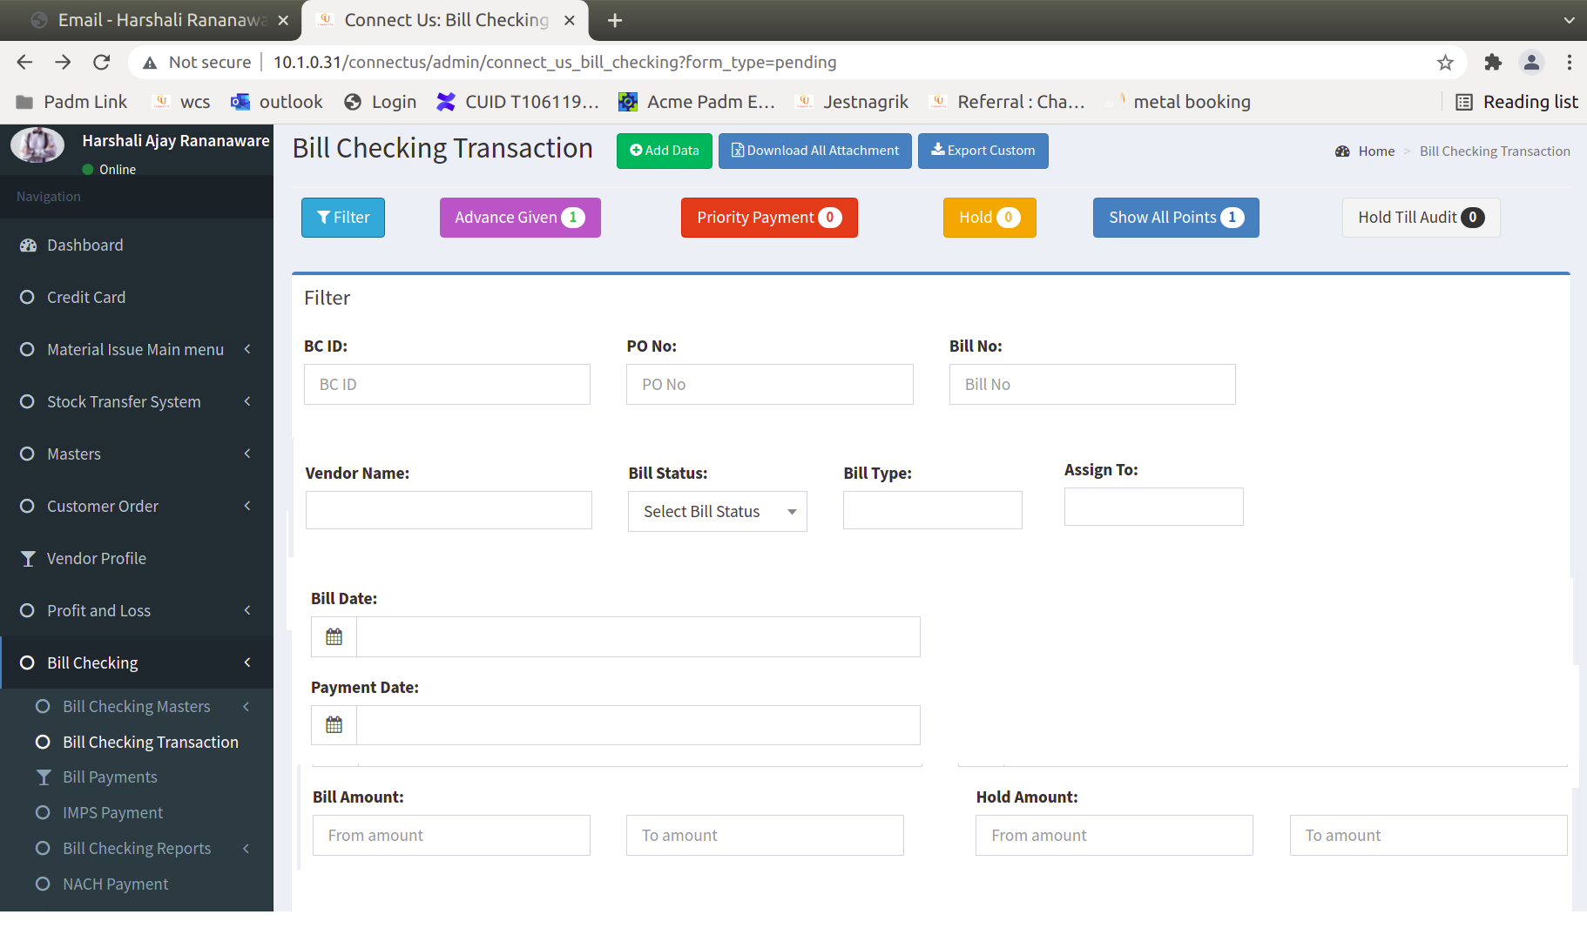

Image 7

|  |
| --- |
| BC Id |
| Bill no |
| Po no |
| Vendor name |
| Bill type |
| Bill status |
| Assign to |
| Bill date |
| Hold amount |
| Bill amount |
| Bill date |

**Custom Export :** Click on “ Custom Export ” then show in following format. We can export as per our requirement. Select column and click on submit. We want export in excel, pdf and csv.



Click here to show image 9

Click here to show image 9

Image 8

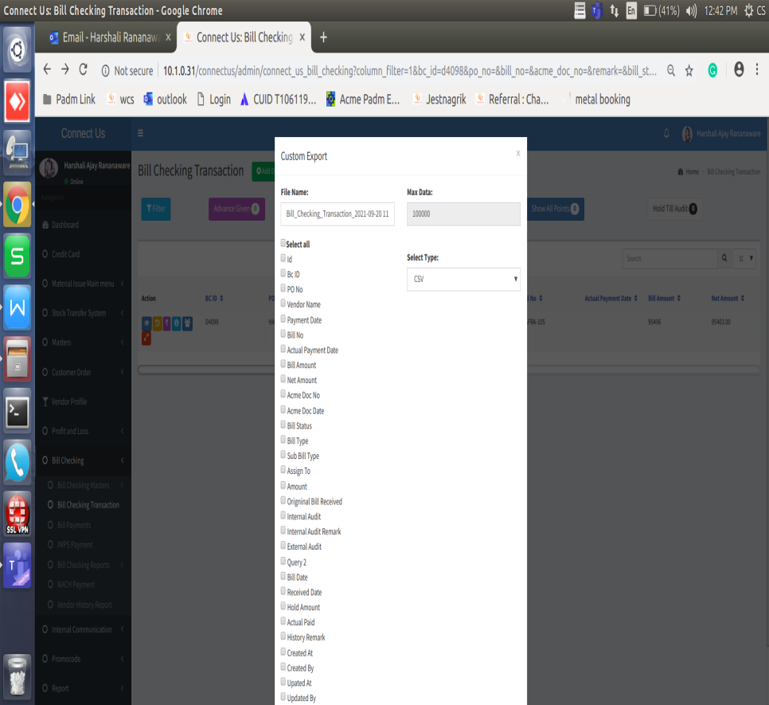

Image 9

**Payment history data :** Here show the history if payment.



Click here to show image 11

Image 10

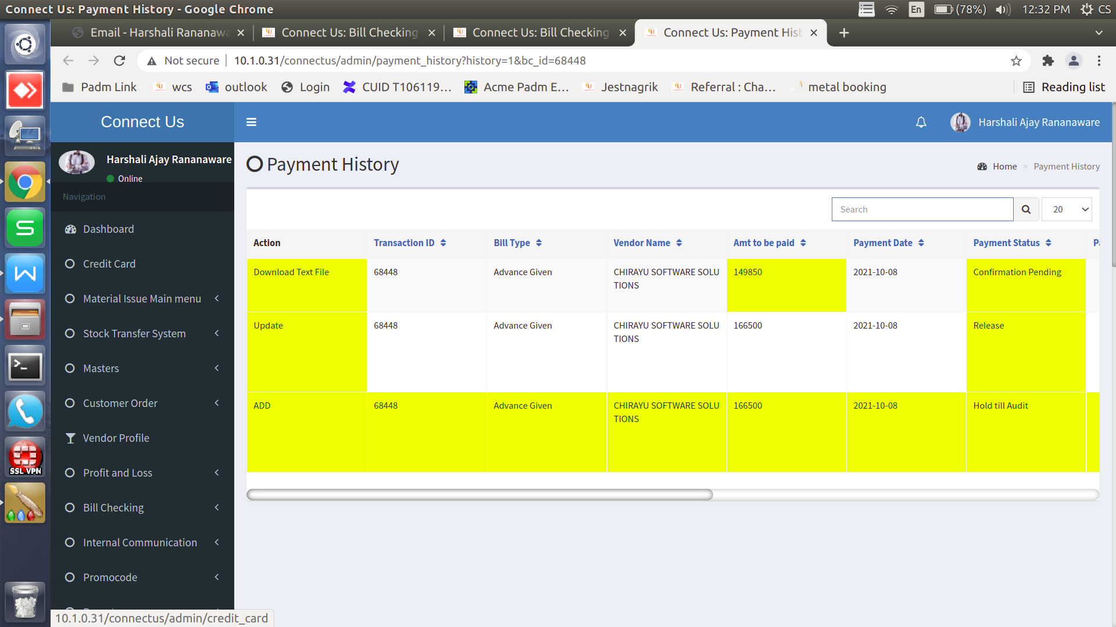

Image 11

**History data :** Here show history of bill checking id.



Click here to show image 13

Image 12

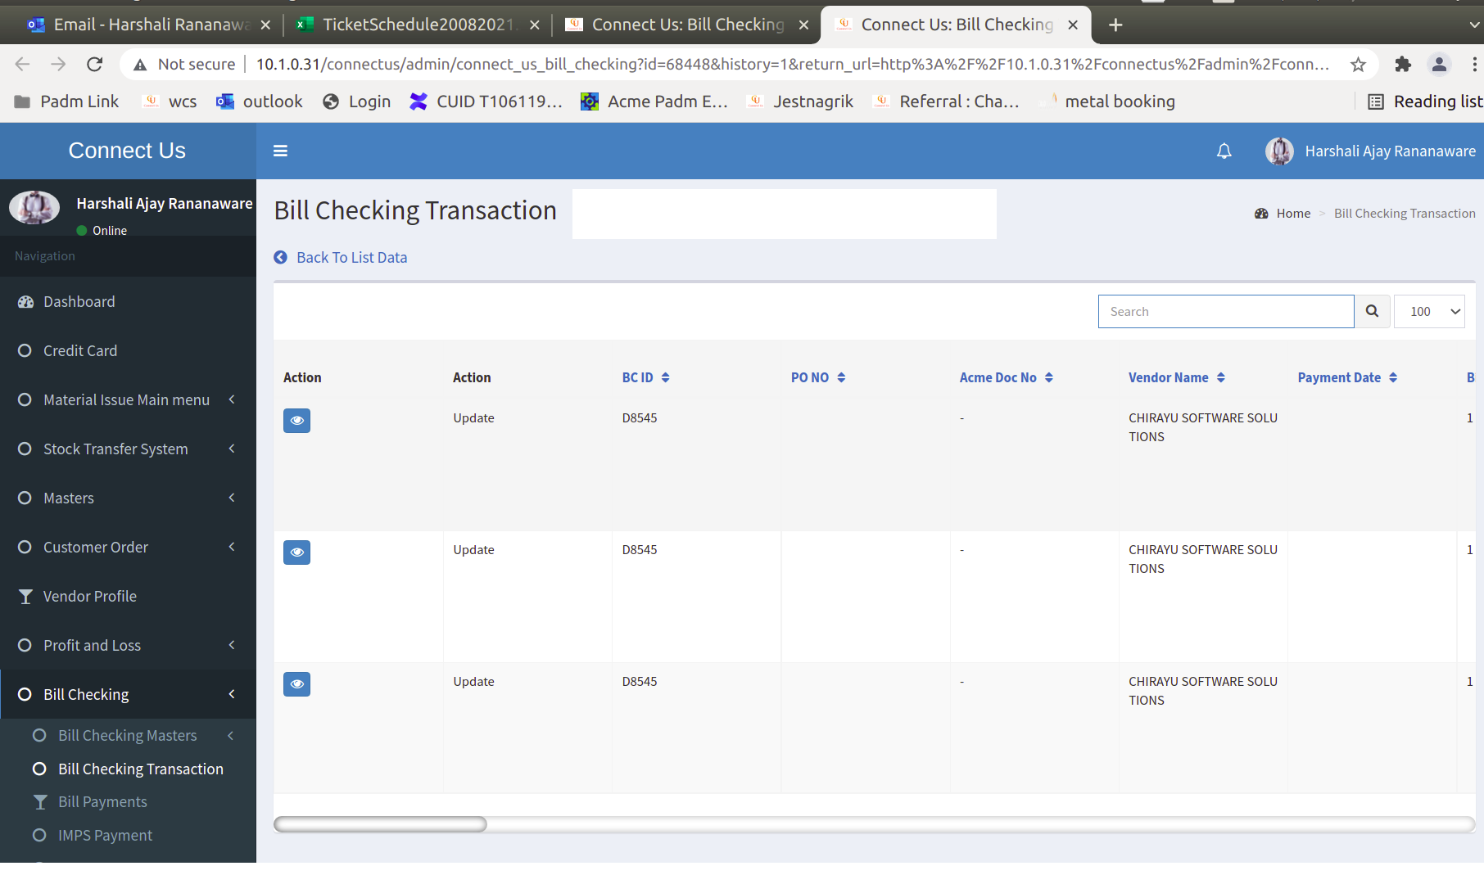

Image 13

**View :** Displays all the data.