LEAVE MASTER

The leave master is used to add the templates of the leave for the reference and mapping. The leave master consist of 3 masters.

* Leave template master
* Leave template period master
* Leave template mapping master

Leave master

In Connect Us >> Masters >> General Masters >> Leave Master

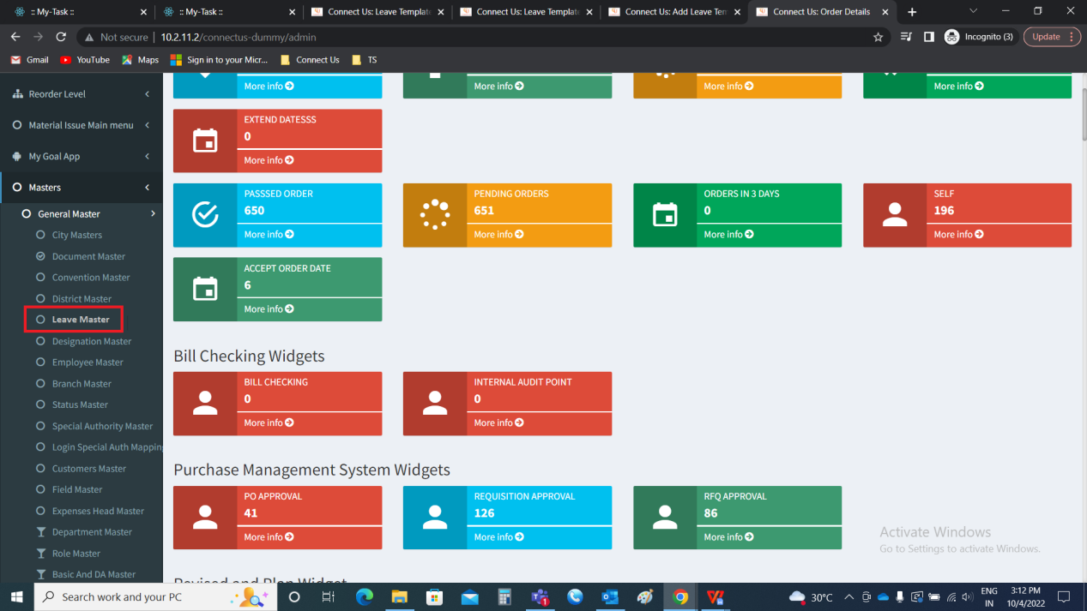

Under leave master, there are 3 sub-module. They are as follows.

* Leave template master
* Leave template period master
* Leave template mapping master

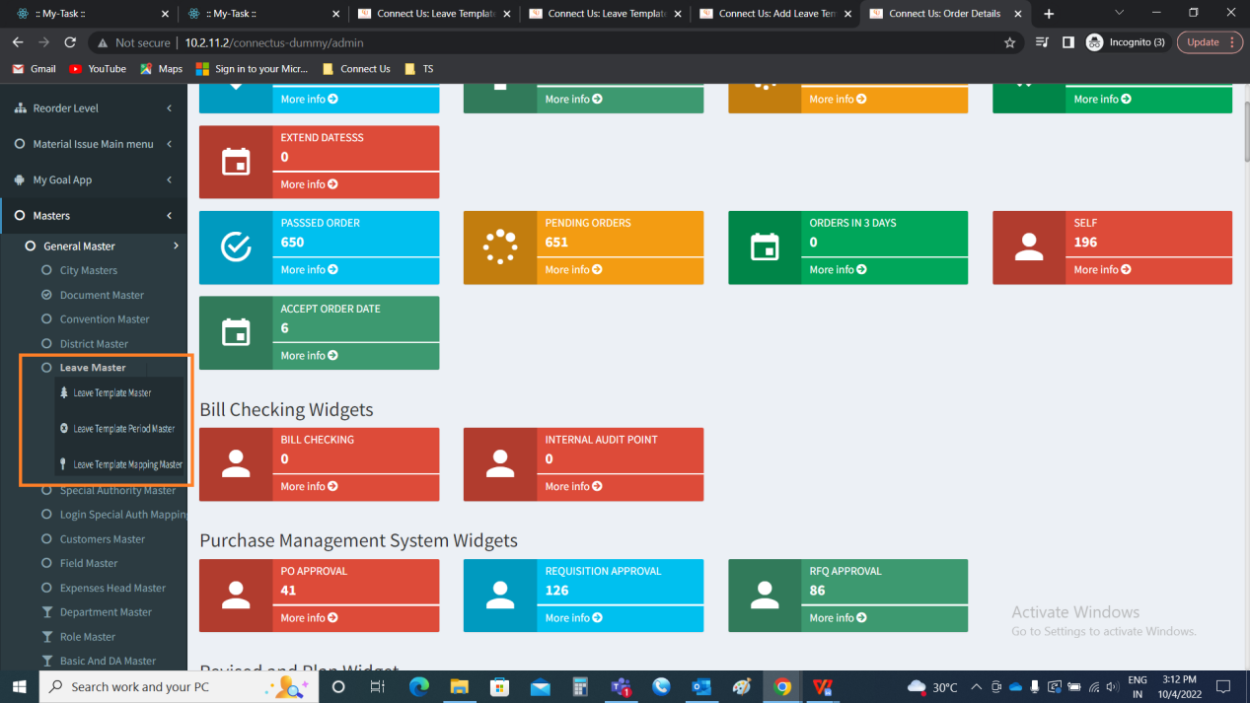

Leave template master

The leave template master is used to enter the templates of the leave in a specific order. So that, it helps in mapping with different conditions to the branches and the employees.

The leave template master consists of the following fields.

* Show data
* Add data
* Action
* Check box
* Name
* Total leaves
* Carry forward
* Max leaves in one go
* Can encash
* Is active
* Updated by
* Updated at

|  |  |
| --- | --- |
| **FIELDS** | **DESCRIPTION** |
| Show data | The show data button to show the data |
| Add data | The add data button to add the data |
| Action | The action field consists of 2 buttons namely, view and edit. The view button to view the data.  The edit button to edit the data. |
| Check box | The check box for the selection. It can be single, multiple and all. |
| Name | The name of the template is displayed |
| Total leaves | The total leaves for that template is displayed |
| Carry forward | The total leaves that can be carried forwarded to next year is displayed |
| Max leaves in one go | The maximum number of leaves that can be applied continuously is displayed |
| Can encash | The leaves can be encashed or not is selected |
| Is active | The is active field displays whether the template is in active mode or not |
| Updated by | The updated by displays the details of the user who updated the data |
| Updated at | The updated at displays the time and date when the record is last updated |

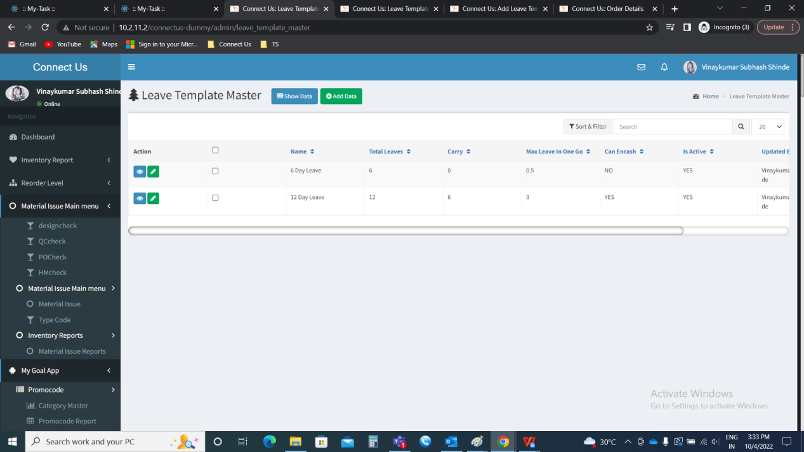

Show data

The show data button to show the data in the grid view.

Add data

The add data button to add the new template in the master. The add data page consists of the following fields.

* Name
* Total leaves
* Carry forward
* Max leaves in one go
* Can encash
* Back
* Save & add more
* Save

|  |  |  |  |
| --- | --- | --- | --- |
| **FIELDS** | **INPUT TYPE** | **MANDATORY/ OPTIONAL** | **DESCRIPTION** |
| Name | Text | Mandatory | The name of the template is entered |
| Total leaves | Int | Mandatory | The total leaves allowed in that template is mentioned |
| Carry forward | Int | Mandatory | The total number of leaves that can be forwarded to next year is mentioned |
| Max leaves in one go | Int | Mandatory | The maximum number of leaves that can be taken at a single time is mentioned |
| Can encash | Radio button | Mandatory | The can encash refers to, when the leaves left without utilizing, whether those leaves can be en-cashed or not. If can be utilized, then yes is selected. If not, no is selected.  By default, no is selected. |
| Back | Button | Optional | The back button to navigate to back page |
| Save & add more | Button | Optional | The save & add more button to save the existing data and to add the new template in the master |
| Save | Button | Optional | The save button to save the template in the master |

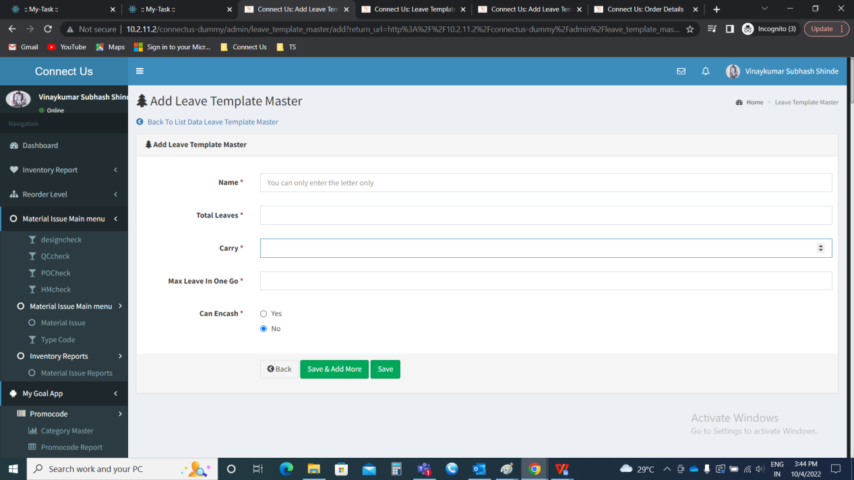

Note: By default, the status of the template is active, when it is created.

View data

The view data button is used to view the data. The following are the fields in the view data.

* Name
* Total leaves
* Carry forward
* Max leaves in one go
* Can encash
* Is active

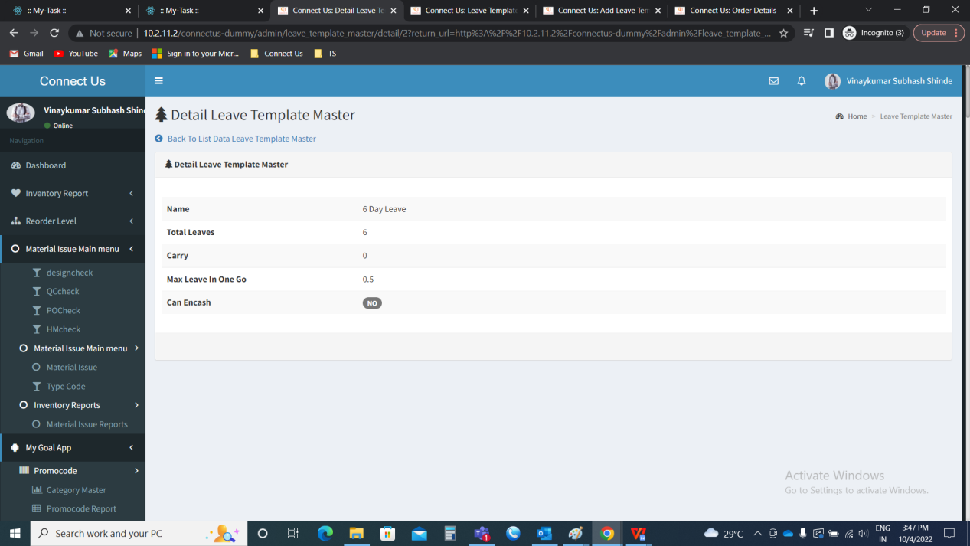

Edit data

The edit data to edit the existing data. The following are the fields that can be edited.

* Name
* Total leaves
* Carry forward
* Max leaves in one go
* Can encash
* Is active

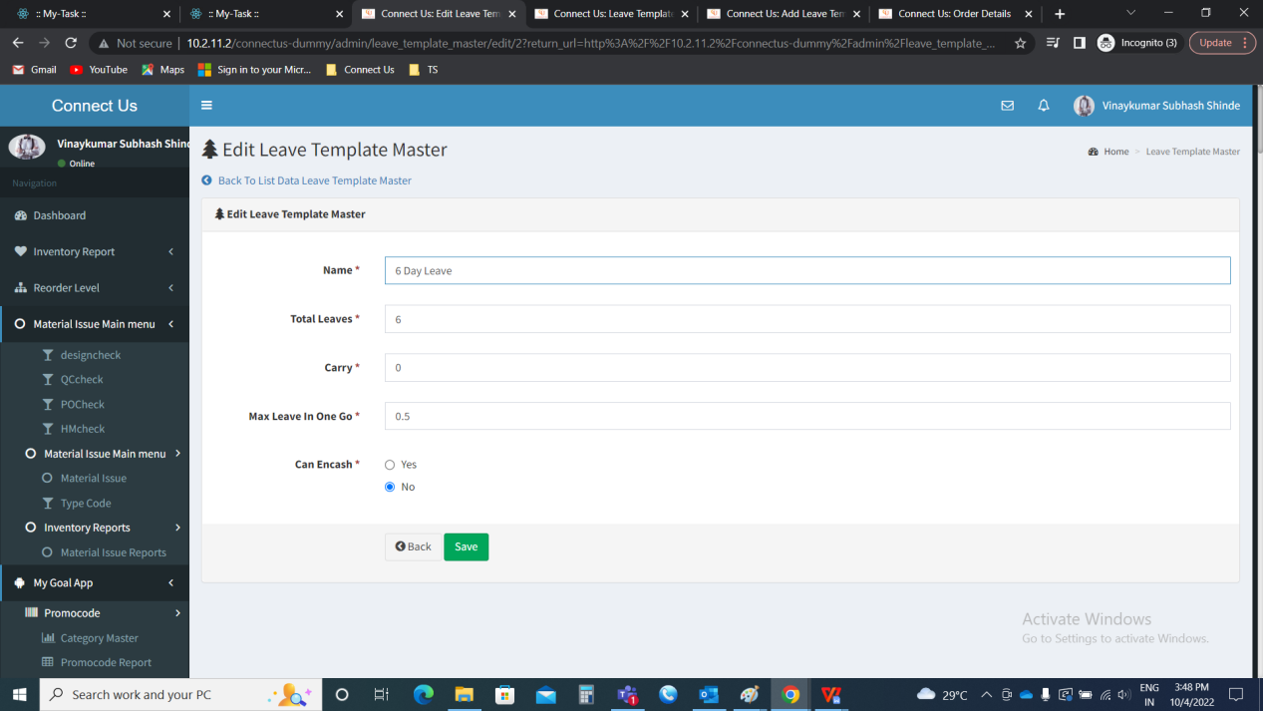

Leave template period master

The leave template period master consists of the periods of the leaves in a template when the employee can apply leave. The leave template period master consists of the following.

* Show data
* Add data
* Action
* Check box
* Leave template master ID
* From date
* To date
* Max leave
* Is active
* Updated by
* Updated at

|  |  |
| --- | --- |
| **FIELDS** | **DESCRIPTION** |
| Show data | The show data button to show the data |
| Add data | The add data button to add the data |
| Action | The action field consists of 3 buttons namely, view, edit and delete . The view button to view the data.  The edit button to edit the data.  The delete button to delete the data. |
| Check box | The check box for the selection. It can be single, multiple and all. |
| Leave template master ID | The leave template ID to which the condition is displayed |
| From date | The from date for the leave is displayed |
| To date | The to date for the leave is displayed |
| Max leave | The maximum leave that is applicable at the period is displayed |
| Is active | The is active field displays whether the template is in active mode or not |
| Updated by | The updated by displays the details of the user who updated the data |
| Updated at | The updated at displays the time and date when the record is last updated |

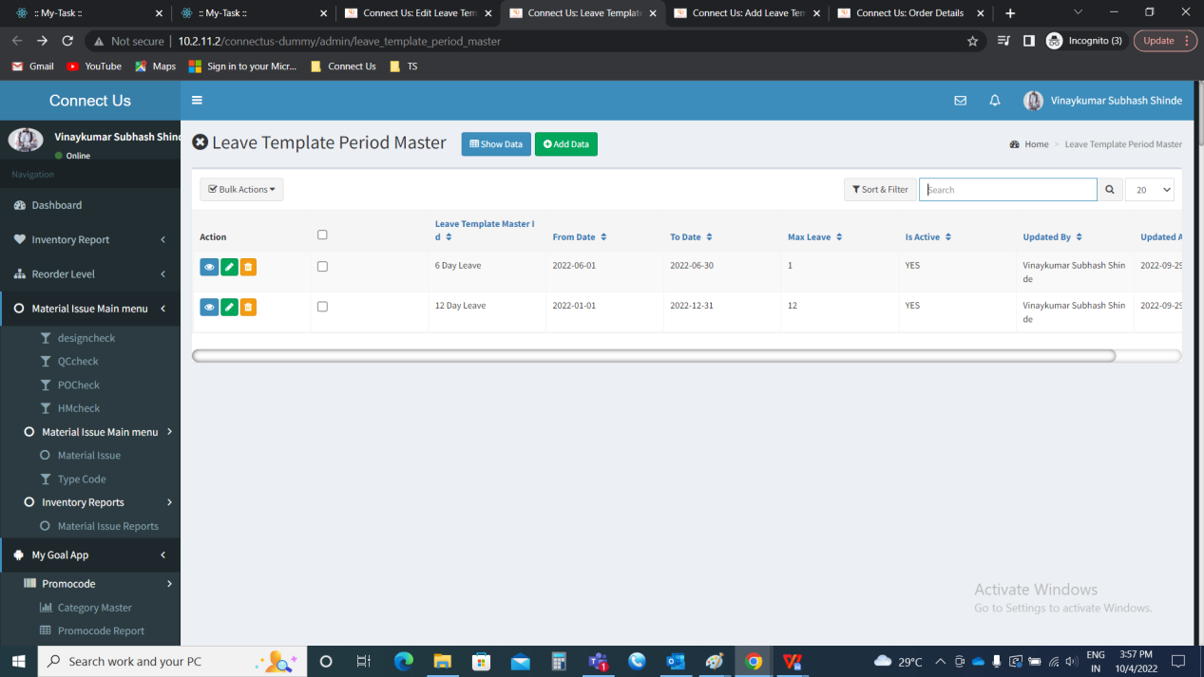

Show data

The show data button to show the data in the grid view.

Add data

The add data button to add the details of the leaves that can be applied by the user for the particular period. The following are the fields in the add data.

* Leave template master ID
* From date
* To date
* Max leave
* Is active
* Back
* Save & add more
* Save

|  |  |  |  |
| --- | --- | --- | --- |
| **FIELDS** | **INPUT TYPE** | **MANDATORY/ OPTIONAL** | **DESCRIPTION** |
| Leave template master ID | Drop down | Mandatory | The template for which the leave type is selected, is selected from the drop down. The drop down options are fetched from leave template master (In connect us >> masters >> general masters >> leave master >> leave template master). |
| From date | Calender | Calender | The from date of the period for the leave is selected |
| To date | Calender | Calender | The to date of the period for the leave is selected |
| Max leave | Int | Calender | The maximum leaves that can be applied at that period is entered |
| Is active | Radio button | Calender | The is active button to display whether the leave template period master is active or not. If active, yes is selected. If no, no is selected. |
| Back | Button | Optional | The back button to navigate to back page |
| Save & add more | Button | Optional | The save & add more button to save the existing data and to add the new template in the master |
| Save | Button | Optional | The save button to save the template in the master |

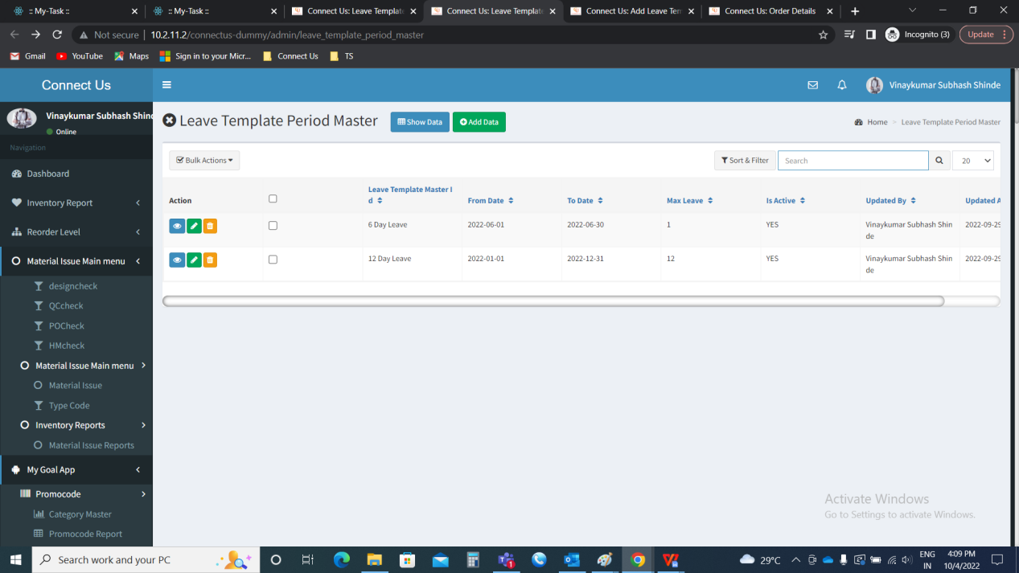

View data

The view data button is used to view the existing data. The following are the fields in the view data.

* Leave template master ID
* From date
* To date
* Max leave
* Is active

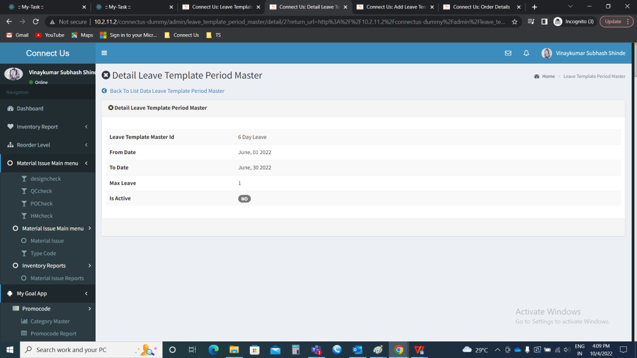

Edit data

The edit button in the action field is used to edit the data. The following are the fields in the edit data that can be edited if required by the user.

* Leave template master ID
* From date
* To date
* Max leave
* Is active

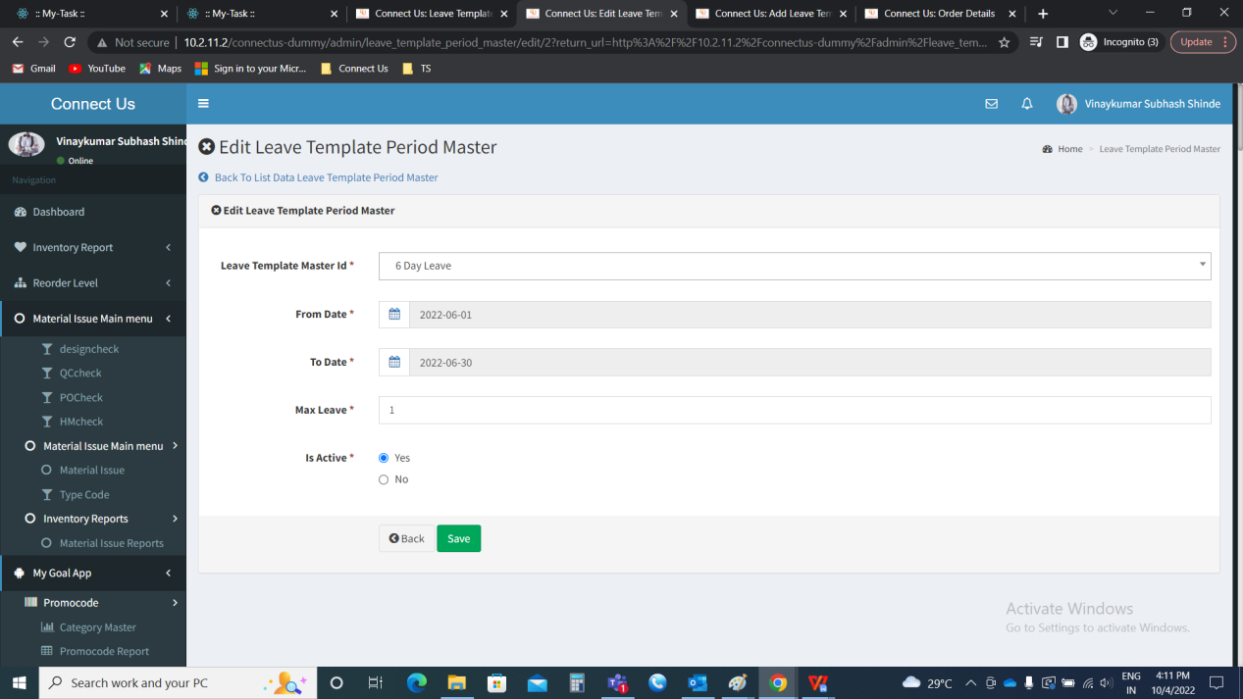

Delete data

The delete button in the action field is used to delete the data.

Leave template mapping master

The leave template mapping master is used to map the leave template master with the branches and the employees. The following are the presented in the leave template mapping master.

* Show data
* Add data
* Action
* Check box
* Branch Name
* Branch Template
* Employee Name
* Employee template
* Is active
* Updated by
* Updated at

|  |  |
| --- | --- |
| **FIELDS** | **DESCRIPTION** |
| Show data | The show data button to show the data |
| Add data | The add data button to add the data |
| Action | The action field consists of 2 buttons namely, view and edit. The view button to view the data.  The edit button to edit the data. |
| Check box | The check box for the selection. It can be single, multiple and all. |
| Branch Name | The branch name selected for that template is displayed |
| Branch Template | The template which is applicable for that branch is displayed |
| Employee name | The employee name selected for that template is displayed |
| Employee template | The template which is applicable for that employee is displayed |
| Is active | The is active field displays whether the mapping is in active mode or not |
| Updated by | The updated by displays the details of the user who updated the data |
| Updated at | The updated at displays the time and date when the record is last updated |

IMAGE

Show data

The show data button to show the data.

Add data

The add data button to add the new mapping. The following are the fields in the add data.

* Mapping
* Branch name
* Branch template
* Employee name
* Employee template
* Back
* Save & add more
* Save

|  |  |  |  |
| --- | --- | --- | --- |
| **FIELDS** | **INPUT TYPE** | **MANDATORY/ OPTIONAL** | **DESCRIPTION** |
| Mapping | Drop down | Mandatory | The type of mapping is to be selected from the drop down. The drop down consists of the following.   * Branch * Employee   When the branch is selected, the branch name and branch template is to be displayed and if any data entered to that branch earlier, that to be fetched based on the branch name.  When the employee is selected, the branch name , branch template, employee name , employee template is displayed. If any data entered to that branch earlier, that to be fetched based on the branch name. |
| Branch name | Drop down | Mandatory | The branch name to which the template is applicable is selected from the drop down. The drop down options are fetched from the branch master (in connect us >> masters >> general masters >> branch master) |
| Branch template | Drop down | Mandatory | The template which is applicable for that branch is selected from the drop down. The drop down options are fetched from leave template master (In connect us >> masters >> general masters >> leave master >> leave template master). |
| Employee name | Drop down | Optional | The employee to which the template is applicable is selected from the drop down. The drop down options are fetched from the employee master (in connect us >> masters >> general masters >> employee master) |
| Employee template | Drop down | Optional | The template which is applicable for that employee is selected from the drop down. The drop down options are fetched from leave template master (In connect us >> masters >> general masters >> leave master >> leave template master). |
| Back | Button | Optional | The back button to navigate to back page |
| Save & add more | Button | Optional | The save & add more button to save the existing data and to add the new template mapping in the master |
| Save | Button | Optional | The save button to save the template mapping in the master |

When branch is selected in the mapping

IMAGE

When employee is selected in the mapping

IMAGE

View data

The view data is used view the existing data. The following are the fields in the view data.

* Mapping
* Branch name
* Branch template
* Employee name
* Employee template
* Is active

IMAGE

Edit data

The edit data is used to edit the existing data. The following are the fields in the edit data that can be edited.

* Mapping
* Branch name
* Branch template
* Employee name
* Employee template
* Is active

IMAGE