|  |  |
| --- | --- |
| **Ticket ID** |  |
| **Ticket description** | *Invoice checking* |
| **Created by** | *Harshali Ajay Rananaware* |
| **Created on** | *24 Jan 2022* |
| **Priority** | *Very high* |
| **Version** | *1.0* |

**Version**

|  |  |  |  |  |
| --- | --- | --- | --- | --- |
| **Sr. No** | **Version no** | **Version Date** | **User name** | **User department** |
| 1 | 1.0 | *24 Jan 2022* |  |  |

**Road Map**

|  |  |
| --- | --- |
| **Phase** | **Description** |
| **Phase 1** | 1. Vendor registration |
| 1. Vendor approval |
| 1. All required master |
| 1. Add invoice |
| 1. Advance process |
| 1. Approval process |
|  | |
| **Phase 2** | 1. Add invoce from vendor side |
|  | 1. Upload bank statemat |
|  | |
| **Phase 3** | 1. Notification |
| 1. Create App for vendor side |
|  | |
| **Phase 4** | 1. Craete app for admin side |

**Proposed system**

This system is mainly use for following purpose.

1. Digitalization of vendor bill
2. Payment on time
3. Auto-generation of the bill for the bank purpose

* **Vendor registration -** When the vendor registers by self, then following fields are shown.

|  |  |  |  |
| --- | --- | --- | --- |
| **Sr. No** | **Field** | **Data Type** | **Description** |
| **Company Contact** | | | |
|  | Company ID | Int(5) | This is an auto-increment field and this is disabled. |
|  | Company name | Char (100) | Here we add company name. |
|  | Address | Varchar (200) | Here we add address. |
|  | Mobile no | Int (10) | Mobile no must be 10 digit. |
|  | Email id | Varchar | Email id enter in standered format.  Ex abc1@gmail.com |
|  | Point of Contact | Char (50) | Here we add contact person name. |
|  | Contact Email | Varchar | Email id enter in standered format.  Ex abc1@gmail.com |
|  | Contact Mobile Number | Int (10) | Mobile no must be 10 digit. |
|  | Services | Drop-down |  |
|  | Details of services/goods | Varchar (200) |  |
| **Tax Details** | | | |
|  | Adhar No | Int (12) | Aadhar no enter only 12 digit. |
|  | Upload Adhar | File |  |
|  | PAN No | Varchar (10) | First 5 is alphabet next 4 is digit and last is alphabet. |
|  | Upload PAN | File |  |
|  | GST No | Varchar(15) | First is state code then PAN no and one digit then laste 2 alphabale. |
|  | Upload GST | File |  |
|  | MSME No | Varchar(50) |  |
|  | Upload MSME | File |  |
| **Bank Details** | | | |
|  | Bank name | Varchar (30) |  |
|  | Bank branch name | Varchar(30) |  |
|  | Bank account No | Int |  |
|  | IFSC code | Varchar(20) |  |
|  | Upload Cheque | File |  |
|  | Upload Bank Passbook | File |  |
|  | Save | Button |  |

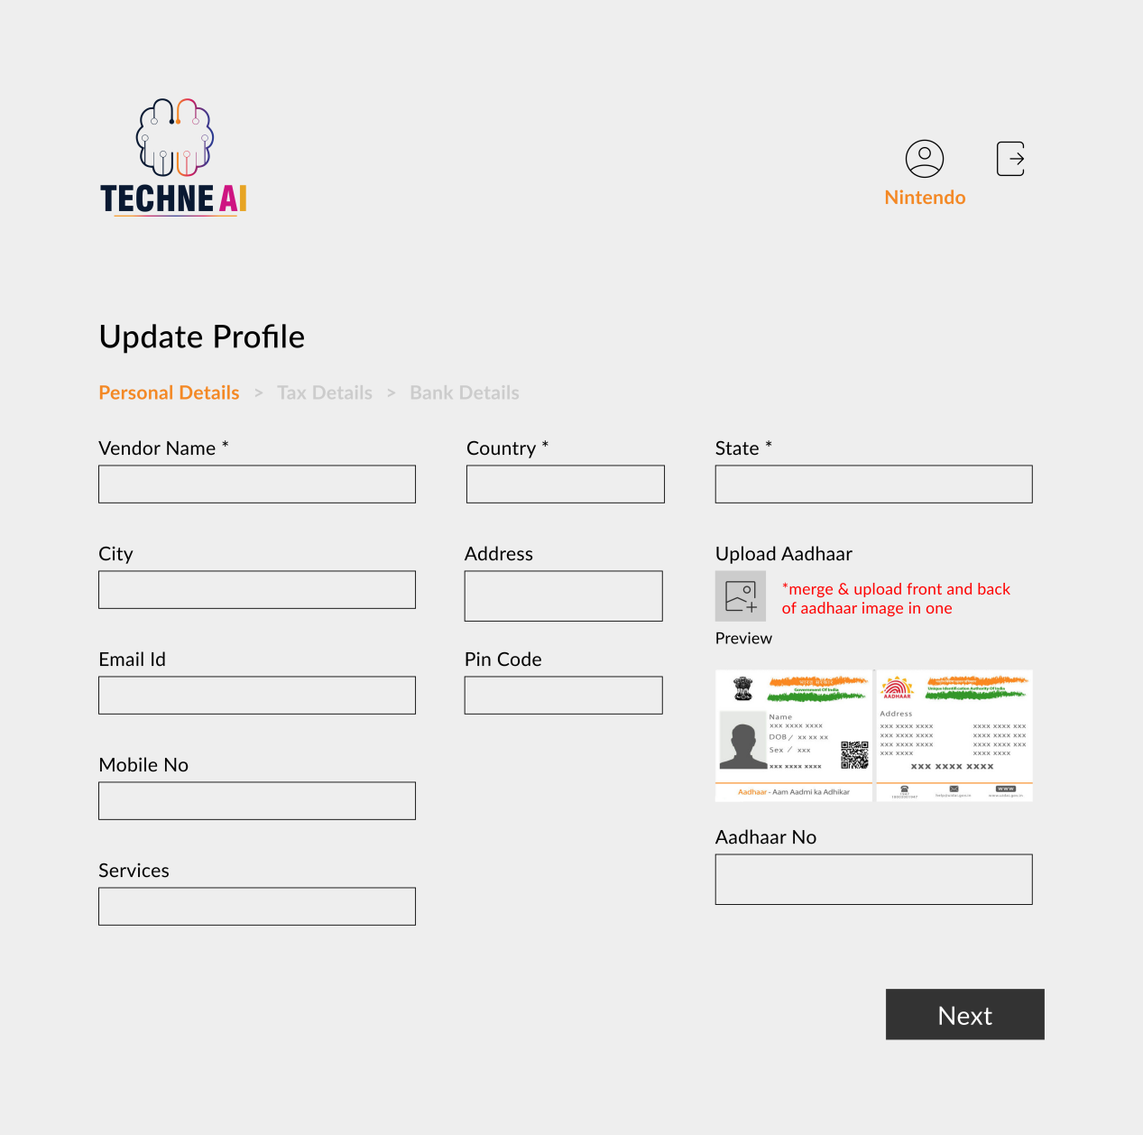

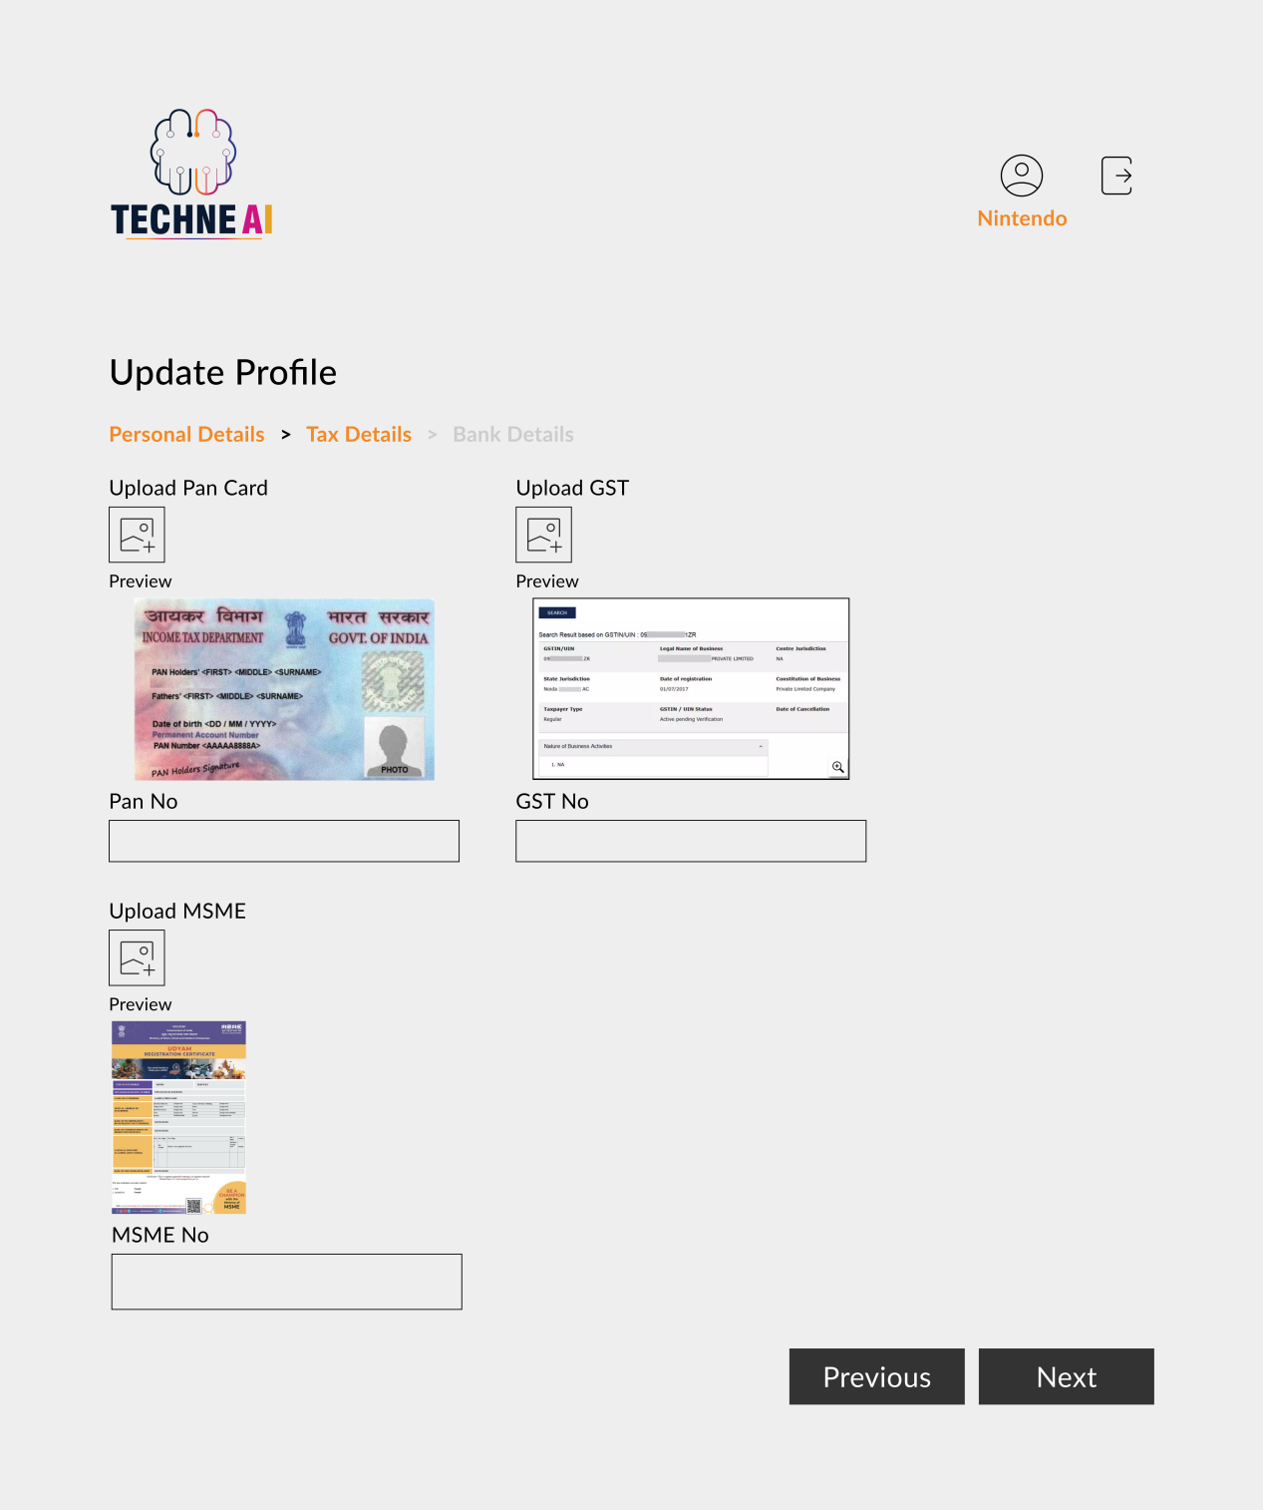

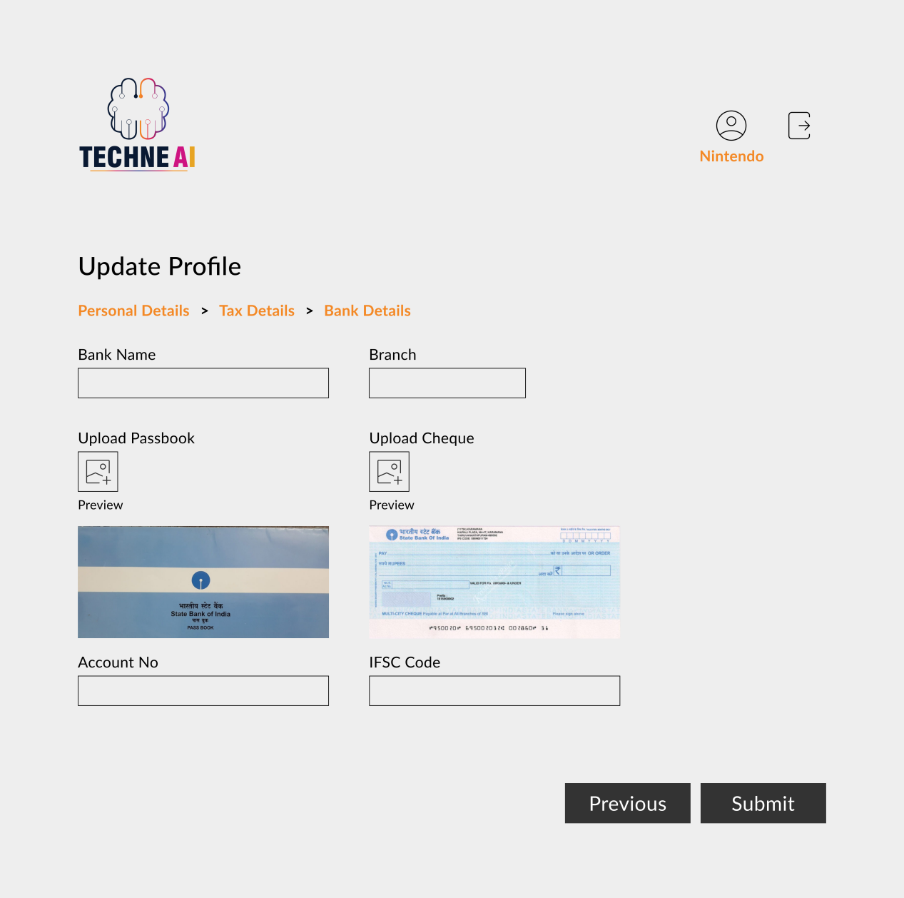

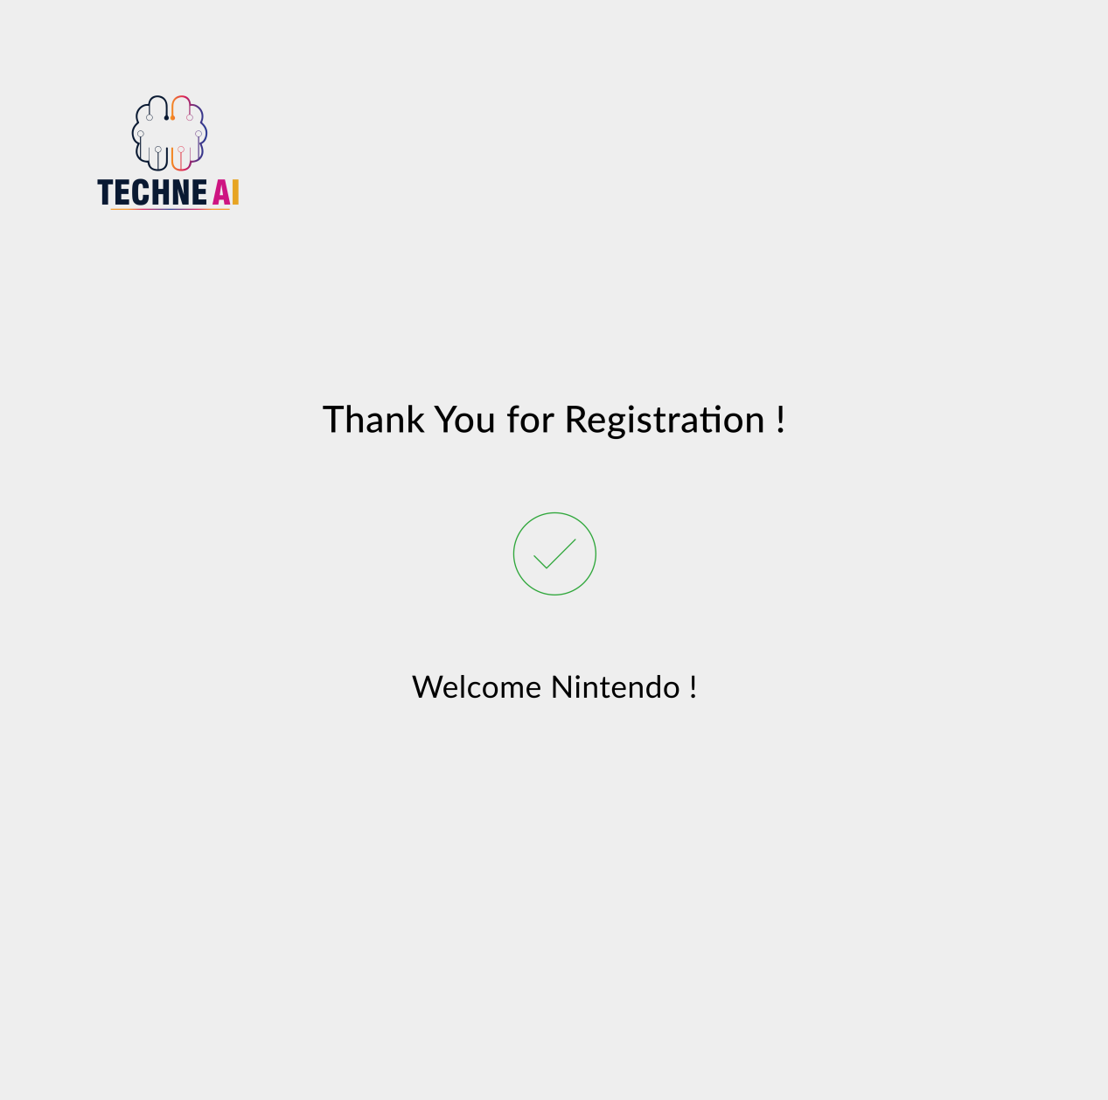

**Vendor Verification -**

The vendor add the details, then the approval should be given by the company. The administration team gets the notifiaction when new vendor is registered. The admin can approve or reject the vendor. There should be a notification to his/her login regarding that approval or rejection. The notifications are sent by whatsapp and SMS.

If vendor is reject then this link is editable to the vendor.

**Notification template -**

Verify - “Dear [vendor Name], your profile is approve.Welcome to [company name].”

Reject - “Dear [vendor Name], your profile is reject.Welcome to [company name].”

Click the view button then show following fields.

|  |  |  |  |
| --- | --- | --- | --- |
| **Sr. No** | **Field** | **Data Type** | **Description** |
| **Company Contact** | | | |
|  | Company ID | Int(5) | This is an auto-increment field and this is disabled. |
|  | Company name | Char (100) | Here we add company name. |
|  | Address | Varchar (200) | Here we add address. |
|  | Mobile no | Int (10) | Mobile no must be 10 digit. |
|  | Email id | Varchar | Email id enter in standered format.  Ex abc1@gmail.com |
|  | Point of Contact | Char (50) | Here we add contact person name. |
|  | Contact Email | Varchar | Email id enter in standered format.  Ex abc1@gmail.com |
|  | Contact Mobile Number | Int (10) | Mobile no must be 10 digit. |
|  | Services | Drop-down |  |
|  | Details of services/goods | Varchar (200) |  |
| **Tax Details** | | | |
| 11) | Adhar No | Int (12) | Aadhar no enter only 12 digit. |
| 12) | Upload Adhar | File |  |
| 13) | PAN No | Varchar (10) | First 5 is alphabet next 4 is digit and last is alphabet. |
| 14) | Upload PAN | File |  |
| 15) | GST No | Varchar(15) | First is state code then PAN no and one digit then laste 2 alphabale. |
| 16) | Upload GST | File |  |
| 17) | MSME No | Varchar(50) |  |
| 18) | Upload MSME | File |  |
| **Bank Details** | | | |
| 19) | Bank name | Varchar (30) |  |
| 20) | Bank branch name | Varchar(30) |  |
| 21) | Bank account No | Int |  |
| 22) | IFSC code | Varchar(20) |  |
| 23) | Upload Cheque | File |  |
| 24) | Upload Bank Passbook | File |  |
| 25) | Status | Radio button | Approve or Reject |
|  | Reject remark |  | If reject then send this remark to the vendor. |
| 26) | Payment Template | Drop-down |  |
| 27) | Save | Button |  |

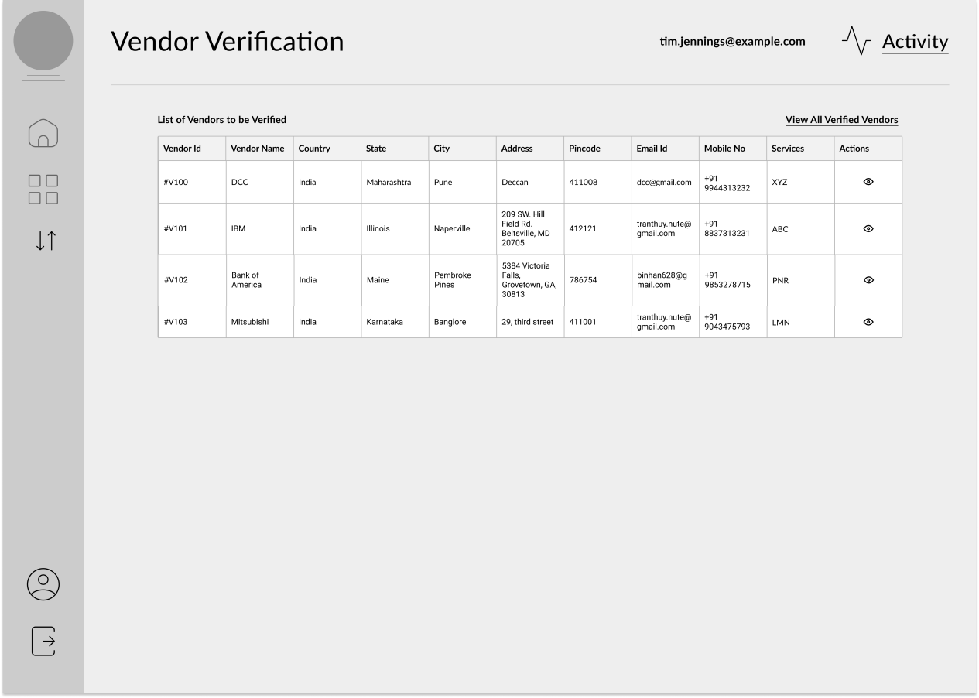

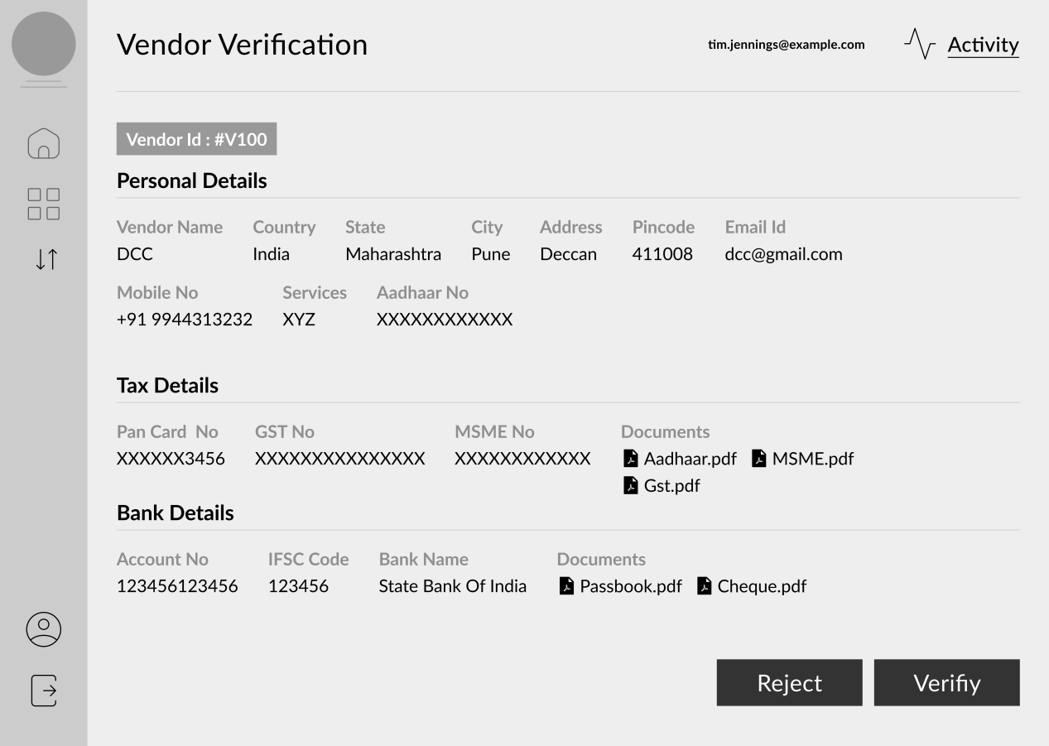

* **Invoice -** Invoice add from the vendor side.

|  |  |  |  |
| --- | --- | --- | --- |
| **Sr. No.** | **Field name** | **Data Type** | **Description** |
| **Header** | | | |
|  | Invoice ID | Int | This is an auto-increment field and this is disabled. |
|  | Service type | Drop-down | The data is fetched from the service master. |
|  | Assign to department | Drop-down | Select department. |
|  | Person name | View | Who is department head will be shown. |
|  | Company Name | Drop-down | The data is fetched from the vendor master. |
|  | Invoice no | Text | We can enter vendor bill no. |
|  | Bill date | Date | We select the bill date. |
|  | Due date | Date | This is auto generate depends upon template. |
|  | Receive date | Date | We select the bill receive date. |
| **Line Details** | | | |
|  | Description | Varchar(100) | Enter a description. |
|  | HSN code | Drop-down | Value fetch from HSN master. |
|  | Rate | float | We enter rate. |
|  | Qty | float | We can enter qty. |
|  | Taxable value | Float | Rate * qty |
|  | Tax | Drop-down | Select |
|  | GST | Decimal |  |
|  | SGST | Decimal | SGST amount is auto calculated. |
|  | CGST | Decimal | CGST amount is auto calculated. |
|  | IGST | Decimal | If select IGST then disable GST. |
|  | Total | float | Taxable value + GST/IGST |
| **Footer** | | | |
|  | Tcs | float | We can enter TCS amount here. |
|  | Total Bill Amount | float | Taxable value + GST/IGST + TCS |
|  | Tds % | Varchar | If TDS is applicable then TDS % show here. |
|  | Advance amount | float |  |
|  | Net payment | float | Total Bill Amount - TDS Amount - Advance amount |
|  | Remark | Varchar | We can enter remark. |
|  | Upload Invoice |  | Here we can add attachment for example .png , .jpeg , .xls |
| **Payment Details** | | | |
|  | Status | Drop-down | Authorised, hold, pending,complete, release |
|  | Payment date |  |  |
|  | Actual Payment Date |  |  |
|  | Transaction ID |  |  |
|  | Remark |  |  |
|  | Submit | Button |  |

**History -** In Bill Checking show all transaction history.

**View -** Invoice details will be shown to the user as per the invocice database.

**Master**

* **Company Configration** -

|  |  |  |
| --- | --- | --- |
| **Sr. No** | **Fields** | **Data Type** |
|  | Company name |  |
|  | Company Logo |  |
|  | Company Address |  |
|  | GST No |  |
|  | TAN No |  |
|  | PAN No |  |
|  | Bank name |  |
|  | Bank account No |  |
|  | IFSC Code |  |
|  | Save |  |

* **Setting master -**

|  |  |  |
| --- | --- | --- |
| **Sr. No** | **Fields** | **Data Type** |
|  | GST details |  |
|  | PAN details |  |
|  | MSME details |  |
|  | BANK details |  |
|  |  |  |

* **Department Master -** In this master, we can add the department to find to which department the bill is assigned.

**Add data**

|  |  |  |  |
| --- | --- | --- | --- |
| **Sr. No** | **Fields** | **Data Type** |  |
|  | Deptartment ID | Int |  |
|  | Dept Name | Varchar | Add dept name |
|  | Remark | Varchar |  |
|  | Is active | Radio button | Yes or no |
|  | Save | Button |  |

**NOTE:** The above all fields can be editable whenever the changes are required.

* **Services Master -** In this master, we can add the services.

**Add data**

|  |  |  |  |
| --- | --- | --- | --- |
| **Sr. No** | **Fields** | **Data Type** |  |
| 1) | Services Name | Varchar | Add services name |
| 2) | Remark | Varchar |  |
| 3) | Is active | Radio button | Yes or no |

**NOTE:** The above all fields can be editable whenever the changes are required.

* **Employee Master -** In employee master, we add the employee details.

**Add data -**

|  |  |  |  |
| --- | --- | --- | --- |
| **Sr. No** | **Fields** | **Data Type** | **Description** |
|  | Employee ID | Int | This is an auto-increment field and this is disabled. |
|  | Employee Name | Char (200) | Here we add employee name. |
|  | Address | Varchar (200) | Here we add address. |
|  | Date Of Joining | Date | Here accepted date before todays date. |
|  | Designation | Char |  |
|  | Date Of Leaving | Date | Here accepted date before todays date. |
|  | Separation Mode | Drop-down |  |
|  | Date Of Birth | Date | Here accepted date before todays date. |
|  | Gender | Radio button | Male and Female |
|  | Blood Group | Drop-down | All blood group show here. |
|  | Marital Status | Drop-down |  |
|  | Email ID | Varchar | Email id enter in standered format.  Ex abc1@gmail.com |
|  | Aadhar no | Int (12) | Aadhar no accept only 12 digit. |
|  | PAN No | Varchar (10) | First 5 is alphabetnext 4 is digit and last is alphabet. |

**Edit data -**

|  |  |  |
| --- | --- | --- |
| **Sr. No** | **Fields** | **Editable** |
|  | Employee ID | No |
|  | Employee Name | Yes |
|  | Address | Yes |
|  | Date Of Joining | No |
|  | Designation | Yes |
|  | Date Of Leaving | Yes |
|  | Separation Mode | Yes |
|  | Date Of Birth | Yes |
|  | Gender | Yes |
|  | Blood Group | Yes |
|  | Marital Status | Yes |
|  | Email ID | Yes |
|  | Aadhar no | Yes |
|  | PAN No | Yes |

* **Payment Duration** - In this master, we add the Payment Duration to define the due dates of a particular payment related to the particular department.

**Add data**

|  |  |  |
| --- | --- | --- |
| **Sr. No** | **Fields** | **Data Type** |
|  | Payment Duration ID |  |
|  | Payment Duration | Varchar |
|  | Payment Type | Drop-down |
|  | Bill Type | Drop-down |
|  | Min days | Varchar |
|  | Payment Weekly | Drop-down |
|  | Bill Day | Date |
|  | Remark | Varchar |

**NOTE:** The above all fields can be editable whenever the changes are required.

* **HSN Code**

|  |  |  |
| --- | --- | --- |
| **Sr. No** | **Fields** | **Data Type** |
|  | Chapter |  |
|  | Heading |  |
|  | Sub-Heading |  |
|  | Code |  |
|  | Code |  |
|  | HSN Code | Here show the HSN code auto from he field chepter heading sub-heading code code |
|  | Description | We can write description |
|  | Is active |  |
|  | Save |  |

* **Payment type master -**

|  |  |  |
| --- | --- | --- |
| **Sr. No** | **Fields** | **Data Type** |
|  | Payment type |  |
|  | Remark |  |
|  | Is active |  |
|  | Save |  |

* **User Login Master -** The user login master is used to create the login credentitials of an employee.

**Add data** -

|  |  |  |  |
| --- | --- | --- | --- |
| **Sr. No** | **Fields** | **Data Type** | **Description** |
|  | Employee Name | Drop-down | Drop-down list given. Data fetch from employee master. In this field data search by employee id or employee name. |
|  | User Name | Char | Here accepted only alphbate. |
|  | Password | Varchar | Minimum of 8 characters in length.  Must have at least one special character.  Must have uppercase and lowercase. |
|  | Advance amount limit | Decimal | We can enter the from and to limit. ( 0-10000) |
|  | Original bill amount limit | Decimal | We can enter the from and to limit. ( 0-10000) |

* **Vendor Master** -

|  |  |  |  |
| --- | --- | --- | --- |
| **Sr. No** | **Field** | **Data Type** | **Description** |
|  | Company ID | Int(5) | This is an auto-increment field and this is disabled. |
|  | Company name | Char (100) | Here we add company name. |
|  | Address | Varchar (200) | Here we add address. |
|  | Mobile no | Int (10) | Mobile no must be 10 digit. |
|  | Email id | Varchar | Email id enter in standered format.  Ex abc1@gmail.com |
|  | Point of Contact | Char (50) | Here we add contact person name. |
|  | Contact Email | Varchar | Email id enter in standered format.  Ex abc1@gmail.com |
|  | Contact Mobile Number | Int (10) | Mobile no must be 10 digit. |
|  | Services | Drop-down |  |
|  | Details of services/goods | Varchar (200) |  |
| 11) | Adhar No | Int (12) | Aadhar no enter only 12 digit. |
| 12) | Upload Adhar | File |  |
| 13) | PAN No | Varchar (10) | First 5 is alphabet next 4 is digit and last is alphabet. |
| 14) | Upload PAN | File |  |
| 15) | GST No | Varchar(15) | First is state code then PAN no and one digit then laste 2 alphabale. |
| 16) | Upload GST | File |  |
| 17) | MSME No | Varchar(50) |  |
| 18) | Upload MSME | File |  |
| 19) | Bank name | Varchar (30) |  |
| 20) | Bank branch name | Varchar(30) |  |
| 21) | Bank account No | Int |  |
| 22) | IFSC code | Varchar(20) |  |
| 23) | Upload Cheque | File |  |
| 24) | Upload Bank Passbook | File |  |
| 25) | Status | Radio button | Approve or Reject |
| 26) | Payment Template | Drop-down |  |
| 27) | Save | Button |  |

**References of the users**

|  |  |  |  |
| --- | --- | --- | --- |
| **User** | **Name** | **Mail** | **Contact number** |
| **Actual user** |  |  |  |
| **Ticket created by (if any)** |  |  |  |
| **Assigned business analyst** |  |  |  |
| **Assigned developer** |  |  |  |
| **Assigned tester** |  |  |  |