**PASSING TICKETS**

In Ticketing System >> Ticket >> My Tickets > Unpassed Ticket (Tab)

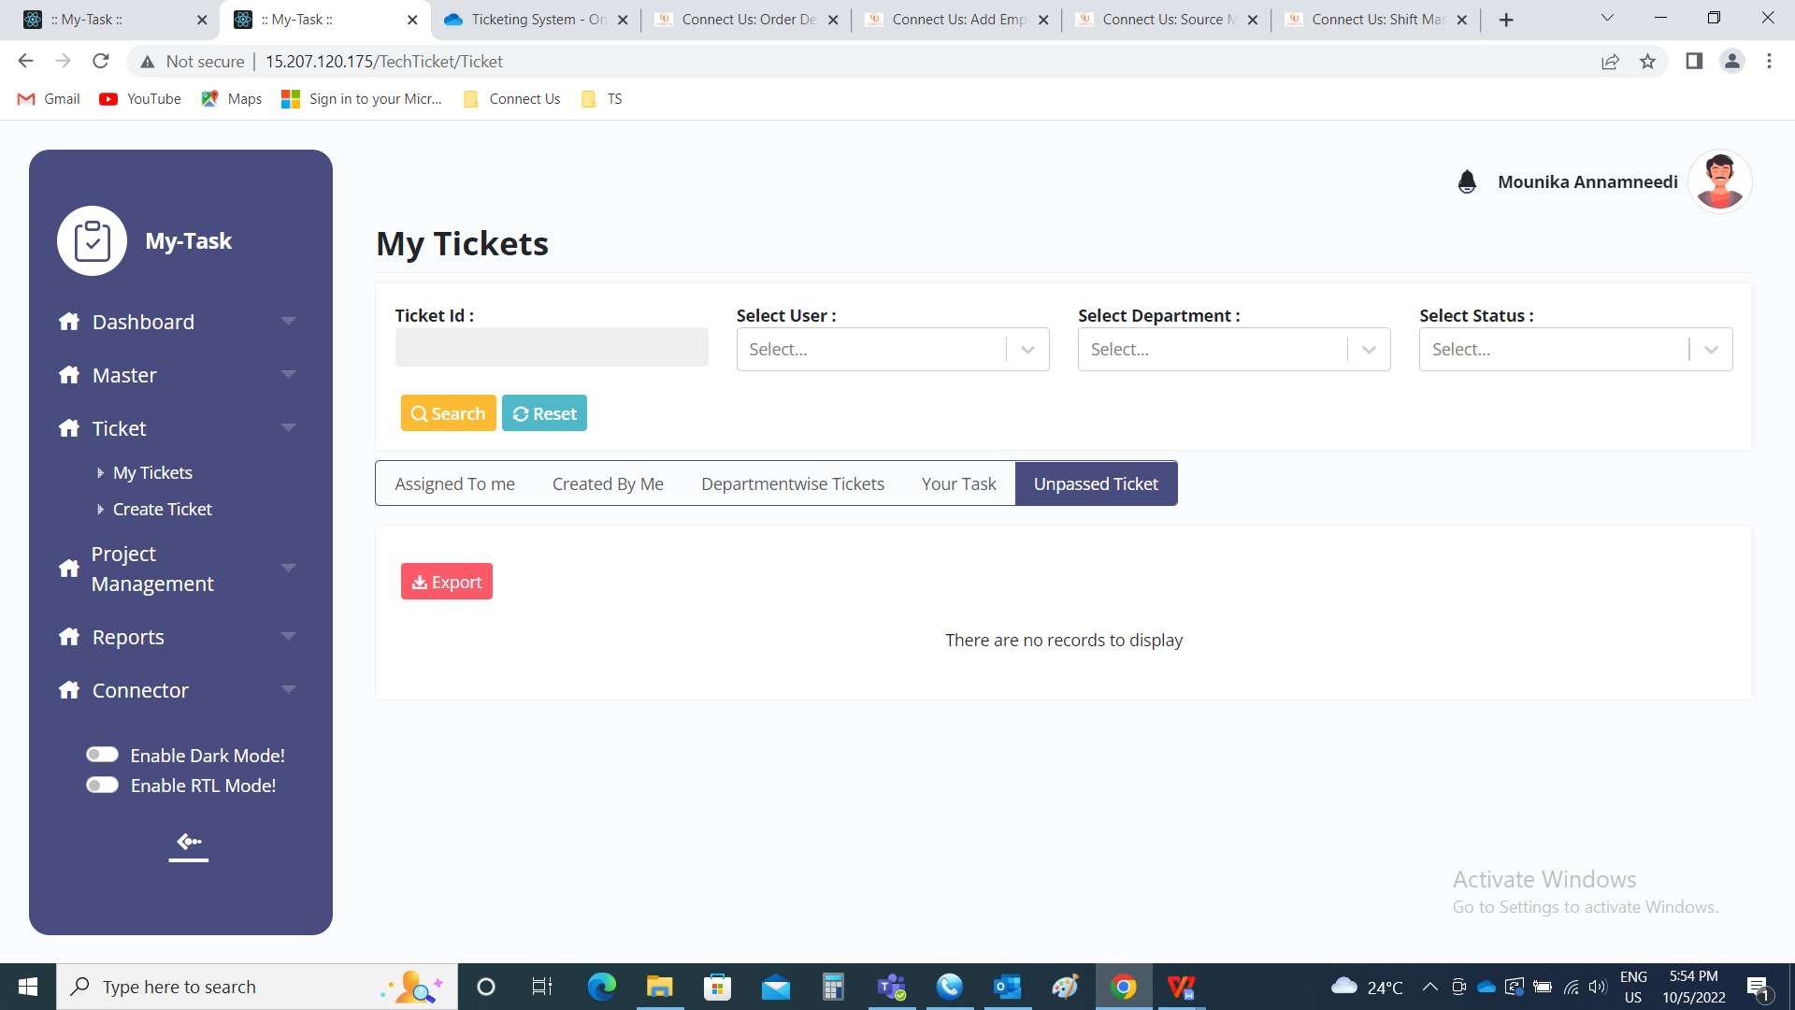

When a ticket is raised by the user, the ticket is shown under unpassed ticket tab in my tickets. If the ticket creator is the authority person, then the ticket is directly passed.

If the user is not a authority person, then the tickets are shown in the authority person - unpassed ticket tab. The ticket can be passed or rejected by that authority person. Based on that, the ticket status is changed.

The authority is mentioned in the user master against the user in the user master - departments - ticket passing authority (in ticketing system >> masters >> user master >> edit (required user) >> department (tab)).

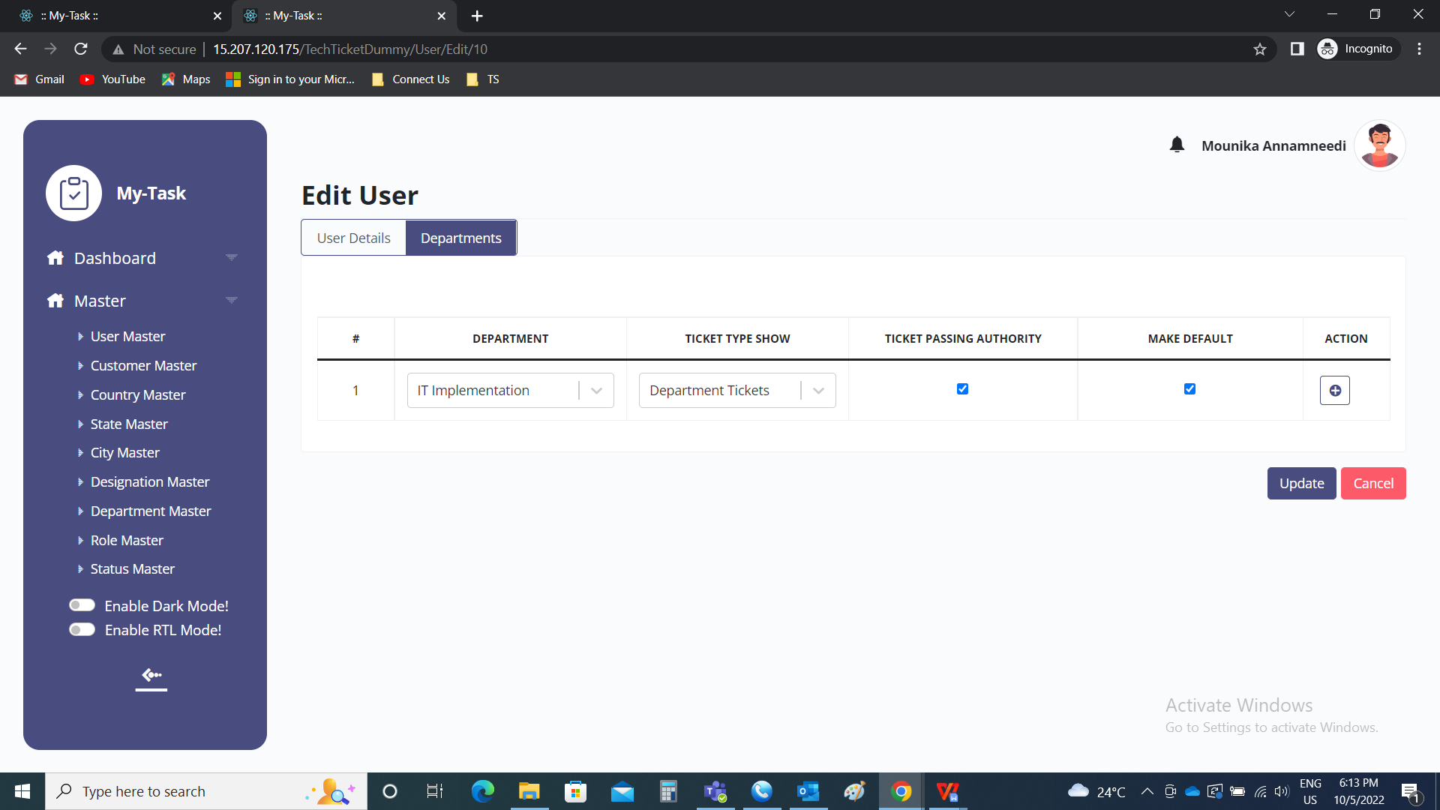

The unpassed ticket tab consists of the following

|  |  |
| --- | --- |
| Field | Description |
| Action | The action field consists of view, pass and reject.  The view button is used to view the ticket details and can be used foe commenting.  The pass button is used to pass the ticket.  The reject button is used to reject the ticket. |
| Sr | The serial count |
| Ticket ID | The ticket ID is displayed |
| Description | The description of the ticket is displayed |
| Ticket date | The ticket creation date is displayed |
| Expected date | The date on which the ticket is expected to solved is displayed |
| Priority | The priority of the ticket is displayed |
| Type | The type of the ticket is displayed |
| Status | The status of the ticket is displayed |
| Assign to department | The assigned department is displayed |
| Assign to person | The assigned person is displayed |
| Created by | The creator of the ticket is displayed |
| Export | To export the tickets of the user. |

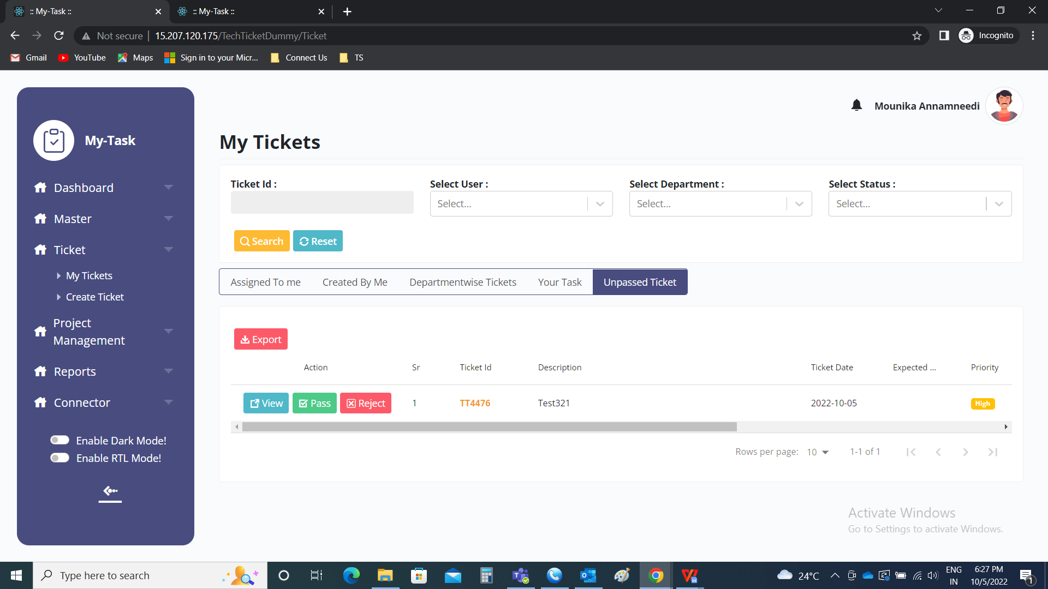

View

The view page consists of the ticket details in details and also have option to chat or comment on the ticket. The ticket details consists of the following

* Ticket ID
* Status
* Created by
* Ticket owner
* Priority
* Description
* Attachments
* Timeline
* Ticket chat

|  |  |
| --- | --- |
| Field | Description |
| Ticket ID | The ticket ID is displayed |
| Status | The status of the ticket is displayed |
| Created by | The user who created the ticket is displayed |
| Ticket owner | The owner of the ticket I.e., the assigned owner is displayed |
| Priority | The priority of the ticket is displayed |
| Description | The description of the ticket is displayed |
| Attachments | The attachments are shown and can be downloaded |
| Timeline | The timeline report is shown in the form of Gantt chart |
| Ticket chat | The ticket chat is shown |

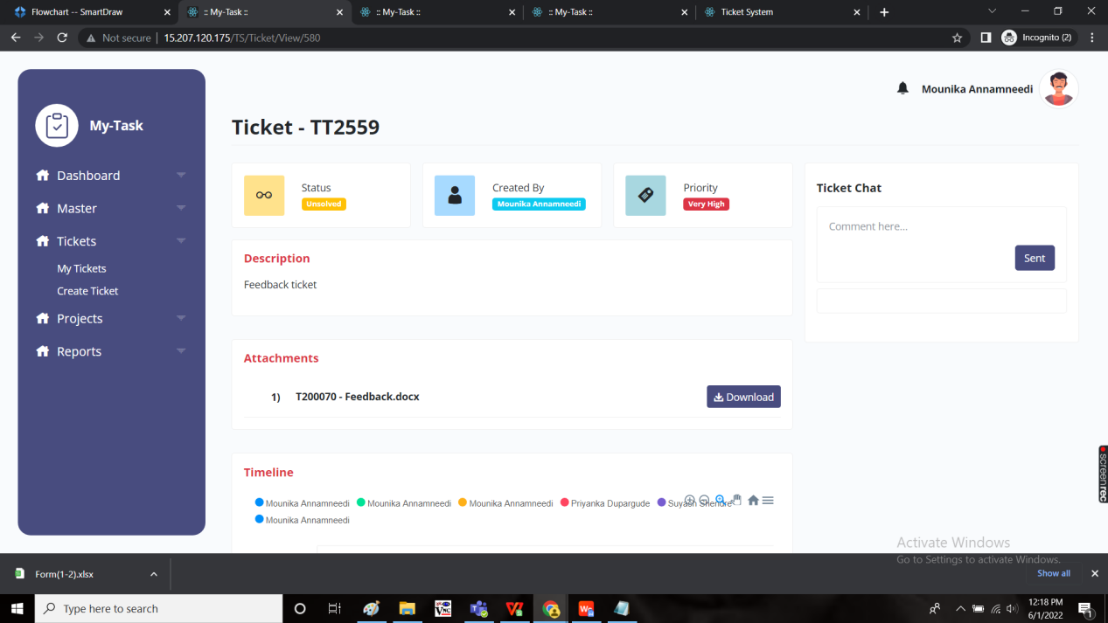

Attachments:

The attachments consists of the images and files attached. There is an option to download the file if required.



The file is downloaded and output can be viewed based on the file uploaded and as follows

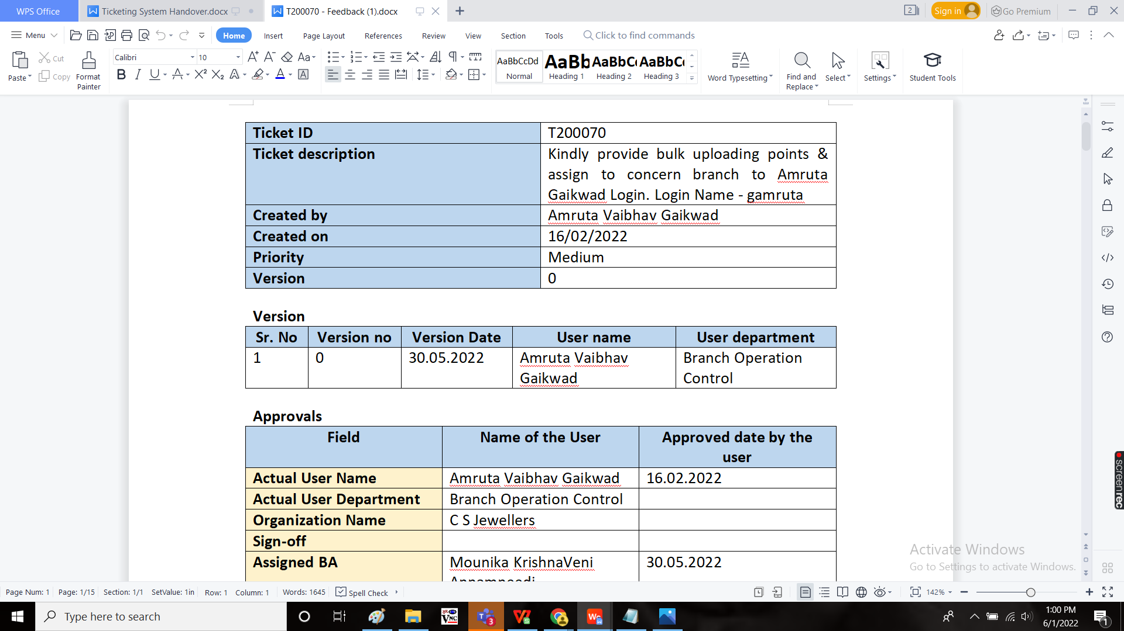

Timeline:

The timeline consists of the report of the entire ticket in the gantt chart view. The following are the sets in timeline

* Timeline tools
* Timeline users
* Timeline charts
* Hamburger

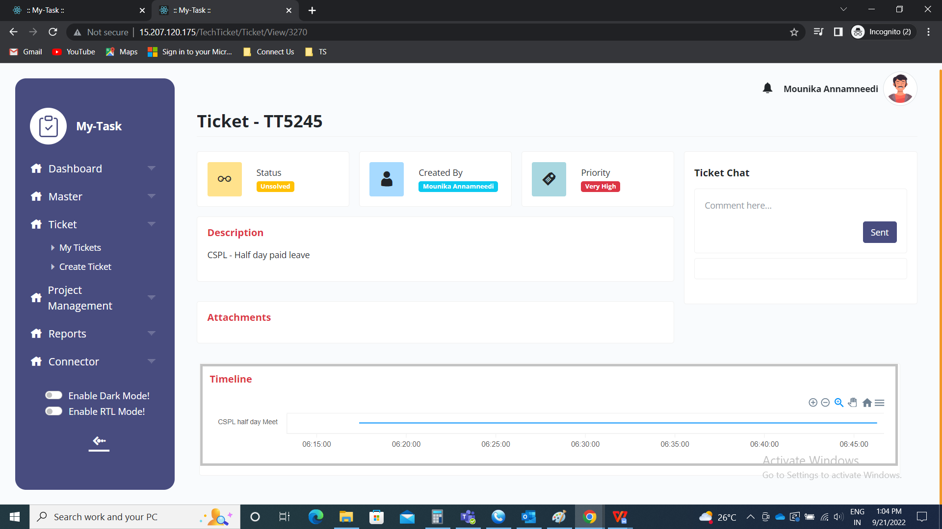

Timeline tools

The timeline tools consists of the following

* Zoom in
* Zoom out
* Selection zoom
* Home

|  |  |
| --- | --- |
| Field | Description |
| Zoom in | To zoom in the chart |
| Zoom out | To zoom out the chart |
| Selection zoom | To select the zoom in and zoom out at the selected area |
| Home | To reset all the features |

Timeline users:

The timeline users are the users who are the part of tasks in the ticket. Each user will have single colour based on the basket.

Timeline charts:

The timeline chart is displayed with task names on y-axis and dates on x-axis. The particular task is shown chart view of in the colour block assigned to that particular user.

Hamburger:

The hamburger menu consists of the following fields

* Download SVG
* Download PNG

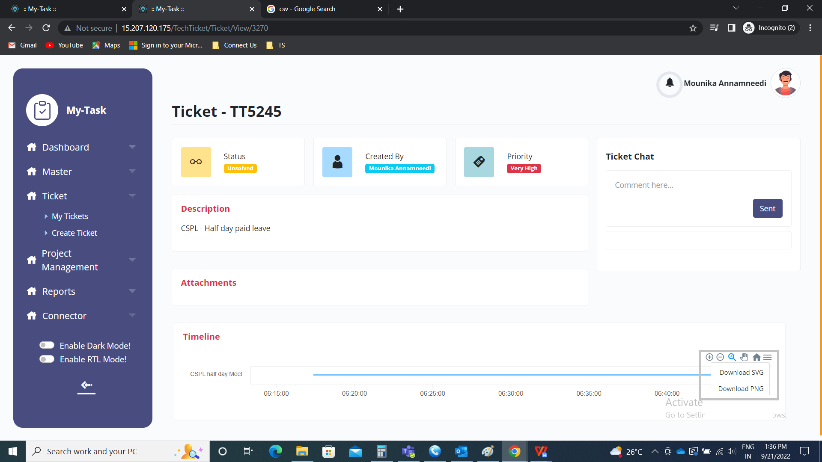

Download SVG:

The SVG stands for Scalable Vector Graphics. It is downloaded and viewed on web.

The following is the output of SVG file.

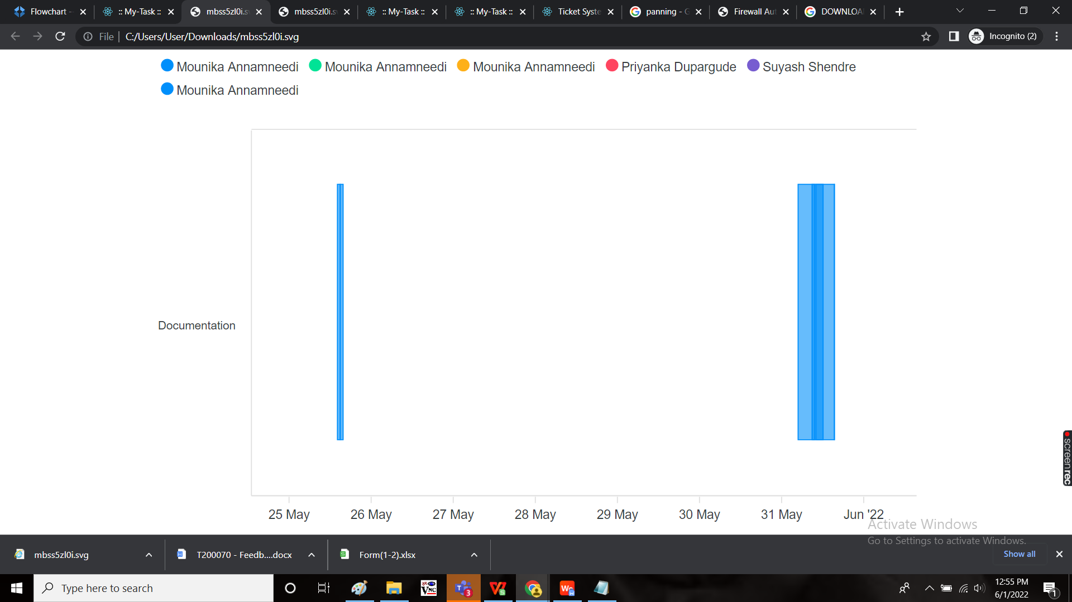

Download PNG:

The PNG stands for Portable Network Graphic. It is downloaded and viewed as image.

The following is the output of PNG file.

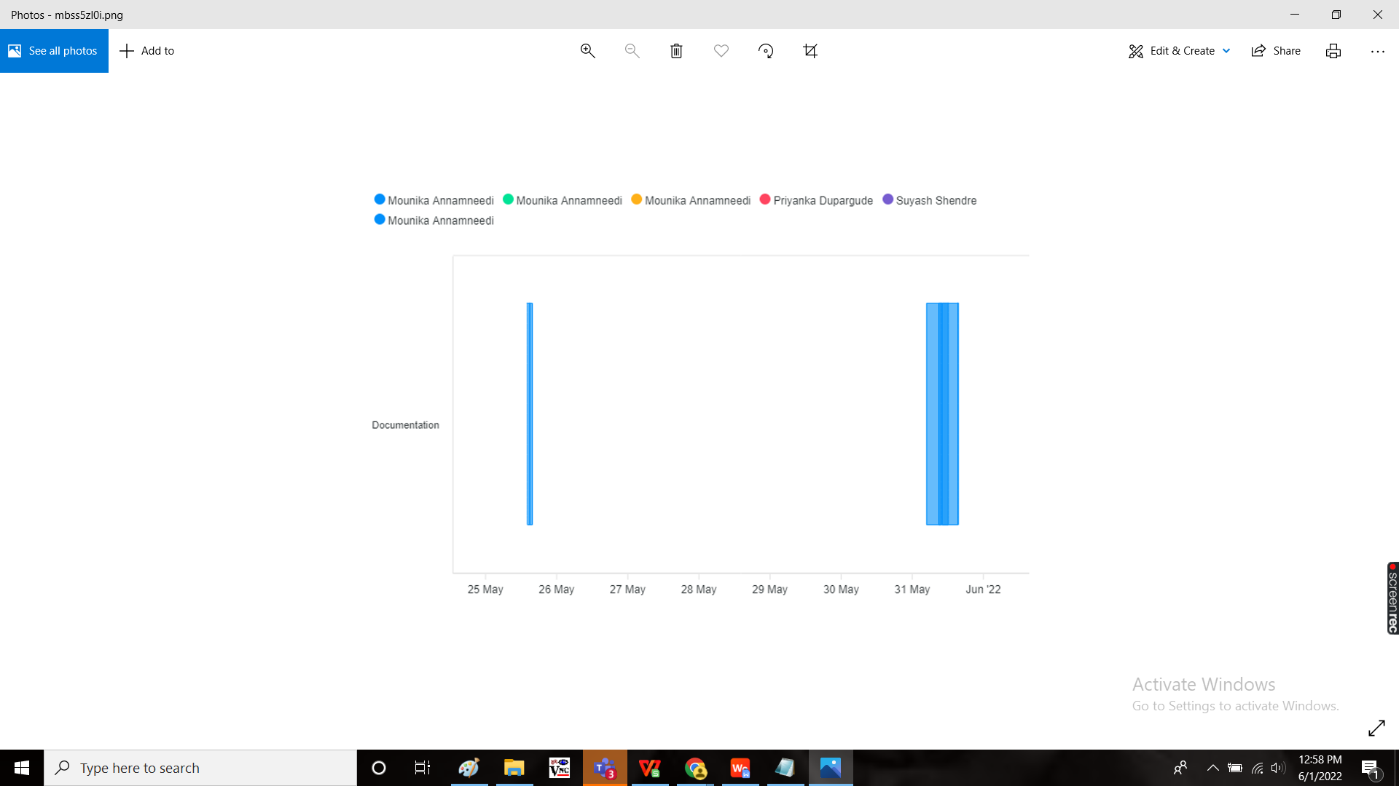

Ticket chat:

The ticket chat consists of the chats and comments made on the particular ticket.

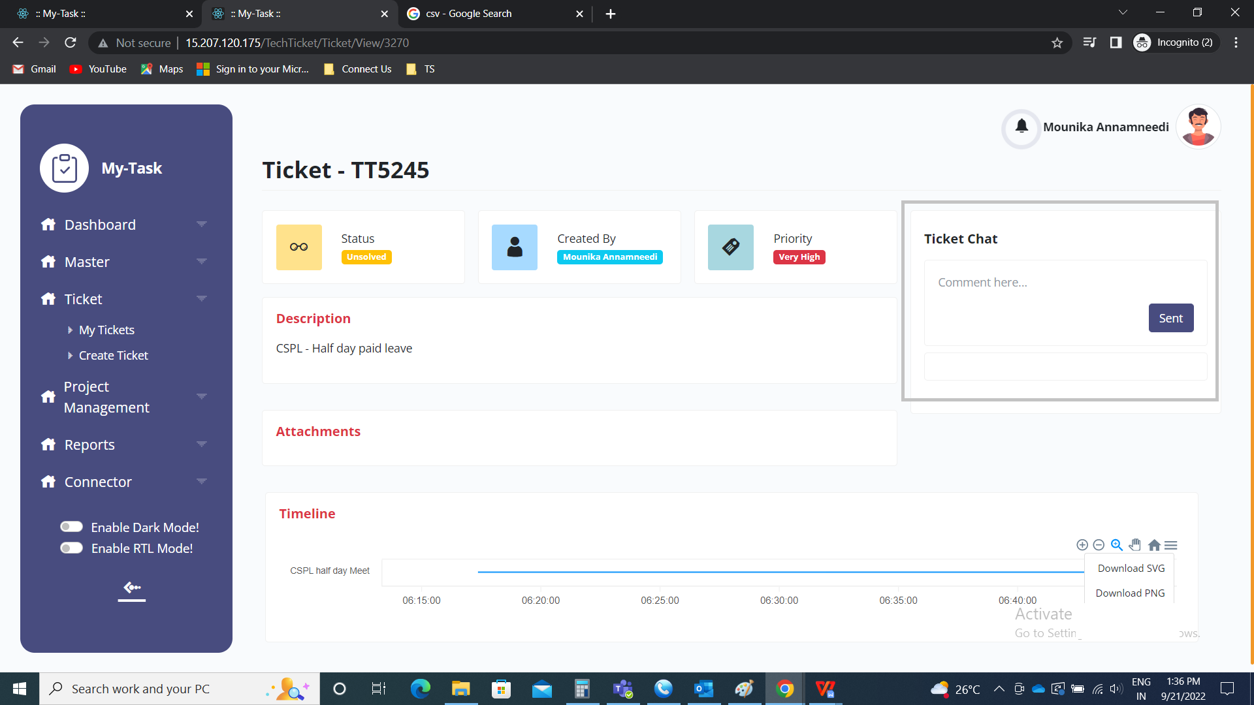

User or multiple users can be tagged in the chat box.

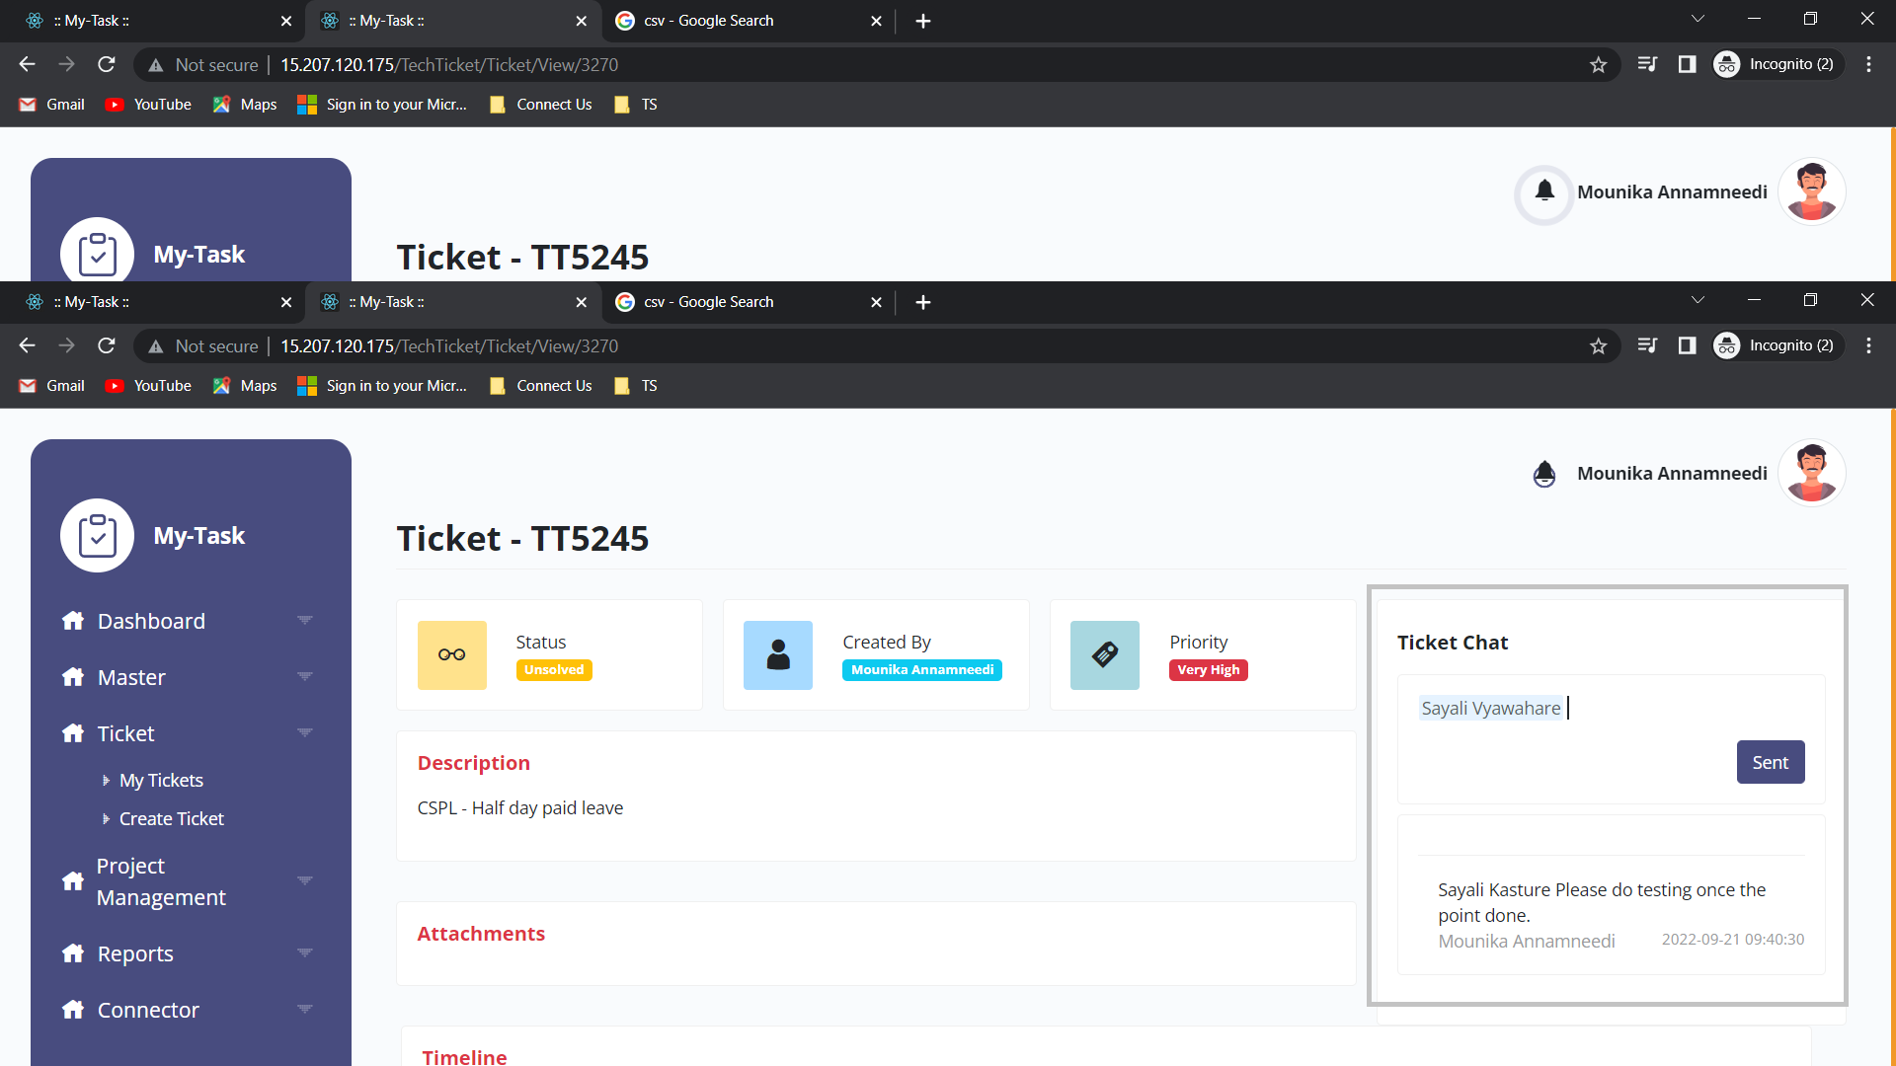

Pass

The pass button is used by the authority person to pass the ticket. When the user clicks on pass button, a pop-up opens. The pop up consists of the following.

* Ticket ID
* Remark
* Submit
* Cancel

|  |  |  |  |
| --- | --- | --- | --- |
| **FIELDS** | **INPUT TYPE** | **MANDATORY/ OPTIONAL** | **DESCRIPTION** |
| Ticket ID | Auto | - | The ticket ID of the ticket is displayed |
| Remark | Text | Mandatory | The remark at the time of passing is mentioned |
| Submit | Button | Optional | The submit button to pass the ticket. As soon as the ticket is passed, the ticket status is changed to unsolved and assigned to the respective person as per the query. The notification is sent to the respective entry user and assigned user that the ticket is passed and assigned. |
| Cancel | Button | Optional | The cancel button to close the pop-up |

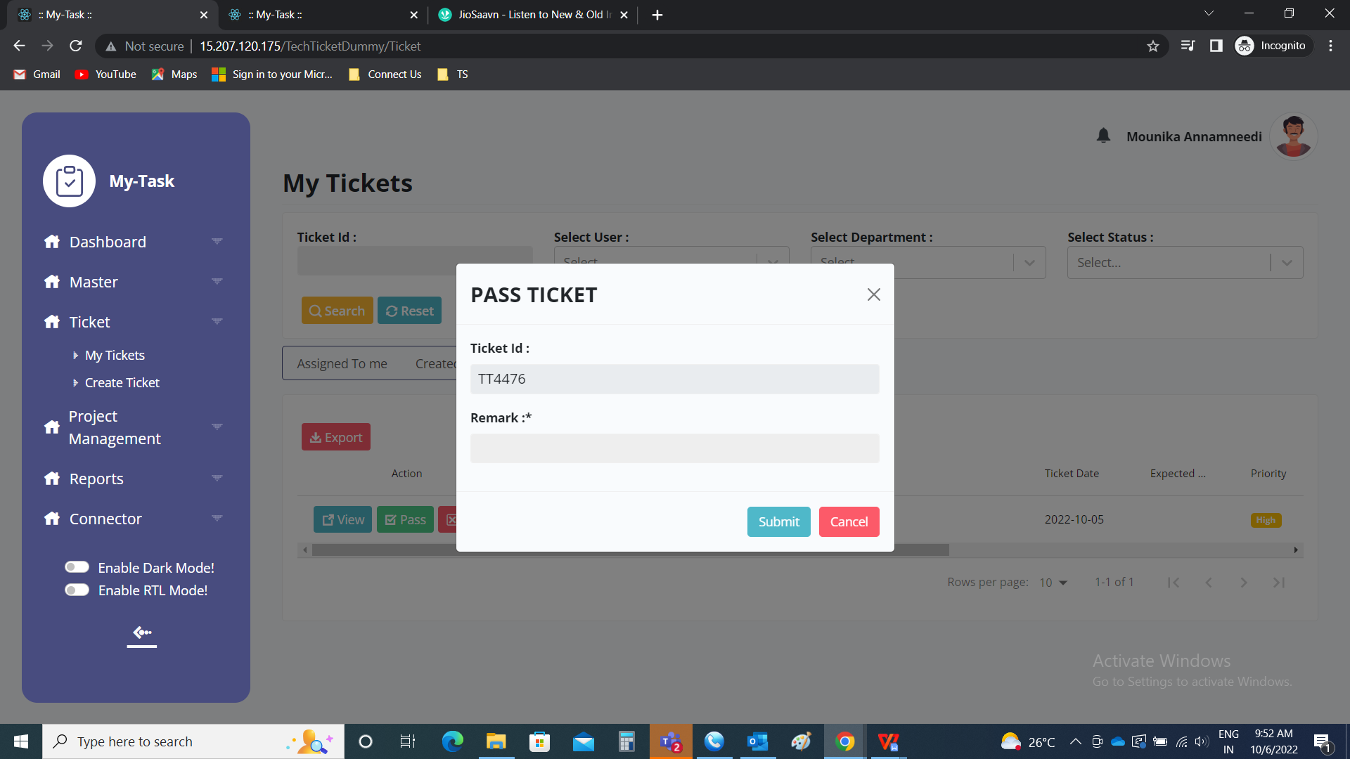

Reject

The reject button is used by the authority person to reject the ticket. When the user clicks on reject button, a pop-up opens. The pop up consists of the following.

* Ticket ID
* Remark
* Submit
* Cancel

|  |  |  |  |
| --- | --- | --- | --- |
| **FIELDS** | **INPUT TYPE** | **MANDATORY/ OPTIONAL** | **DESCRIPTION** |
| Ticket ID | Auto | - | The ticket ID of the ticket is displayed |
| Remark | Text | Mandatory | The remark at the time of rejecting the ticket is mentioned |
| Submit | Button | Optional | The submit button to reject the ticket. As soon as the ticket is rejected, the ticket status is changed to rejected and disables from the tickets. The notification is sent to the respective entry user that the ticket is rejected. |
| Cancel | Button | Optional | The cancel button to close the pop-up |

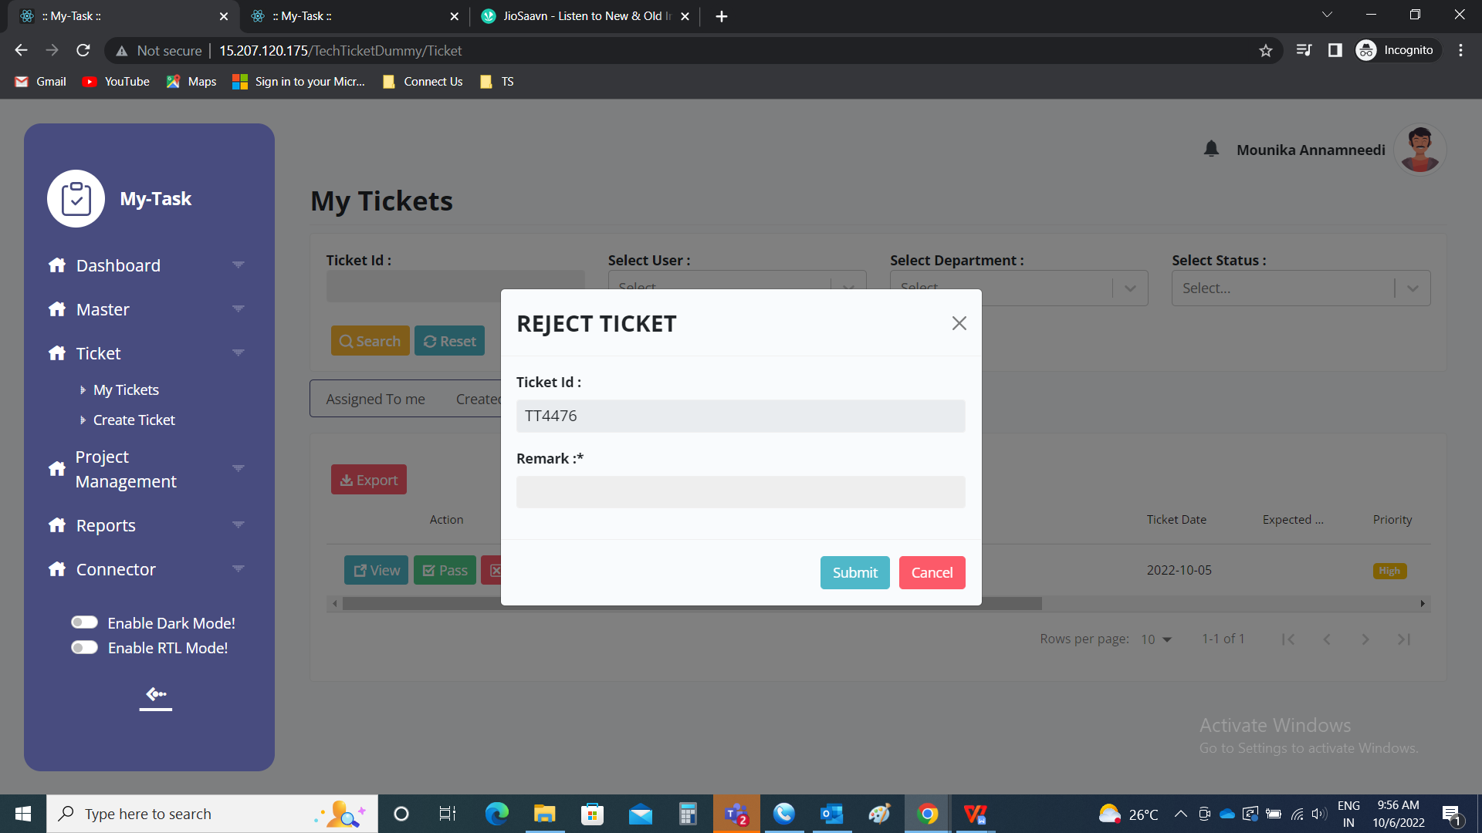

Export

The following are the fields in the export.

* Ticket ID
* CUID
* Ticket date
* Expected solved date
* Assigned department
* Assigned user
* Type
* Priority
* Status
* Description
* Created by

If based on the query type, if the ticket have any extra fields, those will be exported accordingly.

