|  |  |
| --- | --- |
| **Ticket ID** | TT4148 |

**Business requirement**

In connect us -> report -> branch operation report -> cashier denomination report. The user requires to hide the Padm difference column to head cashier.

**Existing system**

In the existing system, the column is visible to every user.

**Proposed system**

* Hiding of the padm difference to head cashier

Step 1:

In connect us -> report -> branch operation report -> cashier denomination report

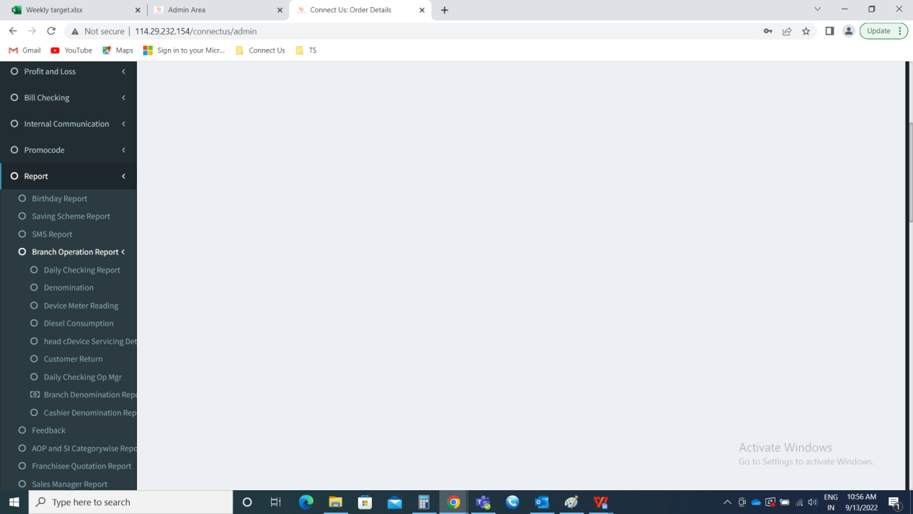

Cashier Denomination Report:

The cashier denomination report consists of the following.

* Date
* Branch
* Search
* Export

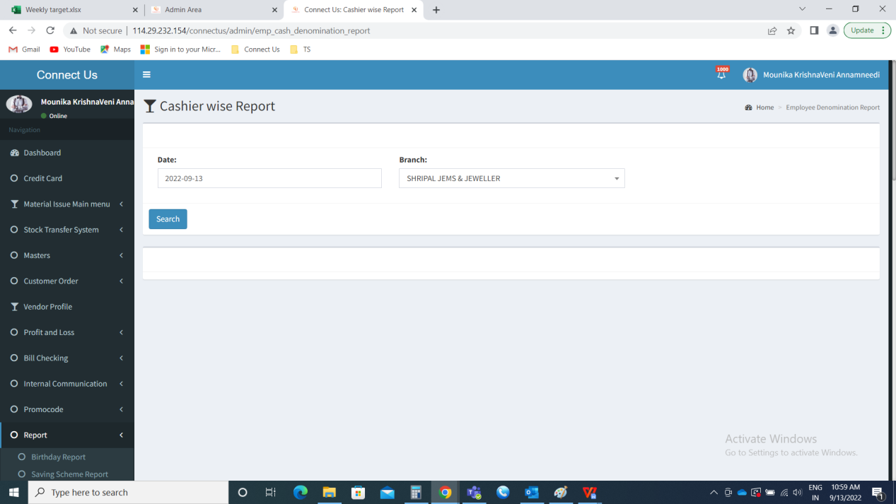

When the report the generated, the following the fields are displayed.

* Cashier name
* Opening cash
* Received cash
* Total cash
* Padm difference
* Denomination table

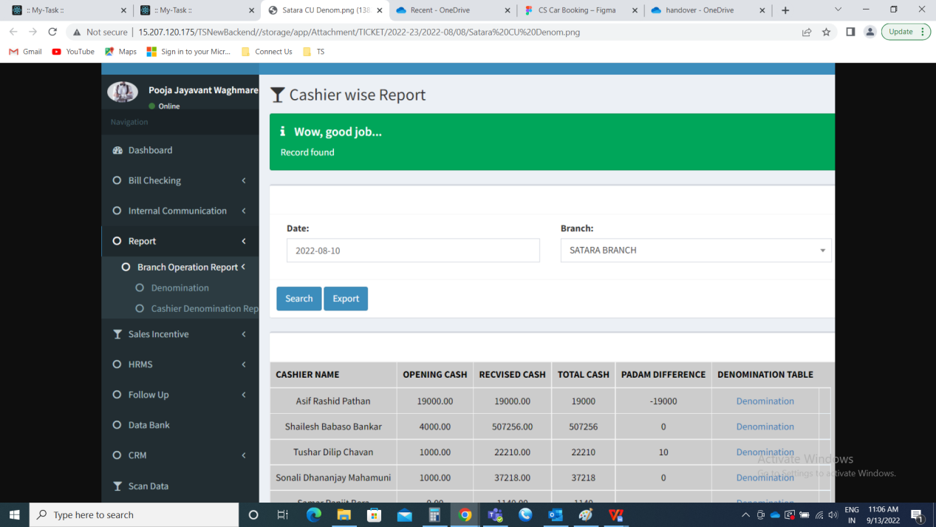

Hide the padm difference to head cashier (In Connect Us -> general masters -> employee master -> designation = head cashier)

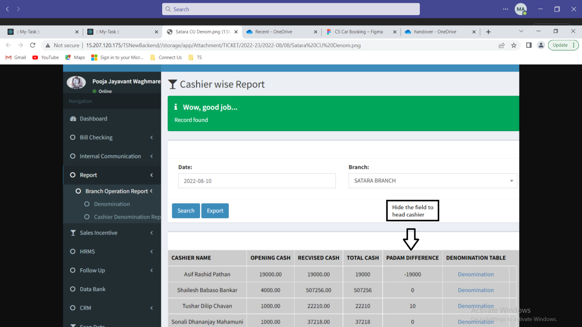

**Output**

In Connect Us >> Report >> Branch Operation Report >> Cashier Denomination Report - To head cashier role, the padm difference field is hidden.