|  |  |
| --- | --- |
| **Ticket ID** | TT5086 |
| **Ticket description** | Dear Team, Required integration of facial attendance system into monthly attendance in connect us, as we do not have the same in techne AI connect us . |
| **Created by** | Minal Pawar |
| **Created on** | 14/09/2022 |
| **Priority** | Medium |
| **Version** | 1 |

**Version**

|  |  |  |  |  |
| --- | --- | --- | --- | --- |
| **Sr. No** | **Version no** | **Version Date** | **User name** | **User department** |
| 1 | 1 | 14.09.2022 | Minal Pawar | Techneai Hr |

**Approvals**

|  |  |  |
| --- | --- | --- |
| **Field** | **Name of the User** | **Approved date by the user** |
| **Actual User Name** | Minal Pawar | 14.09.2022 |
| **Actual User Department** | Techneai Hr |  |
| **Organization Name** | Techneai Pvt Ltd |  |
| **Sign-off** |  |  |
| **Assigned BA** | Mounika KrishnaVeni Annamneedi | 17.09.2022 |
| **Assigned Developer** |  |  |
| **Assigned Tester** |  |  |

**Estimation**

|  |  |  |  |  |
| --- | --- | --- | --- | --- |
| **Department name** | **Estimated Time (In hr)** | **Scheduled Date (Starting date )** | **Estimated date** | **Actual delivery date** |
| **BA** | 2 | 17.09.2022 | 17.09.2022 |  |
| **Development** |  |  |  |  |
| **Testing** |  |  |  |  |

**Business requirement**

In Connect Us (Techneai Connect Us) >> Monthly Payroll >> Monthly Attendance

**Existing system**

In the existing system, there is no such system.

**Proposed system**

* Monthly attendance of Techneai

Monthly attendance

In Connect Us -> Monthly payroll -> Monthly attendance

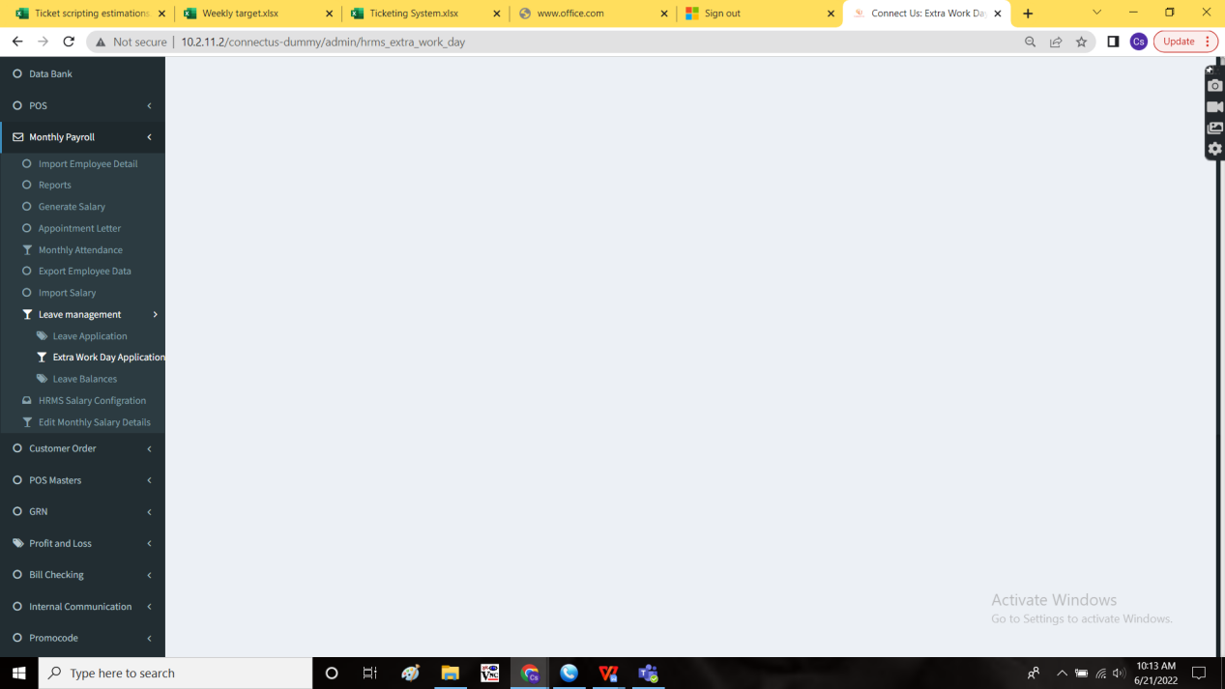

Techneai employees using facial recognition system for the attendance. The data to be fetched in the monthly attendance in Techneai Hr connect us.   
Where the log in and log out time of all the employees to be displayed showing the present and absent differentiated with the colors.

The in time and out time is shown in the calender of the employee. The present day with blue colour. Present days with the green color and the absent days or out time (not according to shift time) in red color.

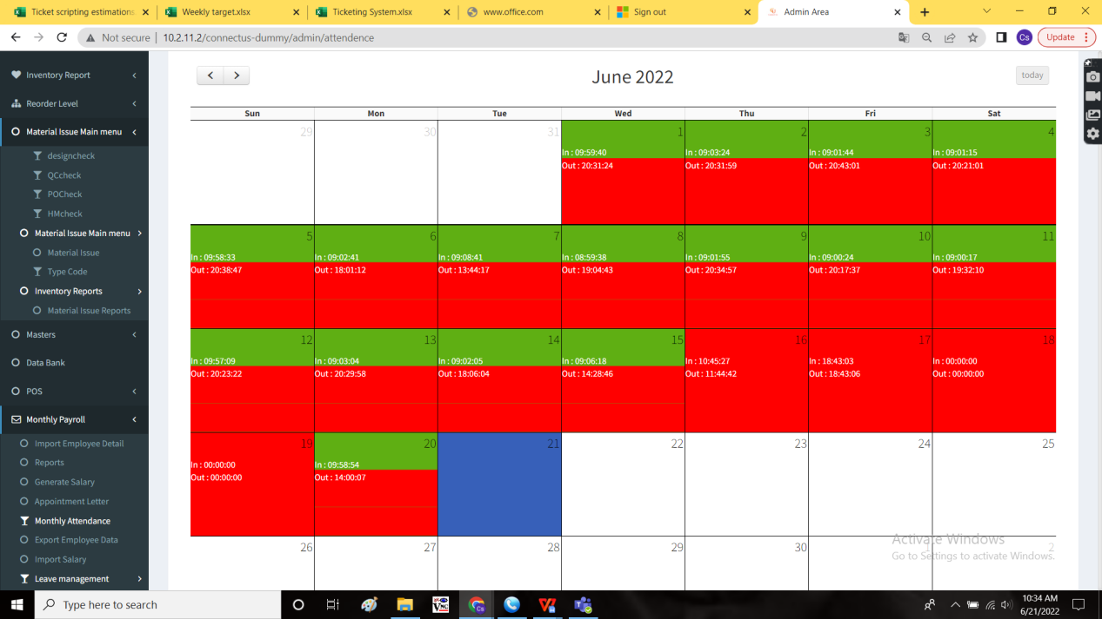

**References of the users**

|  |  |  |  |
| --- | --- | --- | --- |
| **User** | **Name** | **Mail** | **Contact number** |
| **Actual user** | Minal Pawar |  |  |
| **Assigned business analyst** | Mounika KrishnaVeni Annamneedi | Mounika.annamneedi@techneai.com | 9885900039 |