|  |  |
| --- | --- |
| **Ticket ID** | TT5566 |
| **Ticket description** | Connectus > Bill Checking > Bill Checking Master > Sub Supplier Master Maadhe Bulk upload Provision Karun Dene |
| **Created by** | Tushar Shivaji Nikam |
| **Created on** | 06/10/2022 |
| **Priority** | Medium |
| **Version** | 1 |

**Version**

|  |  |  |  |  |
| --- | --- | --- | --- | --- |
| **Sr. No** | **Version no** | **Version Date** | **User name** | **User department** |
| 1 | 1 | 06.10.2022 | Tushar Shivaji Nikam | Inventory Silver HO |

**Approvals**

|  |  |  |
| --- | --- | --- |
| **Field** | **Name of the User** | **Approved date by the user** |
| **Actual User Name** | Tushar Shivaji Nikam | 28.09.2022 |
| **Actual User Department** | Inventory Silver HO |  |
| **Organization Name** | C S Jewellers |  |
| **Sign-off** |  |  |
| **Assigned BA** | Mounika KrishnaVeni Annamneedi | 06.10.2022 |
| **Assigned Developer** |  |  |
| **Assigned Tester** |  |  |

**Estimation**

|  |  |  |  |  |
| --- | --- | --- | --- | --- |
| **Department name** | **Estimated Time (In hr)** | **Scheduled Date (Starting date )** | **Estimated date** | **Actual delivery date** |
| **BA** | 2 | 06.10.2022 | 06.10.2022 |  |

**Business requirement**

Bulk upload format and bulk upload in sub-supplier master in connect us

**Existing system**

In the existing system, there is no such fields in sub-supplier.

**Proposed system**

* Creation of bulk upload format and bulk upload in connect us.

Step 1

In Connect Us >> Bill Checking >> Bill Checking Masters >> Sub-supplier Master

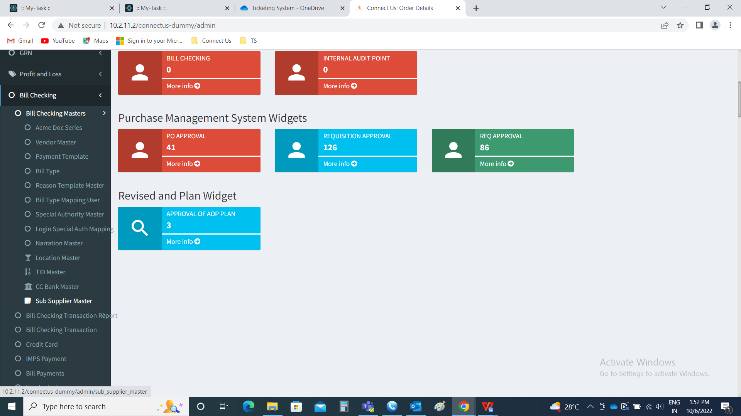

Creation of bulk upload format and bulk upload buttons on sub-supplier master

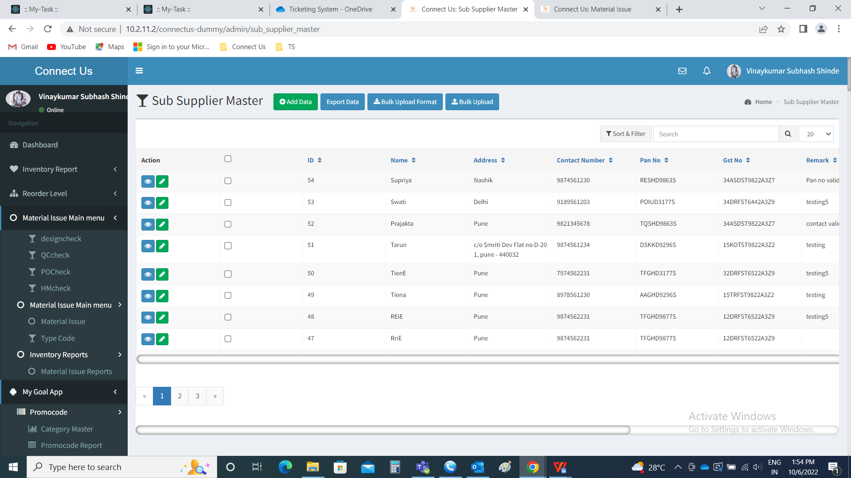

Step 2

Bulk upload format

The bulk upload format button downloads the format of the file to be uploaded in bulk upload. The file consists of the following fields.

* Name
* Address
* Contact number
* Pan No
* GST No
* Remark

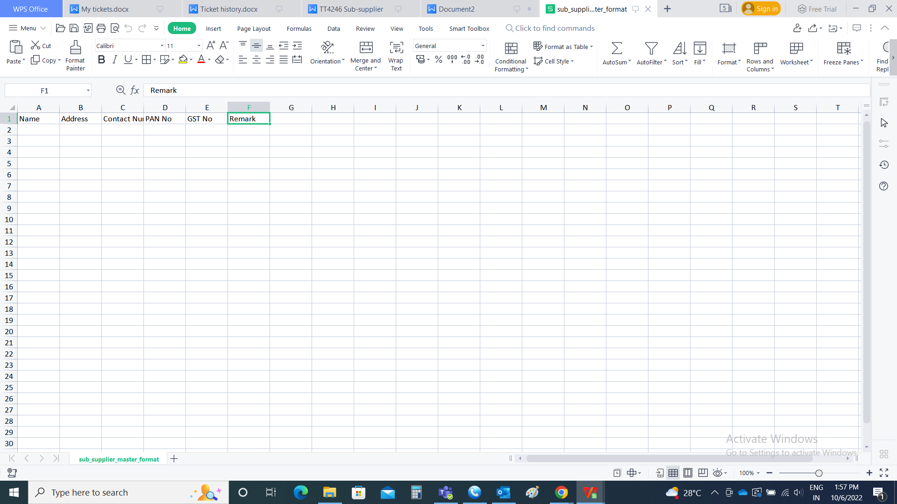

Step 3

Bulk upload

The bulk upload button is used to attach the file for adding the masters. When the user clicks on the bulk upload, the following pop-up opens. The pop-up consists of the following fields.

* Choose file
* Upload
* Back

|  |  |  |  |
| --- | --- | --- | --- |
| **FIELDS** | **INPUT TYPE** | **MANDATORY/ OPTIONAL** | **DESCRIPTION** |
| Choose file | File attachment | Optional | The file to upload is attached |
| Upload | Button | Optional | The upload button to upload the file |
| Back | Button | Optional | The back button to close the pop-up |

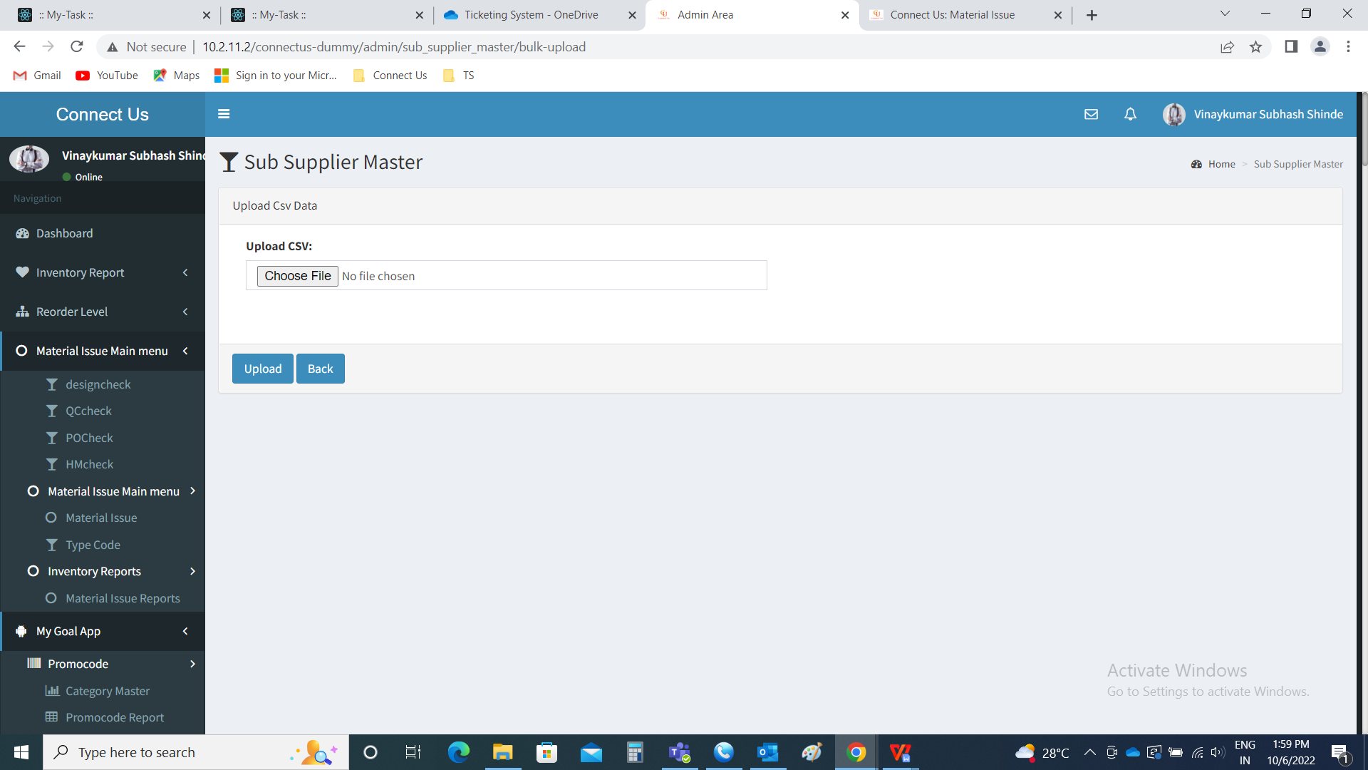

When the empty file uploaded, then error message is displayed “Something went wrong - Empty file uploaded”.

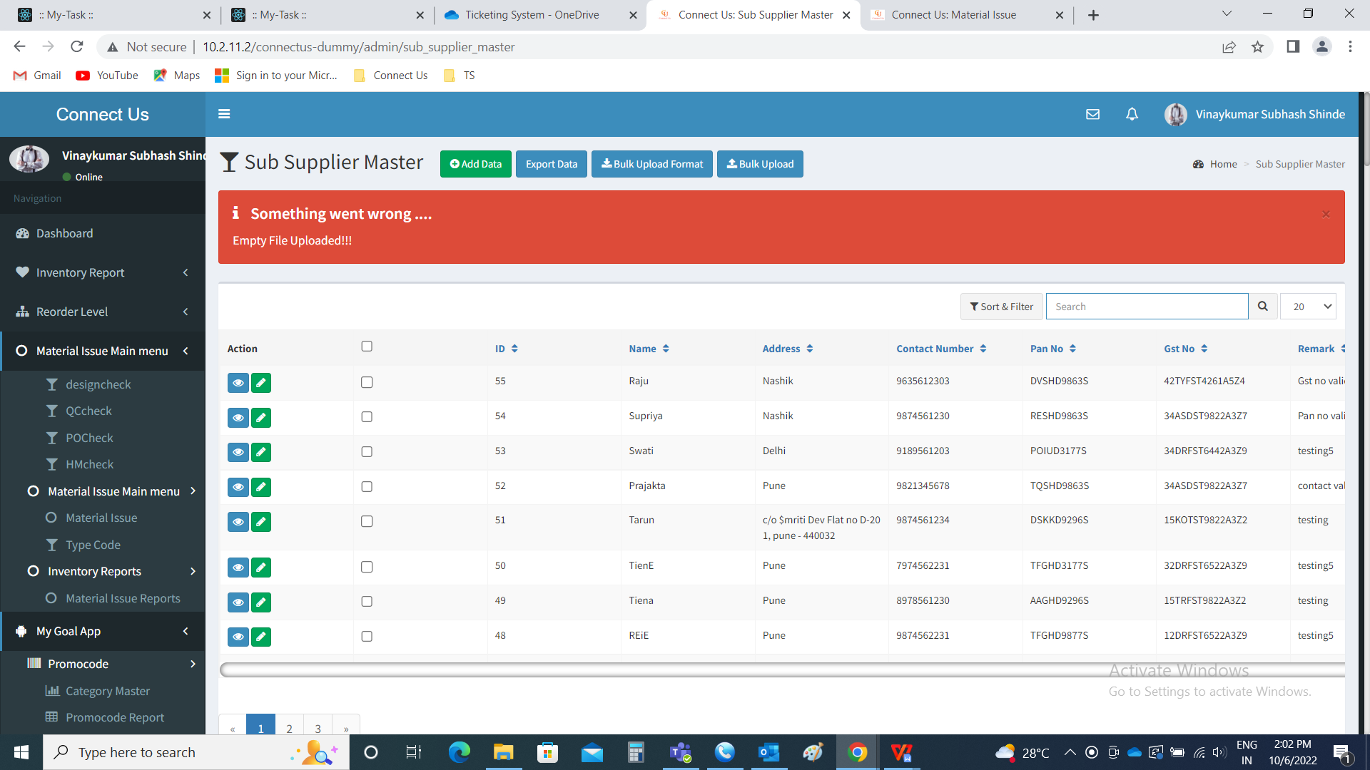

When the wrong file uploaded, then error message is displayed “Something went wrong - Invalid file type”.

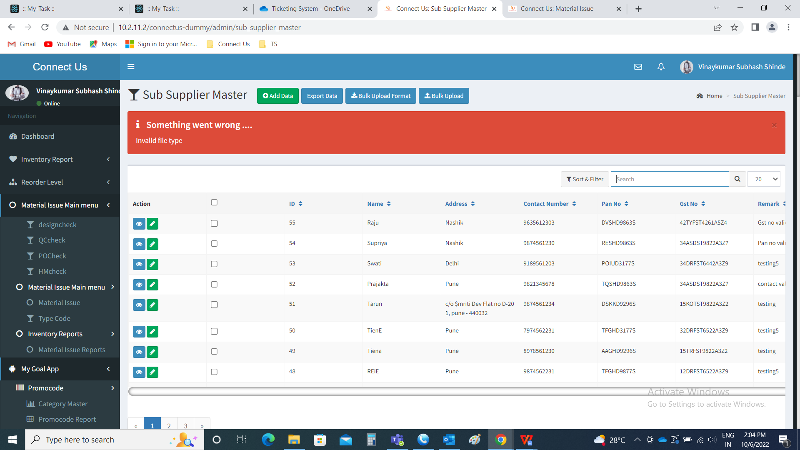

Validations for the input fields.

|  |  |
| --- | --- |
| **FIELDS** | **DESCRIPTION** |
| ID | The Id of the sub-supplier is auto generated in a numeric order |
| Sub-supplier name | The sub-supplier name is entered |
| Sub-supplier address | The sub-supplier address is entered |
| Sub-supplier contact number | The sub-supplier contact number is entered |
| Sub-supplier pan No. | The sub-supplier PAN No. is entered. Pan No. Validations are considered. |
| Sub-supplier GST No. | The sub-supplier GST No.is entered. GST No. Validations are considered. |

When any wrong validations given in the file, an error file is shown to download.

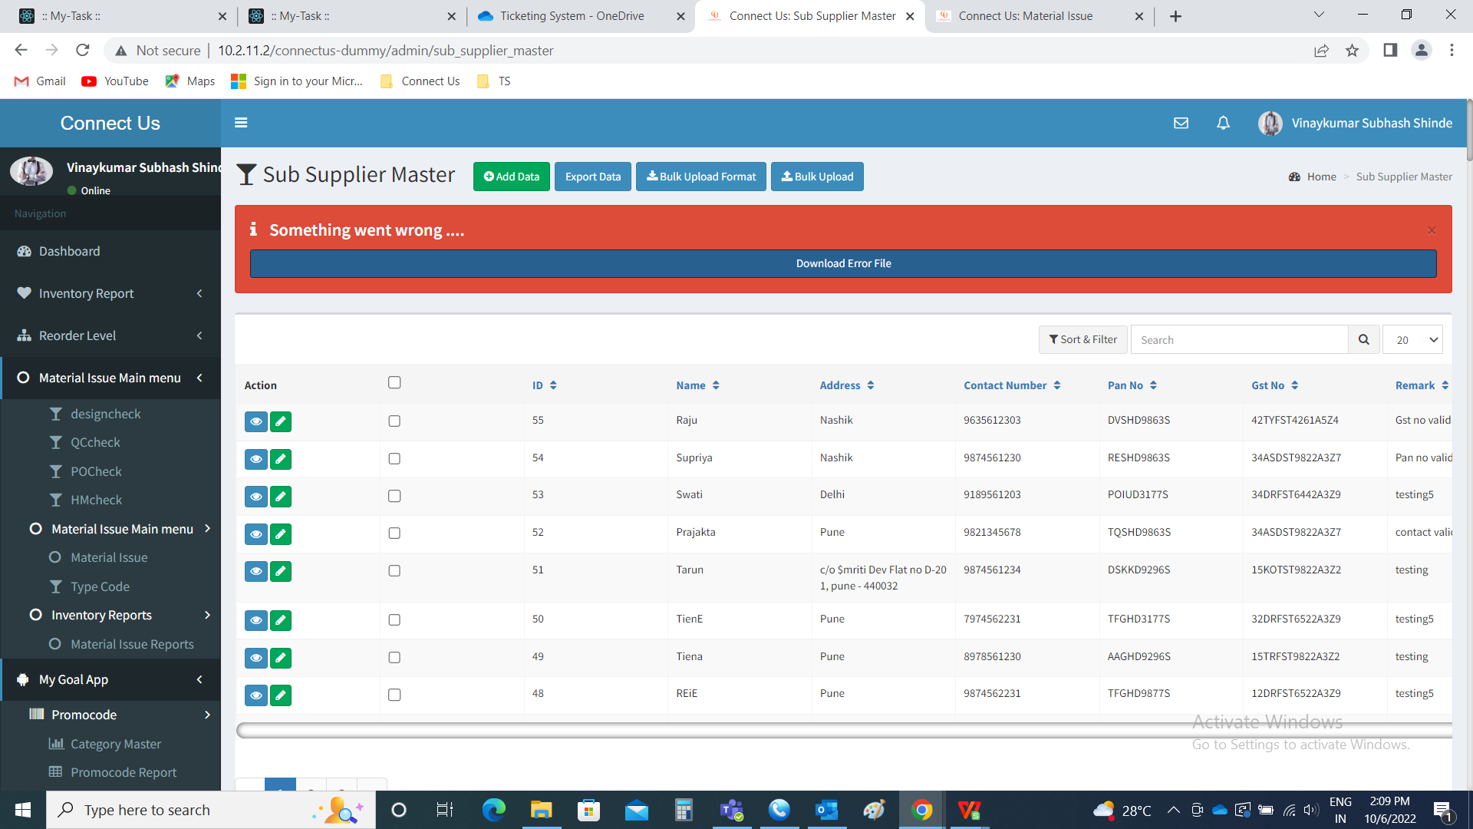

Downloaded file is as follows.

