HRMS - BUGS

1. Shift type master to be fetched in employee master.

In Connect Us >> Masters >> General Masters >> Shift Master

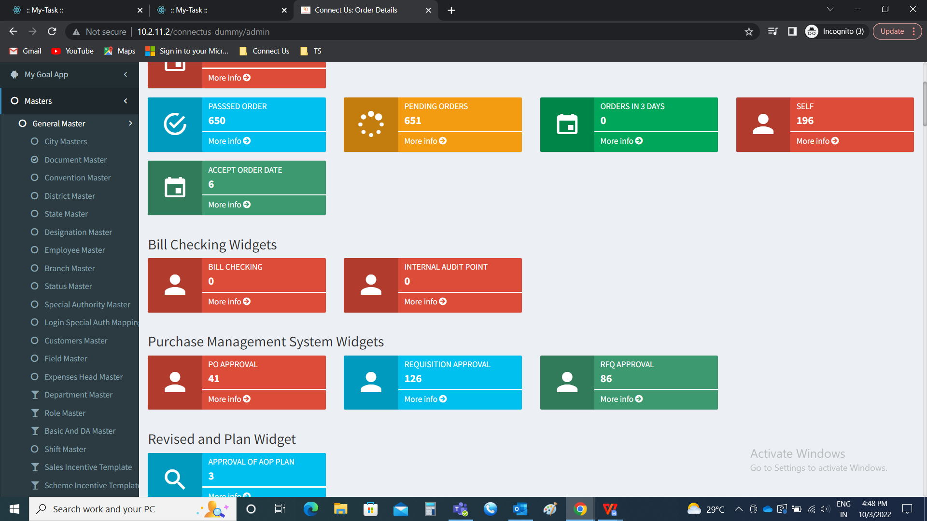

Shift Master

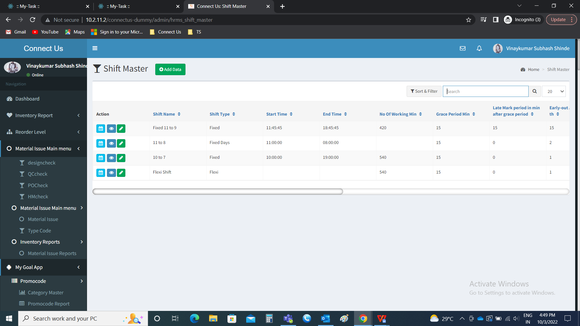

In Connect Us >> Masters >> General Masters >> Employee Masters >> Add data



Employee master

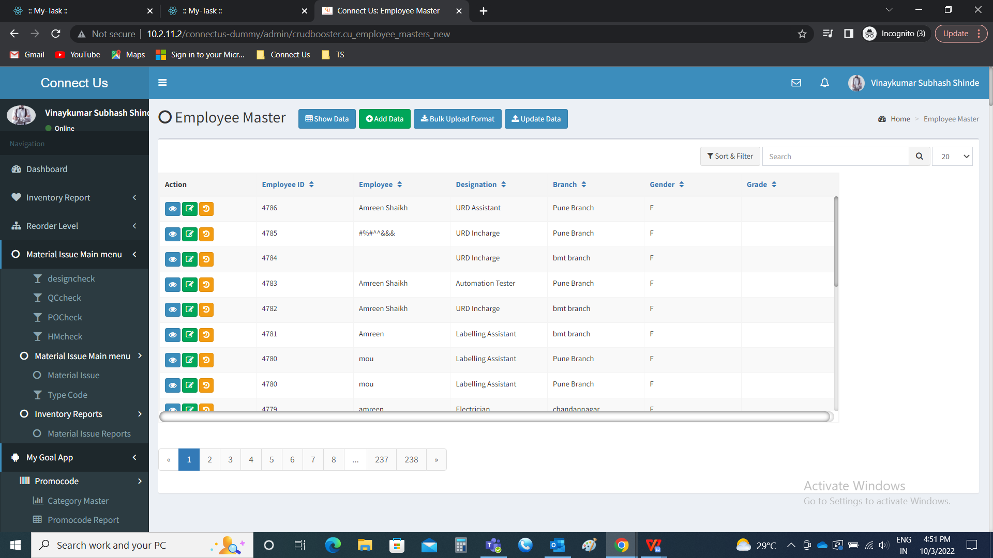

Add data >> shift type

The shift type drop down options to be fetched from the shift master (In connect us >> masters >> general masters >> shift master).

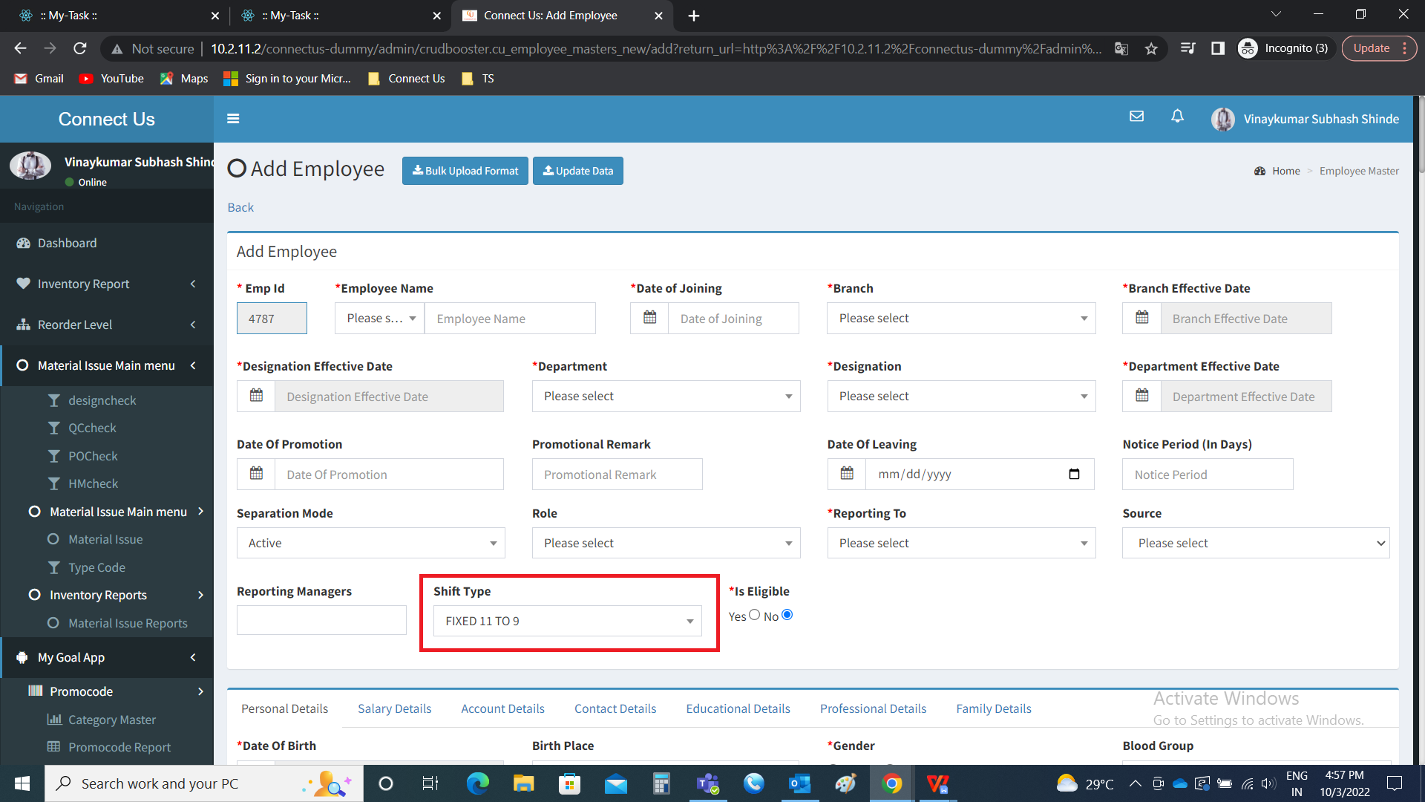

Note : The same to be reflected in edit and bulk upload too.

1. Source is not fetching in the employee master

In Connect Us >> Masters >> General Masters >> Source Master

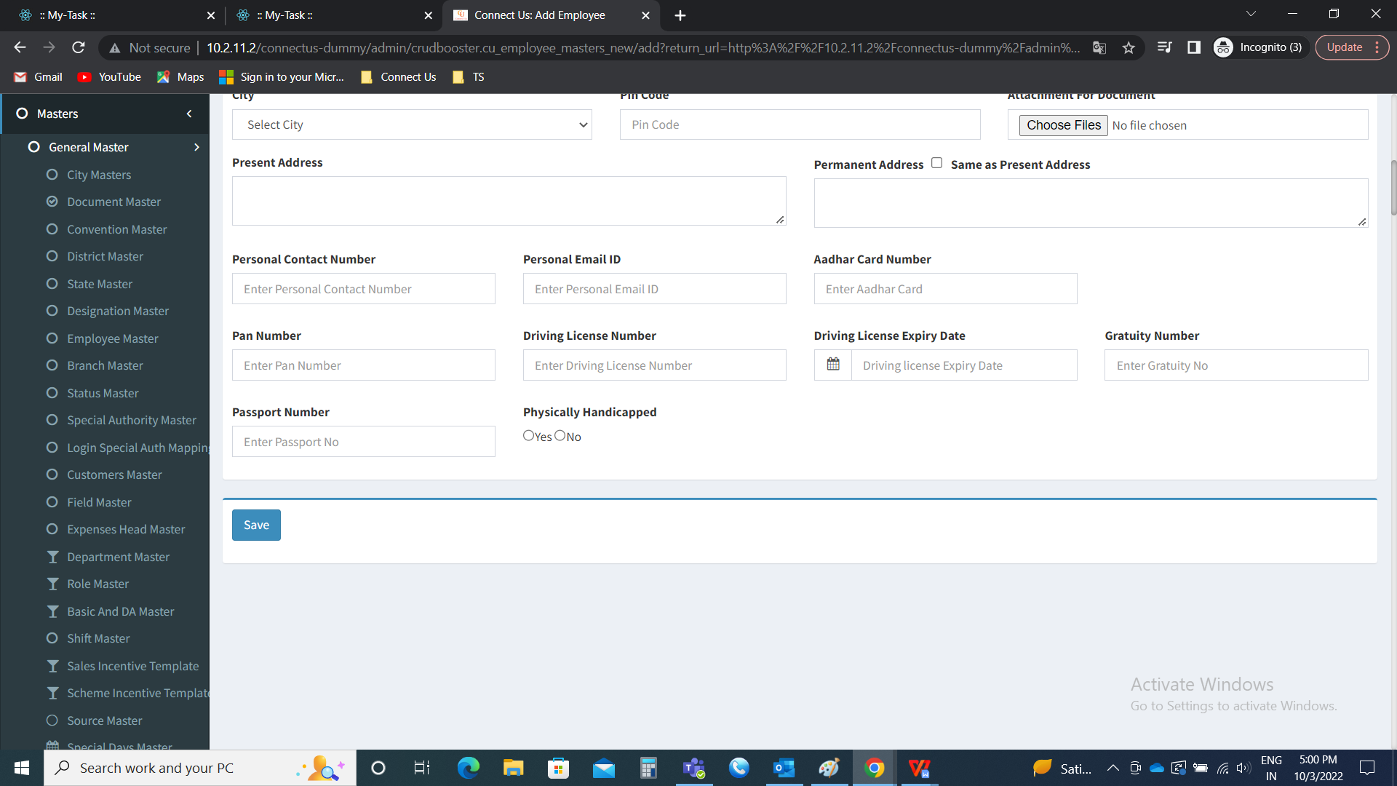

Source Master

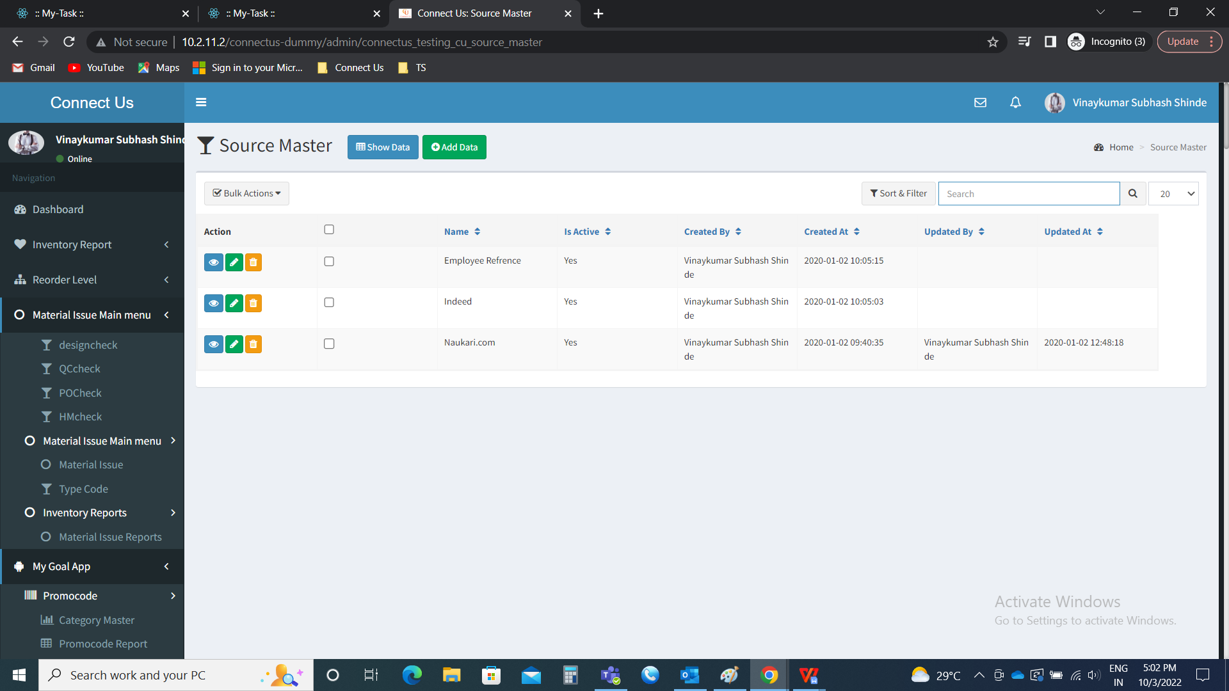

In Connect Us >> Masters >> General Masters >> Employee Masters >> Add data



Employee master



Add data >> Source

The shift type drop down options to be fetched from the source master (In connect us >> masters >> general masters >> source master).

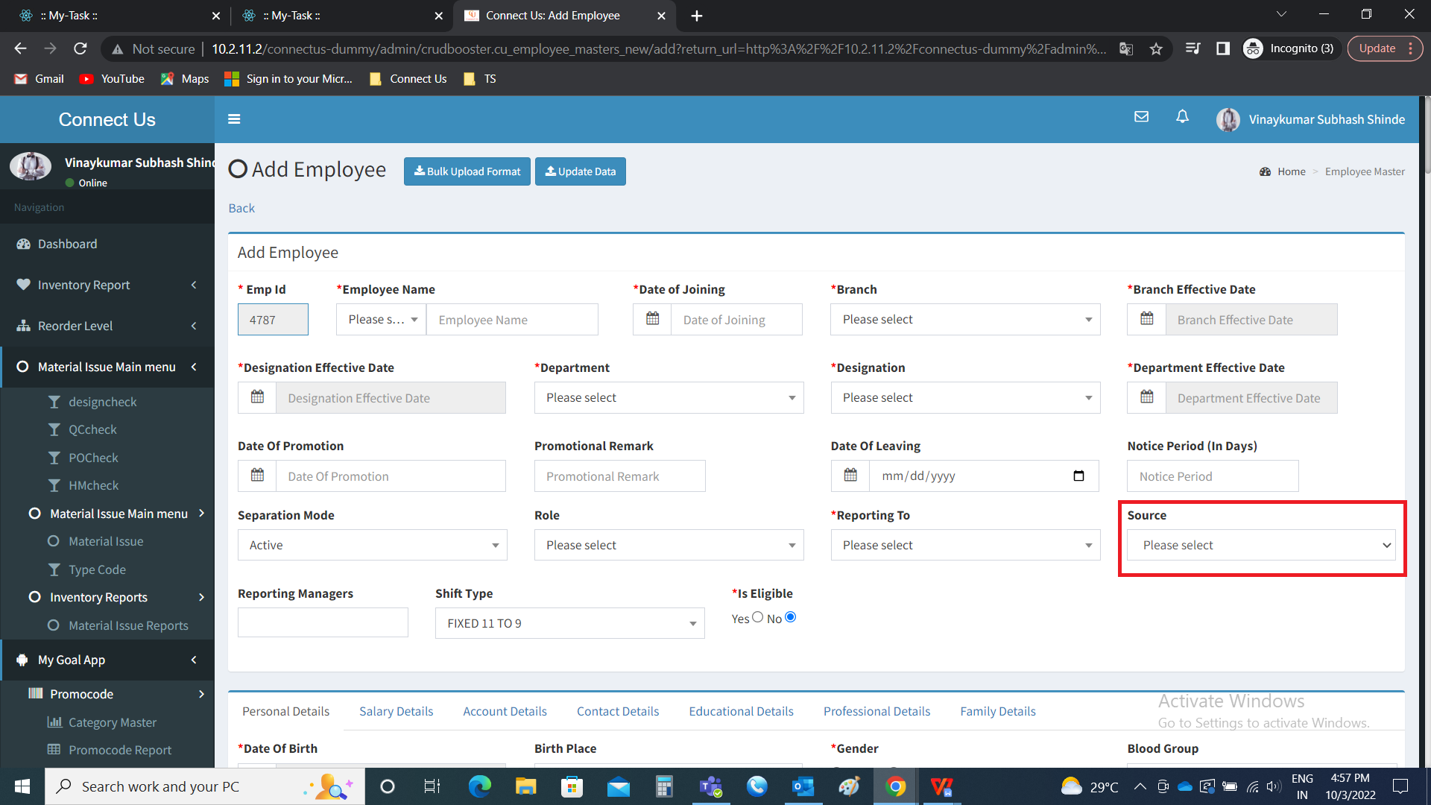

Note : The same to be reflected in edit and bulk upload too.

1. Special days master reflection in monthly attendance

In Connect Us >> Masters >> General Masters >> Special days Master

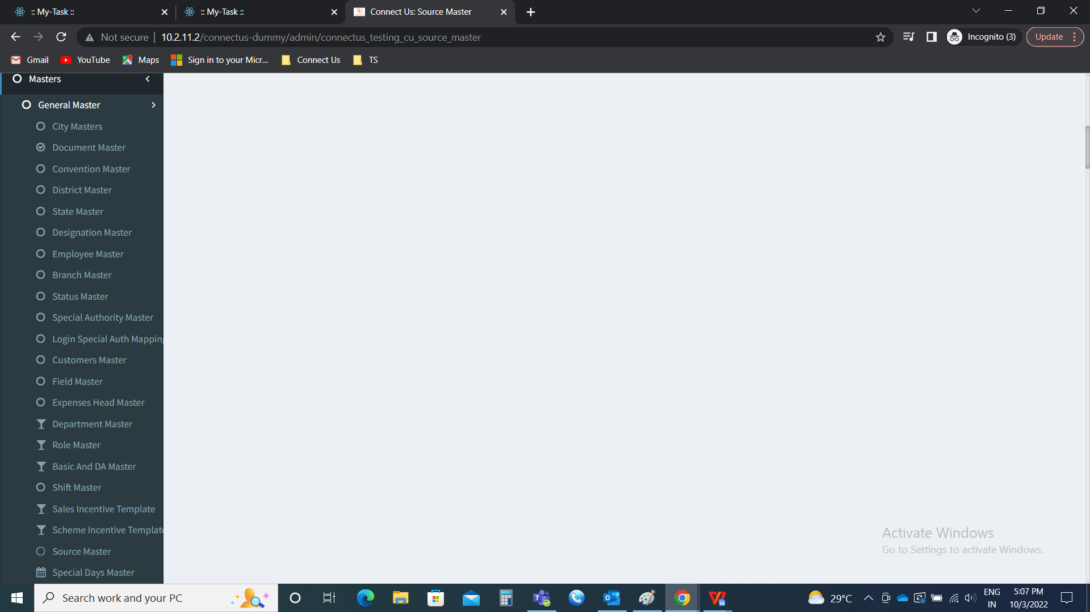

Special days Master

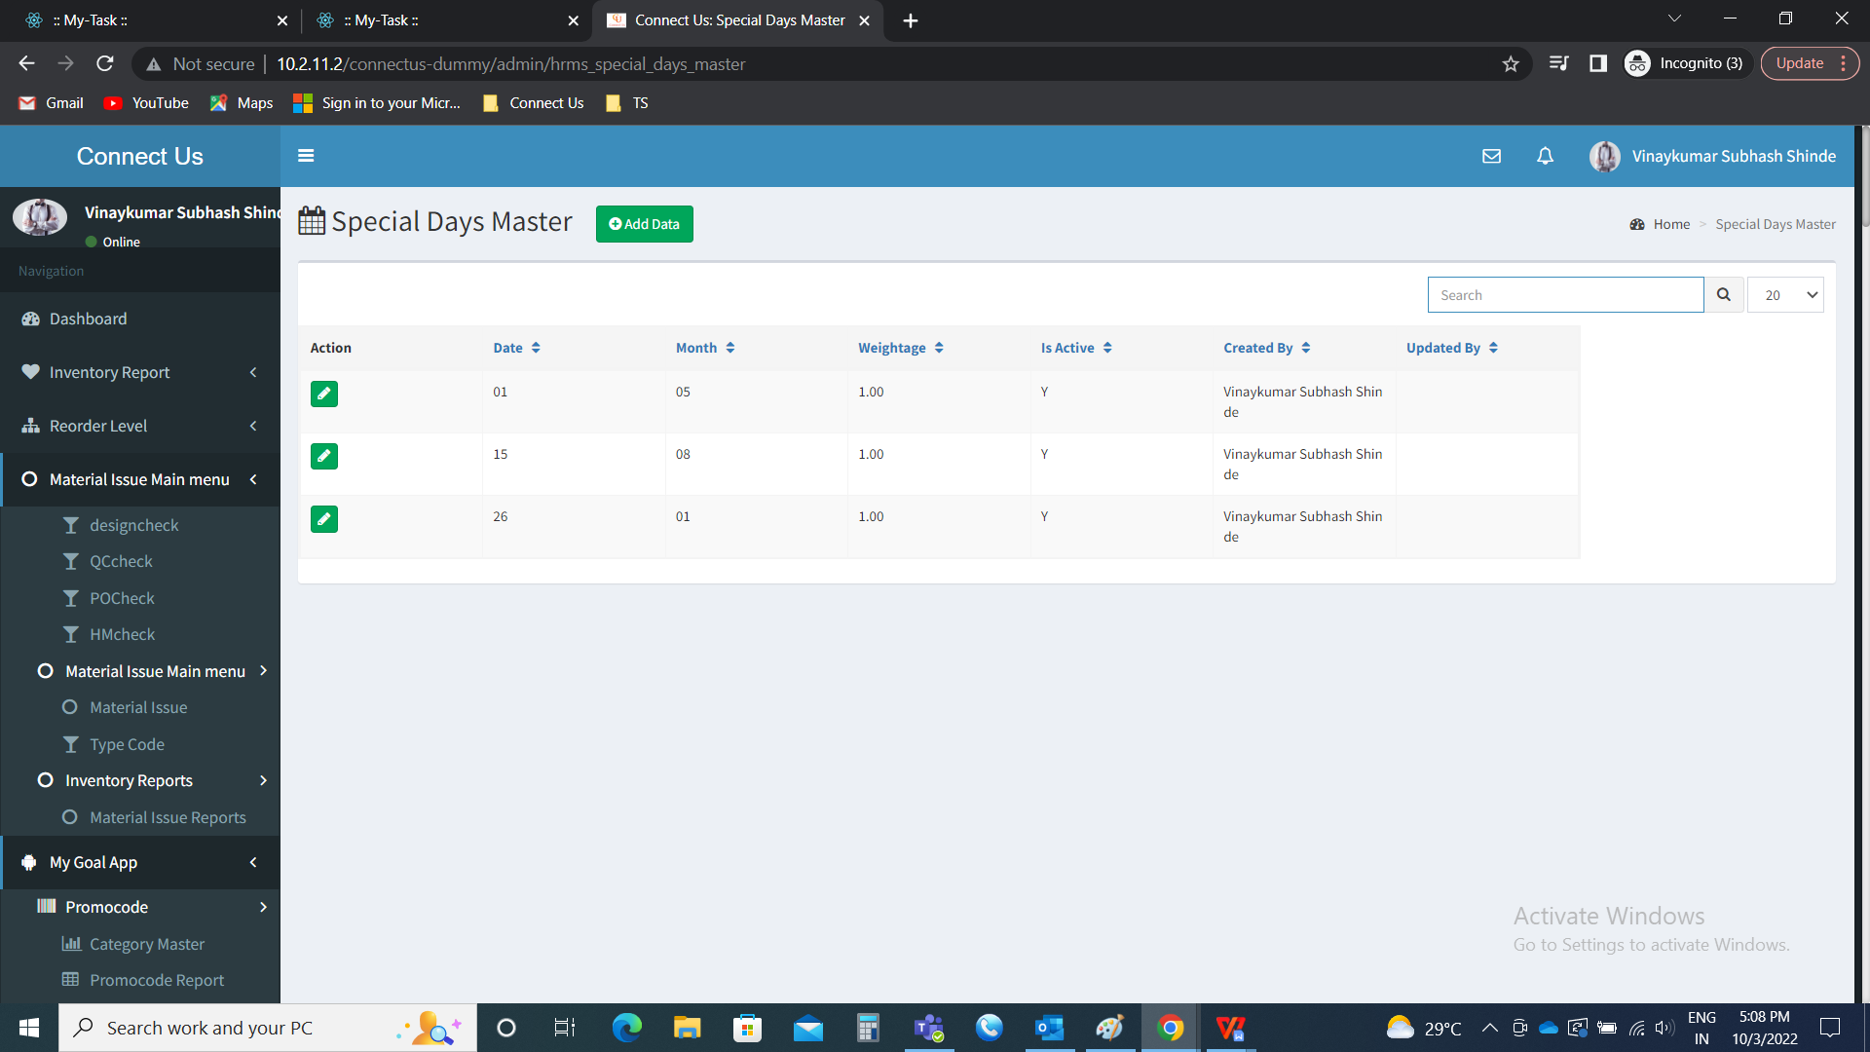

In Connect Us >> Monthly Payroll >> Monthly attendance

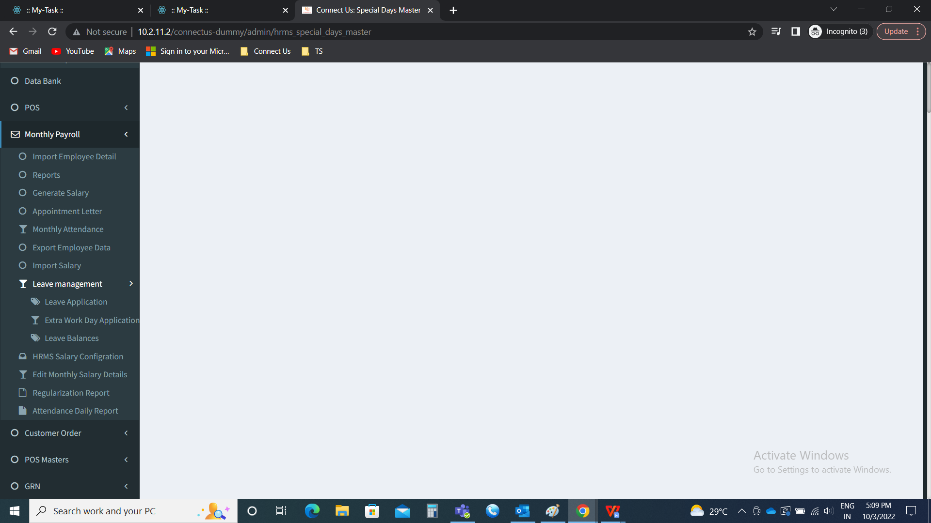

Monthly attendance

When any special day is active in monthly attendance, it should reflect in monthly attendance as the present day of the employee according to the weight-age given in the master.

