**TICKETS HISTORY**

The ticket history can be viewed by the ticket owner and the project owner in the actions fields in my tickets.

In Ticketing System >> Tickets >> My Tickets >> Action >> History

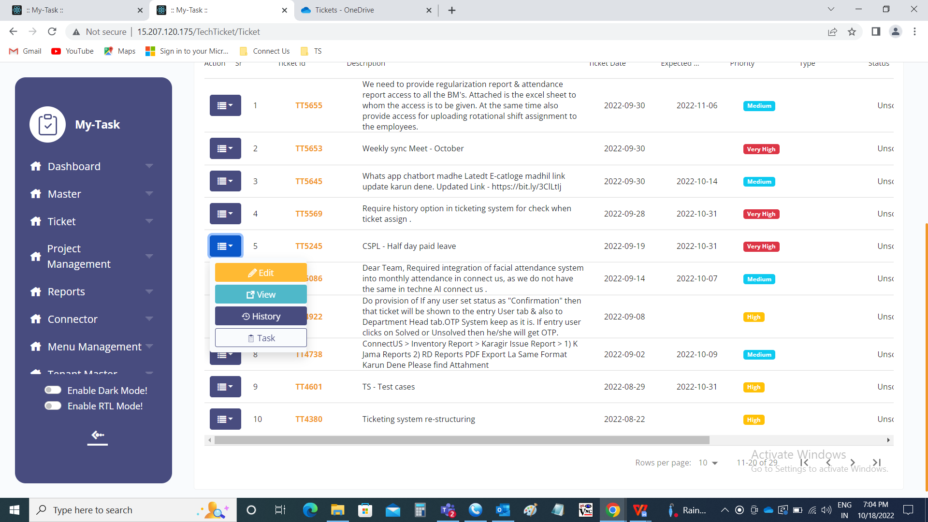

The history of the ticket from the ticket creation to ticket solved can be known in the ticket history. Every edit or change made by any user is known in every row with the respective person, date and time.

The history consists of the following fields.

* Sr
* Ticket ID
* Ticket created by user
* Ticket created by department
* Expected date
* Passing date
* Passing status
* Passed by
* Query type
* Project name
* Module name
* Sub-module name
* Reference ID
* Priority
* Assigned to user
* Assigned to department
* Status
* Confirmation
* Created at
* Updated at
* Updated by
* Operation

|  |  |
| --- | --- |
| Field | Description |
| Sr | The serial number is displayed |
| Ticket ID | The ticket ID of that ticket is displayed |
| Ticket created by user | The ticket created user name is displayed |
| Ticket created by department | The ticket created user department is displayed |
| Expected date | The expected date of the ticket to be solved or any updated is displayed |
| Passing date | The passing date of the ticket when it is passed is displayed |
| Passing status | The passing status of the ticket whether passed or unpassed is displayed |
| Passed by | If the ticket is passed, by whom, it is passed is displayed |
| Query type | The query type of the ticket which is selected at the time of ticket creation is displayed |
| Project name | The project name of the ticket selected or updated if any is displayed |
| Module name | The module name of the ticket selected or updated if any is displayed |
| Sub-module name | The sub-module name of the ticket selected or updated if any is displayed |
| Reference ID | The reference ID of the ticket mentioned or updated if any is displayed |
| Priority | The priority of the ticket selected or updated if any is displayed. |
| Assigned to user | The assigned user based on the query type or the ticket to whom it is assigned selected or updated if any is displayed |
| Assigned to department | The assigned user department based on the query type or the ticket to whom it is assigned selected or updated if any is displayed |
| Status | The status of the ticket selected or updated if any is displayed |
| Confirmation | The confirmation required for that ticket is required or not is displayed |
| Created at | The ticket created at is displayed |
| Updated at | The ticket last updated at is displayed |
| Updated by | The ticket last updated by user name is displayed |
| Operation | The operation type is displayed |

