|  |  |
| --- | --- |
| **Ticket ID** | *TT5206* |
| **Ticket description** | *User needs to convert all current AOPs value into Crore from Lakh.* |
| **Created by** | *Sandeep Avchitte* |
| **Created on** | *20/10/2022* |
| **Priority** | *Medium* |
| **Version** | *1.0* |

**Version**

|  |  |  |  |  |
| --- | --- | --- | --- | --- |
| **Sr. No** | **Version no** | **Version Date** | **User name** | **User department** |
| *1* | *1.0* | *20/10/2022* | *Amarja* | *Account & Finance Department* |

**Approvals**

|  |  |  |
| --- | --- | --- |
| **Field** | **Name of the User** | **Approved date by the user** |
| **Actual User Name** | *Amarja* |  |
| **Actual User Department** | *Account & Finance Department* |  |
| **Organization Name** | *CS Pvt Ltd* |  |
| **Assigned BA** | *Sandeep Avchitte* |  |
| **Assigned Developer** | *Prathamesh Shinde* |  |
| **Assigned Tester** | *Abhijeet Ghodake* |  |

**Estimation**

|  |  |  |  |  |
| --- | --- | --- | --- | --- |
| **Department name** | **Estimated Time (In hr)** | **Scheduled Date (Starting date )** | **Estimated date** | **Actual delivery date** |
| **BA** |  |  |  |  |
| **Development** |  |  |  |  |
| **Testing** |  |  |  |  |

**Introduction**

*User wants to convert all* ***AOPs*** *value in to* ***“Crore*** *from* ***Lakh”****.*

**Business requirement**

*User wants to convert all* ***AOPs*** *value in to* ***“Crore*** *from* ***Lakh”*** *so that user can be able to understand the values.*

**Abbreviations & terms**

*CU- Connect Us.*

**Existing system**

*In the current scenario all AOPs values are visible and calculated in “Lakh” so as per the same, user is not able to read the same values, it take time to convert the values and all. So proposed provision is not available in the system.*

**Proposed system**

*As shown in the below image, user get the AOP report through* ***“Profit and Lose -> AOP Report Data New”*** *sub module. The same is illustrated in the images below.*

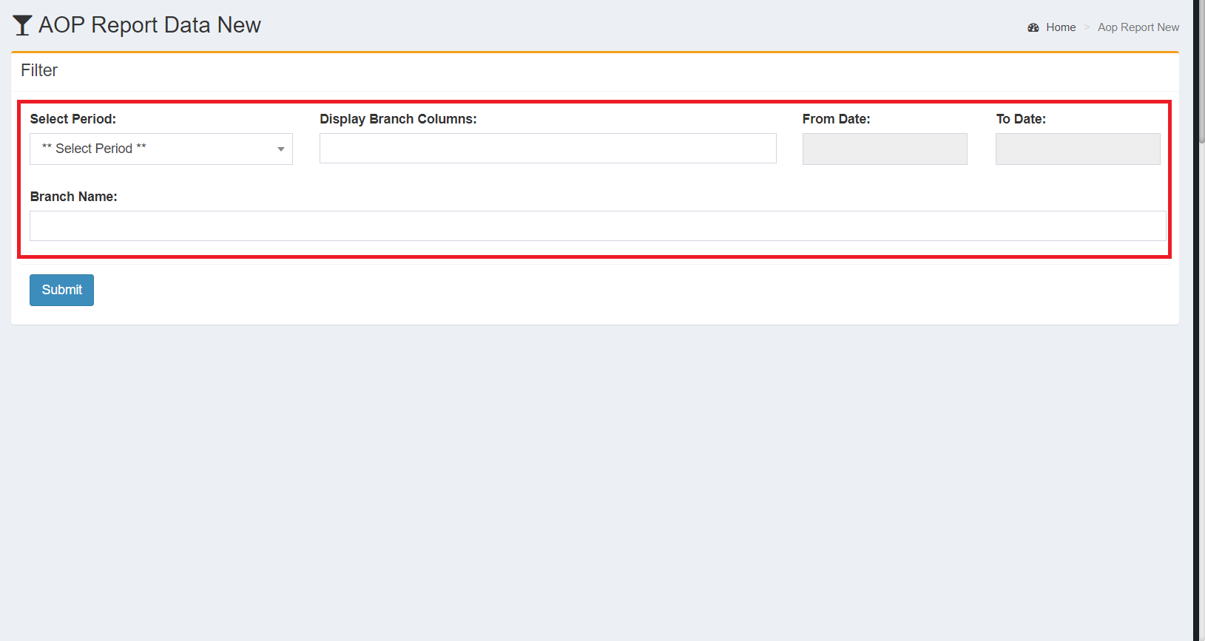

*Image 1: Profit and Loss - AOP Report New*

*After selecting any specific* ***“Period*** *and* ***Branch Name”*** *and**submitting the filter data, user get the all related values as per selections accordingly in the tabular/grid view format as in the image below.*

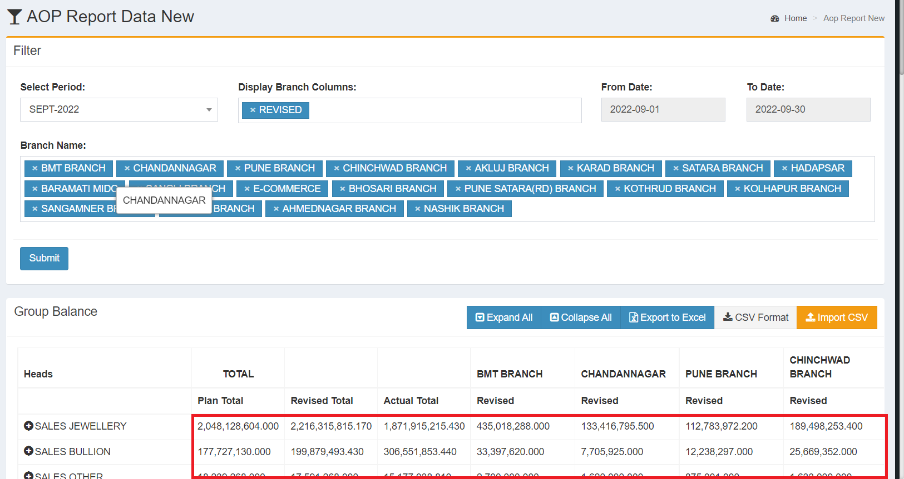

*Image 2: AOP Report For All Branches*

*Now, the generated values are shown in the “Lakh” and these* ***“values should be shown in the Crore I.e. it should be convert from the Lakh to Crore”****.*

* *For instance -*

*As per the above image :*

*The* ***“Actual Total”*** *for the* ***“SALES JEWELLERY”*** *is* ***“1,871,915,215.430”*** *this value is in Lakh.*

*Now, if we will convert the same in the Lakh this would be like:*

*1,871,915,215.430****/****1,00,00,000 =* ***187.19***

*\*\*Please Note : The above shown value “187.19” is converted into Crore I.e. 187.19Cr.*

*Likewise the above example, all the values should be convert into the crore accordingly.*

*Also, the converted values addition should be done as per current formula’s wherever applicable in the module.*

***Export******-*** *The current exported report should have all the above details.*

*\*\*We have some below odus points and need explaination on the same from your side :*

**ODUS ( Open Discussed Unhanded scenarios )**

|  |  |
| --- | --- |
| **Topic** | *Value issues* |
| **Reported by** | *Sandeep Avchitte* |
| **Reported on** | *03/11/2022* |
| **Details** | *If we divide thousand values by 10000000 then we get result in 0.*  *E.g. 21000/10000000 = 0.0021 so as per e.g. we are going to take only two digits after “.” (Point) in the values so it take impact on the calculations.* |
| **Status** | *Incomplete* |
| **Priority** | *high* |

|  |  |
| --- | --- |
| **Topic** | *Actual total getting less* |
| **Reported by** | *Sandeep Avchitte* |
| **Reported on** | *03/11/2022* |
| **Details** | *If we divide thousand values by 10000000 then we get result in 0 and as per this the final addition we get less I.e. getting difference actual total.*  *E.g. 72856242 + 21000 = 72877242 as per current functionality.*  *7.28 + 0.00 = 7.28Cr Proposed functionality, so here the impact is that if we add values in thousand its imoact can occure at the end that values might be change.* |
| **Status** | *Incomplete* |
| **Priority** | *high* |

**References of the users**

|  |  |  |  |
| --- | --- | --- | --- |
| **User** | **Name** | **Mail** | **Contact number** |
| **Actual user** | *Amarja* | *[account@csjewellers.com](mailto:account@csjewellers.com)* | *2900* |
| **Assigned business analyst** | *Sandeep Avchitte* | *[Sandeep.avchitte@techneai.com](mailto:Sandeep.avchitte@techneai.com)* | *2965* |
| **Assigned developer** | *Prathamesh Shinde* | *[Prathamesh.shinde@techneai.com](mailto:Prathamesh.shinde@techneai.com)* | *2965* |
| **Assigned tester** | *Abhijeet Ghodake* | *[Abhijeet.ghodake@techneai.com](mailto:Anhijeet.ghodake@techneai.com)* | *2965* |