**HR can apply leave on behalf of employees**

In case of emergency, the HR can apply leave on behalf of the employees. For this, HR have a special authority named “Leave approved”. The employees assigned with that special privilege can view the button on leave application, so that they can apply leave on behalf.

In connect us >> leave management >> leave application

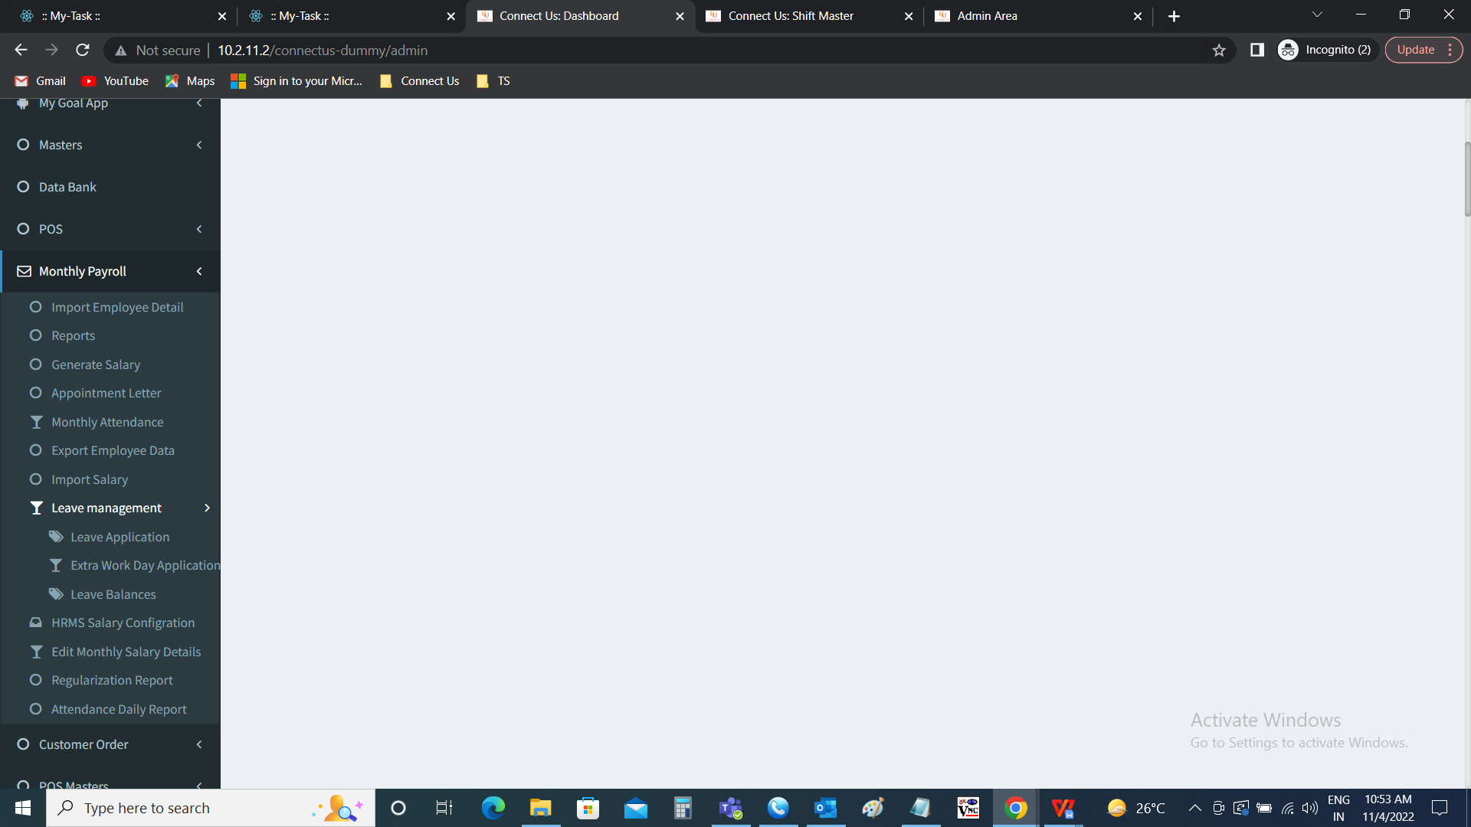

Leave application >> apply leave

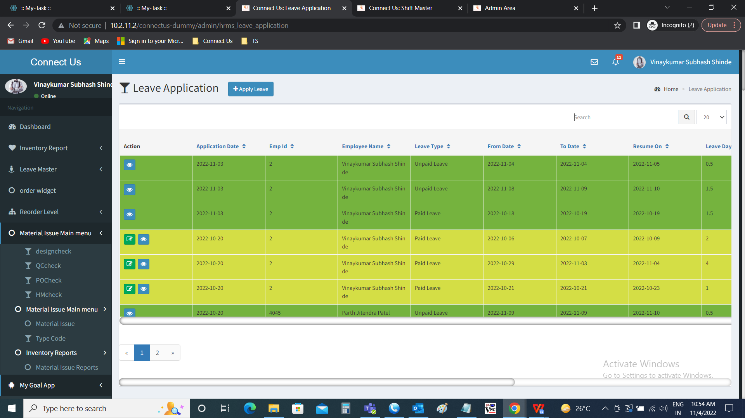

Apply leave >> leave on behalf

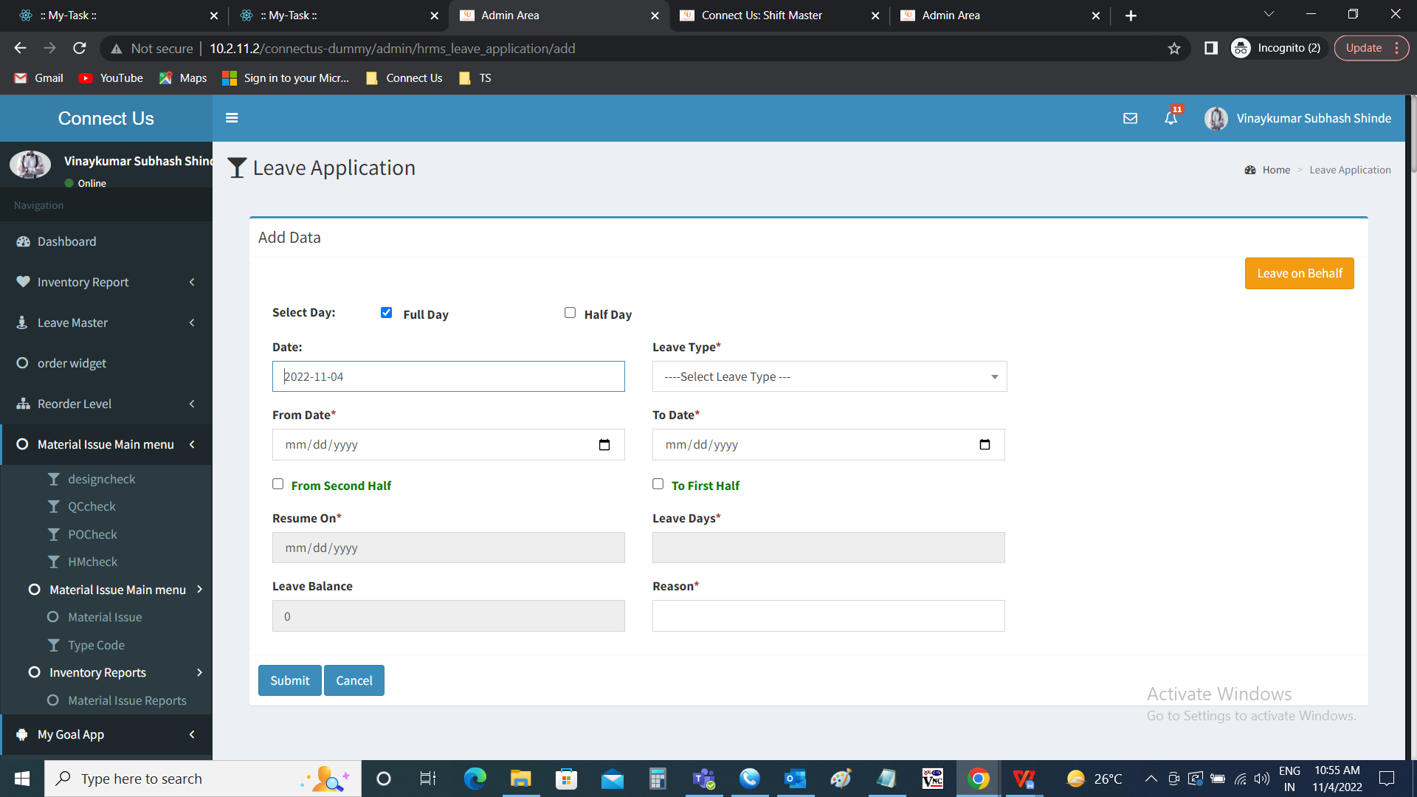

Leave on behalf

On behalf of employee, HR can apply leave. The employee to be selected in the pop up box. The following are the details in the leave on behalf pop up.

* Employee
* Close
* Submit

|  |  |  |  |
| --- | --- | --- | --- |
| **FIELDS** | **INPUT TYPE** | **MANDATORY/ OPTIONAL** | **DESCRIPTION** |
| Employee | Drop down | Mandatory | The employee to be selected from the drop down. The drop down consists of the employees list fetched from the employee master (in connect us >> masters >> general master >> employee master). |
| Close | Button | Optional | The close button to close the pop up box |
| Submit | Button | Optional | The submit button to consider that employee for applying the leave. As soon as the HR submits, the employee details are fetched. |

As soon as the HR submits, the employee details are fetched. The following are the fields in the add data.

* Select day
* Date
* Leave type
* From date
* To date
* From first half
* To second half
* Resume on
* Leave days
* Leave balance
* Reason
* Submit
* Cancel

|  |  |  |  |
| --- | --- | --- | --- |
| **Field** | **Type** | **Mandatory/ optional** | **Description** |
| Select day | Radio button | Mandatory | The radio button to select whether it is full day or the half day. The radio button consists of 2 options which are as follows.   * Full day * Half day   Full day is selected when it is more than 2 half days consecutively.  Half day is selected when it is half day. |
| Date | Auto | - | The date of the application is automatically fetched I.e., the current day |
| Leave type | Drop down | Mandatory | The type of leave is slected from the drop down menu. The following are the drop down options.   * Paid leaves * Unpaid leave   Paid leaves are the leaves where the organization provides certain count of days to be counted as leaves but paid by the organization.  Unpaid leaves are the where the leaves taken are deducted from the salary proportionately. When there are no paid leaves available to the employee, automatically, paid leave option is removed from the drop down. |
| From date | Calender | Mandatory | The from date from when the leave is applied is selected |
| To date | Calender | Mandatory | The from date to when the leave is applied is selected |
| From second half/ First half | Check box | Optional | The from second half is check where the employee is taking leave from second half of the specific day but not the full day, then from second half is selected when full day is selected.  If half day is selected, the if it is first half, then first is selected. |
| To first half/ second half | Check box | Optional | The to first half is check where the employee is taking leave to first half of the specific day but not the full day, then to first half is selected when full day is selected.  If half day is selected, the if it is second half, then second is selected. |
| Resume on | Auto | - | The resume on is automatically calculated and displayed based on the from day and to day selected along with the check boxes. |
| Leave days | Auto | - | The leave days are automatically calculated and displayed based on the from day and to day selected along with the check boxes. |
| Leave balance | Auto | - | The leave balances are the left balance of the paid leaves. This is fetched based on leave balances under leave management (in connect us >> monthly payroll >> leave management >> leave balance >> balance). This is useful in estimations or the calculations of the employees for applying the leaves accordingly. |
| Reason | Text | Mandatory | The reason for the application of the leave |
| Submit | Button | Optional | To save the details and for application of the leave on behalf of the employee. The leave be auto approved. The status will be changed to “auto approved”. |
| Cancel | Button | Optional | To cancel the data |

Note: The employee is applying for the half day, then it is mandatory to select whether it is half day or full day.

When full day is selected

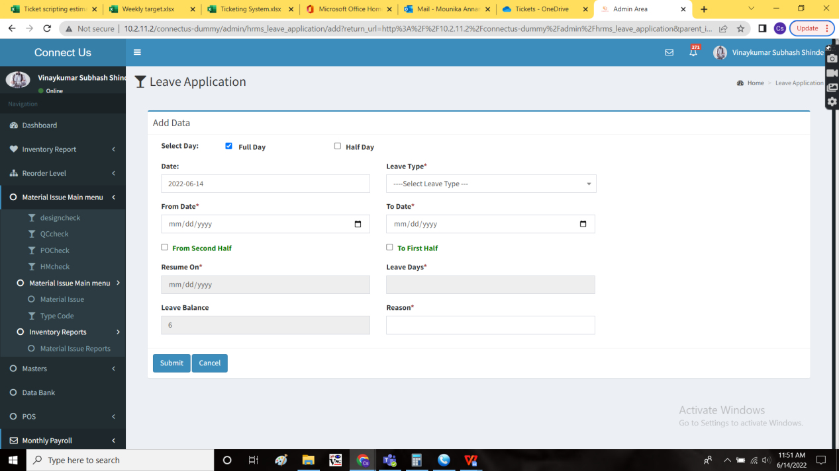

When half day is selected

