**Ticket ID:** 101891

**Project Name:** Need to develop Sub PO against open PO

**Approval (Approved by, Department / Role, Date of approval):**

**TERMINOLOGIES:**

Sub PO: Sub purchase order

PO: Purchase Order.

CU: Connect US.

**PURPOSE:**

Subpo concept is used because if one PO is generated (open po) and valid till certain time period (may be months or years). Here the Rate per unit is freezed after releasing quotation but the user can orders different quantity every time as per requirement. So sub po is generated against that PO (example: PO num: 2021-731, sub po num: 2021-731-1, 2021-731-2 and so on…

Open PO number is used for reference purpose (reference of rate per unit)

**USER REQUIREMENT:** Required Sub PO module.

**Current System:** Don’t have the provision of creating sub po.

**PROPOSED SYSTEM:**

In ConnectUs -> PMS -> create “order portal” module.

Under order portal – 1. Move Order.

2. Vendor Order.

2. (i) Sub Purchase Order (create sub po module against Vendor order)

**Creation:**

On click on Vender Order it opens a new page, user need an option to “Enter sub po number” and “Search”.

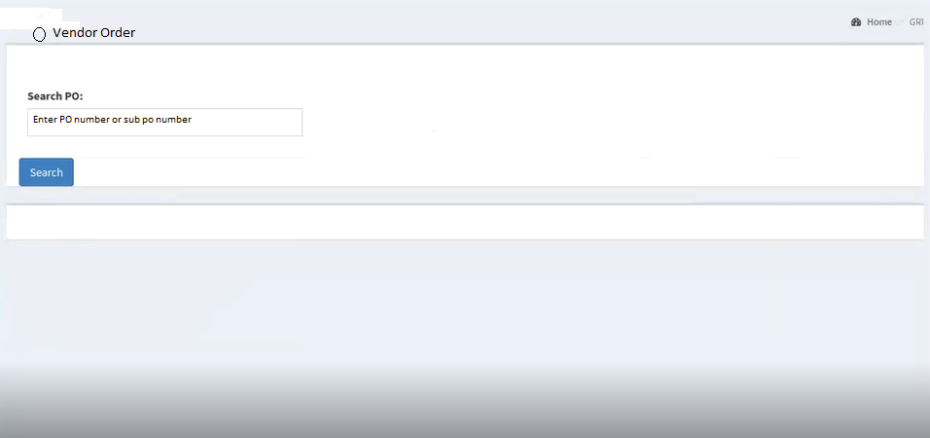

If user enters PO / sub PO number then it should display list of items which are against that PO / sub po number.

**Validation:**

If the PO is Active then only we can create sub po. If PO inactive then we cannot create sub po or we cannot receive any quantity against that PO.

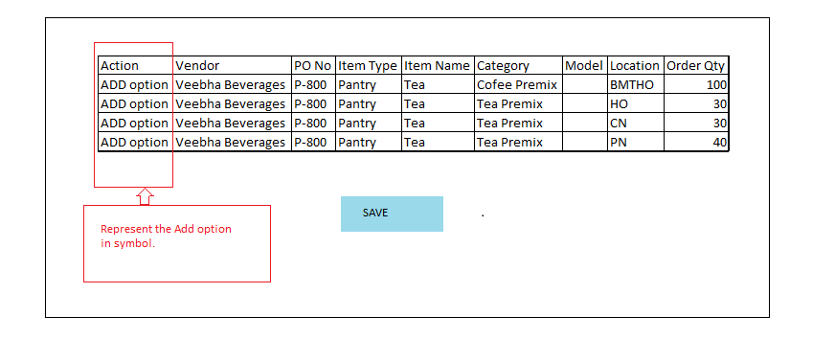

* Location and Order Quantity column should be editable.

**Action column (Placed before vendor column):**

* Add location option should be placed under Action column.
* When the user click on “ADD” option then the above line or complete row data should be copied and displayed below in next row as duplicate. (So that user need not to enter the complete data again manually)
* Save button is displayed. After clicking on save, sub PO number is generated.

Example: sub po number: P-800-1 (here the PO number is P-800)

**At HOD login:**

Sub po column is displayed.

* Edit option is required in Action column.
* Need an option of approval of Head as a checkbox where HOD can click on checkbox for giving approval.
* Save button is required to save the changes if it is done by HOD.
* Save & send mail to vendor button: On click on Save & send mail to vendor mail is sent to vendor (Same as when PO is generated)
* Order Quantity: Should be Editable and approved by Head.
* Location option should be editable.

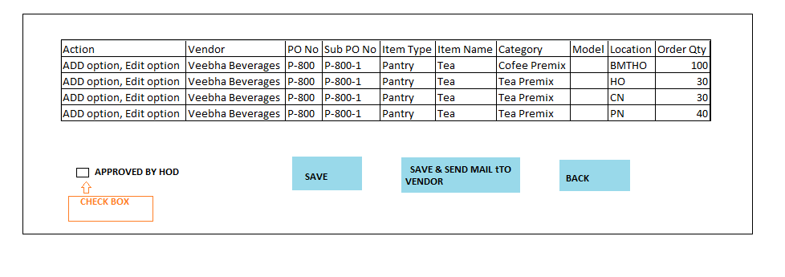

* Vendor should receive the Sub PO number and details at his end.
* On Bill Sub PO number should be displayed.
* After the mail sent to Vendor table should be freezed and it should not be Editable to anyone.

**VENDOR SIDE VIEW:**

When vendor login at his end the below will be format displayed at vendor end.

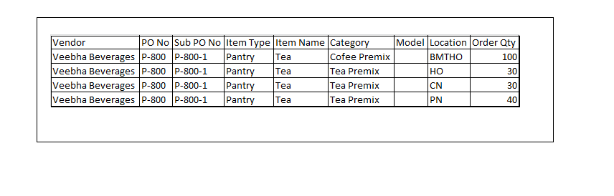

**GRN:**

**GRI:**

After entering into GRI option, the below page is displayed where user can enter PO or sub po number to search details.

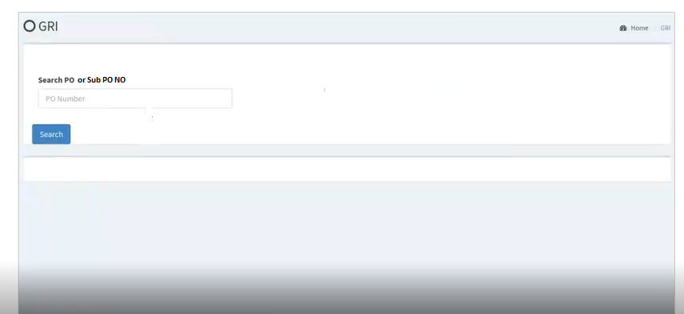

**Validation:**

* If the PO is Active then only we can create sub po. If PO inactive then we cannot create sub po or we cannot receive any quantity against that PO.

Below format should be displayed as GRI page.

* Only **received quantity** option should be Editable here.
* SAVE option is required to save data after entering the Received Quantity.
* For HOD and Store incharge login of BMT HO location, it should display all the locations data.
* For other location’s Store incharge login, it should display that particular related location data details.

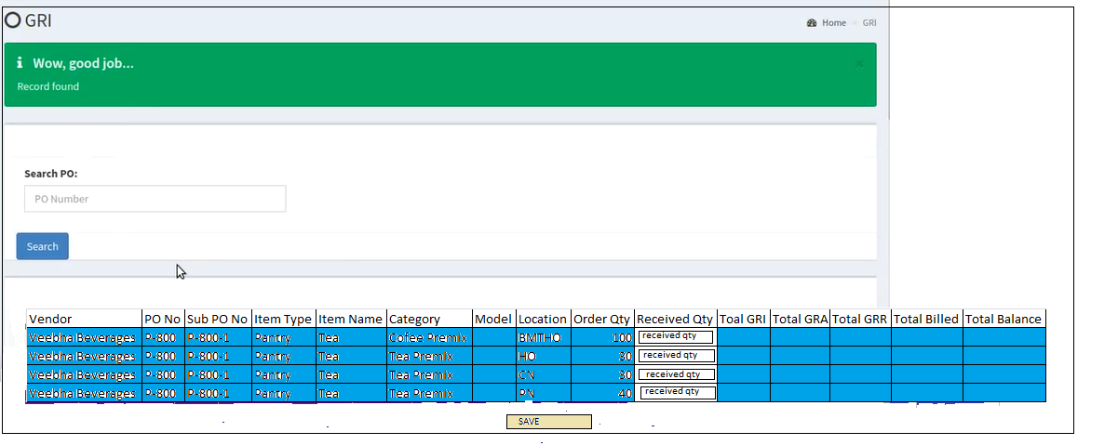

**GRA:**

We need to enter sub po number in text box and click on search.

* Below window is displayed with the table as shown below in GRA.
* Approved Qty and Reject Qty should be editable.
* Then the data can is saved by clicking on SAVE option.
* For HOD and Store incharge login of BMT HO location, it should display all the locations data.
* For other locations Store incharge login, it should display that particular related location data details.

