|  |  |
| --- | --- |
| **Ticket ID** |  |
| **Ticket description** | *In Sales Incentive Sales Report two reports are their 1 Branch performance report (consolidated branch wise)and Sales report (detail product wise) in this two report we define period target (groupwise)and mapped period in specific period eg. FY 2021-22 and we mapped till nov month on this period, but when we generate above two reports Branch performance consider group mapping and sales report not consider group mapping its consider his period date* |
| **Created by** | *Harshali Rananaware* |
| **Created on** | 05 May 2022 |
| **Priority** | *Very high* |
| **Version** | *1* |

**Version**

|  |  |  |  |  |
| --- | --- | --- | --- | --- |
| **Sr. No** | **Version no** | **Version Date** | **User name** | **User department** |
| 1 | 1 | 05 May 2022 | Dinesh Bhagyawan Sonawane | Accounting Department |

**Approvals**

|  |  |  |
| --- | --- | --- |
| **Field** | **Name of the User** | **Approved date by the user** |
| **Actual User Name** | Dinesh Bhagyawan Sonawane |  |
| **Actual User Department** | Accounting Department |  |
| **Organization Name** | CSPL |  |
| **Assigned BA** | *Harshali Rananaware* |  |
| **Assigned Developer** |  |  |
| **Assigned Tester** |  |  |

**Estimation**

|  |  |  |  |  |
| --- | --- | --- | --- | --- |
| **Department name** | **Estimated Time (In hr)** | **Scheduled Date (Starting date )** | **Estimated date** | **Actual delivery date** |
| **BA** |  |  |  |  |
| **Development** |  |  |  |  |
| **Testing** |  |  |  |  |

**Business requirement**

*In Sales Incentive Sales Report two reports are their 1 Branch performance report (consolidated branch wise)and Sales report (detail product wise) in this two report we define period target (groupwise)and mapped period in specific period eg. FY 2021-22 and we mapped till nov month on this period, but when we generate above two reports Branch performance consider group mapping and sales report not consider group mapping its consider his period date*

**Abbreviations & terms :**

Connect us - CU

**Existing system :**

In CU -> sales report -> “branch performance” and “sales report” ACTUAL_TOTAL,ACTUAL_TARGET_AMOUNT and SALES_RETURN_AMOUNT this three column value show wrong.

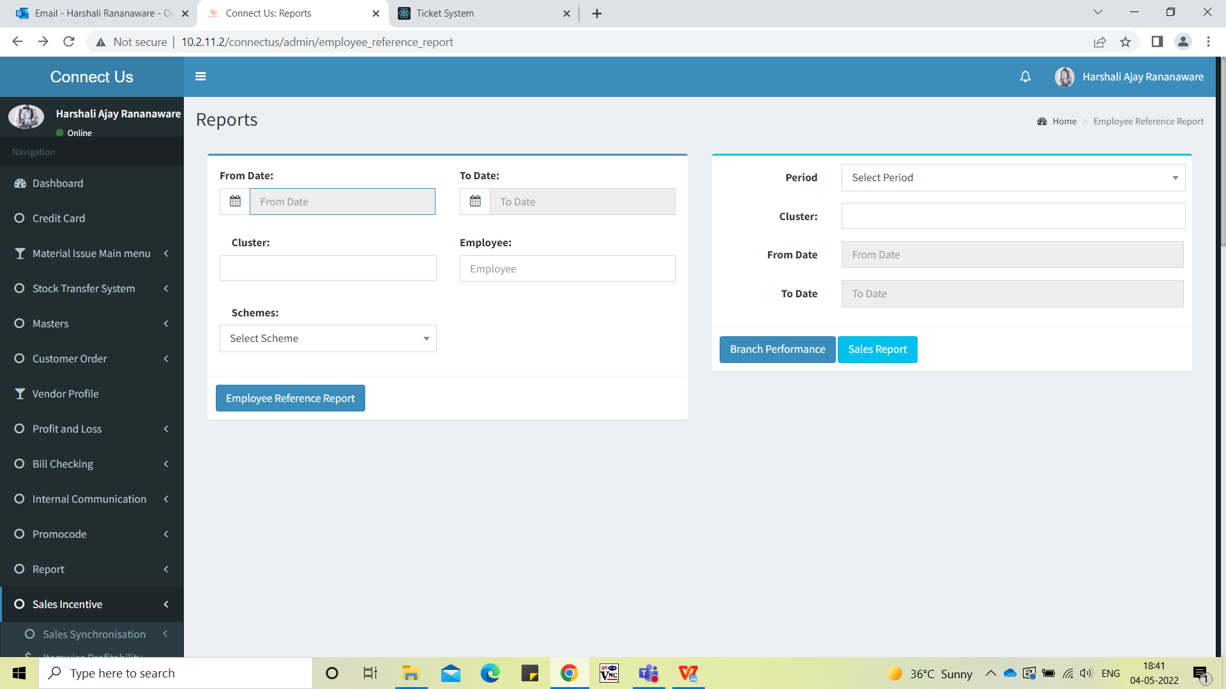

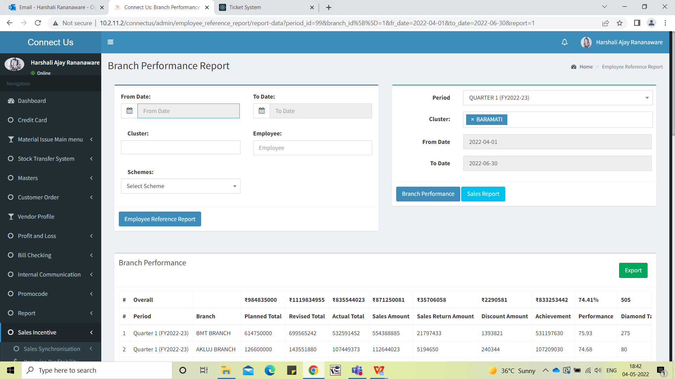

**Proposed System :**

In CU -> sales report -> “branch performance” and “sales report” ACTUAL_TOTAL,ACTUAL_TARGET_AMOUNT and SALES_RETURN_AMOUNT this three column value show wrong.

In sales report want to update the amount ACTUAL_TOTAL,ACTUAL_TARGET_AMOUNT and SALES_RETURN_AMOUNT same as branch performance report.

Br - ACTUAL_TOTAL = ACTUAL_AMOUNT

Br - ACTUAL_TARGET_AMOUNT = SALES_ITEMAMOUNT

Br - SALES_RETURN_AMOUNT = SALES_RETURN_ITEMAMOUNT



Image 1



Image 2

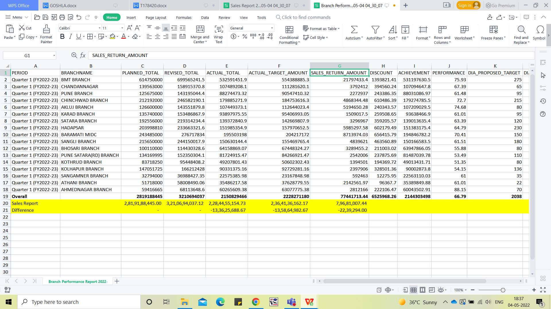

Image 3

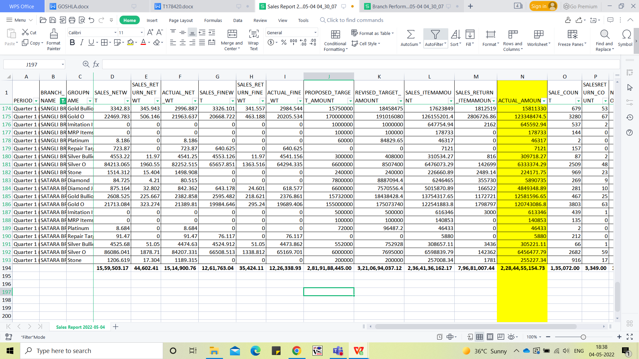

Image 4

**References of the users**

|  |  |  |  |
| --- | --- | --- | --- |
| **User** | **Name** | **Mail** | **Contact number** |
| **Actual user** | Dinesh Sonawane | hoaccountcc@csjewellers.com | 2931 |
| **Assigned business analyst** | *Harshali Rananaware* | [harshali.rananaware@techneai.com](mailto:harshali.rananaware@techneai.com) | 8669917920 |
| **Assigned developer** | Parth Patel | [parth.patel@techneai.com](mailto:parth.patel@techneai.com) |  |