|  |  |
| --- | --- |
| **Ticket ID** | **T97527** |
| **Ticket description** | *Providing Billing module access to vendors for IT vendors.* |
| **Created by** | *Harshali Ajay Rananaware* |
| **Created on** | *08 Oct 2021* |
| **Priority** | *Very high* |
| **Version** | *1* |

**Version**

|  |  |  |  |  |
| --- | --- | --- | --- | --- |
| **Sr. No** | **Version no** | **Version Date** | **User name** | **User department** |
| 1 | 0 | *08 Oct 2021* | Amit Anant Pawar | Purchase Order |
| 2 | 1 | *19 Oct 2021* | Swagata Prajyot Gandhi | Purchase Order |

**Approvals**

|  |  |  |
| --- | --- | --- |
| **Field** | **Name of the User** | **Approved date by the user** |
| **Actual User Name** | Amit Anant Pawar |  |
| **Actual User Department** | Purchase Order |  |
| **Organization Name** | CSPL |  |
| **Assigned BA** | *Harshali Ajay Rananaware* |  |
| **Assigned Developer** |  |  |
| **Assigned Tester** |  |  |

**Estimation**

|  |  |  |  |  |
| --- | --- | --- | --- | --- |
| **Department name** | **Estimated Time (In hr)** | **Scheduled Date (Starting date )** | **Estimated date** | **Actual delivery date** |
| **BA** |  |  |  |  |
| **Development** |  |  |  |  |
| **Testing** |  |  |  |  |

**Introduction**

Vendor can assign directly to customer. For example CSPL

**Business requirement**

*Providing Billing module access to vendors for IT vendors.*

**Existing system**

Currently , their is no provision to add bill from vendor side.

**Proposed system**

**Vendor side :** In connect us vendor log in addnew widget “bill checking transaction”. Vendor can add and view bill only.

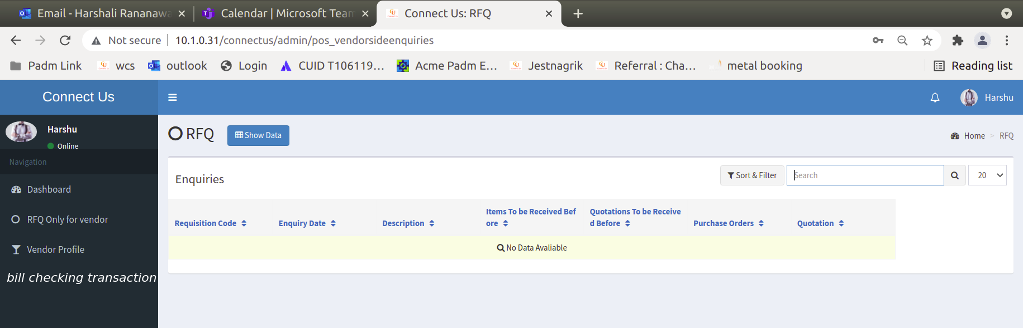

Image 1

Click on bill checking transaction then show in the following format(Refer Image 2). In action view (Refer Image 3) and payment details option show to vendor. (Refer Image 4)

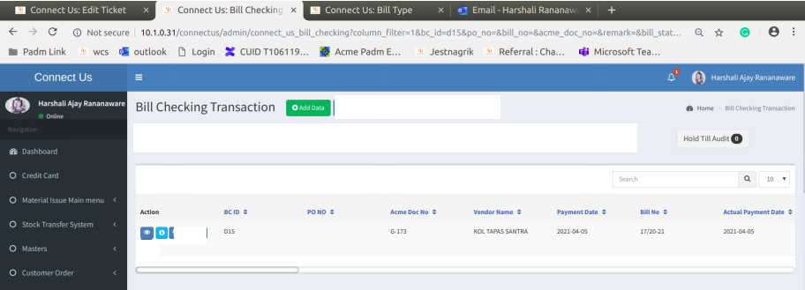

Click here to show in image 3

Click here to show in image 4

Image 2

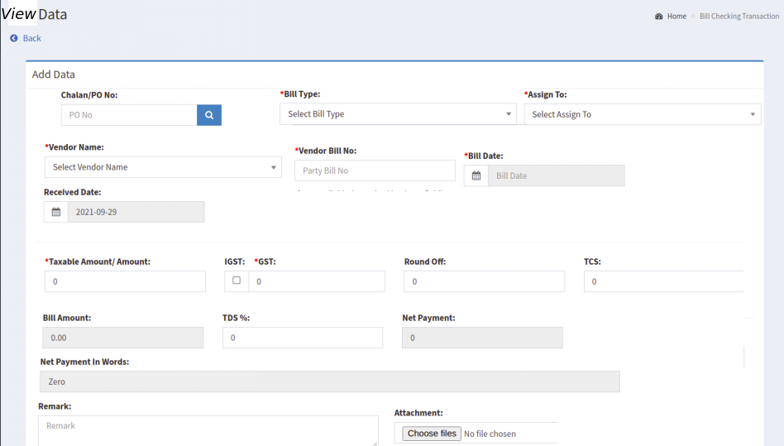

Image 3

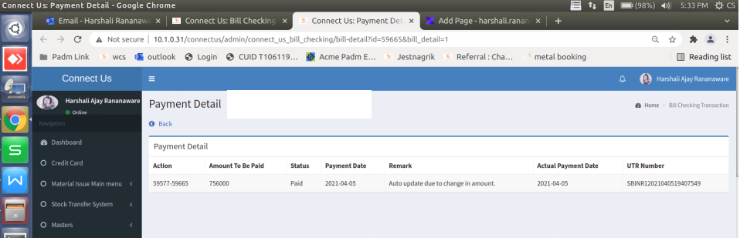

Image 4

**Add data -**

* In bill checking, we click on “add data”, then the following fields display. (Refer Image 6)

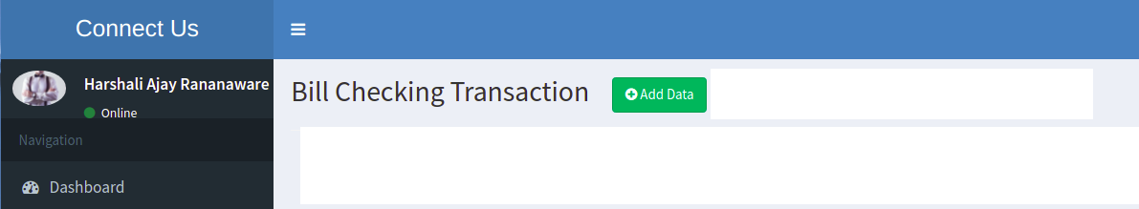

Image 5

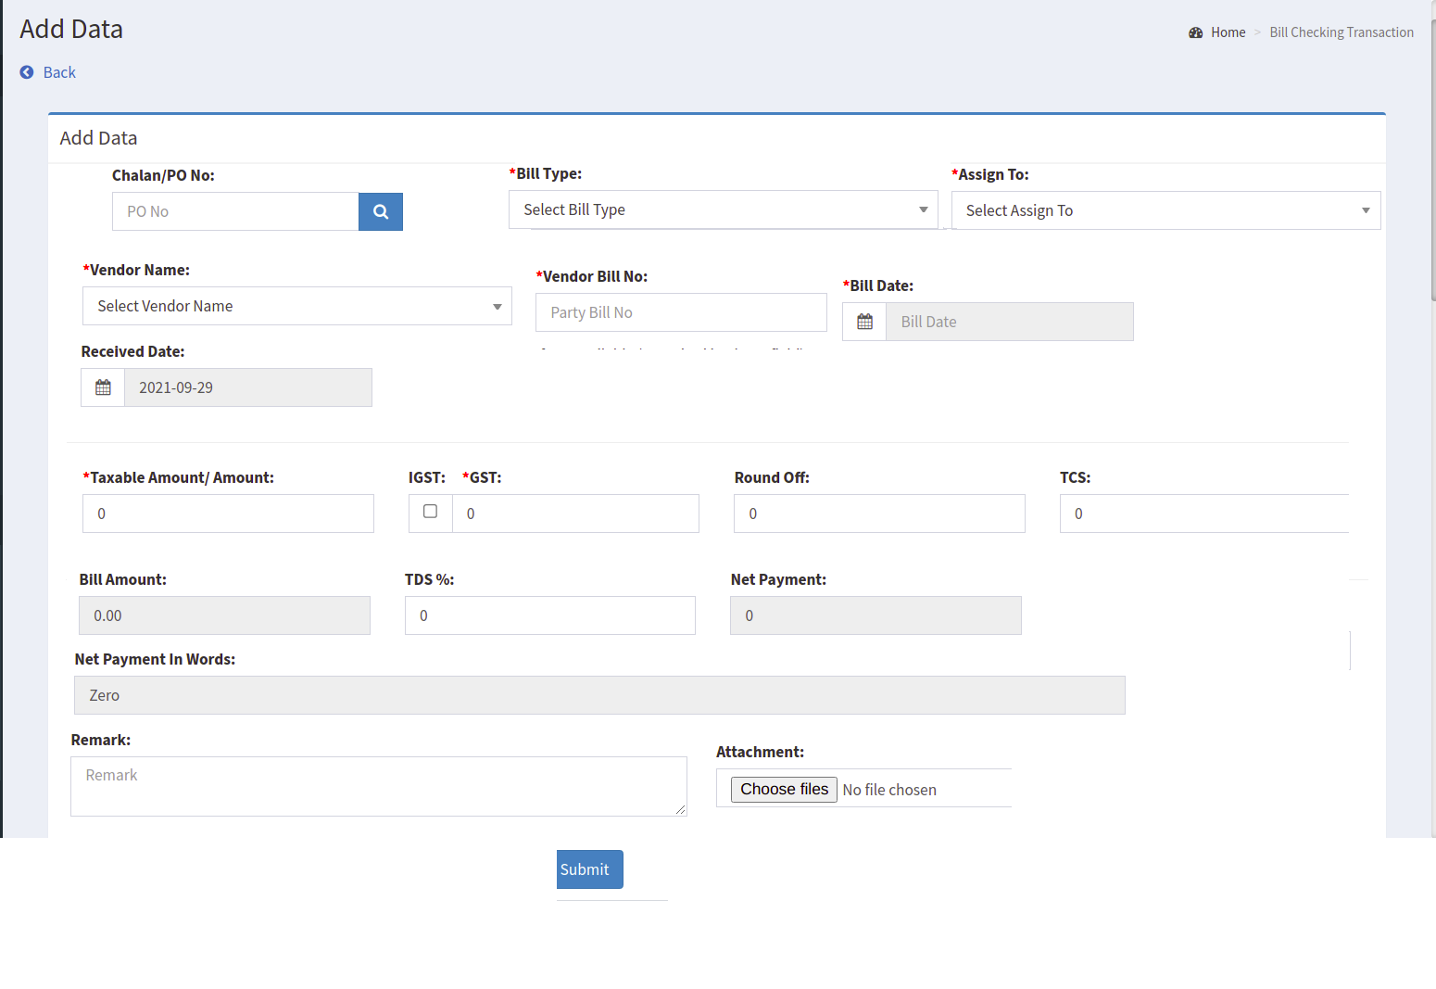

Image 6

* Bill checking id should be generated as per year code.
* Required to show bill checking id of that particulate vendor.
* In “Bill checking” add data then this bill id show against “assign to” person.
* In CU -> Bill Checking -> bill checking transaction our side bill is show in the following format.(Refer Image 6)

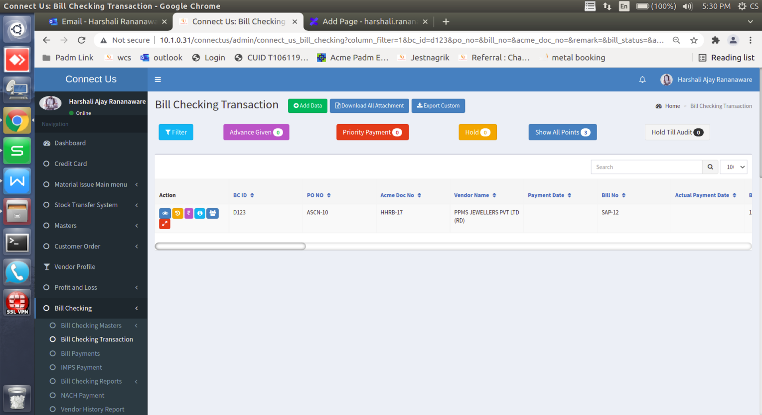

Image 7

|  |  |  |  |  |
| --- | --- | --- | --- | --- |
| **FIELD** | **INPUT TYPE** | **MANDTORY / OPTIONAL** | **CONDITION** | **DESCRIPTION** |
| PO no | Text | Mandatory | - | User can enter po no |
| Bill Type | Drop-down | Mandatory |  | Select bill type. |
| Assign to person | Drop-down | Mandatory | - | buyer name by default auto reference taken from “RFQ” |
| Vendor name | Drop-down | Mandatory | - | select by default |
| Vendor bill no | Text | Mandatory | - |  |
| Bill date | Date | Mandatory | - | Enter by vendor side |
| Received Date | Date | Optional | - | add data then date show blank vendor side. assign to person open this bill then receive date auto show disable. |
| Taxable Amount/ Amount | Text | Mandatory | - | Enter by vendor side |
| IGST | Check box | Optional | - | Enter by vendor side |
| GST |  | Mandatory |  |  |
| Round Off | Text | Optional |  | Enter by vendor side |
| Bill Amount | Text | Mandatory | - | taxable amount auto disable. |
| Net Payment | Text | Mandatory | - | auto disable. |
| Net Payment In Words | Label | Mandatory | - | auto disable. |
| Remark | Text | Optional |  | text box add remark manually |
| Attachment | File | Mandatory |  | add multiple attachment. |
| Save | Button |  |  |  |
| Save & add more | Button |  |  |  |

**ODUS ( Open Discussed Unhanded scenarios )**

|  |  |
| --- | --- |
| **Topic** | *Bill checking* |
| **Reported by** | Harshali Ajay Rananaware |
| **Reported on** | *09 Oct 21* |
| **Details** | *If bill amount is paid then required to show in grid view or not?* |
| **Status** | *Incomplete* |
| **Priority** | *medium* |
| **Estimated time** | *-* |
| **Completion date** | *-* |

**References of the users**

|  |  |  |  |
| --- | --- | --- | --- |
| **User** | **Name** | **Mail** | **Contact number** |
| **Actual user** | Swagata Prajyot Gandhi | opcc@csjewellers.com | 2923 |
| **Ticket created by (if any)** | Amit Anant Pawar | opcc@csjewellers.com | 2923 |
| **Assigned business analyst** | Harshali Ajay Rananaware | [harshali.rananaware@techneai.com](mailto:harshali.rananaware@techneai.com) | 8669917920 |
| **Assigned developer** |  |  |  |