|  |  |
| --- | --- |
| **Ticket ID** | TT2434 |
| **Ticket description** | Need to update Daily live COGS same as per daily Sales ( PLAN /REVISED/ ACTUAL) updated in CU. Refer Branch Performance & Sales Report under Sales Incentive - Sales Report. |
| **Created by** | Harshali Rananaware |
| **Created on** | 16 Jun 2022 |
| **Priority** | Very high |
| **Version** | 1 |

**Version**

|  |  |  |  |  |
| --- | --- | --- | --- | --- |
| **Sr. No** | **Version no** | **Version Date** | **User name** | **User department** |
| 1 | 1 | 16 Jun 2022 | Dinesh Bhagyawan Sonawane | Accounting Department |

**Approvals**

|  |  |  |
| --- | --- | --- |
| **Field** | **Name of the User** | **Approved date by the user** |
| **Actual User Name** | Dinesh Bhagyawan Sonawane |  |
| **Actual User Department** | Accounting Department |  |
| **Organization Name** | CSPL |  |
| **Assigned BA** | Harshali Rananaware |  |
| **Assigned Developer** |  |  |
| **Assigned Tester** |  |  |

**Estimation**

|  |  |  |  |  |
| --- | --- | --- | --- | --- |
| **Department name** | **Estimated Time (In hr)** | **Scheduled Date (Starting date )** | **Estimated date** | **Actual delivery date** |
| **BA** | 3 | 16 Jun 2022 | 22 Jun 2022 |  |
| **Development** |  |  |  |  |
| **Testing** |  |  |  |  |

**Business requirement**

Need to update Daily live COGS same as per daily Sales ( PLAN /REVISED/ ACTUAL) updated in CU. Refer Branch Performance & Sales Report under Sales Incentive - Sales Report.

**Abbreviations & terms :**

Connect us - CU

**Proposed System :**

In CU -> Sales Incentive -> Sales report want to add new report COGS. In this report COGS generate daily basics.

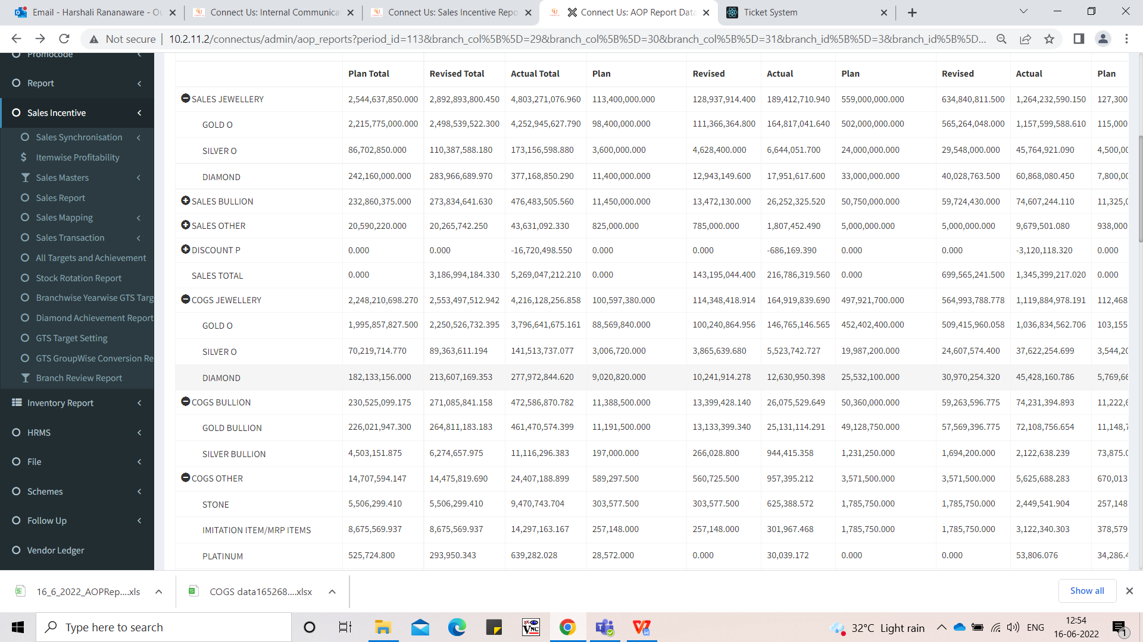

Image 1

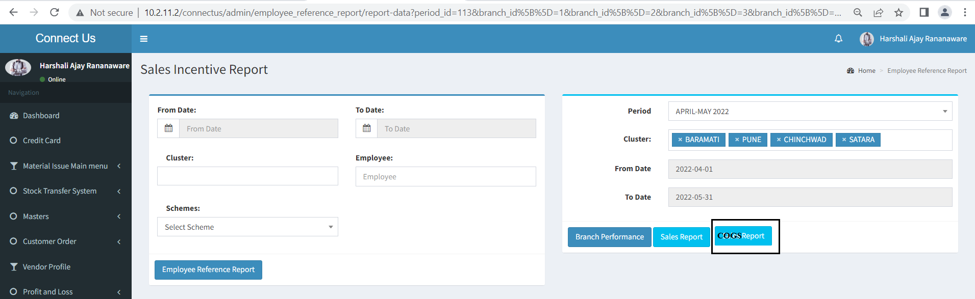

Image 2

In COGS Report want to see the following column.

**Input** -

1. **Period** - This period fetch from period master.
2. **Cluster** - we can select cluster.
3. **From date** - As per period from date should be fetch auto.
4. **To date** - As per period to date should be fetch auto.

**Output** -

1. **Period** - Select period should be show here.
2. **Branch -** As per input cluster show particular branch name here.
3. **Group -** In CU-> sales incentive -> Period target setting we can fetch group.
4. **Fine wt -**  In CU -> Profit and Loss -> P and L master when generate AOP report -> COGS report then this value “Fine Wt” consider here.
5. **Avg Rate** - In CU -> Profit and Loss -> P and L master when generate AOP report -> COGS report then this value “avg rate” consider here.
6. **COGS Amount** - In CU -> Profit and Loss -> P and L master when generate AOP report -> COGS report then this value “COGS AMOUNT” consider here.

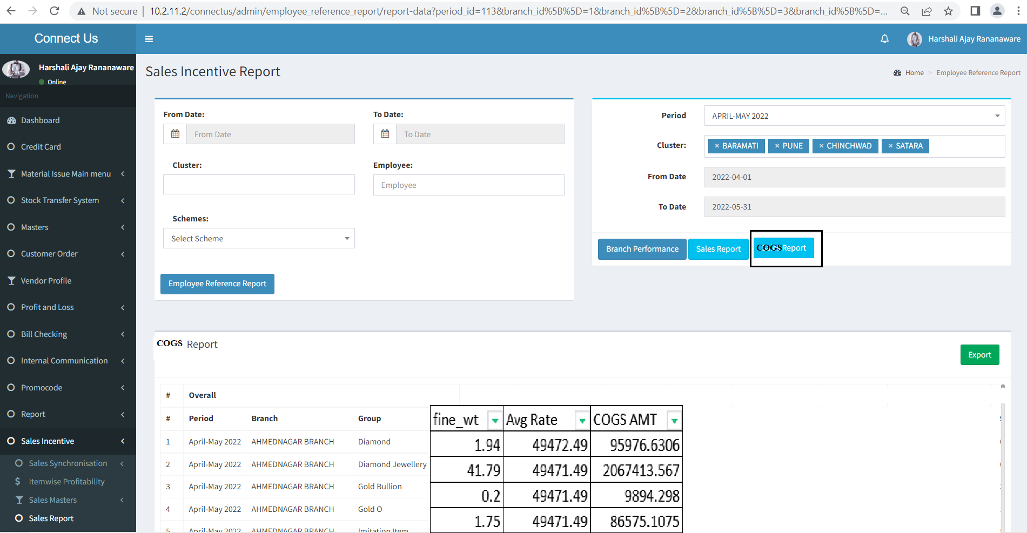

Image 3

In Click on Export then file export in .CSV format. Check the below attachment.

|  |  |  |  |  |  |  |  |
| --- | --- | --- | --- | --- | --- | --- | --- |
| **period** | **from_date** | **to_date** | **branch_name** | **group_master_name** | **fine_wt** | **Avg Rate** | **COGS AMT** |
| April-May 2022 | 01-04-2022 | 30-04-2022 | AHMEDNAGAR BRANCH | Diamond | 1.94 | 49472.49 | 95976.6306 |
| April-May 2022 | 01-04-2022 | 30-04-2022 | AHMEDNAGAR BRANCH | Diamond | 41.79 | 49471.49 | 2067413.567 |
| April-May 2022 | 01-04-2022 | 30-04-2022 | AHMEDNAGAR BRANCH | Diamond | 0.2 | 49471.49 | 9894.298 |
| April-May 2022 | 01-04-2022 | 30-04-2022 | AHMEDNAGAR BRANCH | Diamond | 1.75 | 49471.49 | 86575.1075 |
| April-May 2022 | 01-04-2022 | 30-04-2022 | AHMEDNAGAR BRANCH | Diamond Jewellery | 3.879 | 7167.91 | 27804.32289 |
| April-May 2022 | 01-04-2022 | 30-04-2022 | AHMEDNAGAR BRANCH | Diamond Jewellery | 28.545 | 5265.33 | 150298.8449 |
| April-May 2022 | 01-04-2022 | 30-04-2022 | AHMEDNAGAR BRANCH | Diamond Jewellery | 57.229 | 6457.74 | 369570.0025 |
| April-May 2022 | 01-04-2022 | 30-04-2022 | AHMEDNAGAR BRANCH | Diamond Jewellery | 4.719 | 6650.29 | 31382.71851 |
| April-May 2022 | 01-04-2022 | 30-04-2022 | AHMEDNAGAR BRANCH | Diamond Jewellery | 68.712 | 6103.71 | 419398.1215 |

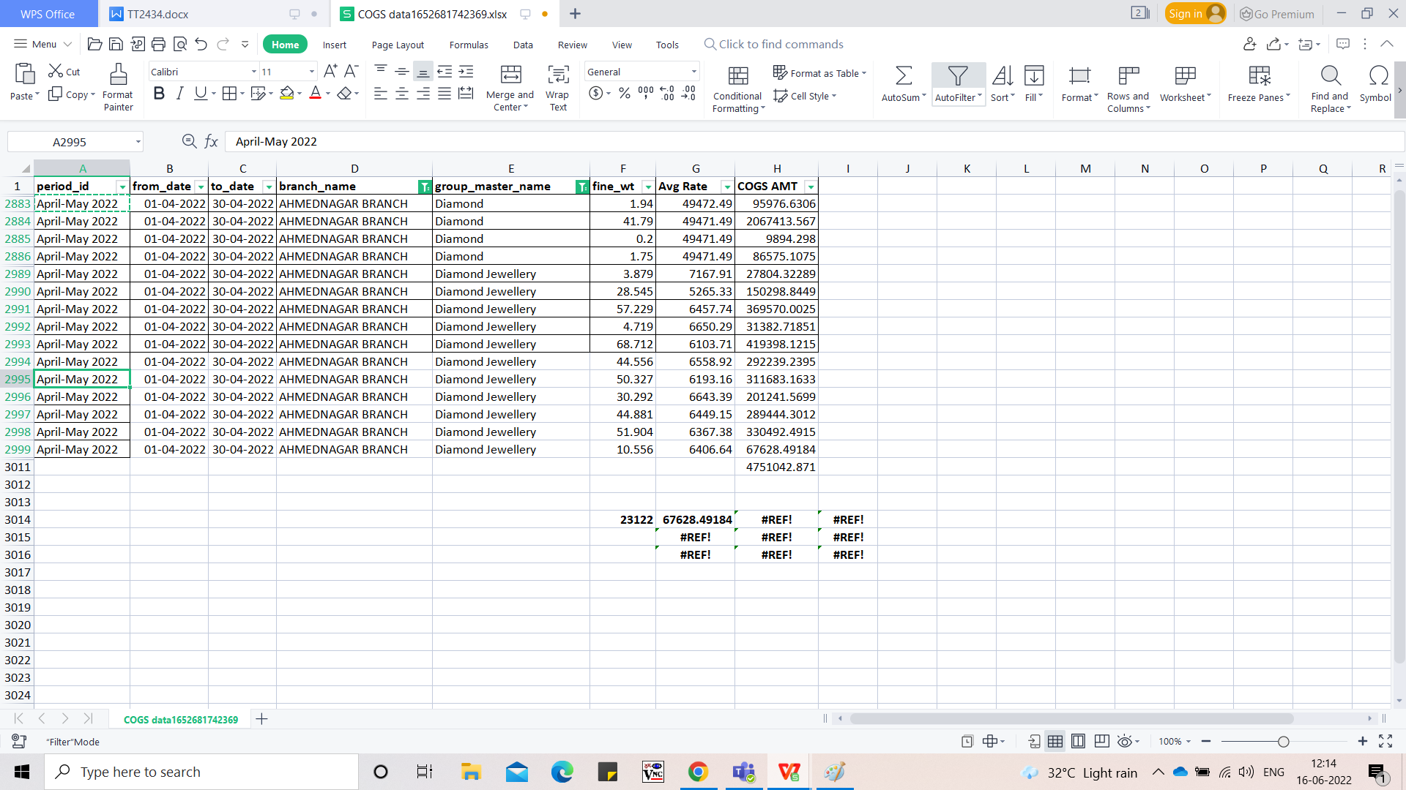

Image 4

**References of the users**

|  |  |  |  |
| --- | --- | --- | --- |
| **User** | **Name** | **Mail** | **Contact number** |
| **Actual user** | Dinesh Bhagyawan Sonawane | hoaccountcc@csjewellers.com | 2931 |
| **Assigned business analyst** | Harshali Rananaware | [harshali.rananaware@techneai.com](mailto:harshali.rananaware@techneai.com) | 8669917920 |
| **Assigned developer** | Parth Patel | [parth.patel@techneai.com](mailto:parth.patel@techneai.com) |  |