|  |  |
| --- | --- |
| **Ticket ID** | TT3086 |
| **Ticket description** | In Connect-Us, we can't generate & view Quarterly/half yearly or yearly PLAN AOP (which is one time filled by Branches monthly Targeted Plan Sales). When we generate this report Under Sales Incentive- Sales Report- Branch Performance or Sales Report , received error & can't generate any quarterly Plan Sales report. Find the attached Yearly Branch Performance & Sales Report Screen Shots & generated wrong Sales Report of FY 2022-23 |
| **Created by** | Harshali Rananaware |
| **Created on** | 22 Jul 2022 |
| **Priority** | Very high |
| **Version** | 1 |

**Version**

|  |  |  |  |  |
| --- | --- | --- | --- | --- |
| **Sr. No** | **Version no** | **Version Date** | **User name** | **User department** |
| 1 | 1 | 22 Jul 2022 | Amarja Dudka | Accounting department |

**Approvals**

|  |  |  |
| --- | --- | --- |
| **Field** | **Name of the User** | **Approved date by the user** |
| **Actual User Name** | Amarja Dudka |  |
| **Actual User Department** | Accounting department |  |
| **Organization Name** | Connect us |  |
| **Assigned BA** | Harshali Rananaware |  |
| **Assigned Developer** | Nikhil Bhosale |  |
| **Assigned Tester** |  |  |

**Estimation**

|  |  |  |  |  |
| --- | --- | --- | --- | --- |
| **Department name** | **Estimated Time (In hr)** | **Scheduled Date (Starting date )** | **Estimated date** | **Actual delivery date** |
| **BA** | 3 | 22 Jul2022 | 27 Jul 2022 |  |
| **Development** |  |  |  |  |
| **Testing** |  |  |  |  |

**Business requirement**

In Connect-Us, we can't generate & view Quarterly/half yearly or yearly PLAN AOP (which is one time filled by Branches monthly Targeted Plan Sales). When we generate this report Under Sales Incentive- Sales Report- Branch Performance or Sales Report , received error & can't generate any quarterly Plan Sales report. Find the attached Yearly Branch Performance & Sales Report Screen Shots & generated wrong Sales Report of FY 2022-23

**Proposed System :**

* In CU -> Sales incentive -> sales report when we generate “Branch performance” report **Period** - QUARTER-3 (FY2022-23) then showing notification. All period plan is already entered.

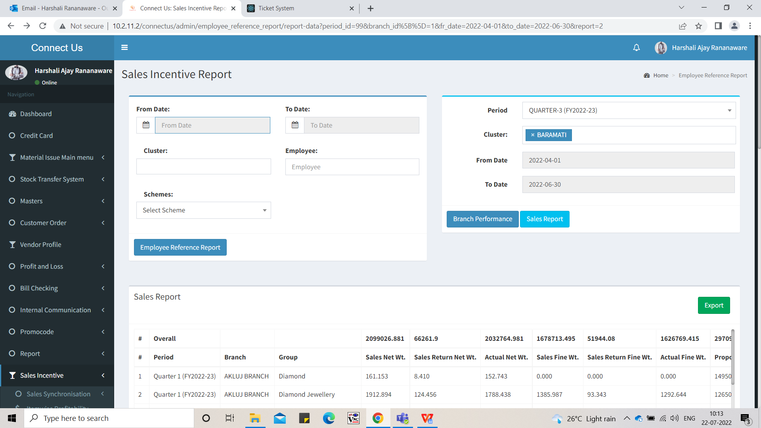

Image 1

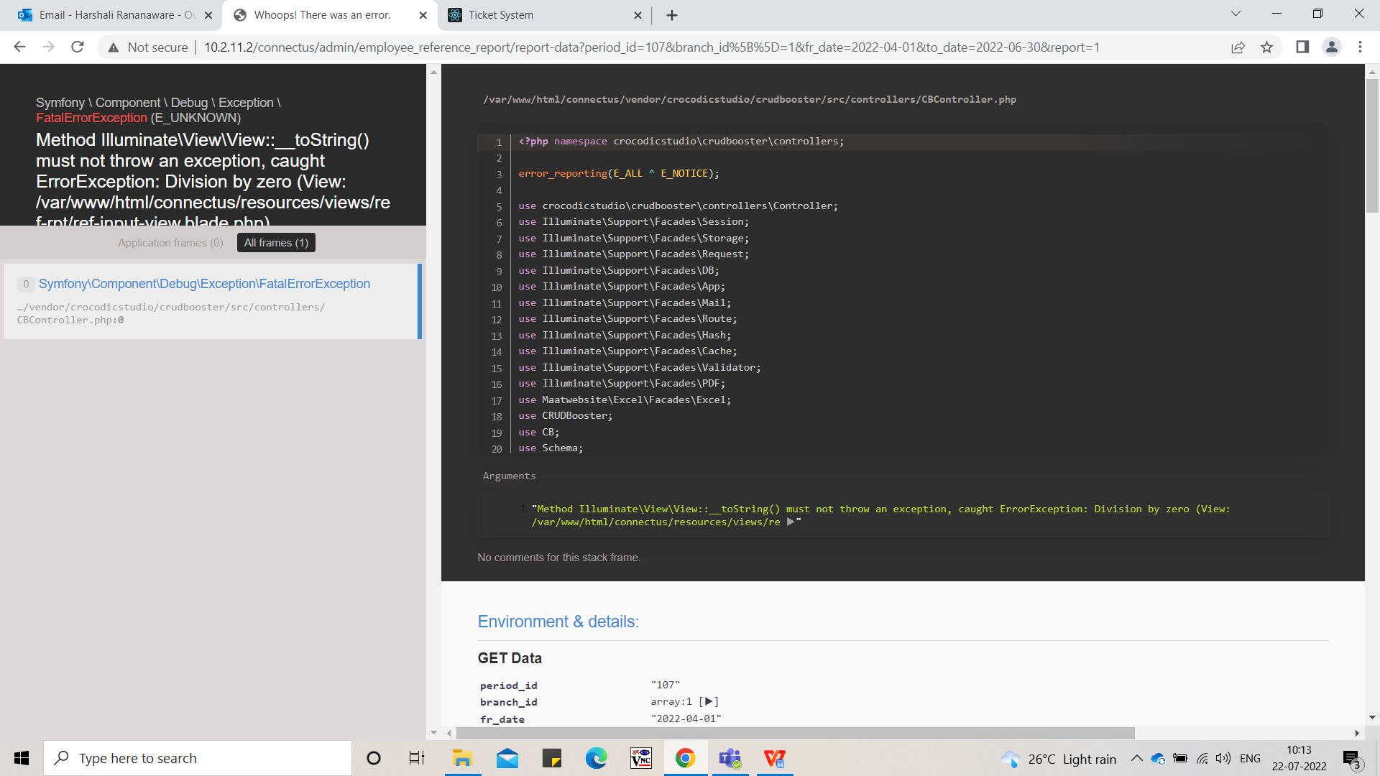

Image 2

* In CU -> Sales incentive -> sales report when we generate “Branch performance” report **Period** - FY 2022-23 then showing blank value. So we want to show the value for all column. PERIOD,BRANCHNAME,PLANNED_TOTAL,REVISED_TOTAL,ACTUAL_TOTAL,ACTUAL_TARGET_AMOUNT,SALES_RETURN_AMOUNT,DISCOUNT,ACHIEVEMENT,PERFORMANCE,DIA_PROPOSED_TARGET,DIA_ACHIEVEMENT,DIA_ACHIEVED

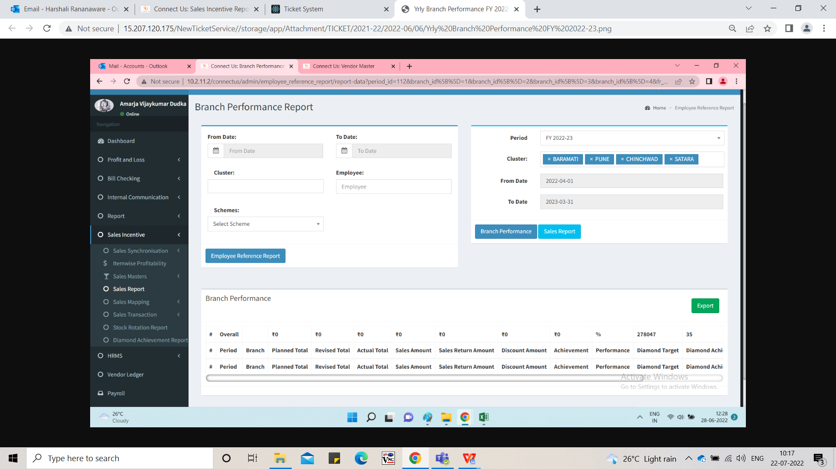

Image 3

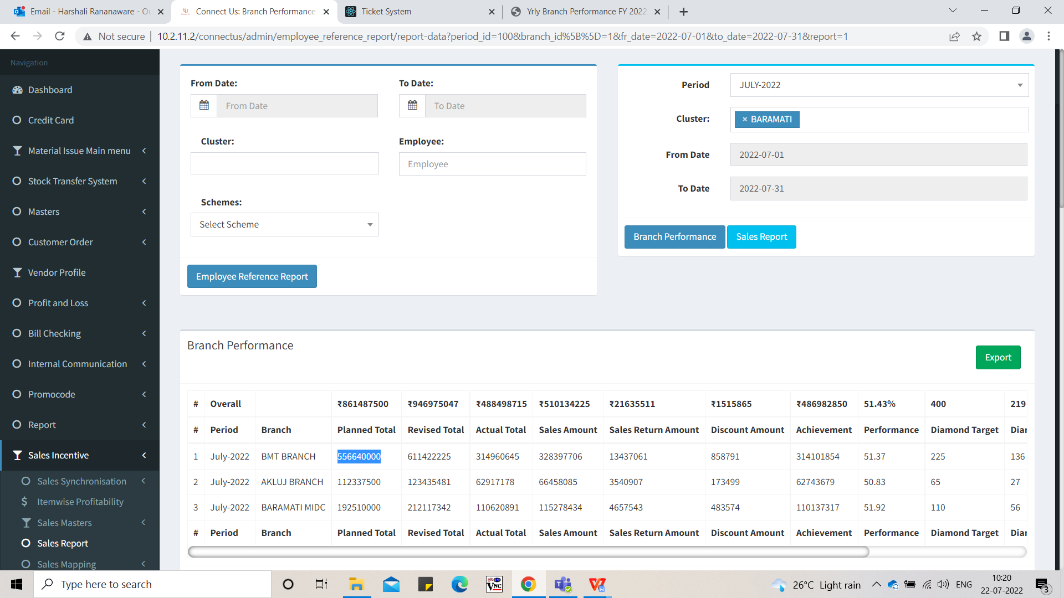

Image 4

* In CU -> Sales incentive -> sales report when we generate “Sales Report” for period FY 2022-23 then PROPOSED_TARGET_AMOUNT , REVISED_TARGET_AMOUNT this two column show blank. For this value fetch from sales incentive -> sales transaction -> period master (Refer Image 6).

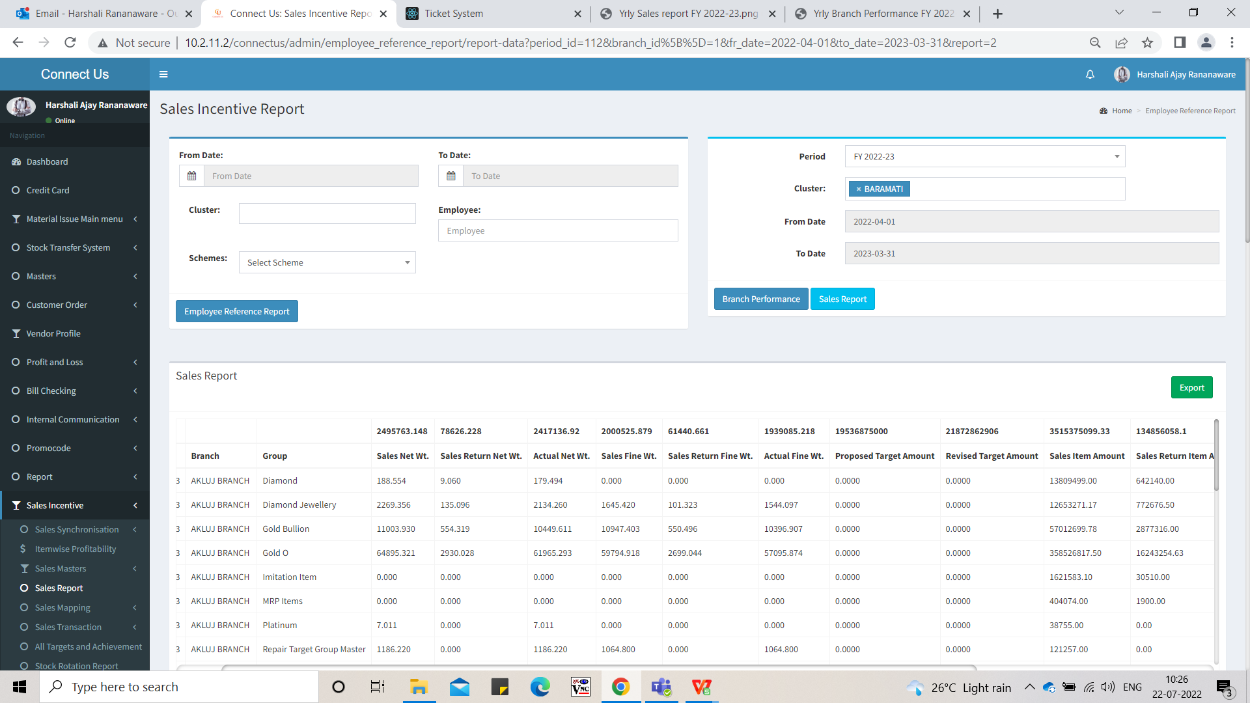

Image 5

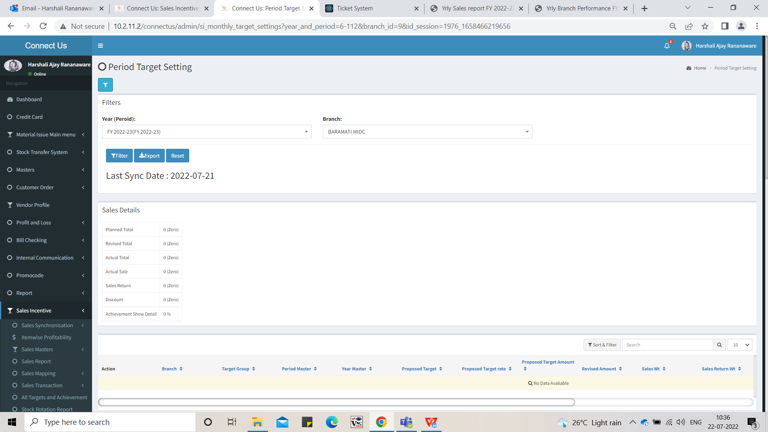

Image 6

**References of the users**

|  |  |  |  |
| --- | --- | --- | --- |
| **User** | **Name** | **Mail** | **Contact number** |
| **Actual user** | Amarja Dudka | account@csjewellers.com | 2930 |
| **Assigned business analyst** | Harshali Rananaware | [harshali.rananaware@techneai.com](mailto:harshali.rananaware@techneai.com) | 8669917920 |
| **Assigned developer** | Nikhil Bhosale | nikhil.bhosale@techneai.com |  |