|  |  |
| --- | --- |
| **Ticket ID** | TT4065 |
| **Ticket description** | Scheme Re-enrolment chi process deli ahe ashi provision padm madhe karun dene. Details - See attachment |
| **Created by** | Vishal Patil |
| **Created on** | 08/08/2022 |
| **Priority** | Medium |
| **Version** | 2 |

**Version**

|  |  |  |  |  |
| --- | --- | --- | --- | --- |
| **Sr. No** | **Version no** | **Version Date** | **User name** | **User department** |
| 1 | 1 | 01.11.2022 | Vishal Patil | Operations Team |
| 2 | 2 | 04.11.2022 | Vishal Patil | Operations Team |

**Approvals**

|  |  |  |
| --- | --- | --- |
| **Field** | **Name of the User** | **Approved date by the user** |
| **Actual User Name** | Vishal Patil | 01.11.2022 |
| **Actual User Department** | Operations Team |  |
| **Organization Name** | C S Jewellers |  |
| **Sign-off** |  |  |
| **Assigned BA** | Mounika KrishnaVeni Annamneedi | 01.11.2022 |

**Estimation**

|  |  |  |  |  |
| --- | --- | --- | --- | --- |
| **Department name** | **Estimated Time (In hr)** | **Scheduled Date (Starting date )** | **Estimated date** | **Actual delivery date** |
| **BA** | 1 | 01.11.2022 | 01.11.2022 | 01.11.2022 |
| **BA** | 2 | 04.11.2022 | 04.11.2022 |  |

**Business requirement**

A new module to know whether the customer is eligible for the discount at the time re-enrollment of the scheme.

**Existing system**

In the existing system, there is no such system.

**Proposed system**

* Creation of the new module “Scheme re-enrollment”
* Generation of unique code
* Creation of the new module “Scheme re-enrollment report”

Step 1

In connect us >> Schemes >> scheme re-enrollment

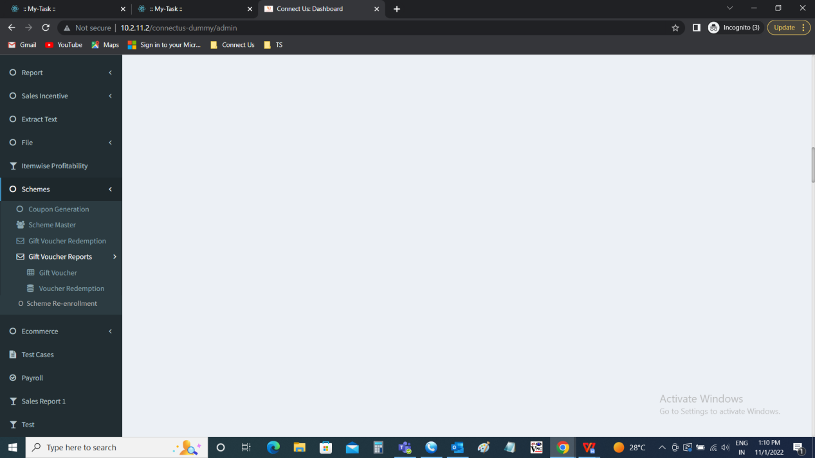

Step 2

Scheme re-enrollment

The scheme re-enrollment module is used by the cashiers in the branch to know whether the customer is eligible for the discount at the time of re-enrollment of the scheme.

The scheme re-enrollment consists of the following fields

* Enter customer number
* Submit
* Cancel

|  |  |  |  |
| --- | --- | --- | --- |
| **FIELDS** | **INPUT TYPE** | **MANDATORY/ OPTIONAL** | **DESCRIPTION** |
| Enter customer number | Int | Mandatory | The customer number is entered. The number should be of the existing customer. The validation - 10 digit. |
| Submit | Button | Optional | The submit button to fetch the details of the customers. |
| Cancel | Button | Optional | The cancel button to reset the page |

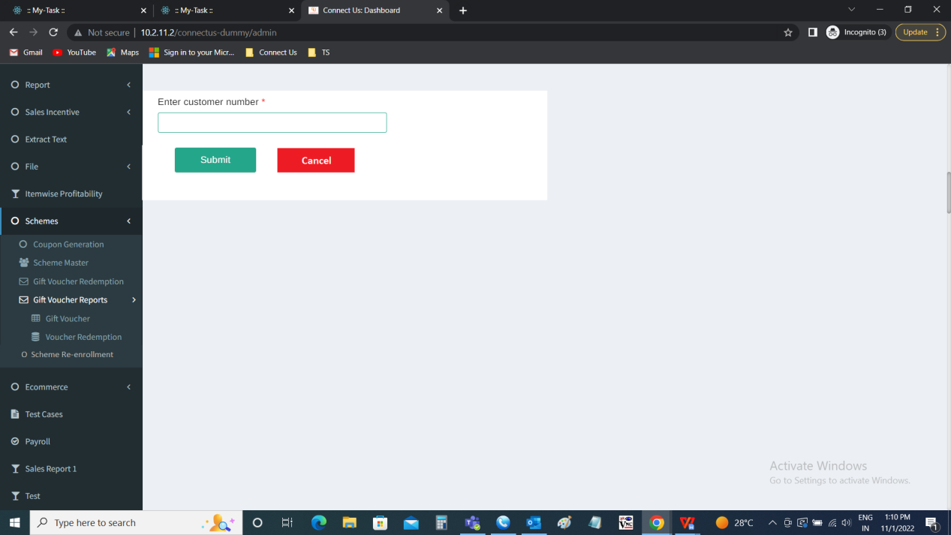

Once the customer number is entered. The following data is displayed related to the customer. The data is fetched from the Padm. The following are the fields.

* Unique code
* Scheme ID
* Customer name
* Scheme name
* Scheme amount
* Scheme maturity date
* Offer applicable or not

|  |  |
| --- | --- |
| Field | Description |
| Unique code | An unique code is to be generated when the offer is applicable to customer which can be used in Padm for discounting the customer. The unique code should be random generated and can be used only time. The series will be in order SRE - 000000 I.e., “SRE-” common for every code and 6 random code. |
| Scheme ID | The scheme ID currently running is displayed |
| Customer name | The customer name is displayed |
| Scheme name | The scheme name is displayed |
| Scheme amount | The scheme amount is displayed |
| Scheme maturity date | The scheme maturity date is displayed |
| Offer applicable or not | The offer applicable or not to the following customer is displayed. The following are the conditions for the application of the discount.   * The scheme maturity date should not be exceeding 1 month before and after maturity date of the existing scheme. * The offer applicable or not is highlighted. |

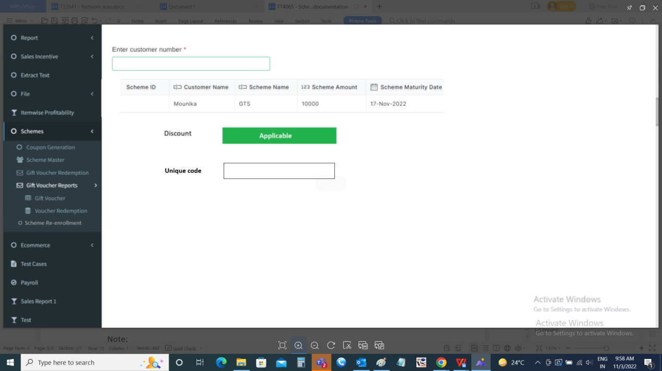

Step 3

Creation of new module “Scheme re-enrollment report”

In connect us >> scheme re-enrollment report

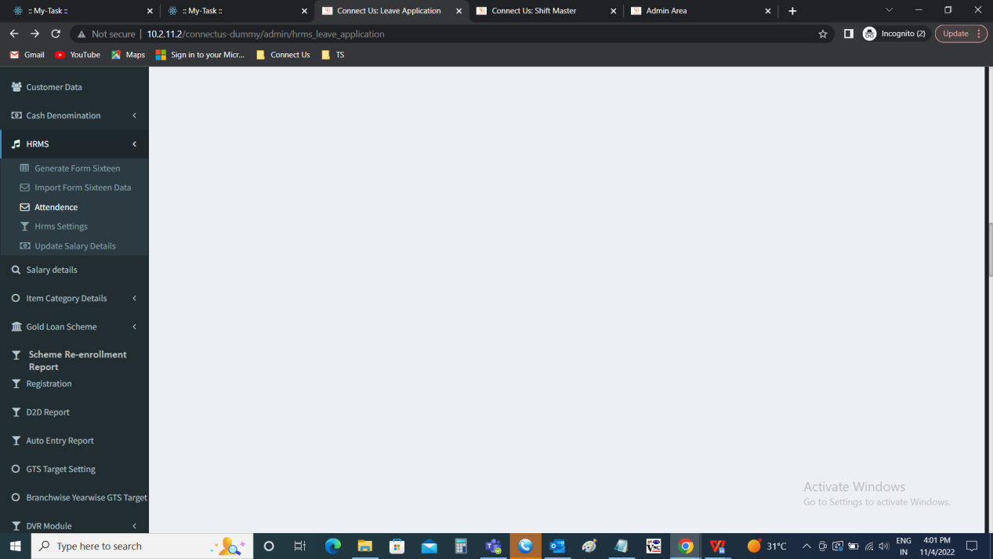

Scheme re-enrollment report:

The scheme re-enrollment report consists of the unique codes generated for the particular mobile number. The scheme re-enrollment report consists of the following fields.

* From date
* To date
* Submit
* Cancel

|  |  |  |  |
| --- | --- | --- | --- |
| **FIELDS** | **INPUT TYPE** | **MANDATORY/ OPTIONAL** | **DESCRIPTION** |
| From date | Calender | Mandatory | The from date is entered. The from date is when the coupon code is generated. |
| To date | Calender | Mandatory | The to date is entered. The to date is to when the coupon code is generated. |
| Submit | Button | Optional | The submit button to fetch the details of the customers. |
| Reset | Button | Optional | The reset button to reset the page |

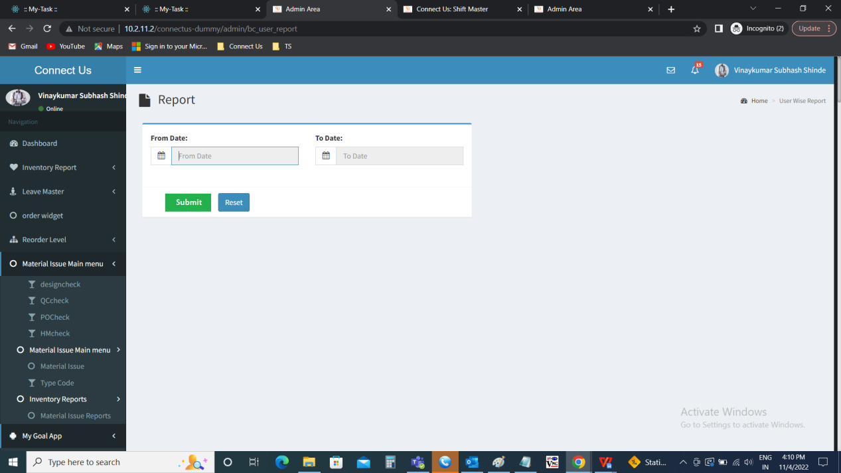

The report consists of the following fields.

* Export - to export the data
* Scheme ID
* Customer name
* Scheme name
* Scheme amount
* Scheme maturity date
* Offer applicable or not
* Unique code

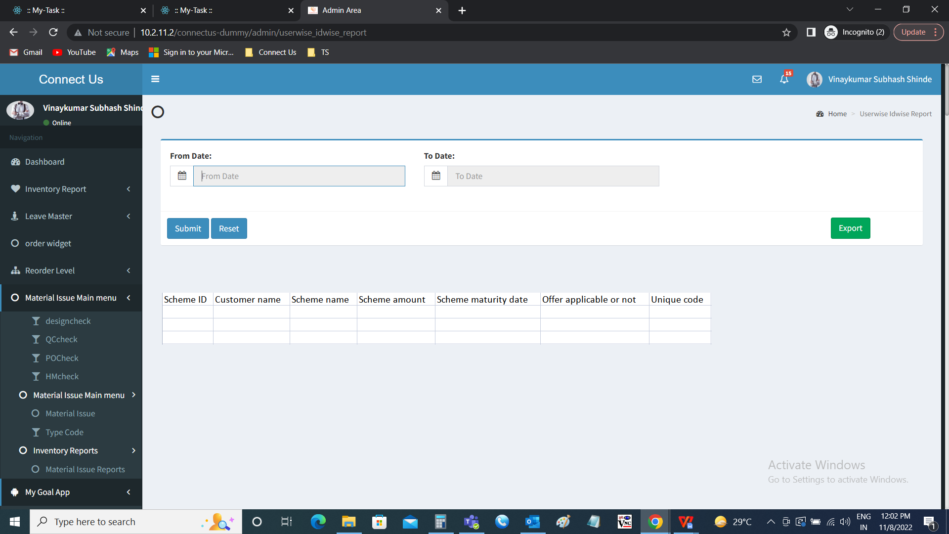

Export

The export button to export the data based on the filters. The export data consists of the following fields.

* Scheme ID
* Customer name
* Scheme name
* Scheme amount
* Scheme maturity date
* Offer applicable or not
* Unique code

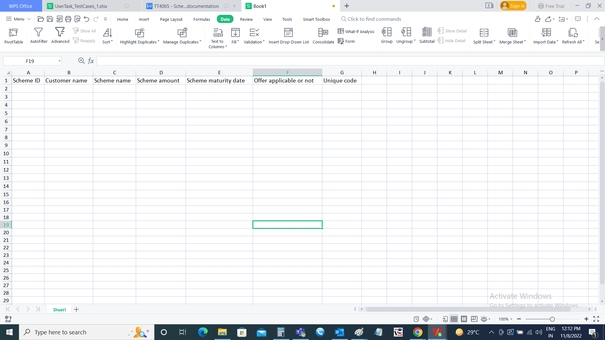

Note:

Padm changes will be done by the Support - Mallikarjun sir as per the discussion.

**References of the users**

|  |  |  |  |
| --- | --- | --- | --- |
| **User** | **Name** | **Mail** | **Contact number** |
| **Actual user** | Vishal Patil | hobcs@csjewellers.com |  |
| **Assigned business analyst** | Mounika KrishnaVeni Annamneedi | Mounika.annamneedi@techneai.com | 9885900039 |