|  |  |
| --- | --- |
| **Ticket ID** | TT6633 |
| **Ticket description** | ConnectUS > Bill Checking > Bill Checking Report > Userwise Bill Id Report Madhe New Coolum Add Karun Dene Coolum Name :- Acme Doc No Ref By Sanjay Danole Sir |
| **Created by** | Tushar Shivaji Nikam |
| **Created on** | 01/11/2022 |
| **Priority** | Medium |
| **Version** | 1 |

**Version**

|  |  |  |  |  |
| --- | --- | --- | --- | --- |
| **Sr. No** | **Version no** | **Version Date** | **User name** | **User department** |
| 1 | 1 | 01.11.2022 | Tushar Shivaji Nikam | Inventory Silver HO |

**Approvals**

|  |  |  |
| --- | --- | --- |
| **Field** | **Name of the User** | **Approved date by the user** |
| **Actual User Name** | Tushar Shivaji Nikam | 01.11.2022 |
| **Actual User Department** | Inventory Silver HO |  |
| **Organization Name** | C S Jewellers |  |
| **Sign-off** |  |  |
| **Assigned BA** | Mounika KrishnaVeni Annamneedi | 01.11.2022 |

**Estimation**

|  |  |  |  |  |
| --- | --- | --- | --- | --- |
| **Department name** | **Estimated Time (In hr)** | **Scheduled Date (Starting date )** | **Estimated date** | **Actual delivery date** |
| **BA** | 1 | 01.11.2022 | 01.11.2022 |  |

**Business requirement**

Addition of column in the bill checking reports - acme document no.

**Existing system**

In the existing system, there is no such column

**Proposed system**

* Insertion of new field - acme doc no in bill checking reports.

Step 1

In connect us >> bill checking >> bill checking reports >> user wise ID wise report

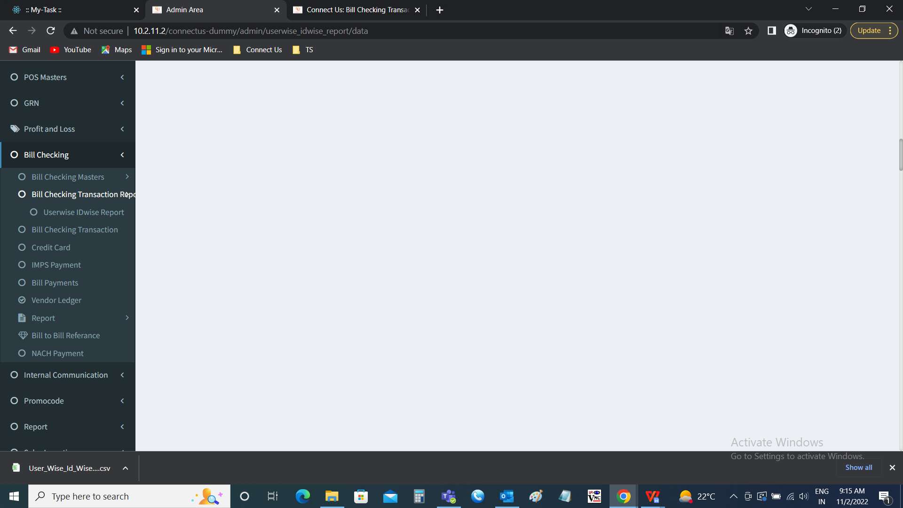

Addition of a column “Acme doc no” in user wise ID wise report

|  |  |
| --- | --- |
| Field | Description |
| Acme Doc No | The acme doc no is fetched from connect us >> bill checking >> bill checking transaction |

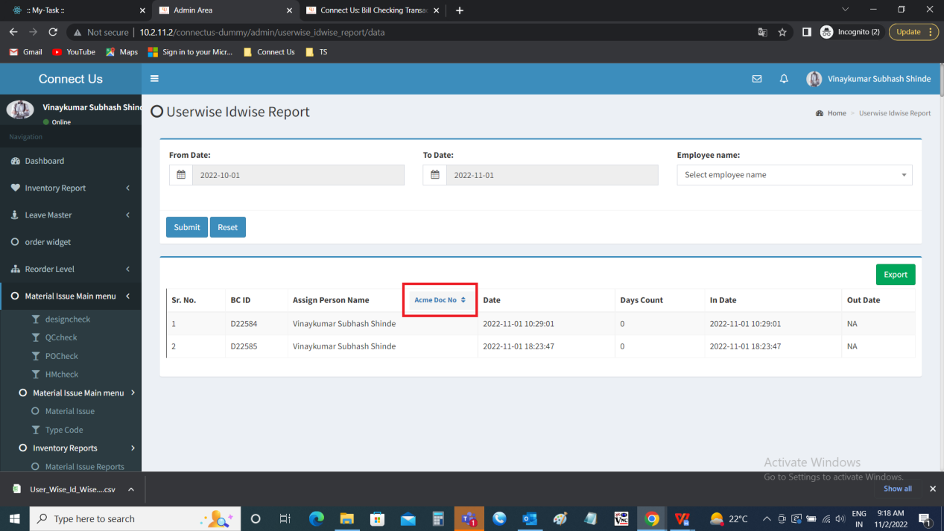

For reference:

In connect us >> bill checking >> bill checking transaction



Bill checking transaction

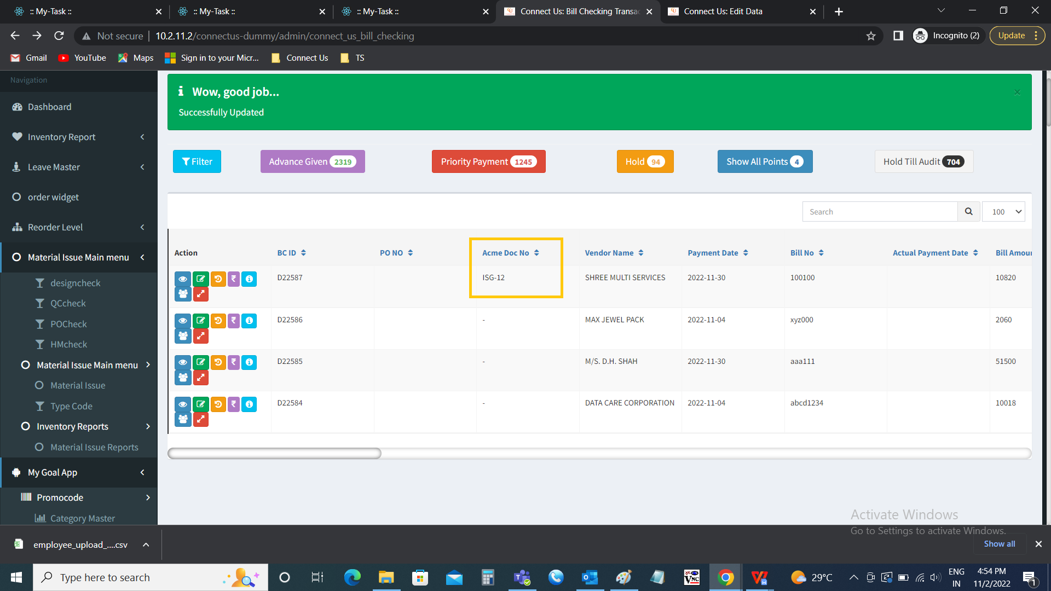

Acme Doc no. Is fetched from connect us >> bill checking >> bill checking transaction >> edit >> ISA (ISA-12)

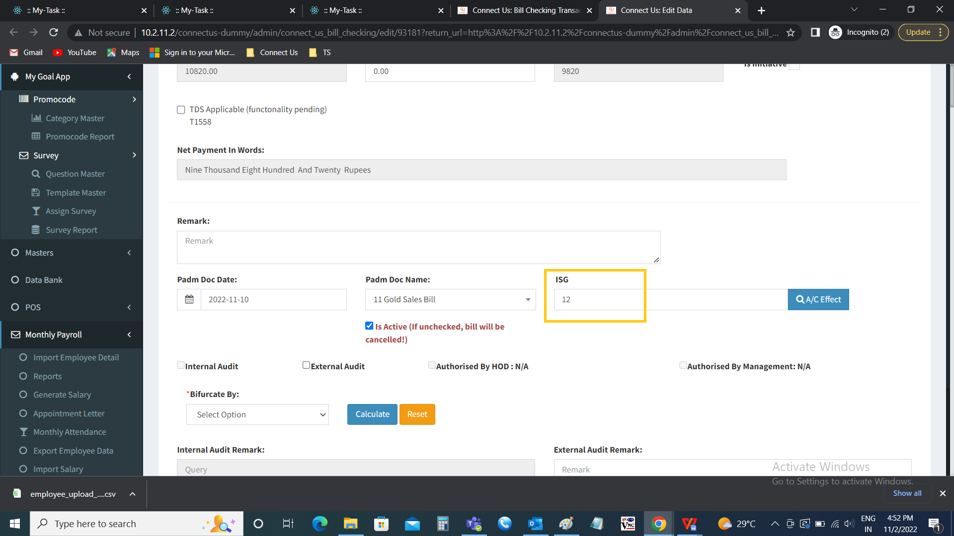

Step 2

Addition of a column “Acme doc no” in user wise ID wise report >> export

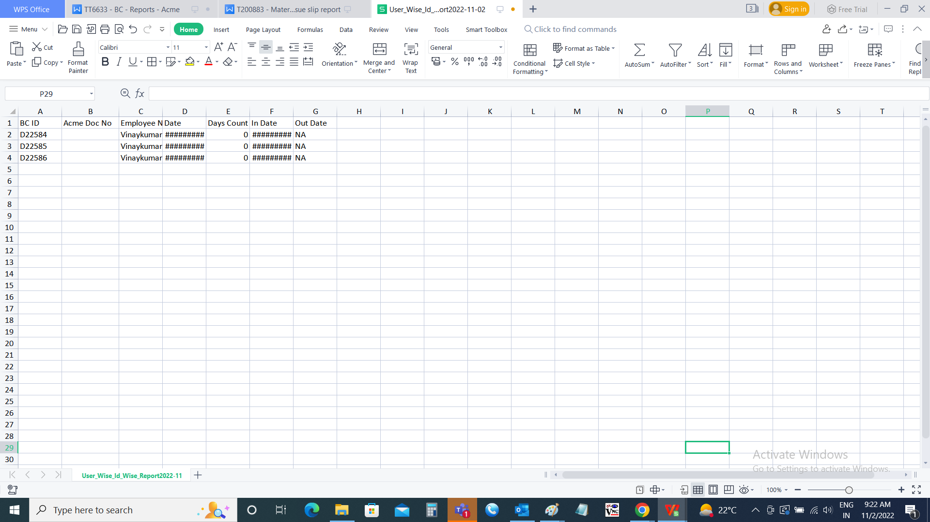

**References of the users**

|  |  |  |  |
| --- | --- | --- | --- |
| **User** | **Name** | **Mail** | **Contact number** |
| **Actual user** | Tushar Shivaji Nikam | designgd@csjewellers.com |  |
| **Assigned business analyst** | Mounika KrishnaVeni Annamneedi | Mounika.annamneedi@techneai.com | 9885900039 |