|  |  |
| --- | --- |
| **Ticket ID** | T615 |
| **Ticket description** | *Description: In AOP require new AOP plan (budgeting) month wise, location and department wise, fulfill online through department and its hit to AOP as per period master and distribute to branch as per sales ratio*  *In Plan two type requirement Revenue expenses (Opex)and Capital expenses (Capex). In Opex and Capex two different type are their 1- Regular and 2. Innitative planning I attach sheet for reference Budget start for FY 19-20 from Jan-19* |
| **Created by** | *Harshali Rananaware* |
| **Created on** | 25 Apr 2022 |
| **Priority** | *Very high* |
| **Version** | *1* |

**Version**

|  |  |  |  |  |
| --- | --- | --- | --- | --- |
| **Sr. No** | **Version no** | **Version Date** | **User name** | **User department** |
| 1 | 1 | 25 Apr 2022 | Dinesh Bhagyawan Sonawane | Accounting Department |

**Approvals**

|  |  |  |
| --- | --- | --- |
| **Field** | **Name of the User** | **Approved date by the user** |
| **Actual User Name** | Dinesh Bhagyawan Sonawane |  |
| **Actual User Department** | Accounting Department |  |
| **Organization Name** | CSPL |  |
| **Assigned BA** | *Harshali Rananaware* |  |
| **Assigned Developer** |  |  |
| **Assigned Tester** |  |  |

**Estimation**

|  |  |  |  |  |
| --- | --- | --- | --- | --- |
| **Department name** | **Estimated Time (In hr)** | **Scheduled Date (Starting date )** | **Estimated date** | **Actual delivery date** |
| **BA** |  |  |  |  |
| **Development** |  |  |  |  |
| **Testing** |  |  |  |  |

**Business requirement**

*Description: In AOP require new AOP plan (budgeting) month wise, location and department wise, fulfill online through department and its hit to AOP as per period master and distribute to branch as per sales ratio*

*In Plan two type requirement Revenue expenses (Opex)and Capital expenses (Capex). In Opex and Capex two different type are their 1- Regular and 2. Innitative planning I attach sheet for reference Budget start for FY 19-20 from Jan-19*

**Abbreviations & terms**

Connect us - CU

**Existing system**

**Proposed System :**

In CU -> profit and Loss -> profit and Loss edit the head or sub head then the “type = Account effect” then show all branches and “type = Department” then show corporate office.

User can add plan using “Revise and plan”.

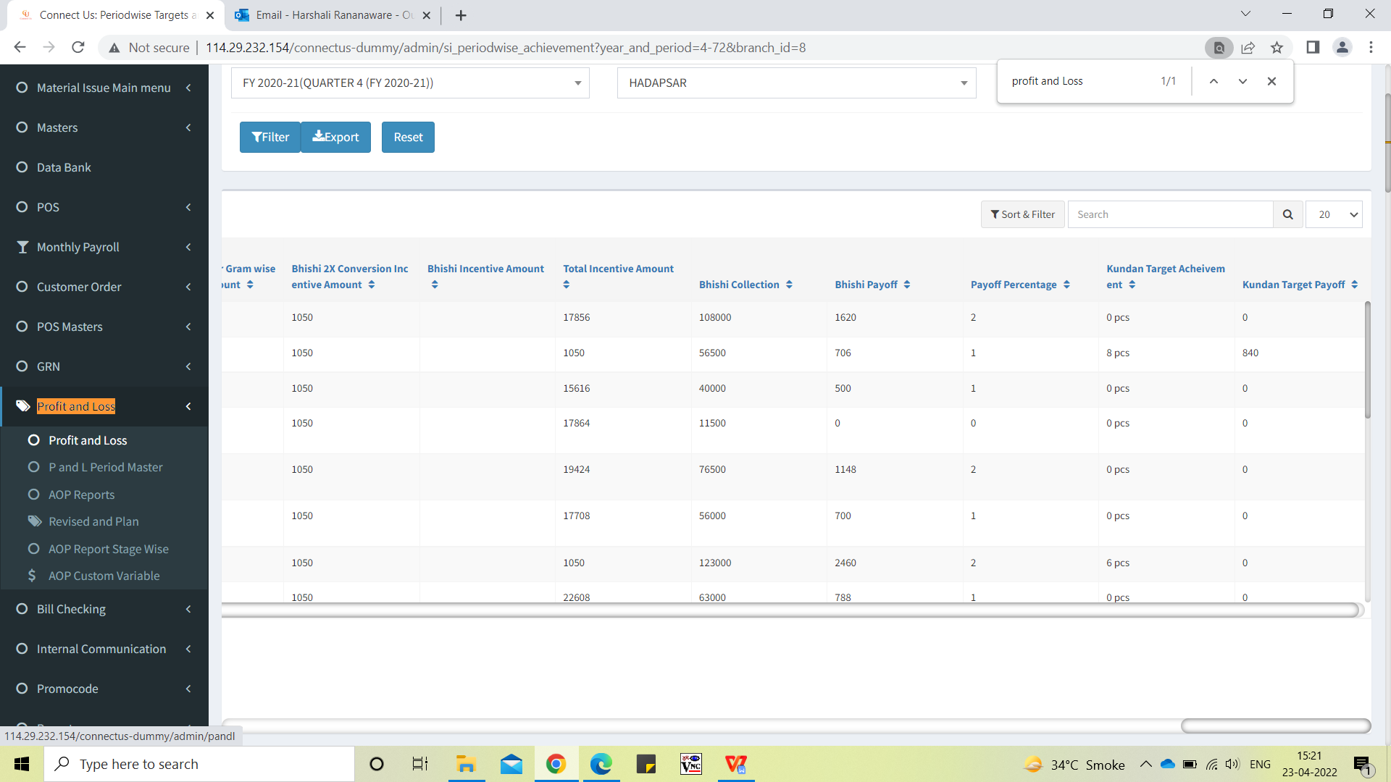

Image 1

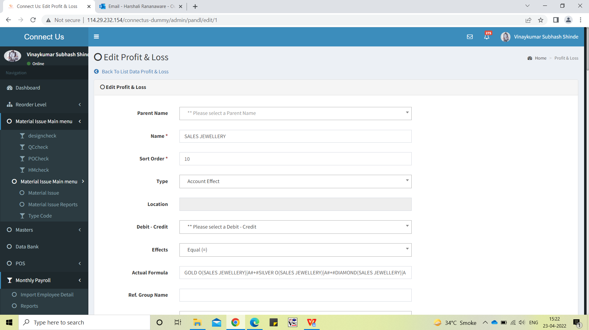

Image 2

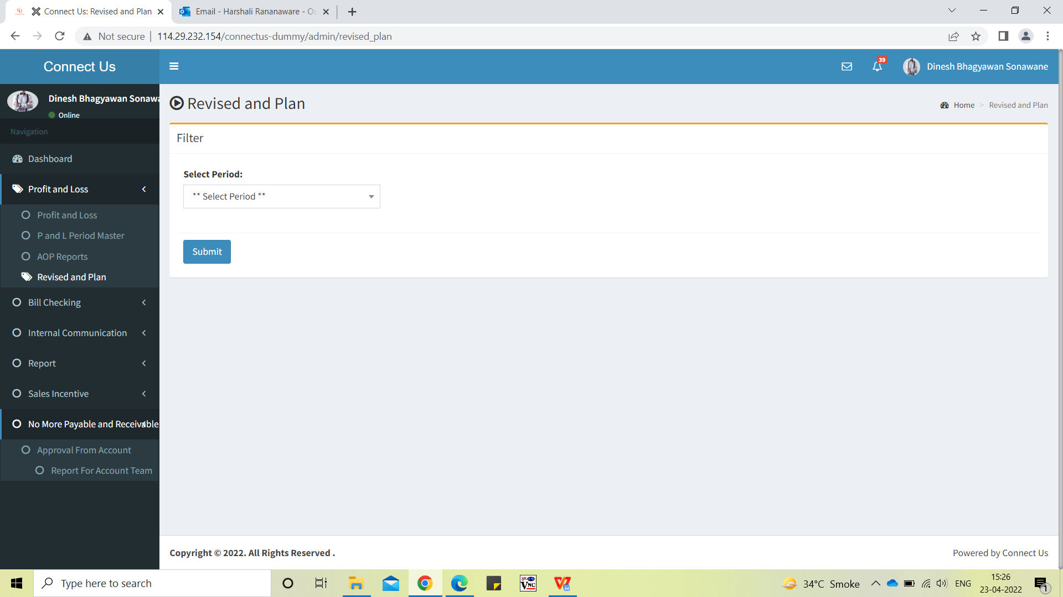Image 3

**References of the users**

|  |  |  |  |
| --- | --- | --- | --- |
| **User** | **Name** | **Mail** | **Contact number** |
| **Actual user** | Dinesh Sonawane | hoaccountcc@csjewellers.com | 2931 |
| **Ticket created by (if any)** |  |  |  |
| **Assigned business analyst** | *Harshali Rananaware* | [harshali.rananaware@techneai.com](mailto:harshali.rananaware@techneai.com) | 8669917920 |
| **Assigned developer** | Parth Patel | [parth.patel@techneai.com](mailto:parth.patel@techneai.com) |  |