|  |  |
| --- | --- |
| **Ticket ID** | TT2927 |
| **Ticket description** | Create New Report In ConnectUS 1) Create New Menu In Connectus :- Silver Inventory Reports > All Report Create Report Name Branchwise Month Wise ALL 1) All CS Monthwise Sale Report In Wt 2) All Month Sale Report In Amount Branchwise Month Wise (2) 1) ONE BRANCH-Sale Report-Branchwise Amount 2) ONE BRANCH-Sale Report-Branchwise WT Itemwise Sale 1) Sale Report-Branchwise WT 2) Sale Report-Branchwise Amount Item Wise Groupings File Uploade Sale Report Fetch From Padm Please find attachment Report and any Issue Discuss with me and vinay sir Full Report MailLa Send Kela Aahe |
| **Created by** | Harshali Rananaware |
| **Created on** | 15 Jul 2022 |
| **Priority** | Very high |
| **Version** | 1 |

**Version**

|  |  |  |  |  |
| --- | --- | --- | --- | --- |
| **Sr. No** | **Version no** | **Version Date** | **User name** | **User department** |
| 1 | 1 | 15 Jul 2022 | Tushar Nikam |  |

**Approvals**

|  |  |  |
| --- | --- | --- |
| **Field** | **Name of the User** | **Approved date by the user** |
| **Actual User Name** | Tushar Nikam |  |
| **Actual User Department** |  |  |
| **Organization Name** | Connect us |  |
| **Assigned BA** | Harshali Rananaware |  |
| **Assigned Developer** |  |  |
| **Assigned Tester** |  |  |

**Estimation**

|  |  |  |  |  |
| --- | --- | --- | --- | --- |
| **Department name** | **Estimated Time (In hr)** | **Scheduled Date (Starting date )** | **Estimated date** | **Actual delivery date** |
| **BA** | 3 | 15 Jul2022 | 19 Jul 2022 |  |
| **Development** |  |  |  |  |
| **Testing** |  |  |  |  |

**Business requirement**

Create New Report In ConnectUS 1) Create New Menu In Connectus :- Silver Inventory Reports > All Report Create Report Name Branchwise Month Wise ALL 1) All CS Monthwise Sale Report In Wt 2) All Month Sale Report In Amount Branchwise Month Wise (2) 1) ONE BRANCH-Sale Report-Branchwise Amount 2) ONE BRANCH-Sale Report-Branchwise WT Itemwise Sale 1) Sale Report-Branchwise WT 2) Sale Report-Branchwise Amount Item Wise Groupings File Uploade Sale Report Fetch From Padm Please find attachment Report and any Issue Discuss with me and vinay sir Full Report MailLa Send Kela Aahe

**Existing system**

There are no such reports in the existing system.

**Proposed system**

* Creation of type master in Connect Us
* In item master, addition of fields such as category and type.
* Provision of bulk upload format and bulk upload for the item master.
* Creation of silver reports in inventory reports.

Step 1

Creation of type master

In connect Us -> Sales incentive -> sales master -> Type master

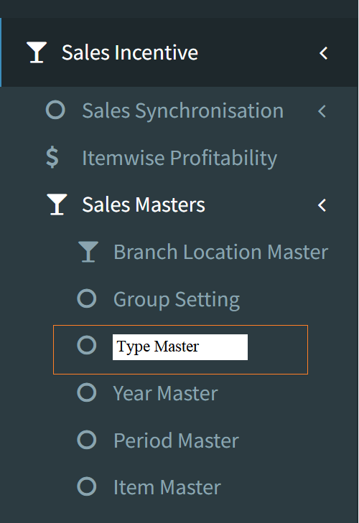

The type master consists of the type of the item such as bullion, ornament, payal, pooja items etc. The following are the fields in the type master.

* Action
* Type name
* Remark
* Active/ Inactive
* Created by
* Created at
* Updated by
* Updated at
* Add data

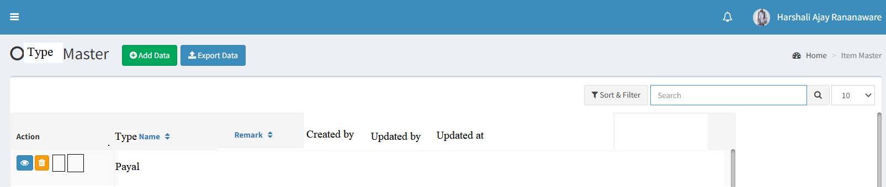

|  |  |
| --- | --- |
| **Field** | **Description** |
| Action | The action field consists of edit and view |
| Type name | The type name is displayed |
| Remark | The remark if any is displayed |
| Active/ Inactive | The active or inactive status of that type is shown |
| Created by | The created person name is displayed |
| Created at | The time and date, when it is created is mentioned |
| Updated by | The updated person name is displayed |
| Updated at | The updated time and date is mentioned |
| Add data | The add data button to add new data |

Add data

The add data consists of the following fields.

* Type name
* Remark
* Active/ inactive
* Save
* Back

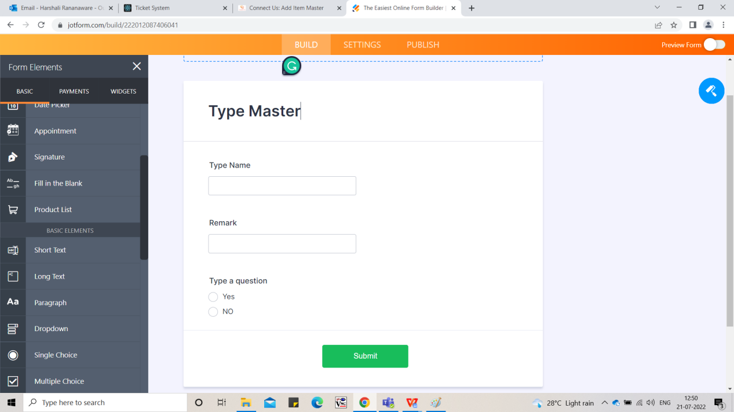

|  |  |  |  |
| --- | --- | --- | --- |
| **Field** | **Type** | **Mandatory/ optional** | **Description** |
| Type name | Text | Mandatory | The type name is entered |
| Remark | Text | Optional | The remark if any is entered |
| Active/ inactive | Radio button | Mandatory | The active or inactive status is selected |
| Save | Button | Optional | The save button to add the data |
| Back | Button | Optional | The back button to navigate to back page |

View data:

The view button in the action field is used to view the data. The following are the fields in the view data.

* Type name
* Remark
* Active/ inactive

Edit data:

The edit button is used to edit the data. The following are the fields in the edit data which can be edited if required.

* Type name
* Remark
* Active/ inactive

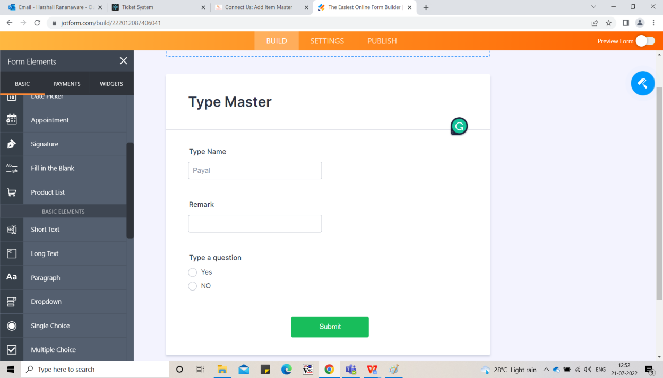

Step 2

Item master

In Connect Us -> Sales Incentive -> Sales Masters -> Item Masters

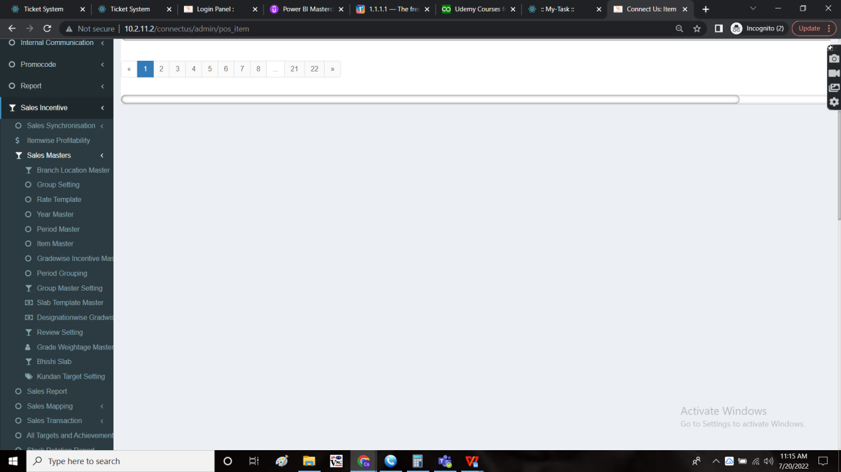

In item master, insertion of new fields

* Category
* Type
* Bulk upload format
* Bulk upload

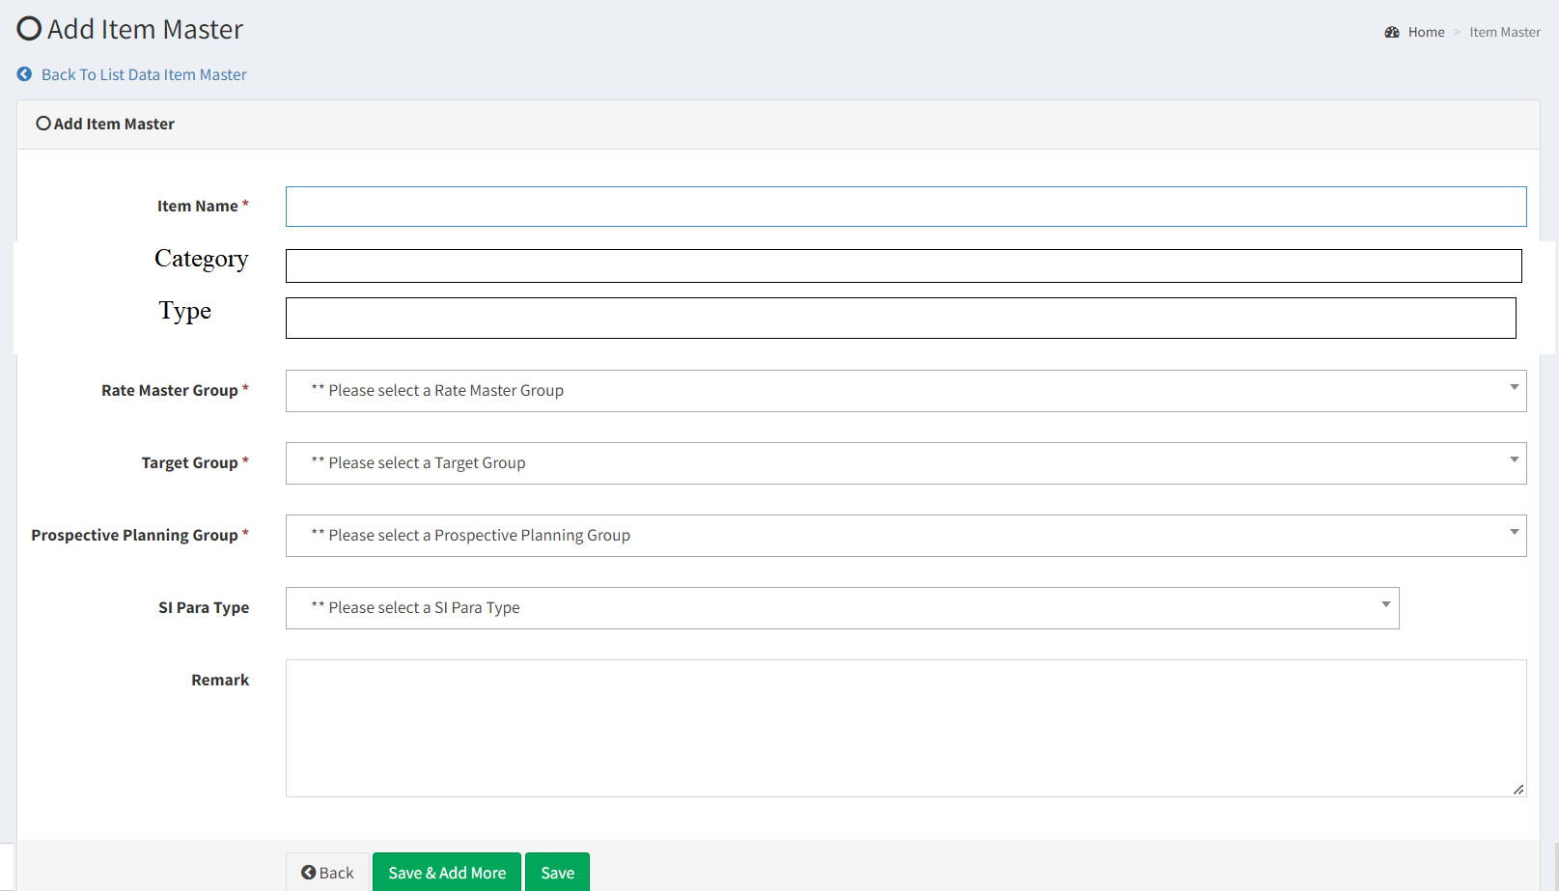

|  |  |
| --- | --- |
| **Field** | **Description** |
| Category | The category of that item is displayed |
| Type | The type of the item is displayed |
| Bulk upload format | The bulk upload format to download the format of the excel sheet to upload the data |
| Bulk upload | The bulk upload button to upload the data |

Bulk upload format

The bulk upload format button is used to download the format of the excel sheet to upload the data. The following are the fields in bulk upload format.

* Item name
* Category
* Type

|  |  |  |  |
| --- | --- | --- | --- |
| **Field** | **Type** | **Mandatory/ optional** | **Description** |
| Item name | Text | Mandatory | The item name is entered |
| Category | Text | Mandatory | The category name is entered |
| Type | Text | Mandatory | The type name is entered |

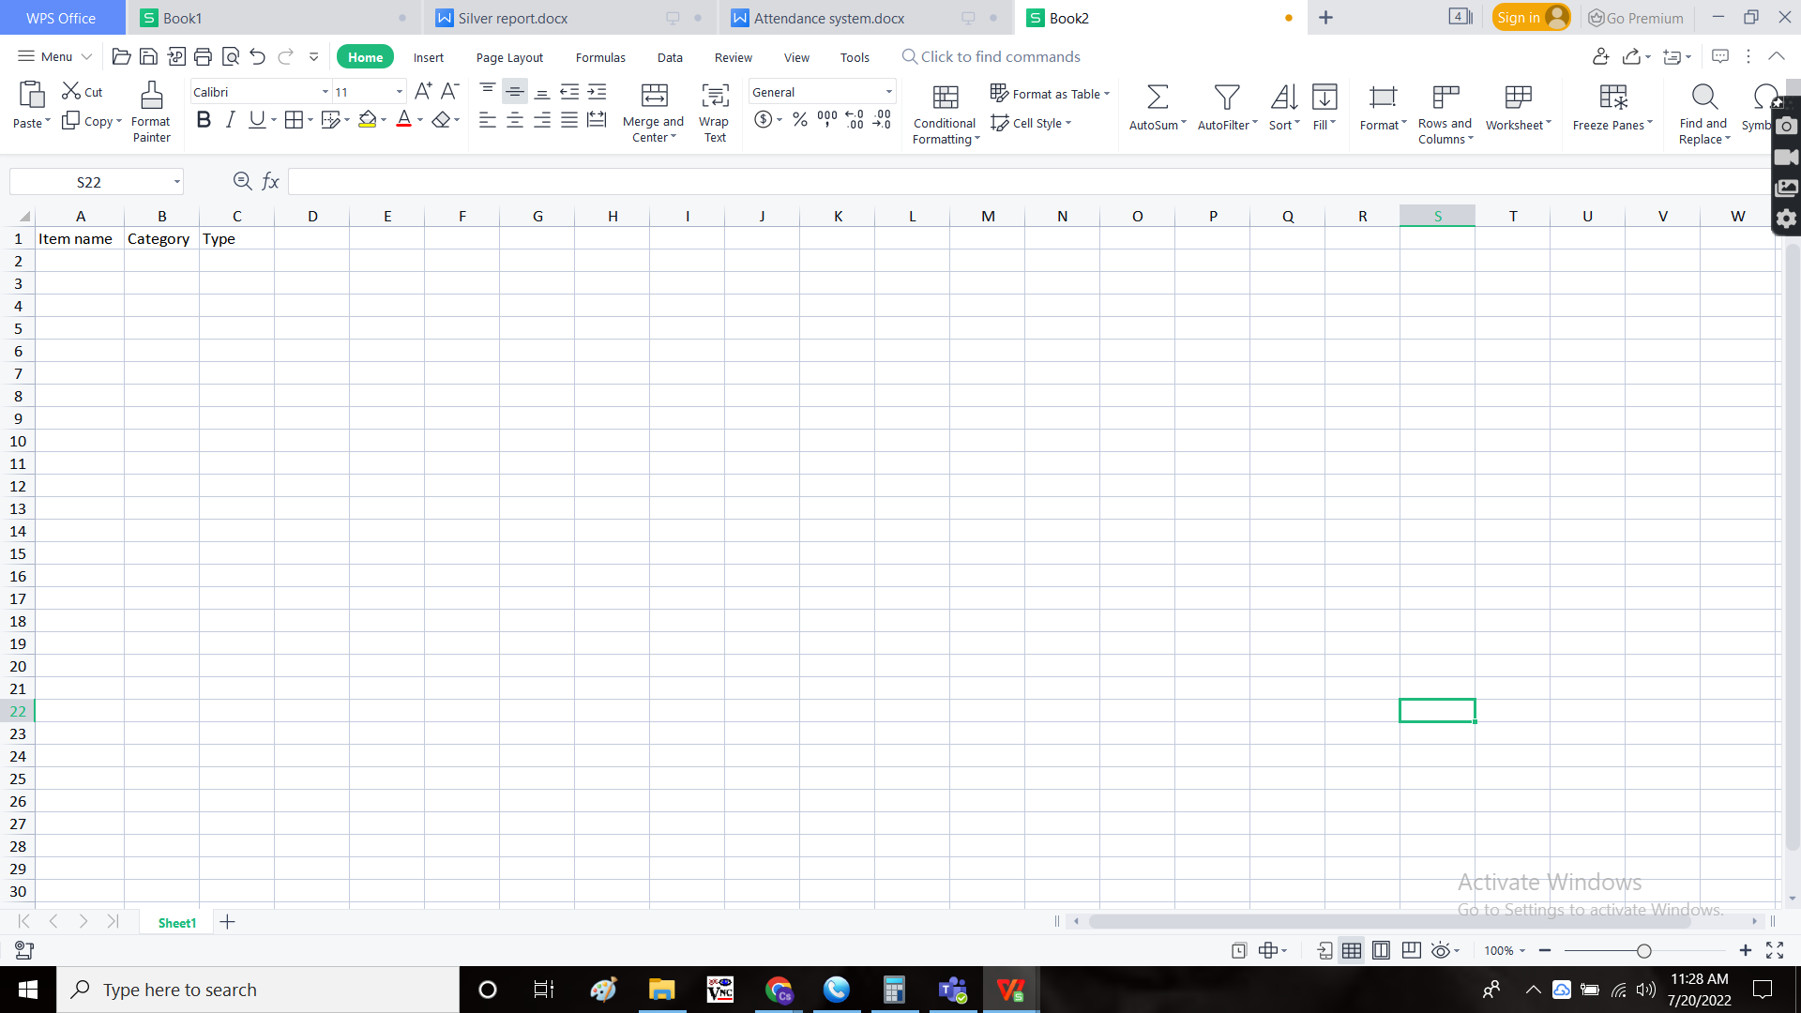

Bulk upload

The bulk upload button to upload the data.

If any wrong file or empty file or wrong input data file uploaded, error message is shown.

Add data

In item master, in add data, insertion of new fields

* Category
* Type

|  |  |  |  |
| --- | --- | --- | --- |
| **Field** | **Type** | **Mandatory/ optional** | **Description** |
| Category | Drop down | Mandatory | The category is selected from the drop down. The drop down options are fetched from the Padm - category master. |
| Type | Drop down | Mandatory | The type is selected from the drop down. The drop down options are fetched from the Connect Us - Sales Incentive - Sales Masters - Type Master. |

View data:

The view button in the action field is used to view the data. The following are the new fields added in the view data.

* Category
* Type

Step - 3

Creation of **Branch-wise Month-wise silver report**

In Connect Us -> Inventory reports -> Branch-wise Month-wise silver report

Silver reports

The silver report consists of the data based on the following filters

* Branch
* Period

The following are the fields in the silver reports.

|  |  |  |  |
| --- | --- | --- | --- |
| **Field** | **Type** | **Mandatory/ optional** | **Description** |
| Branch | Drop down | Mandatory | The branch is selected from down down. The drop down options are fetched from Connect Us - Masters - General Masters - Branch Master. There is a provision to select multiple branches, single and all. |
| Period | Drop down | Mandatory | The period is selected from down down. The drop down options are fetched from Connect Us - Masters - Sales Incentive - Sales Masters - Period Master. There is a provision to select multiple periods, single and all. |
| Type | Drop down | Mandatory | The type is selected from the drop down. The drop down options consists of the following.   * Net weight * Amount |
| Submit | Button | Optional | The submit button to generate the report |
| Reset | Button | Optional | The reset button to reset the filters |
| Cancel | Button | Optional | The cancel button to cancel the report generation |
| Export | Button | Optional | The Export button to export data in CSV format. |

Report

This report use for branch wise month wise. The report is generated when the user clicks on the submit button. There are 2 types of reports based on the type selected I.e., net weight and the amount. The reports is fetched from Padm - Sales data. The following are the fields in the report.

* Branch
* From
* To
* Days
* Bullion
* Jewellery
* Payal
* Plain
* Pooja article
* Sterling - less the swaraski item sale
* Sterling swaoraski -
* Total

**FOR single branch multiple period**

Report (Net weight)

|  |  |  |  |  |  |  |  |  |  |  |  |  |
| --- | --- | --- | --- | --- | --- | --- | --- | --- | --- | --- | --- | --- |
| Branch Name |  | From | To | Days | Bullion | Jewellery | Payal | Plain | Pooja Article | Sterling | Sterling Swaoraski | Total |
| ATHANI BRANCH | Nwt | 1-Apr-2021 | 30-Apr-2021 | 30.00 | 534 | 3042 | 8044 | 3214 | 2691 | 281 | 55 | 17860 |
| ATHANI BRANCH | Nwt | 1-May-2021 | 31-May-2021 | 31.00 | 0 | 145 | 158 | 618 | 353 | 19 | 0 | 1294 |
| ATHANI BRANCH | Nwt | 1-Jun-2021 | 30-Jun-2021 | 30.00 | 638 | 1845 | 3065 | 1016 | 1934 | 104 | 18 | 8621 |

Report (Amount)

|  |  |  |  |  |  |  |  |  |  |  |  |  |
| --- | --- | --- | --- | --- | --- | --- | --- | --- | --- | --- | --- | --- |
| Branch Name |  | From | To | Days | Bullion | Jewellery | Payal | Plain | Pooja Article | Sterling | Sterling Swaoraski | Total |
| ATHANI BRANCH | Nwt | 1-Apr-2021 | 30-Apr-2021 | 30.00 | 37822 | 218651 | 561058 | 242667 | 212560 | 51899 | 18758 | 1343415 |
| ATHANI BRANCH | Nwt | 1-May-2021 | 31-May-2021 | 31.00 | 0 | 10842 | 11782 | 47951 | 30199 | 3488 | 0 | 104263 |
| ATHANI BRANCH | Nwt | 1-Jun-2021 | 30-Jun-2021 | 30.00 | 44132 | 135421 | 219493 | 77291 | 162337 | 18658 | 8234 | 665566 |

* Creation of **Branch-wise Month-wise silver all report**

In Connect Us -> Inventory reports -> Branch-wise Month-wise silver all report.This report use for all branch month wise net weight and amount checking. Want to export this report.

|  |  |  |  |  |  |  |  |  |  |  |  |
| --- | --- | --- | --- | --- | --- | --- | --- | --- | --- | --- | --- |
|  | **All CS Monthwise Sale Report In Wt** | | | | | | | | | | |
|  | From | To | Days | Bullion | Jewellery | Payal | Plain | Pooja Article | Sterling | Sterling Swaoraski | Total |
| Nwt | 1-Apr-2021 | 30-Apr-2021 | 30.00 | 36037 | 33248 | 72469 | 18062 | 54605 | 3154 | 447 | 218022 |
| Nwt | 1-May-2021 | 31-May-2021 | 31.00 | 1262 | 2645 | 4150 | 5695 | 3611 | 67 | 16 | 17447 |
| Nwt | 1-Jun-2021 | 30-Jun-2021 | 30.00 | 166821 | 175577 | 440484 | 70972 | 95740 | 10320 | 2744 | 962658 |
| Nwt | 1-Jul-2021 | 31-Jul-2021 | 31.00 | 198265 | 186936 | 458434 | 86722 | 110912 | 13670 | 4091 | 1059029 |
| Nwt | 1-Aug-2021 | 31-Aug-2021 | 31.00 | 440751 | 285700 | 680306 | 206029 | 272757 | 28725 | 6322 | 1920590 |
| Nwt | 1-Sep-2021 | 30-Sep-2021 | 30.00 | 434864 | 205726 | 439346 | 225870 | 369830 | 14220 | 4696 | 1694552 |
| Nwt | 1-Oct-2021 | 31-Oct-2021 | 31.00 | 290502 | 368085 | 795643 | 239651 | 377846 | 29723 | 8615 | 2110066 |
| Nwt | 1-Nov-2021 | 30-Nov-2021 | 30.00 | 306878 | 420178 | 855566 | 271432 | 442145 | 38007 | 9193 | 2343400 |
| Nwt | 1-Dec-2021 | 31-Dec-2021 | 31.00 | 242987 | 274708 | 512431 | 214245 | 284087 | 21109 | 5890 | 1555458 |
| Nwt | 1-Jan-2022 | 31-Jan-2022 | 31.00 | 302086 | 314066 | 776373 | 123472 | 140108 | 15602 | 3546 | 1675254 |
| Nwt | 1-Feb-2022 | 28-Feb-2022 | 28.00 | 114700 | 200116 | 405371 | 88632 | 230167 | 19389 | 4352 | 1062726 |
| Nwt | 1-Mar-2022 | 31-Mar-2022 | 31.00 | 131320 | 172772 | 369462 | 84055 | 124082 | 15265 | 4159 | 901115 |
|  |  |  |  | 2666473 | 2639758 | 5810035 | 1634836 | 2505890 | 209252 | 54071 | 15520314 |

|  |  |  |  |  |  |  |  |  |  |  |  |
| --- | --- | --- | --- | --- | --- | --- | --- | --- | --- | --- | --- |
| **All Month Sale Report In Amount** | | | | | | | | | | | |
|  | From | To | Days | Bullion | Jewellery | Payal | Plain | Pooja Article | Sterling | Sterling Swaoraski | Total |
| AMT | 1-Apr-2021 | 30-Apr-2021 | 30.00 | 2399044 | 2320604 | 4888848 | 1322586 | 4161026 | 536958 | 187203 | 15816269 |
| AMT | 1-May-2021 | 31-May-2021 | 31.00 | 96556 | 201900 | 312726 | 450499 | 309377 | 13635 | 5568 | 1390261 |
| AMT | 1-Jun-2021 | 30-Jun-2021 | 30.00 | 11440957 | 13161815 | 31962008 | 5494652 | 7926488 | 1758443 | 1158411 | 72902773 |
| AMT | 1-Jul-2021 | 31-Jul-2021 | 31.00 | 13617198 | 13700264 | 32294735 | 6600432 | 9058625 | 2326487 | 1713513 | 79311255 |
| AMT | 1-Aug-2021 | 31-Aug-2021 | 31.00 | 28433087 | 19870527 | 45221453 | 14623364 | 21146181 | 5058741 | 2652170 | 137005524 |
| AMT | 1-Sep-2021 | 30-Sep-2021 | 30.00 | 26766400 | 13872459 | 28407183 | 15811101 | 29406933 | 2543521 | 1951781 | 118759377 |
| AMT | 1-Oct-2021 | 31-Oct-2021 | 31.00 | 17819024 | 25369122 | 52175366 | 16855657 | 28931612 | 5488320 | 3559061 | 150198163 |
| AMT | 1-Nov-2021 | 30-Nov-2021 | 30.00 | 19887467 | 29278959 | 57226117 | 19474497 | 34243760 | 6932464 | 3902185 | 170945449 |
| AMT | 1-Dec-2021 | 31-Dec-2021 | 31.00 | 14833226 | 18184333 | 32802784 | 14419323 | 20891880 | 3848542 | 2461144 | 107441232 |
| AMT | 1-Jan-2022 | 31-Jan-2022 | 31.00 | 16970915 | 21176137 | 51266993 | 8070643 | 10448404 | 2776246 | 1512490 | 112221828 |
| AMT | 1-Feb-2022 | 28-Feb-2022 | 28.00 | 7092899 | 13575531 | 26882367 | 6247574 | 17507151 | 3603518 | 1877178 | 76786217 |
| AMT | 1-Mar-2022 | 31-Mar-2022 | 31.00 | 8331258 | 12720050 | 26305602 | 6270960 | 10134279 | 3009856 | 1809215 | 68581220 |
|  |  |  |  | 167688031 | 183431702 | 389746182 | 115641288 | 194165715 | 37896732 | 22789919 | 1111359568 |

Creation of **Item-wise silver report**

In Connect Us -> Inventory reports -> Item-wise silver report The report is generated when the user clicks on the submit button. There are 2 types of reports based on the type selected I.e., net weight and the amount. The reports is fetched from Padm - Sales data. The following are the fields in the report.

Silver reports

The silver report consists of the data based on the following filters

* Branch
* Period

The following are the fields in the Item-wise silver reports.

|  |  |  |  |
| --- | --- | --- | --- |
| **Field** | **Type** | **Mandatory/ optional** | **Description** |
| Branch | Drop down | Mandatory | The branch is selected from down down. The drop down options are fetched from Connect Us - Masters - General Masters - Branch Master. There is a provision to select multiple branches, single and all. |
| From date | Date | Mandatory | We can select the from date. |
| To date | Date | Mandatory | We can select the to date. |
| Type | Drop down | Mandatory | The type is selected from the drop down. The drop down options consists of the following.   * Net weight * Amount |
| Submit | Button | Optional | The submit button to generate the report |
| Reset | Button | Optional | The reset button to reset the filters |
| Export | Button | Optional | The Export button to export data in CSV format. |

|  |  |  |  |  |  |  |  |  |  |
| --- | --- | --- | --- | --- | --- | --- | --- | --- | --- |
| **Sale Report-Branchwise WT** | | | | | | | | | |
| Date | | From | 1-Apr-2021 | | To | 31-Mar-2022 | | Days | 364 |
| Branch Name |  | Bullion | Jewellery | Payal | Plain | Pooja Article | Sterling | Sterling Swaoraski | Total |
| Sangli Branch | Nwt | 70296 | 178098 | 337964 | 184776 | 203173 | 15409 | 5409 | 995124 |
| KOLHAPUR BRANCH | Nwt | 50240 | 78204 | 161962 | 94036 | 96793 | 11215 | 3676 | 496126 |
| Baramati MIDC | Nwt | 71064 | 287168 | 612345 | 119122 | 174785 | 25118 | 6350 | 1295952 |
| BMT BRANCH | Nwt | 213260 | 869715 | 1865305 | 258047 | 519618 | 45031 | 8217 | 3779193 |
| Corporate Office (HO) | Nwt | 1614106 | 128858 | 268254 | 19600 | 39504 | 3572 | 113 | 2074007 |
| Chinchwad Branch | Nwt | 51961 | 145926 | 369766 | 141248 | 230152 | 14522 | 3651 | 957225 |
| AKLUJ BRANCH | Nwt | 35860 | 132868 | 342785 | 56317 | 62903 | 10934 | 2809 | 644477 |
| KOTHRUD BRANCH | Nwt | 19027 | 48523 | 75820 | 96744 | 110681 | 7889 | 2630 | 361313 |
| HADAPSAR | Nwt | 64614 | 92495 | 208957 | 137109 | 202908 | 11980 | 3171 | 721235 |
| CHANDANNAGAR | Nwt | 217017 | 101837 | 263610 | 91799 | 170461 | 12393 | 3682 | 860798 |
| PUNE SATARA(RD) BRANCH | Nwt | 50192 | 63540 | 119599 | 77785 | 111667 | 6391 | 1963 | 431138 |
| SATARA BRANCH | Nwt | 56631 | 164135 | 373748 | 96051 | 142679 | 11031 | 4312 | 848588 |
| KARAD BRANCH | Nwt | 23809 | 112764 | 296554 | 72566 | 97008 | 9771 | 2403 | 614876 |
| BHOSARI BRANCH | Nwt | 15449 | 62242 | 163699 | 37783 | 62948 | 5649 | 1276 | 349046 |
| SANGAMNER BRANCH | Nwt | 18273 | 36824 | 61885 | 15491 | 20024 | 4778 | 1526 | 158802 |
| Pune Branch | Nwt | 50309 | 69427 | 167961 | 92297 | 195818 | 6854 | 1523 | 584188 |
| E-Commerce | Nwt | 3612 | 694 | 1385 | 442 | 1310 | 1325 | 63 | 8832 |
| ATHANI BRANCH | Nwt | 25800 | 55366 | 94003 | 36933 | 55978 | 4198 | 1046 | 273324 |
| AHMEDNAGAR BRANCH | Nwt | 14950 | 11074 | 24433 | 6689 | 7480 | 1193 | 251 | 66071 |
| Total | | 2666473 | 2639758 | 5810035 | 1634836 | 2505890 | 209252 | 54071 | 15520314 |

|  |  |  |  |  |  |  |  |  |  |
| --- | --- | --- | --- | --- | --- | --- | --- | --- | --- |
| **Sale Report-Branchwise Amount** | | | | | | | | | |
| Date | | From | 1-Apr-2021 | | To | 31-Mar-2022 | | Days | 364 |
| Branch Name |  | Bullion | Jewellery | Payal | Plain | Pooja Article | Sterling | Sterling Swaoraski | Total |
| Sangli Branch | AMT | 4369060 | 12442574 | 22810408 | 13086351 | 15830112 | 2877892 | 2318423 | 73734820 |
| KOLHAPUR BRANCH | AMT | 3082333 | 5402755 | 11062875 | 6683090 | 7475531 | 2092195 | 1540079 | 37338858 |
| Baramati MIDC | AMT | 4570563 | 20036406 | 41434527 | 8539134 | 13336276 | 4389172 | 2647551 | 94953629 |
| BMT BRANCH | AMT | 11063969 | 60790452 | 125805240 | 17541922 | 39665010 | 7935474 | 3504815 | 266306881 |
| Corporate Office (HO) | AMT | 103365899 | 7773938 | 14617837 | 1319427 | 2587594 | 417241 | 25023 | 130106958 |
| Chinchwad Branch | AMT | 3133312 | 10258748 | 25212985 | 10110741 | 18106648 | 2686740 | 1529712 | 71038886 |
| AKLUJ BRANCH | AMT | 2214393 | 9342296 | 23158740 | 4045496 | 4883061 | 1934607 | 1159311 | 46737905 |
| KOTHRUD BRANCH | AMT | 1264966 | 3426723 | 5216984 | 6926096 | 8679894 | 1456814 | 1134000 | 28105477 |
| HADAPSAR | AMT | 4136799 | 6558062 | 14395106 | 9733771 | 15995421 | 2177577 | 1296971 | 54293709 |
| CHANDANNAGAR | AMT | 14343288 | 7161591 | 17998036 | 6547684 | 13403778 | 2325174 | 1522332 | 63301884 |
| PUNE SATARA(RD) BRANCH | AMT | 3275594 | 4505627 | 8191907 | 5529181 | 8812441 | 1244848 | 844312 | 32403910 |
| SATARA BRANCH | AMT | 3653665 | 11387880 | 25038325 | 6826505 | 11046305 | 2065393 | 1845036 | 61863109 |
| KARAD BRANCH | AMT | 1536468 | 7831889 | 19910754 | 5155320 | 7529243 | 1844326 | 1029349 | 44837350 |
| BHOSARI BRANCH | AMT | 1014407 | 4369241 | 11094635 | 2711954 | 4984335 | 1047407 | 547054 | 25769033 |
| SANGAMNER BRANCH | AMT | 1173635 | 2578448 | 4208439 | 1100524 | 1542716 | 876011 | 653340 | 12133114 |
| Pune Branch | AMT | 3422004 | 4893774 | 11459676 | 6624590 | 15352788 | 1279957 | 640687 | 43673476 |
| E-Commerce | AMT | 275127 | 53256 | 104719 | 30985 | 115112 | 244530 | 24572 | 848300 |
| ATHANI BRANCH | AMT | 950738 | 3842837 | 6344773 | 2647559 | 4237082 | 769548 | 422160 | 19214697 |
| AHMEDNAGAR BRANCH | AMT | 841809 | 775203 | 1680215 | 480958 | 582369 | 231828 | 105190 | 4697572 |
| Total | | 167688031 | 183431702 | 389746182 | 115641288 | 194165715 | 37896732 | 22789919 | 1,11,13,59,567.71 |

**References of the users**

|  |  |  |  |
| --- | --- | --- | --- |
| **User** | **Name** | **Mail** | **Contact number** |
| **Actual user** | Tushar Shivaji Nikam | designgd@csjewellers.com | 2604 |
| **Assigned business analyst** | Harshali Ajay Rananaware. | [Harshali.rananaware@techneai.com](mailto:Harshali.rananaware@techneai.com) | 2964 |
| **Assigned developer** |  |  |  |
| **Assigned tester** |  |  |  |

New type create then what?