|  |  |
| --- | --- |
| **Ticket ID** | TT3088 |
| **Ticket description** | Required to be generate day wise, product wise, branch wise detailed SALES REPORT of any period. |
| **Created by** | Harshali Rananaware |
| **Created on** | 22 Jul 2022 |
| **Priority** | Very high |
| **Version** | 1 |

**Version**

|  |  |  |  |  |
| --- | --- | --- | --- | --- |
| **Sr. No** | **Version no** | **Version Date** | **User name** | **User department** |
| 1 | 1 | 22 Jul 2022 | Amarja Dudka | Accounting department |

**Approvals**

|  |  |  |
| --- | --- | --- |
| **Field** | **Name of the User** | **Approved date by the user** |
| **Actual User Name** | Amarja Dudka |  |
| **Actual User Department** | Accounting department |  |
| **Organization Name** | Connect us |  |
| **Assigned BA** | Harshali Rananaware |  |
| **Assigned Developer** | Nikhil Bhosale |  |
| **Assigned Tester** |  |  |

**Estimation**

|  |  |  |  |  |
| --- | --- | --- | --- | --- |
| **Department name** | **Estimated Time (In hr)** | **Scheduled Date (Starting date )** | **Estimated date** | **Actual delivery date** |
| **BA** | 3 | 22 Jul2022 | 27 Jul 2022 |  |
| **Development** |  |  |  |  |
| **Testing** |  |  |  |  |

**Business requirement**

Required to be generate day wise, product wise, branch wise detailed SALES REPORT of any period.

**Proposed System :**

In CU -> Sales incentive -> sales report want to show day wise sales report.

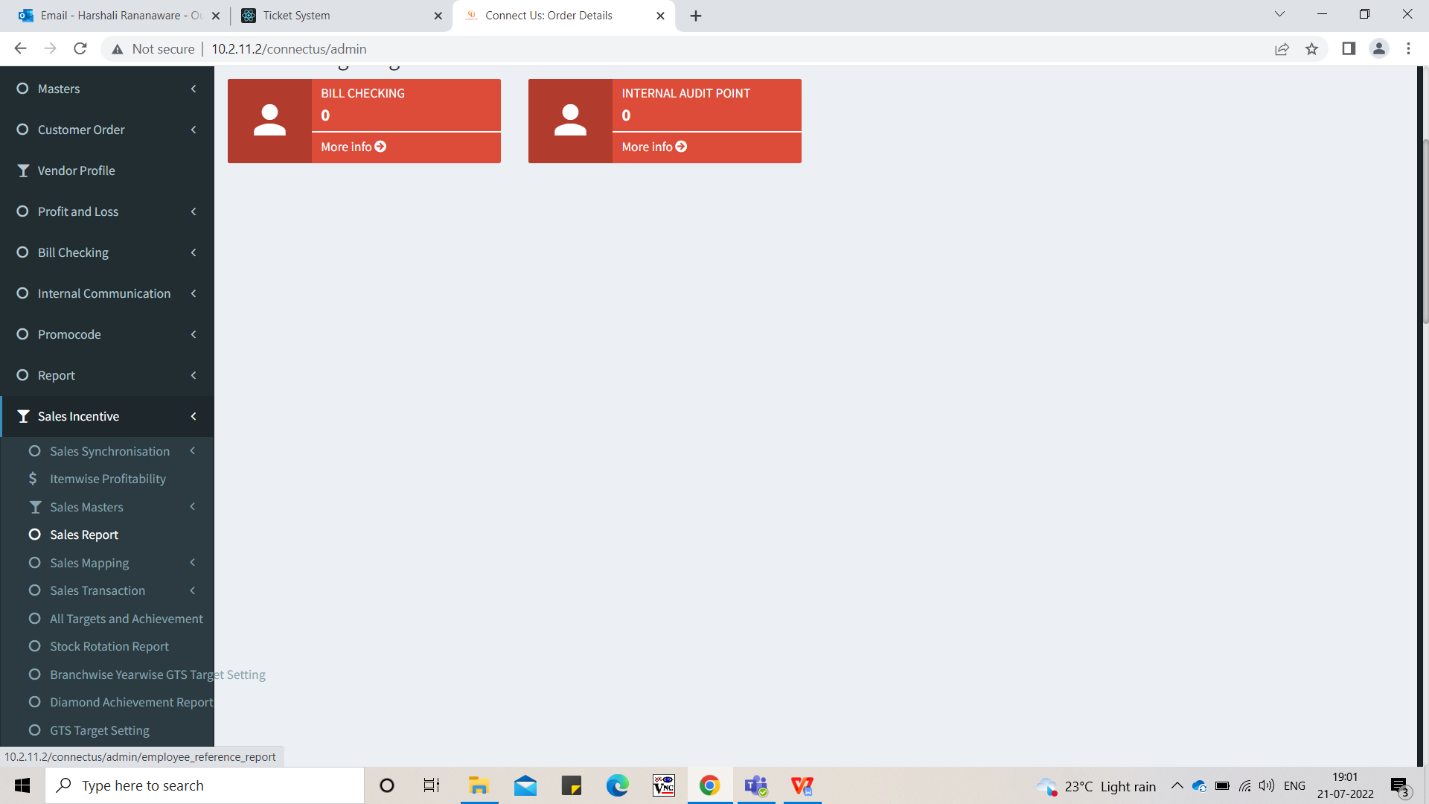

Image 1

In sales report current show period wise so want a new option day-wise.

If we select a period then then report generate a period wise. (Refer Image 2)

|  |  |  |  |
| --- | --- | --- | --- |
| **FIELDS** | **INPUT TYPE** | **MANDATORY/ OPTIONAL** | **DESCRIPTION** |
| Period | Drop down | Mandatory | The period is selected from drop down. The period drop down list is fetched from Sales Incentive -> Sales Master -> period master. |
| Cluster | Drop down | Mandatory | The cluster is selected from drop down. |
| From date | Date | Mandatory | This is disable and auto fetch from period date. |
| To date | Date | Mandatory | This is disable and auto fetch from period date. |
| Sales Report | Button | Optional |  |
| Branch Performance | Button | Optional |  |

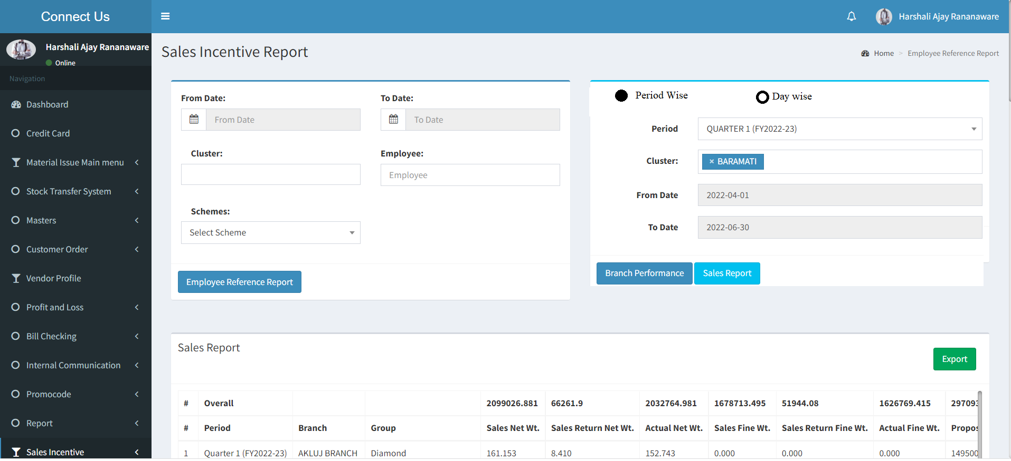

Image 2

We select day wise then show sales report button only. We select from date , to date and cluster.

|  |  |  |  |
| --- | --- | --- | --- |
| **FIELDS** | **INPUT TYPE** | **MANDATORY/ OPTIONAL** | **DESCRIPTION** |
| Cluster | Drop down | Mandatory | The cluster is selected from drop down. |
| From date | Date | Mandatory | We can select from date. |
| To date | Date | Mandatory | We can select to date. |
| Sales Report | Button |  |  |

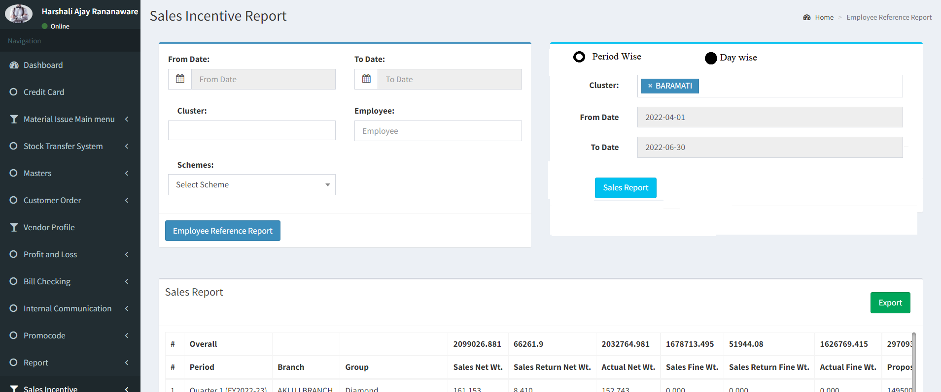

Image 3

|  |  |  |  |  |  |  |  |  |  |  |  |  |  |  |  |  |
| --- | --- | --- | --- | --- | --- | --- | --- | --- | --- | --- | --- | --- | --- | --- | --- | --- |
| Date | BRANCH_NAME | GROUPNAME | SALES_NETWT | SALES_RETURN_NETWT | ACTUAL_NET_WT | SALES_FINEWT | SALES_RETURN_FINEWT | ACTUAL_FINE_WT | PROPOSED_TARGET_AMOUNT | REVISED_TARGET_AMOUNT | SALES_ITEMAMOUNT | SALES_RETURN_ITEMAMOUNT | ACTUAL_AMOUNT | SALE_COUNT | SALESRETURN_COUNT | NETSALES_COUNT |
| 22-07-2022 | AKLUJ BRANCH | Diamond | 161.153 | 8.41 | 152.743 | 0 | 0 | 0 | 14950000 | 16780383.7 | 11757213 | 595990 | 11161223 | 602 | 34 | 568 |
| 22-07-2022 | AKLUJ BRANCH | Diamond Jewellery | 1912.894 | 124.456 | 1788.438 | 1385.987 | 93.343 | 1292.644 | 12650000 | 14137665.3 | 10689245.52 | 711394.5 | 9977851.02 | 646 | 38 | 608 |
| 22-07-2022 | AKLUJ BRANCH | Gold Bullion | 8975.46 | 416.401 | 8559.059 | 8930.574 | 413.437 | 8517.137 | 31500000 | 36304030 | 46549376.08 | 2168725 | 44380651.08 | 1549 | 67 | 1482 |
| 22-07-2022 | AKLUJ BRANCH | Gold O | 55947.976 | 2474.45 | 53473.526 | 51544.847 | 2277.358 | 49267.489 | 320000000 | 354247040 | 309678197.4 | 13728370.24 | 295949827.2 | 10364 | 294 | 10070 |
| 22-07-2022 | AKLUJ BRANCH | Imitation Item | 0 | 0 | 0 | 0 | 0 | 0 | 2050000 | 2050000 | 1449080.06 | 28620 | 1420460.06 | 1056 | 11 | 1045 |
| 22-07-2022 | AKLUJ BRANCH | MRP Items | 0 | 0 | 0 | 0 | 0 | 0 | 400000 | 400000 | 354092 | 1900 | 352192 | 329 | 3 | 326 |
| 22-07-2022 | AKLUJ BRANCH | Platinum | 7.011 | 0 | 7.011 | 0 | 0 | 0 | 0 | 0 | 38755 | 0 | 38755 | 2 | 0 | 2 |
| 22-07-2022 | AKLUJ BRANCH | Repair Target Group Master | 640.54 | 0 | 640.54 | 566.146 | 0 | 566.146 | 0 | 0 | 98956 | 0 | 98956 | 1652 | 0 | 1652 |
| 22-07-2022 | AKLUJ BRANCH | Silver Bullion | 10865.392 | 0 | 10865.392 | 10864.069 | 0 | 10864.069 | 500000 | 636600 | 691727.22 | 0 | 691727.22 | 170 | 0 | 170 |
| 22-07-2022 | AKLUJ BRANCH | Silver O | 187322.786 | 6221.18 | 181101.606 | 143063.261 | 4580.554 | 138482.707 | 13200000 | 15903800 | 13542149.16 | 438800 | 13103349.16 | 6645 | 167 | 6478 |
| 22-07-2022 | AKLUJ BRANCH | Stone | 4114.284 | 158.618 | 3955.666 | 0 | 0 | 0 | 612500 | 612500 | 751971.1 | 21646.92 | 730324.18 | 2547 | 111 | 2436 |
| 23-07-2022 | AKLUJ BRANCH | Diamond | 161.153 | 8.41 | 152.743 | 0 | 0 | 0 | 14950000 | 16780383.7 | 11757213 | 595990 | 11161223 | 602 | 34 | 568 |
| 23-07-2022 | AKLUJ BRANCH | Diamond Jewellery | 1912.894 | 124.456 | 1788.438 | 1385.987 | 93.343 | 1292.644 | 12650000 | 14137665.3 | 10689245.52 | 711394.5 | 9977851.02 | 646 | 38 | 608 |
| 23-07-2022 | AKLUJ BRANCH | Gold Bullion | 8975.46 | 416.401 | 8559.059 | 8930.574 | 413.437 | 8517.137 | 31500000 | 36304030 | 46549376.08 | 2168725 | 44380651.08 | 1549 | 67 | 1482 |
| 23-07-2022 | AKLUJ BRANCH | Gold O | 55947.976 | 2474.45 | 53473.526 | 51544.847 | 2277.358 | 49267.489 | 320000000 | 354247040 | 309678197.4 | 13728370.24 | 295949827.2 | 10364 | 294 | 10070 |
| 23-07-2022 | AKLUJ BRANCH | Imitation Item | 0 | 0 | 0 | 0 | 0 | 0 | 2050000 | 2050000 | 1449080.06 | 28620 | 1420460.06 | 1056 | 11 | 1045 |
| 23-07-2022 | AKLUJ BRANCH | MRP Items | 0 | 0 | 0 | 0 | 0 | 0 | 400000 | 400000 | 354092 | 1900 | 352192 | 329 | 3 | 326 |
| 23-07-2022 | AKLUJ BRANCH | Platinum | 7.011 | 0 | 7.011 | 0 | 0 | 0 | 0 | 0 | 38755 | 0 | 38755 | 2 | 0 | 2 |
| 23-07-2022 | AKLUJ BRANCH | Repair Target Group Master | 640.54 | 0 | 640.54 | 566.146 | 0 | 566.146 | 0 | 0 | 98956 | 0 | 98956 | 1652 | 0 | 1652 |
| 23-07-2022 | AKLUJ BRANCH | Silver Bullion | 10865.392 | 0 | 10865.392 | 10864.069 | 0 | 10864.069 | 500000 | 636600 | 691727.22 | 0 | 691727.22 | 170 | 0 | 170 |
| 23-07-2022 | AKLUJ BRANCH | Silver O | 187322.786 | 6221.18 | 181101.606 | 143063.261 | 4580.554 | 138482.707 | 13200000 | 15903800 | 13542149.16 | 438800 | 13103349.16 | 6645 | 167 | 6478 |
| 23-07-2022 | AKLUJ BRANCH | Stone | 4114.284 | 158.618 | 3955.666 | 0 | 0 | 0 | 612500 | 612500 | 751971.1 | 21646.92 | 730324.18 | 2547 | 111 | 2436 |

**References of the users**

|  |  |  |  |
| --- | --- | --- | --- |
| **User** | **Name** | **Mail** | **Contact number** |
| **Actual user** | Amarja Dudka | account@csjewellers.com | 2930 |
| **Assigned business analyst** | Harshali Rananaware | [harshali.rananaware@techneai.com](mailto:harshali.rananaware@techneai.com) | 8669917920 |
| **Assigned developer** | Nikhil Bhosale | nikhil.bhosale@techneai.com |  |